

TITLE: DEVELOPIN EMOTIONAL INTELLIGENCE SKILLS

STUDENT NAME: CLAUDIA REBECA GORGAN
MODULE CODE: LCLM5006
STUDENT ID: 2209748
LECTURER NAME: SAMUEL OFORI
COMPONENT 2- 3000 WORDS

Table of Contents
Introduction 3
Critical Evaluation of How Employees Use Emotional Intelligence Components in theWorkplace 3
Emotional Intelligence Models and Their Relevance to the Workplace 4
Self-awarenessand its functional role in workplace behaviour 4
EI in Stress Management and Emotional Well-being 8
Emotional Intelligence in a Multigenerational Workforce 9
Emotional Intelligence Characteristics of Generation Y (Millennials) 11
Digital Emotional Communication 12
Critical Evaluation of EI in Generational Recruitment 13
Conclusion and Future Recommendations 14
Future Recommendations 14
References: 16

Introduction

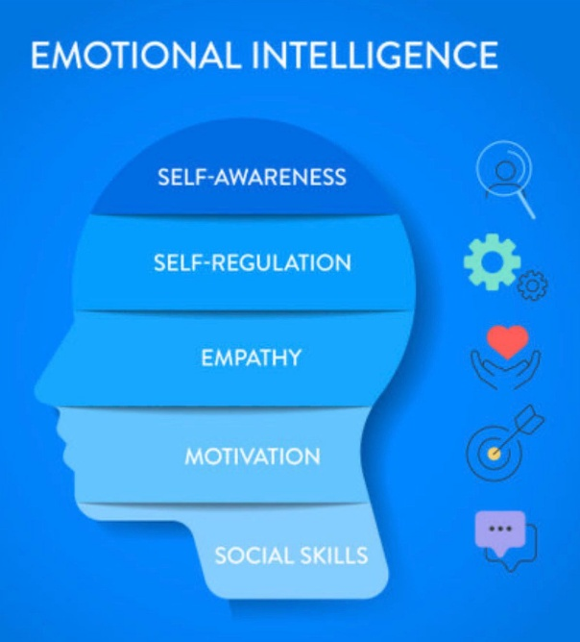
The term, emotional intelligence (EI) has emerged as an important skill required in today's organisational functioning because of the growing interrelatedness, multiplicity and complexity. As described as the ability to recognize, understand and manage emotions in oneself and others (Mayer & Salovey, 1997), EI has been associated with better communication, leadership effectiveness, teamwork; and overall job performance (Goleman, 1995; Cherniss, 2010). In addition, the increasing incorporation of mindfulness-based programs have further strengthened employees’ ability for emotional awareness, resilience and self-regulation with empirically demonstrated corporate benefits in terms of organisational wellbeing (Kabat-Zinn, 2003). Given this context, and the nature of contemporary work environments as characterised by a shift towards teamwork and an accelerated pace of operations, it is increasingly important that workers can utilise EI capabilities that is, self-awareness, empathy, motivation or social skills to behave effectively at work.

Critical Evaluation of How Employees Use Emotional Intelligence Components in the Workplace

I wish I had more time to really understand emotional intelligence (EI) has been just as much part of the essential skills needed in a social business, it also matters for individuals: EI required for collaboration, adaptability and communication." EI is defined as, the capacity to recognize, understand and use emotions in such that it promotes cognitive and behavioural development (Mayer & Salovey, 1997). The last 30 years has seen EI associated with enhanced job performance, leadership ability, team cooperation and conflict resolution (Goleman, 1995; Cherniss, 2010). Critical examination In this section, the application of EI in workplace will be assessed applying various theoretical models such as Goleman’s Mixed Model (1995; 1998), Mayer and Salovey’s Ability Model (1997) and Bar-On’s (2000) Emotional–Social Intelligence Model. Such models help frame the way that EI is evident in professional practice and how it might work to enhance organisational performance.

Emotional Intelligence Models and Their Relevance to the Workplace

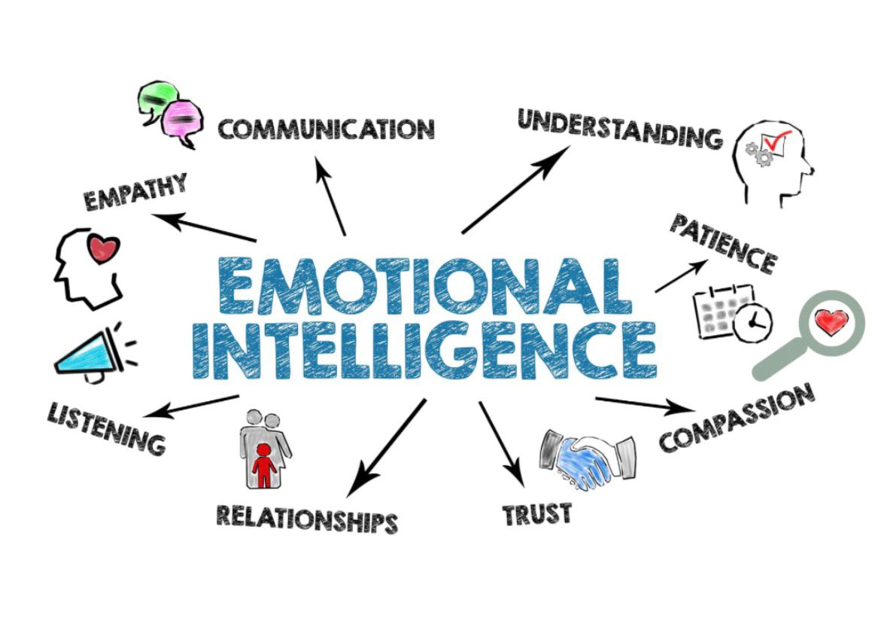
The most prominent of these is Goleman’s (1995; 1998) Mixed Model, which conceptualizes five EI dimensions: self-awareness, self-regulation, motivation, empathy and social skills. Description Of Competency Model This model is based on the essential behavioural and interpersonal skills known to impact job performance. For example, Mayer and Salovey (1997) define EI as a cognitive ability that is comprised of four dimensions: perceiving emotions, using emotions to reason, understanding emotions and being able to manage them. Their theory argues that EI is quantifiable and integral to rational decision-making. Bar-On (2000) offers a third approach and suggests integrating emotional and social competencies such as tolerance of stress, flexibility and interpersonal skills.
Although these models vary in the degree of emphasis placed on these various factors, together they present a comprehensive framework for considering how employees implement EI in their work lives. When integrated, these constructs provide a more comprehensive picture of emotional behaviours and cognitions that influence workplace performance.

Self-awareness and its functional role in workplace behaviour
Key to the EI model is self-awareness, which refers to the ability to identify one’s internal emotional states as well as one's personal strengths and weaknesses and behavioural dispositions (Goleman, 1995). Self-awareness is the ability of employees to recognize emotional signals, pinpoint what’s causing the emotions and understand how these emotions drive their thoughts and behaviour towards others. This skill helps people predict how reactions will impact their peers, making them more deliberate, more reflective about their own actions.
In a practical sense, self-awareness helps employees to manage pressure, identify areas of tension and admit shortcomings as well as respond to feedback effectively. For instance, knowing that frustration levels are escalating during a team meeting, an employee may decide instead of counterattacking defensively to pause, moderate his or her pitch, and/or ask for further explanation. There is evidence that self-aware individuals have more job satisfaction and better performance too, as they are more likely to behave according to their values and adjust their behaviour (Caruso & Salovey, 2004).
Then again, self-awareness is not all that. Cynics contend that self-awareness is limited by cognitive bias and an inflated ego, so that employees potentially overestimate their emotional skills (Dunninge, 2011). In addition, organisational cultures that are unfriendly to openness or emotion may also inhibit employee growth and demonstration of self-awareness allowing its efficacy (if any) to be diminished. Nevertheless, self (emotional) insight is an important factor of work-related behaviour even if more elaborate by mindfulness exercises which are known to improve awareness at the emotional level (Kabat-Zinn, 2003).

Self-Regulation: Emotional Control and Adaptability in the Workplace
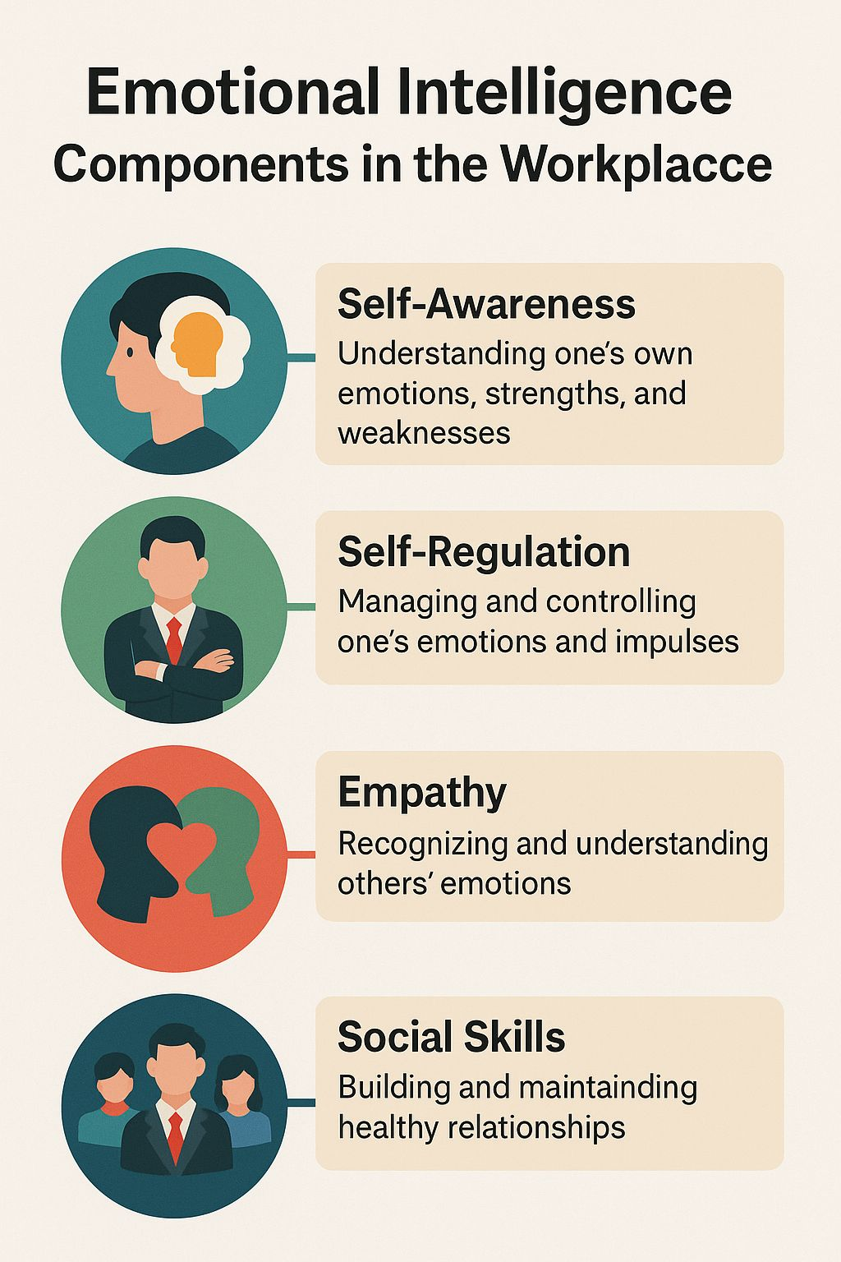
Self-management is the ability to handle one’s disruptive emotions, control impulses and be professional regardless of the circumstances (Goleman, 1998). Self-regulation is also necessary in employees to defend themselves when criticized, resolve friction between coworkers, and stay calm under pressure. Self-regulation allows us to stay calm, think things through and behave appropriately.
For example, in such customer facing jobs the workers need to be able to handle irritation or stress and politely serve their customers. Likewise, in times of organisational change, employees with high levels of emotional intelligence will be more able to accept change and avoid the tendency to resist because of fear or uncertainty. Mayer and Salovey (1997) branch of emotional management which resonates with this subsystem, was stated to reflect control over emotions in order rest on them on the grounds of logic rather than automatic reactions.
For all its benefits, self-regulation also can have the opposite effect. When habitually used, emotional suppression results in burnout, emotional depletion or lack of personal expression (Gross, 2015). Some argue that organisations could “weaponised” EI expectations to coerce emotional conformism from employees and avoid acknowledging more structural causes of stress (Rose, 2020). Thus, self-regulation also depends on healthy organizational policies and psychological safety.
Emotions and Performance Mental Intangible Issues that Motivate Action
Motivation in the EI model is the desire of a person to attain objectives, stay persistent and be committed during adversities (Goleman, 1998). They use the power of high spirits -- or enthusiasm and optimism -- to keep performing. They tend to be proactive, purposeful and committed to life-long learning.
Motivated workers also fosters innovation, problem solving and knowledge sharing in an organisational set up. That is, high EI individuals generate constructive thoughts for coping with a misfortune as opposed to feeling defeated. Bar-On (2000) relates emotional resilience and stress tolerance to greater performance for stressful job functions.
However, motivation can also be affected by external factors such as leadership style, reward systems and organisational climate (Ryan & Deci 2000). It follows that EI alone does not exhaust the possible motivations for behaviours. A supportive climate of autonomy, acknowledgement and meaningful work is necessary for intrinsic motivation. Even so, EI still is an important predictor of continued motivation in the workplace provided it can be redirected to positive purposes at work.

Empathy: Understanding Others and Building Workplace Relationships

The ability to verbalize, empathize (understand and respond the emotions of others), is a critical tool in communication and collaboration (Goleman, 1995). Empathy-driven coworkers listen actively, read emotional cues and adapt behaviour to their co-workers' need. This builds trust, minimizes conflict, and increases team unity.
In a diverse work environment, empathy is what enables us to steer through cultural differences as well as communication styles and personal expectations. In their model of emotional intelligence, Mayer and Salovey (1997) stress that attending to emotional information is a necessary skill in empathy. Workers use this skill to read people’s faces, the tones of their voices and other physical cues to react as expected.
While empathy is certainly a plus, it can have its downsides. Empathy overload, compassion fatigue, or boundary confusion may result from hyper empathy, especially in caregiving professions (Figley, 2015). Empathy can also be abused as manipulation, where one uses the appearance (or simulation) of being understanding to bring about specific objectives. Thus, empathy needs to be qualified by moral discernment and affective limits.
By social skills, this study is referring to the ability to speak out effectively, lead others and make friends/ build a meaningful relationship with colleagues in your profession (Goleman, 1998). Employees with emotional intelligence show high level of social skills; they listen, give feedback, negotiate and team work effectively.
Being emotionally conscious is an important aspect of communication. Workers rely on social skills to read the emotions of others, tailor their communication style and foster cooperation. Having strong EI helps leaders with inspiring and aligning teams, the ability to resolve conflicts, and creating inclusive environments (Boyatzis, 2018).
Yet opponents say that social skills work as emotional management, where workers police their behaviours to suit institutional demands and deny themselves in the process (Hochschild, 2012). Finally, high EI employees may use their abilities to manipulate others for their own as opposed to organisational ends. Promoting an ethical practice Therefore social skills need to be informed by an ethical practice.

EI in Stress Management and Emotional Well-being

The widespread Ness of work-stress caused by fast technological developments, performance requests and social demands. By promoting employees’ ability to understand the early signs of stress, regulate their emotions and remain resilient. Bar-On (2000) identifies stress tolerance as a fundamental dimension of EI and more general literature indicates that the domains of EI are negatively associated with burnout and positively related to psychological well-being (Schutte, et al., 2007).
Mindfulness approaches are especially suitable as an adjunct to EI through their emphasis on attention, reactivity reduction and mood regulation (Kabat-Zinn, 2003). Workers who regularly meditate show enhanced focus, less conflict and better ability to bounce back.
It is also important to recognise that despite these potential advantages, EI should not substitute for organisational responsibility in workload management or toxic culture reduction. Exaggerating the importance of personal EI culpably absolves employers of pressing stress-related responsibilities (Rose, 2020). As such, EI should become part of larger mental health initiatives rather than an end-all and be-all solution.
The Shortcomings and Criticisms of EI in an Organisational Context
While EI is highly acclaimed, there are some criticisms one should be mindful of:
- Difficult to Measure: RCTs are not appropriate for many forms of intervention EI tests come in various form s and the evidence for their validity is debatable (Landy, 2005).
- Cultural Bias: People from different cultures have varying abilities to express emotions which may influence how EI is applied (Matsumoto, 2006).
- Manipulation risk: High EI individuals may employ emotional understanding to manipulate or deceive others (Kilduff, Chiaburu, & Menges, 2010). Disproportional Focus on Personal Competence: EI is not a substitute for poor leadership or dysfunctional organisational systems.

The emotional intelligence traits that are related to indigenous recruiting practices among Generation X, Y and Z
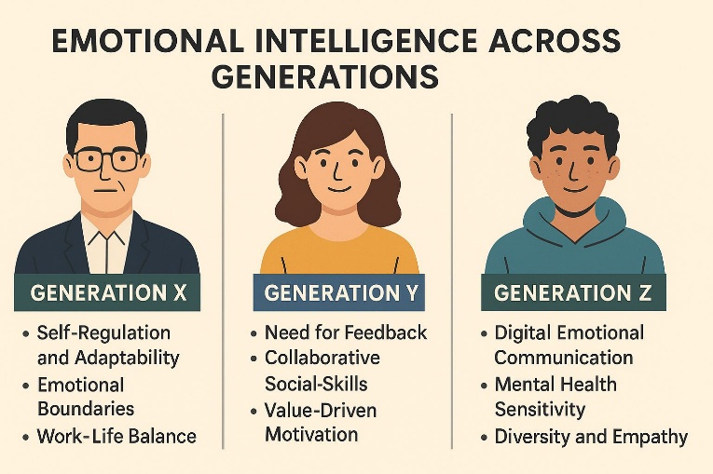
Contemporary organizations are becoming increasingly multigenerational, with employees whose experience has been moulded by dissimilar social, technological and economic circumstances. Generational cohorts including Generation X (1965–1980), Generation Y or Millennials (born 1981–1996) and Generation Z (born 1997–2012) exhibit different values, ways of communication, work expectations and emotional competencies (Parry & Urwin, 2011). Understanding these distinctions is vital for managers who are engaged in selection processes as emotional intelligence (EI) has been found to be critical for predicting job performance, interpersonal effectiveness and organisational fit (Goleman, 1998; Cherniss, 2010).

Emotional Intelligence in a Multigenerational Workforce

While individual variation can be found within each generation, generational theory posits commonalities in emotional expression, communication styles and work values (Twenge et al., 2010). As a result, EI traits can differ between generations, and impact the way employees deal with their emotions, work is managed and adjusted to suit organisational needs. When recruiting, managers should take such differences into account not only to find the appropriate candidates but also to balance diversity and team unity.
The ability model of Mayer & Salovey, 1997 offers an appropriate theoretical framework for contrasting the generations by attending to how people perceive, understand and regulate emotions. Also, in relation to how different groups experience EI at work are Goleman’s (1995; 1998) behavioural competencies self-awareness, self-regulation, motivation, empathy and social skills. Managers need to view EI in the context of generational identity, national culture and personality.
Emotional Intelligence of Generation X Characteristics
Because of their formative years during recession and social changes, Generation X workers are often said to be autonomous, realistic and flexible (Smola & Sutton, 2002). Such contextual factors affect their emotions competence at work.
Self-Regulation and Adaptability
Gen X workers have tendency for self-regulation (control) and preference for tautness (Jurkiewicz, 2000). They are also individually repressing their emotion, instead of revealing it through a resource - as external controlled emotion. In recruitment, managers need to be aware that Gen X applicants can thrive in emotional stability, self-management and independent decision-making positions.
Emotional Boundaries and Communication Style
They tend to favour task-orientated, straight-forward communication and appreciate professionalism from their manager when communicated with (Parry and Urwin, 2011). So, the fact that they are very emotional may be interpreted in a lower verbal emotional expression but should not be mistaken as low empathy or EI. From a interviews-perspective, Gen X job seekers may not necessarily place personal emotional experiences in the spotlight but rather may show their emotional competence through reliability and pragmatic problem-solving.
Work–life balance as an emotional necessity
Given the experience of multiple income families and single parent homes in their youth, work–life balance is important to generation X (Smola and Sutton, 2002). Respecting this emotional priority is important when attracting and retaining Gen X staff, especially for positions requiring a high level of flexibility or autonomy.
Critical Consideration
One downside is that members of Generation X might chafe against emotional, touchy-feely styles of leadership favoured by younger workers. Managers must therefore consider EI not just as an emotional expression but also as effective expressive behaviour given situational norms.

Emotional Intelligence Characteristics of Generation Y (Millennials)

Millennials are widely characterised as collaborative, socially conscious and technologically confident (Twenge, 2010). Their upbringing during rapid digital expansion influences emotional expectations and workplace behaviour.
Strong Need for Feedback and Emotional Support
Feed-Back and Interaction Millennials usually appreciate to have continuous feed-back and open communication, this is evidence of a deep emotional intelligence (Myers and Saraghina, 2010). What this means for recruiters is that they do well in emotionally expressive, collaborative contexts. Their preference for supportive leadership can be seen as a more demanding request of empathy and psychological safety in an organizational context. Collaborative Social Skills
Millennials have no problem with Working Together and Building Relationships; they are a Social Power one of Goleman’s (1998) EI dimensions. Their familiarity with digital communication media is also helpful for managing relationships in virtual teams. Value-Driven Motivation
Millennials are motivated by purpose work and organizational purpose, corresponding with Goleman’s idea of intrinsic motivation. While hiring, leaders should take into consideration that loyalty for Millennials comes in form of passion, motivation and alignment with company values rather than sticking to the good old rules of loyal employee ship. Emotional Expression
Evidence shows that Millennials are more open about talking about mental health, stress and emotional health compared to older generations (Twenge et al., 2010). Being open with their emotions can be an advantage in positions where empathy is important, but this might look like a liability when things are high pressure. Thus, managers should distinguish clearly between emotional expressiveness and unstable emotions when making judgments about EI. Traits of Emotional Intelligence in Generation Z
Generation Z is entering the labour force with a unique EI profile that has been influenced by digital saturation, diversity complexity, and increased mental health issues (Schroth, 2019).

Digital Emotional Communication
Gen Z employees are digital natives who communicate in an online environment and their emotional regulation or expression has adjusted to those of a variety of emoji like cues, tone indicators alien to literature, and text-based communication sources (Turner, 2015). Recruiters may need to consider assessing emotional communication more than solely by facial behaviour but also with digital communication skills.
Greater Emotional Intelligence and Mental Health Sensitivity
Gen Z workers tend to have good emotional self-awareness but are challenged by being able to control and respond effectively due to increased exposure of social media pressures as well as global crises (Schroth, 2019). But although leaders in this generation appreciate open discussion of emotions and mental health, managers must evaluate EI not only by the degree to which they are open about their feelings but also by how well they can navigate stress, develop resilience or manage themselves under pressure in high-demand roles. Diversity and Empathy
The most culturally diverse generation, Gen Z has a strong social conscience when it comes to social justice, inclusivity and equality (Francis & Hoefel, 2018). This fits with Goleman’s (1995) empathy domain, and can assist jobs that involve compassion, diversity consciousness, and customer interaction.
Preference for Authenticity
Authentic leadership and meaningful employer–employee relations are important to gen Z ‘who were raised on the messiness of reality television, which leaned heavily on authenticity’ (Turner 2015). So, a recruiter should have genuine interest, be direct and emotionally honest to establish rapport. A consideration in assessing for EI in this group should involve how the candidate can make true connections and thrive in an emotionally diverse work environment.
Comparatives Contrast in EI Considerations for Recruitment Managers should also be cautious in recruiting across generations and not assume a single generation to be homogenous.
Certain EI-related variables, however, still appear relevant:
Communication style differences: Gen X is more comfortable being direct; Millennials thrive on feedback-rich dialogue, and Gen Z feels at home communicating digitally. EI testing should take these various styles into consideration.
Emotional expression: “Millennials and Gen Zs are more likely to be emotionally open; gen Xers might seem a bit more reserved with their emotions.” Low verbal emotionality shouldn't be mistaken for low EI by recruiters.
Motivational differences: Gen X prioritises stability and independence; Millennials look for a sense of purpose and growth; Gen Z places greater importance on health and authenticity.
Stress resilience: Gen X is often known for strong emotional resilience, while Millennials crave support structures and Gen Z might need more mental health resources.
As a result, recruiters may need to employ flexible EI assessments (to varying degrees), for example behaviour-based interviews, situational judgement tests and/or generational diversity-adjusted ("shotgun") EI-only psychometrics (see Boyatzis, 2018).

Critical Evaluation of EI in Generational Recruitment

While generational EI characteristics provide useful insights, critics argue that generational classifications may overgeneralise and overlook individual differences (Costanza et al., 2012). Additionally, societal and cultural contexts influence EI development, meaning generational patterns are not universal. Nevertheless, understanding generational EI tendencies can support more informed recruitment, provided managers apply these insights ethically and avoid stereotyping.

Conclusion and Future Recommendations

Emotional intelligence or EI has become a major determinant of successful behaviour in the workplace including communication, team working, leadership potential and employee well-being. And this is exactly what the rigorous analysis offered in this work reveals: that EI constructs such as self-awareness, self-regulation, motivation, empathy and social skills are crucial factors affecting how people process emotional information from others, their reaction to organisational demands and maintenance of positive interpersonal relations (Goleman, 1995; Mayer and Salovey, 1997). These competences, when used effectively, lead to improved performance, lower levels of conflict and healthier organisational culture. Furthermore, mindfulness-based approaches offer another route to enhancing emotional regulation and resiliency (Kabat-Zinn, 2003), thereby furthering the value of EI in the workplace.
The report also points out that EI plays a different role in generations. Generation X generally shows emotional independence and stability, the communications of Millennials are relationship based with expectations towards on-the-go feedback, whereas Generation Z has built up digital emotional awareness, yet they seem to be very much stressed sensitive (Parry and Urwin, 2011; Schroth, 2019). These generational differences demand that managers use flexible and situation specific hiring models to ensure that EI assessments reflect a wide variety of communication styles and emotional standards.

Future Recommendations

Organizations should begin by incorporating EI and mindfulness development programs into their professional development to enhance emotional competencies for all generations. Second, recruitment procedures should use structured EI (SB) assessment tools such as behaviour- based interviews or situational judgment tests to ensure that candidates’ emotional perception and management in a context are assessed. Finally, since communication mediums are generation-based and one tailored approach will not suit all generations (nor must), managers should adapt their communication plans according to generational communication preferences while emotionally reassuring without pandering. Fourth, organizations need to create a psychologically safety environment where open dialogue, candid feedback, and well-being support, especially for younger employees who may need more emotional reassurance. Last, future research and HR practice have to consider cultural diversity as well as generational belonging, since EI is affected by broader social and cultural experiences rather than just age trends.

References:
Bar-On, R. (2000) ‘Emotional and social intelligence: Insights from the Emotional Quotient Inventory (EQ-i)’, The Handbook of Emotional Intelligence, 1(1), pp. 363–388.
Boyatzis, R.E. (2018) ‘The behavioural level of emotional intelligence and its measurement’, Frontiers in Psychology, 9(1), pp. 1–12.
Caruso, D.R. and Salovey, P. (2004) The emotionally intelligent manager: How to develop and use the four key emotional skills of leadership. San Francisco: Jossey-Bass.
Cherniss, C. (2010) ‘Emotional intelligence: Toward clarification of a concept’, Industrial and Organizational Psychology, 3(2), pp. 110–126.
Costanza, D.P., Badger, J.M., Fraser, R.L., Severt, J.B. and Gade, P.A. (2012) ‘Generational differences in work-related attitudes: A meta-analysis’, Journal of Business and Psychology, 27(4), pp. 375–394.
Figley, C.R. (2015) Compassion fatigue: Coping with secondary traumatic stress disorder in those who treat the traumatized. New York: Routledge.
Goleman, D. (1995) Emotional intelligence: Why it can matter more than IQ. New York: Bantam Books.
Goleman, D. (1998) Working with emotional intelligence. New York: Bantam Books.
Gross, J.J. (2015) ‘Emotion regulation: Status and future prospects’, Psychological Inquiry, 26(1), pp. 1–26.
Jurkiewicz, C.L. (2000) ‘Generation X and the public employee’, Public Personnel Management, 29(1), pp. 55–74.
Kabat-Zinn, J. (2003) ‘Mindfulness-based interventions in context: Past, present, and future’, Clinical Psychology: Science and Practice, 10(2), pp. 144–156.
Mayer, J.D. and Salovey, P. (1997) ‘What is emotional intelligence?’ in Salovey, P. and Sluyter, D. (eds.) Emotional development and emotional intelligence: educational implications. New York: Basic Books, pp. 3–31.
Parry, E. and Urwin, P. (2011) ‘Generational differences in work values: A review of theory and evidence’, International Journal of Management Reviews, 13(1), pp. 79–96.
Schroth, H. (2019) ‘Are you ready for Gen Z in the workplace?’, California Management Review, 61(3), pp. 5–18.
Twenge, J.M., Campbell, S.M., Hoffman, B.R. and Lance, C.E. (2010) ‘Generational differences in work values: Leisure and extrinsic values increasing, social and intrinsic values decreasing’, Journal of Management, 36(5), pp. 1117–1142.

