Network Operating Systems and Services
Assignment Two
By Timothy Day (1909697)

Name of the Team: KSPT
Team Members
Student Name | Student ID
Timothy Day | 1909697
Peter Holdstock | 2021952
Sam Jackson | 1802975
Kes sumner | 2015409
Team Evaluation
 | Kes Sumner | Sam Jackson |  | Pete Holdstock |  | Tim Day
Kes Sumner | 5 |  | 4 |  | 4 |  | 4
Sam Jackson | 5 |  | 4 |  | 4 |  | 4
Pete Holdstock | 5 |  | 4 |  | 4 |  | 4
Tim Day | 5 |  | 5 |  | 5 |  | 5
Timothy Day: I helped Kes with task 1 implementing shared permissions on the virtual machines.
Kes Sumner: Kes lead the team for assignment 2 with implementing the tasks given on the virtual machine.
Sam Jackson: Sam was the team member that helped with the screenshotting and annotations.
Peter Holdstock: Peter was the team member going through the instruction document point by point making sure everyone understood the task ahead.

Contents
Abstract 4
Introduction 4
Part 1 5
Worksheet Task 1: 5
Worksheet Task 2: 13
Conclusion 31
Reflection on collaborative work 31
References 31

Figure 1 Setting NTFS access permissions for the folder. 5
Figure 2 Message received if the write permission is removed. 6
Figure 3 Configuring the network shared folder. 7
Figure 4 Drive (Z:) mapped to the shared folder. 7
Figure 5 GPO 1: Restricting Access to the control panel. 8
Figure 6 GPO 1: Moderating Access to the Control Panel. 8
Figure 7 GPO 2: Removing Access to the Command Prompt. 9
Figure 8 GPO 3: Restricting Access to Removable Media Drives. 10
Figure 9 GPO 4: Restricting Software Installs 11
Figure 10 GPO 5: Enforcing Password Policy in the ‘accatask.msft’ domain 12
Figure 11 Address resolution protocol cache contents from arp -A command. 13
Figure 12 Arp cache contents from asp -A command after pings. 14
Figure 13 Creation of FTP site on Server 2. 15
Figure 14 Successful FTP login and file transfer. 16
Figure 15 Installing the remote access role. 17
Figure 16 Client 2 pinging Client 1 on its private IP address 18
Figure 17 Configuring IP filter to block ping of router interface (Filter 1). 19
Figure 18 Ping of router interface blocked, other IP addresses respond. 20
Figure 19 FTP service connection. 21
Figure 20 22
Figure 21 23
Figure 22 24
Figure 23 Failover cluster manager 27
Figure 24 Configuration of a failover cluster 28
Figure 25 Configuration cont. 28
Figure 26 Configuration cont. 29
Figure 27 Configuration is validated. 29
Figure 28 Summary of Config 30

Abstract
In this report it details the group work conducted with screenshots and brief descriptions of managing and maintaining network resources using network policy and security practices and routing and packet filtering within core TCP/IP services and critical failover/redundancy practices in our already established virtual network form assignment one. Also within this report is some personal evaluation and learnings conducted alongside the group work.

Introduction
As part of a group, we built upon our virtual LAN from assignment one by implementing and maintaining network resources using network pollicises and security practices. Also, we implemented routing and packet filtering within core TCP/IP services and critical failover/redundancy practices. Also included in this report I answer some questions related to what we have implemented in our virtual LAN. And give reflections on the tasks completed.

Part 1

Worksheet Task 1:
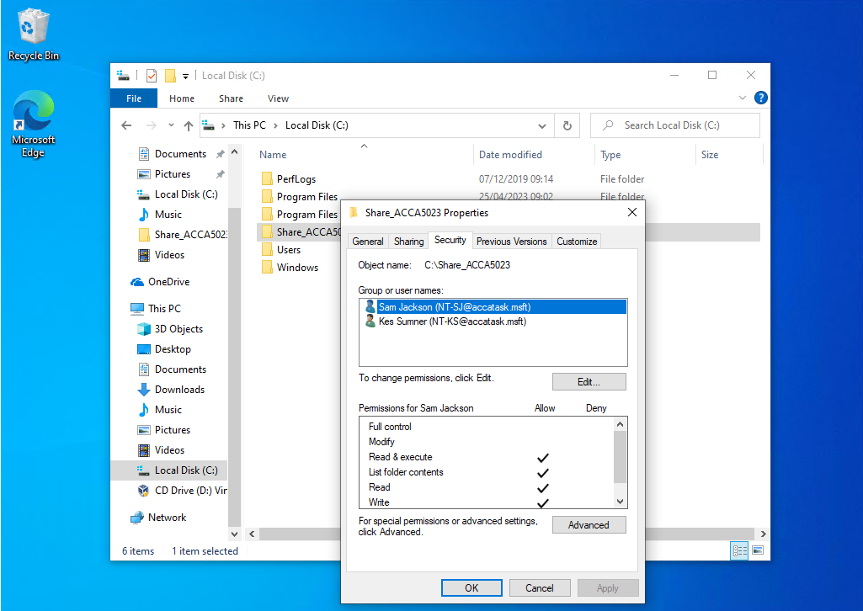
Figure 1 Setting NTFS access permissions for the folder.
The non-admin user (Sam) can type text into the file and save changes with the permissions granted as per the worksheet (“Grant this user everything underneath and including Read and Execute.”). This is because the instructions include write permission, shown above, allowing the user to write a new version of the file.
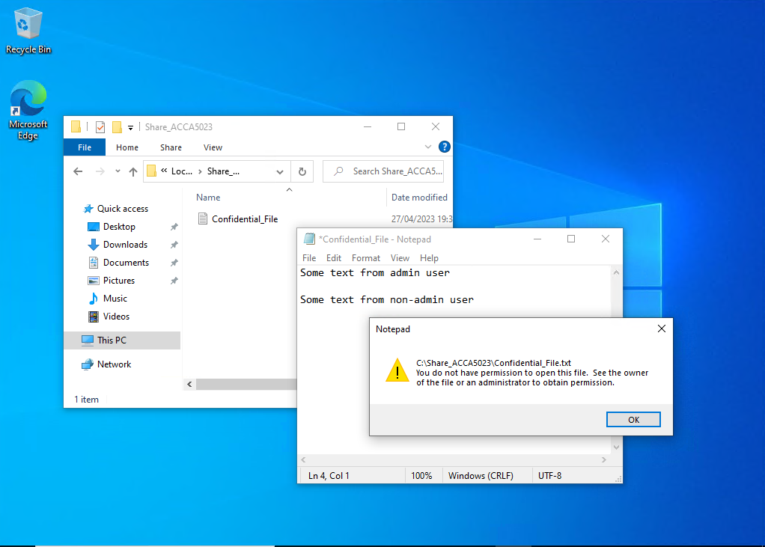
Figure 2 Message received if the write permission is removed.
After removing the write permission, the user cannot save the file, as the figure above shows.

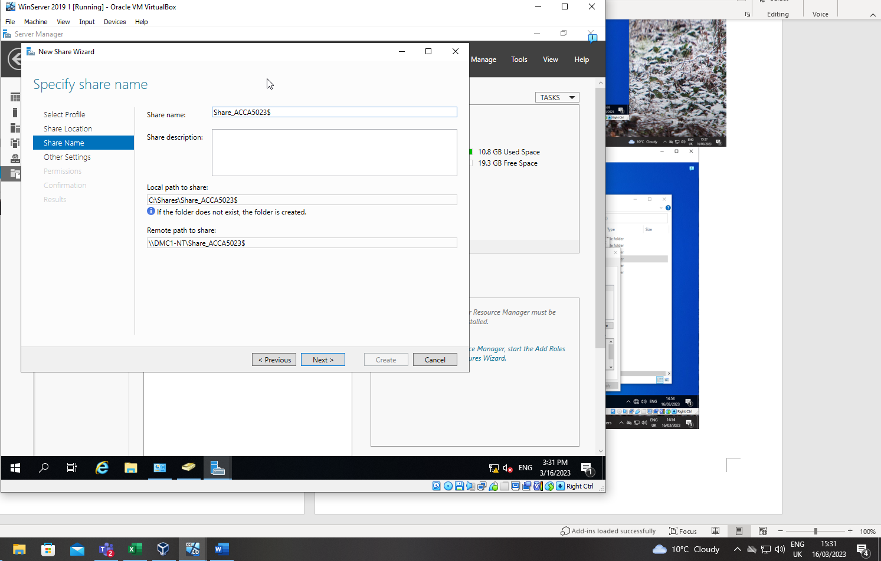
Figure 3 Configuring the network shared folder.
The folder was configured as a network share so that others can access the files within the folder. The ‘$’ at the end of the share name causes the share to be hidden so it cannot be browsed via the network and the name must be known to be able to map to it.
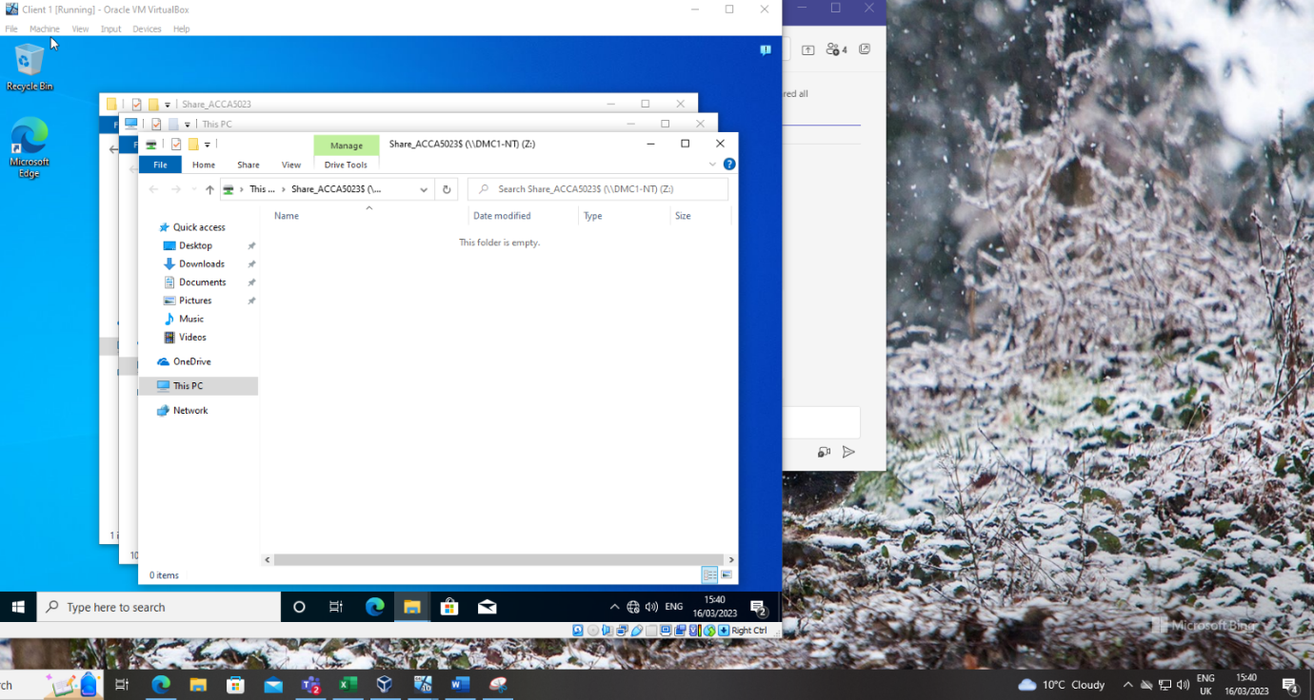
Figure 4 Drive (Z:) mapped to the shared folder.
Once the share was configured on the folder it was possible to map to the share using the full universal naming convention (UNC) path consisting of the name of the server and the name of the share, i.e. \\DMC1-NT\Share_ACCA5023$

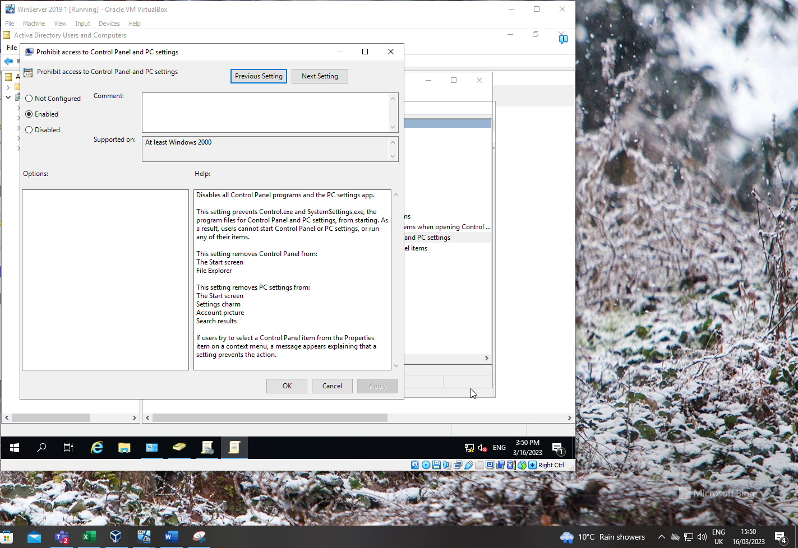
Figure 5 GPO 1: Restricting Access to the control panel.
Using the group policy management console (GPMC), a group policy was created to disable access for standard users to the control panel.
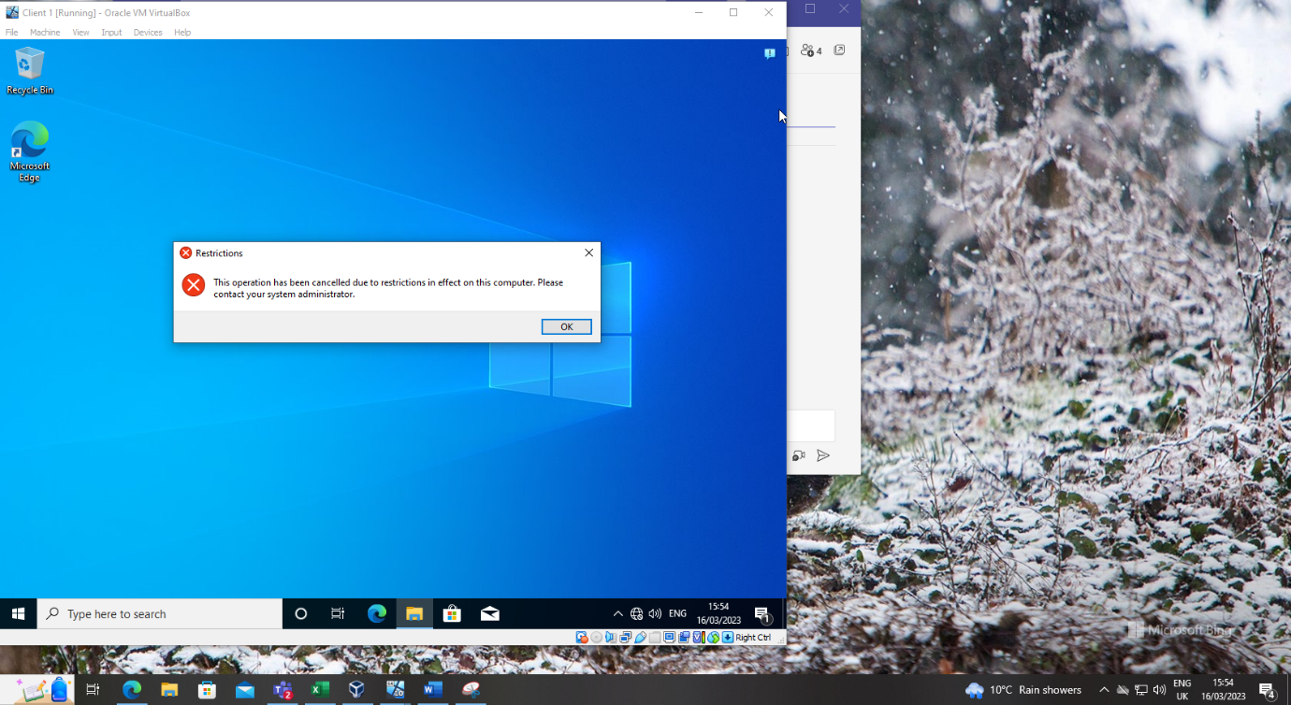
Figure 6 GPO 1: Moderating Access to the Control Panel.
Message displayed when a standard user attempts to open the control panel.

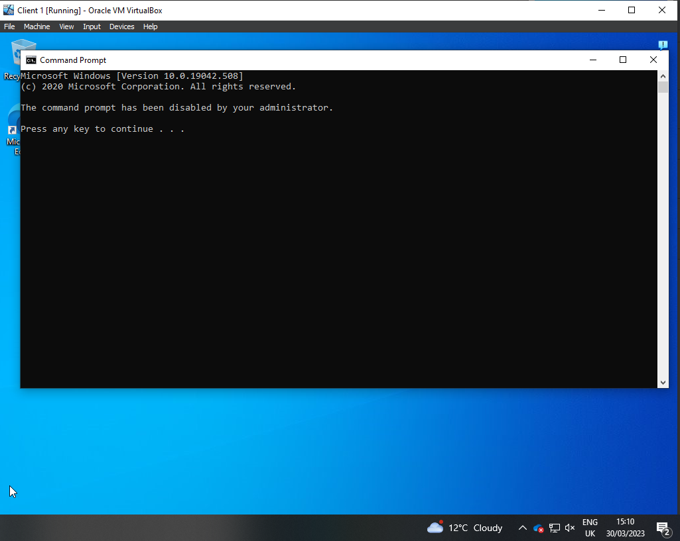
Figure 7 GPO 2: Removing Access to the Command Prompt.
Message displayed when a non-admin user attempts to access the command prompt after configuring a group policy to restrict access.
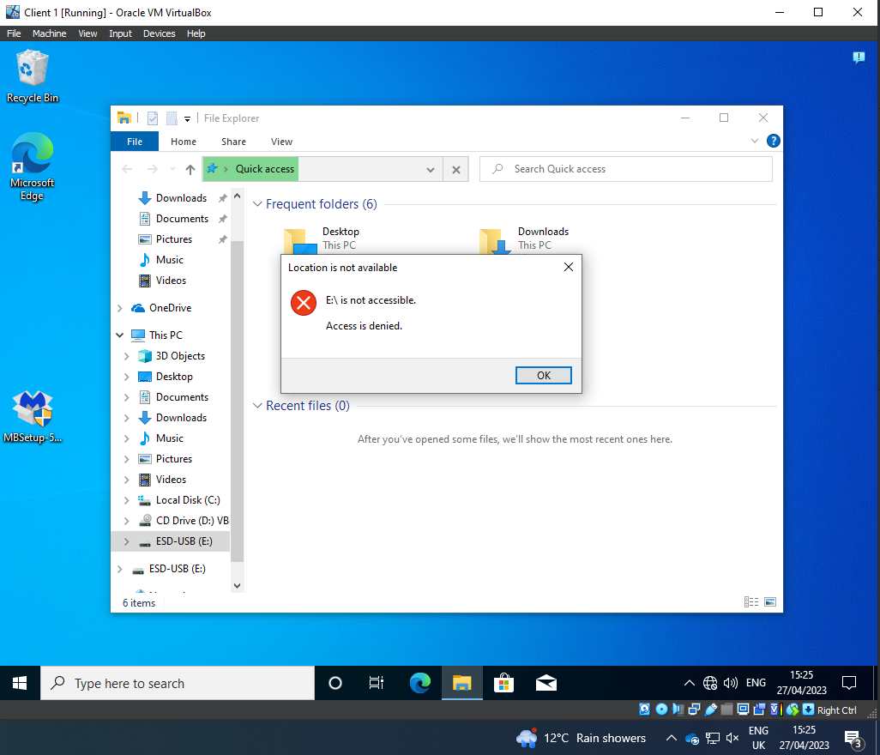
Figure 8 GPO 3: Restricting Access to Removable Media Drives.
Removable storage devices are a significant security risk due to virus and malicious code infection, Group policies can be utilised as a security control to restrict use of USB drives and other removable storage devices, as shown above.
Organisations can implement further policies to allow specific removable storage devices that are encryption protected.
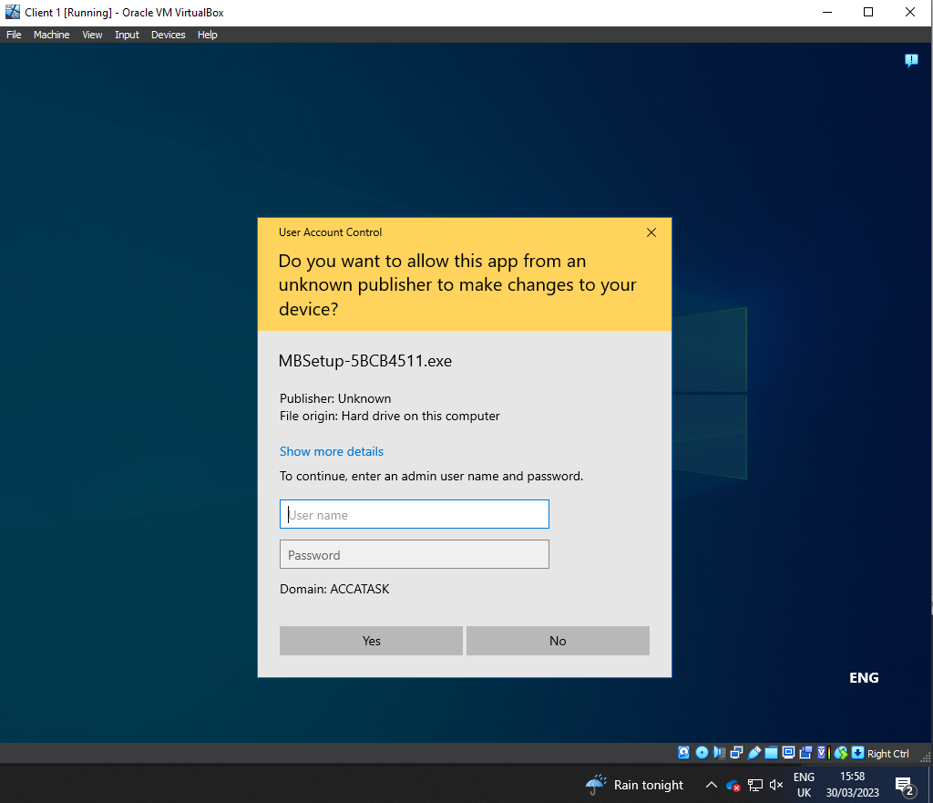
Figure 9 GPO 4: Restricting Software Installs
Installation of software by users can lead to infection of a system allowing lateral movement for hackers to gain access to business systems. Using group policy, it is possible to stop non-admin users from installing software. This helps prevent these types of cyber-attacks. This will also aid an organisation in software version control as standard users will not be able to install or update software without admin access. Allowing for software management tools to be utilised.

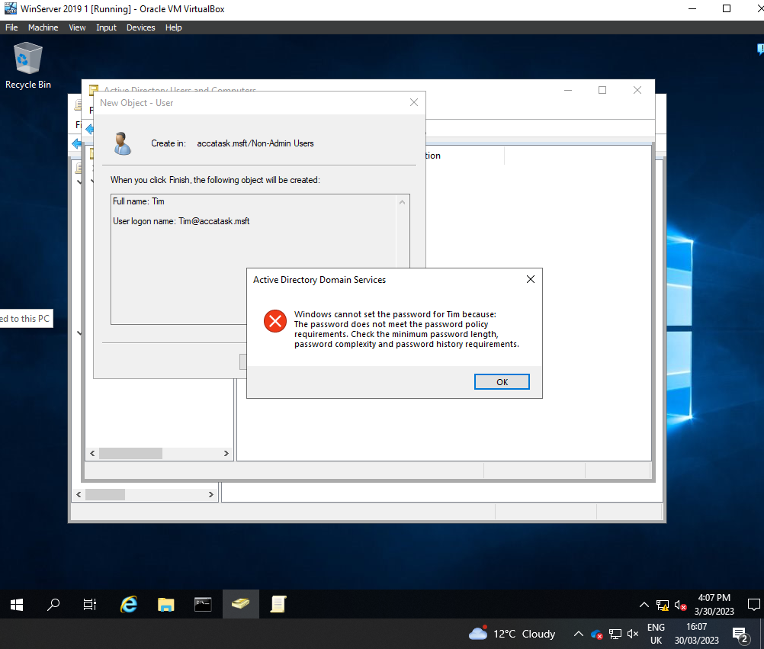
Figure 10 GPO 5: Enforcing Password Policy in the ‘accatask.msft’ domain
Enforcing an organisational password policy contributes to maintaining a good security posture. Using group policy complex password can be enforced on all domain users, both admin and non-admin users. The above figure shows the message displayed if a password is attempted to be set which does not meet the required complexity.
In a Microsoft Windows domain, a complex password must:
- Not contain the user's account name or parts of the user's full name that exceed two consecutive characters.
- Be at least six characters in length.
More elaborative password policies are being implemented across different organisations and businesses where a minimum character's lengths have been increased to an eleven.
- Contain characters from three of the following four categories:
- English uppercase characters (A through Z)
- English lowercase characters (a through z)
- Base 10 digits (0 through 9)
- Non-alphabetic characters (for example, !, $, #, %)

Worksheet Task 2:

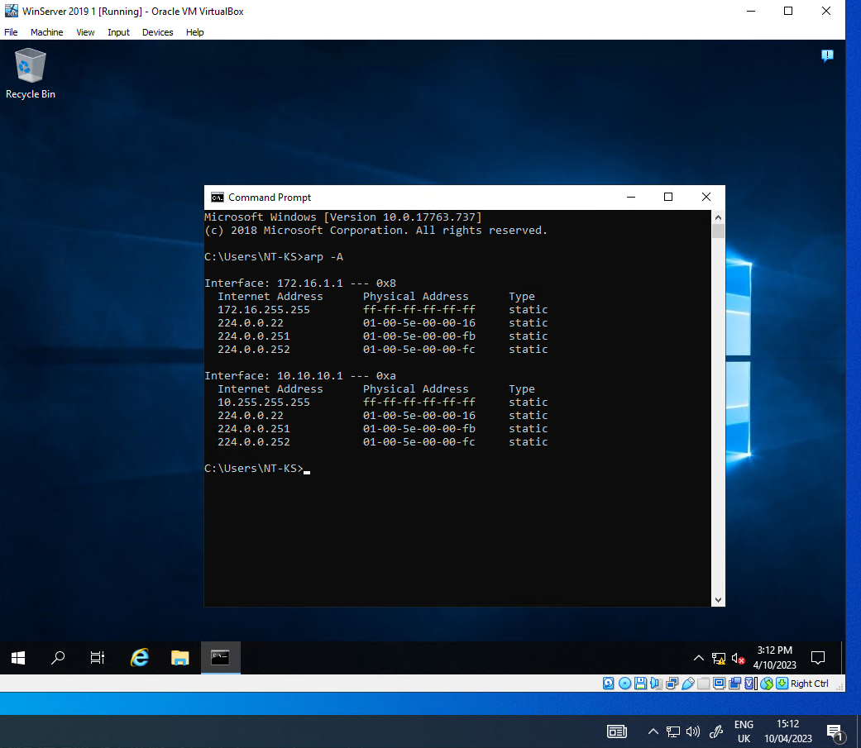
Figure 11 Address resolution protocol cache contents from arp -A command.
Contents of the server address resolution protocol (ARP) cache prior to any other network communication.
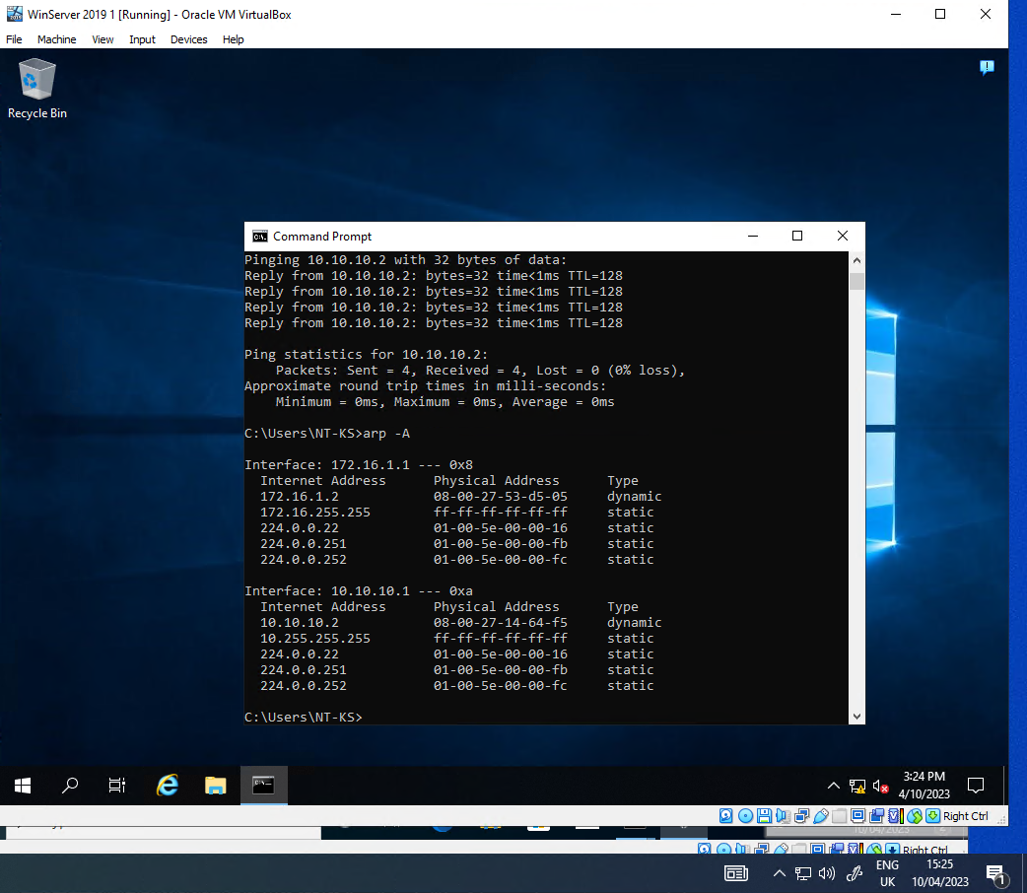
Figure 12 Arp cache contents from asp -A command after pings.
Contents of the server ARP cache after pinging other networked devices.
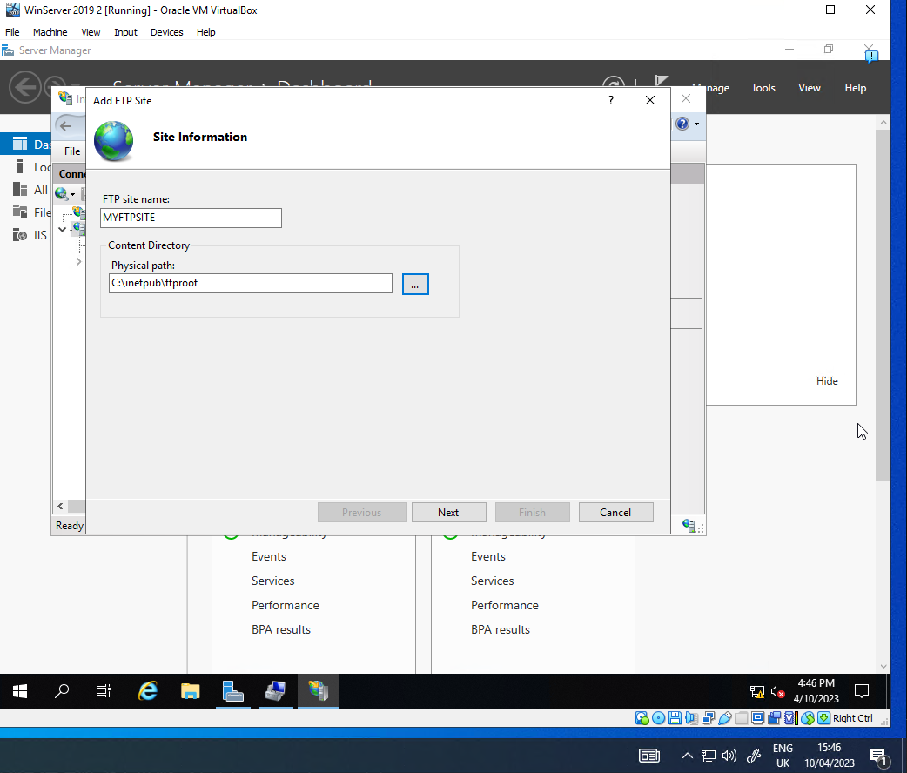
Figure 13 Creation of FTP site on Server 2.
File Transfer Protocol is a common server function used to transfer files between computers. Installation of the FTP role on a Windows 2019 server.
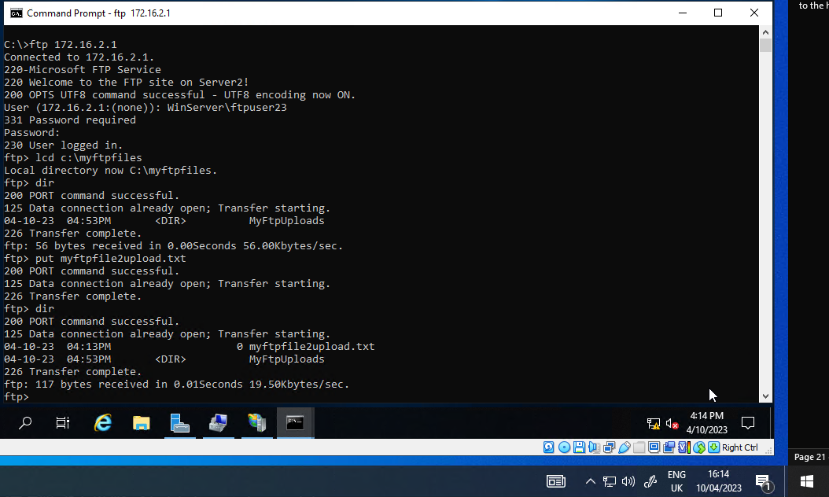
Figure 14 Successful FTP login and file transfer.
After installing the FTP role on Server 2, the local client (client 2) was able to successfully login and upload a simple text file.
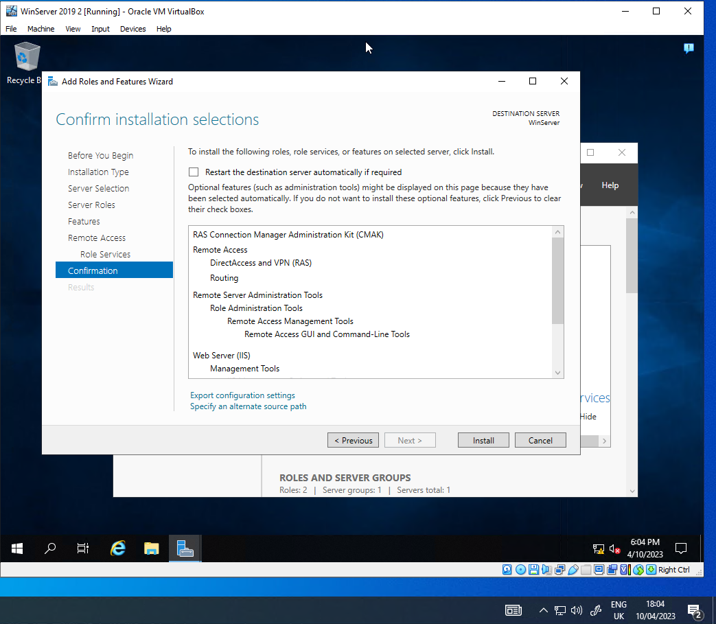
Figure 15 Installing the remote access role.
To be able to configure the two servers as routers, the Remote Access role had to be added to both servers. This would allow the clients in each of the private networks (172.16.0.0.) to communicate.
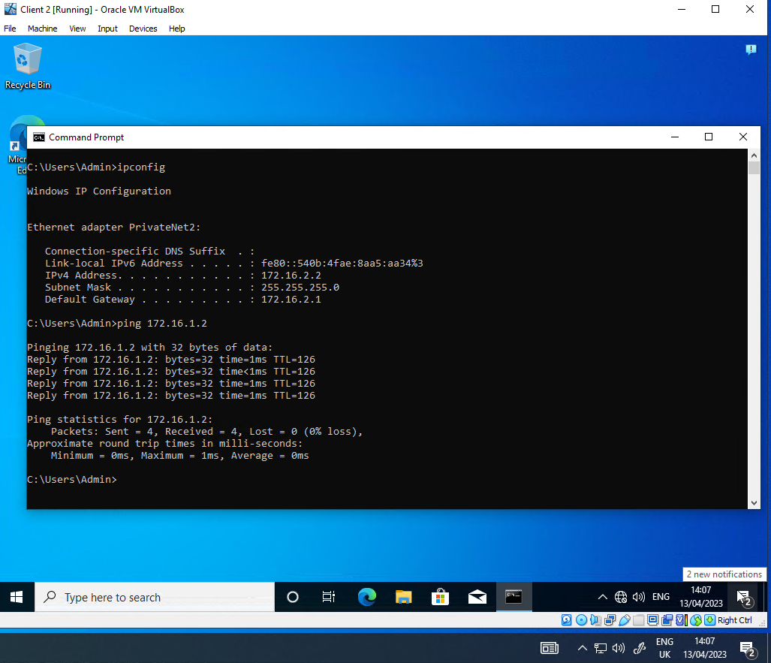
Figure 16 Client 2 pinging Client 1 on its private IP address
After both of the servers had the remote access role configured and RIP routing was configured the two clients on different networks could communicate, as demonstrated by the above screenshot.

I’m pretty sure that there were a couple of gotchyas in the worksheet instructions when the servers were configured as routers, but please feel free to verify:
- The clients needed a default gateway added (the local server private IP address) else no route out of the local network.
- The worksheet specified subnet mask (255.255.0.0) prevented routing from working. The two private networks were 172.16.1.0 and 172.16.2.0. Using the provided subnet mask, the clients would determine that any address 172.16.x.y was on their local network. Needed to change the subnet mask to 255.255.255.0 on the clients to allow traffic to route to the other private network.

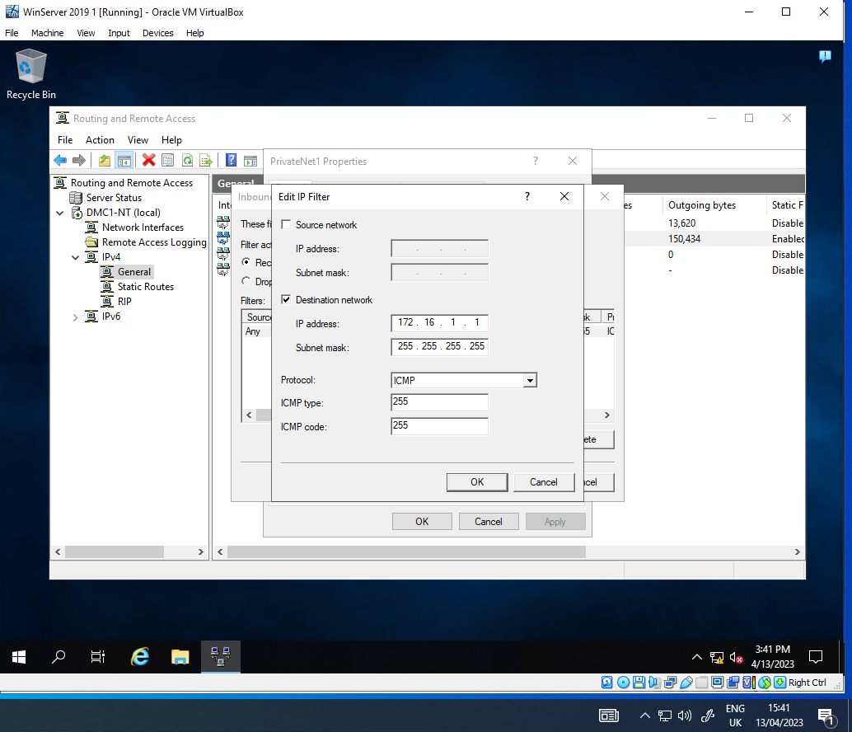
Figure 17 Configuring IP filter to block ping of router interface (Filter 1).
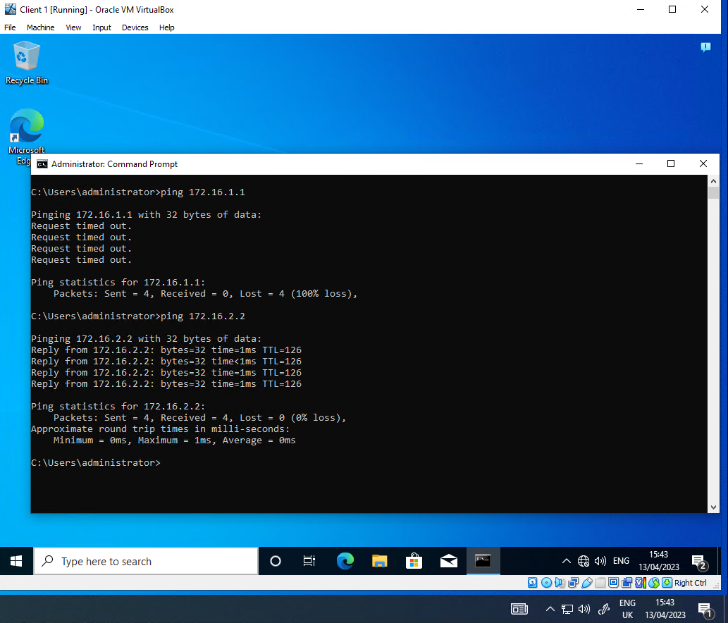
Figure 18 Ping of router interface blocked, other IP addresses respond.

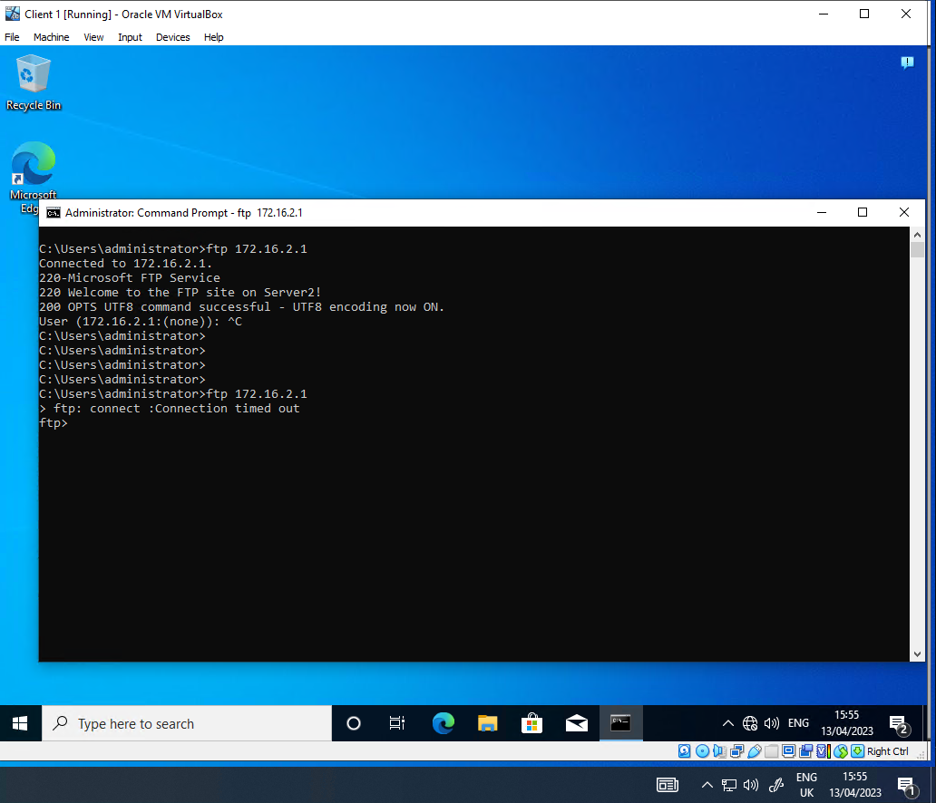
Figure 19 FTP service connection.
The above figure shows the FTP service connecting prior to applying the IP filter rule (Filter 2) and then failing to connect after the filter is applied on the router (Server 1). The filter worked as expected, stopping FTP connectivity to Server 2 from Client 1.
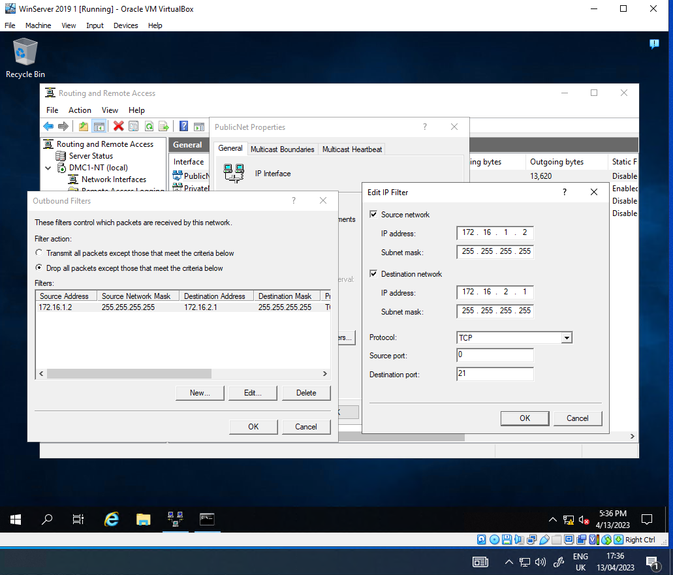
Figure 20
The filter to only allow FTP access to Server 2 from Client 1 in PrivateNet1 is based on the PublicNet interface of Server 1 with the following properties:
- It is an Outbound filter with a filter action of “Drop all packets except those that meet the criteria below”. This means that the filter can block access for any traffic that does not meet the filter.
- The source is defined as the Client 1 IP address with a subnet mask of 255.255.255.255, meaning it only applies to the Client 1 IP address and no other IP addresses in the PrivateNet1 network.
- The destination is the Private address of Server 2, the FTP server.
- The protocol is set to TCP as FTP uses TCP as a transport protocol.
- The destination port is set to 21, as it is the primary connection port from the source to the client connection.
Testing was carried out from the Client 1 VM to the Server 2 FTP site, which was successful as demonstrated below.
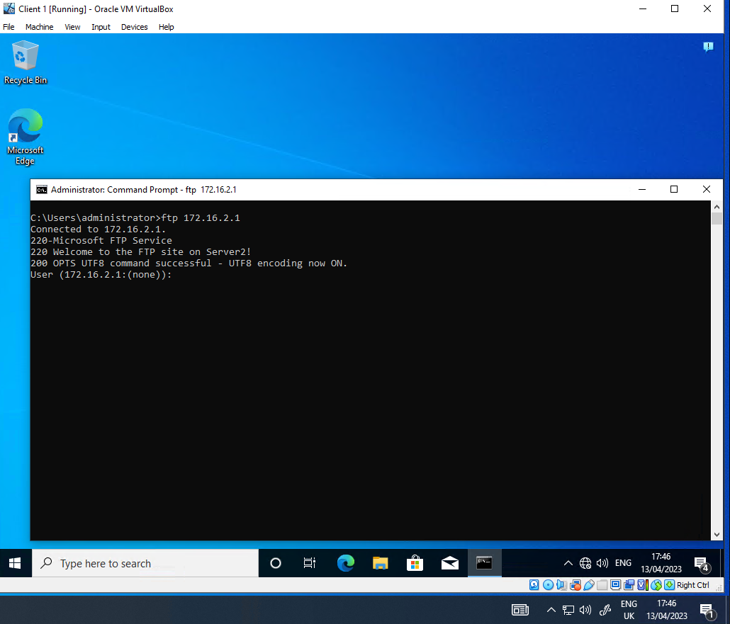
Figure 21
Prior to the filter being applied, Server 1 was used to test FTP connection to the FTP site, which worked. The filter was applied and then Server 1 was tested again. The connection failed after the filter was applied, as shown below.
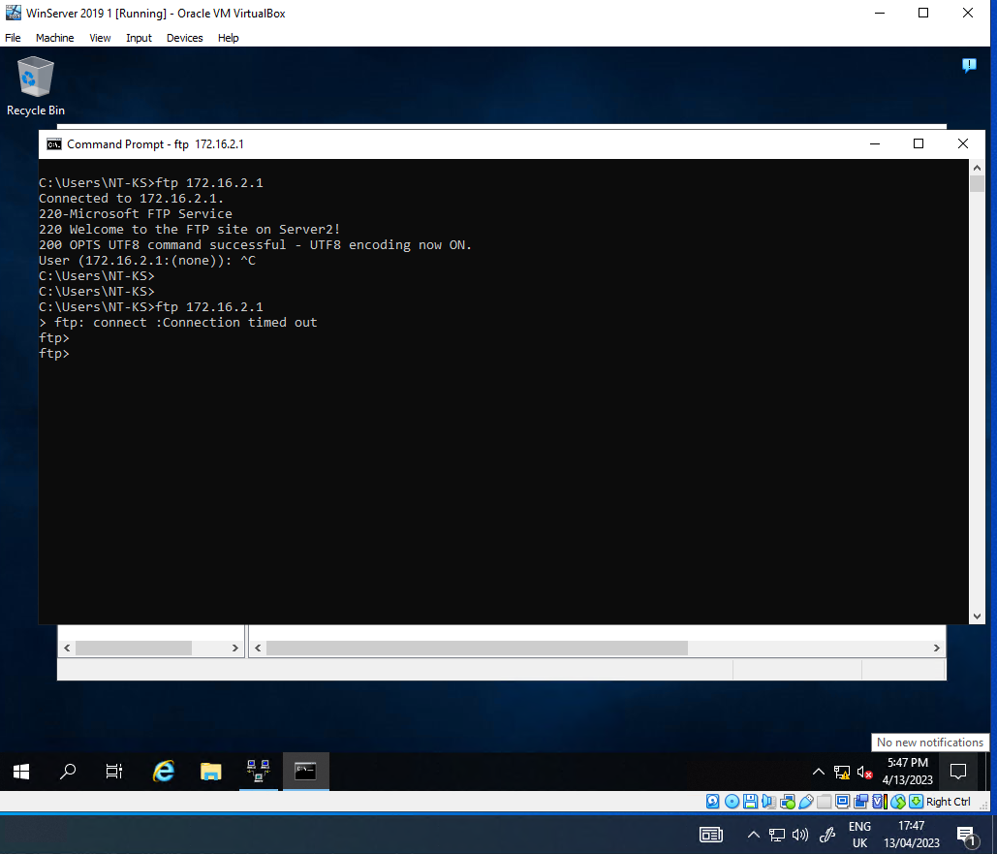
Figure 22

Part 2
There are several actions you can take to enhance the security of a Small Office/Home Office (SOHO) network:
- Change default passwords: Many devices come with default passwords that are well-known and easily guessable. Make sure to change the default passwords to something strong and unique for all devices on your network, such as your router, modem, and network attached storage devices.
- Update firmware and software: Keep your devices up to date with the latest firmware and software updates, which often include security patches and fixes for known vulnerabilities.
- Enable firewalls: A firewall can help prevent unauthorised access to your network by blocking incoming traffic from unknown sources. Most routers come with a built-in firewall, but you may need to enable it.
- Use WPA2 encryption: Ensure that your Wi-Fi network is encrypted with the latest WPA2 encryption standard. This will help protect your network from unauthorised access and eavesdropping.
- Use strong passwords: Use strong and unique passwords for all devices and accounts on your network. Avoid using easily guessable passwords such as "password" or "123456."
- Disable unused services: Disable any unused services or ports on your network devices. This will help prevent attackers from exploiting known vulnerabilities in those services.
- Use antivirus and anti-malware software: Install and regularly update antivirus and anti-malware software on all devices on your network.
- Use a VPN: Consider using a virtual private network (VPN) to encrypt your internet traffic and protect your privacy when accessing the internet from your network.
By implementing these measures, you can significantly enhance the security of your SOHO network and reduce the risk of unauthorised access, data breaches, and other security incidents.

When considering the usage of a failover cluster, there are several key concepts that need careful consideration. These include:
- Hardware requirements: A failover cluster requires multiple physical or virtual computer systems that are connected via a high-speed network. These systems should have identical hardware configurations to ensure consistent performance and reliability.
- Operating System requirements: A failover cluster requires a specialized operating system that is designed to support clustering. In the case of Windows Server, the Failover Clustering feature is required to enable the creation and management of a failover cluster.
- Network considerations: A failover cluster requires a high-speed network with low latency and high bandwidth. It is important to ensure that the network is properly configured and optimized to support cluster communication.
- Storage requirements: A failover cluster requires shared storage that is accessible to all nodes in the cluster. This can be achieved using technologies such as Storage Area Networks (SANs) or Network Attached Storage (NAS).
- Application considerations: Applications running within the failover cluster must be designed to support clustering. This may require modifying the application architecture to ensure that it can operate in a clustered environment.
One possible role within the Windows Server OS environment that can provision these requirements is the Failover Clustering feature. This feature allows multiple servers to work together as a single system, providing high availability and scalability for critical applications and services. When deploying the Failover Clustering feature, the following aspects need to be considered:
- Node Configuration: Each node in the cluster must be properly configured with the necessary hardware and software components to support clustering. This includes installing the Failover Clustering feature, configuring network settings, and ensuring that all nodes have access to shared storage.
- Cluster Configuration: The cluster must be properly configured with the necessary network settings, shared storage, and other resources required by the applications running within the cluster. This includes configuring virtual machines (VMs) if the cluster will host virtualized workloads.
- Quorum Configuration: The quorum configuration determines how the cluster determines which nodes are active and which are inactive. This is critical for ensuring that the cluster remains operational even in the event of a node failure.
- Application Configuration: Applications running within the cluster must be properly configured to operate in a clustered environment. This may require modifying the application architecture, updating configuration settings, and testing the application for compatibility with the cluster.
In summary, when deploying a failover cluster in the Windows Server OS environment, careful consideration must be given to hardware, operating system, network, storage, and application requirements. The Failover Clustering feature provides a centralised tool for configuring and managing a failover cluster, but proper configuration and testing are critical to ensure reliable and scalable high availability for critical enterprise workloads.
Doing some further research into how to deploy a failover cluster I came across this how to guide with screenshots.
Failover Clustering has Failover Cluster Manager. This tool is used to create and maintain failover clustering. It deals with roles, nodes, storage, and networking for the cluster. The tool itself is not specific to Hyper-V, but it does share much of the same functionality for controlling virtual machines. Below is a screenshot of the failover cluster manager.
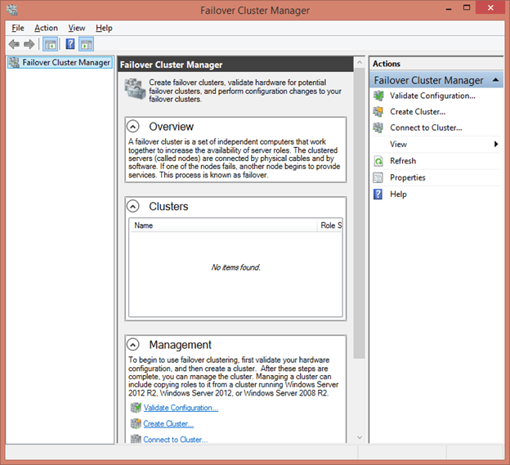
Figure 23 Failover cluster manager
One of the most useful capabilities provided by failover clustering is its ability to scan existing and potential cluster nodes to determine their suitability for clustering. This process should be undertaken prior to building any cluster and before adding any new nodes to an existing cluster. The primary reason is that it can help you to detect problems before they even occur. The secondary reason is that Microsoft support could potentially refuse to aid with a cluster that has not been validated. A cluster that has passed all validation tests is considered fully supportable even if its components have not been specifically certified. Shown below shows how to validate a cluster.

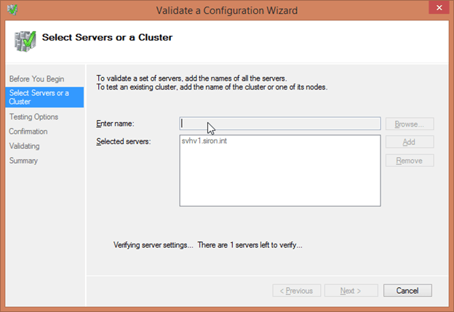
Figure 24 Configuration of a failover cluster
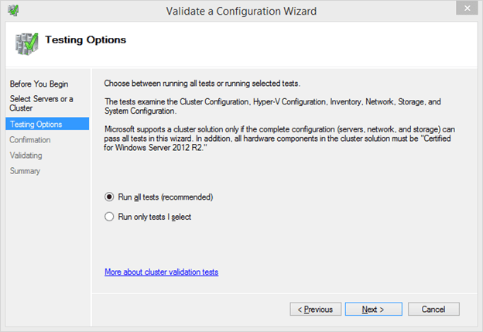
Figure 25 Configuration cont.
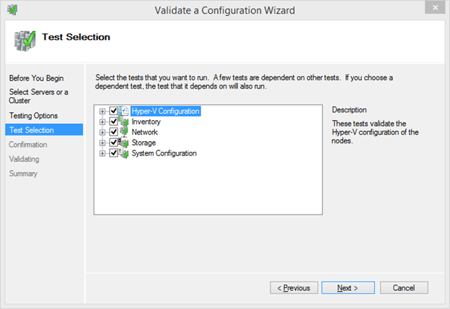
Figure 26 Configuration cont.
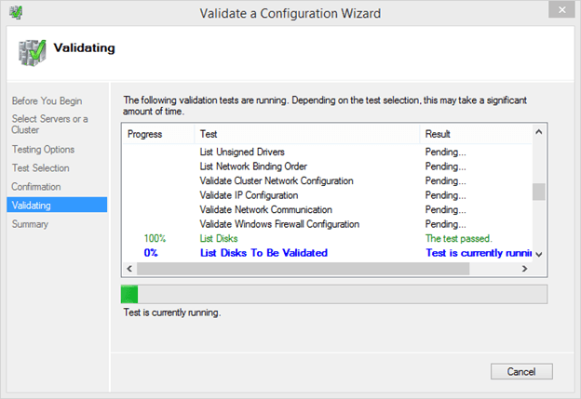
Figure 27 Configuration is validated.
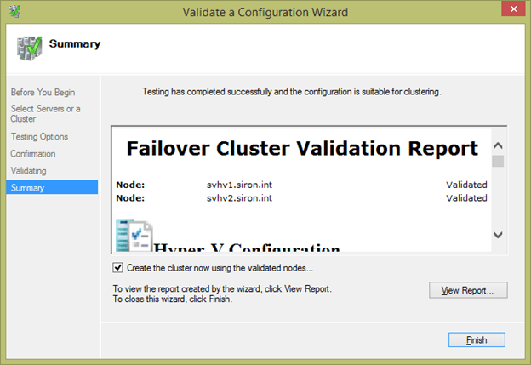
Figure 28 Summary of Config
There are three possible outcomes for the validation process. If the wizard doesn’t find any problems, it will mark your cluster as validated. If it finds any concerns that don’t prevent clustering from working but will result in a suboptimal configuration (such as multiple IPs on the same host in the same subnet), it will mark the cluster as validated but with warnings. The final possibility is that the wizard will find one or more problems that are known to prevent clustering from operating properly and will indicate that the configuration is not suitable for clustering.

Conclusion
In conclusion I have expanded my knowledge and understanding of what security measures can be implemented on a Small Office/Home Office network and gained a greater understanding of what a failover cluster is, how to implement one, what limitations there are when trying to implement one and the possible roles within a windows server OS a failover cluster could have.

Reflection on collaborative work
I have enjoyed working with the same group from assignment one which has allowed me to further my knowledge of how the groups dynamic works and engage with teammates on a more personal and professional level working through the tasks.

References
A. DOJO, Ed., “How to set up and manage a hyper-V failover cluster, step by step,” Altaro DOJO | Hyper-V, 21-Oct-2021. [Online]. Available: https://www.altaro.com/hyper-v/failover-cluster-manager/. [Accessed: 04-May-2023].
D. Hannifin, “PowerShell V2 Feature Focus,” Microsoft Windows Server 2008 R2, 17-Jun-2010. [Online]. Available: https://www.sciencedirect.com/science/article/abs/pii/B9781597495783000116. [Accessed: 04-May-2023].
D. L. Prowse, “Chapter 7,” in Comptia A+: Core 1 (220-1001) and core 2 (220-1002), Indianapolis?: Pearson IT Certification, 2020.
J. Gerend, “Failover clustering,” Failover Clustering | Microsoft Learn, 02-Nov-2022. [Online]. Available: https://learn.microsoft.com/en-us/windows-server/failover-clustering/failover-clustering-overview. [Accessed: 04-May-2023].

