Evidence of Learning
Learning in the Digital Era
Ava Tench
(2203992)

￼
￼

Content page

Summary ................................................................................................................ 3
Mind Map ............................................................................................................... 4
Video Presentation ................................................................................................. 5
Reflection ............................................................................................................... 6
References .............................................................................................................. 7

Summary
As a student advances so does the education they need. Studying at University can be different to the structure you are used to at school or college.
Many different skills that are essential for preparing for higher education include Leadership and Communication. (Laundry 2019) emphasises the importance of a leader, someone who inspires positively empowering those around them to work toward common goals. Independent learning is also an important key factor to acknowledge when preparing for higher education. Being an independent learner has many different benefits such as developing creativity. ‘‘A key responsibility of school is to provide the context in which young people learn how to study on their own’’ (Steed 2013).
Further ways and skill in preparing for higher education include organisation. Reason being it makes everything simpler knowing what to do or where something is, this also makes you work more efficiently. In a recent published resource, The Open University (2021) demonstrates that you should manage your time is as it is a key element to a successful study. This suggests that individual students organise their time they have available and use it wisely. Individuals struggle to manage time due to the three P’s. Planning, Procrastination, Perfectionism.
Being honest with your work becomes more important the higher education you have. Producing authentic work. Avoiding plagiarism. When reading an article in a newspaper or a theory in a textbook and want to use it in your work. You must not copy it, as this is plagiarism even if you have referenced the book or article. Paraphrasing. This means discussing what you have read / researched and putting it into your own words.

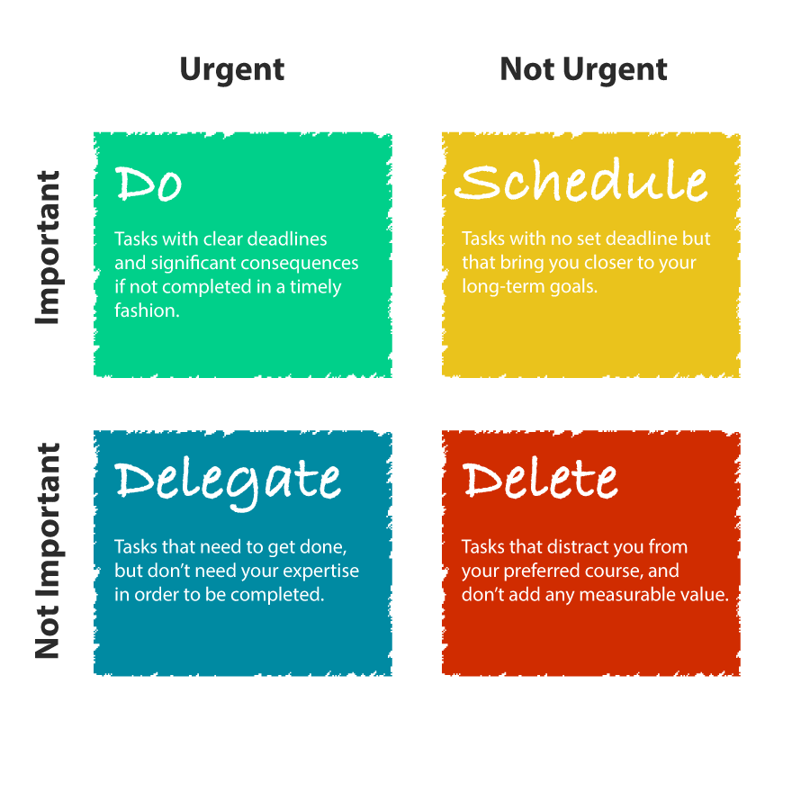
Victorino (2020)
This idea by Eisenhower is to show how to be organized and organise workload and priorities. Victorino (2020) recognized that great time management means being effective as well as efficient. The Eisenhower principle is a productivity, prioritisation and time-management framework designed to help prioritise a list of tasks by categorising them according to their importance and not so important.

Video Presentation
Becoming a team player

Becoming a team player presentation - learning in the digital era

https://youtu.be/oWKPCJDPkqk

Reflection
Starting University was a very scary yet exciting experience, however it is challenging when it comes to writing assignments and doing coursework. It is common and natural to feel nervous and overwhelmed during the first couple of weeks or even the first term at university it took me a while to find my feet. It was overwhelming meeting new people for the first time, especially living with them straight away. Countless students were staring university at the same time as me and I found that I shared a lot of interests with other people. This allowed me to be myself and start to ease into student life at university knowing that all other students were in the same boat as me. (NHS 2020) explains how stressful starting university experience can be and can also help with stress starting also. In order to complete my first assignment, I started early. This allowed me to take my time and do thorough research. Planning was also a good idea when writing my first assignment, using both my own ideas and what I have read. Planning pushes yourself to reach your targets and achieve your goals. (University of Suffolk 2022) expressed how ‘‘planning is useful because it can help you organise your thoughts and prioritise the way you present information’’. You are then able to work out a structure and end point for your writing. Lastly, I just wrote, even if I thought it was rubbish, I just wrote everything down. In order to get to grips with learning information and resources, I ensured myself that I would stay motivated. In effort to keeping myself motivated I started by setting myself some goals, for example finish a certain piece of work by a certain time. Avoid distractions. And setting myself a routine. Time to focus on myself as well as assignments.

References

1 – Laundry, L. (2019). Harvard: Harvard Business School. Boston USA.
[Accessed on 11th October 2022]
Available at:
https://online.hbs.edu/blog/post/leadership-communication

2 – Steed, M. (2013). Importance on independent learning. Hong Kong: British school.
[Accessed 11th October 2022]
Available at:
http://independenthead.blogspot.com/2013/07/independent-learning.html

3 – The Open University. (2021). Online article. Wales.
http://www.open.ac.uk/choose/unison/develop/my-skills/self-reflection#:~:text=Reflecting%20helps%20you%20to%20 develop,doing%20it%20in%20the%20future
Available at:
[Accessed 11th of October 2022]

4 – Victorino, L. September 2020. How to prepare your time.
[Accessed 17th of October 2022]
Available at:
eisenhower-matrix

5 – ECU University. 2022. Becoming a digital learner. Edenborough: United Kingdom
[Accessed 11th of October 2022]
Available at:
https://ecu.au.libguides.com/slide/studying-ecu

6- NHS. (2020). How to cope with student stress.
[Accessed 11th of October 2022]
Available at:
https://www.nhs.uk/mental-health/children-and-young-adults/help-for-teenagers-young-adults-and-students/student-stress-self-help-tips/

7- University of Suffolk (2022). Planning your writing. England
[Accessed 14th of October 2022]
Available at:
Planning Your Writing - Academic Writing - University of Suffolk Libraryhttps://libguides.uos.ac.uk › academic › writing › planning

