Bean & Brew
Project Documentation
About the Project:
I am a student, and this website is my very first project created using HTML. As a beginner in web development, I wanted to build something meaningful and connected to my daily life.
The idea for this coffee shop website came from my university experience. After classes, many of us enjoy tea or coffee to relax and spend time with friends. These small moments inspired me to think about creating a coffee shop in the future.
I was also inspired by two friends from university who started their own coffee business. Seeing their journey motivated me to turn my idea into something real. I wanted to support and share such ideas with others.
This project is not just an assignment for me, but the first step toward my learning journey and future goals.
Objectives of the Project:
The main objective of this project was to design and develop a clean and simple website for a coffee shop. I wanted to practice my HTML and CSS skills and also understand how a real website layout works.
Another goal was to make the website user friendly so anyone can easily read the menu, understand the concept, and place an order. I also wanted to focus on making the design look modern but not too complex.
I also aimed to improve my problem solving skills while coding. When building this project, I faced many small errors and challenges, and fixing them helped me learn better.
What I Built:
I built a basic static website using HTML and CSS. The website includes a homepage, menu section, and some design elements to make it look attractive.
The homepage shows the main idea of the café and gives a welcoming feel. I added some floating text and images to make it look more interactive. The menu section displays different coffee options so users can see what is available.
I used flexbox for layout design, which helped me align elements properly. I also added media queries so the website can adjust on different screen sizes like mobile and tablet.
My Project Screenshots:
Home Page:
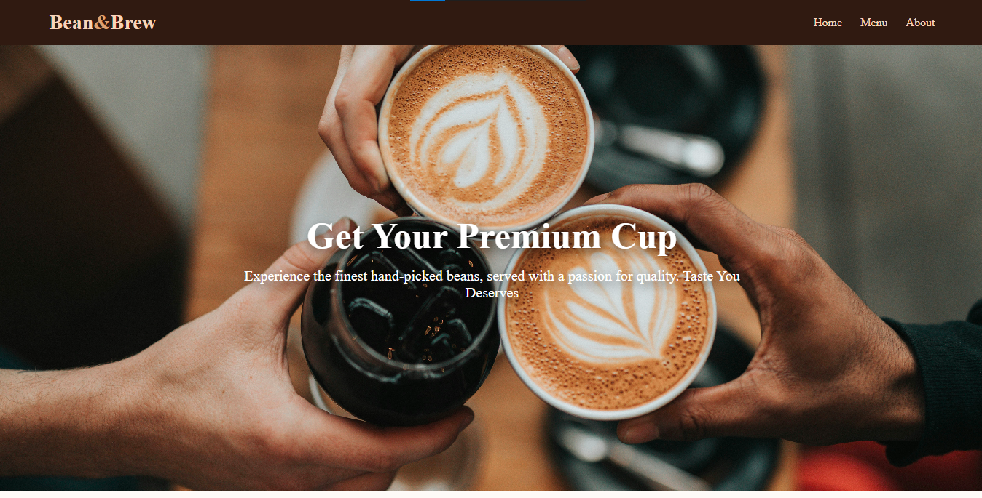
Menu Page:
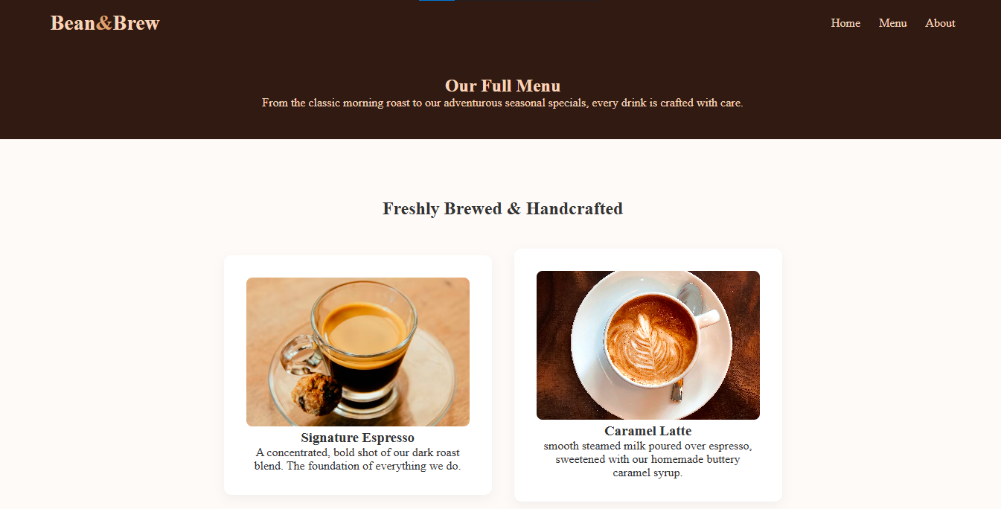
About Page:
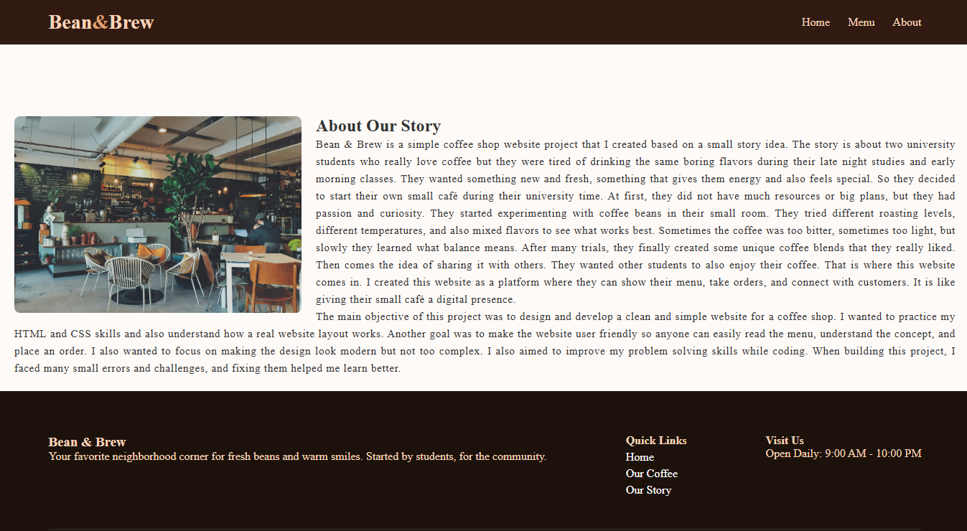

Target Audience (Who It is Built For):
This website is mainly built for students and young people who enjoy coffee and like trying new flavors. It is also for small business owners who want to showcase their products online.
I imagined that university students will visit the website, check the menu, and order their favorite coffee. It is also helpful for people who want a quick and easy online ordering experience.
Inspiration and Ideas:
For design inspiration, I used Pinterest. I browsed different website layouts and UI ideas. I saw many modern and clean designs which helped me understand how spacing, colors, and structure works.
I did not copy any design directly, but I used those ideas as a reference to create my own layout. I tried to keep it simple but still visually appealing.
Sometimes I got confused because there were too many ideas and styles, so it was hard to decide which one to follow. But finally I selected a clean and minimal style.
Resources and Tools Used:
I used HTML and CSS to build this website. These are basic web development languages and good for beginners.
For images, I used Unsplash. It provides high quality and free images which are perfect for projects. I selected coffee related images to match the theme of my website.
For learning and exploring code, I used W3Schools. It helped me understand different CSS properties and how to use them. I learned about float, flexbox, and pseudo classes like ::after from there.
I attached screenshots of websites i use to complete the projects:
1.Pintrest: I use Pinterest for taking designs references and style color inspirations.
2.unsplash: I use unsplash for taking pictures for my website project.

3.w3Schools : I use w3schools to learn and code using new properties i learn float and ::After property :

Design and Structure:
The website design is simple and clean. I used a clear structure to avoid repetition. Each section is properly organized so it is easy to read and understand.
I used modern colors that match the coffee theme, like brown, cream, and light shades. These colors give a warm and cozy feeling.
Flexbox helped me arrange elements side by side and keep everything aligned. Media queries made the design responsive, so it works on different devices.
Challenges and Problems Faced:
While working on this project, I faced some problems. One of the main issues was in my HTML code. I accidentally added two body tags, which caused errors in the layout. It took me some time to figure out what was wrong.
Another mistake I made was using the wrong heading tag. After an h2 tag, I opened an h4 tag instead of h3. This created a structure problem in my document.
Also, sometimes my CSS was not working properly because of small syntax errors. For example, I missed semicolons or wrote wrong property names. These small mistakes caused big confusion at times.
How I Fixed the Problems:
To fix the issues, I carefully checked my code line by line. I removed the extra body tag and corrected the heading structure. After fixing these, the layout started working properly.
For CSS problems, I used W3Schools to check correct syntax and examples. I also used trial and error method, which helped me understand what works and what does not.
Sometimes I got frustrated because the error was very small but hard to find. But slowly I learned to stay patient and keep checking.
Learning :
This project helped me learn many new things. I improved my understanding of HTML structure and CSS styling. I also learned how to design a website layout and make it responsive.
I learned that small mistakes can create big problems, so attention to detail is very important.
I also understood how important it is to take inspiration but still create something original.
Future Improvements:
In future, I want to add more features to this website. For example, I can add a login system, online payment option, and more interactive elements using advance website development concept .
I also want to improve the design by adding animations and better transitions.
Another idea is to connect the website with a backend so it can store real user data and orders.
Conclusion:
Overall, this project was a good learning experience for me. It helped me understand basic web development and improve my coding skills.
Even though I made some mistakes, I learned how to fix them and grow from them. This project is simple but meaningful, and it shows my effort and creativity.
I enjoyed working on this project and I hope to create more advanced websites in future.

References
[1] Pinterest, “Coffee Shop Website Designs,” [Online]. Available: https://www.pinterest.com/search/pins/?q=coffeeshopwebsitedesigns
[2] Unsplash, “Coffee Shop Images,” [Online]. Available: https://unsplash.com/s/photos/coffeeshop
[3] W3Schools, “CSS Float Property,” [Online]. Available: https://www.w3schools.com/cssref/pr_class_float.php
[4] W3Schools, “CSS ::after Selector,” [Online]. Available: https://www.w3schools.com/cssref/sel_after.php

Appendix


