

Manufacture of Wind turbine blades  ACMA6000 Advanced Processes and Materials | Bethan Dubber, 2114470

7th September 2026
Main Body of Research Word Count: 3296

Abstract
This report focuses on the design of a 5MW, triple-blade, horizontal-axis wind turbine with a blade length (rotor radius) of 61.3m. The NACA4412 airfoil was used as a reference for the design and calculations, allowing aerodynamics to be analysed for manufacturing. Secondary research presents background knowledge of applications, calculations and standard values. Material selection was researched and finalised through a weighted decision matrix to compare suitable materials. Glass fibre reinforced polymer (GFRP) achieved the highest score due to the balance of material properties, density and cost. Vacuum infusion was selected as large components could be manufactured at low cost.
A CAD drawing was developed to visually represent the wind turbine blade, demonstrating the reduction in chord length from root to tip. Mechanical analysis assessed the force and stress calculations acting on the blade during operation. These calculations highlighted the requirement of a larger chord length at the root, to withstand bending and torsional stresses. A comparative analysis compares the performance of materials and processes and identifies considerations, such as productivity, scalability, manufacturing defects, environmental and safety factors.
GFRP, using vacuum infusion, was chosen as a suitable solution, providing a balance of performance, manufacturability and cost. Recommendations are suggested to improve this proposal further.

Table of Contents
Abstract 1
1. Introduction 6
2. Literature Review 7
2.1 Wind Turbine Operation 7
2.2 Existing Wind Turbines 7
2.3 Aerodynamic Profiles 8
2.4 Wind Turbine Blade Structure 11
2.5 Wind Turbine Blade Optimal Dimensions 11
2.6 Material Properties 13
2.7 Environmental Factors 14
3. Design Specifications 15
3.1 Rotor Radius 15
3.2 Chord length 16
3.3 Dimensions and Profile 17
4. Material Selection 18
5. Exploration of Manufacturing Routes 19
6. Cost Evaluation 21
6.1 Raw Material Costs 21
6.2 Manufacturing Costs 21
7. Mechanical Properties 23
7.1 Force Calculations 23
7.2 Stress Analysis 24
8. Comparative Analysis 27
9. Blade Drawing 29
10. Conclusion 31
10.1 Recommendations 31
11. References 32
12. Appendices 33

Table of Figures
Figure 1 - Pen y Cymoedd Wind Farm, (Ion, 2026) 7
Figure 2 - Hornsea Three Project Wind Farm, (Orsted) 8
Figure 3 - Wind Turbine Computation Fluid Dynamic, (“Renewable Energy Engineering”) 10
Figure 4 - TSR Operating Conditions Example (Hosseini et al. 2022). 12
Figure 5 - Vacuum Infusion, (“Customized Resin Flow Mesh Optimises Wind Turbine Blade Production”) 19
Figure 6 – RTM, (“New Technologies for Miniaturized Spacecraft and Multi-Point Cluster Missions”) 20
Figure 7 - GFRP Dry Spot Defect (Shevtsov et al.2020) 28
Figure 8 - GFRP Delamination, (Das et al.2019) 28
Figure 9 - Metal Defect Example, (Santamaria et al. 2023) 28
Figure 10 - Creep Stages Graph (Sattar 2020) 29
Figure 11 - Blade Length of 61.3m CAD Drawing 29
Figure 12 - CAD Drawing Cross-Sections 30
Figure 13 - Thickness Reduction 30

Table of Equations
Equation 1 - Camber when x/c less than position of max. camber 8
Equation 2 - Camber line when x/c more than position of max. camber 8
Equation 3 - Thickness distribution along the chord 8
Equation 4 - Y(upper) 9
Equation 5 - Y(lower) 9
Equation 6 - Lift/drag ratio 9
Equation 7 - Lift coefficient 9
Equation 8 - Drag coefficient 9
Equation 9 - Power coefficient 10
Equation 10 - Power output 11
Equation 11 - TSR 12
Equation 12 - Chord Length 13
Equation 13 - GFRP labour costs 21
Equation 14 - CFRP labour costs 22
Equation 15 - Tangential Velocity 23
Equation 16 - Bending moment 24
Equation 17 - Bending stress 24
Equation 18 - Torsional moment 24
Equation 19 - Eccentricity 25
Equation 20 - Safety factor 25

Table 1 - Table of Acronyms
Acronym | Description
WT | Wind Turbines
WTB | Wind Turbine Blades
KE | Kinetic Energy
HAWT | Horizontal Axis Wind Turbine
VAWT | Vertical Axis Wind Turbine
TSR | Tip Spreed Ratio
GFRP | Glass Fibre Reinforced Polymer
CFRP | Carbon Fibre Reinforced Polymer
RTM | Resign Transfer Moulding

Introduction
Wind energy generation plays a significant role in renewable technologies to meet current demand while reducing emissions, shown in Annex 1. The kinetic energy (KE) in the wind rotates the wind turbine blade (WTB) due to the airfoil shape. Wind turbine (WT) performance is influenced by aerodynamics, affecting efficiency of energy generation, (Karam Maalawi, 2022).
Wind farms consist of multiple WTs producing high quantities of power. Due to larger blade size and more consistent wind speeds, offshore applications can produce higher energy. However, harsher environmental conditions increase installation and maintenance costs. Onshore applications are cheaper to maintain, but wind conditions vary, they add wildlife risk and have a negative visual impact. Renewable power allows countries to reduce emissions and enable self-sufficient generation, (National Grid, 2022).
Research is conducted to maximise aerodynamics, material selection, manufacturing processes, and understand environmental conditions. This is followed by a cost, mechanical, and comparative evaluation, to analyse the next-generation WTB. To discuss WT performance and aerodynamics, a triple-bladed HAWT design is evaluated to provide 5MW for the customer, (Jamieson, 2018).
Focusing on maximising power output and reducing maintenance, a next-generation, lightweight and durable WT will be designed.

Literature Review
This section presents research of WTB performance, where the findings provide the design specification. The operations and existing WTs are studied to understand aerodynamic profiles & critical design parameters, materials, and environmental factors.

Wind Turbine Operation
WTBs are attached to a hub and rotate, converting electrical energy through shafts and gears to maximise the energy to a generator. There are two main types of WT; Horizontal-Axis Wind Turbines (HAWT) and Vertical-Axis Wind Turbines (VAWT). Triple-blade HAWTS are used in industry due to aerodynamic performance stability and reduced vibration compared with other blade configurations, (Clayton, 2025).

Existing Wind Turbines
Annex 2 presents existing WT applications to compare blade size to power outputs. Onshore wind farm, Pen y Cymoedd in South Wales, Figure 1, provides 76 Siemens 3MW WTs, generating 232MW, each with a rotor diameter of 101m. In comparison, offshore wind farm, Hornsea Three Project in the North Sea, Figure 2, provides 231 Siemens-Gamesa 14MW WTs generating 2.9GW with a rotor diameter of 230m. (Guy Energy Ltd, 2026) (Keighley, 2026)
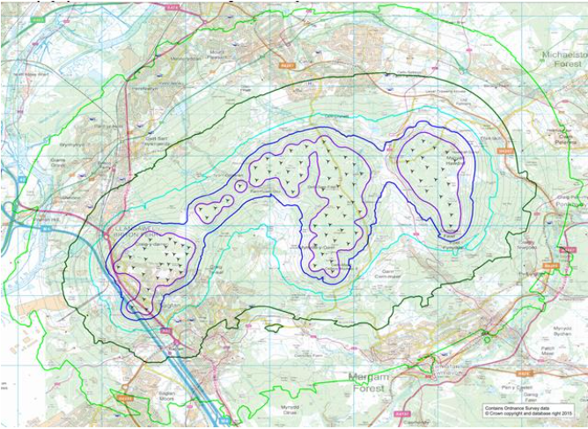
Figure 1 - Pen y Cymoedd Wind Farm, (Ion, 2026)

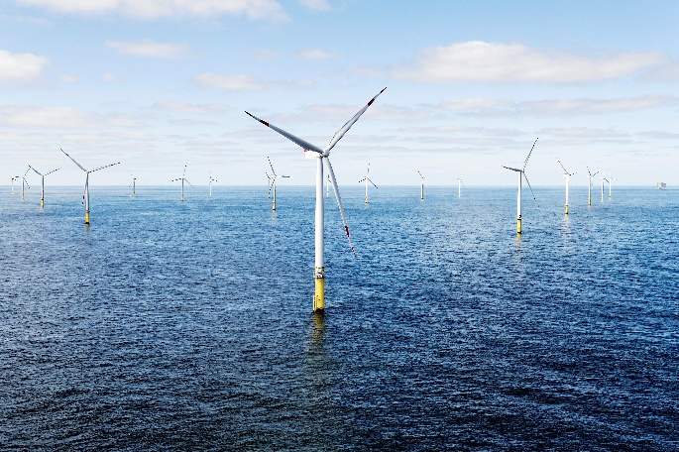
Figure 2 - Hornsea Three Project Wind Farm, (Orsted)

Aerodynamic Profiles
The aerodynamic profile (airfoil) influences lift and drag forces, affecting WT performance. The NACA system defines the airfoil with four digits; NACA4412 states that there is 4% maximum airfoil camber located at 40% along the chord length, with a maximum thickness of 12% of the chord length, (AKGUMUS GOK, 2024).
Camber, Equation 1-2, influences the blade aerodynamics, generating a lift and drag ratio, shown in Annex 3, highlighting large drag caused by 20 º angle of attack, creating flow separation in the airfoil boundary layer, (Mech Proverse, 2025).
To calculate the airfoil shape in a cross-section, see Equations 1-5.
Equation 1 - Camber when x/c less than position of max. camber
$$y_{c}= \frac{m}{p^{2 }}\left(2p\frac{x}{c}-{\left(\frac{x}{c}\right)}^{2}\right)$$
Equation 2 - Camber line when x/c more than position of max. camber
$$y_{c}= \frac{m}{{(1-p)}^{2 }}\left(\left(1-2p\right)+2p\frac{x}{c}-{\left(\frac{x}{c}\right)}^{2}\right)$$
Equation 3 - Thickness distribution along the chord
$$y_{t}=5t\left(0.2969\sqrt{\frac{x}{c}}-0.1260\frac{x}{c}-0.3516{\left(\frac{x}{c}\right)}^{2}+0.2843{\left(\frac{x}{c}\right)}^{3}-0.1015{\left(\frac{x}{c}\right)}^{4}\right)$$
Equation 4 - Y(upper)
$$y_{upper}=y_{c}+y_{t}$$
Equation 5 - Y(lower)
$$y_{lower}=y_{c}+y_{t}$$
$y_{c}$= Camber line height at given x location (m)
$x$= Distance along the chord (m)
$c$= Chord length (m)
$m$= Maximum camber at 4% of chord length (m)
$p$= Position of maximum camber at 40% of chord length (m)
t = Maximum thickness at 12% of chord length (m)
$y_{upper}$= Airfoil upper surface height at given x location (m)
$y_{lower}$= Airfoil lower surface height at given x location (m)

The lift-to-drag ratio, Equation 6, is a comparison of lift to drag. A greater lift coefficient ($C_{l}$) indicates higher lift generation, Equation 7. The drag coefficient indicates the aerodynamic resistance. Lower drag is desirable to increase efficiency, Equation 8, (Cope, 2025).
Equation 6 - Lift/drag ratio
$$Lift to Drag= \frac{C_{l}}{C_{D}}$$
Equation 7 - Lift coefficient
$$C_{l}=\frac{L}{1/2⋅ρ⋅V^{2}.A}$$

Equation 8 - Drag coefficient
$$C_{D}=\frac{D}{1/2⋅ρ⋅V^{2}.A}$$

$C_{l}$ = Lift Coefficient
$C_{D}$ = Drag Coefficient
L = Lift force (N)
D = Drag Force (N)
$ρ$ = Air density (kg/ $m^{3}$)
A = Airfoil area ($m^{2}$)
V $=$ Wind Velocity (m/s)

The power coefficient ($C_{p}$) is a measure of available wind. Maximum theoretical efficiency, the Betz value, where efficiency is limited at 0.593 where the WT allows airflow between the blades, Figure 3. Therefore, due to mechanical losses, the $C_{p}$ is lower in application, Equation 9, (Douak et al. 2018) (“Power Coefficient of a Wind Turbine - iEnergy Plus”)
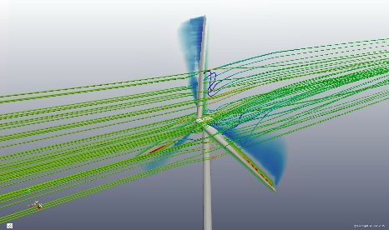
Figure 3 - Wind Turbine Computation Fluid Dynamic, (“Renewable Energy Engineering”)
Equation 9 - Power coefficient
$$C_{p}=\frac{P}{1/2⋅ρ⋅A⋅V^{3}}$$

$C_{p}$= Power coefficient
$P$ $=$ Power (w)
$ρ$ $=$ Air density (kg/ $m^{3}$)
$A=$ Turbine area ($m^{2}$)
V $=$ Wind velocity (m/s)

Wind Turbine Blade Structure
WTBs consist of a hollow blade structure that forms the airfoil with internal shear web. The skin forms the shape of a leading edge that engages with wind first and a trailing edge where airflow leaves the blade, affecting lift and drag. Spar caps help prevent shear forces and collapsing, reducing bending forces. The blade must be stiff and withstand operational conditions, yet lightweight, (“Diagrammatic Sketch of a Typical Wind Turbine Blade Structure”)

Wind Turbine Blade Optimal Dimensions
The power formula, Equation 10, shows that the area is directly proportional to power output.
Equation 10 - Power output
$$P = \frac{1}{2}ρ A V^{3} C_{p}$$

$P$ = Power (W)
$ρ$ = Air density (kg/m³)
$A$= Turbine Area (m²)
$V$ = Wind speed (m/s)
$C_{p}$= Power coefficient
Power output is determined through the swept area depicted by the blade length. However, larger blade lengths require significant structure strength. Therefore, when increasing the rotor size, the design must consider structural limitations.
Tip-Speed Ratio (TSR) determines the relationship between the speed of the blade tip and the wind speed, shown in Equation 11. Excessively high or low TSR results in reduced efficiency, and can cause noise or vibration. Ideal TSR is between 5-9, (Bakırcı and Yılmaz, 2018).
Equation 11 - TSR
$$TSR = \frac{(RPM)}{Wind Speed}$$

$RPM$= Tip Speed
$$RPM=\frac{ω×60​}{2π}$$
Angular Velocity ($ω) = \frac{θ}{time}$
Variations in TSR, aerodynamic errors and operating conditions affects power output. Figure 4 presents how operating conditions, such as WT position and varying wind conditions, will change the TSR. TSR varies from 6.1 to 9.24 here, (Hosseini et al. 2022).
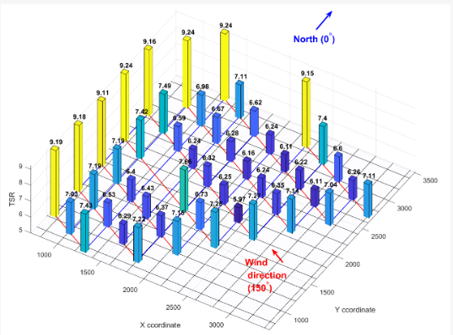
Figure 4 - TSR Operating Conditions Example (Hosseini et al. 2022).
According to Hasan et al., the chord length and twist vary across the blade length, creating a taper. The chord length is the distance between the leading edge and trailing edge of the blade cross-section. The chord length, Equation 12, is larger at the root of the blade and tapers towards the tip. The twist allows the aerodynamic profiles to maximise performance. Annex 4 identifies the change in chord length and twist angle along the blade length. Hasan et al. also notes that the airfoil shape varies along the blade length.
Equation 12 - Chord Length
$$c_{r} = \frac{8πR}{NC_{l}λ} x \frac{(1-\frac{r}{R})}{r}$$

$c_{r}$ = Chord length at specific distance from the hub
r = Distance from the hub to the radial position (m)
R = Blade length (m)
N = Number of blades
Cl = Lift coefficient
$λ$ = Average TSR

Material Properties
Material selection is important when considering environmental conditions and aerodynamic performance. WTs experience cyclic loading during service life and require fatigue resistance properties and high-tensile strength. High stiffness is required to resist deformation throughout operation and maintain aerodynamics. Science direct states low density is desirable, as reducing blade mass reduces inertial loads that lead to mechanical degradation, poor operation, and failure. To achieve these properties, three material categories are considered: metal, ceramic and polymer composites, (Thomas and Ramachandra, 2018).
Metals provide structural stiffness and high strength properties. However, environmental and operational conditions must be considered to prevent accelerated degradation. For example, steel provides high strength and stiffness, yet poor corrosion resistance. Titanium provides strength, stiffness and is lightweight, however it is expensive. Aluminium could be considered due to lower density than steel yet maintaining tensile strength and cost effectiveness, (Reddy N, Ph.D. 2017)
Ceramics provide high stiffness and strength, especially in harsh environmental conditions. However, due to the brittle properties, there is no toughness and ability to absorb energy on impact. Ceramics would not withstand the operational loading of a WT, and material failure would occur on impact. However, it could be used as a coating to another material. For example, silicon carbide coating offers corrosion resistance and a thermal barrier to another material, (Hussain, 2025)
Polymer based composites are commonly used in WTs as they offer a high strength-to-weight ratio that can be modified based on the application. Glass Fibre Reinforced Polymer (GFRP) provides strength and stiffness at a lower cost. Carbon-Fibre Reinforced Polymer (CFRP) offers higher stiffness and strength compared to the weight at a higher price, (“CFRP Vs. GFRP”)

Environmental Factors
WTs experience changing environmental conditions. Storms and unpredictable gusts from varying directions create turbulence and fluctuating loads, affecting the aerodynamic properties and power output. Environmental exposure, such moisture and salts, can accelerate the degradation of the materials therefore, performance and structural integrity. As a result, material selection and design must consider the environmental conditions to prevent failure of the operation to achieve peak performance, (Angeliki Kylili, 2022).

Design Specifications
This section identifies the design specification required to meet the brief of the development of the next generation three-bladed HAWT. A power output of 5MW is chosen to understand the difference of design parameters if the power demand is higher. The following assumptions have been made:
- Power = 5,000,000W
- Wind speed = 12 m/s
- $C_{p}$= 0.4
- $C_{l}$= 1.2
- $C_{D}$= 0.02
- Air density= 1.225 kg/m³
- Sections r/R= 0.1, 0.2, 0.3, 0.4, 0.5, 0.6, 0.7, 0.8, 0.9,0.99
NACA4412:
- $m$= Maximum camber = 0.04
- $p$= Camber position = 0.4
- $t$= Thickness distribution = 0.12

Rotor Radius
The blade length is equal to the rotor radius of the WT. Therefore, Equation 10 is used.
$$P = \frac{1}{2}ρAv^{3}c_{p}$$
$$A = \frac{2P}{ρ{v }^{3}c_{p}}$$
$$A = \frac{(2)(5,000,000)}{(1.225{)(12) }^{3}(0.4)}$$
$$A = 11,798m^{2}$$
$$A=πR^{2}$$
$$R=\sqrt{\frac{A}{π}}$$
$$R=\sqrt{\frac{11,798}{π}}$$
$$R=61.3m$$
$$D=2R$$
$$D=122.6m$$
As blade is connected to the hub, the blade length is the radius of the rotor diameter minus the hub measurement, however this is negligible and will be ignored.

Chord length
Chord length is calculated with Equation 12 at ten sections along the blade of 61.3m. This is shown in Annex 5.
$$c_{r} = \frac{8πR}{NC_{l}λ} x \frac{(1-\frac{r}{R})}{r}$$
$$c_{r} = \frac{8π61.3}{(3)(1.2)(7)} x \frac{(1-\frac{r}{R})}{r}$$
Camber, Equation 1-2, and thickness distribution, Equation 3, is calculated across ten cross-sections of each chord length. The airfoil is presented as the upper measurement, Equation 4, and lower measurement, Equation 5. Annex 6 and 7 highlights the standard values to be applied each chord length.
$$y_{c}= \frac{m}{p^{2 }}\left(2p\frac{x}{c}-{\left(\frac{x}{c}\right)}^{2}\right)$$
$$y_{c}= \frac{m}{{(1-p)}^{2 }}\left(\left(1-2p\right)+2p\frac{x}{c}-{\left(\frac{x}{c}\right)}^{2}\right)$$
$$y_{t}=5t\left(0.2969\sqrt{\frac{x}{c}}-0.1260\frac{x}{c}-0.3516{\left(\frac{x}{c}\right)}^{2}+0.2843{\left(\frac{x}{c}\right)}^{3}-0.1015{\left(\frac{x}{c}\right)}^{4}\right)$$
$$y_{upper}=y_{c}+y_{t}$$
$$y_{lower}=y_{c}+y_{t}$$

Dimensions and Profile
Annex 8 shows calculations for all sections, along the blade length of 61.3m. Taking ten cross-sections allows for increased accuracy when designing the blade. The final section of r/R 0.99 allows for a definitive tip, allowing the model to be created in CAD. Annex 9 presents the data on graphs, highlighting the reduction in chord length over the ten cross-sections.

Material Selection
Material selection is critical for aerodynamic and structural performance. The chosen material must provide enough strength, stiffness and fatigue resistance. The brief states lightweight, durable, and low maintenance characteristics are desired. In addition, manufacturability, costs and environmental factors will be considered. A weighted decision matrix (WDM) is used to evaluate materials in Annex 10.
From the WDM, analyses two examples of each material group, GFRP achieved the highest weighted total of 4.30. This was followed by CFRP with 4.10 and titanium at 3.9. This indicates that GFRP balances the design, operational and customer requirements and is most suitable. Whilst CFRP and titanium also scores highly in mechanical properties, GFRP achieves the highest score for cost, (Rashedi et al. 2011).
The WDM highlights the trade-offs between different materials. For example, CFRP provides high mechanical properties with low-density, however cost is greater, which reduces the overall suitability. Titanium offers high mechanical properties and durability, but has a higher density, reducing the suitability of a lightweight WT. GFRP therefore provides balance of mechanical properties with good durability and low-density at reasonable costs.

Exploration of Manufacturing Routes
As GFRP was selected, vacuum infusion and resin transfer moulding (RTM) are considered for manufacturing. Criteria has been established to assess a suitable manufacturing method:
- Scalability
- Lightweight Properties
- Production Costs
- Production Time
- Environmental Impact
Vacuum infusion, Figure 5, uses a vacuum bag to draw liquid resin through dry fibres, to saturate them, before curing. WT moulds are manufactured, where dry glass fibres, plus reinforcements if required, are laid in the mould prior to the application of the liquid resin. Tooling costs are low, and large, complex, lightweight designs can be manufactured, (Mike, 2024).
However, production time is increased due to cure times, limiting production scalability. Additionally, quality control is required as poor application of resin results in material weakness such as voids and dry spots, increasing labour. Vacuum infusion controls resin quantity to reduce material waste and environmental impact.
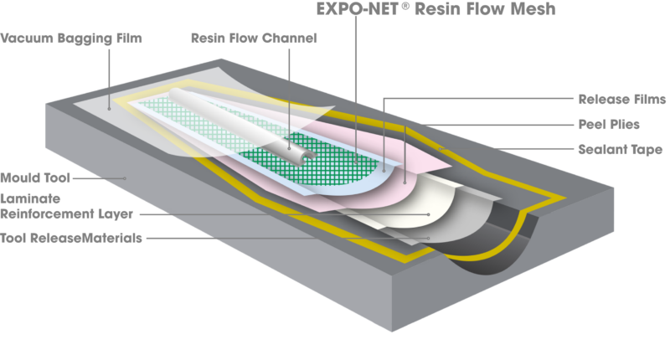
Figure 5 - Vacuum Infusion, (“Customized Resin Flow Mesh Optimises Wind Turbine Blade Production”)
RTM, Figure 6, uses pressure to inject resin in a closed mould around dry glass fibres, controlling resin distribution. RTM provides lightweight and complex components with increased surface finish, and processes can become automated reducing labour further. As a result, production costs are high, especially for larger applications, such as WTBs. With increased tooling, RTM can control the volume of resin to reduce material waste and environmental impact, (“New Technologies for Miniaturized Spacecraft and Multi-Point Cluster Missions”).

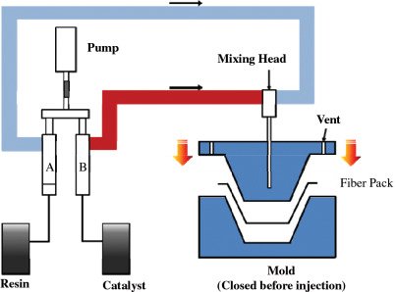
Figure 6 – RTM, (“New Technologies for Miniaturized Spacecraft and Multi-Point Cluster Missions”)
From research, vacuum infusion will be chosen for the WT manufacturing process using GFRP. Compared with RTM, vacuum infusion provides a balance of large-scale production and costs, despite long curing times. To minimise defects, resin flow is to be monitored with additional quality assurance checks to optimise structural integrity and aerodynamic performance.

Cost Evaluation
GFRP and vacuum infusion was selected due to mechanical properties, large scale producibility and low cost. This section investigates all raw material and manufacturing costs for metals, ceramics, and composites.

Raw Material Costs
Annex 11 highlights the balance between density and material costs and estimates total blade manufacturing costs based on blade mass. However, this estimates the cost if the WTB was a solid component. As researched, this is not the case, as the airfoil is hollow in real applications, with spar caps and internal support structures. Therefore, this is only used to calculate the percentage difference between varied materials.
Since the airfoil is hollow, there would be considerably less mass and cost than presented in table x. For example, when comparing titanium, GFRP provides 55.6% mass and 89.3% cost reduction, and GFRP costs 63.4% less than CFRP however, is 34.2% heavier. Therefore, is has been decided that GFRP is the most suitable when balancing mass to cost, (Özkan et al. 2025).

Manufacturing Costs
Vacuum infusion was decided to manufacture the GFRP WTB as manufacturing costs were cheaper. This section highlights the manufacturing costs including labour, equipment and defect mitigation.

Science direct state the labour costs are 41% of the material costs. Therefore, material cost based on a solid blade will be used. GFRP is 63.4% cheaper than CFRP when using vacuum infusion, Equation 13-14, (Schubel, 2010).
Equation 13 - GFRP labour costs
$$GFRP Labour costs=Material x \frac{0.41}{0.51}$$
$$Labour costs=£1,065,893.40 x \frac{0.41}{0.51}$$
$$Labour costs=£856,894.69$$
Equation 14 - CFRP labour costs
$$CFRP Labour costs=Material x \frac{0.41}{0.51}$$
$$CFRP Labour costs=£2,909,044.71 x \frac{0.41}{0.51}$$
$$Labour costs=£2,338,643.79$$
Equipment and tooling costs for vacuum infusion include vacuum pump, moulds and bags to create the vacuum and therefore is considerably cheaper than RTM. Defect mitigation costs will be required to ensure product quality. This can include; inspections, non-destructive testing with potential rework required to control defects such as voids and dry spots.

Mechanical Properties
Calculations are conducted to understand the forces acting on the blade. This is compared to yield strengths of the considered materials, where safety factor is calculated. Ten sections of the blade are analysed, where materials are evaluated for each section.

Force Calculations
Lift and drag forces are calculated at each section midpoint in table x, using Equations 7-8, (Megonigal, 2019):
$$C_{D}=\frac{D}{1/2⋅ρ⋅{Vrel}^{2}.A}$$
$$C_{l}=\frac{L}{1/2⋅ρ⋅{Vrel}^{2}.A}$$
Angular velocity was calculated from rearranging Equation 11. The tangential velocity, Equation 15, was used to calculate the relative velocity at each section, shown in Annex 12.
$$λ=\frac{ωR}{V}$$
$$ω=\frac{λV}{R}$$
$$ω=\frac{(7)(12)}{61.3}$$
$$ω=1.371 rad/s$$
Equation 15 - Tangential Velocity
$$V_{tan}=ωr$$
$$V_{rel}=\sqrt{V^{2}+}{V_{t}}^{2}$$
$$A=c. r$$

Stress Analysis
Using Equations 16, the bending moment at each section was calculated, using the sum of the lift forces acting on each section. The result of the calculation is shown in Annex 13, (Xi et al.2013.)
Equation 16 - Bending moment
$$M=\sum_{i=j}^{10}{Li}.(ri-rj)$$

$M$= Bending Moment
$Li$= Lift Force (N)
$rj$= Selected Section Radial Position
$ri$= Outward Section Midpoint
The maximum bending moment is when r/R=0.1, experiencing lift forces from all other sections combined. All section properties were obtained from the SolidWorks CAD model, the second moment of inertia was found for each section Annex 14. Therefore, bending stress could be calculated using Equation 17, shown in Annex 13.
Equation 17 - Bending stress
$$σ=\frac{My}{I}$$

$σ$=Bending Stress
$y$=Centroid Distance to Critical Airfoil Section (assumed to be $\frac{t_{max}}{2}$)
$I$=Second Moment of Area
Aerodynamic lift also produces torsional loading. The torsional moment was calculated using Equations 18-19, where the results can be found in Annex 15.
Equation 18 - Torsional moment
$$T=L.e$$
Equation 19 - Eccentricity
$$e=\left(\frac{x_{c}}{c}-0.25\right)c$$

$T$=Torsional Moment
$L$=Lift Force
$e$=Eccentricity
$xc$=Centroid Position
$c$=Chord Length
The greatest torsional moment occurs at section 1, since the chord, lift force and eccentricity are larger. The torsional moment decreases significantly as the sections of the blade approach the tip.
The calculated stresses were compared with the mechanical strength of an 11-year-old retired WTB, constructed using GFRP. When comparing the stresses against the mechanical strength of GFRP, this material does not have a conventional yield point. Therefore, to test structural stability, tensile, compressive and shear strength values are used, (Ramaswamy et al. 2025).
The retired blade achieved a longitudinal tensile strength of 620MPa, and a longitudinal compressive strength of 372MPa before failure. These values are the benchmarks in which the newly designed blade will be compared to. The safety factor using Equation 20, is shown in table x for each section.
Equation 20 - Safety factor
$$SF=\frac{σ_{RETIRED}}{σ_{NEW}}$$
SF = Safety Factor
𝜎_{RETIRED} = Compressive Strength of Retired Blade
𝜎_{NEW} = Bending Stress of New Blade
Table x shows the calculated safety factor decreases as the blade tip is approached. In section 1 – 5, the safety factor is over unity. Section 6 – 9 have a safety factor of below unity, indicating that the model would not provide suitable strength in these sections. These calculations are based on preliminary equations that do not consider a hollow blade structure or shear webs, which increase strength parameters in a real GFRP blade.

Comparative Analysis
Selected materials and manufacturing process are analysed and requirements researched highlights advantages of the selected materials and processes. These include:
- Mechanical Properties
- Productivity and Scalability
- Manufacturing Defects
- Environmental and Safety considerations
GFRP provides balanced mechanical properties, such as tensile strength, stiffness and fatigue resistance, including cost effectiveness for WTB application. CFRP provides greater properties, but cost increases. Metal provides high material properties at a higher mass, and ceramics provide lower mass, however, ceramics are brittle and therefore not suitable. Further research to analyse material selection and manufacturing routes of spar caps and internal web structures; lightweight metal could be selected to increase strength and reduce bending and torsional stresses.
Vacuum infusion was chosen due to the low tooling costs and ability to manufacture large components. However, it’s labour intensive; increasing costs and manufacturing times due to cure times. RTM offers scalability due to automation capabilities and increased quality; however, increased tooling costs reduces suitability. As the turbine has capacity to produce higher energy, the blade lengths were increased to 61.3m. This introduces transportation difficulties to the WT location, requiring specialised vehicles, (Smith, 2024)
Manufacturing defects, such as voids, porosity and surface imperfections can occur during manufacturing processes. These defects reduce mechanical properties and aerodynamics by creating stress or failure points, reducing durability that could lead to safety hazards. GFRP can introduce voids due to dry spots, Figure 7, and delamination, Figure 8. Therefore, increased quality assurance, such as resin control and frequent inspections, are required, (Shevtsov et al. 2020).

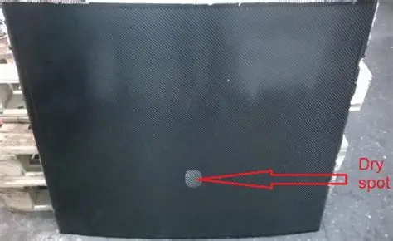
Figure 7 - GFRP Dry Spot Defect (Shevtsov et al.2020)
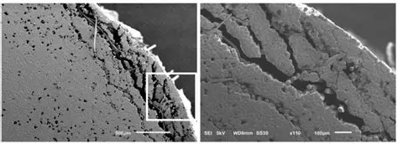
Figure 8 - GFRP Delamination, (Das et al.2019)

In comparison, metals could also produce defects such as porosity, inclusions and cracks along the grain boundary, leading to crack propagation and failure, Figure 9. The WT would experience cyclic loading; therefore, fatigue and creep properties are important, Figure 10. Quality assurance, such as non-destructive testing, would also be required if metals were chosen, (Santamaria et al.).
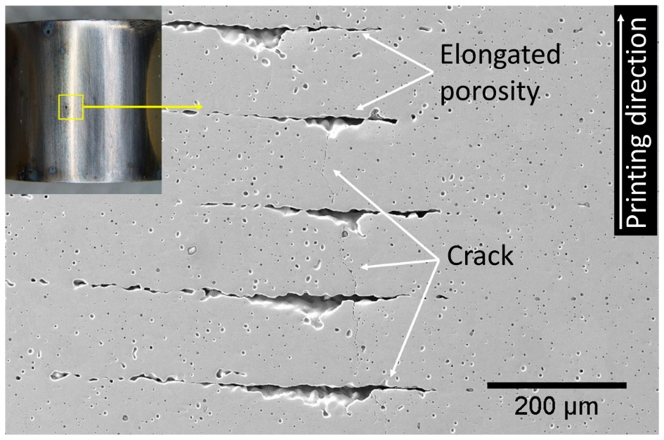
Figure 9 - Metal Defect Example, (Santamaria et al. 2023)

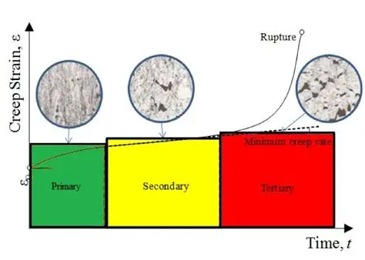
Figure 10 - Creep Stages Graph (Sattar 2020)
GFRP can reduce material waste through the control of resin application in the manufacturing process. GFRP is difficult to recycle at end-of-life, therefore, durability is important to prolong the product in service. Due to the large blade length, additional safety requirements are required during handling and transportation, (Agecko UK, 2025).

9. Blade Drawing
To present the proposed design, the geometry of the proposed WTB has been designed on SolidWorks, Figure 11. Using Annex 8, ten cross-sections, from root to tip, were drawn using the chord length and upper and lower surface, using the thickness distribution, Figure 12. This was extruded and the WTB CAD model was constructed.
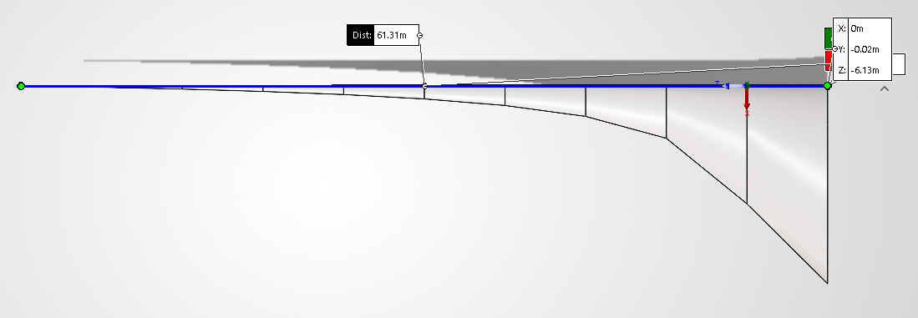
Figure 11 - Blade Length of 61.3m CAD Drawing
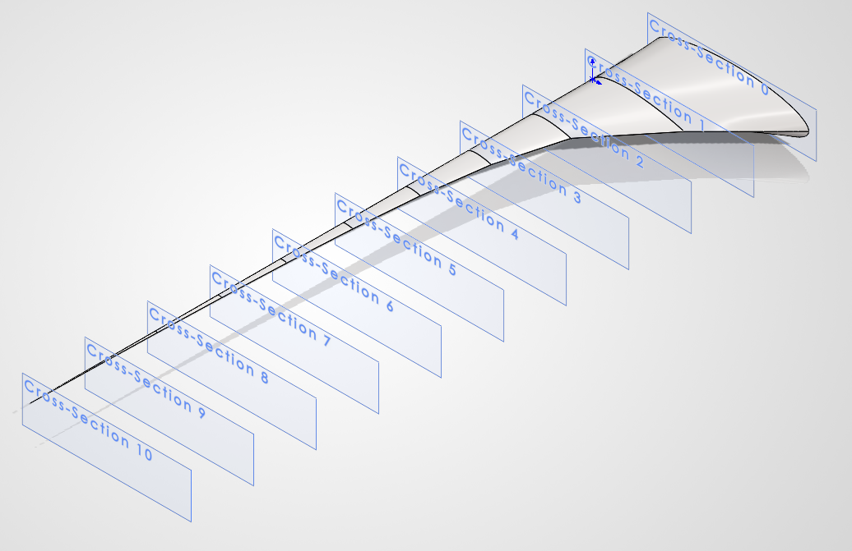
Figure 12 - CAD Drawing Cross-Sections
The chord length decreases from root to tip; larger at the root to provide structural integrity and the smaller toward the tip to aid aerodynamic performance. The chord lengths, Annex 8, was used to produce the taper; with chord lengths of 8.976m at the root to 0.010m at the tip. To visualise the full length of the blade, cross-section 0 has been applied to represent the blade connecting to a hub. Similarly, section 10 has been calculated at r/R=0.99 for a definitive tip.
NACA4412 was used for geometry reference and calculations of the thickness distribution for the ten cross-sections of the blade is shown in Annex 8. This relative thickness distribution across each section, Figure 13, was used to calculate y(upper) and y(lower) that forms the geometry airfoil.
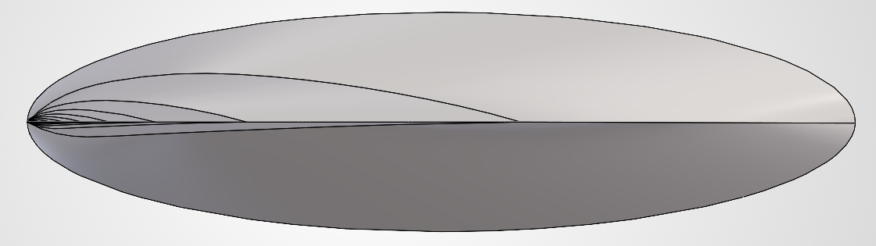
Figure 13 - Thickness Reduction

10. Conclusion
This report has studied design of the next-generation WT, by focusing on the design parameters, materials, manufacturing and costs. A WTB of 61.3m was designed with calculations based on NACA4412 airfoil. Material selection identified GFRP to be most suitable with a weighted decision matrix, and vacuum infusion was chosen as a manufacturing route.
Mechanical analysis demonstrated the aerodynamic loading, bending stresses and torsional moments on the blade. Then, the stresses of the blade were compared to the yield stresses of GFRP. Highlighting the strength required at the root of the blade for operation, specifically when increased. This is shown in the chord length, sections are wider when closer to the hub. Comparative analysis highlights the research conducted and demonstrates the suitability materials and manufacturing processes chosen compared to alternatives. GFRP and vacuum infusion were confirmed as the most appropriate.
The 5MW WT offers the potential to reduce the quantity of WTs onshore; if the blade length increases, without reducing the power output. However, with larger blades, constraints increase as structural integrity, transportation and manufacturing becomes problematic.

Recommendations
Further development would focus on increasing the accuracy of calculations for increased geometries of the WTB. Ten sections of the blade length were taken, however, to increase accuracy, additional points can be added. Similarly, research into dimensioning the hub would allow increased accuracy of the calculations and CAD drawing.
The CAD drawing displayed the outer surface of the blade; however, internal structures were not considered. Therefore, further research is recommended to analyse the internal structures and calculate the airfoil thickness. This will provide accurate measure of volume and cost. Similarly, blade structure, such as internal structure webs and spar caps, could be analysed in addition the GFRP airfoil skin.

11. References
AKGUMUS GOK, Dilsad. “Characterization of NACA 2412 and NACA 4412 Airfoils: Effects of Angle of Attack on Aerodynamics Coefficients.” Journal of Thermal Engineering, vol. 10, 2024, pp. 1524–1538, 10.14744/thermal.0000892.
Angeliki Kylili. “Environmental Assessment of Wind Turbines and Wind Energy.” Elsevier eBooks, 1 Jan. 2022, pp. 55–83, https://www.sciencedirect.com/topics/earth-and-planetary-sciences/windpower-utilization, 10.1016/b978-0-12-817111-0.00004-8. Accessed 6 Sept. 2026.
Bakırcı, Mehmet, and Sezayi Yılmaz. “Theoretical and Computational Investigations of the Optimal Tip-Speed Ratio of Horizontal-Axis Wind Turbines.” Engineering Science and Technology, an International Journal, vol. 21, no. 6, Dec. 2018, pp. 1128–1142, 10.1016/j.jestch.2018.05.006.
“CFRP Vs. GFRP - What’s the Difference? | This Vs. That.” This vs. That, 2023, https://thisvsthat.io/cfrp-vs-gfrp. Accessed 6 Sept. 2026.
Clayton, Dillon . “Types of Wind Turbines: HAWT, VAWT and More Explained - Energy Follower.” Energyfollower.Com, 17 June 2021, https://energyfollower.com/types-of-wind-turbines/. Accessed 6 Aug. 2026.
“Composite Waste Recycling & GRP Waste Disposal | Agecko UK.” Agecko, 28 Jan. 2025, https://agecko.com/services-and-products/waste-management-services/composite-waste/. Accessed 7 Sept. 2026.
Cope, Liam . “What Is the Lift-to-Drag Ratio and Why Does It Matter?” Engineer Fix, 7 Nov. 2025, https://engineerfix.com/what-is-the-lift-to-drag-ratio-and-why-does-it-matter-2/. Accessed 6 Sept. 2026.
“Customized Resin Flow Mesh Optimises Wind Turbine Blade Production.” State of Green, 2 Apr. 2026, https://stateofgreen.com/en/solutions/customized-resin-flow-mesh-optimises-wind-turbine-blade-production/. Accessed 7 Sept. 2026.
Das, Arunita, et al. “Numerical Investigations on Post-Fire Bond Behaviour of Reinforcement in Concrete.” RILEM Technical Letters, vol. 4, 16 May 2019, pp. 1–8, 10.21809/rilemtechlett.2019.88.
De Lellis, Marcelo, et al. “The Betz Limit Applied to Airborne Wind Energy.” Renewable Energy, vol. 127, no. 11, Nov. 2018, pp. 32–40, 10.1016/j.renene.2018.04.034.
“Diagrammatic Sketch of a Typical Wind Turbine Blade Structure.” ResearchGate, 2024, https://www.researchgate.net/figure/Diagrammatic-sketch-of-a-typical-wind-turbine-blade-structure_fig1_360078049. Accessed 6 Sept. 2026.
Douak, M., et al. “Wind Energy Systems: Analysis of the Self-Starting Physics of Vertical Axis Wind Turbine.” Renewable and Sustainable Energy Reviews, vol. 81, Jan. 2018, pp. 1602–1610, 10.1016/j.rser.2017.05.238.
Guy Energy Ltd. “Guy Energy Ltd | Pen Y Cymoedd.” Guyenergy.Co.Uk, 2026, https://guyenergy.co.uk/penycymoedd.html. Accessed 6 Aug. 2026.
Hasan, Mehedi, et al. “Performance Investigation of Three Combined Airfoils Bladed Small Scale Horizontal Axis Wind Turbine by BEM and CFD Analysis.” Journal of Power and Energy Engineering, vol. 5, no. 5, 25 May 2017, pp. 14–27, https://www.scirp.org/journal/paperinformation.aspx?paperid=76476, 10.4236/jpee.2017.55002. Accessed 6 Sept. 2026.
Hosseini, Amir, et al. “Tip Speed Ratio Optimization: More Energy Production With Reduced Rotor Speed.” Wind, vol. 2, no. 4, 31 Oct. 2022, pp. 691–711, 10.3390/wind2040036.
Hussain, Gulzar. “Ceramic Materials Guide: Types, Properties, and Applications.” MAC Ceramic, 10 Dec. 2025, https://www.microns-ceramics.com/post/ceramic-materials-guide. Accessed 6 Sept. 2026.
Ion. “Ion Acoustics :: Pen Y Cymoedd Wales Nuon / Natural Power.” Ionacoustics.Co.Uk, 2026, https://www.ionacoustics.co.uk/projects/wind-farms/pen-y-cymoedd-wales-nuon-natural-power/. Accessed 6 Sept. 2026.
Jamieson, Peter. Innovation in Wind Turbine Design. Wiley, 2018.
Karam Maalawi. Wind Turbines - Aerodynamics. IntechOpen, 2022.
Keighley, Graeme Whitfield Tom. “Hull Workers Build 115M Blades for Hornsea 3, World’s Largest Offshore Wind Farm.” AOL.Com, 3 Sept. 2026, https://www.aol.co.uk/articles/hull-workers-build-115m-blades-120317000.html. Accessed 6 Sept. 2026.
Mech Proverse. Stalling of NACA 4412 Airfoil | -20 Degree Angle of Attack | 2 Dimensional | CFD Analysis. YouTube, 21 Feb. 2025.
Megonigal, Luke. “NACA 4412 Airfoil Study: Lift, Drag, and Stall Angle.” Research Gate, 24 July 2019, https://www.researchgate.net/publication/360630776_NACA_4412_Airfoil_Study_Lift_Drag_and_Stall_Angle. Accessed 6 Sept. 2026.
Mike. “Vacuum Infusion: A Comprehensive Guide to Composite Material Manufacturing.” IncomePultruson, 28 Apr. 2024, https://incomepultrusion.com/vacuum-infusion-a-comprehensive-guide/. Accessed 7 Sept. 2026.
National Grid. “Onshore Vs Offshore Wind Energy: What’s the Difference? | National Grid Group.” Www.Nationalgrid.Com, 30 Mar. 2022, https://www.nationalgrid.com/stories/energy-explained/onshore-vs-offshore-wind-energy. Accessed 2 Sept. 2026.
“New Technologies for Miniaturized Spacecraft and Multi-Point Cluster Missions.” COSPAR Colloquia Series, 1999, pp. 114–122, https://www.sciencedirect.com/topics/physics-and-astronomy/resin-transfer-molding, 10.1016/s0964-2749(99)80015-8. Accessed 7 Sept. 2026.
Orsted. “Hornsea Three.” Hornseaproject3.Co.Uk, https://hornseaproject3.co.uk/. Accessed 6 Sept. 2026.
“Power Coefficient of a Wind Turbine - iEnergy Plus.” Wind Power Plus, 9 Dec. 2024, https://ienergyplus.com/power-coefficient-of-a-wind-turbine/. Accessed 6 Sept. 2026.
Ramaswamy, Nagesh, et al. “Residual Mechanical Properties of GFRP Composites From Decommissioned Wind Turbine Blades for Structural Reuse.” Composite Structures, vol. 374, Dec. 2025, p. 119739, 10.1016/j.compstruct.2025.119739.
Rashedi, A., et al. “Multi-Objective Material Selection for Wind Turbine Blade and Tower: Ashby’s Approach.” Materials & Design, vol. 37, no. 1, May 2012, pp. 521–532, 10.1016/j.matdes.2011.12.048.
Reddy N, Ph.D., Dr. Ranga. “12 Properties of Metals | With Suitable Examples in Chemistry.” Study Read, 8 Oct. 2017, https://www.studyread.com/properties-of-metals/. Accessed 6 Sept. 2026.
“Renewable Energy Engineering.” MR CFD, https://www.mr-cfd.com/industries/renewable-energy/. Accessed 6 Sept. 2026.
Santamaria, Ricardo, et al. “Stress Corrosion Cracking of 316L Stainless Steel Additively Manufactured With Sinter-Based Material Extrusion.” Materials, vol. 16, no. 11, 26 May 2023, p. 4006, https://doi.org/10.3390/ma16114006, 10.3390/ma16114006. Accessed 7 Sept. 2026.
Sattar, Mohsin . “Prediction Model for Creep Crack Growth for the Life Assessment of Steel Components.” Prediction Model for Creep Crack Growth for the Life Assessment of Steel Components, Apr. 2020.
Schubel, P.J. “Technical Cost Modelling for a Generic 45-M Wind Turbine Blade Producedby Vacuum Infusion (VI).” Renewable Energy, vol. 35, no. 1, Jan. 2010, pp. 183–189, 10.1016/j.renene.2009.02.030.
Shevtsov, Sergey, et al. “Experimental and Numerical Study of Vacuum Resin Infusion for Thin-Walled Composite Parts.” Applied Sciences, vol. 10, no. 4, 21 Feb. 2020, p. 1485, 10.3390/app10041485.
Smith, Luke. “Wind Turbine Transportation: Why Route Assessments Are Critical.” Stantec.Com, 2024, https://www.stantec.com/en/ideas/topic/energy-resources/overcoming-challenges-wind-turbine-transportation-why-route-assessments-are-critical. Accessed 7 Sept. 2026.
Thomas, Lijin, and M. Ramachandra. “Advanced Materials for Wind Turbine Blade- a Review.” Materials Today: Proceedings, vol. 5, no. 1, 2018, pp. 2635–2640, 10.1016/j.matpr.2018.01.043.
Xi, Yibo, et al. “Bending Moment Characteristic Analysis of Utility-Scale Onshore Wind Turbine Blades Based on Monitoring Data.” Engineering Structures, vol. 294, 1 Nov. 2023, p. 116714, https://www.sciencedirect.com/science/article/pii/S014102962301129X, 10.1016/j.engstruct.2023.116714. Accessed 7 Sept. 2026.
Özkan, Ramazan, et al. “Multi-Objective Structural Optimization of Composite Wind Turbine Blade Using a Novel Hybrid Approach of Artificial Bee Colony Algorithm Based on the Stochastic Method.” CMES - Computer Modeling in Engineering and Sciences, vol. 145, no. 3, 23 Dec. 2025, pp. 3349–3380, https://www.sciencedirect.com/org/science/article/pii/S1526149225004394, 10.32604/cmes.2025.072519. Accessed 7 Sept. 2026.

Appendices
Annex 1: Wind turbine application growth from 1979 to 2025
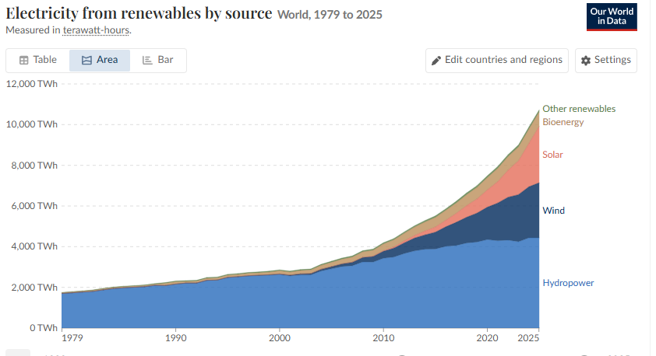

Annex 2: Comparison between onshore and offshore design parameters
Parameter | Pyn y Cymoedd Wind Farm | Hornsea Three Wind Farm
Application | Onshore | Offshore
Number of Turbines | 76 | 231
Turbine Output | 3MW | 14MW
Wind Farm Output | 232MW | 2.9GW
Rotor Diameter | 101m | 230m
Rotor Radius | 50.5m | 115m

Annex 3: Wind turbine airflow streamlines at 20-degree angle of attack
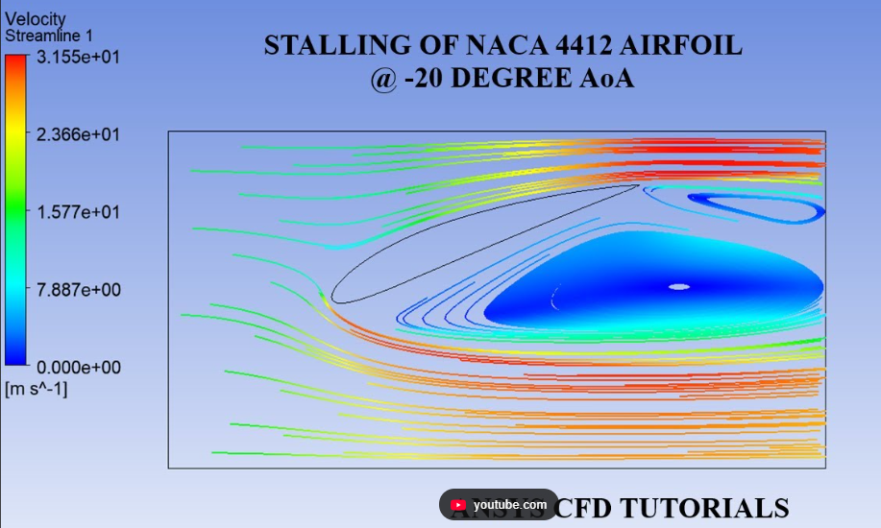
Annex 4: Change in chord length and twist angle along the blade length
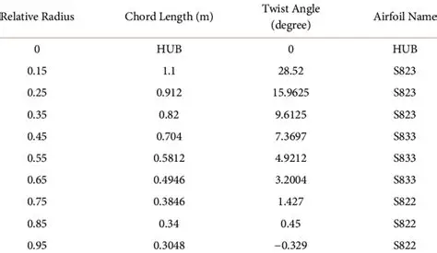

Annex 5: Chord length calculations
Annex 6: Standard values to be applied each chord length
Annex 7: Standard values to be applied for y upper and y lower graph
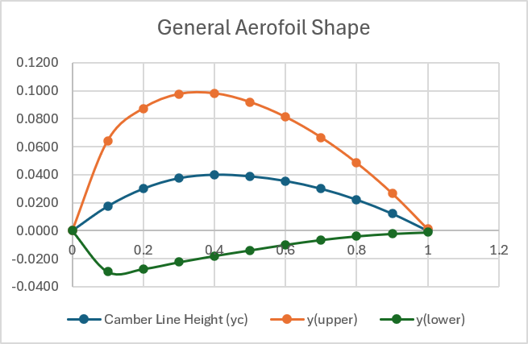
Annex 8: Proposed wind turbine blade geometry calculations over the ten cross-sections. Calculating camber, thickness distribution, y(upper) and y(lower) across 10 sections of each chord length.

Annex 9: Proposed wind turbine blade geometry reduction over the ten cross-sections.

Annex 10: Weighted Decision Matrix for Material Selection, using two examples of each material group.
Weighted Decision Matrix: Wind Turbine |  | Metal |  | Ceramic |  | Polymer
Criteria | Weighting | Titanium | Aluminium | Silicon Carbide | Aluminium oxide | GFRP | CFRP
Tensile Strength and Stiffness | 0.2 | 1 | 0.8 | 1 | 0.8 | 0.8 | 1
Fatigue Resistance | 0.2 | 1 | 0.8 | 0.6 | 0.2 | 0.8 | 0.8
Lightweight | 0.15 | 0.45 | 0.6 | 0.6 | 0.6 | 0.75 | 0.75
Durability | 0.15 | 0.75 | 0.6 | 0.75 | 0.6 | 0.75 | 0.75
Maintenance and Manufacturability | 0.1 | 0.3 | 0.3 | 0.2 | 0.2 | 0.4 | 0.3
Cost | 0.1 | 0.1 | 0.4 | 0.1 | 0.3 | 0.5 | 0.2
Environmental factors | 0.1 | 0.3 | 0.3 | 0.4 | 0.4 | 0.3 | 0.3
Weighted Total | 1 | 3.9 | 3.8 | 3.65 | 3.1 | 4.3 | 4.1

Annex 11: Comparison between density and costs for each considered material to highlight the trade off
Material | Density (kg/m³) | Material Cost (£/kg) | Blade Volume (m³) | Blade Mass (if solid) (kg) | Blade Cost (if solid) (£)
Titanium | 4500 | £12.58 | 175.89 | 791505 | £9,957,132.90
Aluminium | 2700 | £1.64 | 175.89 | 474903 | £778,840.92
Silicon Carbide | 2800 | £26.64 | 175.89 | 492492 | £13,119,986.88
Aluminium Oxide | 3900 | £1.41 | 175.89 | 685971 | £967,219.11
GFRP | 2000 | £3.03 | 175.89 | 351780 | £1,065,893.40
CFRP | 1490 | £11.1 | 175.89 | 262076 | £2,909,044.71

Annex 12: Lift and drag calculations for each section of the proposed blade geometry. Highlighting tangential and relative velocity
Section | Section Length (m) | Midpoint (m) | Chord Length (m) | Section Area (m^2) | Tangential Velocity (m/s) | Relative Velocity (m/s) | Lift Force (kN) | Drag Force (kN)
1 | 0.00- 6.13 | 3.065 | 8.98 | 55.047 | 4.2 | 12.713 | 6.54 | 0.109
2 | 6.13-12.26 | 9.195 | 3.991 | 24.465 | 12.6 | 17.4 | 5.444 | 0.091
3 | 12.26-18.39 | 15.325 | 2.328 | 14.271 | 21 | 24.187 | 6.136 | 0.102
4 | 18.39-24.52 | 21.455 | 1.497 | 9.177 | 29.4 | 31.758 | 6.801 | 0.113
5 | 24.52-30.65 | 27.585 | 0.998 | 6.118 | 37.8 | 39.658 | 7.072 | 0.118
6 | 30.65-36.78 | 33.715 | 0.665 | 4.076 | 46.2 | 47.733 | 6.827 | 0.114
7 | 36.78-42.91 | 39.845 | 0.428 | 2.624 | 54.6 | 55.904 | 6.026 | 0.1
8 | 42.91-49.04 | 44.975 | 0.25 | 1.533 | 63 | 64.133 | 4.633 | 0.077
9 | 49.04-55.17 | 52.105 | 0.111 | 0.68 | 71.4 | 72.403 | 2.622 | 0.044
10 | 55.17-61.3 | 58.235 | 0.0101 | 0.06173 | 79.8 | 80.698 | 0.295 | 0.005

Annex 13: Bending stress calculations for each section of the proposed blade geometry.
Section | Bending Moment (kNm) | Max thickness | y (m) | Moment of Inertia ($m^{4}$) | Bending Stress (kPa)
1 | 1181.64 | 1.0771 | 0.53855 | 0.45192 | 1408.152377
2 | 900.53 | 0.4787 | 0.23935 | 0.017632 | 12224.47003
3 | 652.81 | 0.2793 | 0.13965 | 0.002042 | 44644.91503
4 | 442.69 | 0.1795 | 0.08975 | 0.000349 | 113843.6318
5 | 274.27 | 0.1197 | 0.05985 | 0.000069 | 237899.413
6 | 149.2 | 0.0798 | 0.0399 | 0.000014 | 425220
7 | 65.97 | 0.0513 | 0.02565 | 0.000002 | 846065.25
8 | 19.69 | 0.0299 | 0.01495 | 2.9065E-07 | 1012783.416
9 | 1.81 | 0.0133 | 0.00665 | 1.0368E-08 | 1160927.855
10 | 0 | 0.0012 | 0.0006 | 8.15243E-13 | 0

Annex 14: Bending stress calculations for each section of the proposed blade geometry.


