The ATLAS Model and an analysis of its use in a Real-Life Scenario

Contents:
Introduction ……………………………………………………………………. Page. 3

What is Evidence Based Policing? …………………………………………. Page. 4

The ATLAS Model ……………………………………………………………. Page. 5-6

ATLAS and a Real-Life Incident – Grenfell Tower ………………………... Page. 6-8

Conclusion …………………………………………………………………….. Page. 9

Introduction
This report will outline the introduction to evidence-based policing including the concepts of collaborative working to maximise resource usage when investigating a case.
The ATLAS model and its application will also be outlined in detail including its five steps principles. The cycle model acts will demonstrate the support through enhanced resources and innovative thinking aligned to problem solving mechanisms, challenging and stretching thinking in line with current policies and processes.
An overview of the Grenfell Tower major incident and the application of the ATLAS model providing details of its implementation will also draw out key step examples when applied to real life scenario.

What is Evidence Based Policing?
Evidence based policing was developed by Professor Lawrence Sherman in 1998 with the concept of implementing the most effective and applicable research methods and sources of questioning when investigating a case. This will allow police officers to appropriately question based on the best available evidence gathered, in addition, to better understand the issue and potential cause of the incident whilst also exploring any opportunity of change within policing (College of Policing, 2020).

The focus to Evidence based policing is also to analyse the geographical crime hotspots, also considering any factors encompassing situation and environment while assessing a crime. Within the police consideration must be given to opportunity as well as general knowledge of standard processes (Matrix Demonstration Project Team, 2020).

The approach to evidence-based policing is to fundamentally encourage collaboration with police officers and civilian staff in order to gather and implement the most effective evidence and approaches across a range of methods. This enhances initiative, empowering colleagues to also challenge current policing policies and decisions to maximise effective policing (Wheller, 2019).

The ATLAS Model
One approach used within evidence-based policing is the application of the ATLAS model. ATLAS is an abbreviation of five principles that form a framework for officers when assessing a crime. These principles are:
- Ask - Appropriately question in order to challenge existing practices.
- Test - Critically analyse current research and any potential new initiatives that should be implemented.
- Learn - Apply previous knowledge and experience when considering approach and aligning this to existing practices within the working environment.
- Adapt - Using the best available evidence adapt existing procedures and working practices, making the necessary changes to questioning in order to gain the best available evidence.
- Share – Share outcomes to increase knowledge and understanding to build on future opportunities (Pepper, Rogers and Martin, 2020)

Ask is the first stage of the problem-solving cycle in order to understand the specific case within policing to allow you to understand the most effective route in how you can apply and adapt differently in order to gain the most effective outcome. This concept also allows you to challenge your thinking on not only the next steps but also question current practices and challenge the norm. Once the opportunity has been completed in line with appropriate questioning, test allows you the reflection to consider new initiatives and work collaboratively with colleagues on areas of research and analysis that may compliment your investigation. Under test it is also important to consider the desired outcome and how this will be measured. The learning phase of the model encompasses a view of success and failure and allows you to analyse and share outcomes and experiences with fellow colleagues. This concept allows you to measure the effect against new and existing approaches along with building knowledge and experience against existing and new practices and policies. Adapt is the final the final element of the model whereby reflection is critical in the next steps of your decision making. Any success should be collaborated in areas of similar challenges to maximise the advantages with others. Where intervention has not driven out to the desired effect it is of key importance to learn from results and adapt questioning, restarting the cycle. It is important to share the findings at each stage (WhatWorks, 2020).

The model also enhances academic thinking in order to compliment and encourage value through the innovation of new officers to empower thinking, share ideas and challenge current policies in order to maximise the success of substantial evidence. In line with the current modern day policing demands the approach in empowering colleagues in challenging the norm also enhances balanced views and sharing successes from experience. This in turn creates a workforce that is continually evolving with the times and maximising the advantages of academic background to compliment current policing policies and processes (Pepper, Rogers and Martin, 2020).

ATLAS and a Real-Life Incident – Grenfell Tower
Grenfell Tower was a 24-storey tower block located near Notting Hill in London which contained 120 apartments. It was originally built in 1974 involved with the Lancaster West Estate project. It was later refurbished in 2016 which involved adding exterior cladding, new communal heating system and double glazing. On the 14th of June 2017, a fire broke out on the second floor at 12:54am which later engulfed the whole building due to poorly built and flammable external cladding and insulation. (The Guardian, 2017). There was a total of 72 deaths which included 18 children, 25 men and 29 women (Rice-Oxley, 2018).

The first at the scene for the Metropolitan Police Service (MPS) was PC Joshua Rees along with PC Sangha who identified the immediate threat was occupants of the tower block attempting to vacate the premises. His assessment was to ensure occupants were moved away from the immediate threat which evidences the use of ‘Ask’, understanding priorities and evidencing his thought process. This allowed the officer to assist more occupants vacating the premises in order for London Fire Brigade to gain access and preserve further life. This provides further context in the officer risk assessing the situation in line with competing priorities. Furthermore, when further officers arrived at the scene this allowed the assessment of the area around the tower to expand with officers deployed at further exit points to the south of the building. PC Joshua Rees identified a crowd of people had gathered brining the challenge of hostility with the officer identifying and risk assessing the need for more support. As outlined in the officer’s personal statement of the incident, it is evidenced that the continuing thought process around ‘Ask’ within the ATLAS model is apparent in his continual risk assessment, building on the hypothesis if the hostile crowd is not moved, potential loss of life could be increased due to falling debris (Rees, 2017).

Emergency services including the Association of Chief Police Officers, Chief Fire Officers Association and the Association of Ambulance Chief Executives have clear processes and procedures to ensure interoperability when dealing with major incidents. Each service has differentiating roles and responsibilities when dealing with a major incident in order to work and communicate effectively together (NARU, 2012). The Joint Emergency Services Interoperability Principles (JESIP) was established in 2012 with overall objective to ensure emergency services are continuously trained at an effective level as possible in line with major events. This training is regularly assessed and adapted by the office of security and counter-terrorism parties, overseen by the Ministerial Oversight Board. The training approach, however, is not formalised in line with frequency and familiarity across all staff members as within most services the formality of training is dependent on competing priorities. The ‘Test’ element within the ATLAS model therefore could be enhanced if JESIP training evolved with different scenarios and improved awareness of a major incident such as Grenfell Tower (HMIC, 2016).

Within the Grenfell Inquiry several elements of coordination and efficiency between emergency services have been identified. The inquiry into the major incident outlines key areas that highlights ‘Learn’ within the ATLAS model. A key area of importance that emerged from the evidence provided outlined that coordination between emergency services within the early phases of the incident were ineffective. It was identified whilst each emergency service declared a major incident there was a lack of knowledge across each sector representing a weakness in communication. Key documentation such as CAD logs between each individual emergency service should have been made available and accessible to strengthen communication across all three emergency services. Key resources utilised within the incident such as National Police Air Service observed the progression of the fire from above, however, the images transmitted were restricted in London Fire Brigade accessing to view due to encryption and compatibility challenges. This demonstrates the need for enhanced communication and technology in order to work effectively when dealing with a major incident (Moore-Bick, 2019).

Changes to working practices following the Grenfell incident were outlined as part of the inquiry that required adaptions to current practices and processes. Efficiency and communications were a key fundamental issue throughout the incident at Grenfell across emergency services. The interoperability framework no sets out a standard approach that is clear for each emergency services to communicate effectively where a major incident has been declared. A single pointy of contact should also be aligned to each control room to effectively communicate this information across all parties. The London Emergency Services Liaison Panel are also required to regularly review the major incidents procedures manual. In addition, steps have been taken to ensure systems used within London Fire Brigade are compatible with those of the Metropolitan Police Service and the London Ambulance Service. This is evidenced through enabling all three emergency services systems used to view and read each other’s messages. Improvements to the airborne datalink system have also been improved, making sure that all information taken from National Police Air Service helicopters used in an incident where two or more emergency services are used are transmitted to a National Emergency User encryption. They have also improved ways if information sharing by all investigating different ways of collecting data and information about survivors, increasing the time for those wishing to make contact with them (Mayor of London, 2020).

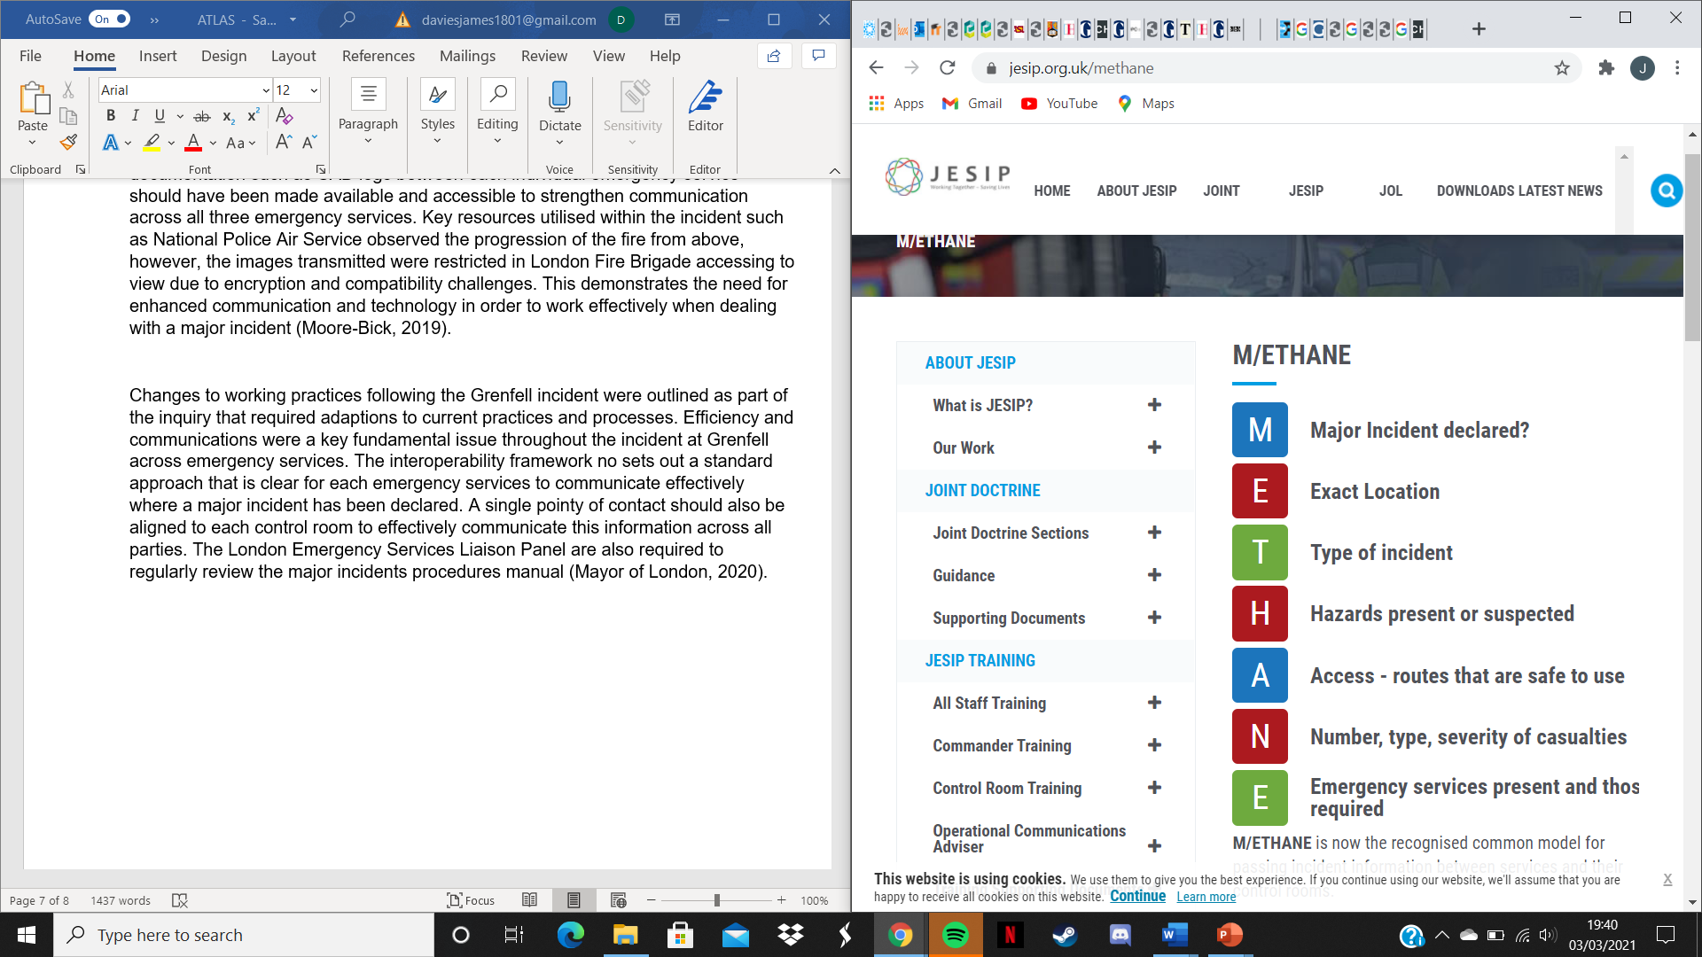
METHANE is a model encouraged by JESIP and is now used in the early stages of a developing major incident. This provides emergency services with a checklist of the information they need to gather and share out with all other emergency services involved (Mayor of London, 2020).

(JESIP, 2021)

Conclusion
From this report we can conclude that the implementation of the ATLAS model allows reflection and innovation to embed learnings from success and failure in order to maintain a modern policing approach. In addition, the model encourages the empowerment of officers to expand on resources and sharing best practice in order to maximise efficiency in an ever-changing demanding society. With future academic recruits within the police force the model will further strengthen thinking and collaboration in turn ensuring working practices and policies continuously evolve across the Police Force.

References
College of Policing. (2020) What is Evidence Based Policing. Available at: https://whatworks.college.police.uk/About/Pages/What-is-EBP.asp (Accessed 28th February 2021)

HMIC. (2016) The tri-service review of the Joint Emergency Services Interoperability Principles. Available at: https://www.justiceinspectorates.gov.uk/hmicfrs/wp-content/uploads/joint-emergency-services-interoperability-principles-review.pdf (Accessed 3rd March 2021)

JESIP. (2021) Early Stages of an Incident & M/ETHANE. Available at: https://www.jesip.org.uk/early-stages-methane (Accessed 3rd March 2021)

Matrix Demonstration Project Team. (2020) Evidence Based Policing: The Basics Study Guide. Available at: http://cebcp.org/wp-content/evidence-based-policing/EBP-Guide.pdf (Accessed 28th February 2021)

Mayor of London. (2020) Update on the implementation of the Grenfell Tower Inquiry Phase 1 recommendations. London: Greater London Authority

Moore-Bick, M. (2019) Grenfell Tower Inquiry: Phase 1 Report Overview. Available at: https://assets.grenfelltowerinquiry.org.uk/GTI%20-%20Phase%201%20report%20Executive%20Summary.pdf (Accessed 3rd March 2021)

NARU. (2012) Emergency Services Interoperability at Incident. Available at: http://naru.org.uk/wp-content/uploads/2012/06/Emergency-Services-Interoperability-Presentation.ppt (Accessed 3rd March 2021)

Pepper, I, Rogers, C and Martin, H. (2020) ‘Evidence based policing: a view on its development within the police service’ Journal of Work-Applied Management, 12(1) pp. 91-96.

Rees, J. (2017) Witness Statement. Available at: https://assets.grenfelltowerinquiry.org.uk/documents/Witness%20statement%20-%20Police%20responder%20-%20Josh%20Rees%20MET00017468.pdf (Accessed 3rd March 2021)

Rice-Oxley, M. (2018) ‘Grenfell: the 72 victims, their lives, loves and losses’, The Guardian, 14th May. Available at: https://www.theguardian.com/uk-news/2018/may/14/grenfell-the-71-victims-their-lives-loves-and-losses (Accessed 3rd March 2021)

The Guardian. (2017) What happened at Grenfell Tower? A visual guide. Available at: https://www.theguardian.com/uk-news/2017/jun/14/what-happened-at-grenfell-tower-london-fire-visual-guide (Accessed 3rd March 2021)

WhatWorks. (2020) What is EBP? Introducing ‘ATLAS’… Available at: https://whatworks.college.police.uk/About/News/Documents/ATLAS.pdf (Accessed 28th February 2021)

Wheller, L. (2019) Evidence Based Policing. Available at: https://www.birmingham.ac.uk/Documents/college-social-sciences/business/research/crime-justice-policing/conference-presentations-2019/cjp-conference-evidence-based-policing.pdf (Accessed 28th February 2021)

