BSC(Hons)Cloud Computing ACCC4004
INFORMATION ENGINEERING
University of Wales
Trinity Saint David
Student name Tsvetelina Tsoneva – Duz
Student number 1914026

Table of contents
- Data flow diagram DFD
- Entity relationship diagram ERD
- Use case diagram

- DFD Pizza for U

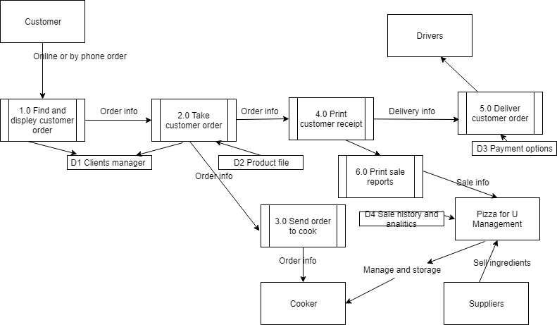

- ERD Pizza for U

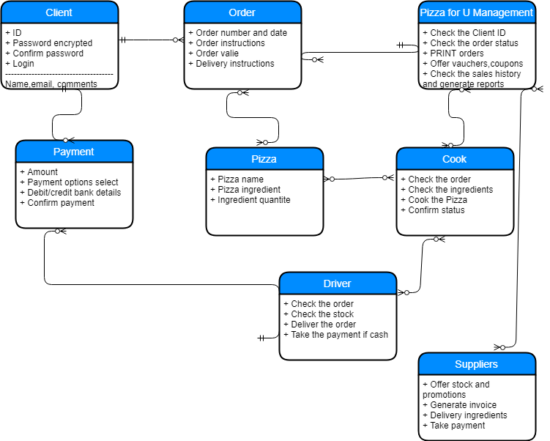
Client attributes and steps :
- Client ID
- Password encrypted
- Confirm password
- Login
- Userinterface
- User address and phone number
- Choice Pizza for U branch
- Choice pizza
- Add plus ingredients (optional )
- Delivery options
- Payment options
- Use voucher code (optional )
- Make payment
- Send feedback (optional )

- Use case diagram Pizza for U

