Research proposal

Multisensory Experiences

Table of Contents
Introduction / Background to the proposed research 2
Working title 2
Background 2
Where web development fits into this field 4
Introduce the industry/organisation/context that is being investigated 4
Define one overarching aim of the study (the research purpose). Construct a series of objectives that specify what you will do to achieve the aim 4
Expected outcomes/deliverables? What will you submit at the end of the study? 5
Conclusion 5
Research and development methods 5
Introduction 5
Research philosophies 5
Identify and justify the research methods that you will use to gather your data and/or evaluate your results. 6
How will you analyse the data/evaluate your results? 9
Conclusion 9
Resources and planning 10
Introduction 10
Identify any resources required 10
Construct a Gantt chart that demonstrates evidence of project planning and management. 11
Conclusion 12
References 13

Table of Figures
Figure 1: The Research Onion [10] 6
Figure 2: Gantt chart 12
Figure 3: Resource sheet 12

Introduction / Background to the proposed research
Within the research proposal, there will be considerations about what the research proposal project will consist of. This proposal will include current literature and research which relates to the project, the purpose including the aims anticipated, the desired end result and the actual result of the project.

Working title
The title of the research proposal project is: Multisensory Experiences.

Background

Educational
The definition of multisensory is when the user is involving more than one of the senses, for example, auditory and visual simultaneously. So, in that particular case playing a game on a smartphone is multisensory as the user is looking at the screen whilst listening to what is going on. Multisensory learning is becoming more popular, as it is known that learning which is experienced through most or all of the user’s senses is beneficial in memory [1]. The senses which are used best for learning are; auditory, visual, kinaesthetic and tactile [2]. Research demonstrates that when children with dyslexia use two or more senses when learning to spell, their spelling ability is enhanced. For example, when the children can hear the words being spoken, see the words, and can feel the shape of the letters by outlining, this helps to improve their writing performance [2]. Brain imaging has proved that multisensory stimuli initialise more areas of the brain, which could potentially be the basis for increased learning [2].
Combining a multisensory game with multisensory learning has even more potential to improve the learning process [3]. Research indicates that the participants involved in the experiments, 117 junior high school students in southern Taiwan, found the experiment enjoyable and they would wish to repeat it to understand and learn more [3]. The outcome of this experiment shows that if people use a multisensory game to learn then they are more likely to enjoy education and are keen to repeat the learning process.
Furthermore, a study which involved teachers used a variety of multisensory approaches for the children to learn English more effectively found that using multisensory strategies were much more beneficial and successful with increasing the achievements in children in education. Four approaches were identified by the greater number of teachers as being effective in general: gestures and visual cues; repetition and opportunities for practicing skills; use of objects and hands-on materials; and multisensory approaches [4]. The teachers found that it focuses on all learning techniques and the children can make connections quicker [4].
In contrast to this, a study involving participants who had been diagnosed with Alzheimer’s, vascular or mixed dementia were randomly allocated to either eight multisensory sessions or activity sessions twice per week for four weeks [5]. The immediate effects results found that there were no substantial differences between the two groups from the start to finish. It was shown that both groups were seen to be less bored after the multisensory and activity sessions than they were before the sessions [5]. However, despite the randomisation of the participants the multisensory participants were at a less advanced stage of dementia than the activity group were. Overall, in the UK the participants general behaviour and eccentric behaviour on the ward seemed to be stable during the multisensory sessions and activity sessions but had declined after the sessions were over [5]. Moreover, there were no significant benefits with the multisensory group over the activity group they both had very similar results. This shows that multisensory approaches may not be successful in every case possible.

Entertainment
Multisensory has been involved within the entertainment business for many years, multisensory was especially included within games consoles, such as, Xbox and PlayStation. Xbox was one of the first games consoles to introduce multisensory experiences, for example; Xbox LIVE first launched in November 2002 and with this also came the ability for users to voice chat whilst playing a game [6]. By creating Xbox LIVE it connects millions of users across 26 countries, so users are able to speak to friends or family members around the world [7]. This was very advanced for Xbox to create, as before Xbox LIVE users were not able to speak to each other when playing the same game, this in turn encouraged other games console platforms to do the same.
Research demonstrations that when participants were provided with two studies, one which included the participants using a computer screen to play a game on and another which involved them physically moving around to interact with the musical materials. Most of the participants involved in this experiment concluded that they were much more entertained when they were moving around to interact with the music than they were sitting down playing a game on the computer [8]. Thirty-two participants responded that they were much more, and more entertained in contrast to the five participants who claimed they were much less, and less entertained. Also, three participants said that there was no difference between the two experiments [8].

Where web development fits into this field
Multisensory experiences, such as educational and entertainment experiences relate to a web development degree at university as there are many previous studies and experiments which have shown this. Website developers could potentially create an application for a mobile phone, tablet or wearable device which could include multisensory features. This is shown in a study [9], where the participants use a wearable device, which have been assembled by using the Oculus Rift, which is a very large application developed for a mobile phone device, for the visual and hearing senses. They have put the oculus rift onto a headset which had been supplied from creative labs. The touch sense was implemented by creating a pair of tactile gloves which presented the participant with vibrations when the user made physical contact with something. Through integrating the three materials, the developers developed an interface which authorises humans to engage and control a humanoid robot platform [9]. This study clearly demonstrates that a student on a web development course could potentially develop an application for any device which could include multisensory experiences for either entertainment or educational purposes. For example; the web developer could create an application and input it onto the oculus rift which the user will be able to view and hear the game, an educational game or a game for entertainment purposes. The developer could also provide the user with a pair of tactile gloves similarly to the study, so the users could feel their surroundings within the game through the vibrating gloves.
This research is particularly worth executing as there are not many studies or applications involving multisensory experiences specifically. Developing an application which involves multisensory experiences could be used frequently and potentially could become very successful. However, implementing an application which does not have numerous other applications of similar qualities could be quite challenging, yet, it could on the other hand become popular within the application development community. This application that will hopefully be developed within the next year could be the breakthrough to other educational multisensory applications.

Introduce the industry/organisation/context that is being investigated
The environment that the development and study will be taking place is within the University of Wales Trinity Saint David Swansea. This University uses Xcode for Apple Mac’s to implement mobile applications for Apple devices. There will also be a questionnaire sent around to the users who have tested the application to understand what the application needs to be improved.

Define one overarching aim of the study (the research purpose). Construct a series of objectives that specify what you will do to achieve the aim
The main aim of this development and study process is to understand how many users would be interested in downloading a multisensory application for educational purposes. For example; a spelling application for users who have dyslexia, or users who need to widen their spelling knowledge. For this application to be developed the following objectives must be attained:
- To investigate multisensory educational applications that have been previously developed and has been tested by users.
- To analyse how to use the Xcode on an Apple Mac to implement the application.
- To develop a requirements and system specification for the constructed multisensory educational application.
- To design and develop the multisensory educational application.
- To examine the application and inspect the user feedback to create a future improvements checklist.

Expected outcomes/deliverables? What will you submit at the end of the study?
Once the multisensory application has been developed, it is expected that it will have been implemented to satisfy the requirements of the users and help the users spell words more effectively and efficiently after using this application. At the end of the study there will be a multisensory educational application which will be submitted as well as an empty and all the completed questionnaires given to the users who have been chosen to test this application. This questionnaire will include what is good with the application, what is bad about it and what could be improved.

Conclusion
Within this section of the research report it included what multisensory is, including some educational and entertainment studies found. Also, the proposed multisensory education application has been mentioned here too in addition to the desired outcomes. The next section will include research and development methods.

Research and development methods

Introduction
In the previous section explained what research will be fulfilled which leads on to this section which will identify and explain what research methods will be applied and how the development method will be executed. The ethical and legal issues which relate to the research task will be examined as well as the risks which may be encountered through creating the application and the course of action which will be taken to avoid and overcome them. Lastly, this section will show how analysis and evaluation of the task results will be executed.

Research philosophies
Before research can commence, a suitable research philosophy must be expressed. The ‘research onion’ shown in figure 1 exclaims how philosophy, approaches, strategies, time horizons and techniques are related. How data is collected is shown in the centre of the onion, with many layers outside the centre showing different sections of using research methods.

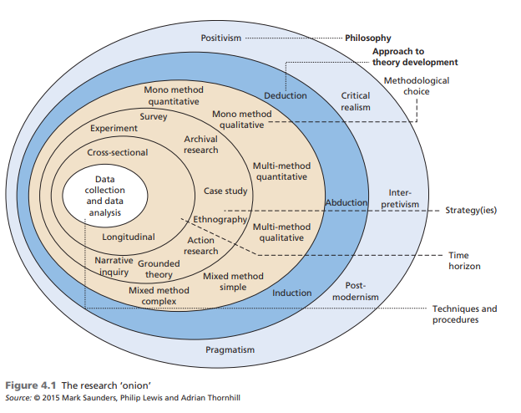
Figure 1: The Research Onion [10]

Research philosophy is important during a research task, this is because it can assist the researcher with refining and specifying the research methods which are to be used in the research task. The understanding of research philosophy can enable and support to researcher in evaluating unalike methodologies and methods and avoid unimportant work [11].

Identify and justify the research methods that you will use to gather your data and/or evaluate your results.

Research philosophy and approach
As the research task selected includes developing software application for users and building on the user’s feedback, the philosophy which relates to the task the most is phenomenology. Phenomenology aids researchers in understanding everyday experiences without assuming knowledge beforehand of the experiences [12]. Whereas positivism helps scientists understand the indeterministic nature of quantum mechanics, it also aids scientists to gather the various disciplines [13].
As the optimum philosophy has been selected, a research approach must be examined and decided. There are two different types of research approaches; inductive and deductive. The purpose for using an inductive approach is to break down and condense undefined textual data into a brief, or summary [14]. This approach is also used to establish clear relationships between the research aims and the conclusions taken from the data [14]. The inductive approach uses logical regression examination and it is seen to be more understandable and more known that the deductive approach [15].
The other research approach is known as the deductive approach. This is where theories are created from important principles before the data has been collected and has received little consideration [16]. The deductive relates more to the quantitative research from a positivistic philosophy and is sometimes referred to as theory testing [17].

Research strategy
By reviewing the type of research going to be implemented, developing a multisensory educational application which will aid with the spelling of users, then recruiting participants to test the application and give constructive criticism and idea for future improvement. The best research strategy for this particular research task is a survey, the type of survey which will be carried out is a semi-supervised survey. This type of survey is the best for the research task as, the questions will be explained to the participants where they can query any question on the survey. After this the participants are left alone to provide feedback.
The survey will contain a questionnaire, the questionnaire will involve a mixture of open questions and closed questions, so for the first part of the questionnaire the user will have to tick the box they agree with the most. For example: Did you think the application worked well? The participants will then select an answer from: Strongly Agree/ Agree/ Neither Agree or Disagree/ Disagree/ Strongly Disagree. For the final part of the questionnaire, it will include the participants to write more lengthy answers, which will be contained in a box. For example; a large box with the question above which reads: What did you like about the application? The questions on the questionnaire will be directly related to the multisensory educational application the participants have recently tested.

Sample population
The population and sample who will be testing the multisensory educational application and providing feedback will be the staff at the University of Wales Trinity Saint David Swansea, family members and close friends will also be reviewing it. These people have been chosen because the staff within the University understand how Xcode works and could read through the code and offer extra help, providing extensive feedback. Family and close friends have also been chosen because they can provide feedback about what looks good and what does not look good about the interface on the application.

Reliability and validity
Reliability is essential within quantitative research and Joppe (2000) outlines reliability as; the scale to where outcomes are consistent over a period of time. Reliability is a precise illustration of the overall population and if the study can be duplicated under comparable circumstances [18]. However, reliability within qualitative research is just as important, Guba & Lincoln (1981) explain reliability in qualitative research as being trustworthy, to guarantee “trustworthiness” within qualitative research there must be credibility, transferability, dependability, and confirmability, which was updated in 1985. There are also recommendations to attain trustworthiness like peer debriefing, member checks and more [19]. These are both referred to as reliability.
Validity is also crucial within quantitative research Joppe(2000) describes validity as; whether the research really outlines what it is proposed to and how honest the results of the research are [18]. Wainer and Braun (1998) outline validity as “construct validity”. This translates to the initial hypothesis which regulates which data is collected and how it is gathered. According to Wainer and Braun (1998) researchers of quantitative data purposely affect the interaction between construct and data to validate the research [18]. Validity within qualitative research can be defined as the level to which the factors of the research task are developed to be measurable and can accurately represent that [20].

Identify and justify any development methods and techniques that you will use as part of systems development
There are multiple options about development methods when implementing a research task, such as; storyboards, UML designs and prototyping. The development method chosen for the development of the multisensory educational application will be a storyboard. The reason for this is that storyboards aid with the design of the application and they also support visual thinking which is essential to the project [21]. A storyboard also provides information about what is destined to be on each page of the application, as storyboards require more than one page, each of these pages will represent each page on the application. It is important to note down explanations about what is in each page of the storyboard, so that there will not be any confusing when implementing the application [22]. After reviewing what a storyboard contains, it has been decided that it will be the optimum development method for the application.

Identify risks/limitations/ethical/legal issues and ways that you might deal with those risks
Risks
Numerous risks that relate to the research task and will need to be reviewed before the project begins and as the project is developing. The risks that relate to the research task and application project are:
- Poor time management
- Stress relating to workload
- The application being unsuccessful and impossible to create on Xcode
- Requirement specification unable to meet due to impractical goals
- The questionnaires are not completed
- Building an application that users do not want

To deal with the risks involving time management and stress is to extend the date it will be completed by. Through extending the time it will take to implement the project and review all the questionnaires this will reduce the stress as the workload will not seem as heavy as the deadline is not too close and the poor time management risk will then be eliminated. To overcome the risk of the application being impossible to create on Xcode and the specification unable to meet due to unrealistic goals, the application must either be implemented on a different system or the application must be condensed and only possess some of the requirements. To control the completion of the questionnaires, they must be given to participants as soon as they have finished testing the application, so there must be previously printed questionnaires given to the participant along with a pen. So, they are able to complete it and return it back as soon as possible. The final risk will be quite difficult to solve, as there is no knowledge on what users will download on to their mobile phones, some users may claim that they will download it, but never will and vice versa.
Legal and ethical issues
The legal issues relating to this application consists of the use of trademarks, so the name of the application is protected as well as the logo. Copyright is also an additional legal issue which relates to the application, when developing the application there may be images which will be put on to the application to confirm that the images used will not be used by others there is a copyright form that must be signed. Similarly, unlawfully copying material off other sources without permission is also copyright [23].
The ethical issues which relate to the application which will take place are that under no circumstances must the participants be mislead intentionally, the participants will be fully aware of what the research will entail. Furthermore, examining the questionnaires will make sure there is a desire to listen to the participants feedback which will include positive and negative criticism.

How will you analyse the data/evaluate your results?
Once the multisensory educational application has been developed and all the research data has been collected, the data must be analysed and evaluated. After considering each method to analyse the data, the one which suits the research task more exceptionally is using content analysis. Content analysis is often referred to as; providing knowledge and understanding of the study [24] through condensing the similar feedback into more manageable sections. Content analysis relates more to the research task which will be carried out because as it will be qualitative data, the feedback can be placed into similar sections, for example, all participants who said they liked the colours will be condensed into the same section. So, there will not be lengthy reports from the qualitative data, instead it will be read thoroughly, and similar feedback will be put together.

Conclusion
This section has explained the research philosophy, approach and strategy that will be utilised through the research task. It has also identified the sample of participants which will be recruited as well as the reliability and validity of the research task. The development methods have also been mentioned along with the risks, ethical and legal issues which relate to the research task and the application. Finally, this section includes information about how the data will be analysed and evaluated.

Resources and planning

Introduction
The previous section included information about research and development methods. This section will be looking at the resources required to build the application and the survey / questionnaire, and a Gantt chart which will demonstrate the project plan.

Identify any resources required
Not many resources will be required for the creation of the application, or the research task. But, the resources which will be required are:
- An Apple laptop to build the application on
- Access to Xcode, which can be downloaded on to the Apple laptop
- Journals which relate to multisensory educational applications
- Journals which will help when completing and finalising the survey / questionnaire
- Staff and family members and close friends to complete the survey / questionnaire

Construct a Gantt chart that demonstrates evidence of project planning and management.
To effectively manage the process of the project a Gantt chart has been created, see figure 2. The process of the project has been mapped out and separated into two segments which are; Requirements and Implementation. The subtasks have been recorded below the two larger tasks which describe what is meant to be implemented next.
A resource sheet has also been created for the project, see figure 3, all the resources which will be needed are placed onto the resource sheet along with the information about how costly each resource is.

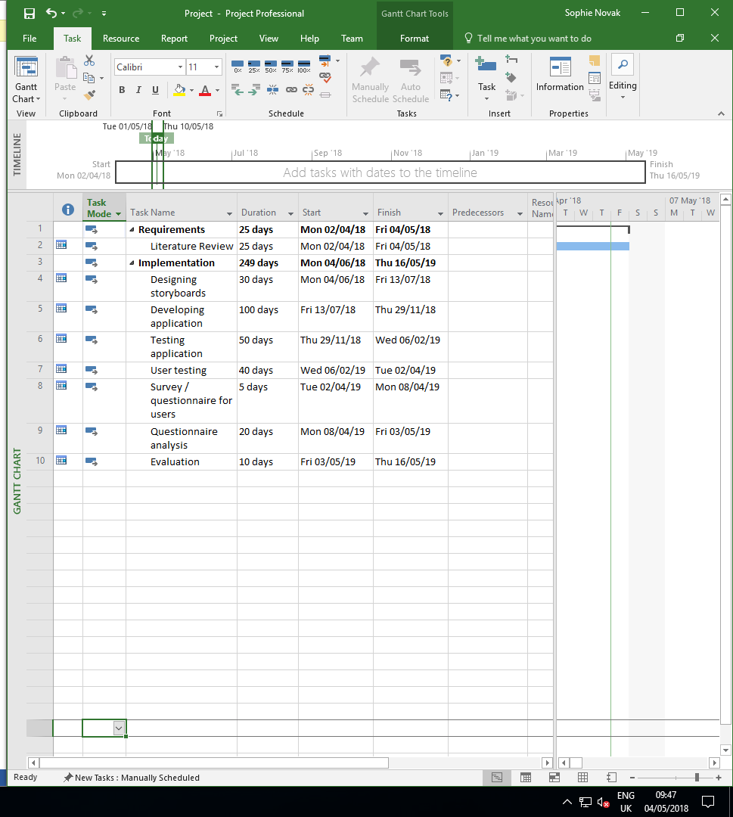
Figure 2: Gantt chart


Figure 3: Resource sheet

Conclusion
Through careful thought about the time scale needed to carry out the project, the Gantt chart was then developed, along with the resource sheet. It is intended that all of the tasks will go to plan and be completed within the given time scale, this should reduce the amount of stress which will be associated with this project.

References

[1] | “Teaching and Learning Programme,” QIA Quality Improvement Agency, pp. 1-3, 2008.
[2] | H. Hamilton, “Multisensory Associative Guided Instruction Components-Spelling,” Journal of Educational Technology Systems, vol. 45, no. 2, pp. 256-284, 2016.
[3] | A. Covaci, G. Ghinea, C. H. Lin, S. H. Huang and J. L. Shih, “Multisensory games-based learning - lessons learnt from olfactory enhancement of a digital board game,” 2018.
[4] | M. A. Facella, K. M. Rampino and E. K. Shea, “Effective Teaching Strategies for English Language Learners,” vol. 29, no. 1, pp. 209-221, 2005.
[5] | J. Holloway, C. C. Holtkamp, A. Larsson, L. C. Hartman, R. Pearce, B. Scherman, S. Johansson, P. W. Thomas, L. A. Wareing and M. Owens, “Effects of multi-sensory stimulation for people with dementia,” Issues and innovations in nursing practice, vol. 43, no. 5, pp. 465-477, 2003.
[6] | M. e. al, “MULTI-SENSORY EMOTICONS IN A COMMUNICATION SYSTEM”. United States of America Patent US 2006/0015560 A1, 19 January 2006.
[7] | A. M. Ledbetter and J. H. Kuznekoff, “More Than a Game: Friendship Relational Maintenance and Attitudes Toward Xbox LIVE Communication,” vol. 32, no. 2, pp. 269-290, 2012.
[8] | Z. Zhou, A. D. Cheok, W. Liu, X. Chen, F. Farbiz, X. Yang and M. Haller, “Multisensory musical entertainment systems,” vol. 11, no. 3, pp. 88-101, 2004.
[9] | U. M. Hernandez, L. W. Boorman and T. J. Prescott, “Multisensory wearable interface for immersion and telepresence in robotics,” vol. 17, no. 8, pp. 2534-2541, 2017.
[10] | M. Saunders, P. Lewis and A. Thornhill, “Understanding research philosophies and approaches,” Research Gate, pp. 122-161, 2009.
[11] | F. Crosssan, “Research philosophy: Towards an understanding,” vol. 11, no. 1, pp. 46-55, 2003.
[12] | M. R. M. Converse, “Philosophy of phenomenology: how understanding aids research,” Nurse Researcher, vol. 20, no. 1, pp. 28-32, 2012.
[13] | S. D. Hunt, “Positivism and Paradigm Dominance in Consumer Research: Toward Critical Pluralism and Rapprochement,” Journal of Consumer Research, vol. 18, no. 1, pp. 32-44, 1991.
[14] | D. R. Thomas, “A General Inductive Approach for Analyzing Qualitative Evaluation Data,” American Journal of Evaluation, vol. 27, no. 2, pp. 237-246, 2006.
[15] | K. P. Overmars, P. H. Verburg and T. (. Veldkamp, “Comparison of a deductive and an inductive approach to specify land suitability in a spatially explicit land use model,” Land Use Policy, vol. 24, no. 3, pp. 584-599, 2007.
[16] | “Modeling the environmental collaboration process: A deductive approach,” Ecological Economics, vol. 59, no. 3, pp. 275-286, 2005.
[17] | I. Newman, “A Conceptualization of Mixed Methods: A Need for Inductive/Deductive Approach to Conducting Research.,” April 2000. [Online]. Available: https://files.eric.ed.gov/fulltext/ED443849.pdf. [Accessed 29 April 2018].
[18] | N. Golafshani, “Understanding Reliability and Validity in Qualitative Research,” The Qualitative Report, vol. 8, no. 4, pp. 597-607, 2003.
[19] | M. B. M. M. K. O. J. S. Janice M. Morse, “Verification Strategies for Establishing Reliability and Validity in Qualitative Research,” vol. 1, no. 2, pp. 13-22, 2002.
[20] | V. Lub, “Validity in Qualitative Evaluation: Linking Purposes, Paradigms, and Perspectives,” International Journal of Qualitative Methods, pp. 1-8, 2015.
[21] | C. v. d. Lelie, “The value of storyboards in the product design process,” Personal and Ubiquitous Computing, vol. 10, no. 2-3, pp. 159-162, 2006.
[22] | S. C. N. M. B. B. Saul Greenberg, “The Narrative Storyboard Telling a story about the use and context over time,” vol. 19, no. 1, pp. 64-69, 2012.
[23] | P. Smart, “Copyright,” vol. 98, no. 3, pp. 162-164, 2016.
[24] | S. E. S. Hsiu-Fang Hsieh, “Three Approaches to Qualitative Content Analysis,” QUALITATIVE HEALTH RESEARCH, vol. 15, no. 9, pp. 1277-1288, 2005.

