Analysis of Electromagnetic wave propagation

STEFAN JAREMA | Electromagnetic Radiation | ACDC5009

Contents
Abstract 3
Introduction 3
Method Task 1 – Rectangular Waveguide Simulation 4
Port field distributions 5
Results 8
Gamma plot for vacuum 8
Gamma plot for Teflon 10
Comparison 12
Conclusion Rectangular waveguides 13
Task 2 Dipole Antenna 14
Possible improvements for accuracy 19
Conclusion Dipole antenna 20
References 22
Appendices 23
Appendix A 23
Appendix B 31
Appendix C 40
Appendix D 48
Appendix E 58
Appendix F 66

Figure 1Mode1 5
Figure 2 Mode 2 6
Figure 3 Mode 3 7
Figure 4 Vacuum Gamma plot 8
Figure 5 Teflon Gamma plot 10
Figure 6 Air gap 15
Figure 7 Air box 16
Figure 8 S plot 17
Figure 9 Gain plot angle 1 18
Figure 10 Gain plot angle 2 18

Abstract

Task 1 investigated a rectangular Perfect Electric Conductor (PEC) waveguide with dimensions derived from a student ID, simulated when filled with vacuum (ϵr​=1) and Teflon (ϵr​=2.1). The first three Transverse Electric (TE) modes (TE10, TE20, TE30) were identified, and their cutoff frequencies were calculated theoretically and determined from simulation results (Gamma plots).The results were found to be like their theoretical counterparts for both Vacuum and Teflon, as well as this Teflon was identified as having a lower cut off frequency due to its higher permittivity that reduced its phase velocity.
Task 2 Involved designing and simulating a half-wave dipole made of PEC using a wavelength derived from a student ID, the theoretical resonance frequency was calculated as ∼ 1.30GHz while simulated results yielded ∼ 1.19GHz identified using the S11 plot however the dipole had good impedance matching as well as its expected omnidirectional radiation pattern.

Introduction

This report aims to understand the catalyst that allowed for modern communication, Electromagnetic waves (EM). Our society has been able to harness and use these EM waves through specialised instruments such as waveguides and antennas that has allowed for the rapid rise of the Radio, Television, and now the internet. Part one of this report will look at different types of wave propagation through different mediums as well it will compare simulated data to theoretical calculations, to gain a deeper understanding of the minimum operating frequency’s also known as cut off frequency’s $f_{c}$. Part two of this report will analyse a simulated Dipole antenna against its theoretical resonant frequency by measuring its performance against parameters such as input impedance matching (S11) and its radiation pattern.

Method Task 1 – Rectangular Waveguide Simulation
For Task 1 of this project, a rectangular waveguide was designed and simulated. The waveguide was constructed using Perfect Electric Conductor (PEC) walls, and two interior configurations were investigated: one filled with a vacuum and the other with Teflon. Teflon is a dielectric material with a relative permittivity (ϵr ) of 2.1.
The physical dimensions of the waveguide were determined based on the student ID’s.
E.G
The waveguide width (a) was set to 23 mm, derived from the first two digits. The height (b) was calculated as 14/2 = 7 mm. The length of the waveguide for the simulation was defined as 50 mm along the z-axis.

Port field distributions
The ports were set up to support three TE (Transverse Electric) modes—TE10, TE20, and TE30 were identified by their distinct field patterns. Each mode has a characteristic electric field distribution across the waveguide cross-section [1]:
TE10 Mode (Figure 1): This mode shows a single half-wave variation across the waveguide width (x-direction). The electric field is strongest at the centre and decays symmetrically toward the sidewalls, with no variation along the height (y-direction). This is the dominant mode, meaning it is the first to propagate as frequency increases.
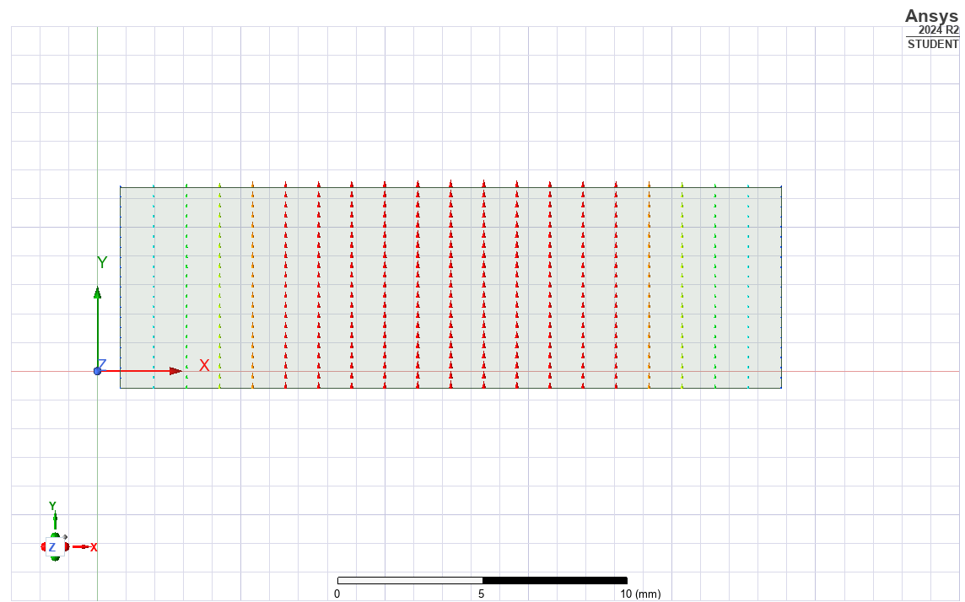
Figure 1Mode1
TE20 Mode (figure 2): The TE20 mode features two half-wave variations across the width. This is visualized by two distinct lobes of electric field intensity, with a clear null (zero field) along the centreline of the waveguide. Like TE10, there is no field variation along the height.
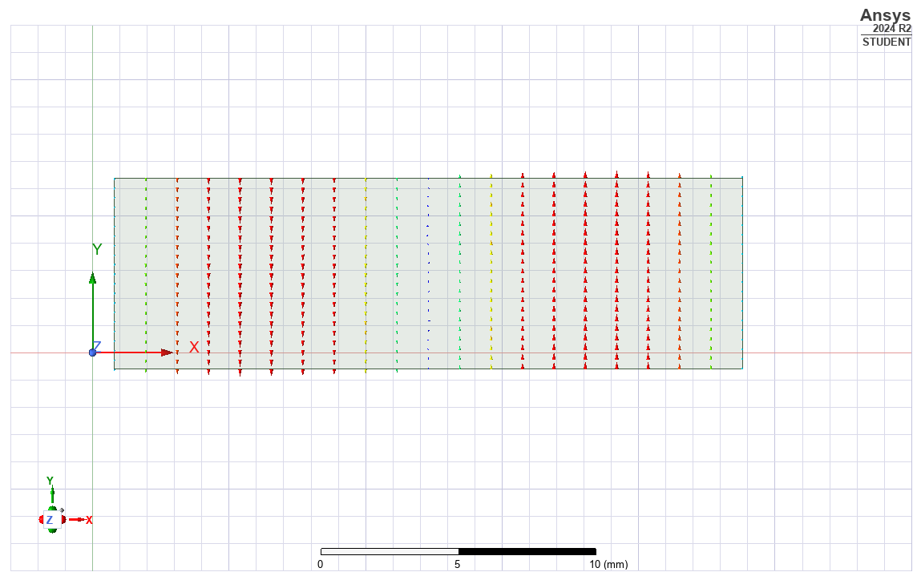
Figure 2 Mode 2

TE30 Mode (figure 3): This higher-order mode displays three half-wave variations across the width. The electric field pattern consists of three lobes separated by two null lines, showing more complex distribution as the mode order increases.
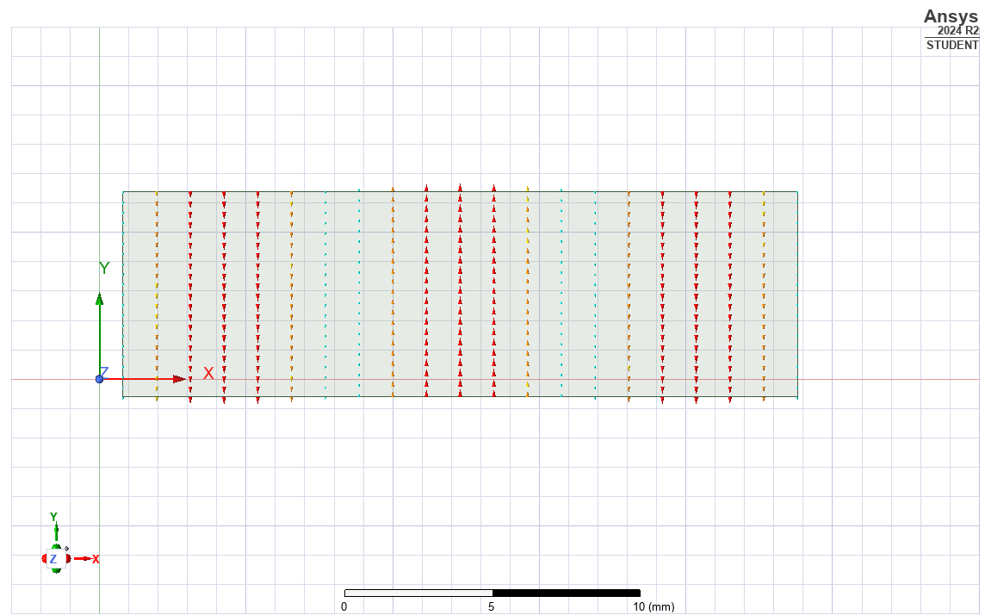
Figure 3 Mode 3

These mode patterns confirm that the waveguide and port definitions are correctly exciting the intended modes, and they provide a visual reference for how energy is distributed within the waveguide for each mode.
The modes observed were the same for both the vacuum-filled and Teflon-filled rectangular waveguides, with consistent mode patterns across the top and bottom halves.

See the Appendices to see how the electromagnetic energy propagates through the waveguides.

Results

Gamma plot for vacuum

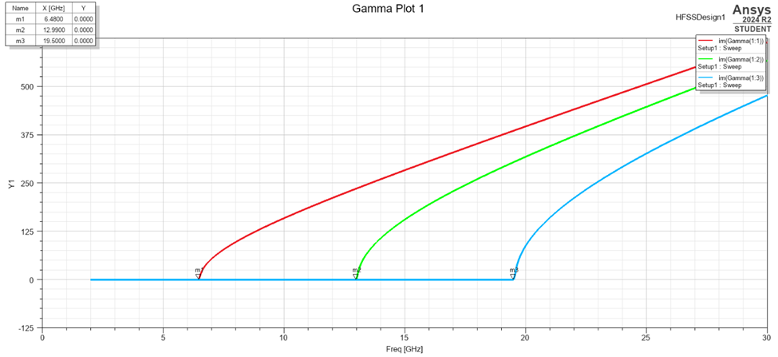
Figure 4 Vacuum Gamma plot

Calculations for vacuum
As the Antenna is a rectangular wave guide, I will use the cutoff frequency formula for rectangular waveguides
$$f_{c}=\frac{c}{2}\sqrt{{\left(\frac{m}{a}\right)}^{2}+{\left(\frac{n}{b}\right)}^{2}}$$
$f_{c}=$Cut off frequency
$c=$Speed of light ${3 ×{10}^{8} m}/s$
$a=$Wave guide width
$b=$Waveguide length
$m=$Mode number
$n=$Mode number

So TE10 Mode (m = 1, n = 0)
$$f_{c}=\frac{3 × {10}^{8}}{2}\left(\frac{1}{0.023}\right)=1.5×{10}^{8} × 43.478 = 6.52 GHz$$

TE20 Mode (m = 2, n = 0)
$$f_{c}=\frac{3 × {10}^{8}}{2}\left(\frac{2}{0.023}\right)=1.5×{10}^{8} × 86.957 = 13.04 GHz$$

TE30 Mode (m = 3, n = 0)
$$f_{c}=\frac{3 × {10}^{8}}{2}\left(\frac{3}{0.023}\right)=1.5×{10}^{8} × 130.435 = 19.56 GHz$$
Mode | Cutoff frequency (GHz)
TE10 | 6.52 GHz
TE20 | 13.04 GHz
TE30 | 19.56 GHz
Mode | Theoretical calculated Cutoff (GHz) | Actual Cutoff from Gamma Plot (GHz) | Difference (GHz)
TE10 | 6.52 | 6.48 | 0.04
TE20 | 13.04 | 12.99 | 0.05
TE30 | 19.56 | 19.50 | 0.06
In the vacuum-filled waveguide simulation, the actual cutoff frequencies observed from the Gamma plot were very close to the theoretically calculated values. For example, the TE10 mode had a theoretical cutoff of 6.52 GHz, while the simulation showed a value of approximately 6.48 GHz — a difference of only 0.04 GHz. Similar sub-0.1 GHz differences were observed for the TE20 and TE30 modes.
This small discrepancy is entirely expected and is primarily due to numerical and environmental factors within the simulation environment. These include:

- Finite Mesh Resolution: The simulation mesh has a limited resolution, meaning the waveguide geometry is represented by small elements. This leads to approximations, especially near edges and ports, potentially causing slight shifts in field behaviour.

- Port Excitation Tolerances: Ports are idealized in theory but modelled with real geometries and field settings in simulation, introducing minor deviations.

- Boundary Conditions and Box Size: The finite simulation environment differs from the theoretical assumption of an infinitely long guide, which can slightly influence the field distributions and observed mode onsets.

- Software used: The simulation software uses a step-by-step approach to find the solution, which can introduce tiny rounding errors in the results. [2]
Despite these factors, the similarity between my theoretical calculations and the simulated results were good. All modes appeared within 0.1 GHz of their predicted cutoff, confirming the accuracy of the theoretical model by using the conformation from the simulation.

Gamma plot for Teflon
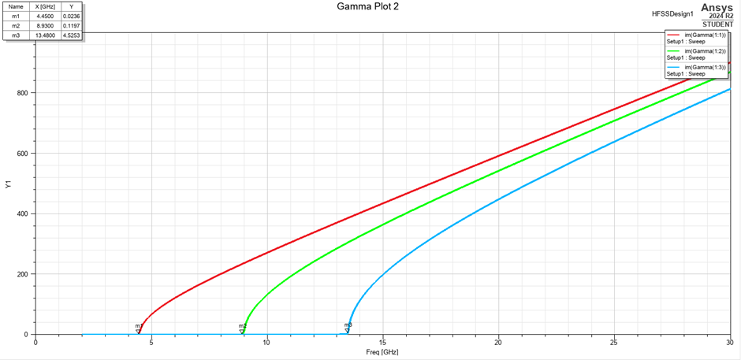
Figure 5 Teflon Gamma plot

Calculations for Teflon
The relative permittivity ϵr plays a critical role in determining wave propagation characteristics inside a waveguide. For a vacuum-filled waveguide, ϵr=1 so $1×C =C$, meaning the phase velocity equals the speed of light $C$, and the standard cutoff frequency formula applies directly. However, for Teflon, with a relative permittivity of ϵr=2.1 so $2.1×3×{10}^{8} ≠C$, the wave propagates more slowly. This reduced phase velocity compresses the wavelength inside the waveguide and results in a denser field distribution. Therefore, modified cutoff frequency calculations that account for the dielectric filling will be included to accurately reflect the behaviour observed in the simulation.
Modified Cutoff Formula for Dielectric-Filled Guide:
$$f_{c}=\frac{c}{2\sqrt{εr}}\sqrt{{\left(\frac{m}{a}\right)}^{2}+{\left(\frac{n}{b}\right)}^{2}}$$
TE10 (m=1, n=0):
$$f_{c}=\frac{3×{10}^{8}}{2\sqrt{2.1}} ∙ \left(\frac{1}{0.023}\right)=\frac{3×{10}^{8}}{2×1.449} ∙ 43.478 =1.035 ×{10}^{8}×43.479 = 4.50GHz$$
TE20 (m=2, n=0):
$$f_{c}=\frac{3×{10}^{8}}{2\sqrt{2.1}} ∙ \left(\frac{2}{0.023}\right)=\frac{3×{10}^{8}}{2×1.449} ∙ 86.957 =1.035 ×{10}^{8}×86.957 = 9GHz$$
*Doubled

TE30 (m=3, n=0):
$$f_{c}=\frac{3×{10}^{8}}{2\sqrt{2.1}} ∙ \left(\frac{3}{0.023}\right)=\frac{3×{10}^{8}}{2×1.449} ∙ 130.435 =1.035 ×{10}^{8}×130.435 = 13.50GHz$$
Mode | Cutoff frequency (GHz)
TE10 | 4.50 GHz
TE20 | 9 GHz
TE30 | 13.50 GHz
Mode | Theoretical Cutoff (GHz) | Actual Cutoff from Gamma Plot (GHz) | Difference (GHz)
TE10 | 4.50 | 4.45 | 0.05
TE20 | 9.00 | 8.90 | 0.10
TE30 | 13.50 | 13.40 | 0.10

In the Teflon-filled waveguide simulation, the actual cutoff frequencies observed from the Gamma plot were also very close to the theoretically calculated values when incorporating the relative permittivity ϵr =2.1. For instance, the TE10 mode had a theoretical cutoff of 4.50 GHz, and the simulation showed a value of 4.45 GHz — a difference of only 0.05 GHz. The TE20 and TE30 modes also differed by just 0.10 GHz from their theoretical calculations.
These minor differences are due to similar factors seen in the vacuum simulation, but they are slightly more noticeable because of the dielectric material:
- Mesh Accuracy at Dielectric Boundaries: Accurately modelling the Teflon, particularly at its edges and interfaces, requires a very fine mesh. Small imperfections in this mesh can slightly alter how the simulation calculates field behaviour within the dielectric.

- Approximations in Material Properties: The simulation uses a numerical value for Teflon's permittivity (ϵr =2.1), but the software's internal precision or rounding during calculations can introduce minor variations in how the material properties affect wave propagation.

- Enhanced Sensitivity within the Dielectric: Electromagnetic fields are more spatially compressed within the Teflon due to the lower phase velocity. This means the simulation becomes more sensitive to even tiny errors in meshing, geometry, or boundary conditions in these regions, slightly impacting the observed cutoff point.

- Inherent Solver Resolution Limits: Like any numerical simulation, the software has a finite resolution. This means it can only capture the electromagnetic fields with a certain level of detail, which can slightly affect the precise determination of the cutoff frequency.
Nevertheless, the simulated results remained within 0.1 GHz of the theoretical predictions, indicating strong agreement. This reinforces the reliability of the analytical cutoff equation when modified for ϵr and validates the accuracy of the simulation setup.

Comparison
Mode | Vacuum (GHz) | Teflon (GHz)
TE10 | 6.52 | 4.50
TE20 | 13.04 | 9.00
TE30 | 19.56 | 13.50

The comparison between the vacuum-filled and Teflon-filled waveguides clearly demonstrates how material permittivity affects waveguide behaviour. In both simulation cases, the actual cutoff frequencies observed from the Gamma plots were closely matched to the theoretically calculated values, with only minor differences (≤ 0.1 GHz). These small discrepancies are attributable to simulation factors such as meshing and boundary conditions.
The key observation is that the cutoff frequencies for the Teflon-filled waveguide are consistently lower than those of the vacuum-filled waveguide. This occurs because Teflon has a relative permittivity of ϵr =2.1, which reduces the phase velocity of electromagnetic waves inside the guide. This slower wave speed means that each mode begins to propagate at a lower frequency compared to propagation in a vacuum, even though the physical dimensions of the waveguide remain unchanged.
Both simulations show consistency between theory and results, reinforcing the validity of the cutoff equation when modified for ϵr, and effectively highlighting the clear material effect on wave propagation characteristics.

Conclusion Rectangular waveguides

In conclusion, the analysis of rectangular waveguides, both vacuum-filled and Teflon-filled, provided valuable insight into mode propagation characteristics and the significant influence of material properties on cutoff frequencies. The simulations successfully demonstrated the expected behaviour of the TE10, TE20, and TE30 modes, with the observed cutoff frequencies closely matching the theoretical predictions. As noted previously, the minor differences between theoretical and simulated results, typically less than 0.1 GHz, are attributable to standard simulation factors such as meshing accuracy and boundary effects.
A key observation from this study was the clear impact of the dielectric filling: the Teflon-filled waveguide consistently exhibited lower cutoff frequencies across all modes when compared to the vacuum-filled guide. This phenomenon is fully consistent with electromagnetic theory, as the relative permittivity (ϵr =2.1 for Teflon) reduces the phase velocity of electromagnetic waves within the guide. This decreased wave speed allows each mode to begin propagating at a lower frequency than in a vacuum, despite the physical dimensions of the waveguide remaining unchanged.
Both simulation setups demonstrated consistency between theory and results, reinforcing the validity of the analytical cutoff equation and highlighting the clear material effect on wave propagation characteristics. From a practical standpoint, the Teflon-filled waveguide could be considered advantageous for applications requiring operation at lower frequencies, as it facilitates earlier mode propagation within the same physical geometry. Conversely, the vacuum-filled waveguide offers benefits in scenarios where a higher phase velocity or minimal dielectric loss is preferred.
Overall, the simulations of both waveguide configurations successfully validated the theoretical principles of waveguide behaviour and the impact of material properties, contributing to a strong understanding of mode propagation and cutoff frequencies.

Task 2 Dipole Antenna

Task 2 consisted of designing and simulating a Halfwave Dipole Antenna made as a Perfect Electric Conductor (PEC) with a radius of 1mm with the desired aim of producing a wavelength (λ) that corresponds to the first 3 digits of our student numbers.
E.G Student ID number = 231 = λ
To be able to achieve this, the length of the Dipole had to be first calculated to produce the desired wavelength.
$$L=\frac{λ}{2}$$
$L=$Lenth
$λ=$Wavelength
$$L=\frac{231}{2}=116mm$$
The reason it is divided by 2 is because a dipole consists of “two poles that have opposite and equal electrical charge or magnetic force, with a space between them”[3]
This Space between them shown in figure 6 was created so that a lumped port with an impedance of 50ohms could be applied
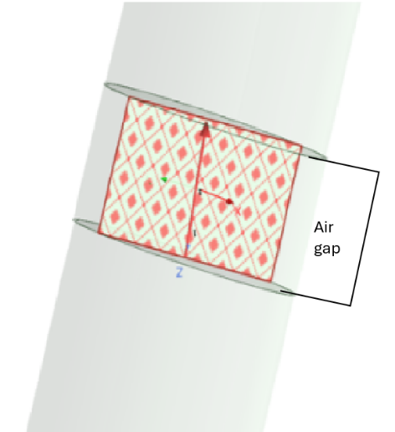
Figure 6 Air gap
The Dipole antenna was then placed inside of a rectangular radiating surface pictured below and the theoretical resonant frequency of the antenna was calculated using the formular:
$$f=\frac{c}{λ}$$
$f=$Frequancy
$c=$Speed of light (in a vacuum) $3×{10}^{8}$
$λ=$Wavelength
$$f=\frac{c}{λ}=\frac{\left(3×{10}^{8}\right)}{0.231}≈1.30GHz$$

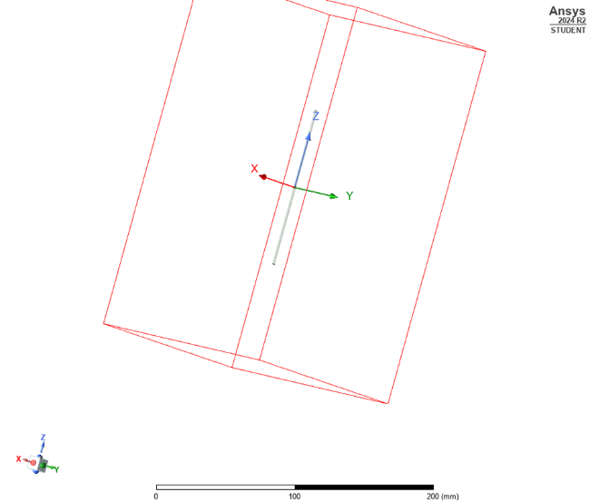
Figure 7 Air box
following the construction of the dipole antenna model, including the central gap for the 50-ohm lumped port, a simulation was conducted to evaluate its performance. This simulation yielded several key results: an S11 (return loss) plot, a 3D radiation pattern, and a gain plot. Analysis of these outputs provides insight into the antenna's resonant behaviour and radiation characteristics.

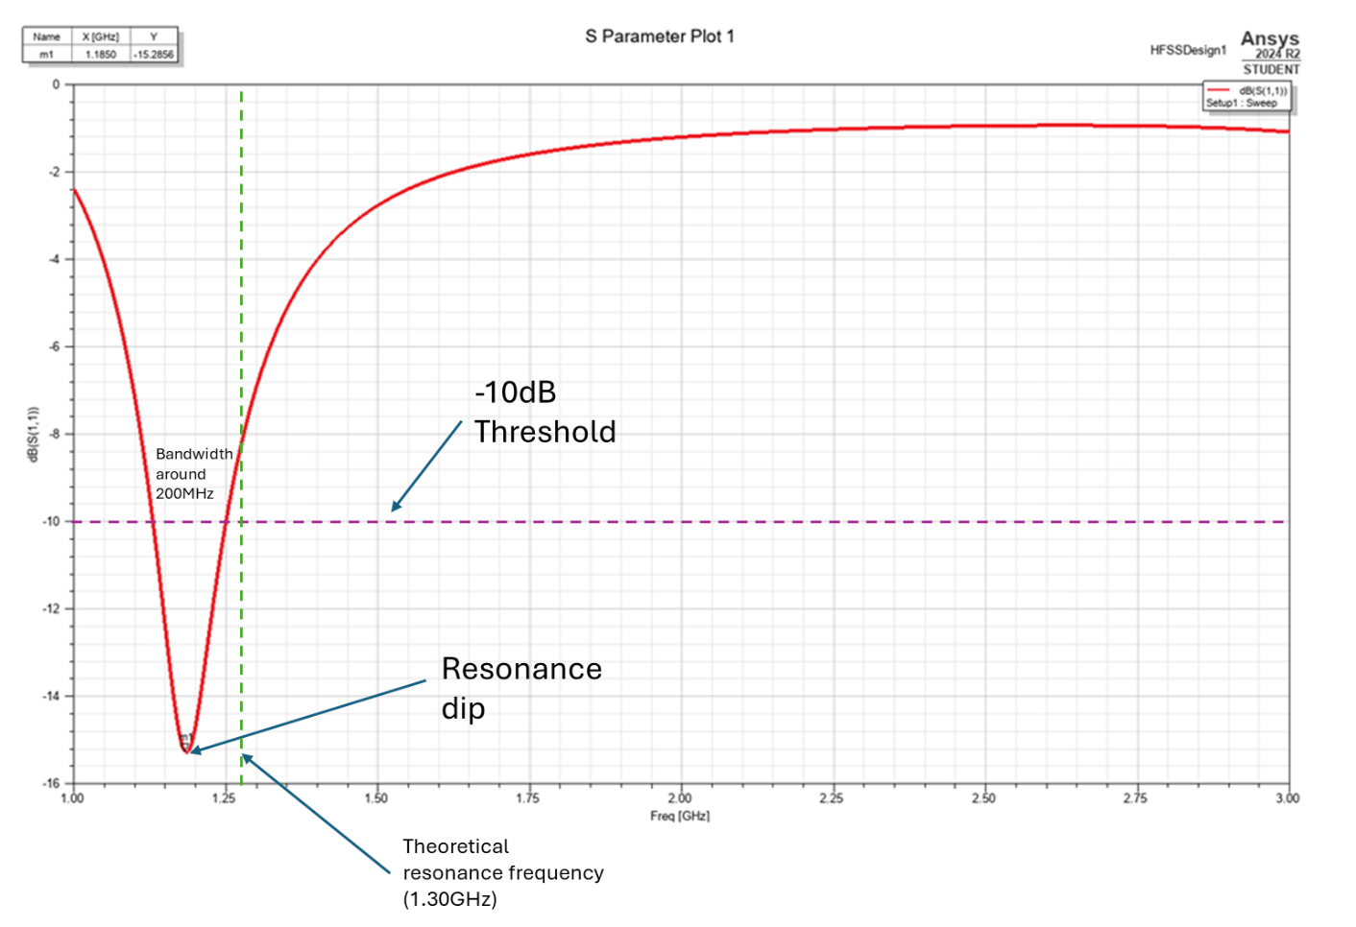
Figure 8 S plot

The S11 plot is important for assessing the antenna's impedance matching with the transmission line across different frequencies. A low S11 value (a deep null) near the theoretical resonant frequency, expected around 1.30 GHz in this case, signifies efficient power transfer and minimal reflection. A return loss below –10 dB is generally considered acceptable for practical applications. [4]
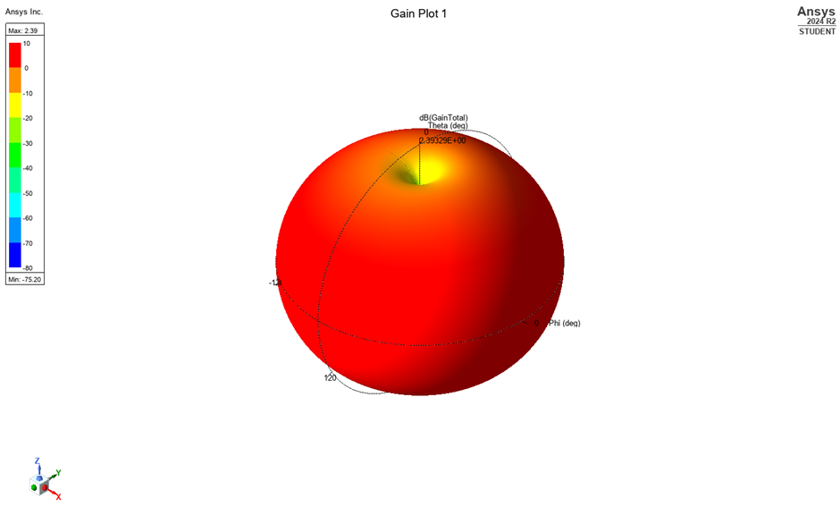
Figure 9 Gain plot angle 1
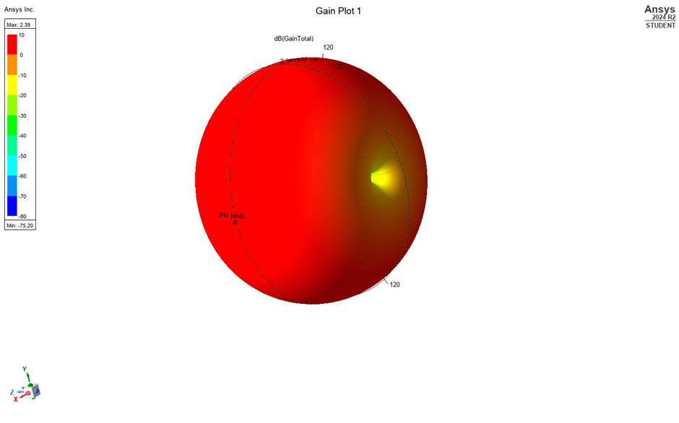
Figure 10 Gain plot angle 2
Furthermore, the 3D radiation pattern and gain plot reveal the antenna's directional properties. For a half-wave dipole, the anticipated pattern is a doughnut shape, exhibiting maximum gain in the plane perpendicular to the antenna elements and minimal radiation along the axis of the elements (the ends). These patterns serve to validate that the antenna radiates as designed.
The simulation results showed the S11 plot featuring a clear resonance dip at approximately 1.195 GHz. While this is slightly lower than the predicted 1.30 GHz, potentially due to factors like the finite simulation environment (airbox), meshing imperfections, or the lumped port's presence, the dip is sharp and reaches below –15 dB, indicating excellent matching. The gain plot shows a maximum gain of approximately 8.93dB. The radiation pattern confirms the expected doughnut shape, which, for a dipole typically oriented along the vertical axis in such plots, is omnidirectional in the horizontal plane.

Possible improvements for accuracy

- Mesh Refinement The level of mesh refinement used in the simulation may have influenced the accuracy of the results, particularly around the lumped port and along the dipole arms where electric field intensity is highest. At the time of simulation, there was limited familiarity with how to manually adjust meshing settings within the software, so default values were used. In future work, gaining a deeper understanding of mesh control options would be a priority, as a finer mesh could help capture more detailed field behaviour and yield a more precise prediction of the resonant frequency, potentially better capturing the effects of fringing fields. [5]
- Balun or Feed Structure In real-world applications, a dipole antenna is often fed using a balun (balanced-to-unbalanced converter) to ensure that the antenna receives a symmetrical current distribution. My current model used a simple 50-ohm lumped port, which is suitable for basic simulation, but it may not fully replicate the complex field distribution near the feed point and thus could influence the accuracy of the simulated resonant frequency and impedance matching compared to a physical implementation. In future simulations, I would aim to either include a simplified balun structure or investigate alternative excitation methods that better replicate physical dipole feeding. [6]
- Impedance Matching and Smith Chart Analysis After further research I found another way i could analyse the antenna's performance that by using a smith chart. In application I would consider plotting the input impedance using a Smith Chart, allowing me to visually assess how well the antenna is matched across a range of frequencies and identify any mismatch conditions that could result in reflected power. Incorporating this form of impedance analysis would add another layer of validation alongside the S11 plot and could help guide any tuning or matching network adjustments if needed for more practical designs. [7] [8]

Conclusion Dipole antenna

In conclusion, Task 2, which involved the design and simulation of a half-wave dipole antenna, provided valuable insight into its fundamental operating principles and performance characteristics. The simulation successfully demonstrated the expected behaviour of a dipole, with key performance indicators closely aligning with theoretical predictions.
The S11 plot revealed a clear resonance dip at approximately 1.195 GHz. While this simulated operating frequency exhibited a slight downward shift compared to the theoretical calculation of 1.30 GHz, primarily attributed to the effect of fringing fields and other simulation-related factors, the depth of the dip, reaching below –15 dB, indicated excellent impedance matching at the simulated resonance.
Analysis of the 3D radiation pattern and gain plot further validated the antenna's performance, confirming the expected doughnut-shaped radiation pattern with maximum gain observed perpendicular to the antenna axis. A peak gain of approximately 8.93 dB was obtained, consistent with the directional properties of a half-wave dipole.
Both the theoretical calculations and the simulation results demonstrated consistency, reinforcing the validity of the dipole antenna design principles and highlighting the clear relationship between physical dimensions and resonant behaviour.
Overall, the simulation results successfully validated the theoretical principles of half-wave dipole antennas, contributing to a strong understanding of their behaviour and key performance characteristics.

References
[1]
E. Jensen, “Cavity basics.” Accessed: May 02, 2025. [Online]. Available: https://arxiv.org/pdf/1201.3202
[2]
ANSYS, “Lecture 3: HFSS FEM Solution Setup,” 2020. Accessed: May 02, 2025. [Online]. Available: https://innovationspace.ansys.com/courses/wp-content/uploads/2021/07/HFSS_GS_2020R2_EN_LE3_FEM_MeshSoln.pdf
[3]
Cambridge Dictionary, “dipole,” @CambridgeWords, Nov. 2023. https://dictionary.cambridge.org/dictionary/english/dipole#google_vignette (accessed May 02, 2025).
[4]
Antenna Test Lab, “Antenna Return Loss and VSWR Explained Without Math,” Antenna Test Lab Company. https://antennatestlab.com/antenna-education-tutorials/return-loss-vswr-explained (accessed May 02, 2025).
[5]
A. Paffi, E. Carrasco, and Q. Balzano, “Influence of the Mesh Size on the Computation of the Close Near Fields of Dipole Antennas,” IEEE Open Journal of Antennas and Propagation, vol. 3, p. 6, 2022, doi: https://doi.org/10.1109/ojap.2022.3217069.
[6]
Z. cai, Z. Weng, Y. Qi, J. Fan, and W. Zhuang, “A High-Performance Standard Dipole Antenna Suitable for Antenna Calibration,” University of Waterloo. https://uwaterloo.ca/scholar/sites/ca.scholar/files/wzhuang/files/a_high-performance_standard_dipole_antenna_suitab_final.pdf (accessed May 02, 2025).
[7]
A. Govind, “Antenna Impedance Matching -Simplified,” Abracon. Accessed: May 02, 2025. [Online]. Available: https://abracon.com/uploads/resources/Abracon-White-Paper-Antenna-Impedance-Matching.pdf
[8]
Antenna Theory., “Smith Charts,” www.antenna-theory.com. https://www.antenna-theory.com/tutorial/smith/chart.php (accessed May 02, 2025).

Appendices

Appendix A

Source 1.1=1 imagines

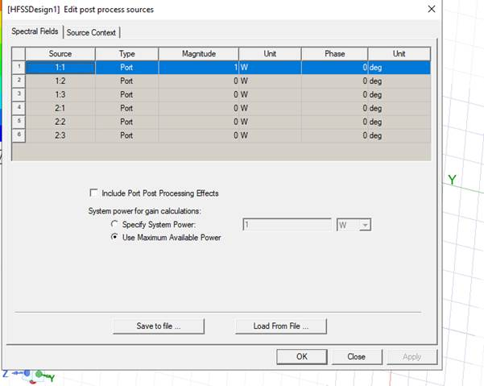
Magnitude of the electric field (Mag E)
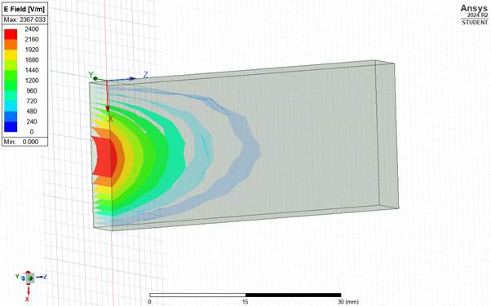
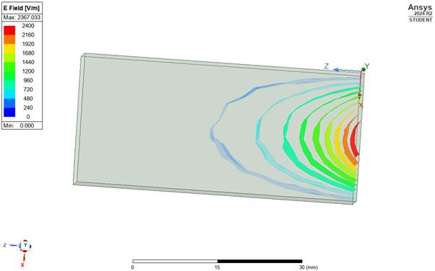

Vector E
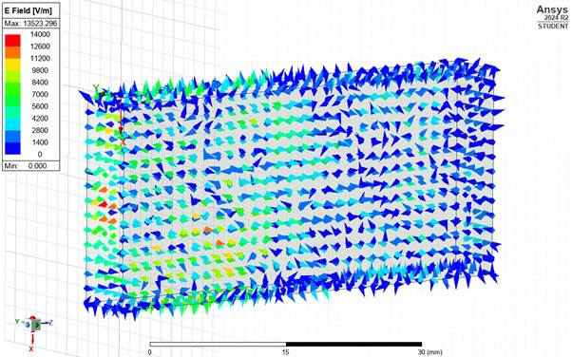
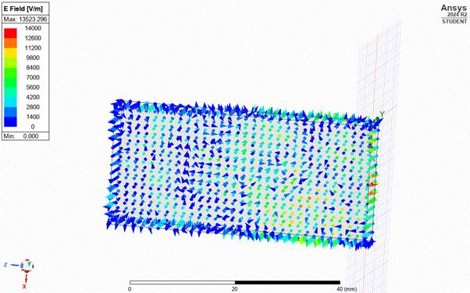
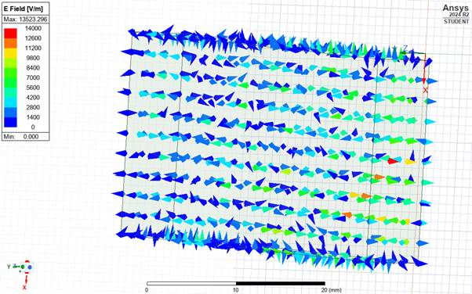
Magnitude of the magnetic field (Mag H1)
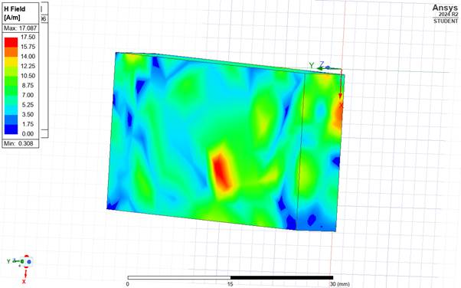
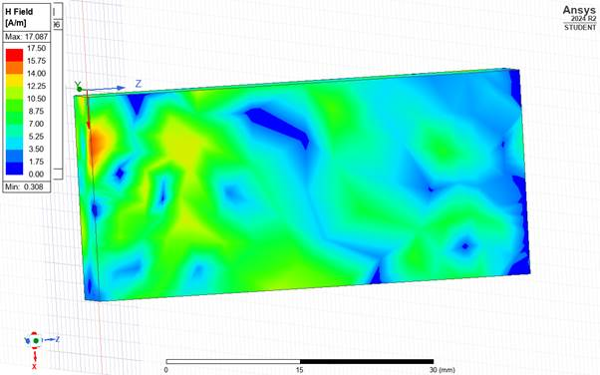
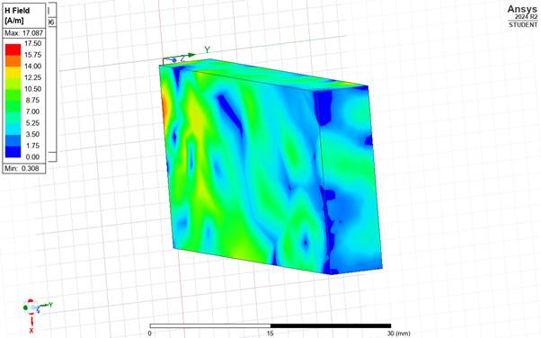
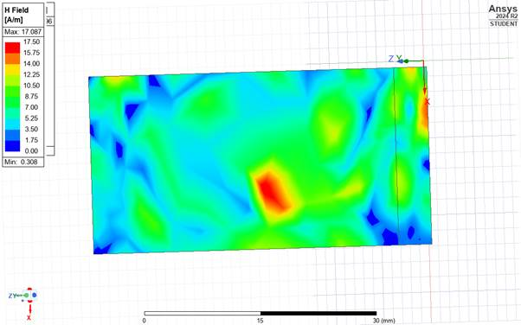
Vector H1
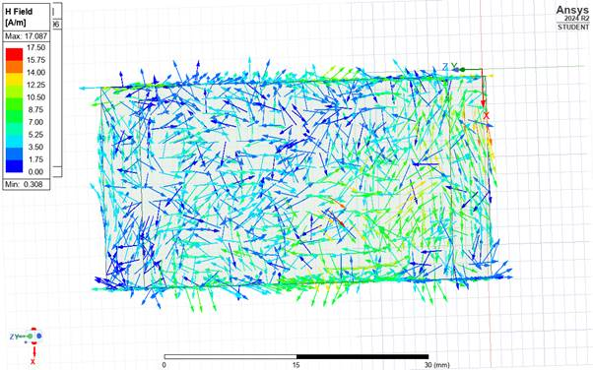
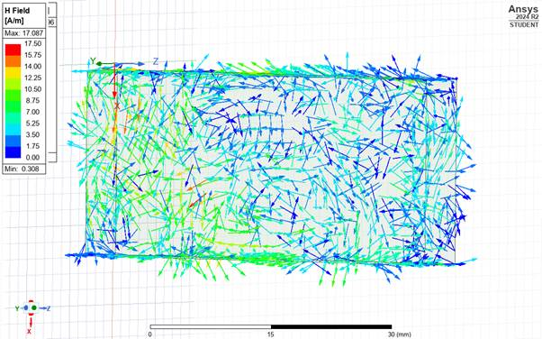
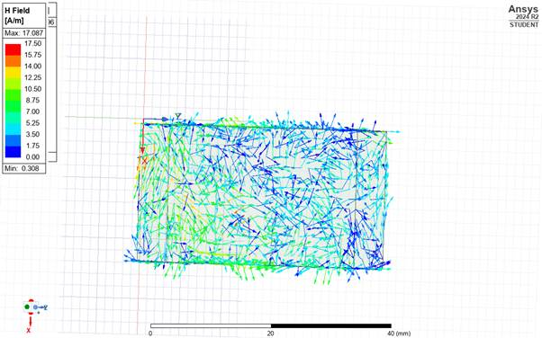
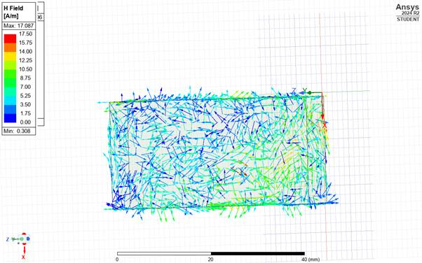
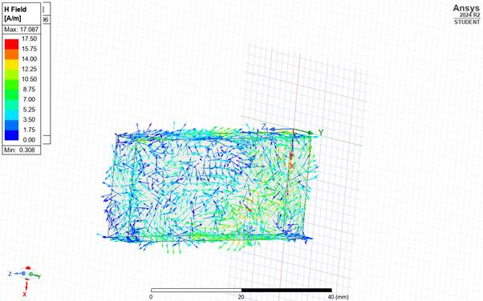

Appendix B

Source 1.2=1 Vaccuum

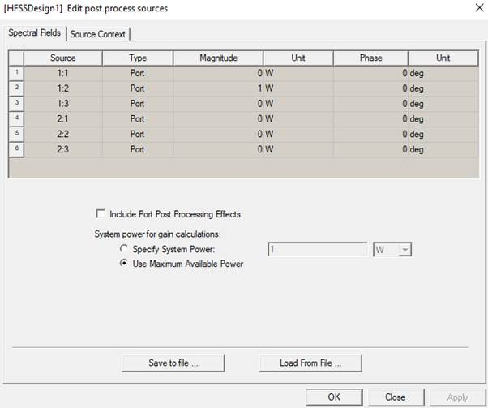

E field
Mag E1
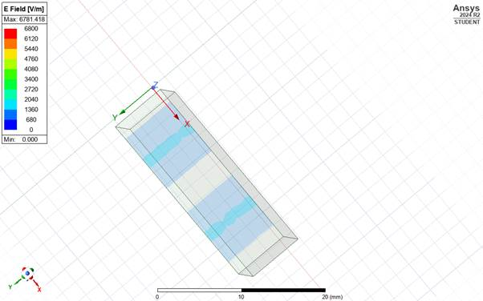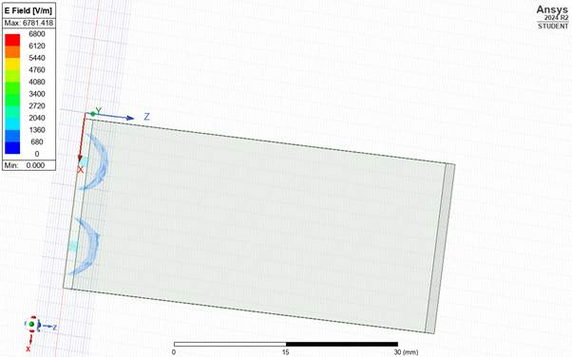
Also, mag E 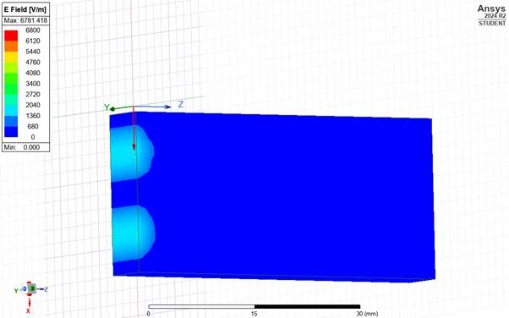
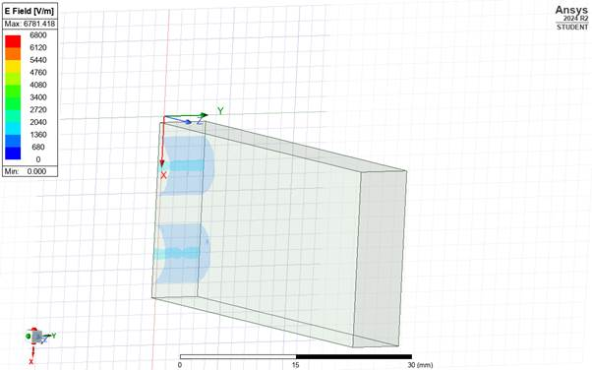
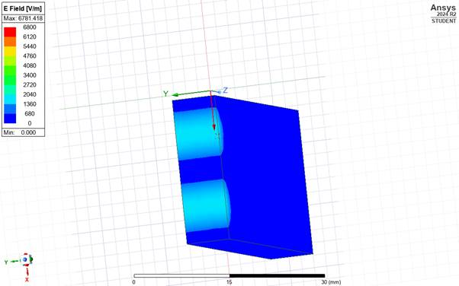

Vector E
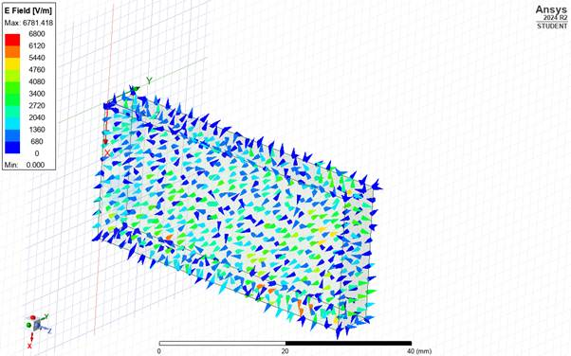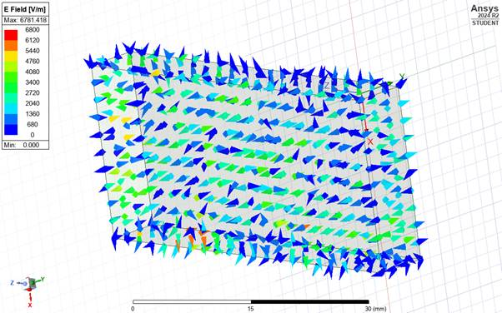

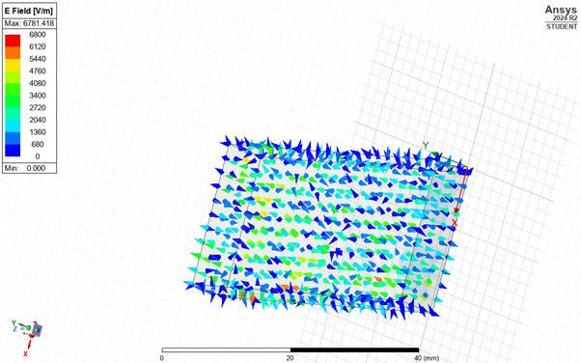
H field
Mag H1
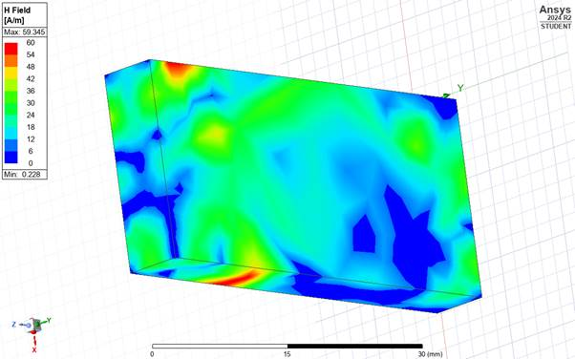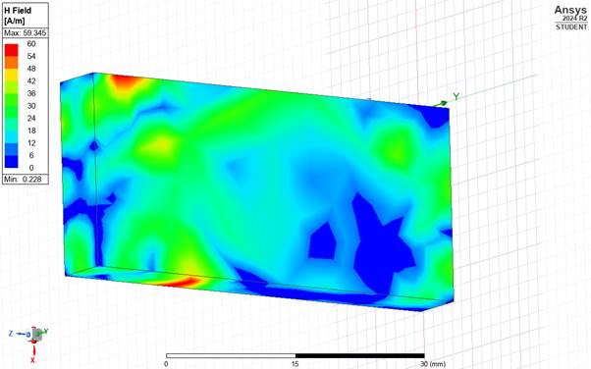
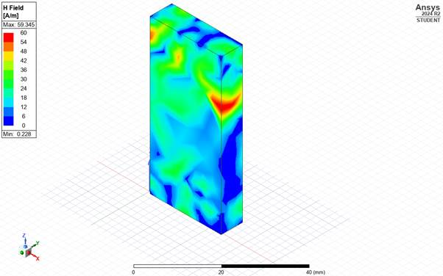
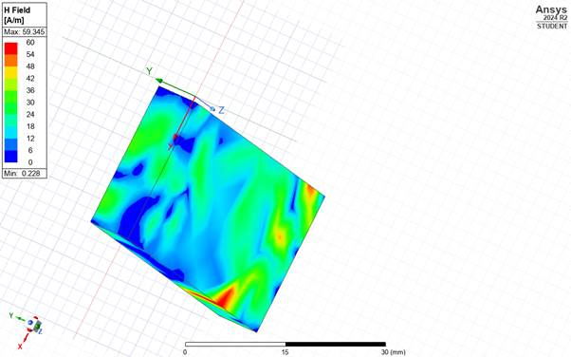
Vector H1
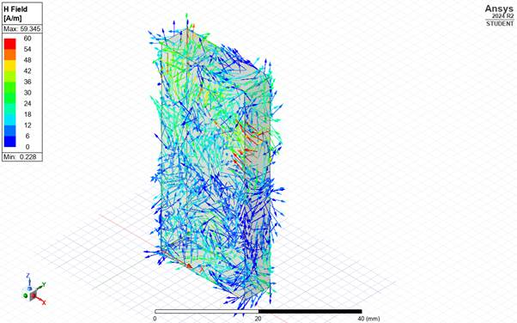
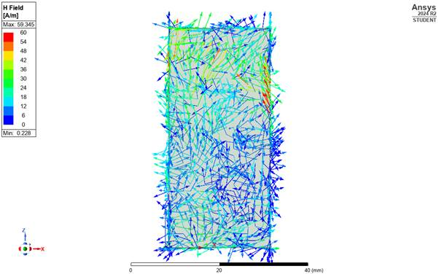
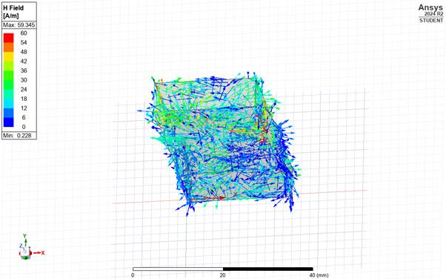

Appendix C

Source 1.3=1Vaccuum

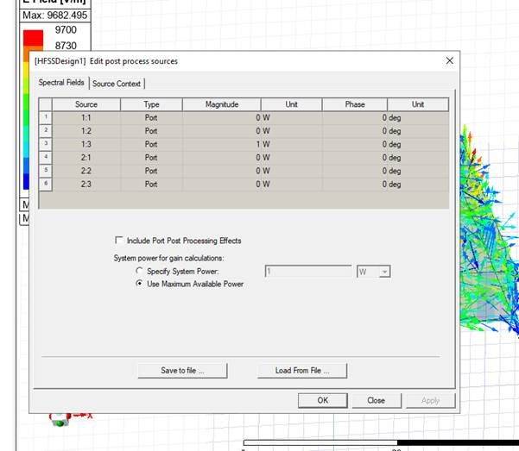

E field E 1
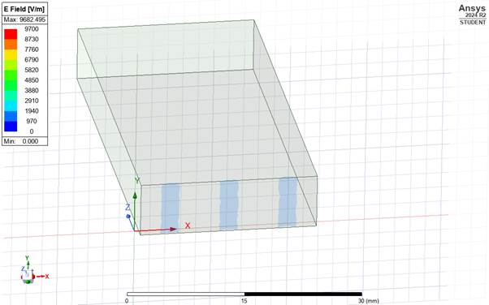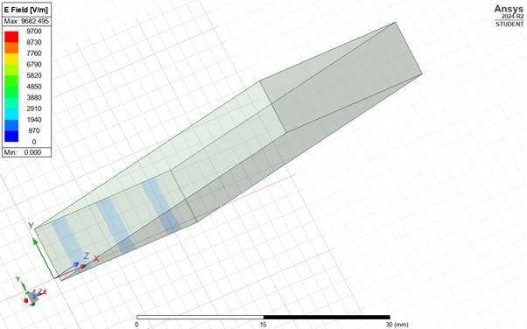 still mag 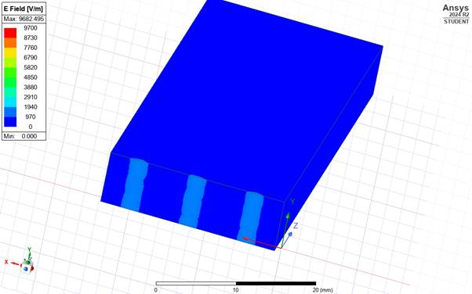
Vector E
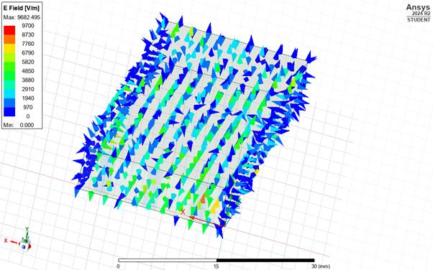
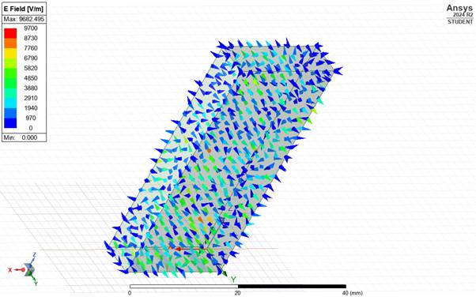
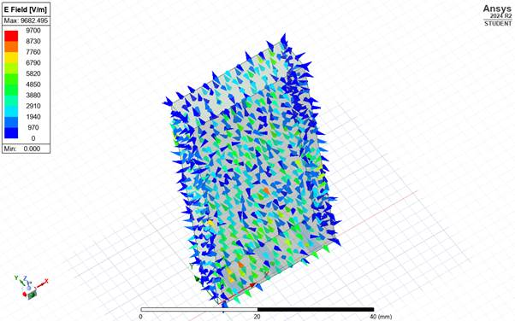

H field
Mag H
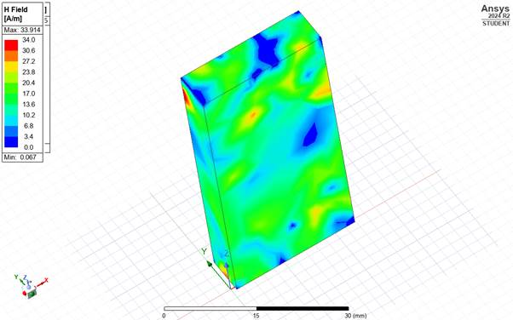
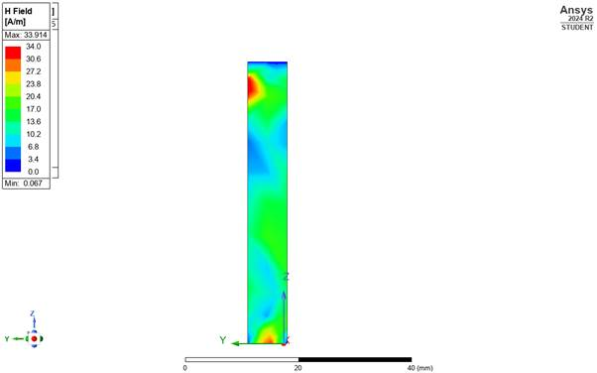
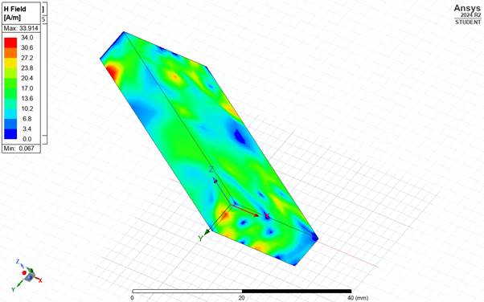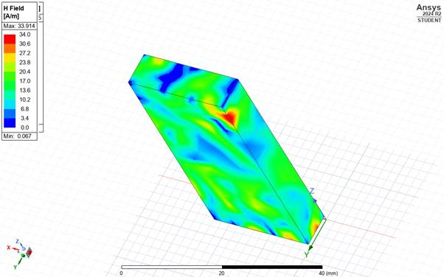
Vector H1
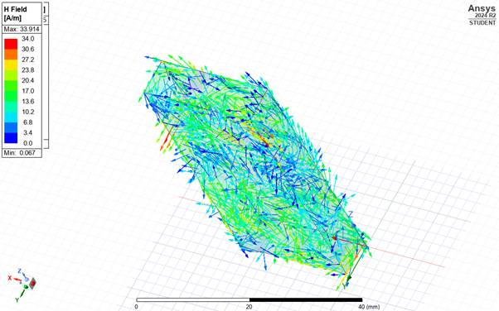
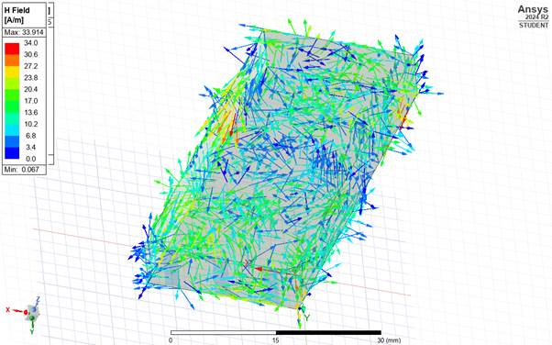
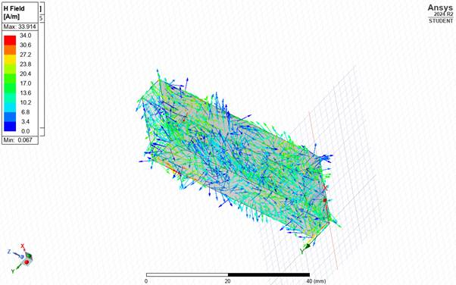

Appendix D
Teflon 1.1=1 images
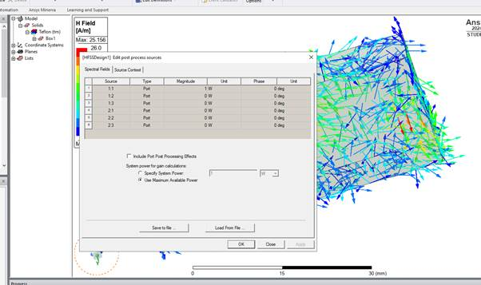

E field
Mag E
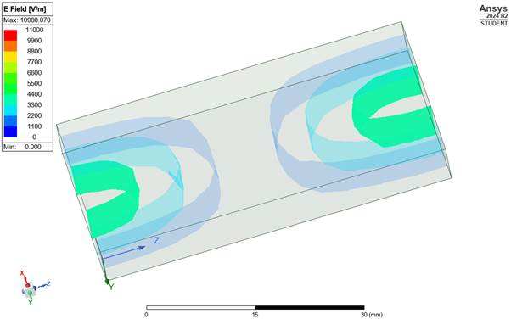
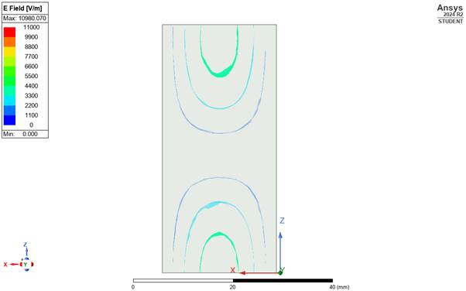
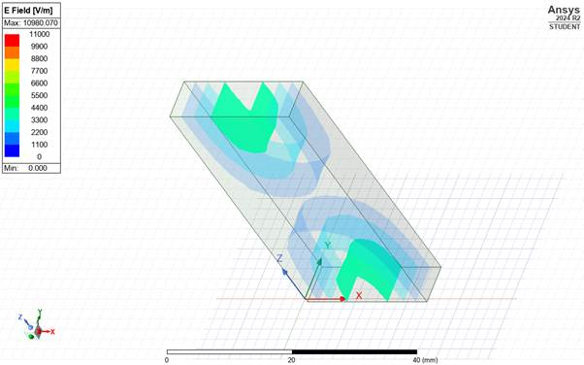
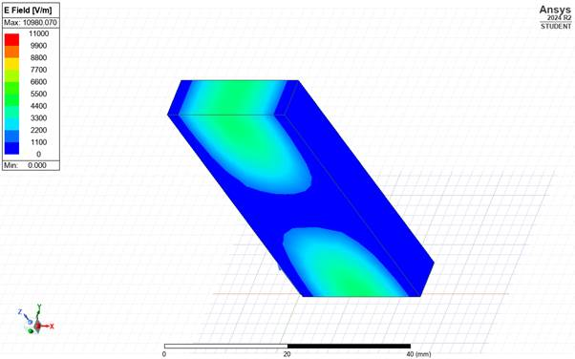
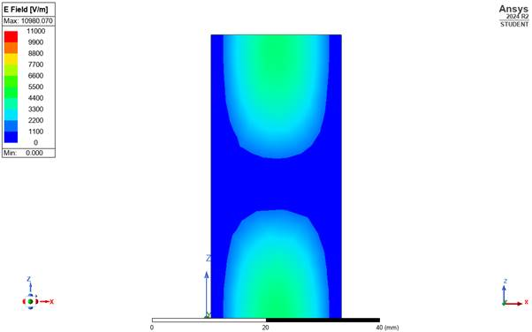
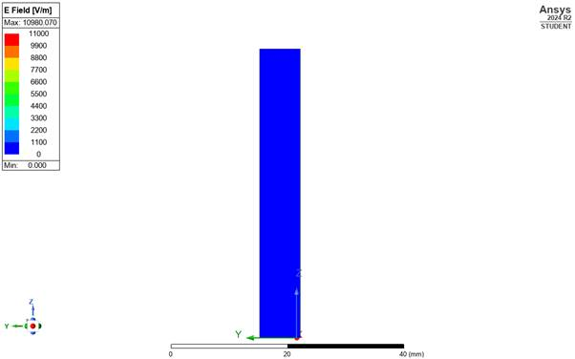
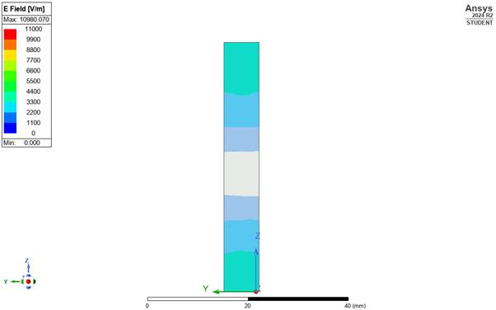

Vector E
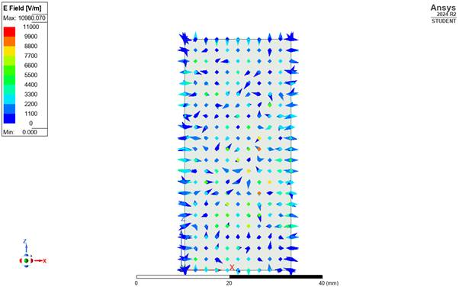
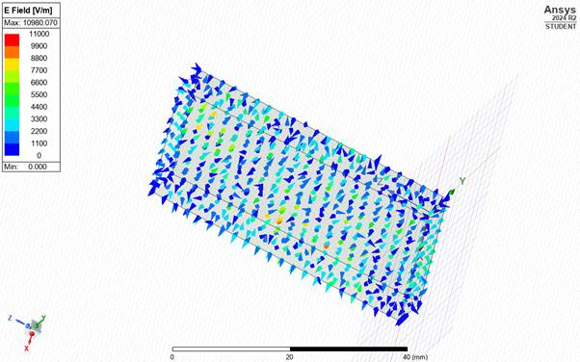
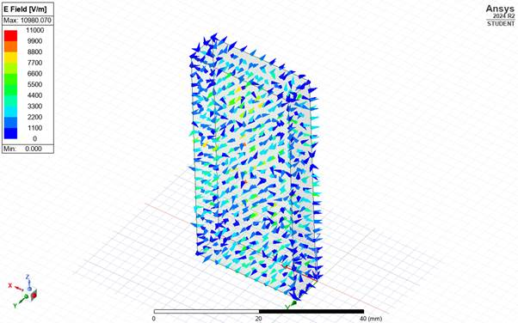
H field Mag H

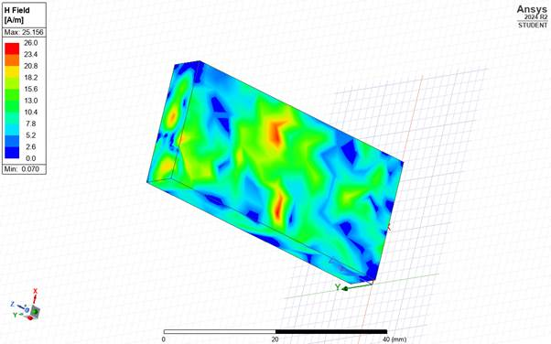
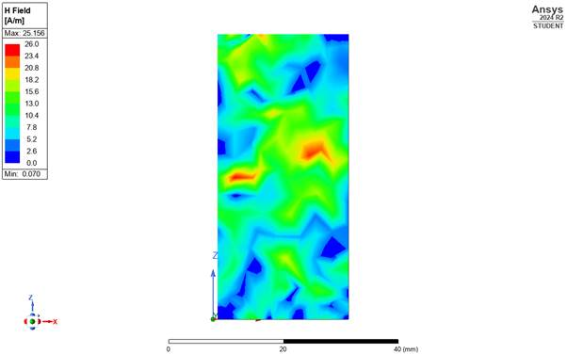
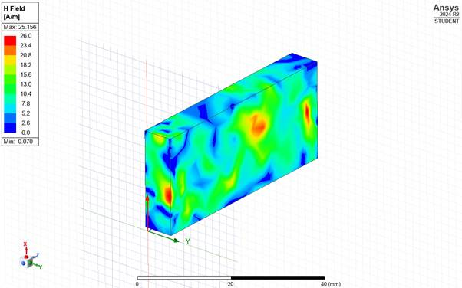
Vector H 1
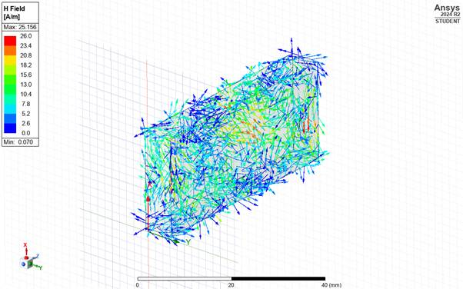
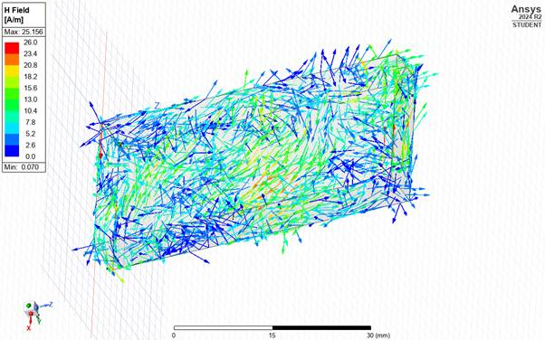
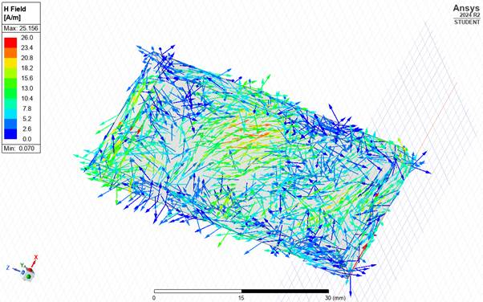
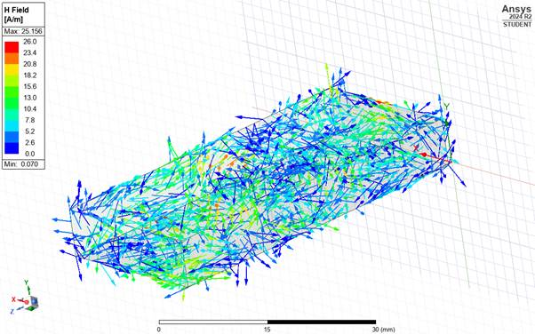
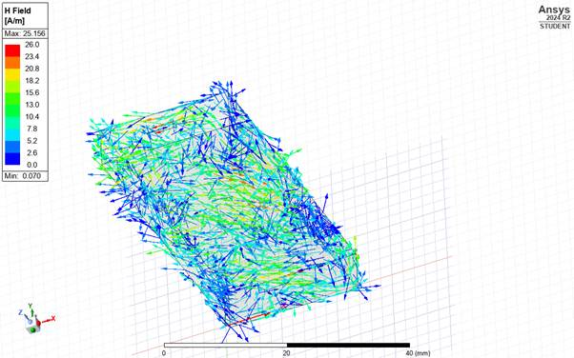

Appendix E
1:2 =1 Teflon
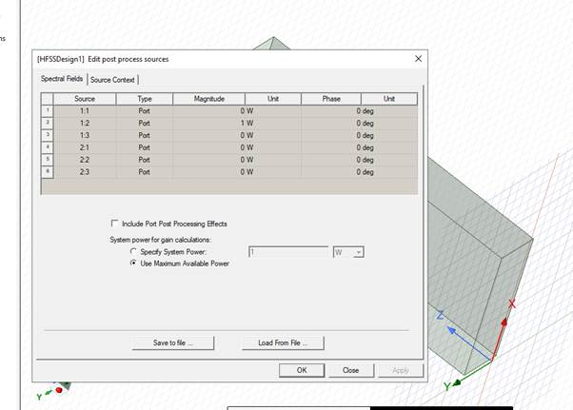
Mag e
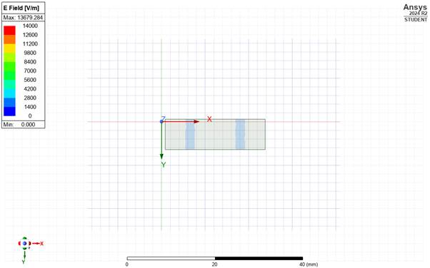
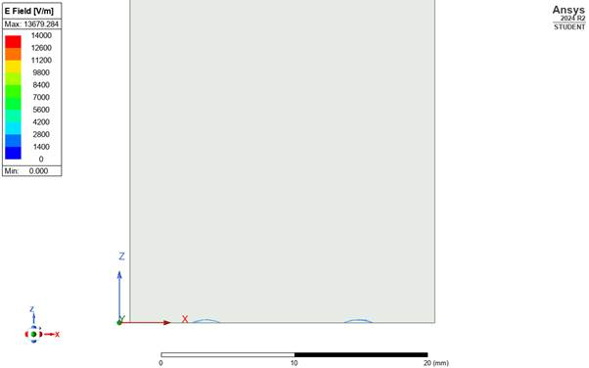
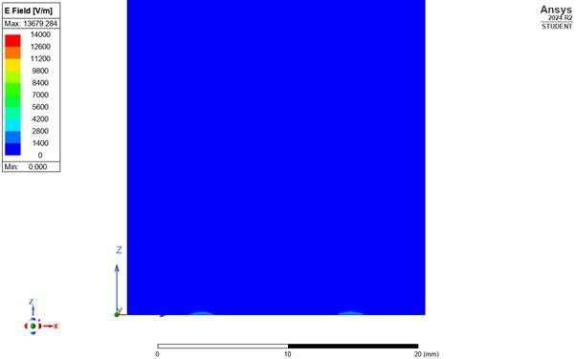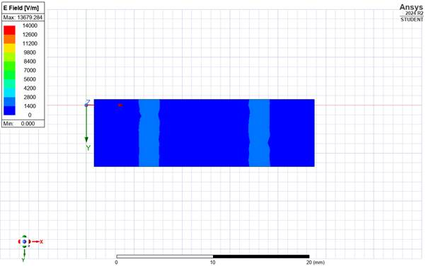
Vector E
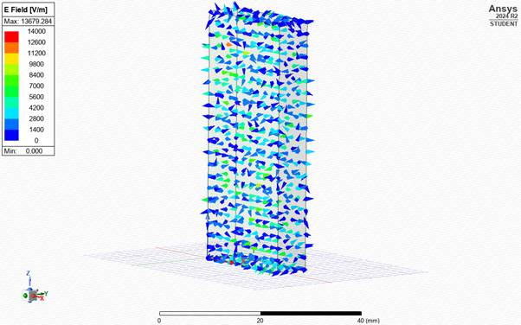
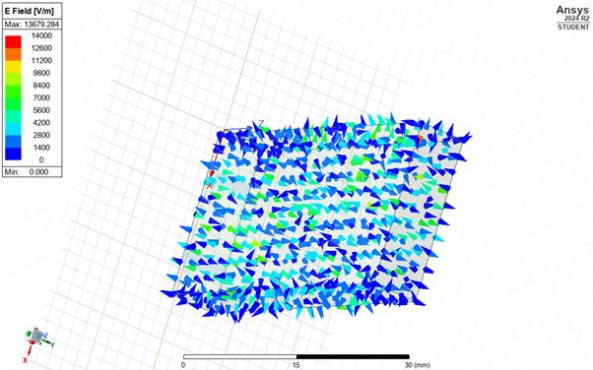

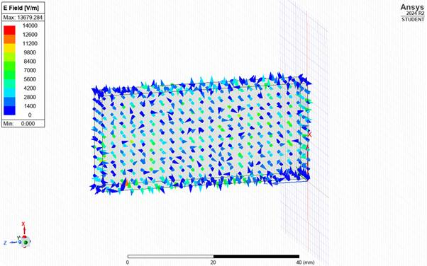
H field
Mag H
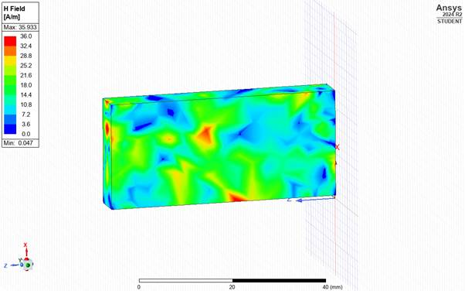
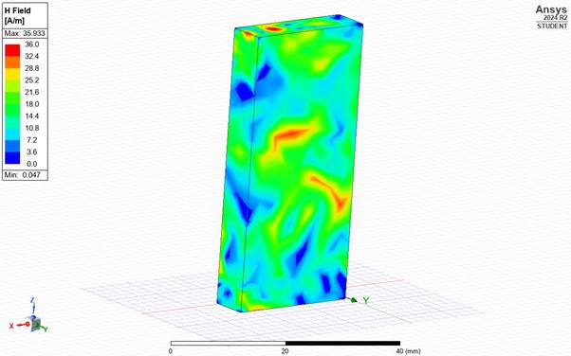
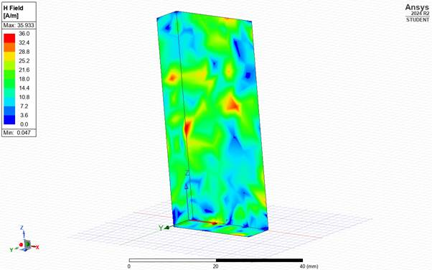
Vector H
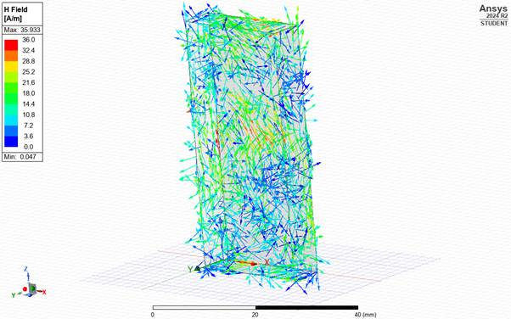
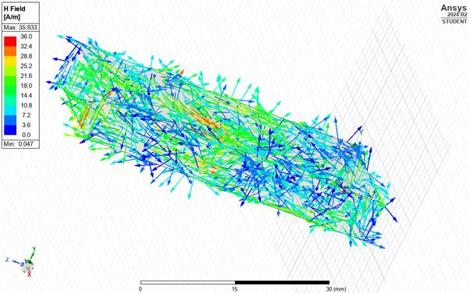

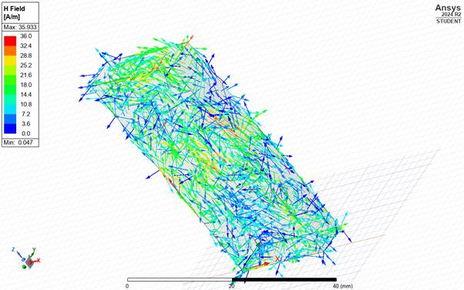

Appendix F
1.3=1 Teflon
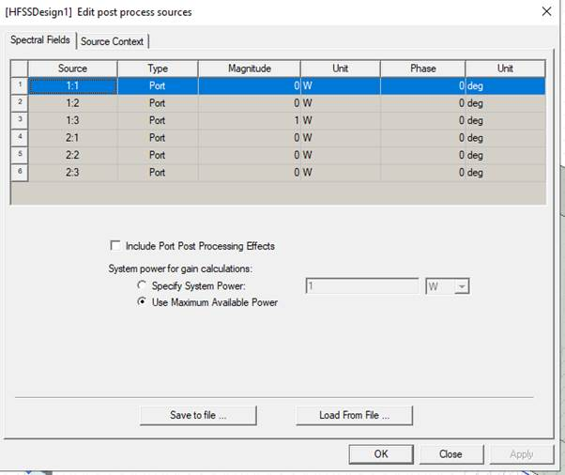
E field Mag E 1
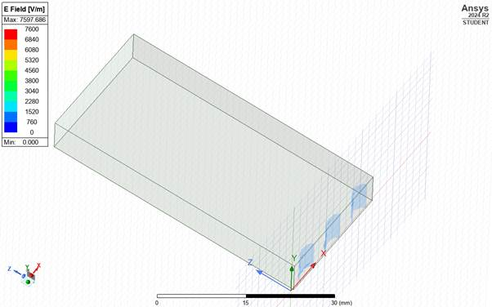
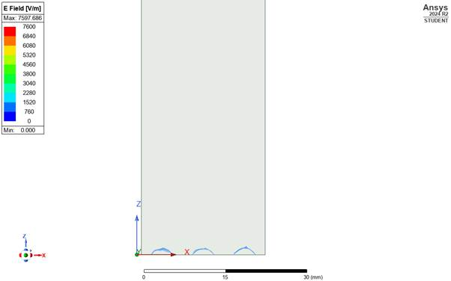
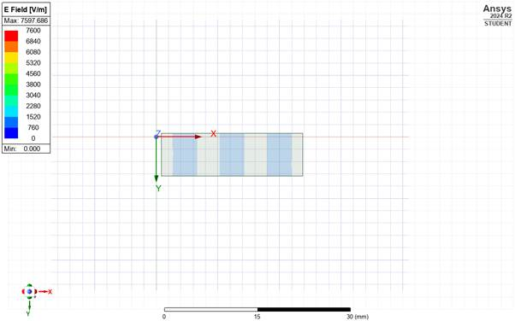
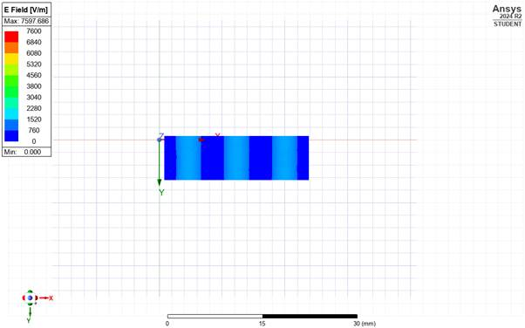
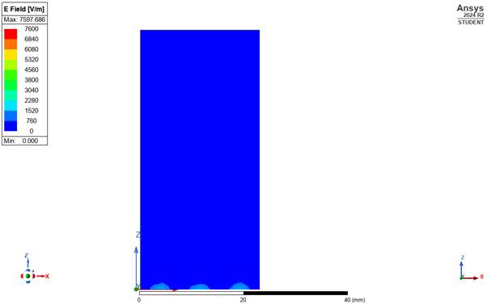
Vector E
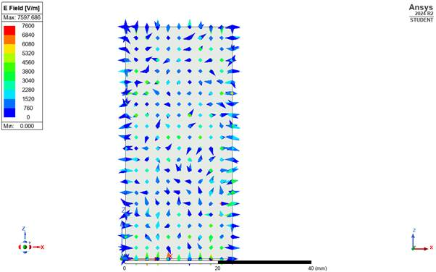
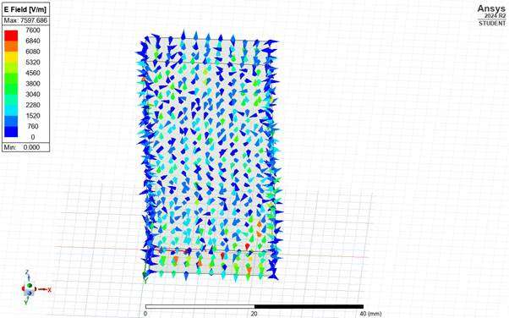
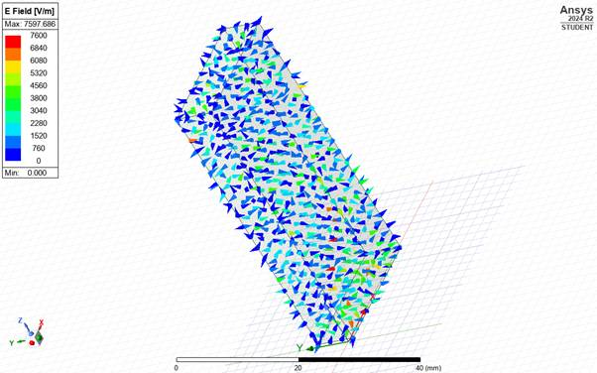
H field mag H
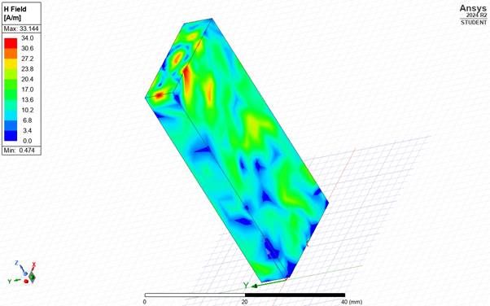
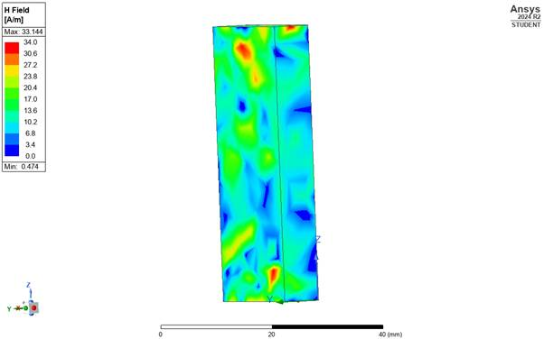
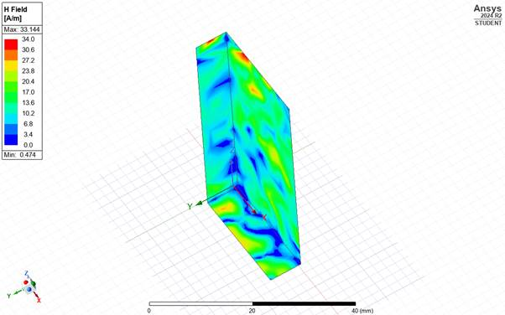
Vector H


