
ECUTIVE SUMMARY

BRITISH AMERICAN TOBBACCO (BAT)

A Successful Journey through Organisational Culture Change and Development

Executive summary
- Summarise your report so the reader gets a full picture of your work before reading the full document;
- At Level 7, this should be accurate;
- Additional guidance is available here: https://www.skillsyouneed.com/write/executive-summary.html
ASSESSMENT 01
Module : Human Resource Management
Module # : BMMB7007
Student Name : Anushi Fernando
Student # : 2222875
Submission Date : 26th March 2023

Table of contents
- Clearly numbered sections linked to correct page numbers;
- Please double check page numbers before submission to ensure accuracy.

Lists of tables/figures/appendices, if necessary

1.0 Introduction
EXECUTIVE SUMMARY
1.0 EXECUTIVE SUMMARY
The report is about British American Tobacco (BAT) Plc. It’s a multinational British tobacco company with it’s head office in London, UK and with a workforce of 52,000 by 2023. BAT has enhanced it’s business around the world including six continents. Their main products, Cigarettes, fine cut tobacco and a variety of nicotine products are in the market in different brandings such as Dunhill, Lucky Strike, Kent, Pall Mall, and Rothmans. The company is running under several challenges, since their product range is categorised under harmful substances and there are continuous government awareness among the community to discourage smoking.

As a result, BAT has restrictions in public marketing of it’s products, specially including youth-appealing media and events including social media. Also, it’s under going high taxes imposed by government to increase the product price and discourage smoking. Moreover, tobacco companies are treated as unethical companies since their products are with addictive substances including Nicotine which is very harmful for human health.

Against all the challenges, BAT is now in a revolution with a clear vision of creating “A Better Tomorrow TM ” to introduce non burnable products with nicotine free or lesser nicotine percentage. As a result, their new product range is now in the market as vapes, heated tobacco and e-cigarettes with significant revenue records. Further, company is more into a sustainable journey with set targets to achieve carbon neutrality for the business, reduce plastic usage and using of renewable energy. Company is fulfilling their social responsibility by increasing the percentage of female representation in the management, maintaining child labour in a healthy range, less water management etc..

BAT should have a thorough HRM practices to successfully meet the company goals. Since the company is in a transformational stage, the company culture should be adapted accordingly, so that the best utilisation of human resource will be benefited in company’s success journey.

Further BAT's annual and special reports demonstrate how vital cultural transformation is to BAT. Organisational success hinges on its culture. Its purpose-driven culture motivates and engages people, enhances stakeholder connections, and delivers long-term shareholder value. BAT can also cope with shifting legislation and stay competitive by adjusting its culture and development.

BAT should prioritize its purpose-driven culture and invest in innovation and flexibility to succeed. BAT recognizes the need for organizational culture growth and transformation, but it has to disclose more openly how well and how long its initiatives work. Because of its stagnant corporate culture, BAT has suffered. The company has struggled to adapt to changing market conditions, and its reputation has suffered because people think it doesn't care about sustainability, social responsibility, or doing the right thing. But there are hints that the corporation is taking these issues more seriously, so it will be vital to monitor its progress over the next few years.

CONTENTS
pg

1.0 EXECUTIVE SUMMARY…………………………………………………………………… 1

- LIST OF TABLES AND FIGURES………………………………………………………… 4

3.0 INTRODUCTION………………………………………………………………….…………. 5

4.0 COMPANY OVERVIEW…………………………………………………………………….. 6

5.0 PURPOSE DRIVEN CULTURE ……………………………………………………………. 7

6.0 DISCUSSION ………………………………………………………………………………… 8
6.1 BAT performance / new approaches and goals ………………………………………. 8
6.2 Challenges for BAT …………………………………………………………………… 8
6.3 Need of organisational culture improvements ………………………………………… 9
6.4 HR function in the organisation ………………………………………………………. 10
6.5 Challenges due to poor organisational culture ………………………………………… 13

7.0 RECOMMONDATIONS …………………………………………………………………….. 14
7.1 Awareness on organisational strategic goals ………………………………………….. 14
7.2 Build Team Spirit ……………………………………………………………………… 14
7.3 Transparency in communication……………………………………………………….. 14
7.4 Professional development plans ……………………………………………………….. 15

8.0 CONCLUSION ……………………………………………………………………………….. 15

9.0 REFERENCES ……………………………………………………………………………….. 16

10.0 APPENDICES ………………………………………………………………………………. 18

0.2 LIST OF TABLES AND FIGURES
Pg

Figure 1 : BAT logo ……………………………………………………………………………….. 6
Figure 2 : BAT products …………………………………………………………………………… 6
Figure 3 : Organisational culture …………………………………………………………………... 7
Figure 4 : Organisational purpose driven culture ………………………………………………….. 7
Figure 5 : How to measure company culture ………………………………………………………. 10
Figure 6 : Different types of organisational cultures……………………………………………….. 11
Figure 7 : Competing values framework ………………………………………………………….. 11

Table 1 : Company culture measuring techniques ………………………………………………… 11
Table 2 : Impact of poor organisational culture …………………………………………………… 13

3.0 INTRODUCTION

British American Tobacco PLC (BAT), is one of the largest tobacco companies in the globe. It’s operating in London, UK. Apart for it’s regular products of cigarettes and fine cut tobacco, company is now in it’s new transformational stage in order to full fill their social responsibilities towards the nation. It has a history of achievements, but due to challenges from government and health care organisations, company is in an era of introducing e-cigarettes, heated tobacco and vapes which has a less nicotine percentage. During this change in their product portfolio, it needs to have a strong work force with a better understanding of the company goals. Hence HRM in the company needs to play a vital role in supporting to thrive to success.

In Addition, company has set targets to fulfil their responsibilities towards environment safely, human rights, renewable energy and less water management, plastic recycling, climate change.. etc. So, the company would need a skilled staff with good focus and proper awareness of organisational targets. Hence, HRM gets the main responsibility to create a purpose driven culture inside the company or it would not be an easy task to win the company goals.

4.0 COMPANY OVERVIEW

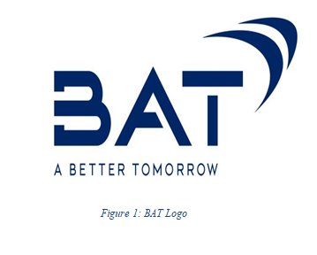
British American Tobacco Plc (BAT) is a multinational British company headquartered in London, UK. It is in business with more than 180 countries around the globe covering six continents. It was founded in 1902 as a joint venture between the UK's Imperial Tobacco Company and the American Tobacco Company. (The Editors of Encyclopedia Britannica, 2019)

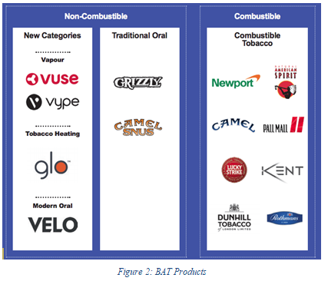
Cigarettes, fine cut tobacco and a variety of nicotine products are the main products of its business. Dunhill, Lucky Strike, Kent, Pall Mall, and Rothmans are few popular cigarette brands among consumers. In addition, the company product range includes snus, moist-snuff, vapour and cigars releasing to the market under different branding such as Vogue, Viceroy, Newport, glo, Natural American Spirit, Kool, Kodiak, and Camel etc…
During past few years, BAT has expanded its business beyond traditional tobacco products by investing in vaping and heated tobacco which falls into non-conbustible product category. It’s Vype brand of e-cigarettes is the most popular in UK. Its Glo and Velo heated tobacco products are winning increasing popularity in other markets.

Company is in a successful journey with increasing revenues. It has a clear vision for environment sustainability and works towards clear mission to meet :
- Fifty million clients of non-combustible products by 2030
- Achieve revenue for new products worth of £5 billion by 2025.
- Achieve carbon neutrality for the business by 2030 and for their total value chain by 2050
- Reduce plastic usage and convert all plastic packaging reusable, recyclable or compostable by 2025
- 100% renewable electricity in operations sites by 2030
(www.bat.com, n.d.)

5.0 PURPOSE-DRIVEN CULTURE
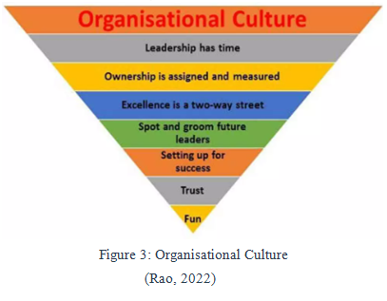
‘Organisational Culture’ can be best described as the personality of the company which is a blend of approaches, performances, expectations and opinions. An Organisation should clearly identify the culture model they need to implement inside the organisation, so that they will have a clear path for success in productivity and profitability. Inside a purposed driven culture, employee voice is most important and each individual will be treated equally, valued, appreciated well and respected. (Bradbury, 2022)
Each individual of an organisation should know the impotency of their job role and final goal. As long as the employee is well aware of the company goals, mission/Vision and core values. So, they feel they are part of a valuable chain and that motivation will lead them to stay on track and perform their best. (Genial.ly, n.d.)
Inside a purpose driven culture, HRM will find it easier to set goals for each employee as they are thorough in the core purpose of the company. Further this will lead to employee motivation where it will lead to successful recruitments and employee retention too. (Miller, 2019)
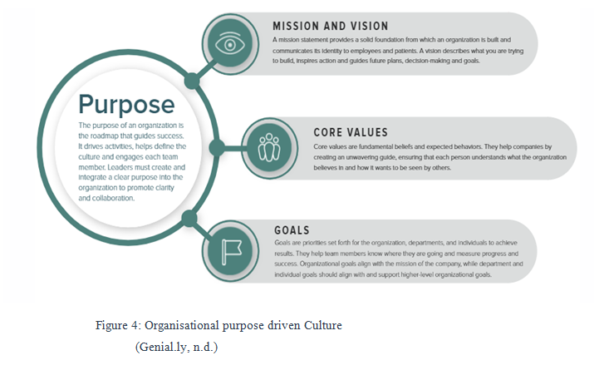

6.0 DISCUSSION

6.1 BAT PERFORMANCE, NEW APPROACHES AND GOALS

BAT annual reports explain its’ financial performance, strategic priorities, and efforts to be more environment friendly.

The company clearly evident how it coped during the COVID-19 pandemic. Through out the bad effect in global economy, BAT succeeded showing strong financial results, keep paying dividends to its shareholders, speed up its efforts to be more sustainable. The report also lists BAT's strategic goals, such as focusing on its core business, changing its portfolio. (BAT, 2020/2021).

Company is changing it’s product portfolio. It includes vaping, heated tobacco products, and oral tobacco products, grew by 32% in 2019, making up 6% of the company's revenue. Further, it works towards sustainability by reducing impact on the environment, promoting human rights and labour standards, and improving its customers' health and well-being (BAT, 2019/2020). There human rights due diligence programme covers all of its operations and suppliers. It has also made partnerships with other groups to deal with human rights problems in the tobacco industry (BAT, 2020). Moreover it has come a long way in reducing the amount of greenhouse gas emission (BAT, 2022).

6.2 CHALLENGES FOR BAT

There are few reasons that BAT needs to be strong in it’s organisational culture. It is not only the top management, middle level management and minor staff inside the company. BAT needs to have a strong encouragement towards the tobacco farmers and rest of the working staff as well in order to successfully face the challenges it has socially and environmentally.

Tobacco and nicotine products are categorised as additives. Hence, the company face a strong opposition for it’s products from the government and as well as from the society. It is said that tobacco has become one of the public health threats among the community. It is announced that more than 8 million deaths record every year due to smoking including 1.2 million due to exposure (World Health Organization,2022).

Further it shows that smoking contributes towards poverty since a considerable amount of personal income can be wasted for health treatments. In order to discourage tobacco consumption, there are several measures have been taken. Public promotions and marketing activities such as television or radio advertisements, distributing of brochures are prohibited for tobacco and nicotine products. Apart for these, company is not allowed to do free distributions, give public discounts and market products on public display boards. (Shout Out UK, 2019)

In order to make more discouragement in buying tobacco products, the government imposes high taxes to make the product price considerably high and it is a must to give pictorial health warnings in product packaging to discourage buying. (ASH, 2023)

So, the company is in continuous innovations to introduce new alternatives which are attractive but less harmful. Further, it invests in scientific research to find out the outcome of long term tobacco use under different product categories.

6.3 NEED OF ORGANISATIONAL CULTURE IMPROVEMENT

BAT reveals that it needs to change and improve its organisational culture to keep up with changes in the market, consumer tastes, and societal expectations. The company talks about its efforts to create a culture that is more diverse and open to everyone, to adopt a purpose-driven approach, and to improve its environmental practises (BAT, 2021/2022).

Further, it explains the need to build a strong organisational culture that encourages innovation, flexibility, and working together. The company knows how important it is to adapt to a market that is changing quickly, especially considering the COVID-19 pandemic. BAT also stresses how important it is to build a strong culture of ethics and keep high standards of corporate governance (BAT, 2020/2021).
BAT reveals about how it is trying to change its culture to be more customer-focused, flexible, and tech-savvy. The company s willing to give its employees more power, improve its leadership development programmes, and encourage a culture of always getting better (BAT, 2019/2020).

By closely examining above it's clear that BAT has recognized it’s needs to change and improve its organisational culture to stay competitive and meet the changing needs of the market and society.

- Changing with the market: The tobacco business is very competitive, and companies like BAT need to keep changing with the market to stay ahead. A strong organisational culture can help BAT respond to these changes faster and come up with new ideas more quickly so it can keep up with competitors.

- Employee Satisfaction: Unhappy employees can lead to high turnover rates, low morale, and less work getting done. By creating a positive culture, BAT can help increase employee happiness, engagement, and loyalty where it will lead to a high performance in the company.

- Aligning with company values: If BAT's current culture isn't in line with the company's values and goals, it can cause problems and slow down company progress. By creating a culture that is in line with its values, BAT can make its organization stronger and more focused.

- Better decisions: A strong culture can help employees understand the mission and values of the company, which can lead to better decisions. By encouraging a culture of innovation, BAT can get its employees to take risks and make smart decisions that are efficient for the company.

- Sticking to ethical standards: The tobacco industry has been criticized for being unethical, and building a positive culture can help BAT stick to ethical standards and improve its reputation. BAT can show that it cares about doing business in a responsible way by promoting ethical behavior and social responsibility.

6.4 HRM FUNCTION IN THE ORGANISATION

BAT HRM should be stronger in achieving company goals maintaining an efficient purpose driven culture inside the company. Also, it should take initiatives to measure company culture regularly using different methods and ensure it is aligned with the requirement.(Gardner, 2021)
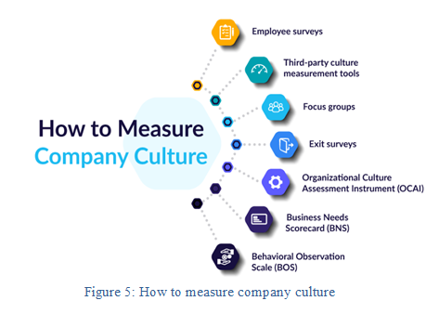

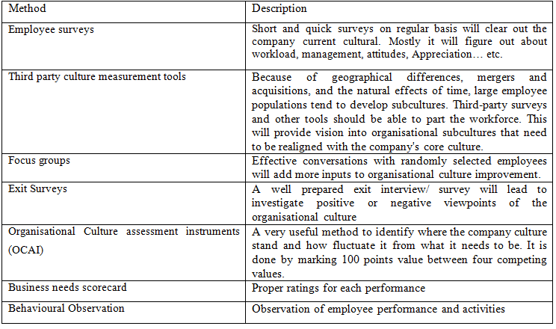
Table 1: Company culture measuring techniques

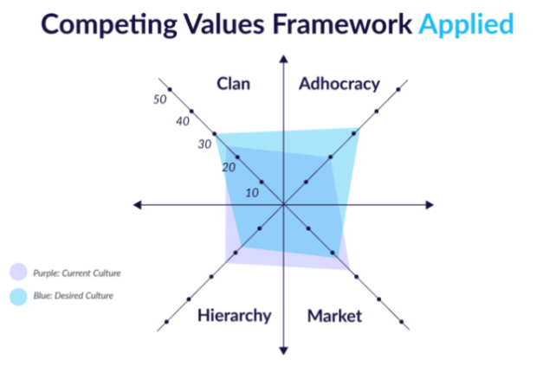
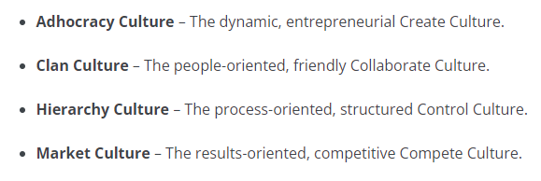

Figure 6 : Different types of organisational culture Figure 7 : Competing Values Framework

BAT has main focus on organization's culture to change and grow. It’s business becomes more and more regulated and tough. It needs to have a strong culture that encourages innovation, flexibility, and do the best to stay competitive and achieve organisational growth. BAT’s organisational success depends on its culture if it is driven by a purpose. By aligning its business strategies with its purpose, BAT can motivate and engage its employees, strengthen its relationships with its stakeholders, and create long-term value for its shareholders. BAT's purpose-driven culture is also important for its reputation and brand value, as consumers and investors are increasingly looking for businesses to act in an ethical and sustainable way. (BAT, 2023)

Also, organisational culture change and development can help BAT deal with the problems caused by the changing rules and regulations. As governments all over the world make rules over tobacco products, BAT needs to be more flexible and creative in how it develops, markets, and distributes its products. By encouraging a culture of innovation, BAT can use new technologies and business models to meet the changing needs of its customers and stay competitive in the market.

In conclusion, BAT's success depends on its ability to change and improve its organisational culture. The company's purpose-driven culture gives it a competitive edge because it inspires and engages its employees, strengthens its relationships with its stakeholders, and creates long-term value for its shareholders. Changes to organisational culture and development can also help BAT deal with the problems caused by changing regulations and stay competitive in the market. BAT should keep putting its purpose-driven culture first and investing in innovation and flexibility if it wants to keep doing well.

It is clearly evident that BAT in in a regular company changes to adopt against the challenges it faces. Lack of communication: Misunderstandings, delays, and mistakes can happen when people in different departments or jobs don't talk to each other well. It can also make the workplace a bad place to work, where people feel unappreciated and unsupported.
• Resistance to change: Some employees may be resistant to change, which can stop them from coming up with new ideas and keeping up with changes in the market. This can mean missed opportunities and less ability to compete.
• Lack of clarity: If roles, responsibilities, and goals aren't clear, it can cause confusion and frustration among employees. This can make them less motivated and less productive

6.5 CHALLENGES DUE TO POOR ORGANISATIONAL CULTURE

Lack of organizational culture change and development can impact on British American Tobacco (BAT) in several ways.
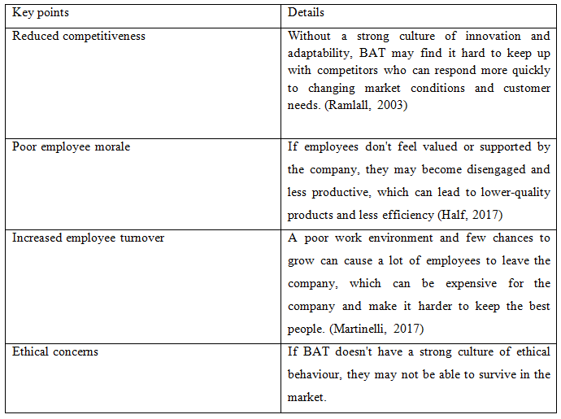
Table 2 : Impact of poor organisational culture

7.0 RECOMMENDATIONS

7.1 AWARENESS ON ORGANISATIONAL STRATEGIC GOALS

BAT is focusing towards sustainability and various innovations take place inside the company. It is one of the HRM responsibilities to make awareness programs to internal staff about the organisational goals. This will be a huge motivation for employees as it will show them where they stand in the company and how their individual performance will contribute to company goals. Further this will eventually improve professional skills and influence employees to take leadership and ownership to drive specific goals. (Thompson,2022)

7.2 BUILD UP TEAM SPIRIT

BAT needs to have a strong development team in order to do sustainable innovations and to produce new product ranges with less harm. It is not only the development team, but it needs to be well inter-connected with the marketing and sales teams too. A strong marketing team can collaborate efficiently with new product until it gets popular among the consumers. Also, proper data sharing on market trends and customer reviews and interests are the key input for new products designing. Hence the company requires a strong interaction between each department in order to thrive for success together. Here the HRM has the biggest role in building up the team spirit. They should let every team member sense they are part of the team and the importance of their contribution towards winning the team goal. This can be achieved with various programmes, group discussions, team get-together, planning of social events etc. (Cullen, 2022)

7.3 TRANSPARENCY IN COMMUNICATION

Employees should have freedom to voice out, so anyone can bring new ideas to the table or do any criticism. As long as the company welcomes employee ideas, they feel they are valued and trusted. On the other hand, it increases job satisfaction and leads to have better relationships with the company so ultimately, it will lead to a high performance in the company. HRM needs to play a major role here to motivate employees to share their thoughts. This can be either by group discussions or personal surveys inside the company. (Team, 2022)

7.4 PROFESSIONAL DEVELOPMENT PLANS

Company is willing to invest on new products with less impact on humans such as e-cigarettes, heated tobacco products and various nicotine free alternatives. So, it can successfully overcome the challenges towards the government awareness on reduction of tobacco consumption. Recruiting new employees with high technological and scientifically knowledgeable is crucial here. Further HRM should regularly conduct proper training programmes for existing employees on new innovations, while adding high skilled staff by efficient recruitments process (Meyer, 2023).

8.0 CONCLUTION

HRM plays an energetic role in every organisation. It ensures that policies and processes are implemented consistently and effectively throughout the organisation. HRM exists to maintain a balance between employee needs and satisfaction and an organization's profitability and ability to achieve its goals.
It operates in different perspectives as per the organisational requirements.

British American Tobacco Plc is a specific organisation with an uncommon product rage which faces many social and marketing challenges. Towards company’s new sustainable practices and efforts to do rapid changes in it’s product portfolio, it is HRM responsibility to maintain a healthy working culture inside the organisation in order to achieve company set goals.

9.0 REFERNCES

ASH (2023). Tobacco taxation and illicit trade. [online] ASH. Available at: https://ash.org.uk/tobacco-industry/tobacco-taxation-and-illicit-trade.

BAT, 2019/2020. Annual Report, London: BAT.

BAT, 2020/2021. Annual Report, London: BAT.

BAT, 2020. BAT Human Rights Report, London: BAT.

BAT, 2021/2022. Annual Report , London: BAT .

BAT, 2022. British American Tobacco - Climate Change, London: BAT.

BAT, 2022. British American Tobacco - Forests 2022, London: BAT.

BAT, 2022. Combined Annual and ESG Report, London: BAT.

BAT, 2023. Building A Better Tomorrow. [Online] Available at: https://www.bat.com/# [Accessed 16 March 2023].

BAT, 2023. People and culture.[Online] Available at https://www.bat.com/peopleandculture[Accessed 15 March 2023].

BAT, 2023. Embracing diversity and inclusion. [Online] Available at: https://www.bat.com/yourvoice
[Accessed 15 March 2023].

BAT, 2023. People and culture.[Online] Available at https://www.bat.com/peopleandculture[Accessed 15 March 2023].

Bradbury, L. (2022). Creating a Purpose-Driven Culture. [online] https://www.serenityinleadership.com. Available at: https://www.serenityinleadership.com/news/creating-a-purpose-driven-culture [Accessed 22 Mar. 2023].

Cullen, E. (2022). 6 ways you can encourage team spirit in the workplace. [online] Mentimeter. Available at: https://www.mentimeter.com/blog/stand-out-get-ahead/6-ways-you-can-encourage-team-spirit-in-the-workplace.

Genial.ly. (n.d.). Organizational Purpose. [online] Available at: https://view.genial.ly/60dcf7efa33a1e0d627fda79/interactive-content-organizational-purpose [Accessed 25 Mar. 2023].

Meyer, T. (2023). How to Encourage Professional Development Among Employees. [online] www.businessnewsdaily.com. Available at: https://www.businessnewsdaily.com/10092-encourage-professional-development.html.

Gardner, R. (2021). How to Measure Company Culture: A Quick Guide. [online] AIHR. Available at: https://www.aihr.com/blog/how-to-measure-company-culture/.

Half, R. (2017). 5 Signs of Low Employee Morale in the Workplace and How to Counteract It. [online] Roberthalf.com. Available at: https://www.roberthalf.com/blog/management-tips/5-signs-of-low-employee-morale-in-the-workplace-and-how-to-counteract-it.

Martinelli, K. (2017). Causes of Employee Turnover and Strategies to Reduce... [online] The Hub | High Speed Training. Available at: https://www.highspeedtraining.co.uk/hub/causes-of-employee-turnover/.

Miller, B. ed., (2019). HR MANAGEMENT & COMPLIANCE. [online] HR Daily Advisor. Available at: https://hrdailyadvisor.blr.com/2019/12/23/what-is-a-purpose-driven-culture/ [Accessed 22 Mar. 2023].

Rao, K.S. (2022). Consequences of organisational culture. [online] www.thehansindia.com. Available at: https://www.thehansindia.com/hans/opinion/news-analysis/consequences-of-organisational-culture-734904.

Ramlall, S., 2003. Organizational application managing employee retention as a strategy for increasing organizational competitiveness. Applied HRM research, 8(2), pp.63-72.

Shout Out UK (2019). Smoking Poverty In The UK. [online] Shout Out UK. Available at: https://www.shoutoutuk.org/2019/10/15/smoking-poverty-in-the-uk/

Team, N.T. (2022). 5 Things You Can Do TODAY to Improve Your Communication! [online] Newbreak Church. Available at: https://newbreak.church/5-communication-tools/?gclid=Cj0KCQjwt_qgBhDFARIsABcDjOfnHopj5v27CvLF2w-jRwiU7VohbPyUnXi8ygREiYRjrWbwuQoR4SkaArorEALw_wcB [Accessed 25 Mar. 2023].

The Editors of Encyclopedia Britannica (2019). cigarette | Definition, Facts, & Health Effects. In: Encyclopædia Britannica. [online] Available at: https://www.britannica.com/topic/cigarette.

Thompson, P. (2022). The best way to set team goals | BetterUp. [online] www.betterup.com. Available at: https://www.betterup.com/blog/the-best-way-to-set-team-goals.

World Health Organization (2022). Tobacco. [online] Who.int. Available at: https://www.who.int/news-room/fact-sheets/detail/tobacco.

www.bat.com. (n.d.). British American Tobacco - We are BAT. [online] Available at: https://www.bat.com/group/sites/UK__9D9KCY.nsf/vwPagesWebLive/DOB4JJB8.

10.0 APPENDICES

- Change theories

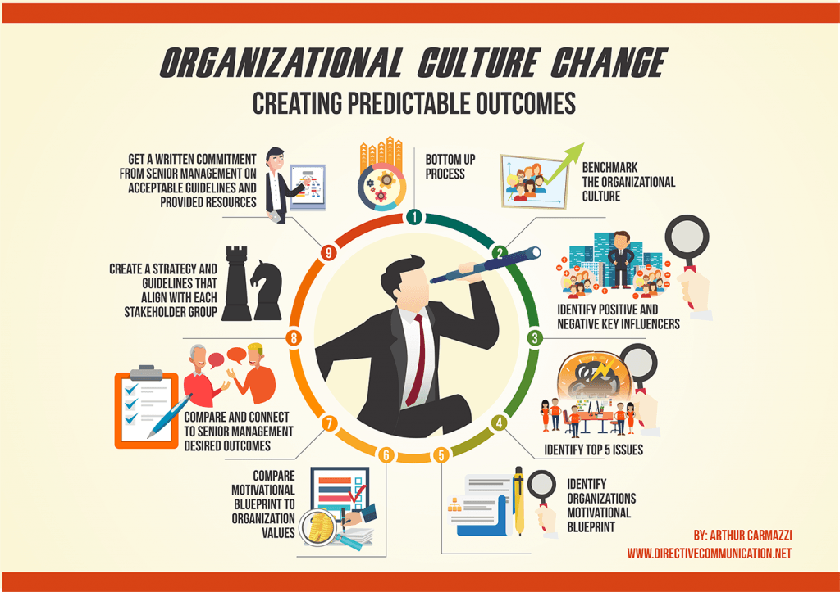

BAT annual report extractions


