
Building My Personal Brand and Professional Future in Health and Social Care: A Reflective Portfolio
Student name: Vannia Celia Delfino
Student ID:2322920

Module name: Changemarkers Bulding your Personal Brand for Sustainable Employment
Module code: BMHP5015-LON
Lecturer name: Brian Mashumba
Building My Personal Brand and Professional Future in Health and Social Care: A Reflective Portfolio
Introduction
This assignment is my reflection on my learning of four units of the module, 'Changemakers: Building Your Brand for Sustainable Employment.' The four units are: Unit 1 - Brand You, Unit 2 - It is a small world, Unit 3 - Opportunity Knocks and Unit 4 - The pursuit of happiness. Together, these units helped me to understand how I can build my own personal brand, how global connections and culture have an impact on health and social care, how I can recognise and utilise opportunities and how I can look after my well-being as a future professional.
In each section, I describe what I learned in the lectures and online activities and how this learning has influenced my thinking. I relate my thoughts to key concepts such as personal branding, cultural awareness, networking, goal setting, well-being and limiting beliefs. I also include screenshots from my online forum posts in order to provide evidence of my involvement with the module. Finally, I go on to explain how the knowledge and skills developed will help my future work in health and social care.
Task 1 – Reflection on Unit 1: Brand You
Unit 1 introduced me to the concept of personal branding and self-awareness. I learned that my personal brand is how I present myself to others, including my values, skills and behaviour. In terms of health and social care, this is very important as the patient and employers need to trust me and know what kind of professional I am. During the unit, I reflected upon concepts such as autonomy, self-determination and goal setting, which all contributed towards me painting a clearer picture of who I am, and who I want to become.
In one online activity, I picked the question concerning the meaning of autonomy. I wrote that autonomy means to have the freedom and independence to make my own decisions as well as to do what I do without needing constant approval. This got me thinking of the ways I need to be able to take responsibility and make safe decisions for the people I support as a professional. In another activity, I dealt with self-determination. I explained that self-determination is having the power and the right to be able to make my own choices and control my life. These ideas gave me an impetus to view myself as an active agent in my own career, rather than as someone who waits for things to happen (British Medical Association, 2024).
Unit 1 also helped me to think about my short-term and long-term career goals. I reflected on the fact that I want to complete my health and social care degree and have some work experience in a home and hospital, and in the future, have my own small care business. Writing out these goals allowed me to have a better direction and to be more motivated. Overall, Unit 1 showed me that my personal brand should represent me as a caring, responsible and determined person who is prepared to continue learning.
Unit 1 – Screenshots of Online Activities
Screenshot 1: Week 1 Forum – Meaning of autonomy.
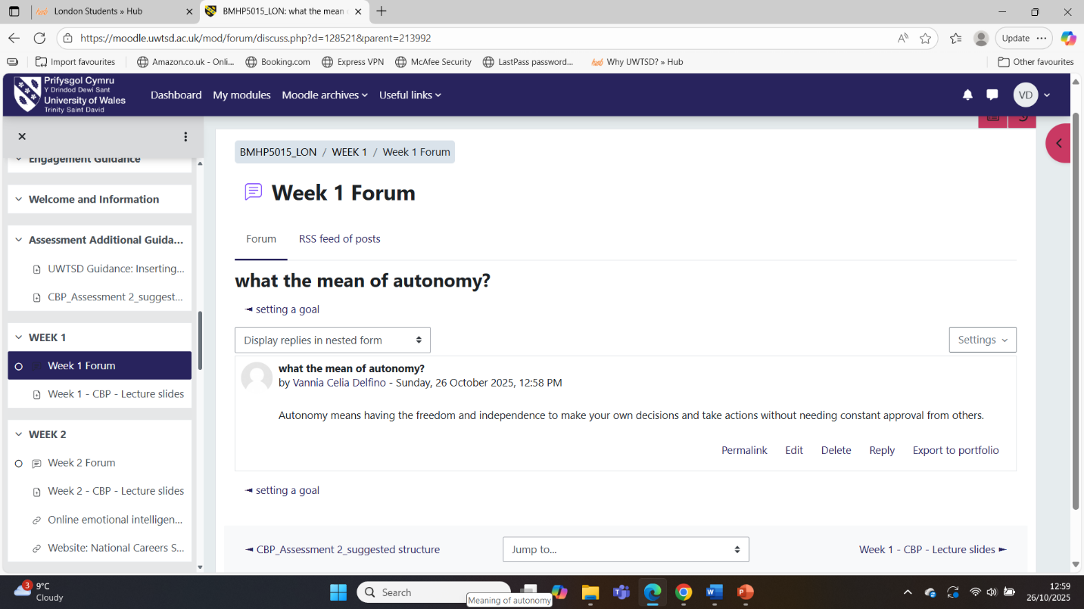
Screenshot 1 presents my Week 1 response on the forum on autonomy. I discuss that autonomy implies freedom and independence to decide on my own and to act without the approval of other people all the time. This screenshot will help me to realise that health and social care workers should respect the decisions of service users and remain responsible at the same time.
Screenshot 2: Week 1 Forum – Setting a goal. 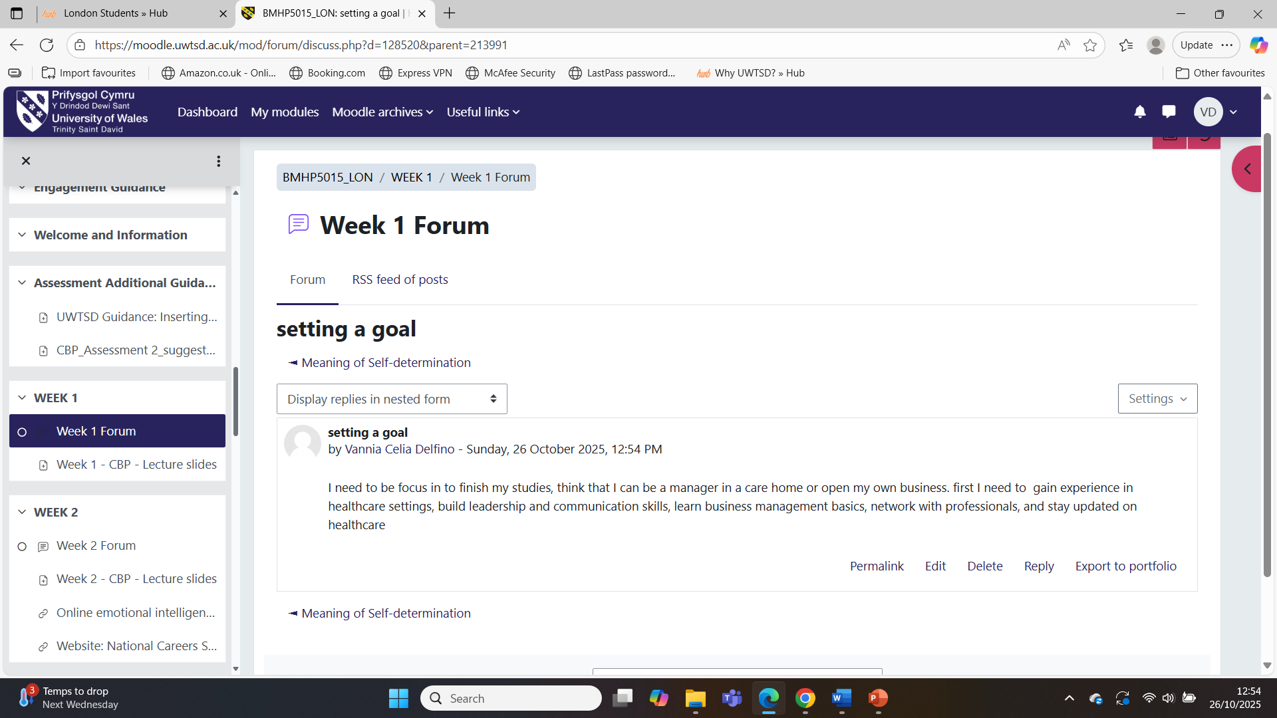

Screenshot 2 features my Week 1 forum post regarding setting a goal. I explain how I completed my degree, worked in health and social care facilities and eventually opened or managed a small care business. This screenshot demonstrates that I can formulate clear career objectives and relate them to my future career.
Screenshot 3: Week 1 Forum – Meaning of self-determination.
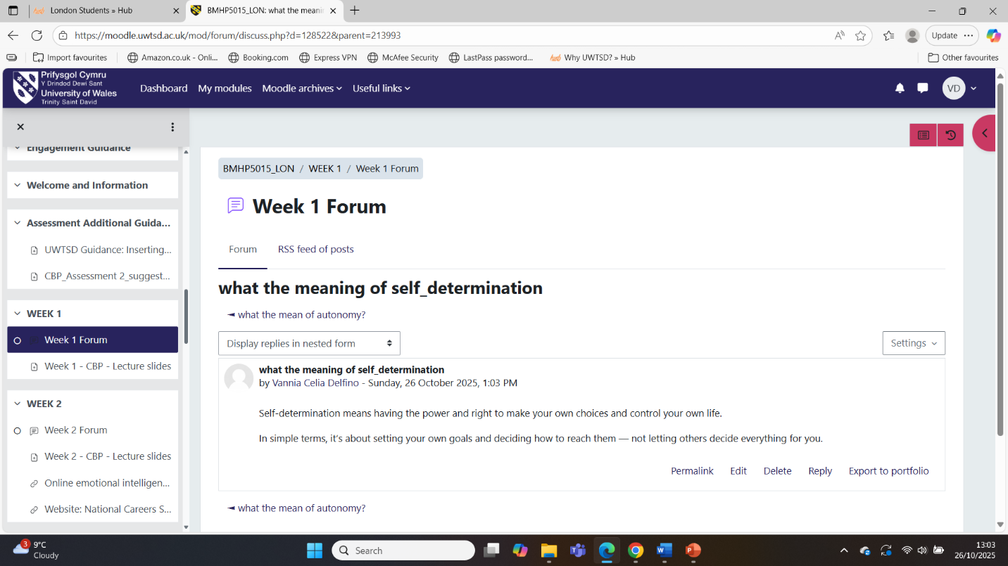
Screenshot 3 shows my contribution to the Week 1 forum regarding self-determination. I define self-determination as the ability and the right to choose my own and shape my life. This screenshot indicates that I appreciate independence and the importance of honouring the decisions of service users in the health and social care practice.
Task 2 – Reflection on Unit 2: It is a Small World
Unit 2 was about global connections, cultural diversity and changing patterns of work. A concept that I learned about is that modern careers are often boundaryless, which means that people can move between different jobs, organisations and even countries instead of staying in one job for life. This idea was connected to my own situation as an international student and helped me to imagine different possibilities for my future in health and social care.
In the online forums, I reflected on what a boundaryless career is. I wrote that it is not being stuck with one company or one strict path, but being able to move between jobs, learn new skills and explore opportunities that support growth. I also talked about soft skills such as communication, empathy and teamwork, which are key when dealing with people from other cultures. These posts made me recognise that my soft skills are one of my strengths and that they will help me adapt to a new environment.
Another important activity in this unit was the comparison between Brazil and the United Kingdom, based on the cultural dimensions of Hofstede. The chart showed that for Brazil, the power distance and the uncertainty avoidance score are higher, and for the UK, the individualism score is higher, and the indulgence score is also higher. Reflecting on this helped me to understand the expectations at work, and differences in communication styles can feel different in the UK. Overall, Unit 2 helped me to become more culturally aware and understand that respect for diversity is essential to good practice in health and social care (Kour and Jyoti, 2021).
Unit 2 – Screenshots of Online Activities
Screenshot 4: Week 2 Forum – What does a boundaryless career mean?
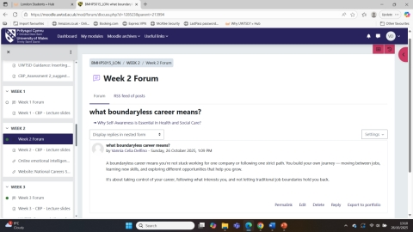
Screenshot 4 presents my Week 2 response in the forum on boundaryless careers. I have written that a boundaryless career is not staying with one employer but moving around between jobs, acquiring new skills and having opportunities. This screenshot shows that I am open to flexible career opportunities and realise how the contemporary labour market evolves.
Screenshot 5: Week 2 Forum – Brainstorm emotional intelligence.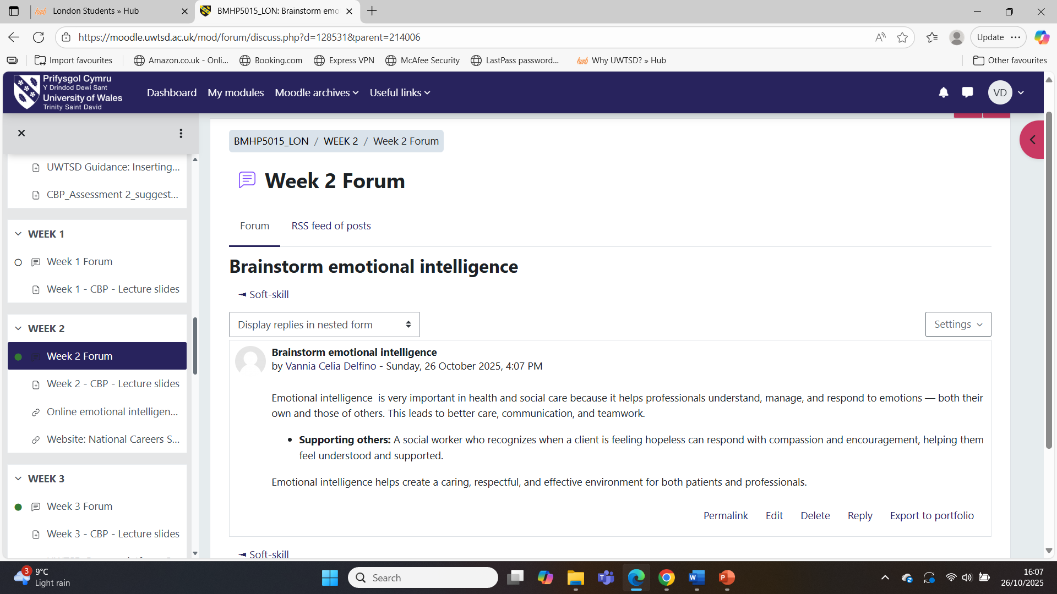

Screenshot 5 shows my Week 2 brainstorm on emotional intelligence. I describe emotional intelligence as being aware, controlling and reacting to emotions in myself and others and provide examples of health and social care. This is a screenshot of the fact that I consider emotional intelligence to be a valuable communication and teamwork skill.
Screenshot 6: Hofstede comparison chart – Brazil and the United Kingdom.
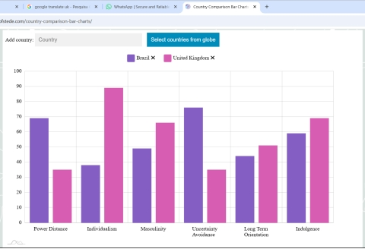
The bar chart of Hofstede of Brazil and the United Kingdom is shown in Screenshot 6. It presents scores of power distance, individualism, masculinity, uncertainty avoidance, long-term orientation and indulgence. The application of this screenshot made me reflect on the differences in culture and how culture may influence expectations, communication styles and professional relationships in care practice.
Task 3 – Reflection on Unit 3: Opportunity Knocks
Unit 3 assisted me in recognising and using opportunities for my personal and professional development. The main topics were about networking, professional relationships, professional online presence and skills for the job market. At first, I was nervous about networking, but during the activities, I began to realise that it is a natural part of working with others in health and social care (Nigar, 2021).
In one forum assignment, I answered the question "What does networking mean to you?" I wrote that networking is building relationships with people, sharing information, resources and opportunities. In some other activities, I explained the importance of increasing networking in health and social care. I said that good networking makes teamwork more efficient and helps us to provide better joined-up support for patients (Meneses-La-Riva et al., 2025). These reflections led me to the understanding that the idea of networking is not only about finding jobs, but also about the quality of care (Wani, 2024).
Another activity was to think about my skills, interests and the labour market. I did identify skills such as patience, good communication and empathy, and I mentioned places where I would like to work, such as Right at Home and St Helier Hospital. I also thought about the possibility of having to work as a self-employed individual one day. By relating these ideas to networking and online platforms, I can actually look for the opportunities rather than waiting for them. Unit 3, therefore, helped to boost my confidence in connecting with people and planning the next steps in my career (Mata et al., 2021).
Unit 3 – Screenshots of Online Activities
Screenshot 7: Week 3 Forum – What does networking mean to you?
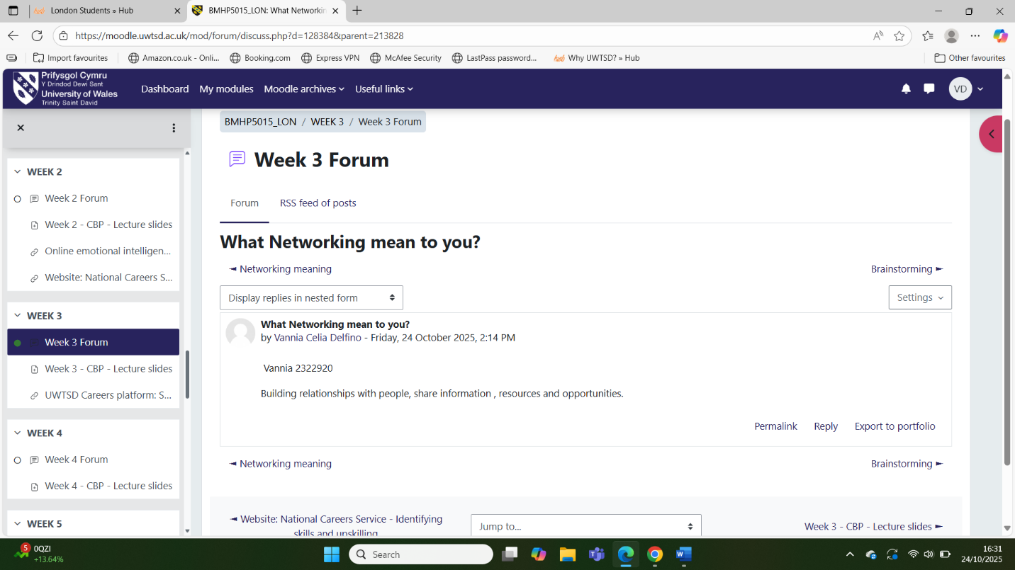
Screenshot 7 presents my post on the Week 3 forum in response to the question What does networking mean to you? Networking is the creation of relationships, the exchange of information, resources and opportunities. This screenshot shows that I have the concept of networking as collaboration and support, and that I recognise its usefulness in development and patient care.
Screenshot 8: Week 4 Forum – In what ways can professionals in health and social care make connections?
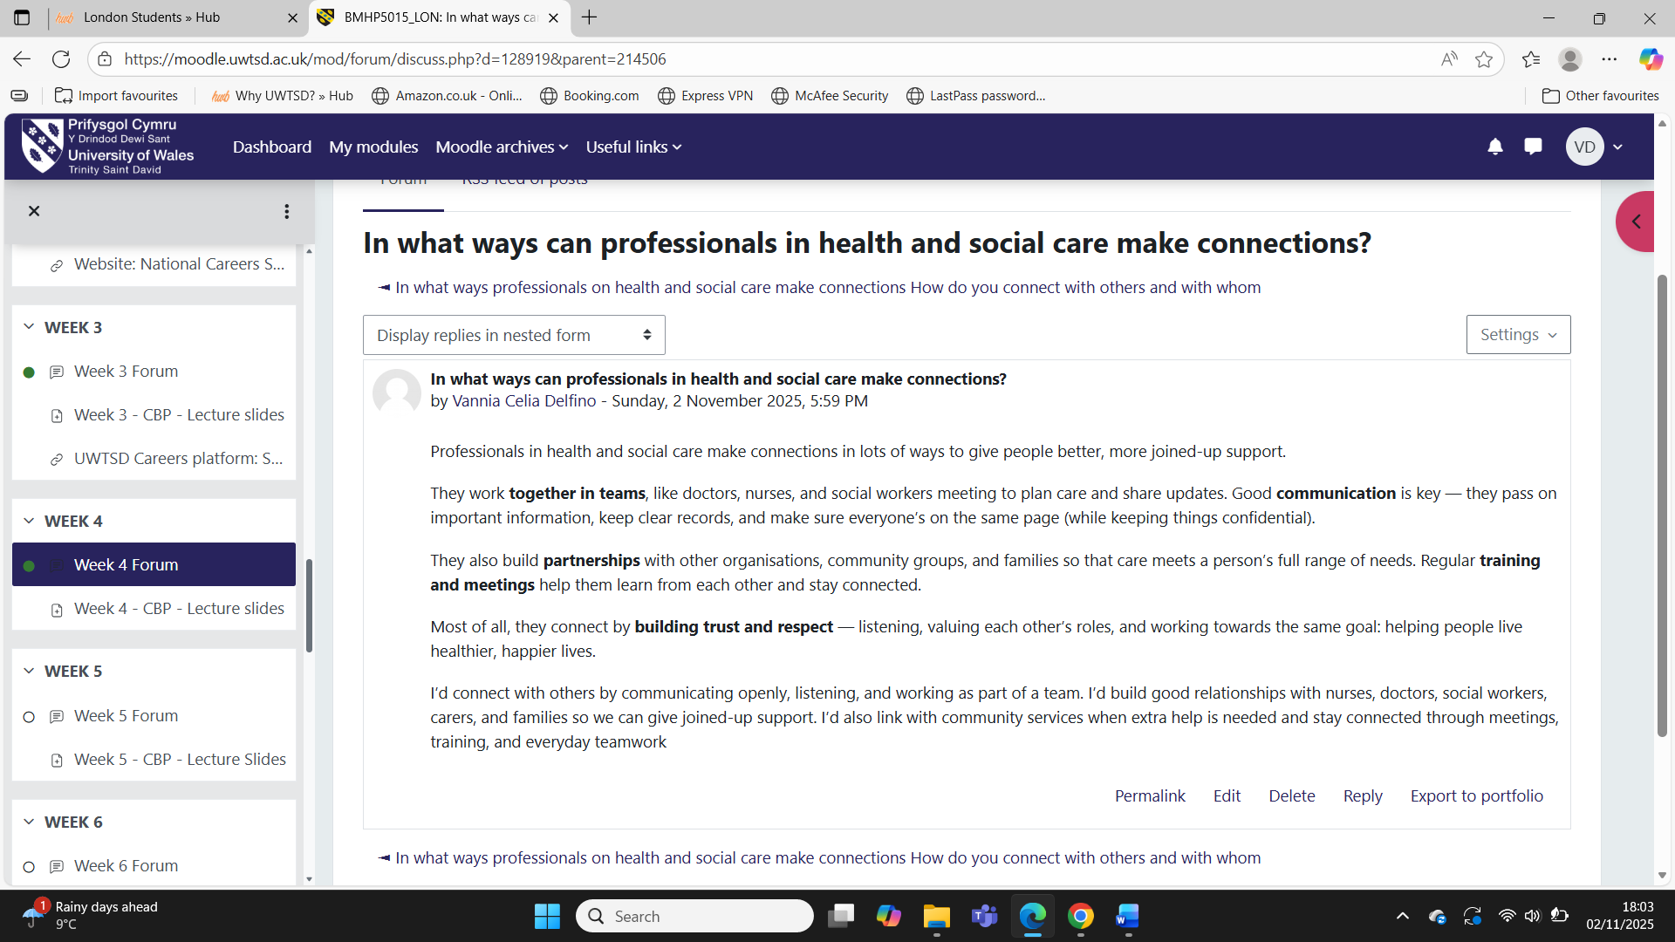
My Week 4 reflection on the way professionals in health and social care establish connections is shown in Screenshot 8. My teamwork, collaboration with organisations and families, frequent trainings and meetings, and the development of trust and respect are described. This screenshot demonstrates that I am aware of how professionals can work together in practice to ensure patients get holistic and coordinated care.
Screenshot 9: Week 5 Forum – Skills, interests and market.
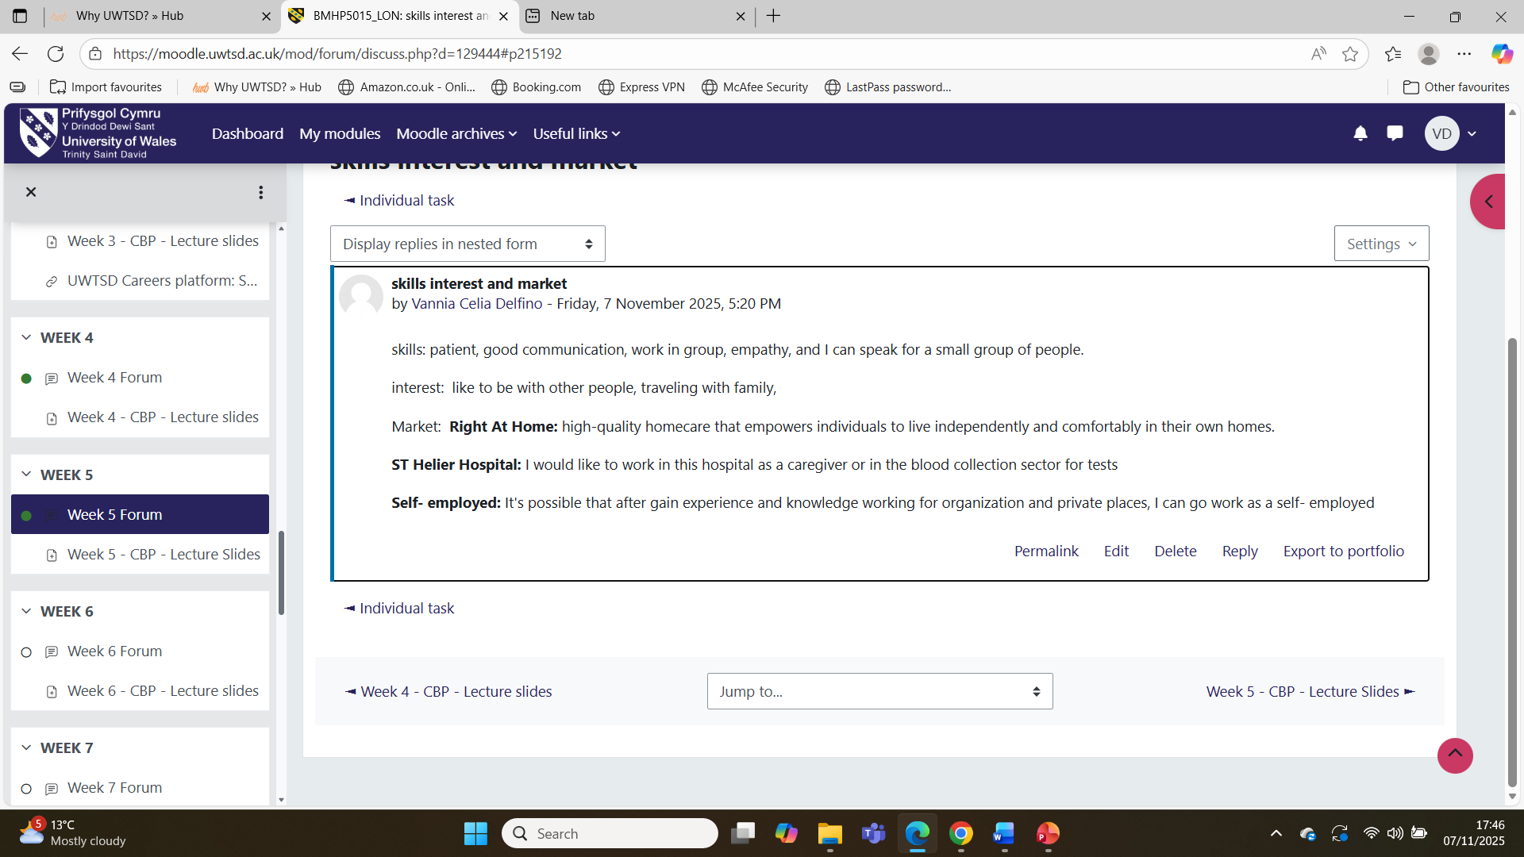
Screenshot 9 displays my Week 5 skills, interests and the labour market forum activity. The skills that I include on my list include patience, empathy, communication and teamwork, and the interests that I mention are working with people and travelling. I also refer to employers and self-employment. This screenshot shows that I am able to align strengths with opportunities.
Task 4 – Reflection on Unit 4: The Pursuit of Happiness and Overall Learning
Unit 4 was about well-being, resilience and limiting beliefs. This unit made me consider the impact of my mindset on my happiness and my future profession. I was informed that it is not selfless to take care of my own well-being. It is needed in case I would like to provide good care to others and prevent burnout in a stressful career (O’Neil and Kruger, 2022).
One of the activities in the forums, I considered the significance of perspective change in health and social care. I explained that it is necessary to have various points of view and concentrate on each case and each patient, in order to provide a better service (Khalife et al., 2023). The other assignment inquired about the serendipity attitude. This attitude implies the ability to be receptive to new things and to transform negative situations into something good. Such concepts made me view challenges as learning opportunities, as opposed to indicators that I ought to quit.
We also learned about limiting beliefs and positive self-talk. I also explained limiting beliefs as ideas which keep us in one place, such as the belief that we are too old, not smart enough or that we will never succeed. I then transformed these beliefs into positive ones, including that I can learn and grow, and it is never too late to start. This exercise helped me to be more conscious of my inner voice and inspired me to be kinder to myself. In general, Unit 4 helped me to synthesise all my learning throughout the module and demonstrated that self-care, resilience and a positive outlook on the future are also components of a good personal brand.
Unit 4 – Screenshots of Online Activities
Screenshot 10: Week 5 Forum – Importance of changing perspective in health and social care.
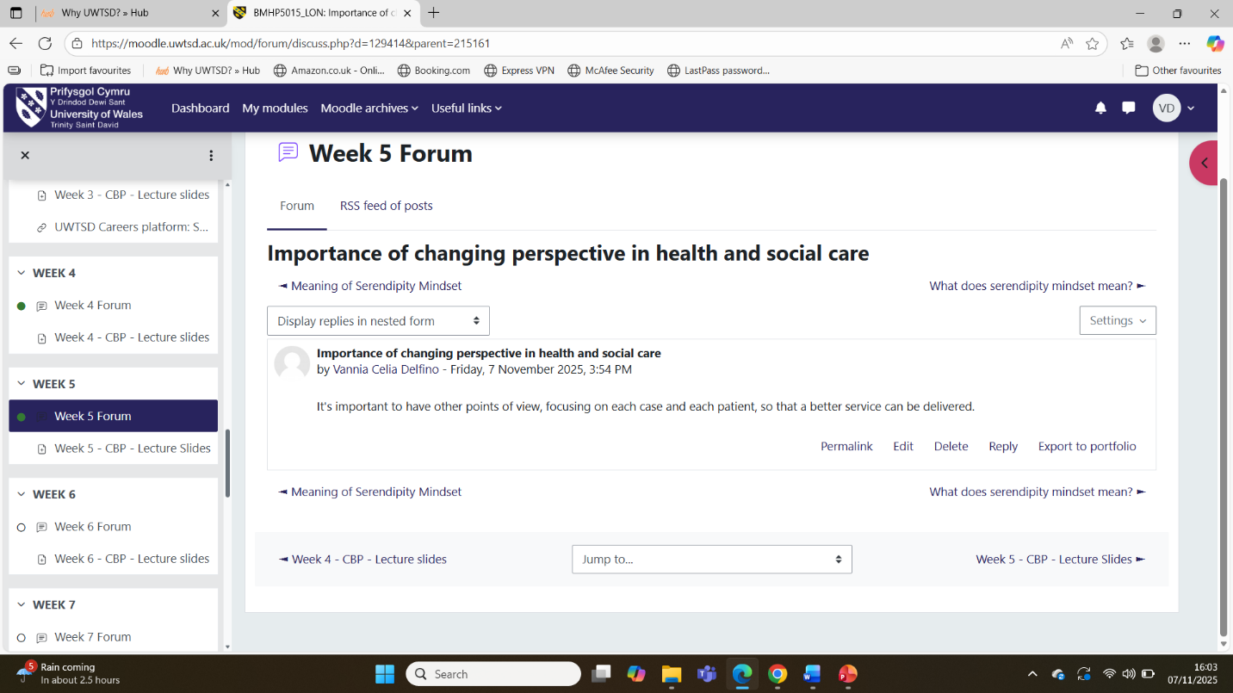
Screenshot 10 shows my Week 5 forum post concerning the value of perspective change in health and social care. The professionals should take into account various perspectives and concentrate on each patient to enhance service. This screenshot demonstrates that flexible thinking is in favour of person-centred care.
Screenshot 11: Week 5 Forum – What does the serendipity mindset mean?
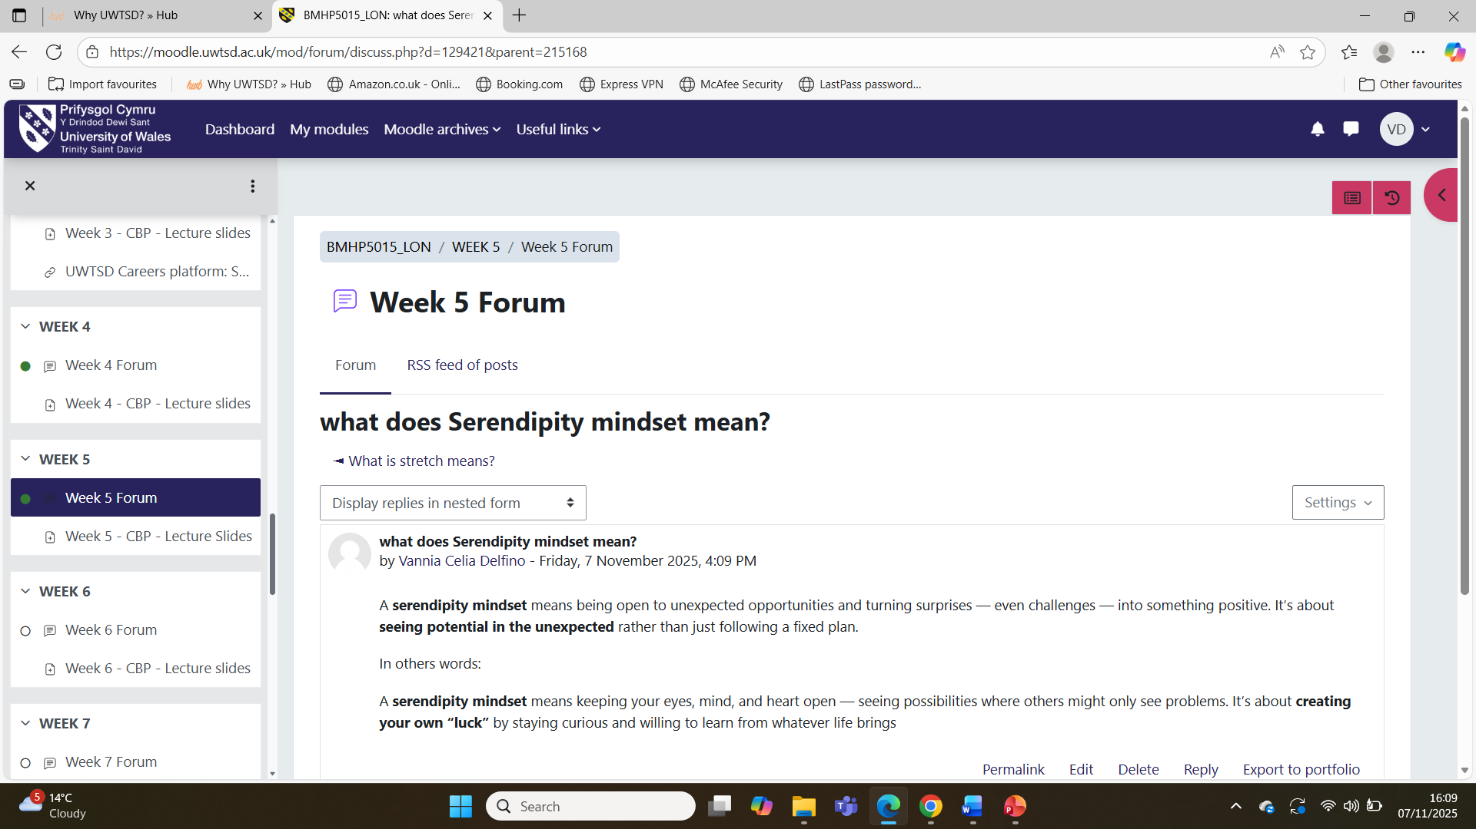
Screenshot 11 shows my answer in the Week 5 forum regarding the meaning of a serendipity mindset. I explain the ability to open to unanticipated opportunities, learn through obstacles, and perceive potential in unexpected events rather than having a predetermined plan. This screenshot indicates that I am becoming positive and hopeful about my career.
Screenshot 12: Week 7 Forum – From limiting belief to positive self-talk.
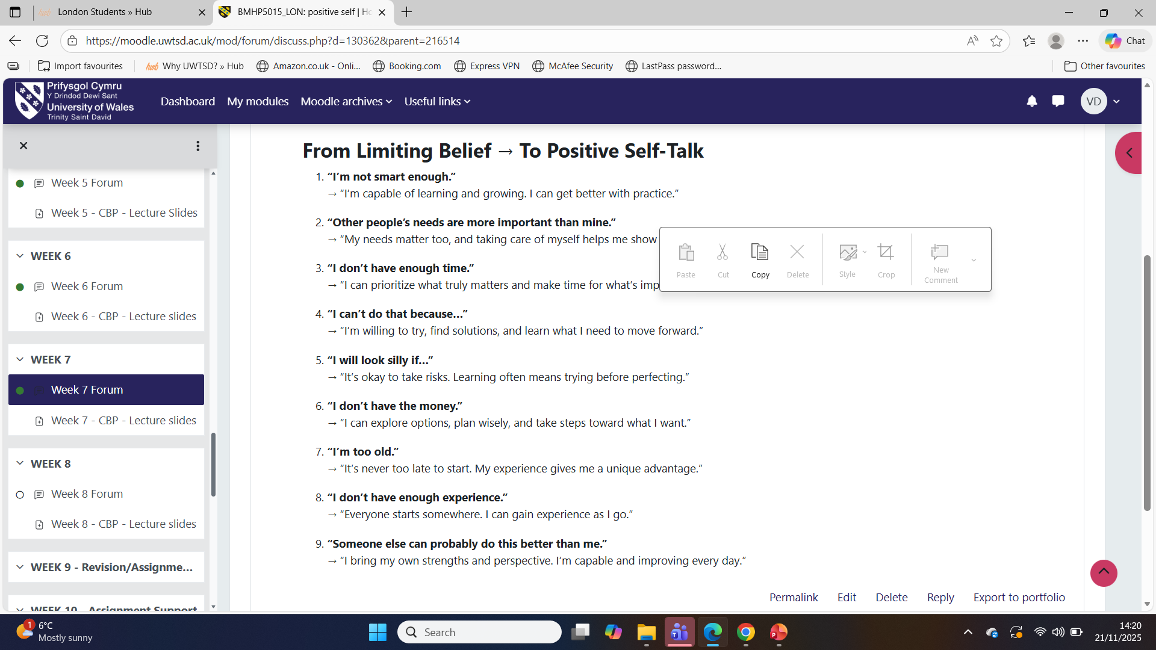
Screenshot 12 presents my forum activity in Week 7 when I transform limiting beliefs into positive self-talk. I make a more positive sentence for every negative statement, for instance. I am too old. This screenshot is evidence that I am training to overcome self-doubt and affirm my well-being with more positive messages about myself.
Conclusion
Overall, through the four units, I have gained a better insight into myself as a future health and social care professional. Unit 1 assisted me in determining my values, strengths and objectives. Unit 2 helped me to be more aware of the cultural diversity and global interconnections. Unit 3 demonstrated to me how networking, skills and online presence can lead to employment opportunities. Unit 4 has made me realise that to have a sustainable career, I have to be well, resilient, and have a positive mindset.
The screenshots used in this assignment demonstrate how I interacted with the online forums and applied the concepts of the module to my case. I will continue to apply what I have learned in the future to build my personal brand, establish good working relationships and take care of my own mental and emotional health as well as help others.

References
British Medical Association (2024). Autonomy or self-determination as a Medical Student. [online] The British Medical Association. Available at: https://www.bma.org.uk/advice-and-support/ethics/medical-students/ethics-toolkit-for-medical-students/autonomy-or-self-determination(Accessed: 27 November 2025).
Khalife, J., Ekman, B., Ammar, W., El-Jardali, F., Al Halabi, A., Barakat, E. and Emmelin, M. (2023). Exploring patient perspectives: A qualitative inquiry into healthcare perceptions, experiences and satisfaction in Lebanon. PloS One, [online] 18(8), p.e0280665. Available at: https://pmc.ncbi.nlm.nih.gov/articles/PMC10434906/ (Accessed: 27 November 2025).
Kour, S. and Jyoti, J. (2021). Cross-cultural training and adjustment through the lens of cultural intelligence and the type of expatriates. Employee Relations: The International Journal, 44(1), pp.1–36. Available at: https://www.researchgate.net/publication/353388962_Cross-cultural_training_and_adjustment_through_the_lens_of_cultural_intelligence_and_type_of_expatriates (Accessed: 27 November 2025).
Mata, Á.N. de S., de Azevedo, K.P.M., Braga, L.P., de Medeiros, G.C.B.S., de Oliveira Segundo, V.H., Bezerra, I.N.M., Pimenta, I.D.S.F., Nicolás, I.M. and Piuvezam, G. (2021). Training in communication skills for self-efficacy of health professionals: A systematic review. Human Resources for Health, [online] 19(1), pp.1–9. Available at: https://www.researchgate.net/publication/349899641_Training_in_communication_skills_for_self-efficacy_of_health_professionals_a_systematic_review( Accessed 30 November 2025).
Meneses-La-Riva, M.E., Fernández-Bedoya, V.H., Suyo-Vega, J.A., Ocupa-Cabrera, H.G., Grijalva-Salazar, R.V. and Ocupa-Meneses, G. di D. (2025). Enhancing healthcare efficiency: The relationship between effective communication and teamwork among nurses in Peru. Nursing Reports, [online] 15(2), pp.1–13. https://www.mdpi.com/2039-4403/15/2/59
Nigar, N. (2021). Networking and professional development in today’s world of work. Academia Letters. Available at: https://www.researchgate.net/publication/349381076_Networking_and_professional_development_in_todays_world( Accessed: 28 November 2025).
O’Neil, J.W. and Kruger, L. (2022). Mindset as a resilience resource and perceived wellness of first responders in a South African context. Jàmbá Journal of Disaster Risk Studies, 14(1). Available at: https://pmc.ncbi.nlm.nih.gov/articles/PMC9257934/( Accessed: 30 November 2025).
Wani, P. (2024). Connecting for success: The role of networking in medical education. PubMed, [online] 16(11). Available at: https://pmc.ncbi.nlm.nih.gov/articles/PMC11682727/ ( Accessed: 30 November 2025).

