Student Name: | Samsul Alom
Student Number: | 1605851
Module No: | BMSK5005_LON
Module Title:  Lecturer: | Developing Workplace Critical Thinking  Dr Husam Helmi

Contents
Page
- Introduction……………………………………………………………………………….1
- Definition of belief………………………………………………………………............2
- Brief discussion on the job role………………………………………………………...3
- Difference between belief, attitude & value……………………………………...3 to 7
- Management theories relevant to my role as a manager………………………….. 7
- Behavioural management theory…………………………………………………….. 7
- Maslow’s Hierarchy of Needs………………………………………………………… 8
- System theory…………………………………………………………………………. 9
- Theory X and Theory Y…………………………………………………………..9 to 10
- My own beliefs, attitudes and values relating to behavioural theory of management……………………………………………………………………. 11 of 12
- Reason to select behavioural theory of management……………………… 12 to 13
- Critical assessment of the impact of beliefs, attitudes and values on my behaviour in the workplace ………………………………………………………………...13 to 15
- Linking management theories to look at opportunities as a manager……………………………………………………………………..................15
- My Role and ranges of activities I perform in the workplace………………………15
- Linking management theories to my role……………………………………..15 to 16
- Evidence of wide reading and research……………………………………………..17
- Conclusion………………………………………………………………………………18
- Reference……………………………………………………………………… 19 to 20

List of Figures
Figure 1 Behavioural model………………………………………………………………...4
Figure 2 Beliefs, Values and Attitudes…………………………………………………….6
Figure 3 Maslow’s Hierarchy of needs…………………………………………………….8
Figure 4 Fiedler's contingency Model……………………………………………………..9
Figure 5 Theory X and Theory Y…………………………………………………………10
Figure 6 Own beliefs, values, and attitudes……………………………………………..12
Figure 7 Learning cycle……………………………………………………………………13

Introduction

In order to stay efficient and competitive within any industry, a company is required to develop an effective workplace environment in which it goes beyond the traditional structure as well as a hierarchical support that tends to serve an organisation and focus on people who perform the duty of building up the organisation. An organisation can develop an effective workplace in many ways such as effective communication, relationship-building, workplace safety, employee benefits and motivation. However, implementing these ways takes time but organisations can certainly reap the rewards there after as a result of an effective workplace environment. In recent times, organisations are emphasising on the importance of good workplace environments. This is because it improves the productivity and quality of organisational output. But it is not so easy to ensure such a desired workplace that can facilitate the organisation to meet these types of expectations. It requires detailed effort, competency, expert skills, application of theories and principles. This report will provide various workplace roles and responsibilities, management theories, workplace behaviour and attitude whilst considering my own experience in an organisation.

Page 1 of 20
(Rokeach, 1969) defines belief as any simple statement, feeling and or thought, from evidence and reasoning of what a person says or does (p. 113). He suggests that all beliefs are defined from a person who acts in a particular manner. Rokeach also proposed that beliefs can be defined from when a person states I believe that leaves fall from trees, I believe this apple tastes good or that a person who believes that it is desirable for children to listen to their parents. Rokeach also considers that the difference between belief and value is that it is within what you believe in and in which manner one should or should not behave.

Page 2 of 20
Brief discussion on the job role

The Department of Work and Pensions (DWP) is a public service not for profit business that provides benefits for the public of the United Kingdom. It also provides services for European customers. The UK’s DWP is the most leading welfare benefit social care provider on the globe. It works with doctors, clinical commission groups, and councils in order to deliver various care and support for all aged people, also known in part as the “Working age Directorate”. It also provides support to people with learning disabilities, mental health and physical disabilities. It now operates internationally into Europe and continues to provide pensions to people who have retired and moved over seas.

My role is to perform the role of a manager of the Work Capability Assessment (WCA) section decision makers for DWP. There are many responsibilities that I need to perform one of them being an extremely skilled person in dealing with difficult customers by phone. My other role is to communicate, motivate, and delegate with my staff members on a regular basis. However, there are other aspects of business that must be performed that has been described in this report, throughout. Standards of behaviour must be upheld although this is not the case for every eventuality as there is always some key points that require critical thinking as long as the operation has not been compromised.

Difference between belief, attitude & value

In our society, everyone is distinctively entitled to their own set of values, attitudes and beliefs. It is always expected that everyone should accept and respect the attitudes, values and beliefs of each other especially in my work place as it is a government public office. In spite of this others tend to differ in behaviour from person to person. Therefore, it is necessary to understand the difference between these concepts to develop a healthy workplace environment. This section describes the differences between the beliefs, attitudes, and values.

Page 3 of 20
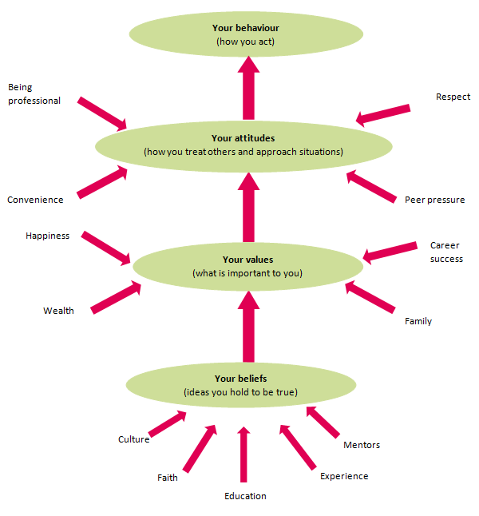
Figure 1 Behavioural model
(Source: iaa.govt.nz, 2018)

Page 4 of 20
Beliefs: according to (Wiklun, 2003) a belief is generally an idea that a person holds as a truth. Such belief of a person can base upon certainties, probabilities or particular matter of faiths. Belief comes from different sources such as – experiences of a person, acceptance of societal as well as cultural norms, people’s thinking etc. Change in one’s belief sits firm. This most often holds rational base because the belief of truth can change any time when they find a reason or evidence to question the truth. Since belief comes from one’s real experience, it may change when the original experience starts distorting from the originality. As a result, we establish the new belief that affects our daily life and quality of work significantly. A belief is a precious thing. This is because it reflects what we are and what we do. Such beliefs can be religious, moral, cultural, political and from having wealth. The diversity of belief is one of increasing conflicts in the workplace. Understanding how beliefs are formed and how they differentiate from each other can be a great advantage for any organisation.
Attitude: According to (Gable and Wolf, 2012) attitude means how we used to react when we see a person, object, or place. This can be either our like or dislike towards the thing most often. Besides, this attitude can be both like and dislike considering some particular aspect of an entire thing. Such an attitude of ours is formed over years, which is the result of both our conscious and subconscious aspects. Therefore, it is sometimes known as our instinctive nature. An example from our daily life is that one rich man may feel disgusting when he sees a beggar while another rich man may feel empathy towards the beggar and as a result, he may want to pass his help. (Best and Mayerl, 2013) found that attitudes change and evolve, from location, economy, culture, environment, and culture. Most importantly such attitude has both rational and irrational basis. Since attitudes refer to the mental dispositions that people have towards others around them, it is, therefore, an important component for a workplace. This is because a person can be influenced by their attitudes while making any decision in relation to a business.
Values: these are principles, standards and qualities of people and individual holding in high regard to them selves. Values guide the way that we live our daily lives (Jette et al., 2003). It also guides our decision-making approach. A value, therefore, is formed by a belief related to the worth of a behaviour or idea. For example, some people may find a great value in saving rainforest but someone who tends to rely on the regular logging of a forest may not see such great value in saving the rainforest. As a result, the value of individuals may not be the same always. Moreover, values can influence our judgements regarding things around us. Besides, our values govern our action in everywhere including the workplace. Therefore, positive values towards the organisation and employees are critical to business success.

Page 5 of 20
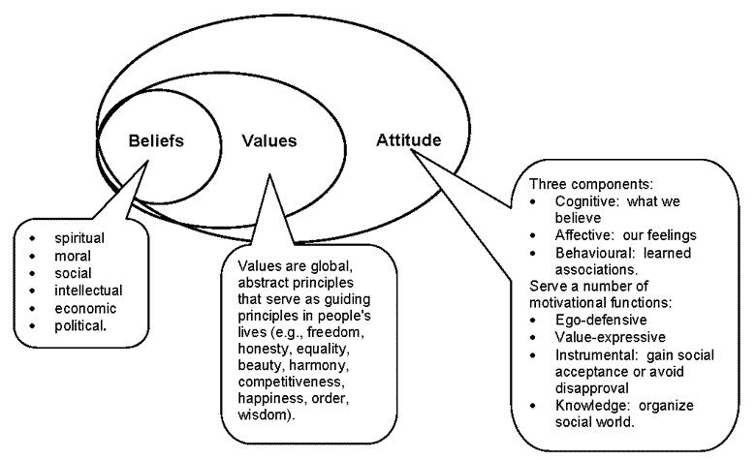
Figure 2 Beliefs, Values and Attitudes

The summary of the differences between belief, attitudes and values is in the following table.
 | Belief | Attitudes | Values
Definition | Conviction of confidence. | Immediate disposition to a person, place and object. | Ideals guiding our behaviours.
Changeability | Change over time. | Subject to change | Long-lasting
Source | Experience | Long lasting Beliefs and experience. | Family, peers, workplace.
Nature | Perception | Response | Judgement
Rationality | Rational | Both rational and irrational | Not rational always
Example | This course is important. | I enjoyed practising exercise today in the class. | Effective communication at the workplace is crucial.

Management theories relevant to my role as a manager

As a manager of the DWP WCA department, I need to work with both work colleagues, which includes managers and higher grade colleagues and customers. It wouldn’t be possible for me to perform my role without the assistant of relevant theories. As decision maker manager I am required to perform various activities. In the DWP, most of the activities are very sensitive because they directly related to the health and welfare of the public. Being a manager at the WCA section department, I always find the relevance of some management theories that can be applied in my practical job. This section has discussed some of those management theories that can be related to my role as a WCA manager.

Behavioural management theory

It is one of the most popular management theories which is often referred to as the human relations movement (Cole, 2004). This is because it addresses different dimensions of a human behaviour in the workplace. This theory believes the argument that a better understanding of different human behaviours in the workplace improved the dynamics of a workplace environment. Such understanding may include employee motivation, conflict, group dynamics and expectations, (Mayo, 2004). This theory asks the manager to create a safe environment where employee’s will have a feeling of freedom of sharing their own opinions and ideas. It also includes the proper recognition and valuation of their work at the workplace. Moreover, this theory suggests the managers to encourage employee’s to reflect on their own work and behaviour which will motivate them to improve their productivity. This is a result of some managers being close to them, which eventually limits their potential growth and the potential excellence of the team. The application of this theory motivates employees to build a high level of morale and new ways to transfer and collaboration of their ideas and thinking.

Page 7 of 20

Maslow’s Hierarchy of Needs

Hierarchy of needs theory by Maslow helped the managers visualise the employee motivation, (Cherry, 2014). Apart from some criticism, it remains valid until today for understanding human motivation, personal development and management training. This theory provides the outline of responsibility of the managers that should be performed at the workplace to encourage and enable the employees to fulfil their potential.
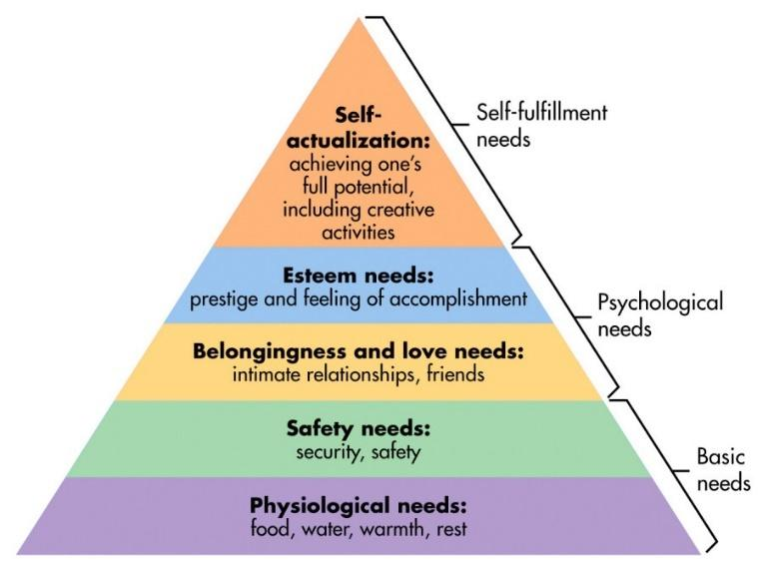

Figure 3 Maslow’s Hierarchy of needs
Source: (Simply Psychology, 2018)
On the other hand, contingency management theory is another popular management theory that can be linked to my role as a manager in the organisation (Garrison, 2001). The basic premise of this popular management theory is that there is more than one way that can lead to achieving the aims and objectives. It believes there are too many constraints including both internal and external constraints that lead to the best alternatives in a given situation for the organisation. In other words, this theory believes the best solution depends on the situation.
Page 8 of 20
A direct correlation between leadership traits and leadership effectiveness was explored by contingency theory (Saadé and Bahli, 2005). It explains that certain leadership traits are helpful in certain crisis and therefore such leadership approaches require a change in the new circumstance. Three concepts have been described by Fielder’s following contingency theory that includes:
1) there is no best way that can manage an organisation
2) leaders must have the ability to identify the best management style, and
3) least preferred co-worker scale.
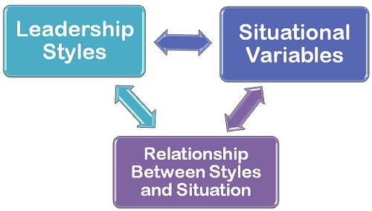

Figure 4 Fiedler's contingency Model
Source: self-made

System theory

The system theory focuses on the broader view of management in which the organisation is viewed as a unified, purposeful and whole entity that is composed of different parts. According to (Rice, 2014) it emphasises one aspect such as task, people, or decision-making at first. Then it applies them under definite assumption set. Since it sees the organisation as an interconnected body of several functions, therefore it doesn’t analyse things independently. As a result, an effective communication system builds up within the organisation which makes the task of a manager easy and comfortable. It is also known as a unified management theory that encompasses the concepts of process, quantitative and behavioural theory.

Theory X and Theory Y

(McGregor’s, 2008) Theory X and Theory Y explain two different styles of management in which Theory X refers to an authoritarian approach and Theory Y refers to the participative approach. According to (McGregor and Cutcher-Gershenfeld, 2008) if the managers find that their team members dislike their assigned work and have poor motivation, managers are likely to use an authoritarian approach which in fact refers to the Theory X. According to (Arslan and Staub, 2013) this authoritarian approach is a hands-on approach and usually in micromanaging the work of the

Page 9 of 20
people to ensure the proper accomplishment of their work. In contrast, if it is seen that people take pride in their own work take their works as a challenge, then it is expected to adopt Theory Y which means participative management style. Manager practised this approach tend to develop trust in their people.
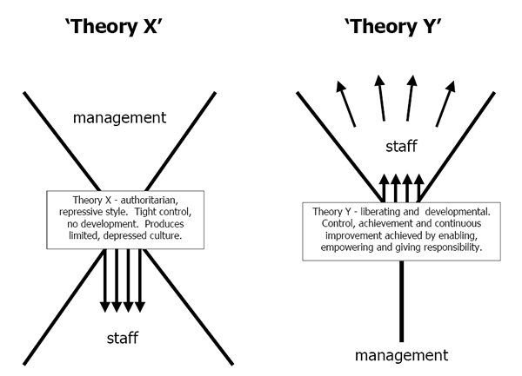

Figure 5 Theory X and Theory Y
Source: (Conjunctured.com, 2018)
Page 10 of 20
In this part of the report a critical assessment of my own beliefs, attitudes and values being a manager relating to behavioural theory of management.

In the earlier discussion, it was described that the beliefs, attitudes and values of people vary from each other. As a result, in our various roles in the workplace, our own belief, attitudes, and values constantly interfere with those of others. According to (Gibson, 2009), harmonising our value systems can generate the business success both in our personal and professional environment.

My own beliefs, attitudes and values

The following figure is showing my own beliefs, values and attitudes. It is showing my sources of beliefs that I used to believe as true are my religion, education, culture, faith, and mentors. In contrast, the values that are important to me include my happiness, wealth, family and my success at everything. My attitude towards others in my workplace, include professionalism, respect, peer pressure and convenience. These are the things that guide me in my personal and professional life. These things outline what I am and what I do in general. Now it is necessary to link these beliefs, attitudes and values to my professional role to be being a manager. (Bean, 2011) has shown that my belief can interact with the belief of my colleagues.

Most importantly my educational belief may interact with them also because of the difference and gap between my educational qualification and their educational background. Since the UK is full of different religions, it is certain that interaction of religious beliefs at the workplace can arise. By values such as happiness and success can develop some positive attitudes towards my workplace. The passion for success can encourage me to do things in the best possible way.
So that I focus on the effective workplace which can bring my success. My professional attitudes guide me to control my emotion in the workplace which is essential for every professional. Besides, peer pressure will present the importance of their collaboration and support. My attitude to paying respect to the people at the workplace will certainly create a healthy environment in which everyone will feel fresh and energetic while working. All these beliefs, values and attitudes guide me in developing the desired workplace for the employee. According to (Goetsch and Davis, 2014) it makes employee feel safe, energetic, and motivated every time.

Page 11 of 20
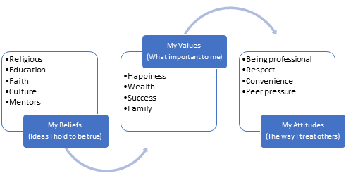
Figure 6 Own beliefs, values, and attitudes
Source: Self-made
Since the report is about developing workplace through critical thinking, managers and myself must possess the ability to think things critically. According to Andrews and (Lewis, 2002), an effective manager generally means a good thinker. This is because good thinking is the combo of both critical as well as creative thinking skills of the individual that supposed to possesses the right belief and value systems. In fact, critical thinking leads to influence motivation, engagement as well as intention in a specific task (Elliott and Turnbull, 2004). In order to ensure all these, a positive attitude from the managers is necessary in order to motivate and engage the workers. Management theories help the manager to build and encourage the workers in becoming more productive. Such a theory also teaches them how to be a good boss. Besides, it is the key to success in dealing with the issues and conflict that arise at the workplace.

Reason to Select Behavioural Theory of Management

Being a manager of WCA, the behavioural theory is always a great helpful tool for me (Greenberg and Zhang, 2010). This theory explains the understanding of human behaviour at the workplace concerning employee motivation and their productivity. For example, employees at my workplace are offered over time weekends and bank holiday work if they show a higher performance level. In contrast, they are also offered growth opportunities through further study and training if managers find employee’s with great productivity and efficiency. According to (Browne and Keeley, 2007) this is the most effective way to influence organisational overall performance. If we go for checking at the best companies to work for in the UK, we will see their exclusive focus on the values of the company and engagement of the employees

Page 12 of 20
that are their highest agenda. Some studies show that one-third of the employees work at their full potential because of poor motivation which directly explains lack of managers in putting extra effort. Therefore, it is completely justifiable to rely on behavioural management theory. Besides, this theory teaches how to shape the behaviour of the staffs gradually towards the organisational culture and vision. This theory supports the idea of different leadership traits which can be learned by everyone through development and experience. It argues that a leader makes it possible to making changes. As a result, it encourages the study of business experts to develop various leadership approach, styles and traits.

Critical assessment of the impact of beliefs, attitudes and values on my behaviour in the workplace

According to the learning cycle of Kolb, the experience is not sufficient for learning (Kolb, 2014). This cycle puts focus on the reflection on one’s own experience, knowledge base, and then identifying new concepts and ideas which can later be applied to new situations. This is because without the reflection it is certain that we will continue doing the same mistakes repetitively. Therefore, it is necessary to reflect on the belief, attitudes and values of myelf at the workplace (Kolb and Kolb, 2009).
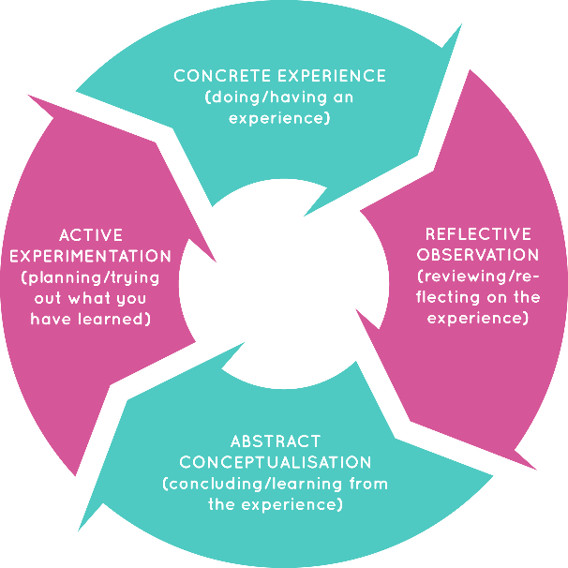
Figure 7 Learning cycle
Source: (Coworkshops, 2018)
Page 13 of 20
We all know that our beliefs tend to grow from the ration of observing, hearing, reading, thinking and experiencing various things around us. Based on these, we finally develop our opinion as a truth that ultimately stands as our belief. From such belief, we then develop our values which can be correct or incorrect compared to the evidence. (Gray, 2007) found that experience strengthens our values and beliefs. For example, a patient may require an immediate blood transfusion, but her daughter may refuse to do that when her mother was placed in the situation between life and death. This is because she may believe blood transfusion isn’t permitted in their religion and that’s why it is against their religion which can’t be accepted by her.
But on the other hand, she may want to prolong the life of her mother. As a result, she may break her long-established conviction and agree to the doctor’s advice for blood transfusion and ultimately her mother could recover. It is an example that proves that our beliefs and values can change over time after encountering new challenges against the previously held views. (Halpern, 2013) addressed in his discussion that some tend to believe in the God’s miracle, and some belief in both god and human beings. Besides, how we deal with the colleagues and customers is the reflection of our own belief, attitudes and values.
In my workplace, I always ask the colleagues to treat the service users in the way they might treat their own family members which I learn from my family’s contribution in upbringing. My established belief, state that we should treat others in the way we want to be treated by others. The meaning of this believe is that the positive attitude as well as behaviour we will show to others, they will also do the same to me or someone else. However, despite having positive attitudes, it doesn’t guarantee that I can please everyone every day (Greenberg and Zhang, 2010).
As a result, I also face conflicts and various issues at the workplace. This is because people have a different belief, values and attitudes and they sometimes conflict with each other. It often happened with me during the teamwork for managing critical emergency enquiries. Such conflicts due to the difference between beliefs, values and attitudes taught me an important lesson that despite being different, thet gap should be bridged to resolve any issues and conflicts. This attitude can lead to generate a positive outcome for the organisation.
However, being a manager, it is not easy to understand own values, beliefs, and attitudes. Besides, it is also difficult to understand the importance of not affecting the employee in their work strictly. Therefore, it is always essential to leave my own personal values out of my colleagues and customer relationship (Colquitt et al., 2011). This is because it will allow the colleagues to make their own perception and decisions based on their own established values and beliefs. During my work, it was experienced by me several times that we hardly concern about the different attitudes, beliefs and values of others. Most often I am asked for necessary information related to my team members’ performance and activities. But I frequently found that everyone in this regard can be relied on and trusted to take the responsibility for the work. Besides, it was also experienced by me that some people used to blame others. For example, some member once said that they didn’t receive the information I provided them which was fully a false claim. This is because the rest of the team members received the information. However, another type of

Page 14 of 20
experience I saw sometimes that some employees tend to lie regarding their work. As a result, my perception, belief, and attitudes changed about them.
It, in fact, generates a negative value about them that they are no longer to be trusted for important tasks (Robbins and Judge, 2012). But I noticed that my changing perception wasn’t helping me get the best out of the employees. And then I realised my belief, attitudes, and values as a manager more are quite different from those of the employees as they believe it is me who is responsible for their lower performance. They were sceptical about the matter that I may feel something else when they present or ask anything from them. That’s why they often tried to lie to me to please top management. It was the result of poor communication at the workplace which I later sort out through arranging meetings and discussing with them.

Linking management theories to look for opportunities as a manager

There are various management theories that can benefit both the organisation and employees. Therefore, understanding the link between the role and management theories is necessary for everyone in developing an effective workplace.

My Role and ranges of activities I perform in the workplace

There are various activities I need to perform as the manager of this organisation. The very first thing that I need to do is ensuring the daily functioning of every group. According to (Sorne-Romero, 2013), this is because the malfunctioning of any department can threaten the successful outcome of the company. I also have to perform the duty of my colleagues that includes the activities of interviewing, hiring, and most importantly training the employees. Sometimes, I need to involve in the decision-making process to set organisational goals. I need to communicate with my colleagues as well in different matters. I also need to delegate tasks according to the needs of different departments. One of the most important tasks I need to do is motivating colleagues so that they can work to their full potential. If there are any issues detected in their poor performance, I then need to arrange training and development programs for them. Most importantly I evaluate their performance report as well to determine their performance variance. These were some common activities that I need to do being a manager.

Linking management theories to my role

In this section, I have chosen three different theories that can benefit me while playing my role as a manager. Those theories are contingency theory, systems theory, theory X and theory Y. The rationale for choosing these theories have been described in the below.
Contingency theory
Contingency theory explains that leaders in an organisation fall into two different categories – task-oriented and people-oriented. (Fiedler and Garcia, 1987) also
Page 15 of 20

proposed three different elements to this theory for effective leadership. Besides, this theory teaches the management that there is no one best solution but there is the different best solution for the different situation.
There are lots of opportunities that can be gained through the application of this theory to the organisation. Such as:
- Flexibility is important for any organisation (Osland and Turner, 2011). This is because the business environment can change any time and the organisation, as a result, need to prompt responses. Failure to making timely response can lead to the ultimate devastation of the organisation. But contingency theory asks for considering every situation as a different event so that the organisation can think about a new solution every time.

- Under the contingency theory of (Fiedler and Garcia 1987), the effectiveness of workplace directly depends on the relationship between the employees and management. Therefore, it promotes the relationship approach which is beneficiary for building effective workplace.

- According to Wagner III and (Hollenbeck, 2014), it promotes leadership. It believes that anyone can be a leader. Therefore, this theory asks for preferring an individual with good interpersonal skills when the organisation is poorly structured. Therefore, it is a good way to bring new leaders through a systematic approach.
Systems Theory
We all know that effective communication is one of the major components of creating an effective workplace. An effective communication is possible only when the organisation starts considering all the departments so that an integrated communication system among them can be established. The following opportunities can be avail from the application of systems theory in Care UK.
- According to Liu and (Forrest, 2010) it can focus on specific objectives of each department since this theory asks for considering each and every part of the organisation. Therefore, as a manager, it will be easy for me to establish an effective interrelation among the departments.
- The practice of system theory can benefit me to identify the areas that require much emphasis than other departments.

Theory X and Theory Y
Another management theory developed by McGregor can be linked to my role as a manager at Care UK. This theory explains two different approaches of leading an organisation. It discusses when to use which theory to generate the desired outcome for the organisation. It provides the following benefits for the manager.
- It helps to analyse the situation so that organisational circumstances can be determined.
Page 16 of 20

- It helps to apply an authoritarian approach when the employee of the organisation has poor motivation and performance.
- It helps to apply a participative approach when the employees are willing to take every single challenge through their competency and skills.
Evidence of wide reading and research
This report has made a long discussion on developing workplace. This discussion has included various aspects of developing workplace critical thinking. In order to justify the discussion, various theories and models were used as well in order to substantiate the discussion. First, the explanation of belief, values and attitudes were made using different source of literatures. Then a model was presented that describes how our behaviour, both in workplace and personal life, is formed.
Then various management theories were described as well that are relevant to my role in an organisation. Behavioural theory shows the importance of understanding and building relationship with employees. Contingency theory shows the flexibility of making appropriate solution to changing organisational situation based on past experience. Theory X and Theory Y developed by Douglas Macgregor explains two distinctive approach of leadership to effectively manage the workplace. Then the system theory was also discussed in relation with my role as being a manager. Maslow’s hierarchy of needs theory shows the visual representation of managers. This essay discusses the application of these theories as well.

Page 17 of 20

Conclusion
The success of an organisation depends on the quality of its workplace. The discussion throughout the report substantiates the fact that poor workplace condition is detrimental to employee performance. It deters the employees to work at their full potential. But a good workplace can be developed through critical thinking that includes both creative and in-depth understanding of the workplace (Driver, 2011). It also discusses the link between professional role and different management theories in developing a healthy workplace. However, the difference between the concepts of beliefs, values and attitudes was a very crucial part of this essay which will help the managers. It will also help organisations understand the differences in beliefs, values and attitudes from person to person so that they can know the consequences of the impact of such differences. The better strategy can be developed after understanding the workplace. This report also benefits the organisation and managers to an emphasis on the staffs through creating good relationship environment within the organisation. Any Learner from the academic and professional background can get many important insights into developing workplace.

Page 18 of 20

References

Andrews, D. and Lewis, M. (2002). The experience of a professional community: teachers developing a new image of themselves and their workplace. Educational Research, 44(3), pp.237-254.
Arslan, A. and Staub, S. (2013). Theory X and Theory Y Type Leadership Behavior and its Impact on Organisational Performance: Small Business Owners in the Şishane Lighting and Chandelier District. Procedia - Social and Behavioral Sciences, 75, pp.102-111.
Browne, M.N. and Keeley, S.M., 2007. Asking the right questions: A guide to critical thinking. Pearson Education.
Bruce, K. and Nyland, C., 2011. Elton Mayo and the deification of human relations. Organisation Studies, 32(3), pp.383-405.
Cherry, K., 2014. Hierarchy of needs. Retrieved Aug, 16, p.2014.
Cole, G.A., 2004. Management theory and practice. Cengage Learning EMEA.
Colquitt, J., Lepine, J.A., Wesson, M.J. and Gellatly, I.R., 2011. Organisational behavior: Improving performance and commitment in the workplace. McGraw-Hill Irwin.
Driver, M., 2011. Fostering creativity in business education: Developing creative classroom environments to provide students with critical workplace competencies. Journal of Education for Business, 77(1), pp.28-33.
Elliott, C. and Turnbull, S. eds., 2004. Critical thinking in human resource development. Routledge.
Feather, N. T. (1975). Values in education and society. New York, US: Free Press.
Fiedler, F. E., & Garcia, J. E. (1987). New approaches to effective leadership: Cognitive resources and organizational performance. Oxford, England: John Wiley & Sons.
Gable, R.K. and Wolf, M.B., 2012. Instrument development in the affective domain: Measuring attitudes and values in corporate and school settings (Vol. 36). Springer Science & Business Media.
Garrison, D.R., Anderson, T. and Archer, W., 2001. Critical thinking, cognitive presence, and computer conferencing in distance education. American Journal of distance education, 15(1), pp.7-23.
Gibson, J.W., Greenwood, R.A. and Murphy Jr, E.F., 2009. Generational differences in the workplace: Personal values, behaviors, and popular beliefs. Journal of Diversity Management, 4(3).
Goetsch, D.L. and Davis, S.B., 2014. Quality management for organisational excellence. Upper Saddle River, NJ: pearson.
Gray, D. (2007). Facilitating Management Learning. Management Learning, 38(5), pp.495-517.
Greenberg, J. and Zhang, Z., 2010. Managing behavior in organisations. Boston, MA: Pearson.
Halpern, D.F., 2013. Thought and knowledge: An introduction to critical thinking. Psychology Press.
Jette, D.U., Bacon, K., Batty, C., Carlson, M., Ferland, A., Hemingway, R.D., Hill, J.C., Ogilvie, L. and Volk, D., 2003. Evidence-based practice: beliefs, attitudes, knowledge, and behaviors of physical therapists. Physical therapy, 83(9), pp.786-805.
Kolb, D.A., 2014. Experiential learning: Experience as the source of learning and development. FT press.
Kolb, A.Y. and Kolb, D.A., 2009. The learning way: Meta-cognitive aspects of experiential learning. Simulation & Gaming, 40(3), pp.297-327.
Liu, S. and Forrest, J.Y.L., 2010. Grey systems: theory and applications. Springer Science & Business Media.
McGregor, D. and Cutcher-Gershenfeld, J. (2008). The human side of enterprise. McGraw-Hill Professional.
Osland, J. and Turner, M., 2011. The organisational behavior reader. Pearson.
Rokeach, M.(1969), Beliefs, Attitude and Values: A Theory of Organization and Change. San Francisco: Jossey-Bass, 1968, 214pp.
Saadé, R. and Bahli, B., 2005. The impact of cognitive absorption on perceived usefulness and perceived ease of use in on-line learning: an extension of the technology acceptance model. Information & management, 42(2), pp.317-327.
Wagner III, J.A. and Hollenbeck, J.R., 2014. Organisational behavior: Securing competitive advantage. Routledge.
Wiklund, J., Davidsson, P. and Delmar, F., 2003. What do they think and feel about growth? An expectancy–value approach to small business managers’ attitudes toward growth. Entrepreneurship theory and practice, 27(3), pp.247-270.

.

Page 20 of 20

