

LEVEL 4

SEMESTER 2

MODULE CODE: SHSS4078
Adventure: A Risk worth Taking

aSSESSMENT TYPE: aSSIGNMENT
Assessment/Component: 1 (Part A)
COMPONENT WEIGHTING: 40 %
WORD COUNT: 2000 WORDS
MODULE TUTOR: Denise leonard

Assignment:
Complete a logbook recording every activity session you complete during this module and include these as appendices to your submission.

With reference to a critical incident case study that we have examined, identify one key contributing hazard. Evaluate your own personal logged experiences in different activities, of risk management in relation to this identified hazard. You should include a synopsis of the critical incident case study in your appendices.

SUBMISSION DETAILS:

Deadline:
Date: 4th May 2018
Time: 3.00pm
Portal: Turnitin

School of Sport, Health & Outdoor Education

Assessment Feedback Sheet

Student No./Name: 1704569 / Elliot Davies
Module: SHSS4078
Module Code: Adventure: A Risk Worth Taking

Personal Evaluation – to support your academic progress please complete the section below BEFORE submitting your work.
What do you consider to be the best aspects of this work? |  |  | My explanation on why it is important to keep experienced in an activity.
Which aspects do you consider could have been improved in this piece of work? |  |  | I wanted to include an evaluation within my essay. Word count could have been higher.
What have you found most satisfying whilst undertaking this submission? |  |  | Researching different events which had negative impacts on the outdoor industry is interesting and gives thought to my potential future.
ASSESSMENT CRITERIA | Learning  Outcomes |  | GRADE
ASSESSMENT CRITERIA |  |  | Poor  0 – 25% | Unsatisfactory  26-39% |  | Satisfactory  40 – 49% | Good  50 – 59% | Very Good  60 – 69% | Excellent  70 – 85% |  | Exceptional  86– 100% | %
Complete logbook for each session | All |  |  |  |  |  |  |  |  |  |  | 15%
Provide a synopsis of a critical incident case study | All |  |  |  |  |  |  |  |  |  |  | 15%
Identify a specific significant hazard and the risk it poses to undertaking adventurous outdoor activities. | 1,2,3,5 |  |  |  |  |  |  |  |  |  |  | 30%
Discuss a range of appropriate measures that might effectively control the identified hazard and consequent risks. | 1,2,3,5 |  |  |  |  |  |  |  |  |  |  | 30%
Appropriate references used and correctly formatted | All |  |  |  |  |  |  |  |  |  |  | 10%
It is expected that students will present work that is proof read, correctly referenced and adheres to the Assessment Checklist. Therefore a range of 0 – 10 marks will be deducted for non-completion of any of the points on the checklist below.
TUTOR COMMENTS:

Submission date:  via Turnitin |  | Return date:  (at least within 4 weeks) |  |  | Tutor: Denise Leonard |  |  |  |  | Mark:
Assignment Checklist

- Please complete the Personal Evaluation section of the Assessment Feedback sheet, add your name and details, and paste the whole of this assignment document into the front of your assignment

- Submission is a single word file, clearly labelled with your name and module code
- Font style - Times New Roman, size -12 for text and 14 for headings
- Ink colour – black only
- Line spacing – 1.5 line spacing and 2cm- 2.5cm page margins
- Quotations more than three lines to be indented 1 line spacing
- One line space between paragraphs, paragraphs must be left aligned
- Pagination (your assignment should have page numbers)
- All tables and figures are internally referenced and have a title
- Word count checked and written at end of text (before references and any appendix)
- Assignment is within 10% of the word limit (excluding references and any appendices)
- All references in the text are included in the reference list
- Correct referencing following the Harvard style, as described in the Palgrave study skills book ‘Cite them Right’.
- Correct spelling using UK English
- Correct use of punctuation
- Grammar and syntax correct- double check anything that has a green line under it
- I have read my assignment out loud to myself and it makes sense and is easy to read
- Somebody else has read my work and it makes sense to him or her!
- I have checked and I have not plagiarised
Failure to follow these guidelines will cost you marks!
This essay will examine the hazardous outcomes of not having adequate competence and experience within an outdoor adventure activity as from the practitioner’s side. It will endeavour to assess how the hazards and the subsequent risks can be managed. How the competence and lack of experience involved in the Lyme Bay Tragedy partially led to the deaths of four students. It will finally conclude on why it is necessary to take a level of responsibility for personal experience and how that will give positive value to future participants of adventure activities.
A key contributing hazard that played a part in the risks of the Lyme Bay tragedy is the instructor’s lack of competency and experience. Competency is the ability to be confident within a certain discipline. In this case paddle sports.
The instructors who took the sixth form group out to sea as pointed out in the Devon County Council report of The Lyme Bay Tragedy by (Jenkinson, 1994) they had only recently received their qualifications. Regardless of passing the qualifications they were only British Canoe Union star one award. The Instructors as a result of being under and newly qualified would have had very little experience in regards to the local area and its conditions.
The risks that can stem from lack of competency and experience are clearly displayed in the unfortunate events of the Lyme Bay tragedy. As Haddock (1993) explains, even the smallest of hazards can arise and contribute to a potentially fatal event occurring. Haddock (1993) explains this as lemons adding up until they line up to hit the ‘jackpot’ essentially a negative event.
Through the low level of training and experience the outcome of those children was imminent in my opinion. Other factors including the environment and equipment were also not adequate for a day of paddling. I personally think that with competence and experience the instructors should not have proceeded out onto the water that day and should have had a better understanding of the weather and estimated the group dynamic better.
Through my experiences in different outdoor adventure activities I have a better understanding of the hazards and the subsequent risks involved. One potential reason to ensure effectively carrying out a positive session while maintaining the health and safety of the self and group is the personal competency and experience of the instructor.
The competence can include the person’s ability, skill level and awareness for the activity. The experience of the person can include how much time the instructor has spent in specific activity, how well they know the area which they operate it and how much experience they have working with groups, especially how diverse those groups have been.
In my rock climbing session at Three Cliffs Bay it was important for the instructors to be fully competent at checking the basic competency of the group to be able to tie in and belay other group members. The risks outcomes can be highly severe in adventure activities if basic competency isn’t followed as Ewert and Sibthorp (2014) explain.
If we aren’t experienced in the venue or at least know its site specific hazards the group can potentially be subjected to those hazards. As for the river kayaking at the Afon Teifi the same can be applied in terms of competence and experience of the river itself. Knowing specific information and having the skill level needed to paddle on the river can also deliver a better session for the group participates.
The hill walking session is particularly important in terms of competence as hill and mountain environments can easily change and it is important to not underestimate the hazards. For example, if a sudden weather front is coming in it is important for the instructor to evaluate the goals of the session and decide if it is worth still proceeding.
As Dickson and Gray (2012) say, taking risks and experiencing adventure is a universal desire, by gaining achievement, to overcome something or even to gain acceptance from others. The instructor responsible for the group will have to remember that these expressions of human nature must be overlooked and subdued at times when safety and wellbeing is more significant for a positive activity session.

To ensure that competency and experience in the particular activity are effectively controlled it is important that instructors are adequately trained, covering all aspects and outcomes of their chosen activity. The use of national governing body (NGBA) awards allows employers and participants to essentially vet the individual.
The syllabi on NGBA’s are usually set at the bare minimum for the award’s participant to be adequately competent for the specific criteria. While some activity centres use in-house training it tends to be more tailored to the site and the equipment being used. These in-house schemes are still usually assessed by someone with official NGBA competence and experience.
Also some form of site specific training is important as environments can differ widely in the UK. So on arrival to the site or new job role it is important for higher management or someone qualified to check the competence. As for experience it will become obvious for an assessor to spot weaknesses with a number of demonstrations and questioning to test their ability and discipline in the activity area.
For staff members that has worked for the company and run the activity for a considerable amount of time and are familiar with their settings and job role, it is important for them to keep continual professional development plans and records of their experience to validate their competence.
The level of competence is imperative if an outdoor practitioner wants to operate legally, not only that but to give the participants a memorable and positive experience is also something every practitioner should desire to do. There are many hazards within outdoor adventure activities and through the practitioners experience and competence they can all be managed and controlled to a respectable standard.
It is crucial to take a moral responsibility to stay up to date with training and keeping experienced as the industry is always advancing and changing. However, predictably by not keeping up to date will make it harder to find work when other candidates might have recorded all their experience.

Word count: 1036

Appendix
Lyme Bay Tragedy Synopsis
On the 22nd of March 1993 four teenagers tragically died in the Lyme Bay area which is located on the south coast of England. The teenagers were on a sixth form trip to participate in canoeing organised and run by the St. Albans centre. Early warnings of poor health and safety management and equipment were known by Joy Cawthorne an employee of the centre prior to the tragedy.
The two instructors responsible for taking the sixth form group out onto open water were not qualified to the standard recognised by the British Canoeing Union. As a result, they lacked knowledge and experience of the conditions faced out at sea. The group set off with the objective of getting to a café at Charmouth, the teacher Norman Pointer was given a canoe that was technically out of his skill capability. The weather forecast specified a north westerly wind 3-5, a rough sea state.
Mr Pointer consistently capsized his vessel and one instructor decided to tow Mr Pointer in his vessel. The two soon became separated from the group and the other instructor. The group’s canoes were not fitted with deck lines or additional buoyancy bags. Out of sight, the group’s canoes started to fill with sea water as a result from waves subsequently submerging the canoes without spray decks.
Pushed further out to sea from the offshore winds the group struggled. The sixth formers only equipped with wetsuits and lifejackets which the majority had not been inflated via the mouthpiece. The canoes could not be efficiently rafted together because of the lack of deck lines and they therefore, struggled to stay head above the water.
The teenagers from Southway College in Plymouth named, Simon Dunne, Clair Langley, Dean Sayer, and Rachel Walker died as a result of the negligence of Peter Kite’s deficiencies to ensure a safe and well-run company ‘OLL Ltd’. Mr Kite was found guilty of corporate manslaughter at Winchester Crown Court and was also fined £60,000. The manager of the centre Joseph Stoddard was not found guilty.
After the court proceedings legislation was passed in the UK through parliament. The Activity Centres Young Persons’ Safety Act 1995 was passed. Later the formation of the Adventurous Activities Licensing Authority (AALA) was created apart of the Health and Safety Executive (HSE), which exists to regulate and monitor anyone or company delivering adventure activities Jenkinson (1994).

Outdoor Activity Logbook & Risk Assessments
Before the Activity
During the Activity
After the Activity

Activity | Rock Climbing and Abseiling
Date | 27th February 2018
Venue | Three Cliffs Bay, Gower Peninsula
Weather | Cloudy. Light wind progressing to moderate by afternoon. 10-20mph (SW) then (N). 7 ºc.
PPE / Kit | Back Pack, Waterproofs, Suitable Shoes, Helmet, Harness, Ropes and Metal Equipment, Group Shelter, First Aid Kit, Food, Warm Drink.
Personal Summary, Thoughts / Feelings of activity | I personally enjoyed the session however I was ill on the day and this impacted my concentration and ability at times. I learnt that in terms of climbing equipment, less equipment is better (the safety chain) I climbed two routes and one abseil.

Generic risk assessment | 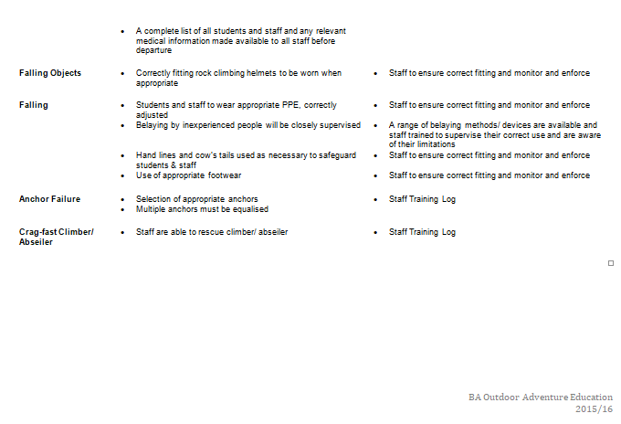  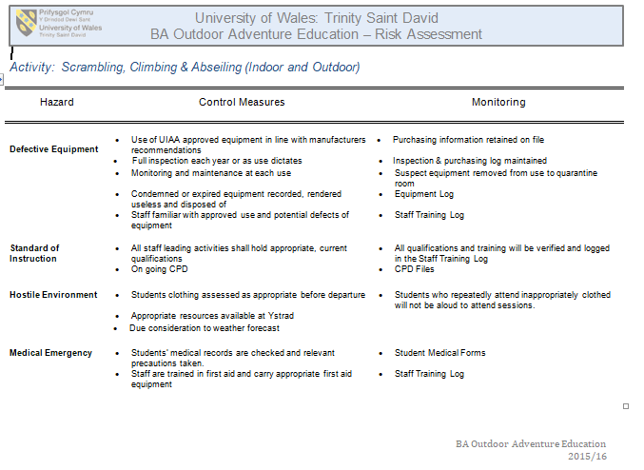
Site-specific risk assessment | The venue is a tidal climb and therefore can be partially submerged at high tide. The rock pools around the area can be substantially deep and wide. Parking can be an issue and a short walk to the venue is required. The beach is public and therefore open to dogs and their owners from certain times of the year. There is a river flowing into the bay and out to sea. Weather was suitable for the activity but wind direction did change in the afternoon which was unanticipated.
Relevant legislation | - The Management of Health and Safety at Work Regulations 1999  - Working at Height Regulations 2005  - Health & Safety (first aid) Regulations 1981  - Health And Safety at Work Act 1974  - Be licenced by AALA
Relevant NGB awards | SPA (Rock Climbing Instructor Award)  First Aid minimum eight hour certificate
Key technical terms (words and phrases) | UIAA - The International Climbing and Mountaineering Federation, its French name Union Internationale des Associations d'Alpinisme  Half Hitch - attaches a rope to something  Belay - Belaying is a process used in climbing that typically uses a rope system to protect a climber in the event of a fall  Lock-off - Pulling on a hold until your arm is in a bent position, then holding that position using body tension in order to reach the next hold with your free hand  Static Rope - A rope that is not designed to stretch when placed under load  Dynamic Rope – A rope that is designed to stretch slightly when placed under load  Single Pitch Venue – A climbing pitch that requires one rope to get to the ‘top out’ location. Not a ‘multi-pitch’  Grade – A system used to differentiate climbing route difficulty  Limestone – A hard sedimentary rock, composed mainly of calcium carbonate or dolomite  Tidal Range – The vertical difference between the high tide and the succeeding low tide  Rule Of The 12th’s – An approximate method of determining the height of the tide at any time of day  Barnacle - A marine crustacean with an external shell, which attaches itself permanently to a surface
Key activity specific skills to be developed | Tying figure of eight and stopper knots. Estimating tidal ranges and using visible landmarks as points to do so. Belaying skills to make the climber safe.
Access and conservation/ environmental sustainability relating to the venue | https://www.visitswanseabay.com/listings/three-cliffs-bay-beach/  http://www.thisisgower.co.uk/learn/nature-and-landscape/wildlife-watching/wildlife/birds/  https://www.nhs.uk/Livewell/fitness/Documents/climbing_outside_booklet.pdf  While the Gower Coast National Nature Reserve doesn’t span into Three Cliffs Bay certain birds may be nesting at certain times of the year within the limestone cliffs.
potential benefits of session | The benefits are to engage in overcoming personal fears and to then gain personal satisfaction from climbing and being at heights.  To dynamically risk assess the venue and environment for potential hazards. Learning about single pitch venue suitability for a group.
health and safety history of the site/ activity | https://www.dailypost.co.uk/news/north-wales-news/paramedics-fall-climbing-trip-left-2903278  https://www.ukclimbing.com/articles/skills/8_common_climbing_accidents_and_how_to_avoid_them-6962
Inspect relevant kit in accordance with the guidelines provided | All kit was checked before sign out.  The equipment is checked for general wear and tear. Visual and physical checks are made to ensure equipment is safe to use.  All kit has purchasing information kept on file.  The UIAA standards are met on equipment.  Yearly inspections or as equipment usage dictates are made by UWTSD staff and kept on file.
Events and relevant observations throughout the day | Some members of the group did not wish to abseil over the cave and therefore decisions had to be made regarding what they would do otherwise. The rising tide meant they had to scramble over the cliff to make it out without getting wet. Making sure we moved our bags from the affected tidal zone in time.
Reflect on their own and others’ preparation for the activity | I was prepared for the activity and signed out all necessary kit before leaving for the venue. To my knowledge everyone else was just as prepared. However as a group we were unsure of the Rule of the Twelfths method for gaging tide level.
Dynamic risk assessments/ considerations | Tide was getting closer to cut off point and decisions had to be made about the session regarding a final abseil. We estimated how long the tide would take to get to the cut-off point to see if we could have time to abseil. There was an escape route even if everyone didn’t get to abseil.
Record any near misses or accidents
Suitability of the generic and site-specific risk assessment | The generic risk assessment does not cover specifically tidal zone climbing. It does however cover all essential hazards faced on that day of climbing at Three Cliffs Bay. The site specific risk assessment however does cover that fact of climbing at a tidal cut off crag. The suitability of both risk assessments was therefore good.
Specific learning outcomes from session | The ability to overlook tide times and effectively plan around them with the use of an escape route if necessary.  How to effectively manage a group while at a climbing venue.

Outdoor Activity Logbook & Risk Assessments
Before the Activity
During the Activity
After the Activity

Activity | River Kayaking
Date | 6th March 2018
Venue | Llandysul Centre, Teifi River
Weather | Cloudy turning to overcast by early afternoon. Light wind (NW). 5 mph. 8ºc.
PPE / Kit | Back Pack, Waterproofs, Suitable Shoes, Water Helmet, PFD, Throwlines, Neoprene Gloves & Socks, Wetsuit, Shorts, Safety Knife, Whistle, Group Shelter, First Aid Kit, Food and Warm Drink.
Personal Summary, Thoughts / Feelings of activity | Initially I had presumed I would not enjoy the session due to my dislike of cold water. However I used two wetsuits to stay warm. This worked well but at a cost of my movability and overheating at times. But overall I enjoyed the session and learnt about rescue techniques for the FSRT.

Generic risk assessment | 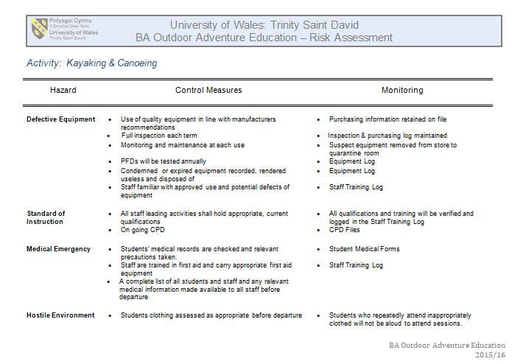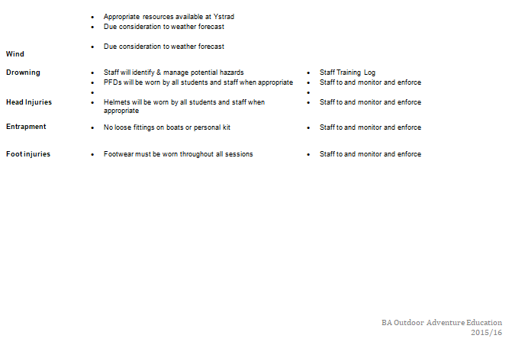
Site-specific risk assessment | Taking into account the recent storm ‘Emma’ that had hit the area; there might be pollution in the water and debris in the water. Parking is good for Llandysul although a road crossing is necessary to get to the paddler centre. The weather on the day was forecast for light wind and low chance for rain, suitable conditions for the activity. A water volume marker on the bridge at the site marks how high the water level is and therefore dictates the grade of certain sections of the river.  https://flood-warning-information.service.gov.uk/river-and-sea-levels
Relevant legislation | - The Management of Health and Safety at Work Regulations 1999  - Health & Safety (first aid) Regulations 1981  - Health And Safety at Work Act 1974  - Be licenced by AALA  - https://webcommunities.hse.gov.uk/gf2.ti/f/6594/638245.2/PDF/-/CInt5.15v08_Paddlesports_competency_21_12_2016.pdf
Relevant NGB awards | First Aid Certificate in date  FSRT (Foundation Safety and Rescue Training)  1 & 2 Star (or higher) in Canoe and Kayak or Paddlepower Discover  Paddle Sport Instructor  Coach Award
Key technical terms (words and phrases) | Kayak – A kayak is a small, narrow watercraft which is propelled by means of a paddle.  CLAP – COMMUNICATION, LINE OF SIGHT, AVOIDANCE, POSITIONING.  Catchment Area – An area where water collects to form or join another body of water.  Silurian Mudstone - The Silurian is a geologic period. Therefore Silurian Mudstone is a type of sedimentary rock found at that time in history.  Afon Teifi – A welsh river starting at Llyn Teifi, mostly flowing through Ceredigion and Carmarthenshire, before ending at the Atlantic ocean in Pembrokeshire.  Eddy – A place of calm water usually behind rocks or near river banks.  Grade - A system used to differentiate river route and rapid difficulty, Grades can change depending on volume of water.  Salmon – A type of fish found in freshwater.  Flow rate – The rate at which a volume of fluid flowing through an area each second can be measured by.  Japanese Knotweed - A dense weed growth that crowds out native vegetation. It can erode entire riverbanks by causing structural damage from its deep spreading roots.  Slalom - A course in which you zigzag between obstacles.  Appropriate Footwear – Footwear suitable for the activity and its encompassing hazards.
Key activity specific skills to be developed | Using different styles of Kayaks (sit on tops, sit ins, tandem)  To practice rescue techniques in line with the FSRT syllabus.
Access and conservation/ environmental sustainability relating to the venue | http://www.llandysul-paddlers.org.uk/teifi/teifi.htm  http://jncc.defra.gov.uk/protectedsites/sacselection/sac.asp?EUCode=UK0012670  https://www.naturalresources.wales/media/670702/Afon%20Teifi%20%20River%20Teifi%20Management%20Plan.pdf
potential benefits of session | To observe and evaluate the rivers condition and suitability for paddling. To practice different paddle strokes and different water craft used for river paddling. To gain an understanding of the rescue techniques for the FSRT.
health and safety history of the site/ activity | http://news.bbc.co.uk/1/hi/wales/1311537.stm  https://www.independent.co.uk/news/uk/the-school-canoe-tragedy-schoolchildrens-adventure-at-sea-that-turned-father-tells-of-survivors-1499565.html  https://www.independent.co.uk/news/uk/the-school-canoe-tragedy-canoe-instructors-were-not-qualified-teachers-no-official-checks-on-centres-1499567.html
Inspect relevant kit in accordance with the guidelines provided | All kit was checked personally before sign out.  The equipment is checked for general wear and tear. Visual and physical checks are made to ensure equipment is safe to use.  All kit has purchasing information kept on file and expired kit is disposed of.  The PFDs are checked for buoyancy and maintained.  Termly and yearly inspections or as equipment usage dictates are made by UWTSD staff and kept on file.
Events and relevant observations throughout the day | The Afon Teifi was higher than initially expected and therefore the decision was made to abandon the original plans and to instead practice on the manmade lake on the Llandysul site.  The lake was suspected to be colder so a warm up on the bank was necessary.  The session progressed to practicing rescue techniques and therefore involved less physical movements resulting in less heat being generated from the muscles. The weather also changed to overcast and the wind picked up. The consequence of being already wet and in these conditions resulted in the instructors curtailing the session.
Reflect on their own and others’ preparation for the activity | The group was not overly excited about kayaking in the Afon Teifi as it was a fairly cold day. One member was ill but still attended, choosing not to participate before the activity commenced. As I do not enjoy cold water I was anxious about participating but wanted to regardless. Bringing two wetsuits complete with neoprene gloves and socks helped me to enjoy the water and activity more. I also brought extra high energy food to keep my energy levels high.
Dynamic risk assessments/ considerations | The Afon Teifi volume and flow rate was higher than anticipated and therefore constituted a different plan. The group got cold when less paddling was happening and also as the weather changed. The river level could have been checked by forwarding a call to Llandysul centre prior to arrival. Advising participants to bring plenty of food and a hot drink.
Record any near misses or accidents
Generic and site-specific risk assessment for that day and update accordingly | The Universities generic risk assessment relies of the competency and experience of its instructors dynamically risk assessing the venue and activity. The site specific risk assessment covered the main hazards but didn’t take into account the probability of more debris in the water from the recent storm.
Specific learning outcomes from each session | The river volume and flow rate might not be suitable for all participants. The group should come well prepared on cold days and also be prepared to be in the water for longer periods of time.

Outdoor Activity Logbook & Risk Assessments
Before the Activity
During the Activity
After the Activity

Activity | Hill Walking
Date | 13th March 2018
Venue | Herbert’s Quarry, Brecon Beacons
Weather | Sunny with Clouds, 4 ºc, 10 MPH winds (20 Gust) North-westerly. Changing to Easterly by late afternoon.
PPE / Kit | Back Pack, Waterproofs, Suitable Shoes / Boots, Spare Socks, Warm Hat, Gloves, Sun Cream, Group Shelter, Survival bag, First Aid Kit, Whistle, Map, Compass, Food and Drink.
Personal Summary, Thoughts / Feelings of activity | I personally enjoyed this session and looked forward to doing some navigation. The weather was pleasant and the group worked well together apart from an individual that proceeded to walk in front not having much regard for the rest of the group. I discovered I was slightly too big for my walking boots making descents slightly painful.

Generic risk assessment | 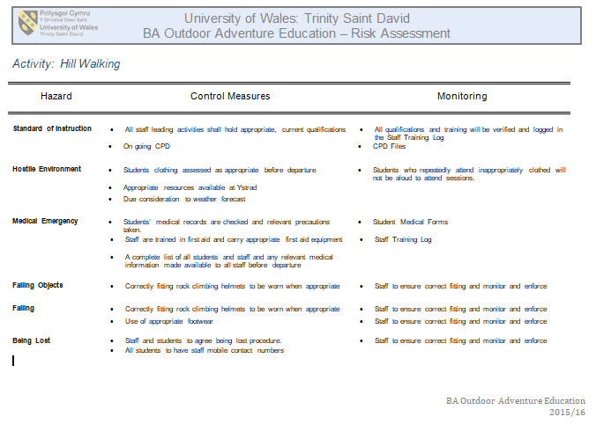
Site-specific risk assessment | The recent weather for the Brecon Beacons west had high levels of precipitation. This raised a concern for particularly boggy areas. Suitable footwear was essential. Mobile cellular signal is scarce in the area and due care should be taken. Weather Forecasts from reliable mountain forecasting sources are important to build an idea of the conditions expected. Temperature would become a degree less for every 100 metres gained in elevation also more exposure to wind on higher grounds with no protection.
Relevant legislation | - The Management of Health and Safety at Work Regulations 1999  - Health & Safety (first aid) Regulations 1981  - Health And Safety at Work Act 1974  - Be licenced by AALA  - Countryside rights of way act 2000 (CROW ACT.)
Relevant NGB awards | First Aid Certificate in date  Mountain Leader  Hill and Moorland Leader  Experience in the national park
Key technical terms (words and phrases) | Cold Front – A transition where a cold air mass replaces a warm air mass  Ring Contour – They mark the last contour of a hill or knoll  Hill Fog – A type of cloud. It can occur when the cloud base is lower than the tops of the hills called a stratus cloud  Temperature Inversion - A reversal of the normal behaviour of temperature in the troposphere (the region of the atmosphere nearest the Earth’s surface), in which a layer of cool air at the surface is overlain by a layer of warmer air. (Under normal conditions air temperature usually decreases with height.)  Trig Point - A fixed surveying station, used in geodetic surveying and other surveying projects in its vicinity  Lowland Leader – A NGB from Mountain training covering taking groups into lowland settings for walks  Naismiths rule - A rule of thumb that helps in the planning of a walking or hiking expedition by calculating how long it will take to walk the route, including ascents.  Ordnance Survey – A company that produces scaled maps of the United Kingdom  Grid Lines -Grid lines on maps define the coordinate system, and are numbered to provide a unique reference to features  Mountain Rescue – An organisation that exists as an emergency service for all incidents that require diffiuclt access typically in the outdoors (Mountains, Hills, Moorland, etc.)  Contour Line – Lines on a map which depict the height and relief of the land.  Moel (Welsh) – A Hill (English)  Wind Chill – The cooling of a surface from being hit by wind.
Key activity specific skills to be developed | Group hill walking  Orienteering and Navigation techniques  Classification of Flora and Fauna
Access and conservation/ environmental sustainability relating to the venue | http://www.beacons-npa.gov.uk/wp-content/uploads/Brecon-Beacons-Visitor-Management-Plan-adopted-ENG.pdf  The walking and bridal routes within the national park can see significant traffic in relation to the upkeep of route quality it is important to be aware of the conservation.  http://www.beacons-npa.gov.uk/planning/heritage2/built-heritage-draft/conservation-areas/  http://www.beacons-npa.gov.uk/wp-content/uploads/the-impacts-of-leisure-and-tourism-on-the-national-park.pdf  http://www.beacons-npa.gov.uk/environment/climate-change/
potential benefits of session | To engage participants in a British National park by exploring the different landscapes and also environments of its inhabitants.  To dynamically risk assess a Hill walk in the Brecon Beacons.  To learn navigation and keeping fit while doing it.
health and safety history of the site/ activity | https://www.walesonline.co.uk/news/wales-news/mountain-rescuer-recalls-shocking-day-11554019  https://www.mountain.rescue.org.uk/information-centre/incident-statistics  http://www.bbc.co.uk/news/uk-wales-33506589
Inspect relevant kit in accordance with the guidelines provided | All kit was checked personally before sign out.  The equipment is checked for general wear and tear. Visual and physical checks are made to ensure equipment is safe to use.  All kit has purchasing information kept on file.  Yearly inspections or as equipment usage dictates are made by UWTSD staff and kept on file.  Personal kit is checked by UWTSD staff to ensure it is fit for purpose.
Events and relevant observations throughout the day | The ground conditions were particularly boggy in places. The cairn on the walk was very rocky and could be a risky place to take groups.  The groups dynamic changed throughout the session as one member became distant from the group. This could have caused implications in the wrong conditions. The performance levels of group members varied and as a result the slowest person was made to set the pace.
Reflect on their own and others’ preparation for the activity | I was very prepared for the activity, having prepared my equipment and food the night before. I researched the technical words and navigation techniques. I am already familiar with hill walking. The Preparation of others was reasonably good apart from a few individuals who decided to wear trainers that weren’t waterproof. Their feet ended up wet half way into the walk.
Dynamic risk assessments/ considerations | The decision to make an end point for an objective to get back to the minibus on time to get home. This had to be carefully considered and planned using a map. As a group we could have chosen a less boggy route to avoid people’s feet getting wet. The cairn was very uneven and rocky terrain. A change in the weather could affect moral and safety of group.
Record any near misses or accidents
Generic and site-specific risk assessment for that day and update accordingly | The Generic Risk assessment covers the aspect of walking but lacks definition in different areas; this would be taken over by the site specific risk assessment. The site specific risk assessment did cover the terrain in the region of the Brecon Beacons. It also covered the environmental conditions related to British mountains.
Specific learning outcomes from each session | How to navigate using topography, Compass and Maps.  Different facilitator styles when leading groups in the hills.  How to keep safe while in the mountains by reading weather forecasts and preparing for it as necessary.

Bibliography
Ewert, A. W. and Sibthorp, J. (2014) Outdoor Adventure Education, Foundations, Theory and Research. Leeds: Human Kinetics.
Haddock, C. (1993) Managing Risks In Outdoor Activities. Wellington: New Zealand Mountain Safety Council Inc.
Jenkinson, P. (1994) The Lyme Bay Canoeing Tragedy. Devon County Council Interim Report. Unpublished.

