BSc Health and Social Care

Student name: Yelmi Sebastiao
Student ID: 2122805
Module name: Introduction to Physiology
Module Code: BMHP5003
Lecture name: Olusegun Awolaran

Assessment: Report

Contents Page

- Introduction
- Anatomy and Physiology of the health condition
- Health and lifestyle routine measures
- Health and Social Care practice
- Recommendations
- Conclusion
- References

Topic: Asthma
A respiratory condition known as asthma affects the lungs, trachea, and bronchial passageways. Dr. Miles Weinberger, a professor of paediatrics at the University of Iowa Children's Hospital, claims that an asthma attack happens when the respiratory system's airways, which are collectively referred to as the respiratory system, constrict and prevent oxygen from easily entering the body. (w, 21 August 2021)
The organ system respirator lung

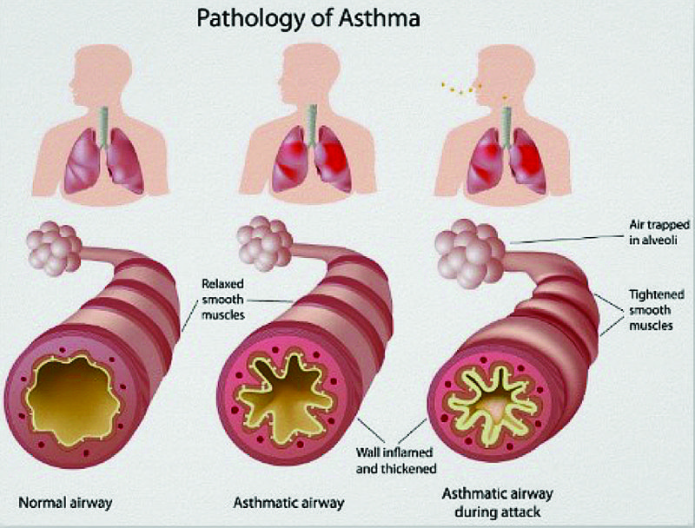
https://img.knowyourasthma.com/wp-content/uploads/identifying-and-managing-asthma-tulsakids-magazine.jpeg

Introduction

A chronic disease that damages the lungs' airways is asthma. The tubes that transport air into and out of your lungs are called airways. When you have asthma, your airways may occasionally become inflamed and congested. This makes it more difficult for air to exit your airways during exhalation.
The symptoms of asthma, which can change over time and in intensity, include coughing, wheezing, tightness in the chest, shortness of breath, and fluctuating expiratory airflow limitation.
Exercise, exposure to allergens or irritants, changes in the weather, and viral respiratory infections are just a few examples of the causes that might cause symptoms.
Symptoms can disappear on their own or in response to medicine, and they can occasionally disappear completely for several weeks or months at a time. (CKS, April 2022)
Anatomy and Physiology
The lungs are the organ system that is impacted by asthma. The lungs are made up of segments and lobes, with the left lung having eight or nine segments depending on how the lobe is divided, and the right lung having ten segments. The conducting zone and respiratory zone are the two anatomical zones that make up the respiratory system. The respiratory zone, where gas exchange occurs, runs from the alveolar duct to the alveoli, while the conducting zone extends from the nose to the bronchioles and the respiratory region from the alveolar duct to the alveoli is where gas exchange occurs. Asthma affects the bronchial tree, which is responsible for distributing air to the alveolar sacs in the lungs. The trachea's tip, which separates into the left and right bronchi, is where the bronchi originate. The left bronchus is smaller and more horizontal, while the right bronchus is larger and lies more vertically. The secondary and tertiary bronchi are then separated from the bronchi. Elastic fibres and smooth muscle are present in the bronchi to maintain the integrity of their walls. Smooth muscle is contracted and relaxed by inflammatory mediators, bronchoconstrictors, and bronchodilators, respectively.
From the bronchi to the alveoli, there are much more smooth muscle fibres involved. During normal respiratory physiology, lung compliance refers to the lungs' readiness to expand, whereas elastance refers to their capacity to contract back to their resting state. In asthma sufferers, inflammation alters the physiological process, reducing the radius of the airway. Together, these systems alter the lungs' compliance only a little bit, making breathing slightly more laborious (Sinyor, May 8, 2022)
In a beautiful supply and demand system, the lungs are intricately entwined with the heart and blood vessels. The lungs are vital component of the respiratory system and aid in the processing of oxygen, which is necessary for both life and activity. As a result, the circulatory system assists in the body's overall oxygenation.
The pulmonary veins transport blood to the lungs from the right ventricle of the heart and return blood from the lungs to the left atrium of the heart.) Circulatory System: Blood Flow Pathway Through the Heart”) Although we cannot see or touch them, we can feel them when we are working out hard.
This sophisticated system often precisely matches the amount of oxygen provided to the amount absorbed when we are idle, going about our daily activities, or even just being physically active. Under these circumstances, the energy required to fuel these low to moderate levels of physical activity is provided by aerobic metabolism (processes requiring oxygen). (Kilgore, November 3, 2020)

Health and lifestyle routine measures
Managing asthma and allergies can benefit from eating anti-inflammatory foods. It calls for consuming fresh produce, lean meats, and minimal amounts of alcohol and carbs. Aim for a healthy, clean diet that does not encourage inflammation.
Asthma is a chronic condition that can have a variety of negative effects on your quality of life. Every person is affected by this respiratory ailment differently. Some persons with asthma may need to miss work or school. Someone with the condition may require care from others. Asthma may also hinder certain people from engaging in specific activities, particularly sports. Asthmatics frequently restrict their physical activity due to their symptoms.
(Pat Bass, 10 April 2022).
Using your inhaler properly is one thing you can do if you have asthma to help. If you are unsure, see Asthma + Lung UK's guidelines on using your inhaler or a nurse or GP for guidance.
- keeping your symptoms under control and preventing asthma episodes by using your preventer inhaler or tablets each day.
- screening before ingesting additional medications - Always read the package insert to determine whether a medication is appropriate for someone with asthma, and if in doubt, consult a doctor, nurse, or chemist. not smoking: Giving up smoking will lessen the intensity and frequency of the symptoms, which include.
- routinely exercising – once you are receiving the right treatment, exercise should not bring on your symptoms; How to exercise while managing asthma is covered by Asthma + Lung UK.
- eating well-being Most asthmatics can maintain a normal diet while becoming immunised; it is a promising idea to have the annual flu shot and the one-time pneumococcal vaccination (Anon., n.d.)
Many people who have asthma will continue to have it for the rest of their lives.
However, if you were diagnosed with asthma as a child, your asthma may get better or go away entirely as you age, especially if it was a mild case.
Even if asthma goes away, it might return later in life for a variety of reasons, such as moving to a more polluted location or meeting new triggers at work. It might also recur because of hormonal changes brought on by pregnancy and menopause.
The good news is that there are many safe and effective options available to help you stay symptom-free even while asthma does not go away. (Robert, October 15, 2022)
The following can assist patients in controlling their asthma, according to the National Heart, Lung, and Blood Institute Trusted Source:
- if applicable, giving up smoking,
- achieving or maintaining a healthy weight,
- exercising regularly, getting enough sleep,
- using stress-reduction techniques like mindfulness and deep breathing. (Dresden, October 11, 2021)

Health and Social Care practice
Each patient's asthma treatment needs to be individually designed. Medical practitioners can provide medication prescriptions and assistance in managing symptoms. Asthma sufferers should be provided with the following, according to recent recommendations (British Thoracic Society/ SIGN 2016):
- Doctors and nurses who have received training in managing asthma provide care at the GP office.
- comprehensive information on asthma and self-management instruction.
- Regular expert reviews to ensure that the asthma is kept under control.
- a customised asthma action plan in writing that you and your doctor or nurse agreed upon.
The level of relationship between the asthmatic patient and the medical professional affects communication, in addition to the quantity and quality of contact and information. People with asthma wished that medical personnel would pay close attention to them, value their expertise as asthma sufferers, speak to them in terms they could understand, and regard them as equal partners in their care. (Health talk, n.d.)
It is preferable when decisions about care and treatment are made jointly. Your healthcare providers should be able to answer any of your questions, discuss your alternatives with you, and pay close attention to your concerns and opinions.
Consider the following questions to assist in your decision-making:
- What concerns you the most? Are there features of asthma and its management that cause you more concern than others?
- How will the medication change your day-to-day activities?
- If there are any adjustments you can do to assist control your asthma, such taking your medication as prescribed, quitting smoking, or recognising triggers, (NHS, 22 March 2021)
Individuals can benefit from the work of health and care professionals if they:
- Knowing the risk factors and exposures that raise the likelihood of developing respiratory diseases and advising patients on how to reduce or avoid these exposures.
- To identify and treat these disorders early, it is important to be aware of the populations that are at risk as well as the symptoms and indicators of respiratory illness.
- adopting best practise recommendations for the diagnosis and treatment of people with respiratory diseases and, when necessary.
- sending them to specialise care such as pulmonary rehabilitation and smoking cessation services.
- offering individualised care to help patients manage and live with their disease while preserving excellent quality of life and encouraging eligible groups to get the flu and pneumonia shots.
(NHS, 19 May 2022)

Recommendations
Recommendations The report's nineteen recommendations, which are focused on six priority subject areas and were published in the Journal of Allergy and Clinical Immunology external link in December 2020, are as follows:
- where necessary, taking inhaled corticosteroids for asthma or recurrent wheeze. With continued use, this medication helps to gradually reduce airway swelling or inflammation.
- combining inhaled corticosteroids with long acting antimuscarinic drugs (LAMAs) to control asthma over the long term. A LAMA is an inhaled medication that aids in maintaining the flexibility of the airway muscles.
- employing one or more techniques to lessen exposure to asthma triggers inside.
- Some persons with allergic asthma can be treated using immunotherapy, which involves administering shots with extremely small doses of allergens. Your body may become less susceptible to allergens (such grass or ragweed pollen) if you receive immunotherapy.
- fractional exhaled nitric oxide (FeNO) tests may be used to assist in the management of asthma or to assist in the confirmation of a diagnosis in some patients whose condition is unclear. Nitric oxide, which can rise when there is airway inflammation, is measured via a device that requires the subject to breathe into a tube that is attached to it.
- selecting individuals with chronic asthma for treatment with bronchial thermoplasty (BT). The muscle surrounding the airways is relaxed using heat throughout the process. (Government, 04 February 2021)
Those who have asthma should be monitored at least once a year to see if their medication needs to be altered. People with poor lung health, severe asthma, or a history of an asthma attack within the last year may benefit from closer monitoring.
Anyone above the age of five should undergo peak flow variability testing or spirometry at each visit to track their asthma control.
It is not advised to regularly employ FeNO testing to monitor asthma in adults or children outside of specialised asthma clinics.
Observe the person using an inhaler and provide suggestions:
every time there is a consultation about an asthma attack.
when the ability to regulate asthma deteriorates.
when the inhaler is switched out.
during each annual assessment.
if they want that it be examined. (CKS, April 2022)

Conclusion
Reviews of asthma in primary care provide a significant role in enhancing control and lowering morbidity and death.
The best people to make sure these reviews are done well are primary care nurses. The main goal should be to help people with asthma live symptom-free lives, or at least with little symptoms, so they may engage fully in all parts of everyday life.
Successful asthma reviews must evaluate control to target care correctly; they must also pinpoint the causes of poor control and modify therapy; accordingly, and they must delve into the attitudes of the patients themselves to offer supported self-management to keep control. The nurses conducting evaluations must have received the necessary training and be familiar with the most recent evidence-based recommendations to achieve these results.

References
Available at: https://www.nhs.uk/conditions/asthma/living-with/?dm_i=3IW9,G2T2,33JHZG,1PPJA,1 Anon., n.d. NHS. [Online]
[Accessed 12 April 2023].
CKS, April 2022. National Institute for Health and Care Excellence. [Online]
Available at: https://cks.nice.org.uk/topics/asthma/background-information/definition/
[Accessed 11 April 2023].
CKS, April 2022. Nice. [Online]
Available at: https://cks.nice.org.uk/topics/asthma/management/follow-up/
[Accessed 13 April 2023].
Dresden, D., October 11, 2021. Medical News Today. [Online]
Available at: https://www.medicalnewstoday.com/articles/home-remedies-for-asthma
[Accessed 14 April 2023].
government, U. S., 04 February 2021. NIH. [Online]
Available at: https://www.nhlbi.nih.gov/health-topics/asthma-management-guidelines-2020-updates
[Accessed 13 April 2023].
Health talk, n.d. Health talk. org. [Online]
Available at: https://healthtalk.org/asthma/dealing-with-health-professionals
[Accessed 14 April 2023].
Kilgore, L., November 3, 2020. CrossFit. [Online]
Available at: https://www.crossfit.com/essentials/the-basic-anatomy-of-the-lungs
[Accessed 13 April 2023].
NHS, 19 May 2022. Public Health. [Online]
Available at: /www.gov.uk/government/publications/respiratory-disease-applying-all-our-health/respiratory-disease-applying-all-our-h
[Accessed 12 April 2023].
NHS, 22 March 2021. Nice. [Online]
Available at: https://www.nice.org.uk/guidance/ng80/informationforpublic
[Accessed 12 April 2023].
Pat Bass, M., 10 April 2022. Very well health. [Online]
Available at: https://www.verywellhealth.com/asthma-impact-200775
[Accessed 11 April 2023].
Robert, W., October 15, 2022. know your Asthma. [Online]
Available at: https://www.knowyourasthma.com/what-two-body-systems-are-affected-by-asthma/
[Accessed 13 April 2023].
Sinyor, B., May 8, 2022. Stat Pearls. [Online]
Available at: https://www.ncbi.nlm.nih.gov/books/NBK551579/
[Accessed 11 April 2023].
w, R., 21 August 2021. know your Asthma. [Online]
Available at: https://www.knowyourasthma.com/what-two-body-systems-are-affected-by-asthma/
[Accessed 13 April 2023].
(w, 21 August 2021)
(Robert, October 15, 2022)
(Kilgore, November 3, 2020)

