ASSESSMENT 1
MARKETING MANAGEMENT
SUBMITTED TO THE
UNIVERSITY OF WALES TRINITY SAINT
DAVID
IN PARTIAL FULFILLMENT OF THE REQUIREMENT
FOR THE AWARD OF THE
MASTER OF BUSINESS ADMINISTRATION
PROGRAM
BY
ALI IMRAN SHAHJEHAN
(Student id:2216196)
UNDER THE GUIDANCE OF
Mrs. Tushara Balendran
(Associate professor)

UNIVERSITY OF WALES TRINITY SAINT
DAVID LONDON
ENGLAND, UNITED KINGDOM
2022-2023

MARKETING MANAGEMENT OF STARBUCKS

Executive summary
Starbucks is known to be one of the most definitive companies in the drinks and beverage sector within the United Kingdom. However, the company has recently faced some issues in terms of appealing to a large set of customers. This has been brought forth due to the fact that the company mostly relies on offline marketing. Additionally, they also face issues in terms of decision making. Therefore, this study has further explored the marketing strategies that the company can take to appeal to a large set of customers. On the other hand, brand awareness is a crucial part and therefore interlinks have also been established with the strategies that can be sued by the company as a result. The report concluded with the stakeholder management matrix depicting the power and interest if the shareholders.
Table of Contents
Introduction 4
Rationale for choosing the organisation 4
Organisation overview 4
Challenges faced by Starbucks 5
Innovative marketing strategy formation 6
Establishing interlinking of marketing strategy with brand awareness 8
Evaluation of Starbucks’ marketing management and initiatives 9
Brand Awareness and Satisfaction of the Customer 9
Marketing initiative 11
Customer journey across a variety of communication channels 12
Stakeholders’ expectations management 14
Conclusion 15
Reference List 17

Introduction
In order to sustain in a competitive environment, it is important to highlight that an organisation has to conduct marketing activities to gain further advantage. Therefore, the marketing department of an organisation plays a crucial part in terms of sustaining within a market. In this particular study, Starbucks has been chosen as the organisation for which marketing environment will be evaluated and strategies will be defined. Therefore, the contemporary issues faced by the organisation will also be highlighted in the process. On the other hand, approaches regarding mitigating all these issues will also be taken into considerations.

Rationale for choosing the organisation
There are few reasons why Starbucks has been chosen as the organisation that will be put more focus on. For starters, Starbucks is one of the most prominent brands in terms of coffee and beverage and also has a strong presence in the UK market. However, there are some internal issues that are put little to no attention to by the management and are therefore required to be highlighted in order to function without facing many issues in the process (Duncza, 2021). Therefore, in order to aid the organisation in further enhancing their business capabilities, this particular organisation has been chosen in the process.

Organisation overview
Starbucks was first founded in Seattle back in 1971 and initially it focused on providing fresh roasted coffee to the customers. In 1983, the Italian standard and style of coffee was incorporated into Starbucks and since then it has been the focus of the company as well. In 1987, Howard Schultz purchased the company (Starbucks.co.uk, 2023). In the 21st century, the company also incorporated foods and snacks and started providing services in the process. As of 2023, Starbucks has over 32000 stores in over 80 countries in the process. In the meantime, it needs to be highlighted that as of 2022, the company has over $33 billion as revenues (Alwaleed et al. 2019). Therefore, it has become certain that the company has experienced a growth rate of over 8.41% in the process.
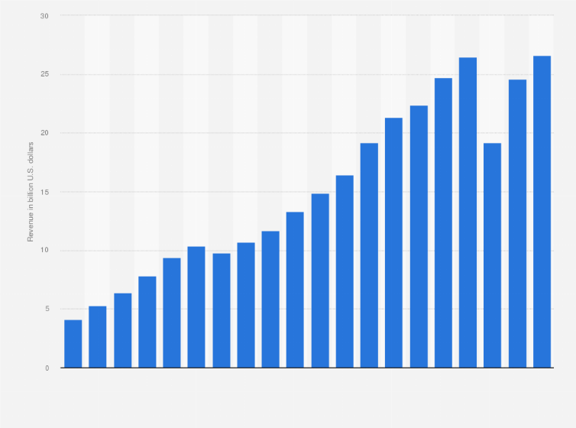
Figure 1: Revenues of Starbucks
(Source: Statista.com, 2022)
In the meantime, it should be noted that Starbucks is also constantly taking major steps in order to ensure that they stay ahead of other companies accordingly. In order to do so, they have also put a strong focus on the expansion of businesses in both the physical and the digital space (Bonaparte, 2020). However, it is essential to highlight that the organisation has also started facing major competition from different well-known companies in the process. Some of the competitors in the current marketing environment are McDonald’s, Dunkin’ Donuts, Subway, Whitbread and Costa. The emergence of digitalisation has also forced various companies to incorporate and implement new plans as well as technologies. Therefore, this has also resulted in Starbucks get a prominent platform accordingly (Alwaleed et al. 2019). Even though the company has performed decent in the overall organisational market, it should be noted that they have not been quite up to their full potential as many issues occurred because of competition, segmentation, digitalisation and globalisation in the process.

Challenges faced by Starbucks
It needs to be stated that Starbucks currently faces major competitors due to the fact that the current era of globalisation has indeed brought about the opportunities to further capitalise in the market. As mentioned by Chuang (2019), the brand is not successfully appealed to a large set of customers due to the fact that they have not manage to capitalise in the market accordingly. Therefore, it needs to be noted that the company has to bring some changes to their operations in the process. On the other hand, it has also been seen that the company has underperformed in terms of the provision of flavours and quality to the customers recently. This has also increased the level of dissatisfaction among the customers.
On the other hand, it can be observed that the company has also lacked composure in terms of making decisions and acting accordingly (City, 2021). Therefore, this has also resulted in the brand being affected in terms of maintaining image. Starbucks has also laid off about 5% of their employees in the midst of the COVID-19 pandemic accordingly. In the meantime, it should also be highlighted that inconsistencies can also further affect the operations of the brand if it keeps continuing like this.
In order to complete the study, it should also be noted that one of the main challenges that is faced by Starbucks is understanding the needs of the customers and acting accordingly. As mentioned by Duncza (2021), there have been several instances where it has been observed that Starbucks did not pay much attention to the needs of the customers and have therefore been accused of slacking off in the crucial moments. When it comes to food waste management, the company is still insignificant, but customers can always get things like biscuits from them. Regarding the implications of sustainable corporate leadership, this further looks to be among the major issues for the business (Gupta, Nagpal and Malik, 2018). An ongoing issue at Starbucks is their excessive reliance on the internet and neglect of investment more than that in regional shops across the country.
Starbucks currently has 10 million subscribers on their online platform. However, it needs to be noted that more subscribers might not always produce fruitful results in the process. At the same time, it remains to be noted that because of digitalization, more firms and consumers are gravitating towards to virtual environment, which has increased competition there (Hui‐Jung, 2019). However, Starbucks’ reliance on the physical shopping could cost the company a lot of money in terms of aggressive local and worldwide advertising competition.

Innovative marketing strategy formation
To maintain a place in the cutthroat global, the corporation must improve its market penetration strategies. It is clear that one of Starbucks’ effective techniques for grabbing customers' interest has consisted of reduce the price of basic necessities. It is a fundamental need for maintaining the company that the company has met (Khan, Yusop and Baharudin, 2018). On the contrary hand, the corporation must recognise the needs in addition to offering the goods at reasonable rates if it wants to penetrate the market deeply. There, commercial fragmentation or STP theory must be used. Organizations can categorise their targeted audience using STP's methods, which will aid them in better comprehending their needs. Starbucks has the chance to get to know their clients well thanks to the STP analysis, which allows them provide items that are appropriate for the needs (Kim and Park, 2021). It aids them in getting customers to appreciate the values they hold in common with customers. Moreover, consumers' sense corporate loyalty might be increased.
The industry's clothes sales are one of the biggest problems it has. The company's poor sales success is obvious because it was not appealing to any one generation. Depending on this methodology, marketing strategies really have to take item development plan into account. The business must group its products, which are coffee and other types of beverages under names that are catchy. For example, the business can identify its Gen Z target market and create unique items related to beverages for them (Lombardi, Chidiac and Record, 2021). This element aids the business in growing brand recognition among various age groups. The model of product uniqueness must be considered as well.
With the aid of this method, the business is able to produce goods that appeal to different age groups. One example is the preference for customised drinks among today's youth. Considering this, Starbucks can offer roomy clothing to this particular segment, helping to satisfy consumer preferences. As a result, Starbucks is able to handle the difficulties presented by the shifting demands of the customer.
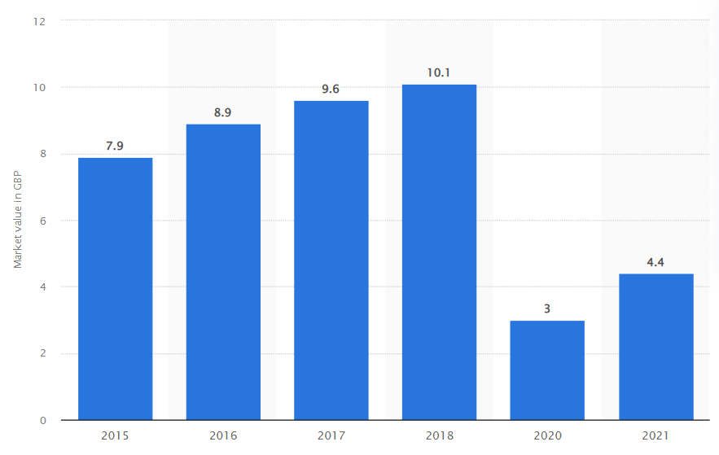
Figure 2: UK coffee market growth
(Source: Statista.com, 2023)
One element that the business must take into consideration as it manages its current issues is its marketplace development plan. In addition, it should be noted that a strategy for market expansion aids the organisation in forging and sustaining a foothold in a cutthroat industry (Musonera, 2021). Organizations can use the current products to address a new market in accordance with their development strategy in order to grow their businesses. In using this strategy, evolving customer characteristics can indeed be accounted for. For example, the business can create new channels for reaching customers more effectively (Nguyen, 2020). It is clear that now the corporation invests more now in in-store sales than online shopping. Therefore, it should be noted that Starbucks will have to take this opportunity to invest more in the online sales and services growth in addition to the offline operations (Rahmawati, Rachmawati. and Saifuddin, 2021). Furthermore, the company will also have to seek out advices from ever employee involved in a particular operation as this will also provide them an opportunity to expand their businesses.

Establishing interlinking of marketing strategy with brand awareness
As highlighted by Santika (2018), it has been observed that variety in strategies for marketing serves multiple purposes for a particular company. Therefore, it needs to be pointed out that Starbucks will have to formulate different strategies while also raising the awareness of the brand and establish a direct link in order to take the opportunity to exemplify their operations. In the meantime, it can be noted that recognition of popular brands is necessary for different organisations to operate in a market as competitive as that of the United Kingdom. As per the views of Shim et al. (2021), expansion of businesses on social media as well as SEO is important for the organisation to finally put brand thoughts as well as penetrate the markets in the process.
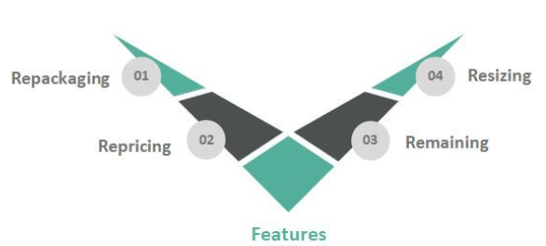
Figure 3: Product diversification methods
(Source: derived from the concept by Polat and Çetinsöz, 2021)
Starbucks has generally focused on promoting their brand and provide cross marketing initiatives to raise awareness related to their brands. However, this has not been as beneficial as they expected this to be (Subramaniam, 2020). Therefore, it can be noted that providing the same number of products online can also be useful for the organisation as this type of marketing has indeed been popular to a great extent. At the same time, it can be observed that Starbucks does possess equity of brands and therefore they should also use it to further imply their strategies of development of coffee and beverage items.
At the same time, diversification of products can also be quite beneficial for the item and this should also be helpful in raising awareness of the brand as a result (Tsai et al. 2020). One of the most effective methods in order to win the support of the customers is to offer customisable services to them. Therefore, this can also be quite advantageous as the brand will be able to gain the trust of the customers to a great extent. If customers are allowed to get the exact type of foods they are looking for, they will be satisfied with the performance of the brand. Additionally, the awareness of the brand will also increase considerably in the process.
As per the views of Dilip et al. (2021). Starbucks can use their brand image as a leverage to win over customers of various regions within the United Kingdom. This is especially true as first impression does matter on a long run. At the same time, it should also be clarified that when an organisation is willing to expand its business, they will have to do so by keeping the online services intact.

Evaluation of Starbucks’ marketing management and initiatives
Organizing marketing campaigns serves a variety of objectives, including boosting consumer satisfaction, building brand equity, gaining competitive advantages, and snatching up new markets. To engage with their customers, Starbucks and their marketing director have acknowledged these factors and complemented their marketing initiatives on the internet platform. To stay competitive in the marketplace in this technology age, innovation in accordance with target audience needs is essential. The next part provides a thorough summary of the marketing strategy and initiatives.

Brand Awareness and Satisfaction of the Customer
Starbucks has contrasted its marketing efforts to convey its marketing image for the brand and what it does for the customers' choice. The company successfully incorporates consumer satisfaction information from various market sectors into new marketing efforts and brand-awareness campaigns. In 2020 and 2021, Starbucks raised sales of its goods and services and calculated the market's effective growth (Alwaleed et al., 2019). These factors clarified consumer satisfaction levels and raised brand recognition in Starbucks' operational market categories. The awareness can be generated by engaging with the customer base.
For Starbucks to engage with their customers on a key level, brand familiarity, enhanced value of services, and the productivity of the company are beneficial. Also, reassuring customers is essential for winning their trust and persuading them to use the company's goods and services. Starbucks has engaged with similar programmes, and the motivated customers have used their products and given encouraging reviews, ultimately strengthening the brand positions (Duncza, 2021). Starbucks highlights the elements of customer happiness and the feedback they receive in order to leverage it and, on a fundamental basis, raise consumer awareness of their brand. The target audience's feedback can be used to improve the goods and services.
Starbucks may be able to understand the development of a strong brand image and adjust their current marketing plans to differentiate a better and healthier result. The brand resonance framework describes the components of a consumer's relationship with a certain brand. Starbucks may create a cautious communication strategy with their target audience and engage on a new level. Brand salience, "brand performance," "brand imagery," "brand judgement," "brand sentiments," and "brand resonance" are the six components that make up the brand resonance model (Bonaparte, 2020). For Starbucks to build marketing resilience and generate consumer reliability coefficients that improve brand performance across market segments, these elements are crucial. For Starbucks to build marketing resilience and generate consumer reliability coefficients that improve brand performance across market segments, these elements are crucial. According to Bonaparte (2020), organisations employing the brand resonance theory can understand how long-term commercial activities and consumer relations develop. The combined effect of the six components can aid Starbucks in contrasting a potent campaign for brand awareness for a larger range of market segments. Customer relationships also give an organisation the chance to expand its product and service offerings, enhance revenues, and boost consumer satisfaction levels. As a result, achieving gratification, commitment, and loyalty are key mechanism that Starbucks must incorporate into their current marketing tactics which will enhance their relevant structure.
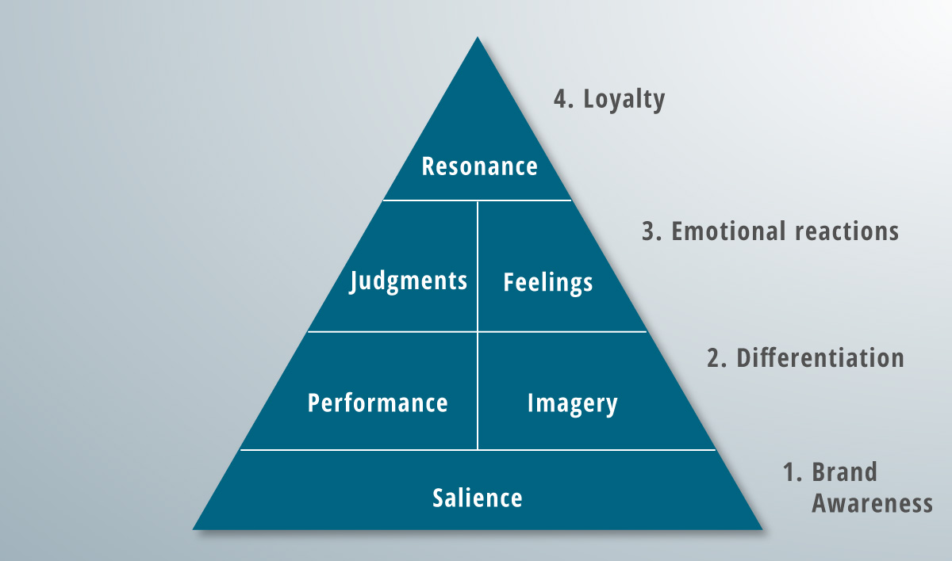
Figure 4: Brand Resonance Framework
(Source: Musonera, 2021)

Marketing initiative
The consumer journey helps in evaluating the strategies and development which is implemented by the organization in order to ameliorate the business.
Pre-purchase stage:
It needs to be noted that this stage is known to be the stage where the interested customers usually focus on choosing alternative products in the process. The company's main objective through doing this is to establish the ability of the current products to maintain their market share (Santika, 2018). This will be done through advertising, pricing strategies, and the use of extra instruments for personal selling. Increasing market penetration in tourist-friendly regions of Europe would help Starbucks achieve supremacy.
Purchase stage:
This particular stage is known for the stage where the customer has made decisions in terms of investing in the products or services provided to the customers. The company's success will be determined by the revenue it generates from all corners of the world. The company is unique in a number of respects, including its improvised supply chain management, which enables them to distribute more goods, increasing sales rate. Therefore, it needs to be noted that Starbucks will also have to effectively provide them products of higher quality so that the customers stay invested and the company manages to generate higher revenue.
Post purchase:
This is the stage where customers evaluate whether their purchasing decision has been correct and whether they should make future purchases form the company or not. Therefore, companies usually make sure that their after purchase services are top notch (Shim et al., 2021). Starbucks can provide new items to new markets and therefore can also strengthen their customer service. They can draw a wide variety of clients thanks to the variety of their product. In the meantime, they can also provide subscription memberships to the customers in the process.

Customer journey across a variety of communication channels
The user experience can be drawn out across numerous channels and touch points, according to (Nguyen, 2020). Based on this strategy, it can be concluded that Starbucks needs to address and use a variety of channels in order to obtain a clear understanding of customer needs and incorporate those needs into communication development.
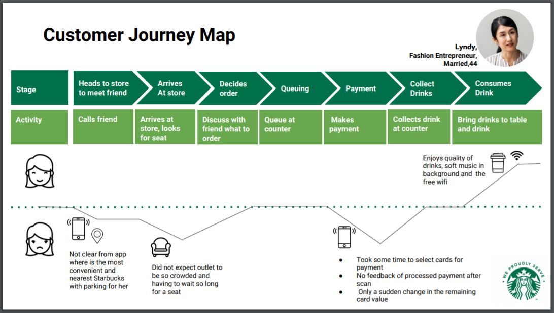

Figure 5: Customer Journey Mapping of Starbucks
(Source: self-created)
- Marketing via text message: It is clear that people check their alerts at least five times a day, and this is a chance to increase market awareness. Starbucks has the option of using general messaging to tell customers about their products and to present them with alluring offers. The business can use online messaging services and standard messages to communicate with its customer base (Santika, 2018). The business can access a customer's phone number-related information through a store's billing department. Starbucks can tweak its chat bots to send messages to its customer base using those phone numbers. This element enriches the client experience by giving the customer detailed information that increases customer happiness.
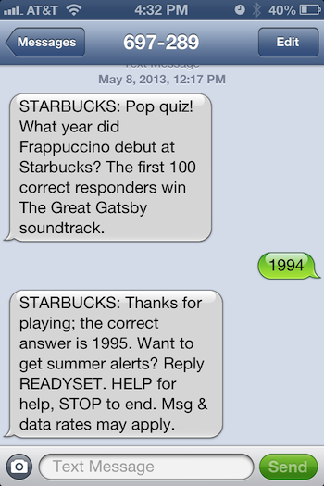

Figure 6: Starbucks text message marketing
(Source: Starbucks - service exploration on Behance, Pinterest, 2021)

- Marketing via Email: Emails may be designated as particular channels that Starbucks may employ to improve customer journey strategies. Email provides one of the most affordable and often used marketing platforms for improved product and service promotion. These are channels that businesses can employ in addition to STP. More particular, the business can send emails that encourage interest by include consumer preference-based information.
- Endorsement of the Brand: For the organisation to use social media marketing channels and go farther, the creation of a brand endorsement plan is essential. Using well-known public figures' faces and notoriety to promote services and products in a wider market segment is the guarantee of a brand endorsement (Shim et al., 2021). Furthermore, Starbucks may take into account collaborating with significant personalities and influencers in order to engage with consumers through their marketing campaigns.
- Digital Media Marketing: Companies need to leverage a variety of social media platforms to improve customer journey mapping. A positive customer experience is greatly influenced by social media. In this situation, it is appropriate to use the company's official Facebook profile. Starbucks may explicitly inform customers about their deals and other strategies for winning their loyalty by using the company's official Facebook page. In this context, social media platforms like YouTube should also be mentioned because they aid in campaign promotion (Subramaniam, 2020). With this strategy, consumers are informed about the qualities and items that help create a positive consumer experience.

Stakeholders’ expectations management
Type of stakeholders | Description | Power | Interest | Influence on the company | Company initiative
Venture Capitalists | The monetary aspects are being controlled by the venture capitalists and also provide gains if possible. | High | High | The influence on the organization is high for the venture capitalists. | Managed Closely
Shareholders | The business prosperity depends upon the shareholders and decision making is another task. | High | High | The influence of th shareholders is high as they are superior members of the organization. | Managed closely
Suppliers | The raw materials are being supplied by the producers. | Moderate | High | The influence is moderate to high for the suppliers | Monitor
Workers | The backbone of the organization who is responsible for the work which is carried out | Moderate | Moderate | The influence of the workers are totally moderate | Keep Informed
Community | The customer base of the organization that gets the services and products of the enterprise. | Low | High | The influence of the audience on the organization is low | Keep Informed
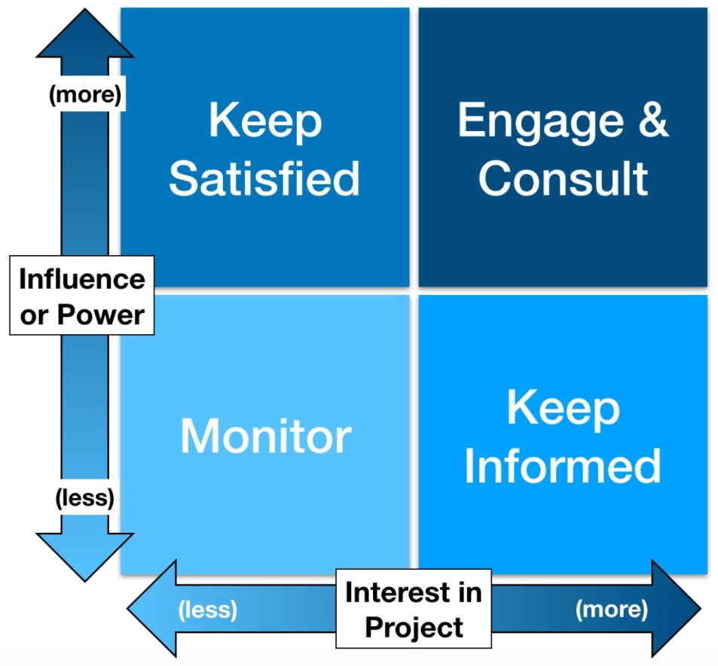
Employees

Community
Suppliers
Shareholders

Owner and Investor
S

Conclusion
From the above study, it has been observed that Starbucks is one of the most notable companies in the coffee and beverage sector and it has also expanded its business within the United Kingdom. Therefore, it needs to be noted that notwithstanding the company's rapid expansion, inconsistent behaviour and poor judgement have hurt the professional image as a company and created problems for it in the marketplace. Starbucks has become overly reliant on its physical space due to the usage of the offline stores to market its company, which will eventually have an influence on the company’s most important marketplace both in the local and international markets. The STP model's adoption enables Starbucks to strategically segment its client base and then target and position the brand within the marketplace with both the greatest degree of flexibility in marketing and promotion. The report concluded with the stakeholder analysis and the matrix portrays the factors which are to be dealt by the organization.

Reference List
Alwaleed, N., Al Huwail, N.H., Singh, S. and AlMejhem, A., (2019). A case study on Starbucks. Journal of the Community Development in Asia (JCDA), 2(2). http://www.ejournal.aibpm.org/index.php/JCDA/article/view/519
Ayesh, L. and Al-Zyoud, M., (2021). The Influence of Brand Equity on Customer Loyalty in Starbucks Chain in Jordan. International Journal of Business and Social Science, 12(2), pp.56-69. https://www.academia.edu/download/77433400/5.pdf
Bonaparte, Y.L., (2020). A Starbucks Blend: Race, Social Marketing and Corporate Social Responsibility. https://digitalcommons.kennesaw.edu/cgi/viewcontent.cgi?article=1440&context=ama_proceedings
Chuang, H.J., (2019). Starbucks in the world. HOLISTICA–Journal of Business and Public Administration, 10(3), pp.99-110. https://sciendo.com/article/10.2478/hjbpa-2019-0031
City, Q., (2021). STARBUCKS CORPORATION. https://outwiths.com/uploads/user/kbf-jimenez/portfolio_attachments/case-study-starbucks-corporation-2009-kbf-jimenez-Outwiths-1628769806.pdf
Dilip, D., Sinha, R., Wen, C.P., Kee, D.M.H., Ching, C.S., Er, L.K., Agarwal, S., Pandey, R., Putra, T.W., Sin, L.G. and Yan, Y.W., (2021). The influence of brand equity on consumer purchase decisions at Starbucks. International Journal of Accounting & Finance in Asia Pasific (IJAFAP), 4(1), pp.37-50. https://ejournal.aibpmjournals.com/index.php/IJAFAP/article/view/1031
Duncza, L., (2021). Starbucks Social Media Strategy Report. https://digitalcommons.sacredheart.edu/acadfest/2021/all/43/
Gupta, P., Nagpal, A. and Malik, D., (2018). Starbucks: global brand in emerging markets. Emerald Emerging Markets Case Studies. https://www.emerald.com/insight/content/doi/10.1108/EEMCS-03-2018-0044/full/
Hui‐Jung, C.H.U.A.N.G., (2019). Starbucks in the World. HOLISTICA–Journal of Business and Public Administration, 10(3), pp.99-110. https://holisticajournal.ro/docs/adcf457744f878614a0ea017bc27e787.pdf
Khan, S.K.B.N.Z., Yusop, Y.B.M. and Baharudin, F.B.W., (2018). Starbucks Market Segmentation and Targeting. International Journal of Business and Management Invention (IJBMI). https://5y1.org/download/75bd53ead0dfb5209ae69a151bcd21ef.pdf
Kim, J.E. and Park, E.S., (2021). The Spatial Design Marketing Strategy of Global Franchises That Take into Consideration the Characteristics of Modern Consumers—A Study Involving the Global Coffee Companies of Starbucks and Blue Bottle. Land, 10(7), p.716. https://www.mdpi.com/2073-445X/10/7/716/pdf
Lombardi, C.V., Chidiac, N.T. and Record, B.C., (2021). Starbucks coffee corporation’s marketing response to the COVID-19 pandemic. Innovative Marketing, 17(2), p.177. https://www.businessperspectives.org/images/pdf/applications/publishing/templates/article/assets/15206/IM_2021_02_Lombardi.pdf
Musonera, E., (2021). STRATEGIC MARKETING CASE ANALYSIS: STARBUCKS. Journal of Business and Social Science Review, 2(11), pp.12-22. https://jbssrnet.com/wp-content/uploads/2021/12/2.pdf
Nguyen, C., (2020). Sustainability marketing concept: Case Starbucks. https://www.theseus.fi/handle/10024/355410
Polat, A.S. and Çetinsöz, B.C., (2021). A The Mediating Role of Brand Love in the Relationship Between Consumer-Based Brand Equity and Brand Loyalty: a Research on Starbucks: Reference: Polat, AS & Çetinsöz, BC (2021). The Mediating Role of Brand Love in the Relationship Between Consumer-Based Brand Equity and Brand Loyalty: a Research on Starbucks. Journal of Tourism and Services, 22 (12), 150-167. Journal of Tourism and Services, 12(22), pp.150-167. https://jots.cz/index.php/JoTS/article/view/252
Pratama, M.A., Siregar, R.P.S. and Sihombing, S.O., (2019). The effect of consumer-based brand equity and satisfaction on loyalty: an empirical study. Jurnal Economia, 15(2), pp.275-291. https://www.researchgate.net/profile/Sabrina-Sihombing/publication/338748452_The_Effect_of_Consumer-Based_Brand_Equity_and_Satisfaction_on_Loyalty_An_Empirical_Study/links/5e5dc835a6fdccbeba147054/The-Effect-of-Consumer-Based-Brand-Equity-and-Satisfaction-on-Loyalty-An-Empirical-Study.pdf
Published by Statista Research Department and 10, A. (2022) UK coffee shop market value 2021, Statista. Available at: https://www.statista.com/statistics/1072721/coffee-shop-market-value-united-kingdom-uk/ (Accessed: February 17, 2023).
Published by Statista Research Department and 28, N. (2022) Starbucks revenue worldwide 2022, Statista. Available at: https://www.statista.com/statistics/266466/net-revenue-of-the-starbucks-corporation-worldwide/ (Accessed: February 17, 2023).
Rahmawati, D.H., Rachmawati, F. and Saifuddin, W., (2021). Green Integrated Marketing Communication Starbucks: Studi Kasus Pada Program Bring Your Own Tumblr. Jurnal Ilmu Komunikasi, 4(1), pp.15-31. http://jkom.upnjatim.ac.id/index.php/jkom/article/download/122/68
Santika, W., (2018). INFORMATION CREDIBILITY TOWARDS BRAND TRUST IN GREEN MARKETING USING STRUCTURAL EQUATION MODELLING (A CASE STUDY IN STARBUCKS). https://dspace.uii.ac.id/handle/123456789/13401
Shim, J., Moon, J., Song, M. and Lee, W.S., (2021). Antecedents of purchase intention at Starbucks in the context of COVID-19 pandemic. Sustainability, 13(4), p.1758. https://www.mdpi.com/989640
Starbucks - service exploration on Behance: Service Blueprint, customer journey mapping, journey mapping (2021) Pinterest. Available at: https://www.pinterest.com/pin/starbucks-service-exploration-on-behance--880805639591399709/ (Accessed: February 17, 2023).
Starbucks SMS trivia game these companies utilize text (SMS) marketing everyday to drive sales. want to know more? go...: Text message marketing, SMS Marketing, SMS (2014) Pinterest. Available at: https://www.pinterest.com/pin/466896686341520436/ (Accessed: February 17, 2023).
Starbucks.co.uk (2023). About Us Starbucks. Available at: https://www.starbucks.co.uk/about-us (Accessed: February 17, 2023).
Subramaniam, T.V., (2020). Impact of social media on digital marketing: starbucks marketing strategy on Twitter. Case study, 2, pp.1-7. https://www.researchgate.net/profile/Tevayshini-Subramaniam/publication/338448273_IMPACT_OF_SOCIAL_MEDIA_ON_DIGITAL_MARKETING_STARBUCKS_MARKETING_STRATEGY_ON_TWITTER/links/5e157dcf4585159aa4bcf716/IMPACT-OF-SOCIAL-MEDIA-ON-DIGITAL-MARKETING-STARBUCKS-MARKETING-STRATEGY-ON-TWITTER.pdf
Tsai, P.H., Lin, G.Y., Zheng, Y.L., Chen, Y.C., Chen, P.Z. and Su, Z.C., (2020). Exploring the effect of Starbucks' green marketing on consumers' purchase decisions from consumers’ perspective. Journal of Retailing and Consumer Services, 56, p.102162. https://www.sciencedirect.com/science/article/pii/S0969698920303313

