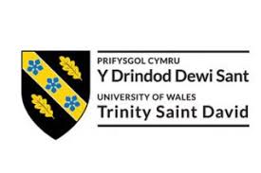

ACADEMICAL REPORT
For Academic and Employability Skills

Student: Viorica Buzatu 1817387
Lecturer: Matthew Peake

London, 2019

Good day, my name is Viorica and here I will try to do my best writing a report in a foreign language. In my report I will reflect on CV writing, analytical and critical thinking skills, academic writing (language and grammar) and referencing. These are some chapters that helped me to develop both professionally and personally.

Well, let’s start with the CV.
CV is the abbreviation of the Latin phrase "curriculum vitae", which translates to "life program". At the lessons of Academic and Employability Skills I found out that well-structured and informative CV will definitely stand out because it is the simplest way to convince an employer that you are the right person for the job. The perfect resume should re-enact our career path in a way that highlights your skills and abilities. A good-drafted CV will give an employer a general picture of our professional and academic career and will provide basic information about our skills. I can say, a resume is the mirror of our career. In some cases, CVs may also contain personal information about job applicants, such as hobbies. Most of the specialists, however, recommend us to skip this section. This body depends largely on the type of job we are applying for. In recent years it has become very popular recruitment through social networks like LinkedIn, but the CV remains a mandatory requirement of employers when we come to an interview.

Mistakes you don't have to make in your resume.
According to The Guardians (2017), on average, an employer receives around 250 CVs for a single job in the competition. In these conditions, the person who deals with their filtration will give about 6 seconds to a CV. Candidates who have jumped from one job to another in short periods of time are eliminated (which thing in my opinion is wrong), those whose work experience does not correspond to the job requirements, but especially the CVs full of mistakes. I thought about and I write a list of errors that exclude you from the beginning of the recruitment process:
A resume too long or too short - a resume too long is boring. The information must be summarized. We must not confuse the CV with the cover letter. Too short one reduces your chances of employment to zero. Even if you are looking for your first job, it details the academic experience, the prizes won, the volunteer work or the internships. This way we will prove to the employer that although you have no experience in the field of work, you are a person involved, active and eager to learn new things.
Listing all the responsibilities for each job separately - to appear as competent as possible, many candidates fall into this trap: mentioning all the responsibilities of a particular job, but forgets to explain what they have done specifically for that company.
A CV full of mistakes - spelling or grammar mistakes are unforgettable (at this sentence I will return below). So we must make sure that we haven't even lost a character, comma or a full stop. We can also ask the help of a friend, who, at the first reading, will more easily identify the mistakes or as I am confident after two terms of ACE* it will be easy to write one without any help.
Career goal too general - we must be tailored to the job we are applying for, so we should avoid the cliches.
Mentioning information that is not relevant – we don’t have to impress employer with details that have no relevance to the job, even if we find remarkable achievements.

Now it is the time to speak about that point, without the CV is just a piece of paper with a lot of letters on it - the importance of writing as a communication tool. Most students go through a course unit that prepares them for the formal written work they are expected to present to their readers during their campus stay. The academic writing course helps to acquire the development, writing and editing skills. An academic writing is structured to answer specific questions and to show understanding of a topic. The punctuation and grammar rule must be respected to create clarity and to avoid ambiguity, to avoid the use of colloquial language: figures of speech, idioms and clichés. The use of short sentences and clear paragraphs is recommended to avoid boredom of the reader. One should be clear and straight to the point. The use of appropriate time should also be considered. A good academic writing should have a proper outline that will help to formulate the thoughts of the writers and to raise awareness of certain relationships between subjects. One should be aware of his audience and respect the formal nature associated with academic writing. One should target a wider audience, who are intellectual thinkers and not just the reader. At the end of our academic writing, we must define the terms used and do not assume that the reader understands all the terms and concepts associated with your activity. In academic writing you should have a consistent stylistic approach. The consistency of the writing style adheres to the narrative flow of the paper and improves its readability. One should always avoid using the first person in academic writings, because it describes the views or opinions of those from works he has read; unless you are asked to create a reflection piece, the rules are different. However, this does not mean that a writer cannot find his own voice. Your voice is an important aspect of becoming an effective writer. The first person (I) can be used effectively, especially in introductions and conclusions, but overuse should be avoided. Academic writings have accurate references that support those who write.
So, another topic that impressed me at ACE is Referencing.
Mandatory elements of bibliographic references are systematized by types of information resources: official publications, books, articles, electronic documents: authors, titles, place of publication, publisher, year of publication, page, date of accessing the site. The main source of information for the compilation of the bibliographic reference is the document itself. The primary source of information within the document is the title page. The title of the document must be reproduced as follows appears on the title page. The punctuation is important: EACH element of the reference must be separated by a comma, stop / comma (;) or full stop.

A very important moment in fulfilling the tasks at work is Critical Thinking.
This kind of thinking is clear one, free and rational. This is not focused on the accumulation of information, but on the advancement of information processing capabilities. The following capabilities fall under the umbrella of critical thinking as The Guardian (2017) sais:
- to identify, understand and make logical connections between one's ideas and arguments;
- to detect reasoning errors in arguments and presentations;
- to solve problems with high degree of difficulty;
- to understand the relevance and importance of ideas;
- to identify the context and implications of an argument or idea;
- to identify, construct and understand the justifications behind opinions, arguments or beliefs;
- to build new arguments and ideas based on those accumulated up to the present moment;
- to distinguish between facts, opinions and value judgments.

A person who has these qualities can understand arithmetic issues much more effortlessly, can get it way better any content or contention from any subject, without requiring to hold colossal sums of data. Basic considering is fundamental quality in both individual and proficient life. To begin with, it encourages the transmission of one's thoughts and understanding of the thoughts of others, making communication much more advantageous and profitable.
In addition, it quickens the digestion of modern data and the induction of its results. These aptitudes are basic in any field of work. The aptitudes are all inclusive and can offer assistance in understanding the logical and social concepts. Along side imagination, basic considering is significant in development, inquire about and improvement. At long last, the advancement of basic considering benefits not as it were the taught people, but moreover the society of which they have a place. Critical thinking mends a society of bias and lack of involvement, making political and social concepts much more open and enabling members to ended up educated and included. When we need to think accurately, we must take after the precise rules of reason. Knowing the theory means knowing these rules, which represent the basic principles of critical thinking, such as logical laws, the methods of scientific reasoning, etc. It would also be useful to know something about what you don't have to do when we want to think correctly. That means you should know, to a degree, the mistakes people make. First of all, it's need some knowledge of typical errors. Second, psychologists they discovered a number of persistent preconceptions and limitations in human thinking. Knowing these empirical findings, we will be able to detect the possible problems.

In conclusion, I can say that the knowledge gained during this two terms helped me to develop both professionally and personally qualities. At the workplace I began to analyze from the beginning what would be the reasons for a conflict, in many cases I asked the opinion of people who had no attribution to the given conflict, I listened to the people involved in the conflict and I analized the situation, applying in practice the studied theory we have come to the best solution to reduce this conflict. Critical thinking helped me to position myself on a higher level than my colleagues and I noticed that people in leadership positions started to ask me for my advice in some cases, which proves the good suitability of the material and its efficient application every day.

Appendices
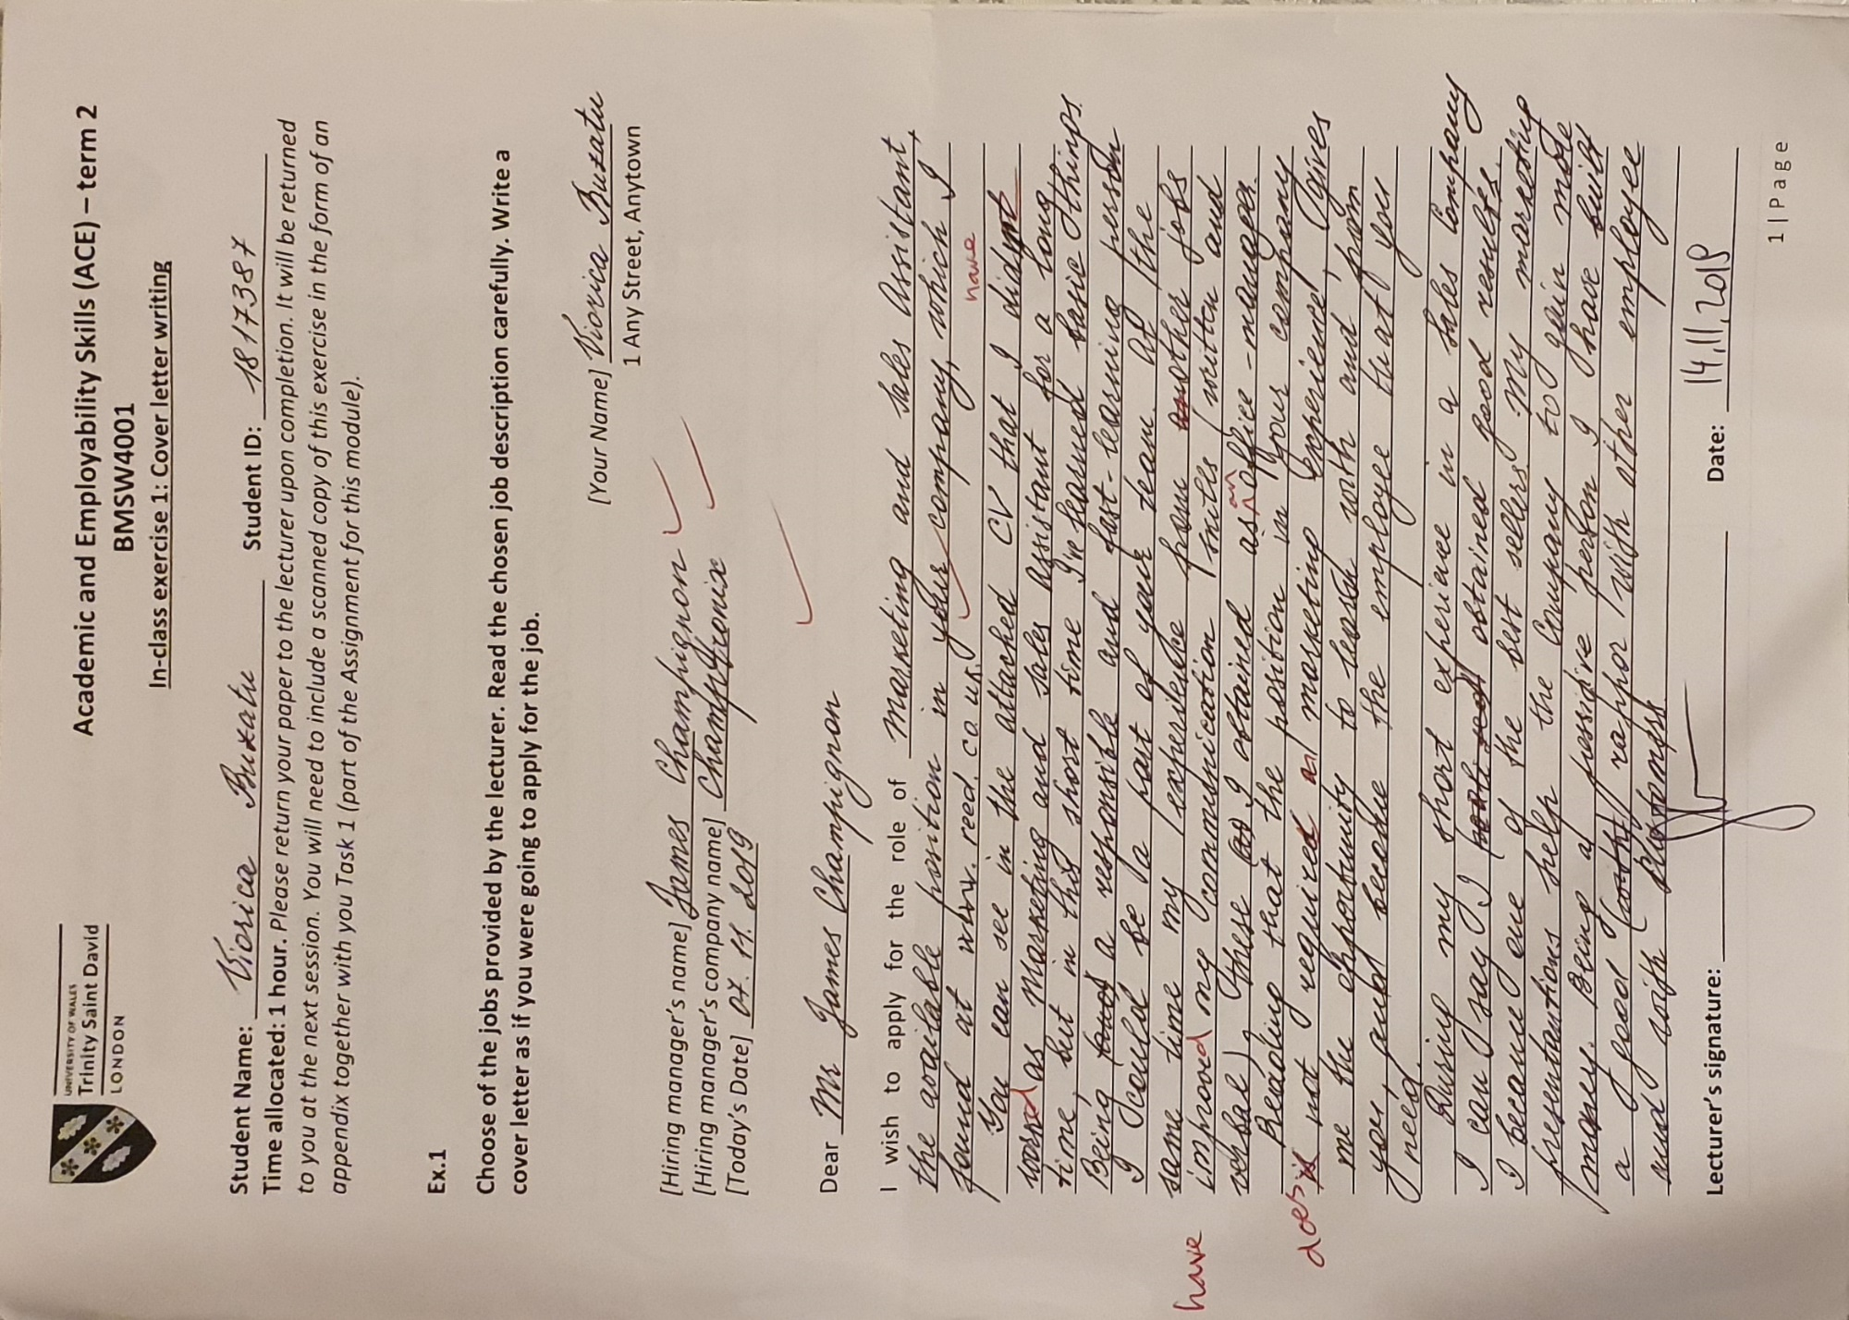
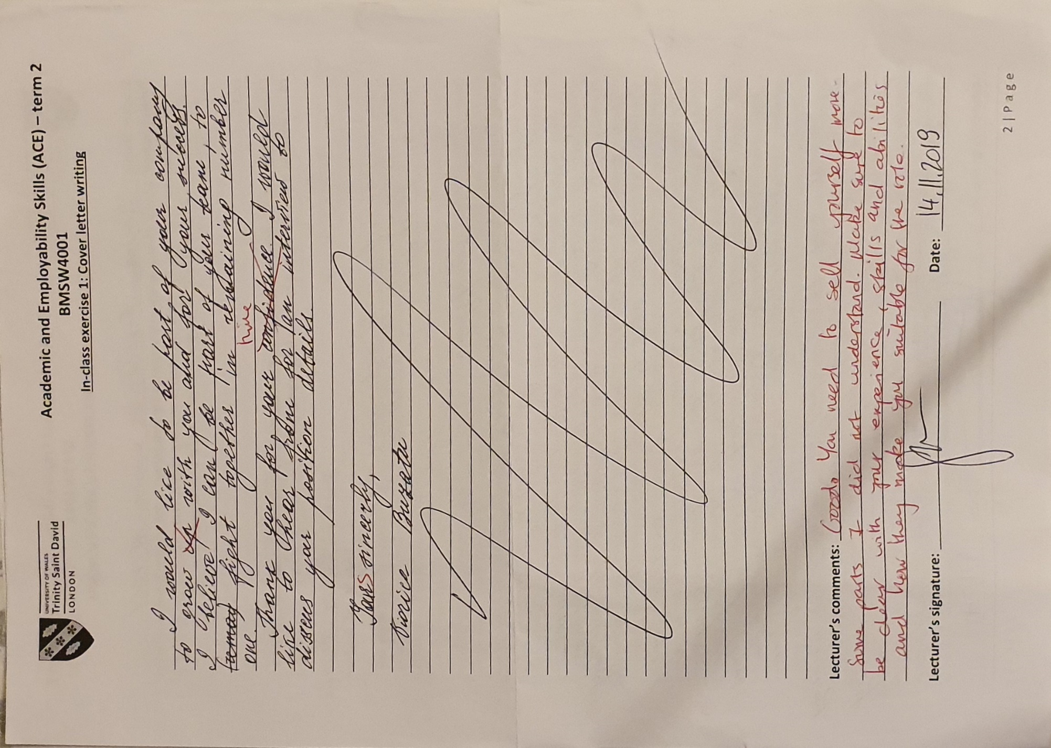

References
The Guardian (2017)
Available at: www.theguardian.com/careers/2017/oct/03/five-ways-to-get-your-cv-noticed-by-employers
(Accessed: 13 december 2019).
LEVY, S. n.d. busyteacher.org.
Available at: https://busyteacher.org/6214-how-to-teach-summary-writing.html
(Accessed: 11 december 2019).
Maund, A., Schriek, M. & Tinkler, P. K., 2017. Certificate in Higher Education: Skills for the Workplace Student Yearbook. London: SAGE Publication Ltd.
Ruca, O. (2013). multsucces.wordpress.com.
Available at: https://multsucces.wordpress.com/2013/02/14/6-stadii-ale-dezvoltarii-unei-echipe-de-lucru/
(Accessed: 10 december 2019).
Cardinal, R. (2015) huffpost.com.
Available at: https://www.huffpost.com/author/shapingchangeworldwide-251
(Accessed: 09 december 2019).

