Awe and Wonder, maths and science, outdoors
I am going to provide an image and discussion of an outdoor space that could be used by early years children to develop their mathematic and scientific understanding through play outside. I will provide a risk-benefit assessment alongside this image of the outdoor space and follow up with an evaluation of how adults within the early years sector can work alongside children to encourage the mathematic and scientific concepts within this outdoor setting as they play.
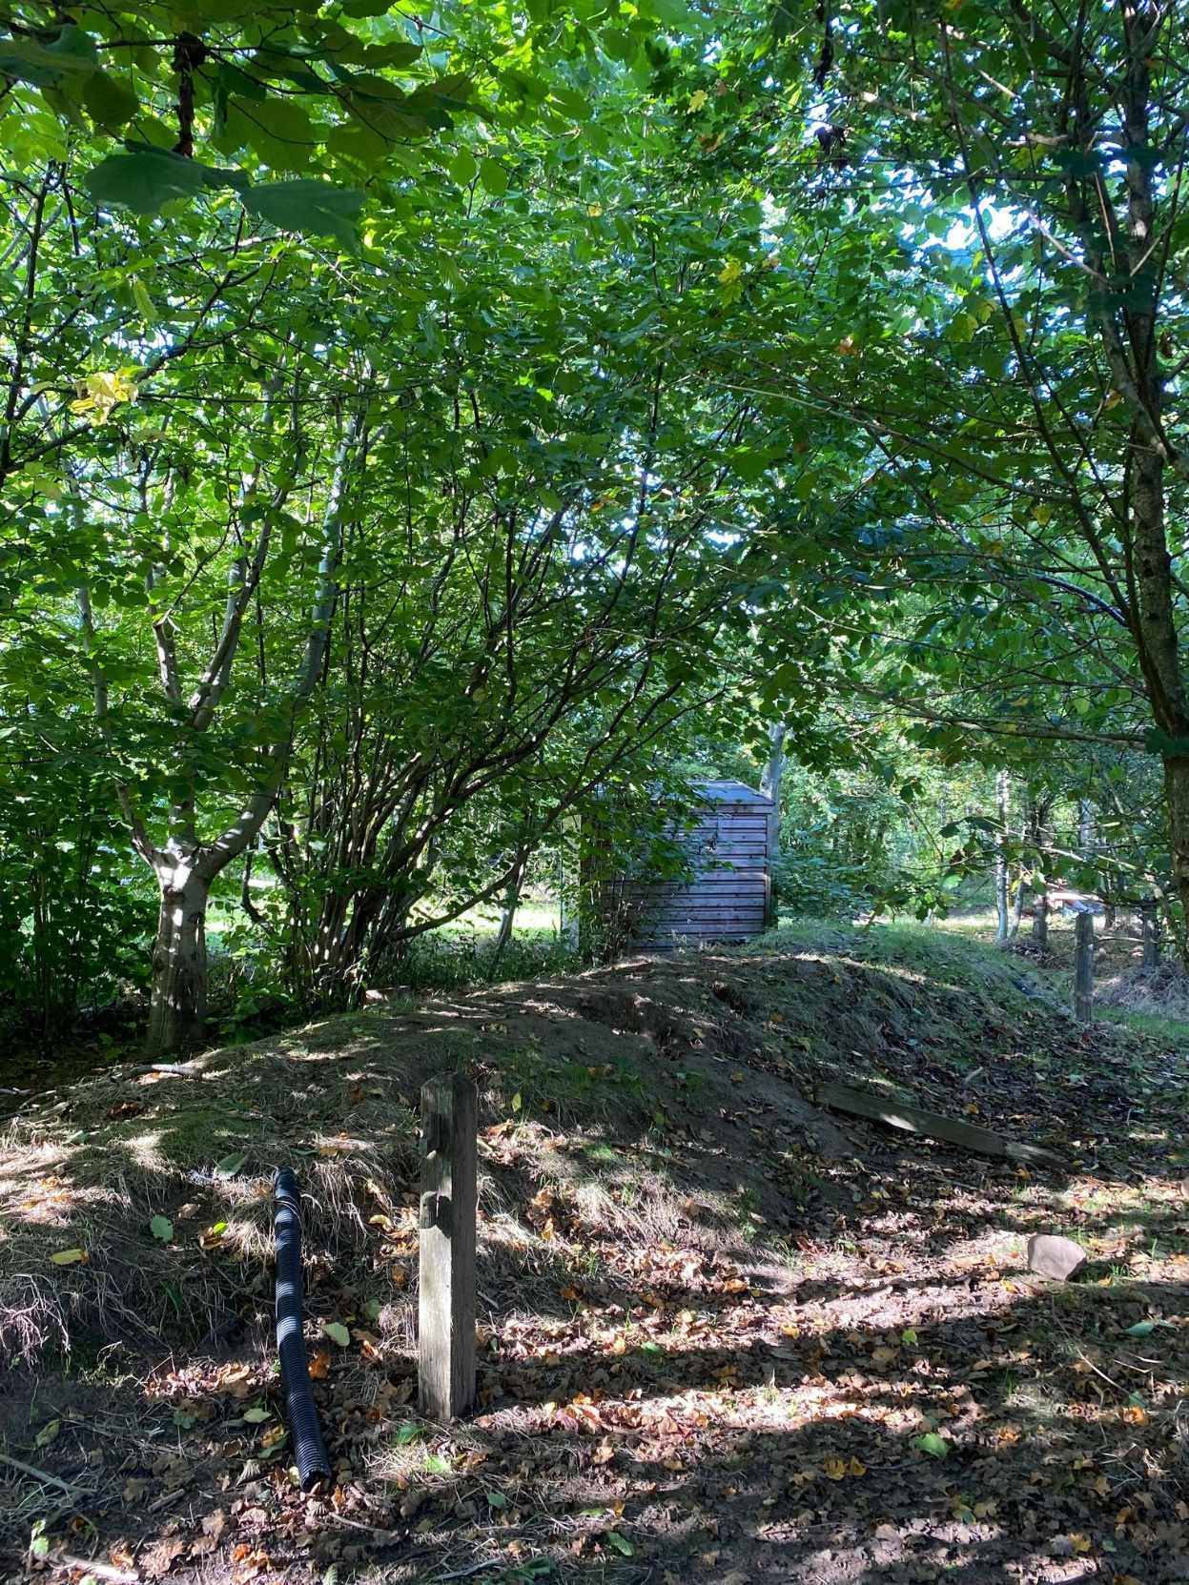
Own image-taken 16th September 2022
This image is a small section of the ‘Coed Clase’ forest schools area within Clase Primary School. It is used by pupils at the school from the age of 2 until age 11, and the activities and learning that is complete in this area varies hugely depending on the area of learning and age group. This specific area of the forest provides endless opportunities for learning through play and gathering understanding of different mathematical and scientific concepts such as shape, size, colour and gravity. According to Estyn 2019, both first-hand experiences and play focussed activities provide children the best outcomes in their learning, they back this up with the Foundation Phase Framework, Welsh Government (2015).
The list of opportunities for learning in this area are endless, some options for activities and concepts to discover are as follows.
- Growth
Within this topic you would be looking at life cycles and size, it could be through the plants and trees around you, the insects children come across. If the children are left to direct themselves and discover things themselves freely and through play, they will likely discuss between themselves what they can see and talk about their own knowledge and share ideas and this would them promote conversation towards adults and initiate curiosity in a fun and natural way. It’s an opportunity to start the cycle of life and connect it back to the human body, and how all living things grow throughout their life, and it will promote discussion about what they need to grow, for example plants need water and sunlight, and creatures need food, water and a habitat, alongside humans, which is a huge scientific concept for children to discover and understand.
- Habitats
This conversation and learning could come off the back of the growth session, it simply allows children to navigate through their own learning and learn what they would like to learn, which promotes engagement from learners, which is the aim of the new Welsh curriculum. Children can be sent to discover natural habitats that creatures create such as nests, as are they able to find out what insects like for their habitat, for example children may lift a rock and discover lots of woodlice, they may dig a hole and discover lots of worms. It also opens up space for a creative task where children can create bug hotels, which is a human made home that is aimed at attracting bugs, children can go off and do their own research both in and out of the classroom and then as a project create their own bug hotel to leave in the forest, they can then check on it weekly in their sessions to discover their findings.
- Symmetry, shapes and patterns
This is yet another concept that children will gain an understanding of in this exact outdoor setting, both are mathematical concepts that can naturally be portrayed to children through their own curiosity and questioning. Children can discover natural patterns by seeing and feeling the trees, bark, grass on the bank, different colours of plants in different places, they are able to look at symmetry by looking at leaves from the trees and the lines within them. Another mathematical concept that could be explored within this environment could be shape, for example, logs are circular, but the shape of a log would usually be a cylinder, this would show the difference between 2d and 3d shapes.
- Shadows
Children will be able to discover shadows and how they work within this setting, they will be able to see the shadows of different item alongside themselves and their peers and it opens up conversation about how they work, how they differ at different points in the day, for example they may be longer or shorter depending on the sun direction, again another scientific concept.
- Collecting nature items and counting
Children love collecting things and they are nearly always proud to then show them off to their peers and staff, this could be encouraged and then extended, children could be asked to go and find things and then there could be a discussion on what they find, and children could then count them which is a simple mathematical concept that children need to learn, this makes it fun and experiential.
Children could also be sent out in groups to discover as many different creatures as possible or different types of plants, this would encourage conversation regarding biodiversity and they could also count the number of different things they find, they could tally them in the dry mud on the floor using a stick.
- Measuring
Again, this is a mathematical concept that is a vital skill for children to develop, this could be a complex task within a classroom and one that may not engage children, this is a concept that can be complete in so many different ways in this image. Children could measure each other using sticks and stones (nonstandard measure) they could measure the bank, the pipes, the size of sticks using stones, or this could be extended by bringing in measuring tapes and rulers if the children are ready for standard measure, and they could read the numbers and find out about mm and cm outside of the classroom.
- Balancing and Gradients
There is a bank within this area that can be clearly seen in the photo, from experience I’ve witnessed children using this area to balance and jump, seen as a type of risky play. Children balance, run or hop along the top or they will stand on the gradient and see how long they can balance there before falling off. Children are often laughing at their own outcomes and what happens to others here and they often leave with cuts and bruises from their own experiment, they also mark their own progress each time they do it and find that each week they get ‘better’ at it. In the past this has opened up conversation regarding balance and how it works, and how sometimes if the ground is wet their balancing skills may seem ‘worse’ as it slippery, it has encouraged trial and error and allowed them to discover that it may not matter how ‘high’ they are as long as they are standing on a solid, flat surface it is possible to balance there for a while. You develop your vestibular sense and increase your balance through using it, if children do not have opportunities to balance, they may not have a good vestibular sense. Our vestibular sense helps improve smooth eye movement, the use of both sides of the body in sync and allows children to feel confident in their body and its capabilities in movement.
- Seasons
This area allows for lots of curiosity regarding seasons, for example within this photo which was taken at the beginning of September it can be seen that autumn was well on its way, as there were lots of brown leaves fallen off the tree, therefore depending on what the trees look like it could be determined what season it was. It could be an opening conversation for staff to have on each visit to this area, and children will learn what to look out for as they start to learn about the seasons and when they come into force and what may happen. It also allows children to find out processes such as photosynthesis, as it can be seen that the trees grow and flourish more in the summer, due to the increase in sunlight, and the leaves fall off in autumn and remain bare in winter due to the lack of sunlight. It can also start a conversation regarding the water cycle and how it works, encouraging words such as precipitation to be used, as it may rain, or they see puddles, that are not drying up for example, it can be explained that puddles will dry up more quickly in open areas as there’s more space for evaporation and there is more access for sunlight to speed up the process. These are both necessary scientific terms and concepts that children may not discover within the classroom but would or have definitely come across in this area.
If some loose parts were added or pots, pans and cooking utensils this could encourage children to use the area as a mud kitchen, which could promote the following concepts: Cooking, shopping and entrepreneurial skills, making music/sounds through banging the items together with mud inside or stones inside to create different sound vibration and discover what happens. Other things like Magnifying glass, microscopes, binoculars, tarpaulin, and watering cans could be added to spark new concepts and curiosity and promote the use of this area in a different way too, allowing children to be ‘explorers’ or build dens, you could also provide children with cameras for them to document their activities and use their digital skills in a different way than they might in other classroom contexts. They could also be provided with a ball to use with the pipes that are in the photo to see how they work, and test gravity, and different forces, such as kinetic and friction.
Children are able to direct their play and learning in their own way and find out different things about what they are interested in, they are able to navigate their way through different areas of learning and learn in a hands-on way, which may look different for each child within a setting, this is in like with the curriculum for non-maintained settings alongside the 4 purposes, new welsh curriculum.
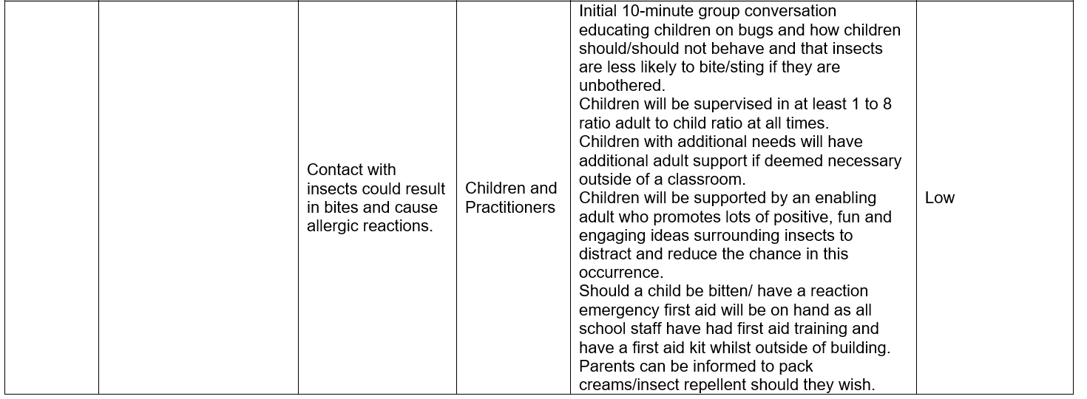
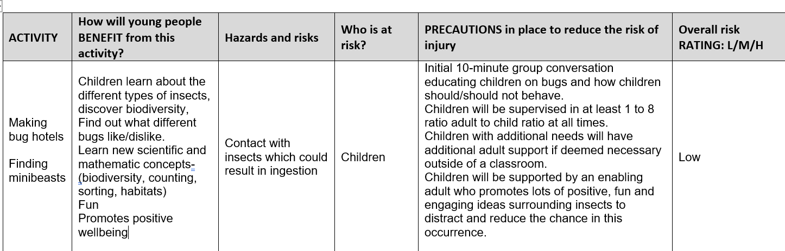
Risk Benefit Assessment
Location / Activity: | Section of Coed Clase-Clase Primary School | Date: | 20/09/2022
Assessor: | Ellie Thomas | Review date: | 20/12/2023  (New season-different conditions)

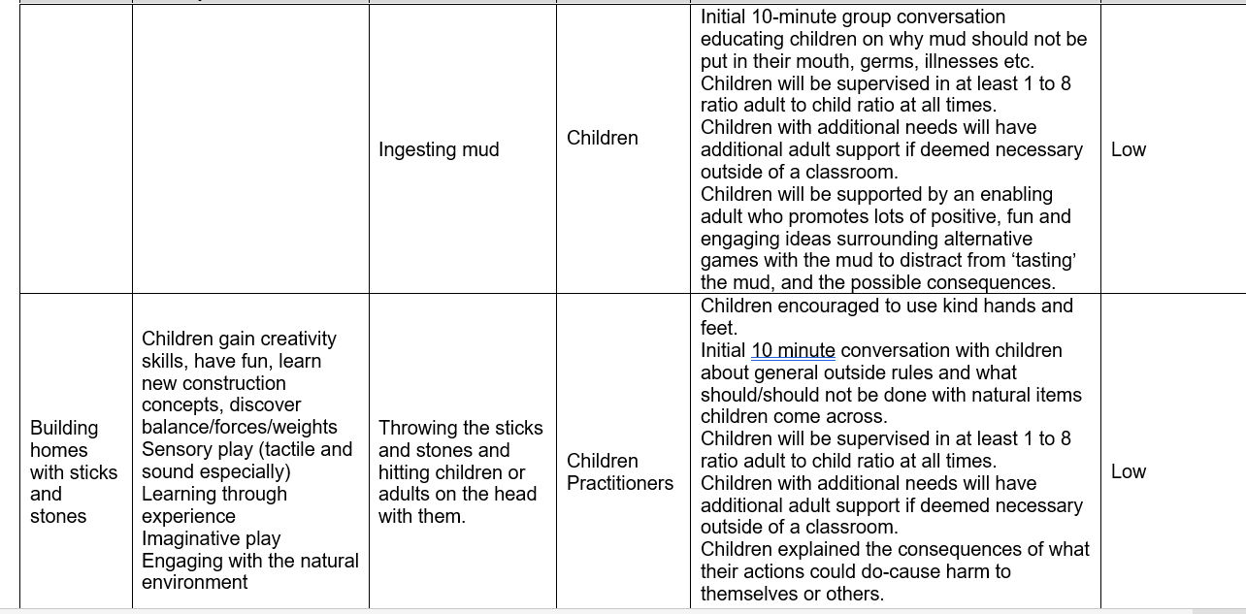
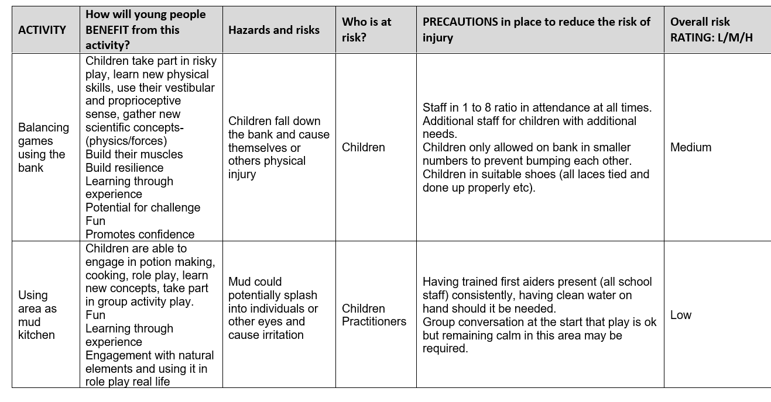

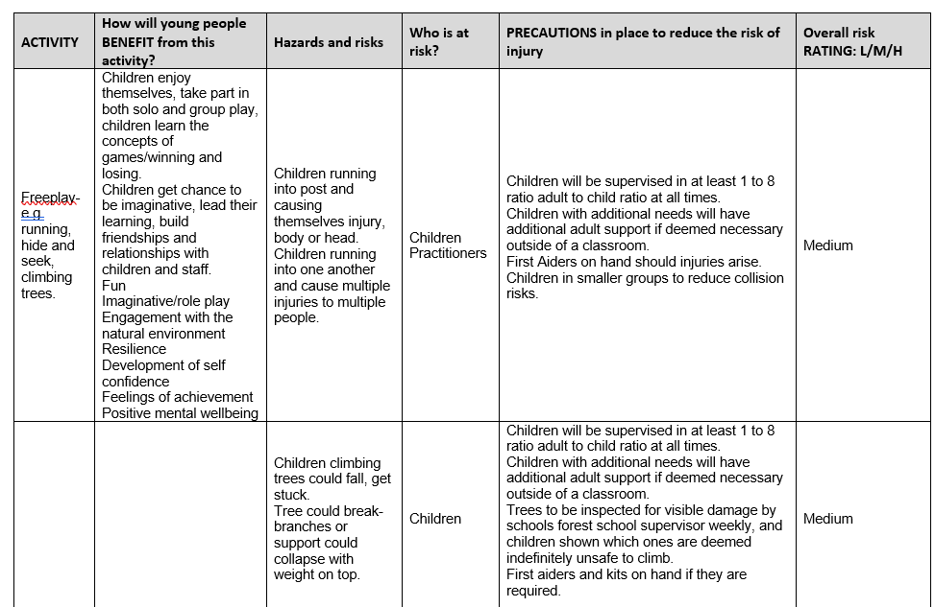

Investigated next is the role of the adult within the Early Years. A huge role covering so many aspects of children’s experience in a setting. This evaluation is going to be focussed on their role within the outdoor environment, mainly the photo above and how they may be able to promote a child’s development and understanding of different mathematical and scientific concepts naturally.
Firstly, an adult would need to provide the environment to the children and allow them to play within it in an open-ended way. According to Albert Einstein, cited by Red Apple School, 2013, play is the highest form of research, this would suggest that children being left to freely play and explore in their own way within any outdoor environment would gain far more knowledge than being taught in the typical expected way within a classroom. In line with this, according to Froebel Trust (no date) was Froebel’s approach to learning, which generally suggests that he believed children learn better through their experiences, therefore being outdoors and actively taking part in any activity is more beneficial than remaining in the classroom, which according to Aubrey and Riley (2019) is similar to the Montessori approach which is learning within the real world, with authentic equipment and real-life experiences. The new curriculum for Wales, according to Gov.Wales (2020), explains that education is being improved and educators are now expected to have a more integrated, holistic and ever-growing approach to children’s learning and their development should involve them just as much as it does practitioners, therefore practitioners must remain inclusive and open minded. This should help children to feel at ease and enjoy their education experience, which should result in better outcomes. It was proven by Howard and McInnes (2012), that children perform better, feeling less pressure, when they are playing with no end goal, free, self-directed play should promote positive emotional wellbeing and lead to a child feeling happier, which in turn should develop and increase their understanding of mathematic and scientific concepts discovered through exploring this section Coed Clase.
An adults role within the area in the above photograph might simply be to overlook the children playing, ensuring they are happy, settled, safe and having fun, just being on hand sometimes is enough. Adults being able to answer questions and promote conversation will help children feel confident within their environment, according to Vygotsky, cited by Aubrey, K and Riley, A (2019).
Practitioners may struggle to support the new curriculum at the beginning as they need to stand back. The adult could be a potential barrier for children to use their awe and wonder within an outdoor space. If a practitioner is of the understanding that children need to develop their mathematic and scientific concepts, they may not see outdoor play as a way of doing this, therefore preventing them from doing so, and focussing on classroom based activities, which for most children would be less engaging and may result in less performance. This is backed up by Gov.Wales (2020) and Gov.Wales (2022). The New curriculum that needs to be adopted by practitioners aims to provide long, holistic experiences that covers different areas at once, which suggests that its more open to hands on, outdoor activities than previous teaching guides and moves away from separating the two topics of maths and science, as it is now cross disciplined and focussed on areas od learning, and agrees that sometimes they may interlink, so separate subjects do not need to be taught at separate times. An example of this could be measuring, if a child starts collecting rainwater they may measure the amount of rainfall in 24 hours, which would then be a mathematic concepts. The role of the adult in this situation would be to be enabling and open the conversation about the water cycle, what it is and why it might occur, which then turns the learning to have a heavier focus on geographical and scientific concepts, alongside the mathematics. This truly supports the new curriculum, promotes lots of cross discipline learning and shows a child would get so much more from hands on outdoor learning than if they were being taught in the classroom and carrying out written work.
Vygotsky and Piaget both had similar beliefs that children needed hands on experiences in order to construct their knowledge and neither believed in staged, planned learning environments and suggested that this did not engage or involve children, whereas a natural outdoor environment like the one in the picture above would be perfect. (Aubrey, K and Riley, A, 2019)
According to Aubrey, K and Riley A (2019) Piaget believed that the human brain works in schemas, which are a mental structure that when exposed to something you discover what it is, and unless told otherwise anything similar will fit in the same mental structure, for example if a child knows that ants exist, unless they are exposed to other insects and explained, shown and experienced the difference they will forever see all insects as ants. Therefore, the role of the adult in this outdoor space, could be to use sustained shared thinking with children when they are exploring minibeasts or collecting natural items. According to Twinkl (2021) sustained, shared thinking is when two or more individuals (a practitioner and children in this case) have an intellectual conversation in order to establish new information, it may begin with an adult saying, ‘I wonder if...’ and a child may attempt to find out the answer to the adults query, it is useful helps children develop thinking skills, think critically and problem solve, it promotes curiosity too. Sustained shared thinking provides better academic progress and it supports communication and language, which is helpful alongside developing maths and science concepts through experiment and discussion. Sustained shared thinking supports pedagogy and is supported by the zone of proximal development according to Aubrey, K and Riley, A (2019) as this zone is the gap of what a child can do with and without an adult, so where they may not be able to do something before after sustained shared thinking with a practitioner they may discover how to do something afterwards, for example, a child may notice their shadow and through this outdoor scientific process find out why a shadow is formed, what it is and how it works.
Another role an adult may hold when supporting children’s awe and wonder in the early years could be to find and provide ‘loose parts’. Loose parts come from a theory from Simon Nicholson in 1971 cited by both Play Scotland (no date) and Creative Star Learning (2017), where he explained that if an adult added loose parts or encouraged children to find and use natural loose parts within their environment they would be empowered and creative within it, children will learn, discover and enjoy themselves more and it allows a learning space to have become a sensory experience with endless opportunities. Twinkl (no date) suggest that loose parts can be random, tangible materials that could be meaningless, but used for symbolic play. Symbolic Play according to Piaget cited by Aubrey, K and Riley, A (2019) is when a child uses one material and its purpose in play is another, for example using a stick as an aeroplane or using a pebble as a marble, she said that symbolic play helps children initially make sense of objects and their environment. Loose parts allow an environment to become a sensory experience as children can look, smell, and feel their loose parts and experiment with them, which is a scientific concept alone. Children can discover mathematic and scientific concepts this way through looking for different shaped loose parts, counting and using them to physically learn simple maths like addition and subtraction, or use them to make patterns. Whereas, scientifically, children could discover concepts like floating and sinking, gravity, movement, reasons for textures and shaped (abrasion and weathering). Both Froebel and Nicholson believe that children using loose parts within enabling learning environments provide the best outcomes for children in education settings, this ensures children have purposeful, authentic learning opportunities. Practitioners can ensure this by adapting the environment to suit the learner and make sure it is always engaging and differs each time it is used.
According to Aubrey, K and Riley, A (2019), David Kolb also had a theory that suggested that experiential learning was the way children made the most progress, he claimed that learning needed to start with an experience, whether it be indoor or outdoor, in order to engage them and use their feelings, when an experience allowed them to feel something the learning became more meaningful and could then be followed up by reflection, conclusion and then trying out what had been learnt before moving along to something else. This theory is supported within the area in the photograph above and allows for mathematic and scientific concepts to be explored but does suggest that each topic should be kept separate, which is not the aim of the new welsh curriculum and does not allow experiences to remain totally child led.
According to Robertson, J 2017, teaching maths in the early years is a constant occurrence, whether practitioners realise it or not, and the maths lessons within the classroom and the standard tests account for a small amount of the mathematical learning. The reason it is taught is not simply because ‘it must be according to the curriculum’ but as it has a long-term benefit, it is a life skill for money management, shopping, measuring, routine, data handling in instances not even considered. It is a purposeful skill that needs to be applied throughout anyone’s lives.
Science is another necessary life skill that should begin developing in the early years as it is constantly in the surroundings, for example, Cooking is a science and is also a necessary life skill. Science is a part of the STEM section of the curriculum; therefore, it is mandatory. However, now with the new welsh curriculum, GOV.WALES (2020) suggest that science can be taught in a wider way, with other topics crossing over. According to Early Education Zone (no date) STEM (Science, Technology, Engineering and Maths) must be taught within early years settings because it results in higher language and literacy outcomes, helps to build resilience and build confidence in learning processes, it teaches how to examine problems and create plans to solve them by using critical thinking skills and it encourages risk taking and unorthodox thinking.
To conclude, the theory of outdoor learning and allowing children to use their awe and wonder to discover mathematic and scientific concepts is a very useful, fun and successful tool that is not always reflected in practice, there are many reasons for this. Example’s being, not having enough staff, staff themselves not having the education that suggests hands on experiences being beneficial, and also the difficulties that outdoor learning can pose on health and safety regulations, as they are tighter in recent years that ever before, however, with both the new curriculum for education settings and non-maintained settings coming into force.
Reference List
- Aubrey, K and Riley, A. (2019) Understanding and using educational theories (Second Edition) Published by SAGE. [Accessed 30 September 2022].
- Creativestarlearning.co.uk. 2022. Simon Nicholson and The Theory of Loose Parts – 1 Million Thanks | Creative STAR Learning | I'm a teacher, get me OUTSIDE here!. [online] Available at: <https://creativestarlearning.co.uk/early-years-outdoors/simon-nicholson-and-the-theory-of-loose-parts-1-million-thanks/> [Accessed 30 September 2022].
- Estyn.gov.wales. 2022. Learning through play to support independent learning | Estyn. [online] Available at: <https://www.estyn.gov.wales/effective-practice/learning-through-play-support-independent-learning> [Accessed 30 September 2022].
- Flannigan, C. and Dietze, B., 2018. Children, Outdoor Play, and Loose Parts. Journal of Childhood Studies, pp.53-60.
- GOV.WALES. 2022. Curriculum for funded non-maintained nursery settings | GOV.WALES. [online] Available at: <https://gov.wales/curriculum-funded-non-maintained-nursery-settings> [Accessed 30 September 2022].
- Howard, J, McInnes, K. (2012). The impact of children's perception of an activity as play rather than not play on emotional well-being. Child: Care, Health and Development. 39 (5), 737-742.
- Hwb.gov.wales. 2022. Curriculum for Wales - Hwb. [online] Available at: <https://hwb.gov.wales/curriculum-for-wales> [Accessed 30 September 2022].
- Hwb.gov.wales. 2022. Foundation Phase Framework - Hwb. [online] Available at: <https://hwb.gov.wales/curriculum-for-wales-2008/foundation-phase/foundation-phase-framework/> [Accessed 30 September 2022].
- Hwb.gov.wales. 2022. Hwb. [online] Available at: <https://hwb.gov.wales/> [Accessed 30 September 2022].
- Ouvry, & Furtado, A. (2020). Exercising muscles and minds : outdoor play and the early years curriculum (Second edition.). Jessica Kingsley Publishers.
- Playscotland.org. 2022. [online] Available at: <https://www.playscotland.org/wp-content/uploads/Play-Scotland-Loose-Parts-Leaflet.pdf> [Accessed 30 September 2022].
- Red Apple School. 2022. “Play is the highest form of research.” – Albert Einstein. [online] Available at: <https://www.redappleschool.org/play-is-the-highest-form-of-research-albert-einstein/> [Accessed 30 September 2022].
- Robertson, J 2017, Messy Maths : A playful, outdoor approach for early years, Crown House Publishing, Carmarthen. Available from: ProQuest Ebook Central. [26 September 2022].
- The Froebel Trust. 2022. Froebelian Principles. [online] Available at: <https://www.froebel.org.uk/about-us/froebelian-principles> [Accessed 30 September 2022].
- Twinkl.co.uk. 2022. [online] Available at: <https://www.twinkl.co.uk/blog/sustained-shared-thinking> [Accessed 30 September 2022].
- Twinkl.co.uk. 2022. [online] Available at: <https://www.twinkl.co.uk/resource/loose-parts-theory-handout-t-cpd-1657102528> [Accessed 30 September 2022].

