

Programme: Master of Business Administration

Module: International Business Concepts

Module code: LCMB7034

Name: Meet Malani

Student Id: 2504764
TABLE OF CONTENTS
Section 1 3
1.1 Introduction 3
1.2 Industry and Country Overview 3
a. Introduction of Fintech Industry in the United Kingdom 3
b. Size, Scope, and Economic Importance of the FinTech Industry 5
c. Major domestic and multinational firms and the relative positioning of key companies 6
1.3 Global Competitiveness in FinTech Industry using Michael Porter’s Diamond Model of National Advantage 8
1.4 Market’s overall attractiveness for Revolut and factors influencing success in the UK FinTech Industry 12
1.5 Conclusion 21
Section 2 23
2.1 Introduction 23
2.2 Reflective Account of Process 24
2.3 Conclusion 27
Reference List 28

Section 1

1.1 Introduction
The United Kingdom has become one of the most popular financial technologies (FinTech) sector centres in the world due to the developed financial services environment, robust regulatory framework, and a highly innovative digital economy. The report is a critical analysis of the competitiveness of the UK FinTech industry in the international arena, focusing on the structural, institutional and strategic conditions underpinning its development and positioning on the global arena. It starts with a general overview of the UK FinTech industry with particular reference to its size, its economic role, and the key domestic and multinational companies in the industry. The sources of competitive advantage are then determined using the Diamond Model of National Advantage by Michael Porter. The report also evaluates the appeal of the UK market to foreign multinational enterprises in terms of political, economic, legal and cultural factors, and ends by providing insights on how strategic international firms operating in the industry should be.

1.2 Industry and Country Overview

a. Introduction of Fintech Industry in the United Kingdom
Financial technology (FinTech) is one of the most vibrant crossovers between the older financial services and the modern digital and innovation. Based on the long-established role of the country as a global financial centre, the UK FinTech ecosystem has grown at a fast rate, due to the level of expertise, capital markets and institutional infrastructure that is concentrated in London as per Vijayagopal, Jain, and Ayinippully Viswanathan, (2024). The industry has a wide spectrum of digital financial offerings, such as payments, digital banking, peer-to-peer lending, RegTech, Insurtech, wealth management applications, and blockchain-delivered services.
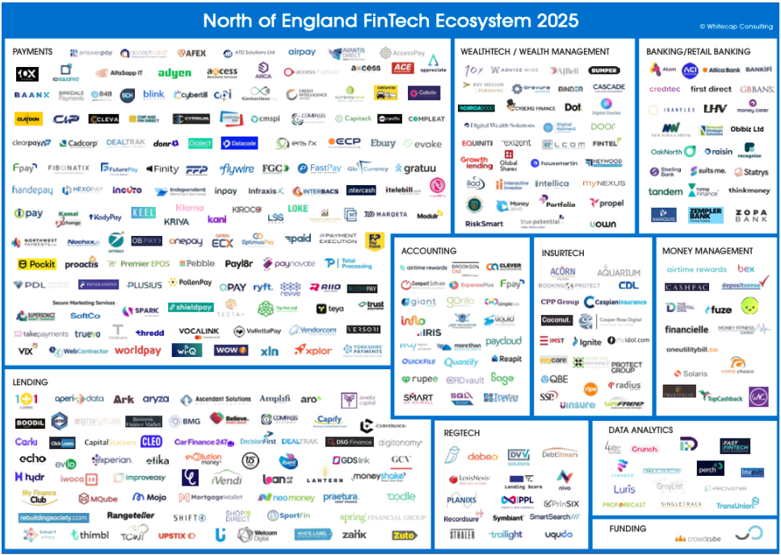
Figure 1: FinTech Ecosystem in the United Kingdom
(Source: Walsh, 2025)
A liberal regulatory framework, especially that of the Financial Conduct Authority, which has facilitated innovation via regulatory sandboxes and open banking schemes has helped the UK to develop FinTech considerably according to Kálmán, (2025). These regulations have reduced entry barriers to start-ups as well as promoting competition and partnership between old banks and FinTech companies.
FinTech has a strategic role in the national context as it helps to increase financial inclusiveness, add efficiency to the various financial services, and make the UK a stronger competitiveness in the global digital economy (Obeidat et al., 2021). It is also a sector that has high skilled jobs and is a source of foreign direct investment and strengthens the UK reputation as a major global financial innovation centre.

b. Size, Scope, and Economic Importance of the FinTech Industry
The FinTech sector in the United Kingdom represents a foundation of the national digital economy, as it is one of the largest international fintech centres. The UK was the second-largest fintech investment destination in the world, with around 2.6 billion worth of investments in 2025, beating every other European competitor and only second to the United States in terms of the amount of funds invested in the industry (Pickering, 2026).
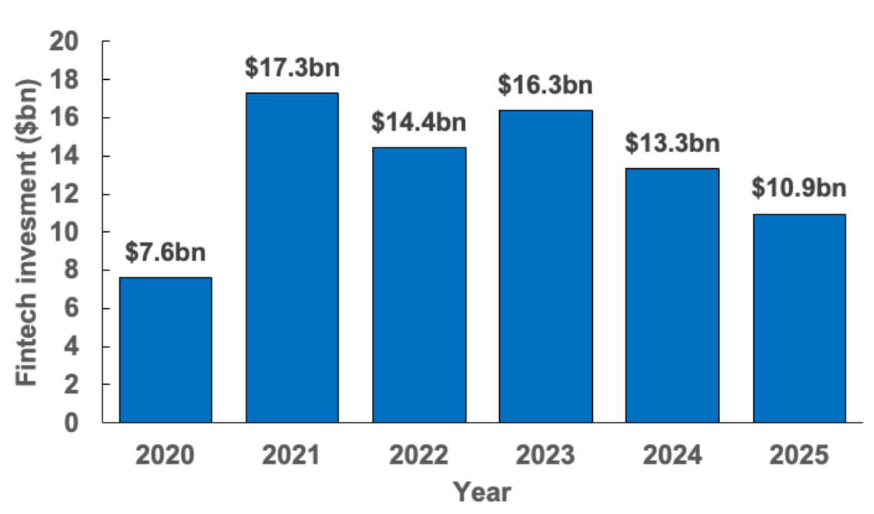
Figure 2: Growing Investment on FinTech Industry
(Source: KMPG, 2025)
Although there have been more widespread economic head winds that have resulted in investment slowing down in the past few years, the UK fintech investment levels have been a high point compared to other key markets and shows long held faith in the potential of the growth of the sector (KMPG, 2025).
The sector includes a wide scope of digital financial services, which are payments, challenger banking, and blockchain applications. It helps to maintain a fast-growing workforce, and job opportunities in UK fintech will be growing by more than 44% in 2024 as companies continue to scale their operations and adopt new technologies like artificial intelligence (Bleach, 2025).
In addition to capital and employment opportunities, the UK FinTech industry has a significant economic contribution to regional economic systems; an example is the creation of 5 billion yearly in the economy of the North of England and the contribution to the improvement of financial inclusion and innovation in the overall UK economy as studied by Walsh (2025).

c. Major domestic and multinational firms and the relative positioning of key companies
The UK FinTech sector contains a combination of domestic challengers with high growth rates and multinational ones, each focused on a specific market segmentation and organizational strategies. Revolut is the most prominent of the domestic neobanks. Depreciating as an account with multiple currencies and low foreign exchange rates, Revolut has quickly expanded into wealth management, crypto trading, and lending. In 2024, the company announced that it saw a 149 percent increase in pretax profit to £1.1 billion, with revenues of £3.1 billion and a customer base of over 52 million since it has a wide range of consumers and international growth prospects as per Howcroft and Wilkes, (2025).
There is also another large domestic player Monzo that is in the digital banking market with high retail involvement. Monzo reached the mark of 1 billion in annual revenues, which was supported by a fast-growing client base of more than 12 million and a substantial growth in deposits, making it a sincere competitor to long-established high-street banks both nationally and internationally (Financial Times, 2025).
Checkout.com draws attention to high value and enterprise-grade processing services in the category of payments infrastructure, such as Netflix, Uber Eats, and Pinterest (Checkout.com, 2026). Its B2B-based approach on payment services is in contrast to Revolut and Monzo that are more consumer-oriented. Similarly, GoCardless is an expert in processing direct debit and subscription payments, and its technology is employed by more than 100,000 businesses and handles over 130 billion dollars every year, meaning that recurring payments automation is highly penetrated (GoCardless, 2025).
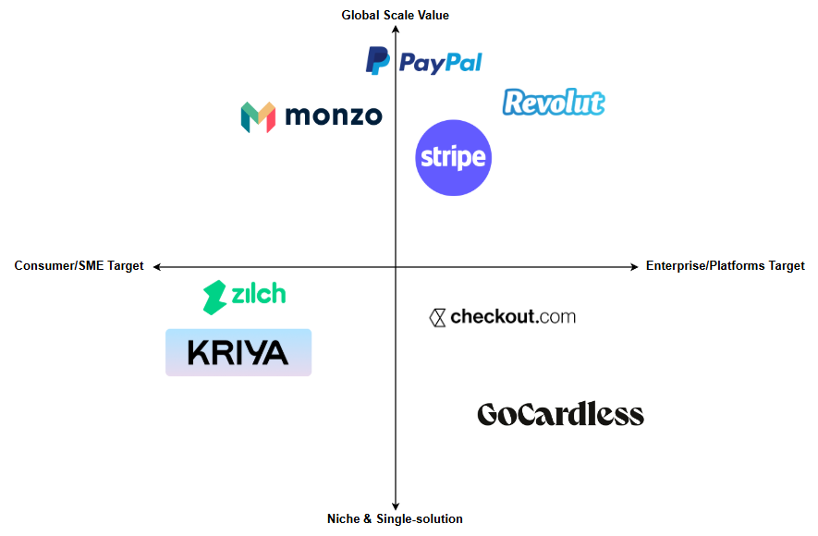
Figure 3: Positioning Map
(Source: Self-developed)
Examples of strategic diversification in the UK FinTech include emerging mid-sized companies such as Zilch (BNPL and payments) and Kriya (SME financing), which focus on niche lending and embedded finance.
The UK domestic fintech entities tend to focus on speed in innovation, local engagement and regulatory flexibility, as compared to multinational entrants such as PayPal and Stripe which exploit global scale and network effects as per Clarke, (2025). Such strategic differences form their performance and future positioning in the domestic and international market.

1.3 Global Competitiveness in FinTech Industry using Michael Porter’s Diamond Model of National Advantage
The concept of Diamond Model of National Advantage developed by Michael Porter bases the notions of competitive advantage on the national level of competitive advantage sources. It has four basic determinants, Factor Conditions, Demand Conditions, Related and Supporting Industries, and Firm Strategy/Structure, and Government and Chance as the external variables which are influential according to Al Hiary, (2021). The use of this framework in the UK FinTech industry can show how the combination of these factors has confirmed the global competitiveness and sustained innovation.
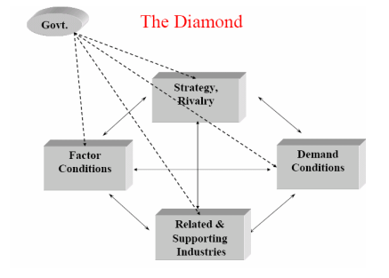
Figure 4: Porter’s diamond model
(Source: Al Hiary, 2021)
1. Factor Conditions
Factor conditions are inputs that are special like skilled labour, infrastructure, and technology which allows industries to be competitive. The factor conditions in the UK FinTech industry are highly developed, which makes it easy to innovate and scale fast.
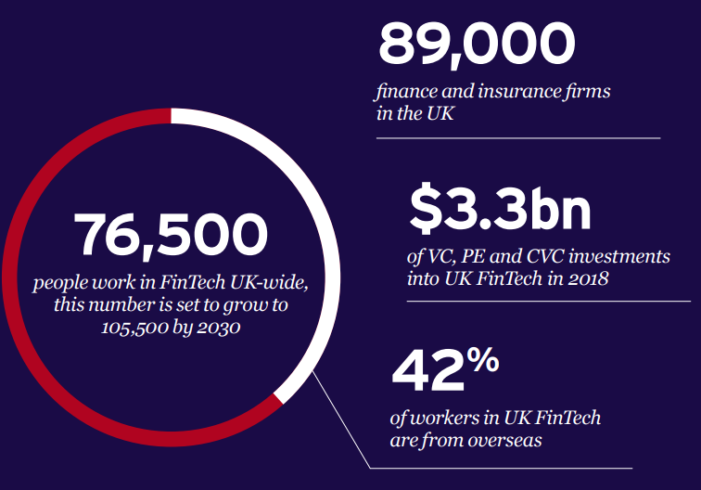
Figure 5: Contemporary UK FinTech Condition
(Source: UK FinTech State of the Nation, 2025)
There is a vast pool of digital and financial services talent in the UK, which is facilitated by well-ranked universities and dedicated research institutes. Government data estimates that the UK has around 76,500 people working in fintech with the figure expected to grow to 105,500 by 2030 as the digital skills needed are on the increase according to Fayad et al., (2025).
High ability to compete is also enhanced by high technological and financial infrastructure. Real-time payment systems, open banking API have become the norms in the industry, allowing FinTechs to create and develop new products more quickly than the traditional ones, offering a smooth customer experience. The Financial Conduct Authority (FCA) sandbox environments have enabled more than 700 companies to test products under controlled environments and save time to market and uncertainty (OECD, 2023).
These high factor endowments emphasize on the capacity of the UK to produce above-average productivity and innovation concentrations. According to Obeidat et al. (2021), specialised factors, in particular those related to technology and talented human capital are more difficult to imitate by other countries on a rapid basis, which strengthens the UK competitive advantage.
2. Demand Conditions
The sophistication and demands of the local customer base are described through demand conditions that may put pressure on firms to deliver high levels of performance and innovation. The consumer base is digitally literate, and this is one of the major sources of growth of fintech in the UK. The rate of British people adopting digital financial services is far much higher than most of the European counterparts as more than 86 percent of UK adults have been identified accessing some kind of fintech service as per Polly Jean Harrison, (2021), which is an indication that the people are in need of digital banking, payments, and other credit services.
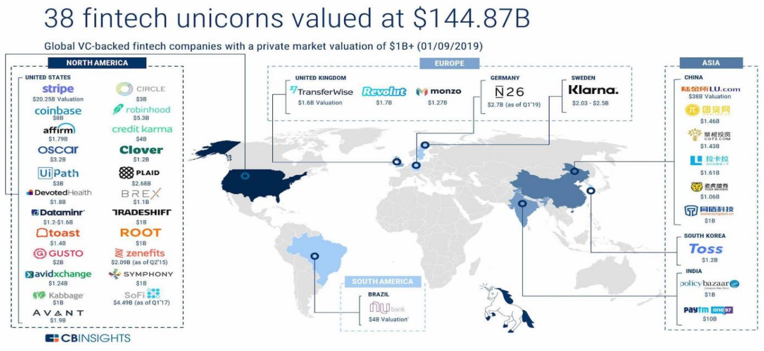
Figure 6: Demand thriving by Global FinTech Unicorns
(Source: Paesani and Valli, 2021)
Such a high level of demand compels fintech companies to be innovative, with the presence of neobanks such as Revolut and Monzo going beyond rudimentary services to include wealth, crypto, and lending features as per Paesani and Valli, (2021). Domestic demand is both wide and deep; this brings about similar pressures as those in the Diamond theory of Porter, where companies are being subjected to customers who need better performance, quicker services and a seam-to-digital experience, which subsequently will bring about global competitiveness.
3. Related and Supporting Industries
The competitive industries are also characterized by robust local suppliers and other industry sectors that will boost innovation, spillover of knowledge, and network effect. FinTech ecosystems of the UK have close links with financial services around the world, law services, institutions of higher learning, and technology clusters. London, with more than 90,000 financial and professional services firms, is a fruitful source of knowhow, affiliations and finance to both startups and scaleups (London.gov.uk, 2024). In addition, the fact that there are accelerators, incubators and university research centres like Cambridge Centre for Alternative Finance encourages the exchange of knowledge and development of the industry (Georgiev, 2024). These related industries are the drivers of innovation, which is congruent with Porter's opinion that the closeness of an industry to the advanced supporting industries accelerates productivity and competitiveness.
4. Firm Strategy, Structure and Rivalry
According to Porter, the way in which firms are structured, their strategic objectives and the strength of local competition affect competitiveness. The domestic and multinational companies operating in the UK FinTech industry are subject to dynamic and competitive pressures. The UK market has a number of domestic champions including Revolut, Monzo, Checkout.com and specialised lenders like Lendable who all have differentiated strategies, ranging between consumer-focused banking apps and enterprise payment infrastructure (Paesani and Valli, 2021). High competition in the local markets leads to constant improvement and innovation of the product, which are stressed in the model by Porter. More importantly, the competition is not domestic only. PayPal and Stripe are also multinationals that target the customers in the UK, and the UK local companies need to react to their competition with differentiated value propositions, price models, and technological sophistication according to Okat, Paaso, and Pursiainen, (2024).
5. Government and Chance
The UK FinTech competitive environment is significantly influenced by government policy. Regulations related to innovation sandboxes and open banking have promoted experimentation while fostering financial stability. The recent adoption of a fast-track licensing regime by the UK as reported by Seers, (2025), is another example of responsiveness to policy in order to minimize the risks to new entrants in FinTech. Strategy has also been influenced by chance events like Brexit. Although regulatory differentiation with the EU creates market access issues, it has provided the UK with the freedom to develop tailor made innovation friendly regulations, which could be a greater competitive edge in the future (Odumuwagun, 2025).

1.4 Market’s overall attractiveness for Revolut and factors influencing success in the UK FinTech Industry
Revolut Ltd. has become one of the most outstanding foreign multinational FinTech companies that are active in the digital financial services environment in the United Kingdom. Revolut was established in 2015 and is based in London. The company started as a currency exchange application and quickly transformed into a fully-fledged digital banking service offering an extensive variety of products, such as payments, foreign exchange, investments, cryptocurrency trading, and business banking services. Its emergence is correlated with the general increase in the speed of FinTech adoption in the UK, which is a market with liberal regulatory support and sophisticated consumer demand for digital financial services.
Towards the end of 2024, Revolut had reported remarkable growth, with revenues of around 3.1 billion, a 72 percent year-on-year increase, and net profits of 1.1 billion, surpassing most financial performance amongst neobanks in the world as reported by CNBC, (2025). Having more than 65 million customers around the globe, including the number exceeding 12 million in the UK, Revolut has made its mark as a global player in the FinTech sector with a goal of making a substantial presence of its banking and financial services in the domestic and international market (UK FinTech, 2025).
Overview of Revolut and Strategic Positioning
Revolut Ltd. is one of the pioneers in the digital financial services sector that provides mobile-first banking with a range of diversified financial products. The business model, which was initially designed around low-cost foreign currency exchange, has gradually evolved to include digital banking accounts, debit and credit cards, deposits, loans, wealth management, cryptocurrency trading, and business solutions making Revolut not a payment alternative but a fully integrated FinTech platform.
By the end of 2025, the company should have a customer base of more than 65 million around the globe, and approximately 12 million users in the UK, which highlights its high penetration in its domestic market and in other countries as per the study of UK FinTech, (2025). This level of adoption base exhibits market attractiveness and network effect in digital finance whereby the number of users increases as a result of product versatility and competitive price. The services offered by Revolut are multinational and globally ambitious, given the fact that it operates in 48 countries.
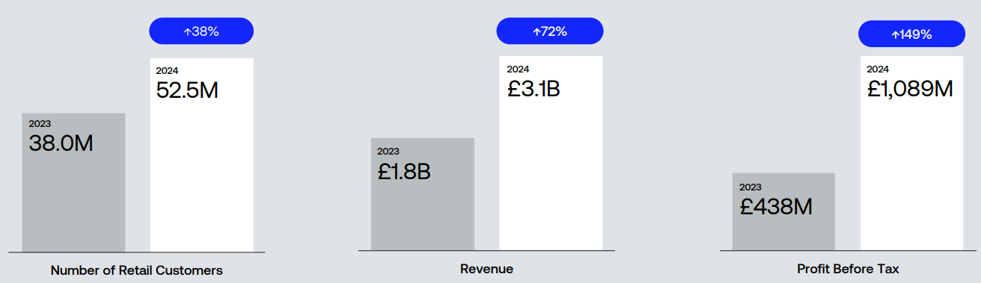
Figure 7: Strategic Positioning of Revolut
(Source: Revolut, 2024)
Revolut has performed strongly financially. In 2024, it made its biggest revenue of £3.1 billion, with net profit increasing more than twofold to around £1.1 billion which represents a strong monetisation in payment charges, interest income, subscriptions and wealth services according to CNBC, (2025). Such is a profit trend observed in an industry where lots of digital challengers continue to fail to achieve sustainable profitability, which creates an example of Revolut using scale, diversified revenue and operational efficiency.
The multi-dimensional positioning has been strategic to Revolut. Its value proposition will be a combination of convenience via mobile, low-cost competitiveness due to low fees and transparent pricing, and the extension of its offerings including banking, trading, and business services. This is in contrast to conventional banks and most of its competitors neo-banks which might focus on a single segment. Moreover, the UK origin and the world HQ of Canary Wharf, London, strengthen the competitive image of Revolut and associate it with one of the most developed financial regions in the world (UK FinTech, 2025).
Besides, as Revolut continues to become a full-licensed UK bank, having been granted a restricted banking licence in 2024, the competitive strategy involves increased products including savings, lending and deposit protection. This innovation in banking enables more interaction with customers, trust, and makes Revolut compete more actively with digital as well as traditional UK financial organizations.
External Influential Factors
The external influential factors to the success of Revolut have been assessed using PESTLE framework.
Political Factors
The political landscape in the United Kingdom is a relatively positive but complicated environment facing FinTech companies like Revolut that determines the extent to which the market is attractive in terms of regulatory and governmental frameworks. The government and its regulators, especially the Financial Conduct Authority (FCA), have traditionally encouraged innovation by policy tools such as regulatory sandboxes and project-based initiatives with the focus of responsible development of new technologies. There have been more than 700 innovations by companies since the introduction of Project Innovate and the sandbox regime, and this has minimized time-to-market risk in fintech entrants due to the ability to test products under a regulated environment (Parliament.uk, 2025).
The existing political policies focus on enhancing additional provision of digital finance. The UK Treasury and FCA are strengthening open banking and variable recurring payment frameworks, and the government has plans on how to move to open finance by 2027 to increase data-based financial services. Also, new products like expedited licensing are meant to help cut down the time taken to authorize high-potential startups, which is one of the biggest obstacles to scaling in the sector (Seers, 2025).
Regardless of these pro-innovation policies, there are risks in political uncertainty especially in the upcoming elections and the intention by political parties such as Reform UK to reform financial regulation. Such a combination of unwavering institutional backing and possible regulatory changes sheds light on the interaction of institutional theory and policy uncertainty in determining the appeal of multinationals in the highly regulated FinTech industry.
Economic Factors
The economy of the United Kingdom is a crucial factor in the attractiveness and competition of the operations of Revolut. Being the third-largest European economy, the UK boasts of a diversified services-based economy where financial services add around 8% of GDP before the pandemic and digital finance is becoming a more and more significant factor in economic performance. Good consumer buying power and high usage of digital platforms also portend a good demand environment by Revolut's broad range of payment, banking and investment offerings.
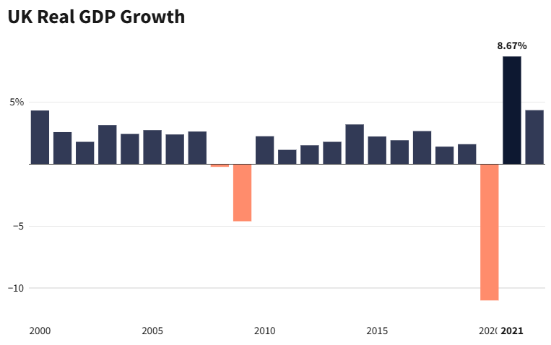
Figure 8: Contribution of Services-based Economy to UK GDP
(Source: Page, 2023)
Such macroeconomic factors as inflation and the strain on the cost of living are still relevant. Late UK inflation is in the 3 to 4 percentage range in 2025, downward to levels lower than it was earlier and yet still influencing a discretionary spending and saving pattern according to Bank of England, (2025).
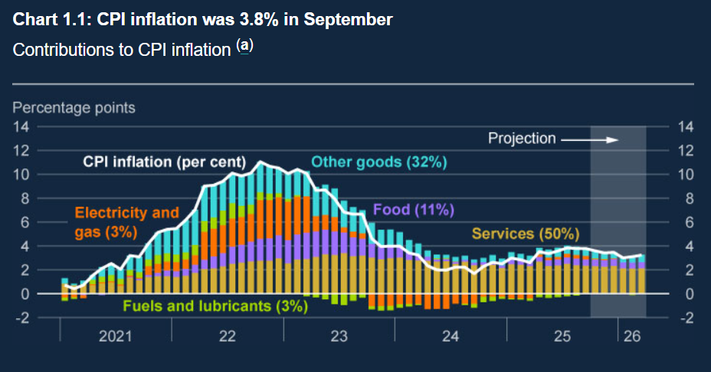
Figure 9: Impact of Inflationary Pressure in the UK
(Source: Bank of England, 2025)
In the case of Revolut, the increased inflation will not only limit consumer spending, which may decrease transactional volumes and stimulate demand for low-cost digital financial alternatives, but it is consistent with economic concepts of price sensitivity and substitution effects. The dynamics of labour markets are also important. The skills gap in digital technologies in the UK adds to the competition among fintech talent employees, which increases operational expenses and the need to invest in training or mobility bonuses. At the same time, the ease of entry of foreign capital and good venture capital climate as demonstrated by the £2.6 billion in 2025 UK fintech financing increase the availability of growth capital by Revolut (Pickering, 2026).
Social and Cultural Factors
The social and cultural environment of the United Kingdom offers a rich opportunity to implement and expand digital financial services, which determine the success of the Revolut business. Digital literacy and smartphone penetration in the UK are high which means that mobile-first financial platforms will be easily accepted in the UK. This fits the Diffusion of Innovation Theory of Rogers, in which early adopters and a culture of innovation will speed up the adoption of technologies and maintain a demand for high technology fintech solutions as per Sharma et al. (2025).
The UK consumers are culturally becoming increasingly trusting in digital payments and fintech solutions. The high usage pattern of fintech service in the UK strengthens the techniques of client acquisition and retention by Revolut, especially among younger age groups, who focus on digital wallets, no fees, and cross-border transfers.
However, the increased interest in data protection and cybersecurity impacts the user behaviour and regulatory requirements as discussed by Odumuwagun, (2025). The compliance with stringent data protection regulations of the UK (UK GDPR) requires high levels of compliance investments on the part of Revolut, which may raise operational expenses but also helps to win trust, which is a primary element of social legitimacy in the financial services sector.
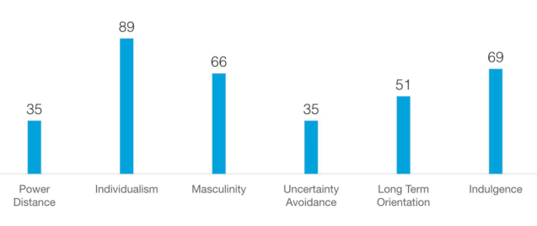
Figure 10: UK Cultural Dimensions Model of Hofstede
(Source: Sánchez, 2021)
Moreover, cultural differences in the regions of the UK imply that there may be different product adoption and preferences and the approaches to marketing and user experience may need to be customized. Using the Cultural Dimensions provided by Hofstede, comparatively high individualism and low uncertainty avoidance of the UK indicates that consumers demand more individualised digital experience and innovativeness according to Sánchez, (2021), which Revolut aims to achieve by feature diversification and localisation.
Technological Factors
High maturity in digital infrastructure and high innovation adoption are key factors that make the United Kingdom highly attractive to the market of digital finance companies like Revolut because of the high technological environment. The UK has a high population covered by broadband and the highest rate of uptake of fintech in the world indicating the willingness among the consumers to adopt high-level mobile first financial solutions (Bleach, 2025). The ease of using the app-based services of Revolut due to high smartphone penetration and ubiquitous 4G/5G connectivity minimise the barriers to user engagement.
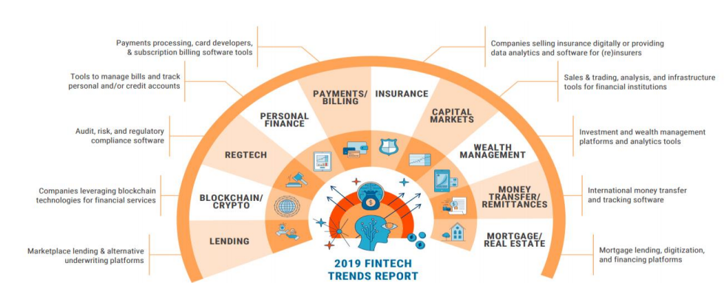
Figure 11: FinTech Trends
(Source: Paesani and Valli, 2021)
The open banking technological developments have had a profound effect. Upon the adoption of Open Banking standards supervised by the Competition and Markets Authority (CMA), UK banks will have to provide customer data via secure APIs. This regulatory-technological convergence enhances competition and innovation enabling Revolut to merge account aggregation, faster payment and personalised financial services that contributes to its competitive strategy as per the dynamic capabilities’ theory, which underscores firm adaptation with technological capabilities (Lala et al. 2023).
Environmental Factors
Also, as regulating bodies, customers, and investors consider Environmental, Social and Governance (ESG) factors in their decision-making processes, environmental sustainability is becoming an increasingly important aspect of market appeal to financial services companies, such as Revolut. Although the direct environmental impacts of fintech companies are often lower than that of traditional banks relying on extensive branches, the companies are affected by the demands regarding the responsible use of resources, the mitigation of carbon emissions, and the reporting. The UK has highly ambitious climate goals as part of the Net Zero Strategy where it intends to achieve a 78 per cent reduction in greenhouse gas emissions by 2035 relative to 1990 levels as revealed by Warren et al. (2024).
Even though the main business of Revolut is digital, to ensure that the company remains legitimate among environmentally conscious stakeholders, the organization needs to discuss the environmental aspects of its international infrastructure, including data centre energy usage and digital payment processing emissions. Industry research shows that the emissions that financial institutions funded emissions associated with investment and credit portfolios are becoming more scrutinised, even in the case of fintech lending portfolios. In this context, stakeholder theory stresses that companies should address a wide range of stakeholder interests, not only of shareholders, where environmental issues are gaining greater and greater importance according to Wang et al. (2022). The ESG commitments that Revolut has made public are based on reducing operational carbon footprint and improving transparency via sustainability reporting, which is in line with green financial best practices.
Legal Factors
Legal environment in the United Kingdom is a key factor in determining the appeal of the market to the operations of Revolut, especially owing to the fact that financial services are highly regulated. Revolut has to operate within a fully developed system of laws and regulatory frameworks of payment services, data protection, anti-money laundering (AML), and consumer protection. Among the important legal frameworks are the Payment Services Regulations 2017 (PSRs) and the Financial Services and Markets Act 2000 (FSMA), both of which include strict licensing and operation regulations of payment institutions and e-money companies. Legal legitimacy and consumer protection is achieved through compliance, and it is necessary to ensure that people trust financial intermediaries.
The use of UK GDPR in the UK also places severe data processing and privacy rules that influences the process of collecting, storing, and using customer data by Revolut. Failure to comply may result in severe sanctions, such as, recently, the Information Commissioner Office (ICO) of the UK fined a large technological company 20 million pounds in fines and penalties due to GDPR violations, which shows the intensity of regulation (GDPR, 2021).

1.5 Conclusion
This report has critically discussed the competitiveness of the FinTech industry in the United Kingdom and strategic implications to multinational enterprises with specific reference to Revolut, which is a primary foreign player in the market. The industry analysis has shown that the FinTech ecosystem in the UK has been supported by good factor conditions, advanced domestic demand, pronounced financial and technological centres, and fierce competitive rivalry, which is in line with the driver forces in the Diamond Model of National Advantage by Michael Porter. All these circumstances make the UK one of the most favourable FinTech destinations in the world, regardless of the increase in competition and regulatory burden.
The analysis of the political, economic, social, technological, environmental and legal environment in the UK market showed that operating conditions are mostly favourable to FinTech businesses, with favourable regulatory initiatives and high digital penetration, well-developed technological infrastructure and increasing demand of innovative financial services. Nevertheless, there are still a set of persistent issues, such as the need to comply with regulatory requirements, the cost of operation is on the rise, the competition is rather intense both in-country and in international platforms, and the expectations regarding information security and environmental sustainability continue to rise. Henceforth, the UK has good location opportunities to FinTech multinationals, however, to succeed in the long run, companies like Revolut need to be able to constantly innovate, remain legitimate, and respond to changes in market, technological and policy environments.

Section 2

2.1 Introduction
This reflective report assesses the procedure that I have undertaken in conducting the research, analysing and drafting the international business report on the United Kingdom FinTech industry and the activities of the company Revolut. This reflection aims at critically evaluating my learning experience, defining strengths and weaknesses of my research method, and reflecting on the development of my academic and analytical strengths and weaknesses in the course of the assignment. In order to organize this reflection in a systematic way, I will use Gibbs Reflective Cycle that comprises description, feelings, evaluation, analysis, conclusion and action plan as identified by Ocampo et al. (2025). This framework allows me not to dwell on description and indulge in more critical thinking as far as my academic progress and research competence are concerned.
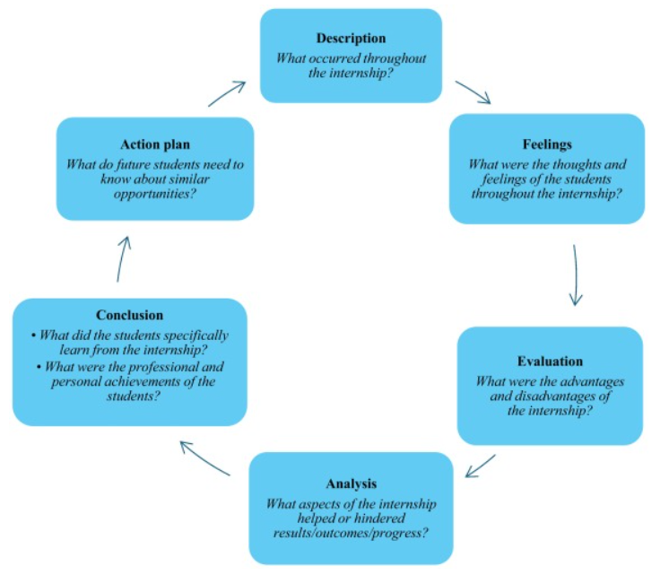
Figure 12: Gibbs Reflective Cycle
(Source: Ocampo et al. 2025)

2.2 Reflective Account of Process
Description
The research made me conduct an international industry analysis of the UK FinTech industry and assess the appeal of the market to a multinational firm. It consisted of several steps, which included the industry and company selection, collecting secondary data, conceptualizing analytical models, including the Diamond Model of Porter and the PESTLE, and providing well-organized arguments based on evidence.
I started off by first finding pertinent academic theories in the lecture materials and the textbooks. I then sought industry reports, government publications and financial news sources to get trustworthy actual on-the-ground information. Once I gathered information, I sorted out my data in sections according to the assessment requirements and performed refinement gradually to incorporate theory with practice. It was an iterative process and not linear. I went back to the previous chapters many times to enhance clarity, provide better evidence, and create coherence throughout the report.
Feelings
I was not sure how to choose the right sources of data at the initial stage due to the rapid development of the FinTech sector, and data became outdated rather quickly. I feared that I would not differentiate between reliable and less reliable online content. It was also difficult for me to blend academic theories with industry evidence as opposed to providing them individually.
But the more I went on, the more confident I got. I felt more at ease when assessing the sources and determining how business behaviour, as practiced within a particular theoretical framework, could be described. The sense of achievement came with the time I did the market environment analysis since I was able to clearly align theory and business strategy rather than to articulate information.
Evaluation
Systematic research organisation was one of the positive factors about my approach. I divided the resources into academic sources, governmental sources and industry sources, which contributed to the balance of evidence. This enhanced the reliability of the report and supported the arguments (Thornhill-Miller et al. 2023).
The other strength was that analytical frameworks were used in an organized manner. The models, including Porters Diamond and PESTLE models, enabled me to analyse the industry logically to write as opposed to writing in a descriptive manner (Sumba-Bustamante et al. 2024)
Nevertheless, weaknesses were also present. To begin with, I overused descriptive statistics as opposed to critical analysis. I also realised that merely a report presentation was not an indicator of understanding. Another thing that slowed me down is that I was also wasting too much time in attempting to find ideal sources rather than effectively synthesising information that was available to me.
Analysis
This experience demonstrated the critical thinking that should be considered when writing academic assignments as per Ruiz-Rojas, Salvador-Ullauri, and Acosta-Vargas, (2024). As the higher-education learning theory states, deep learning happens when students perceive and assess information instead of memorising it (Samoshkina, 2024). I came to know that business frameworks are not merely theoretical but analytical prisms that are used to explain strategic behaviour.
The use of numerous frameworks enhanced my depth of analysis as well. In one instance, by integrating PESTLE and competitive strategy, I was able to analyse the external environment in addition to its strategic implication. This would be in line with the constructivist learning theory that proposes that knowledge is constructed by linking concepts together instead of studying concepts separately according to Marougkas et al. (2023)
I also realised that time management and filtering of the research were important. The digital economy generates extensive amounts of information, and academic literature demands that one chooses the evidence that is relevant instead of gathering all the data possible (Ganesha and Aithal, 2022)
Conclusion
To conclude, this assignment has enhanced my skills in performing independent research, critical analysis of evidence, and combination of theory and practice. I became more analytical in my writing and was able to study the application of academic models to the actual business environment. However, I also found some improvement points, especially in the field of early planning and the minimization of excessive dependence on descriptive information. I also got to know that academic confidence builds up with time by involving repetition of applying analytical models.
Action Plan
In future tasks, I will be more proactive and have a clear research strategy at the beginning of work by identifying set themes and keywords and then proceed to collect sources. This will help to avoid the overloading of information and enhance efficiency (Ganesha and Aithal, 2022)
I will also make critical interpretation an important part of the writing process as opposed to attaching it at later stages during the editing process. I will also read more journal articles to improve theoretical knowledge and academic argumentation.
Lastly, I will spend more time going through feedback and going through drafts in a systematic way in order to enhance coherence and depth of analysis as suggested by Sudirman et al. (2024). Through such measures, I hope that I would be able to create more concise, analytic and academically sound work in future examinations.

2.3 Conclusion
Application of the Gibbs Reflective Cycle enabled me to analyse my learning process critically instead of merely narrating the experience in the assignment. The reflection showed that I had made a great improvement in my research skills, critical thinking and academic confidence. Although there were some difficulties in dealing with information and inside in the association between theory and practice, those problems eventually led to deeper learning. The experience of these reflections will influence my further study and will help me to maintain the improvement of my analytical and professional skills.

Reference List
Section 1
Al Hiary, M. (2021). Assessing porter’s framework for national advantage: The case of Jordanian agricultural sector. Jordan Journal of Agricultural Sciences. https://www.academia.edu/download/77717558/729.pdf
Bank of England (2025). Monetary Policy Report - November 2025. [online] Bankofengland.co.uk. Available at: https://www.bankofengland.co.uk/monetary-policy-report/2025/november-2025 [Accessed 11 Feb. 2026].
Bleach, T. (2025). Capital Funding and AI Adoption Drive Fintech Hiring Growth, as Banks Vacancy Numbers Fall. [online] The Fintech Times. Available at: https://thefintechtimes.com/capital-funding-and-ai-adoption-drive-fintech-hiring-growth-as-banks-vacancy-numbers-fall/ [Accessed 16 Feb. 2026].
Checkout.com (2026). Pinterest selects Checkout.com to strengthen global payment performance for its clients. [online] Checkout.com. Available at: https://www.checkout.com/newsroom/pinterest-selects-checkout-com-to-strengthen-global-payment-performance-for-its-clients [Accessed 16 Feb. 2026].
Clarke, C. (2025). THE SOCIAL FOUNDATIONS OF FINTECH. THE SOCIAL FOUNDATIONS OF GLOBAL FINANCE, 111. https://eprints.whiterose.ac.uk/id/eprint/224809/10/CLIFT_CLARKE_SocialFoundationsGlobalFinance_OA_PDF.pdf#page=127
CNBC (2025). British fintech Revolut tops $1 billion in profit as revenue jumps 72%. [online] CNBC. Available at: https://www.cnbc.com/2025/04/24/british-fintech-revolut-tops-1-billion-in-profit-as-revenue-jumps.html.
Fayad, N.M., Awdeh, A., Mrad, J.A., Ghaithaa El Mokdad and Nassar, M. (2025). The Impact of Technological Development on the Productivity of UK Banks. FinTech, 4(3), pp.45–45. Available at: https://www.mdpi.com/2674-1032/4/3/45.
Financial Times (2025). Monzo revenues hit £1bn for first time. [online] @FinancialTimes. Available at: https://www.ft.com/content/4a2ed502-c253-49ca-aa0b-352edf2b0b93.
GDPR (2021). ICO fines British Airways £20m for data breach | GDPR Register. [online] GDPR Register. Available at: https://www.gdprregister.eu/news/british-airways-fine/ [Accessed 15 Feb. 2026].
Georgiev, L. (2024). Fintechs, Banks, and Financial Re-Intermediation. Economic Alternatives, 3, 587-608. https://www.unwe.bg/doi/eajournal/2024.3/EA.2024.3.08.pdf
GoCardless (2025). Mollie to acquire GoCardless, creating Europe’s most complete payment platform. [online] Gocardless.com. Available at: https://gocardless.com/blog/mollie-to-acquire-gocardless/.
Howcroft, E. and Wilkes, T. (2025). Revolut profits soars on crypto boom as CEO lifts stake. [online] Reuters. Available at: https://www.reuters.com/business/finance/revolut-profit-soars-15-billion-storonsky-increases-stake-more-than-25-2025-04-24/.
Kálmán, J. (2025). The role of regulatory sandboxes in FinTech innovation: A comparative case study of the UK, Singapore, and Hungary. FinTech, 4(2), 26. https://www.mdpi.com/2674-1032/4/2/26
KMPG (2025). UK remains the European leader for fintech investment, despite funding levels at five year low. [online] KPMG. Available at: https://kpmg.com/uk/en/media/press-releases/2026/02/uk-remains-the-european-leader-for-fintech-investment.html [Accessed 15 Feb. 2026].
Lala, H., Olivieri, M., Wang, N., and Corsaro, D. (2023). Dynamic capabilities in the internationalisation process: A study on fintech startups. In Rediscovering local roots and interactions in management. Conference Proceedings. Short papers. Sinergia-Sima. https://apeiron.iulm.it/bitstream/10808/53988/1/Dynamic%20capabilities%20in%20the%20internationalisation%20process.pdf
London.gov.uk (2024). Supporting London’s sectors growth. [online] London City Hall. Available at: https://www.london.gov.uk/programmes-strategies/business-and-economy/mayors-priorities-londons-economy-and-business/supporting-londons-sectors-growth [Accessed 13 Feb. 2026].
Obeidat, U., Obeidat, B., Alrowwad, A., Alshurideh, M., Masadeh, R., and Abuhashesh, M. (2021). The effect of intellectual capital on competitive advantage: The mediating role of innovation. Management Science Letters, 11(4), 1331-1344. https://www.academia.edu/download/80065255/msl_2020_390.pdf
Odumuwagun, O. (2025). Future of security in FinTech: Balancing user privacy, compliance, and technological advancements. International Journal of Research Publication and Reviews, 6(1), 1296-1310. https://www.researchgate.net/profile/Olanrewaju-Odumuwagun/publication/388190214_Future_of_Security_in_FinTech_Balancing_User_Privacy_Compliance_and_Technological_Advancements/links/678e6382ec3ae3435a70a089/Future-of-Security-in-FinTech-Balancing-User-Privacy-Compliance-and-Technological-Advancements.pdf
OECD (2023). OECD DIGITAL ECONOMY PAPERS. [online] Available at: https://www.oecd.org/content/dam/oecd/en/publications/reports/2023/07/regulatory-sandboxes-in-artificial-intelligence_a44aae4f/8f80a0e6-en.pdf [Accessed 15 Feb. 2026].
Okat, D., Paaso, M., and Pursiainen, V. (2024). Trust in Traditional Finance and Consumer Fintech Adoption–Internet Appendix. https://denizokat.com/wp-content/uploads/2024/08/internet-appendix.pdf
Paesani, P., and Valli, E. (2021). Fintech: how technologies are shaping banking future. https://www.academia.edu/download/87151596/212531_VALLI_EDOARDO.pdf
Page, V. (2023). The Economy of the United Kingdom. [online] Investopedia. Available at: https://www.investopedia.com/articles/investing/042915/how-uk-makes-money.asp.
Parliament.uk (2025). FinTech Sector Report. [online] Available at: https://www.parliament.uk/globalassets/documents/commons-committees/Exiting-the-European-Union/17-19/Sectoral-Analyses/15-Fintech-Report.pdf [Accessed 13 Feb. 2026].
Pickering, K. (2026). UK fintech investment second highest globally at £2.6bn - UKTN. [online] UKTN. Available at: https://www.uktech.news/fintech/uk-fintech-investment-second-highest-globally-at-2-6bn-20260108 [Accessed 14 Feb. 2026].
Polly Jean Harrison (2021). Digital Payments Drives Growth as UK Fintech Hits 86% Consumer Adoption Rate. [online] The Fintech Times. Available at: https://thefintechtimes.com/digital-payments-drives-growth-as-uk-fintech-hits-86-consumer-adoption-rate/ [Accessed 15 Feb. 2026].
Revolut (2024). Annual Report Contents. [online] Available at: https://assets.revolut.com/pdf/annualreport2024.pdf [Accessed 15 Feb. 2026].
Sánchez, S. V. (2021). How culture shapes emotional reactions in the United Kingdom. https://repositorio.comillas.edu/xmlui/bitstream/handle/11531/68258/TFG%20Vargas%20Sanchez%20Sara.pdf?sequence=1
Seers, P. (2025). Britain unveils fast-track licensing to boost fintech growth. Reuters. [online] 4 Dec. Available at: https://www.reuters.com/sustainability/boards-policy-regulation/britain-unveils-fast-track-licensing-boost-fintech-growth-2025-12-04/ [Accessed 14 Feb. 2026].
Sharma, V., Rupeika-Apoga, R., Singh, T., and Gupta, M. (2025). Sustainable investments in the blue economy: leveraging fintech and adoption theories. Journal of Risk and Financial Management, 18(7), 368. https://www.mdpi.com/1911-8074/18/7/368
UK FinTech (2025). Revolut unveils global headquarters, sets sights on 100 million customers. [online] UK FinTech. Available at: https://ukfintech.co/revolut-unveils-global-headquarters-sets-sights-on-100-million-customers/ [Accessed 16 Feb. 2026].
UK FinTech State of the Nation (2025). UK FinTech State of the Nation. [online] Available at: https://assets.publishing.service.gov.uk/media/5cd9511740f0b62d81cad294/UK-fintech-state-of-the-nation.pdf [Accessed 15 Feb. 2026].
Vijayagopal, P., Jain, B., and Ayinippully Viswanathan, S. (2024). Regulations and fintech: A comparative study of the developed and developing countries. Journal of Risk and Financial Management, 17(8), 324. https://www.mdpi.com/1911-8074/17/8/324
Walsh, R. (2025). New report finds FinTech is adding £5 billion per year to the North of England’s economy - FinTech North. [online] FinTech North. Available at: https://www.fintechnorth.uk/new-report-finds-fintech-is-adding-5-billion-per-year-to-the-north-of-englands-economy/ [Accessed 15 Feb. 2026].
Wang, D., Peng, K., Tang, K., and Wu, Y. (2022). Does FinTech development enhance corporate ESG performance? Evidence from an emerging market. Sustainability, 14(24), 16597. https://www.mdpi.com/2071-1050/14/24/16597
Warren, L., Dawodu, A., Adewumi, A. S., and Quan, C. (2024). Can the UK deliver zero carbon ready homes by 2050?. Sustainability, 16(13), 5820. https://www.mdpi.com/2071-1050/16/13/5820

Section 2
Ganesha, H. R., and Aithal, P. S. (2022). How to choose an appropriate research data collection method and method choice among various research data collection methods and method choices during Ph. D. program in India. International Journal of Management, Technology, and Social Sciences, 7(2), 455-489. https://www.academia.edu/download/100063600/26._How_to_Choose_an_Appropriate_Research_Data.pdf
Ganesha, H. R., and Aithal, P. S. (2022). When to collect data? Choosing an appropriate time frame for data collection during Ph. D. program in India. International Journal of Applied Engineering and Management Letters (IJAEML), 6(2), 271-287. https://www.academia.edu/download/102663338/17._When_to_Collect_Data_Choosing_an_Appropriate_Time.pdf
Marougkas, A., Troussas, C., Krouska, A., and Sgouropoulou, C. (2023). Virtual reality in education: a review of learning theories, approaches and methodologies for the last decade. Electronics, 12(13), 2832. https://www.mdpi.com/2079-9292/12/13/2832
Ocampo, F. A., McIntyre, B. G., Massey, D., and Saunders, R. (2025). Nursing student reflections on a research internship: A reflective discussion following the Gibbs' reflective cycle. Nurse education today, 145, 106481. https://www.sciencedirect.com/science/article/pii/S0260691724003915
Ruiz-Rojas, L. I., Salvador-Ullauri, L., and Acosta-Vargas, P. (2024). Collaborative working and critical thinking: Adoption of generative artificial intelligence tools in higher education. Sustainability, 16(13), 5367. https://www.mdpi.com/2071-1050/16/13/5367
Samoshkina, I. (2024). Applied learning in higher education: Bridging the gap between theory and practice. In Proceedings of The International Conference on Modern Research in Education, Teaching and Learning (Vol. 3, No. 1, pp. 25-34). https://pdfs.semanticscholar.org/36ea/67ead432d24ee1a637bb0b6d755396c60264.pdf
Sudirman, A., Gemilang, A. V., Kristanto, T. M. A., Robiasih, R. H., Hikmah, I. A., Nugroho, A. D., ... and Rais, B. (2024). Reinforcing reflective practice through reflective writing in higher education: A systematic review. International Journal of Learning, Teaching and Educational Research, 23(5), 454-474. https://www.researchgate.net/profile/Anselmus-Sudirman/publication/381195133_Reinforcing_Reflective_Practice_through_Reflective_Writing_in_Higher_Education_A_Systematic_Review/links/66617a2d85a4ee7261a8fbe2/Reinforcing-Reflective-Practice-through-Reflective-Writing-in-Higher-Education-A-Systematic-Review.pdf
Sumba-Bustamante, R. Y., Cantos-Figueroa, M. D. L., Santistevan-Villacreses, K. L., Soledispa-Rodríguez, X. E., Nieves-Lizárraga, D. O., Cervantes-Martínez, L., ... and Rincón-Guio, C. (2024). Strategic model for strengthening smes: An empirical study based on porter’s five forces. Journal of Infrastructure, Policy and Development, 8(10), 1-22. https://repository.ucc.edu.co/bitstreams/d34ade93-b61e-4abf-8d35-8a98b1dfc007/download
Thornhill-Miller, B., Camarda, A., Mercier, M., Burkhardt, J. M., Morisseau, T., Bourgeois-Bougrine, S., ... and Lubart, T. (2023). Creativity, critical thinking, communication, and collaboration: Assessment, certification, and promotion of 21st century skills for the future of work and education. Journal of Intelligence, 11(3), 54. https://www.mdpi.com/2079-3200/11/3/54

