
Master of Business Administration
Student Name: Lakhan odedara
Student Number: 2427114
module Name: Marketing Management LCMB7024
Lecturer Name: Laila Maazouz
Term: February 2025
Word count: 2541
Submission deadline: 28th April 2025

ASSESSMENT 2: PORTFOLIO: BRAND EXTENSION

Table of Contents
Introduction 3
1. New Brand Extension for Tesla in Kenya to Selling its Electric Cars 3
2. Segmentation, Targeting and Positioning for New Brand Extension in Kenya 7
3. Customer Persona including Demographic and Psychographic Information 10
4. 7Ps Marketing Strategies for Tesla to Extend its Business in Kenya 11
Conclusion 14
References 15

Introduction
The term “Marketing Management” refers to the procedure of planning, implementing, and controlling marketing activities in terms of achieving organizational goals. Through strategically guiding how existing brand equity can be used to successfully launch a brand's products in a new market, marketing management supports brand extension to capture new market share (Trigeorgis et al. 2021). Focusing on successful brand extension strategy generation, the present report has selected Tesla, a leading innovator in the electric vehicle (EV) industry for expanding to the electric vehicle market in Kenya.

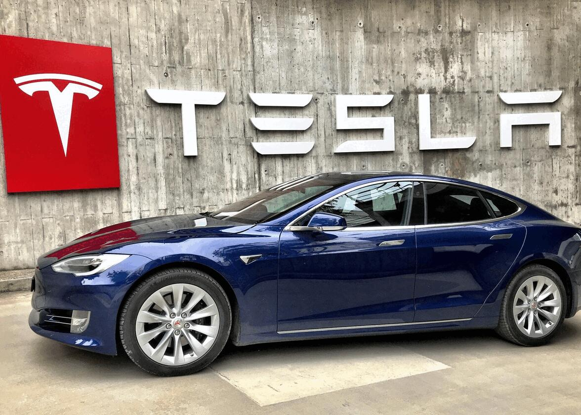
Figure 1: Brand Logo of Tesla
(Source: Tesla, 2025)
In this context, the present report has aimed to develop a new brand extension for Tesla's electric cars in Kenya with the ever-evolving global automobile market. Furthermore, the report delves into exploring segmentation, targeting, positioning, customer profiling, and proposing appropriate marketing mix strategies to ensure a successful market entry in Kenya’s EV market for Tesla.

1. New Brand Extension for Tesla in Kenya to Selling its Electric Cars
Introduction to Brand Extension
The term “Brand Extension” refers to a strategic marketing approach assisting a company to leverage its established brand name through introducing its product and service into a new market. Brand extension theory is primarily rooted in consumer behaviour and marketing principles. The theory revolves around leveraging the reputation and brand equity of an existing product to launch a new product within the same or a related category (Yoon et al. 2021). In this regard, Tesla is becoming popular due to its cutting-edge electric vehicle (EV) technology, strong brand loyalty, and commitment to sustainability that are well positioned for introducing a new brand extension in the EV market of Kenya.

Brand Extension Concept of Tesla
Tesla has expanded its brand beyond electric vehicles into areas like solar energy and energy storage solutions, demonstrating a strategic use of brand extension to capitalize on its established brand image and customer loyalty. In addition, Tesla primarily uses a direct-to-consumer market entry mode for selling its electric vehicles directly to customers through its own network of showrooms and online sales platforms (Joachimsthaler and Olderog, 2022). Apart from this, direct sales approach allows Tesla to better control over the customer experience and brand messaging.

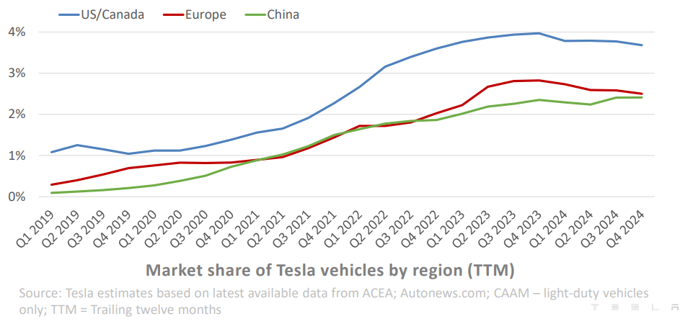
Figure 2: Brand Extension Notion of Tesla
(Source: Tesla, 2024)
Brand extension report of Tesla has suggested the company is having significant brand presence in the US and Canadian market with more than 4% market share (Tesla, 2024). Additionally, in Europe and China, Tesla’s brand extension achieved significant market presence with operating a total 7,121 Supercharger stations across 52 countries to support its EV sales. Thus, the market entry mode used by Tesla can differentiate the brand from traditional car manufacturers who rely on franchised dealerships in the evolving and modern international automobile sector.

EV Market Situation in Kenya
In recent times, the EV market in Kenya is experiencing rapid growth driven by supportive government policies, increasing infrastructure, and growing consumer interest. EV sales rate has highlighted a significant increase, with one source reporting a 150% growth in 2025 compared to previous year in the Kenyan automobile market. Depending upon economic perspective The future EV market is forecasted to grow at a CAGR of 57.9% until 2031 (6wresearch, 2023). However, from the political point of view Kenya's “First-Ever Green Mobility Policy” for EV sales focuses on incentivizing the transition to electric vehicles to reduce emissions and promote a green economy (Empower Africa, 2024). The key policy includes a target of 5% EV sales by 2025 that is coupled with incentives like tax breaks, subsidies, and duty exemptions in the Kenyan market (Linkedin, 2024). Additionally, in this country, the government has also aimed to promote local manufacturing and assembly of EVs, including setting zero-emission vehicle (ZEV) sales targets. However, the electric vehicle (EV) market in Kenya also faces challenges including limited competition, high initial costs, and a developing charging infrastructure (Gicha et al. 2024). Despite such challenges, the market of Kenya also holds significant potential due to supportive government policies, renewable energy resources, and increasing consumer interest in sustainable mobility.

Value Proposition and Innovation
Mission of Tesla is to accelerate the world's transition to sustainable energy. Their vision delves into becoming an attractive automobile company of the 21st century by driving the global shift to electric vehicles. Focusing on future sustainability, Tesla has wanted to build a world powered by using solar energy, running on battery power and transported through electric vehicles. Additionally, the value proposition of Tesla in the EV market centres around offering innovative, high-performance electric vehicles that don't compromise on utility, safety, or a strong brand image. Apart from this from the perspective of ‘Innovation’, Tesla Model Y is a popular and innovative EV model that has been instrumental in Tesla's market expansion, particularly in Europe (Automotive Manufacturing Solutions, 2024). This mid-size crossover SUV, based on the Model 3 platform and advanced battery technology becomes the top-selling EV brand globally which is also expected to gain market attention in the Kenyan market.

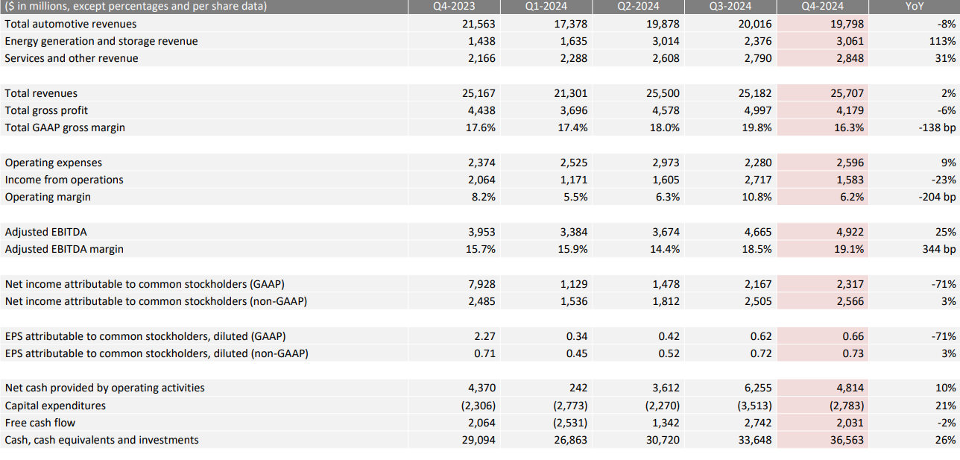
Figure 3: Financial Performance of Tesla
(Source: Tesla, 2024)
Total automotive revenue of Tesla in the third quarter of 2024 was about $20,016 million with $4,997 million gross profit (Tesla, 2024). The financial performance supports innovation and the value proposition of Tesla can also assist in economic growth in Kenya through expanding sales of EV cars. Value proposition and innovation by Tesla has allowed it to avoid 20.4 Mmt¹ CO₂e back in 2023 (Tesla, 2025). Therefore, brand value, perceived quality and brand awareness of Tesla is expected to assist this brand in further extension into the Kenyan market based on interest among environmentally conscious consumers with driving brand loyalty.

2. Segmentation, Targeting and Positioning for New Brand Extension in Kenya
In the recent business market, by providing a structured approach to understanding and reaching new customer segments with a new product, “Segmentation, Targeting, and Positioning (STP) model” plays a crucial role in brand extension. Application of this STP model can assist Tesla to link its product innovation and growing preferences as well as EV demands on target audience with minimising chances of success and wasted resources. For instance, while expanding into the Indian emerging market, Tesla initially focused upon affluent, environmentally conscious individuals and families prioritizing technology and sustainability (Tesla, 2024).

Segmentation | Targeting | Positioning
- Behavioural: People seeking fuel-efficient alternatives, brand-conscious buyers, as well as tech-savvy users with significant environmental concern.  - Geographical: Urban areas in Kenya including Nairobi, Mombasa, Kisumu, and emerging towns  - Psychographic: Eco-conscious individuals, early adopters of technology, status-driven consumers in Kenya  - Demographics: Middle to upper-income Professionals, entrepreneurs, and government officials from age 28 to 55. | Tesla needs to adhere to a “differentiated targeting strategy” through focusing on urban professionals and progressive government agencies in terms of establishing its EV market in Kenya. | Based on advanced, premium and tech-savvy Smart and Sustainable SUV or other EV models, Tesla can tailor advanced electric technology, environmental responsibility, and high performance in the Kenyan market.
Table 1: STP strategy for Tesla in Kenya
(Source: Self-developed)
Market segmentation by Tesla also preferred middle and upper-class customers seeking prestige and the perceived long-term cost-effectiveness of electric vehicles in emerging markets like Kenya. However, Tesla has an aim to expand its reach based on development of more affordable models to tap into a broader segment in emerging markets (Tesla, 2025). Customer-centric business model of Tesla has involved understanding customer needs, developing strategies to satisfy them, and managing the entire marketing process, from product development to customer relationship management (Vidili, 2021). Considering global consumer preferences and rapid digitalisation, Tesla is innovating its EV industry through focusing on electric powertrains, battery technology, and autonomous driving features like Autopilot as well.
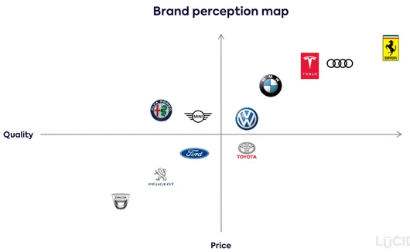
Figure 4: Positioning Map
(Source: Medium, 2021)
Due to rising fuel costs, environmental concerns, and government incentives, the Kenya EV market is experiencing a significant growth rate along with growing competition. In this country's context, Energy-as-a-Service (EaaS) and other models emerge to address affordability and gaps in infrastructure (Del-Río-Carazo et al. 2022). Several EV companies are operating or have presence in Kenya from homegrown brands and international manufacturers including BasiGo, Roam Electric, Jet Motor Company, Ampersand and Volkswagen. Moreover, Volkswagen has a joint venture with the Kenyan government for a plant in Thika and is considering introducing electric cars in Kenya.
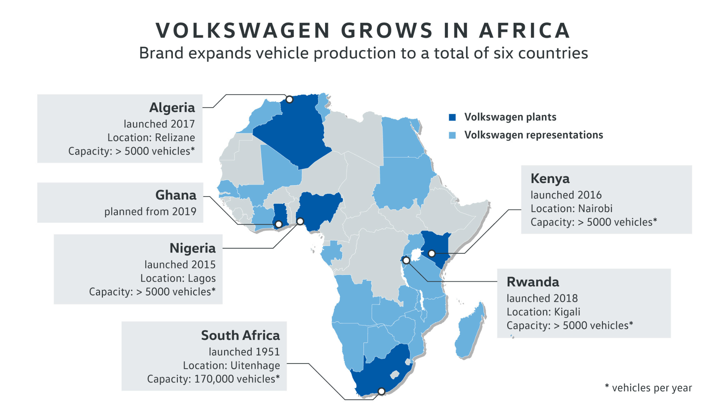
Figure 5: Volkswagen Growth in Kenya
(Source: Automotive Purchasing and Supply Chain, 2024)
Volkswagen can provide immense market competition to Tesla while expanding to Kenya due to its strong brand value since 2016 and >5000 vehicle capacity (Automotive Purchasing And Supply Chain, 2024). Therefore, market positioning of Tesla’s famous EV like “Smart and Sustainable SUV” ranges needs to focus on market differentiation strategy depending upon innovation, eco-friendliness, and social prestige to secure market position.

3. Customer Persona including Demographic and Psychographic Information
Profile    Name: Atieno - Luo  Address: Nairobi, with frequent travel to Mombasa and Kisumu  Age: 35 years  Gender: Male  Occupation: Tech entrepreneur  Income: KES 250,000+ per month (middle to upper class)  Relationship status: Married  Personal Trait: Ambitious, environmentally aware, tech-savvy, progressive thinker | Goals  - To lead a sustainable and eco-conscious lifestyle for better future  - To position as innovator and early adopter in his professional and social circles.  - To invest in long term as well as cost effective technologies reflecting upon its value.
Motivations for Tesla’ EV  - Primary motivation comes from aligning green values with climate-conscious mission of Kenyan government  - Becoming a forward thinker, he has a focus on cutting-edge technology and autonomous features  - Budget concerned with focus on reduction of fuel and maintenance costs over time. | Pain point Tesla will solve  - Rising fuel prices and high costs of maintaining traditional combustion engine cars in Kanyan emerging market  - Limited eco-friendly vehicle options in the Kenyan market  - Growing environmental concern in the country context.
Table 2: Customer Persona
(Source: Self-developed)
The persona designing has reflected upon a higher need of EV associated with innovation, status, and environmental responsibility in the Kanyan EV market. In the context, application of “Maslow’s Hierarchy of Needs” theory provides a valuable insight upon “esteem and self-actualization” prospect of persona. In this regard, the customer has identified demands of EV by considering personal contribution in industry revolution. Based on the recent market report, in Kenya, “Electric Vehicle Market size” was forecasted to reach USD 4999.51 billion by end of 2033 from 2024 with 58.11% of CAGR (Sperresearch, 2024). Therefore, growing government fleet electrification, with policy direction and consumer preferences in the Kenyan EV market presents a B2C model application scope for Tesla.

4. 7Ps Marketing Strategies for Tesla to Extend its Business in Kenya
The “7Ps of the marketing mix” refers to a strategic framework used in marketing to guide decisions and actions related to product, price, place, promotion, people, process, and physical evidence. By releasing immense market effort, 7Ps including “Product, Price, Promotion, Place, People, Packaging, and Process”, ensure a consistent and successful launch of new products or services under the existing brand name (Dharma et al. 2024). In this regard, application “7Ps of the marketing mix” for Tesla’s expansion in the Kenyan market can provide a comprehensive overview on effective marketing strategy.

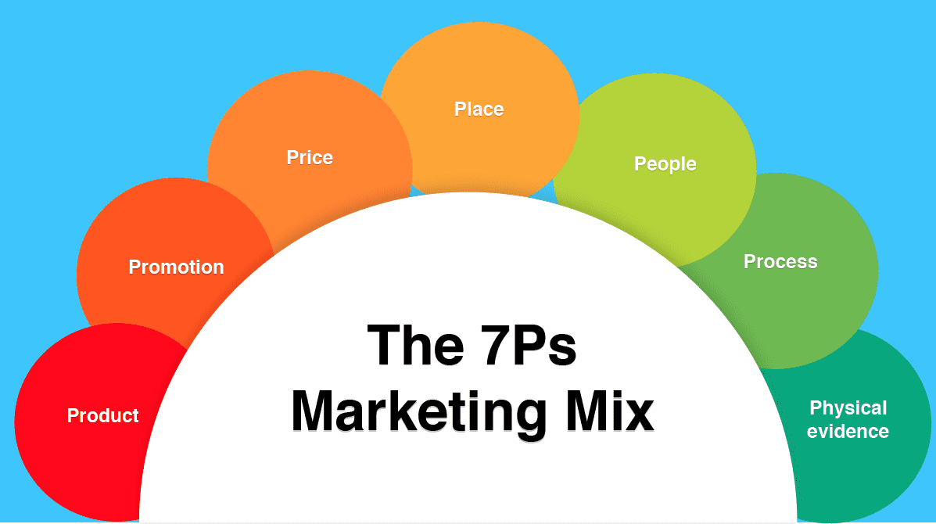
Figure 6: “7Ps of the Marketing Mix”
(Source: Inspired by Dharma et al. 2024)
- Product: Focusing on emerging demand of electric cars market in Kenya, Tesla needs to focus on solar-assisted charging, durable suspension, and longer battery ranges SUV designing. Moreover, smart features like autopilot, over-the-air updates, touchscreen controls, and superior safety standards can also attract tech savvy consumers in Kenya (Lee, 2025). However, presence of local infrastructural challenges might reflect on obstacles to implement innovation and sustainability commitment of Tesla in Kenyan electric car market.
- Price: Tesla generally employs a dynamic pricing strategy, adjusting prices frequently in response to market conditions and production costs, rather than relying on a fixed price list across global market operations. In addition, the EV market in Kenya is responsible for attracting investment, with new players entering and lenders like Kenya Commercial Bank (KCB) financing e-buses due to its rapid and gradual growth rate (Linkedin, 2024). Based on this scenario, Tesla needs to focus on a flexible pricing strategy in terms of facilitating premium features and long-term cost savings approach.
- Place: Tesla can introduce both online and offline platforms leveraging its omnichannel business model to attract tech savvy and traditional buyers in the market of Kenya based on its present market expertise (Xu, 2022). Furthermore, test drives and mobile sales events of Tesla might be conducted across Tech-hubs in Kenya and Universities to increase significant brand awareness.
- Promotion: As a promotional strategy, Tesla has been recommended to adopt “digital-first marketing” strategy to focus on social media, YouTube, and tech blogs for enhancing awareness among target audience. Additionally, Tesla might also highlight CSR efforts including tree planting and EV education workshops to build brand affinity through developing influencer partnerships, eco-awareness campaigns, and virtual launch events as well.
- People: Based on STP framework evaluation in the customer segment, Tesla can attract fuel-efficient alternatives, brand-conscious buyers, tech-savvy users and environmentally concerned individuals in Kenya. Apart from this, Tesla needs to strengthen its HRM roles to hire trained local professionals, including EV engineers and customer support staff in terms of ensuring personalized services in this international market (Szalavetz, 2022). Therefore, the ‘People’ mix for Tesla relies on customers, employment and partnership demands who need to be satisfied for achieving a competitive and sustainable market presence.
- Process: Tesla utilizes a process mix that adheres to a “production-to-order” strategy, as it produces cars based on customer orders rather than stocking large inventories. In brand expansion in Kanya, connection between highly automated manufacturing processes, a focus on sustainability and efficiency are highly necessary for managing market demands and costs in an effective manner for Tesla.
- Physical Evidence: In the context of emerging markets, Tesla has a focus on both product and service experiences that includes strategically located sales and service centres, Supercharger networks, and innovative display and retail environments. The Kenyan electric vehicle (EV) market is experiencing growth, with the Ministry of Roads and Transport that forecasted EVs are heading to constitute 5% of vehicles registered by 2025 (Linkedin, 2024). In this context, government incentives, reducing excise duties, and the exemption of fully electric vehicles from value-added tax are acting as catalysts in supporting EV market growth and expansion in Kenya. Thus, during expanding in this international market, Tesla has been recommended to reinforce its premium and green image for enhancing its trust and consistency.

Conclusion
The process of marketing management involves understanding customer needs, developing strategies to satisfy them, and managing the entire marketing process, from product development to customer relationship management to expanding in new markets. The report also highlighted that through diversified offerings, increasing market share and competitive advantages, effective brand extension strategy can assist Tesla to leverage a significant footprint into Kenya based on EV sales. Key principles of marketing management including planning, implementation, control, customer focus, strategic thinking, and resource management are essential for Tesla to promote its brand presence in the EV market of Kenya. Therefore, EV market in Kenya can be an exact choice in front Tesla to expand its international market in near future through aligning company’s value proposition with layered human motivations.

References
6wresearch, (2023). Market Forecast By Vehicle Types (Two-Wheeler, Passenger Vehicle, Bus, Trucks), By Regions (Central Region, Coastal Region, Rift Valley, Eastern Region, Western Region, Northern Region) and competitive landscape. Available at: https://www.6wresearch.com/industry-report/kenya-electric-vehicle-market-2020-2026#:~:text=According%20to%206Wresearch%2C%20Kenya%20Electric,EV%20market%20in%20the%20country.(Accessed: 22 April 2025)
Automotive Manufacturing Solutions, (2024). Electric Dreams: Tesla’s gigafactory network and EV battery production blueprint. Available at: https://www.automotivemanufacturingsolutions.com/ev-battery-production/teslas-ev-battery-production-and-global-gigafactory-network/45873.article#:~:text=Production%20of%20the%20Model%20Y,conditions%20and%20evolving%20consumer%20demands.(Accessed: 22 April 2025)
Automotive Purchasing And Supply Chain, (2024). North Africa - a new car making frontier?. Available at: https://magazine.automotivepurchasingandsupplychain.com/magazine/issue33/north-african-automotive.html (Accessed: 22 April 2025)
Del-Río-Carazo, L., Acquila-Natale, E., Iglesias-Pradas, S. and Hernández-García, Á., (2022). Sustainable rural electrification project management: An analysis of three case studies. Energies, 15(3), p.1203.
Dharma, P.P., Purwanegara, M.S. and Wibowo, S.A., (2024). Proposed Marketing Strategy to Increase Brand Loyalty: Study Case of Lazada Indonesia. International Journal of Current Science Research and Review, 7(07).
Empower Africa, (2024). Kenya to Approve First-Ever Green Mobility Policy to Accelerate EV Adoption. Available at: https://empowerafrica.com/kenya-to-approve-first-ever-green-mobility-policy-to-accelerate-ev-adoption/ (Accessed: 22 April 2025)
Gicha, B.B., Tufa, L.T. and Lee, J., (2024). The electric vehicle revolution in Sub-Saharan Africa: Trends, challenges, and opportunities. Energy Strategy Reviews, 53, p.101384.
Joachimsthaler, E. and Olderog, A., (2022). Branding and digital business models. In Handbook of Business-to-Business Marketing (pp. 225-246). Edward Elgar Publishing.
Lee, B.K., (2025). Digital Product Management: Strategic Planning and Market Opportunity. CRC Press.
Linkedin, (2024). Kenya's Road to 5% EV Adoption by 2025. Available at: https://www.linkedin.com/pulse/kenyas-road-5-ev-adoption-2025-warren-ondanje-wfckf/ (Accessed: 22 April 2025)
Medium, (2021). Using Perceptual Mapping for Competitive Analysis. Available at: https://anupambajra.medium.com/using-perceptual-mapping-for-competitive-analysis-9aae239ec736 (Accessed: 22 April 2025)
Sperresearch, (2024). Kenya Electric Vehicle Market Growth, Size, Trends, Share. Available at: https://www.sperresearch.com/report-store/kenya-electric-vehicle-market.aspx#:~:text=What%20is%20the%20Market%20size,billion%20from%202024%20to%202033. (Accessed: 22 April 2025)
Szalavetz, A., (2022). Transition to electric vehicles in Hungary: A devastating crisis or business as usual?. Technological Forecasting and Social Change, 184, p.122029.
Tesla, (2024). Q4 and FY 2024 Update. Available at: https://digitalassets.tesla.com/tesla-contents/image/upload/IR/TSLA-Q4-2024-Update.pdf (Accessed: 22 April 2025)
Tesla, (2025). About Us. Available at: https://www.tesla.com/about (Accessed: 22 April 2025)
Trigeorgis, L., Baldi, F. and Katsikeas, C.S., (2021). Valuation of brand equity and retailer growth strategies using real options. Journal of retailing, 97(4), pp.523-544.
Vidili, I., (2021). Journey to centricity: a customer-centric framework for the era of stakeholder capitalism. The Smarter Crew.
Xu, J., (2022). FinTech innovation and strategy. The future and FinTech: ABCDI and beyond, pp.1-36.
Yoon, S., Choi, Y.K. and Taylor, C.R. eds., (2021). Leveraged Marketing Communications: The Importance of Studying the Transfer of Object-to-brand Associations. Routledge.

