A critical analysis of external factors impacting High Street retailers in the UK.
Module Name: Problem Solving and Innovation (BMSW4014)
Lecturer Name: Christopher Rogers
Student Name: Mihaela Miculescu (2422449)

Page Contents:
- Introduction:
- Findings:
2.1 PESTLE Analysis
2.2 SWOT Analysis
2.3 Key Factors in Detail
3. Conclusion:
4. Recommendations:

- Introduction
The actual situation of the High Street retailers is characterized by various challenges and opportunities, influenced by the continuous changing of the external factors. In the last few years, the retail sector has been affected by the pandemic, the technological evolution, changes in the consumers behaviour and the global economic instability. Never the less the shoplifting, the political instability caused by the Brexit and the pandemic impact are just a few factors that shape the business model for the retailers. In this report we will analyse deeply these external factors using tools like PESTLE and SWOT analyses to understand how the performance and the strategies of the high street retailers in UK are affected. Mostly we will analyse how the stealing and other challenges, as well as how the owners are dealing with all these situations.
- Findings
To understand better the external factors affecting the high street retailers, it is necessary to analyse the external factors using SWOT and PESTLE analyses. A PESTLE analysis is a strategic framework used to evaluate the external macro-environmental factors that may impact an organization. It considers Political, Economic, Social, Technological, Legal, and Environmental influences, helping organizations understand the broader context in which they operate and informing strategic decision-making (Johnson, Scholes, & Whittington, 2017). The appropriate use of this tool makes it possible to detect potential opportunities and threats for the company, which can quickly turn into a significant competitive advantage (Marmol, 2015)
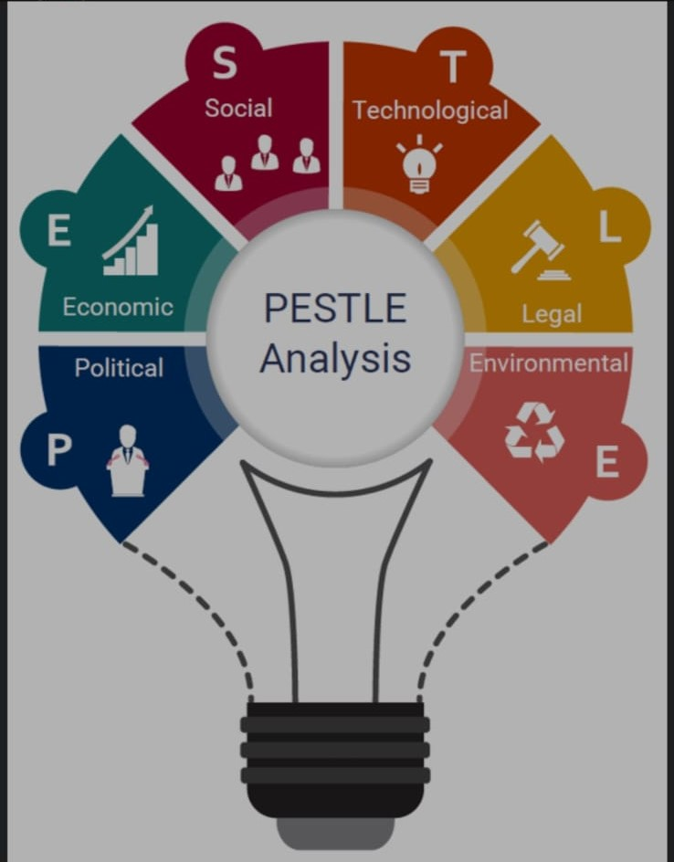
  - Pestle Analyse
Political
Brexit had a significant impact over the retail sector, showing no reliability in the commercial sector and immigration. The political governments support or the security measures in regards the local retail, they can influence in a direct manner the retail. The strategy measures to stop the shop lifting are essential.

Economic
After the pandemic the economic crisis affected the power of buying of the consumers by affecting the fluctuation of the customers. The rise of the inflation and operational costs like rent and salaries put a lot of pressure on the retailer’s profitability. The currency fluctuations can affect the costs of import transportation.
Social
The changes in the shopper’s behaviours, like the online shopping or for new experiences instead of traditional shopping is affecting the pedestrian traffic. Also, the safety and security concerns in the shops affect the shopping decisions and how often they will visit the shop.
Technologic
The technological adoption and the digital transformation in retail like mobile payments and electronic trade represents the challenges but also the opportunities. To keep up with the challenges the traders need to keep up with the evolution of the technology and invest in solutions to stay above the competition, but this means higher costs and cybernetical attacks.
Legal
To avoid legal penalties, the security, the protection data and the consumers rights even though they are in a continuous change they need to be highly respected. Also, the Anti -Theft legislation and the prevention measurements are critical for the loss prevention
Environmental
The consumers expectations and sustainability regulations influence the way the retailers manage their activity, from managing their waste to using durable resources. Retailers should embed sustainability into their core strategies by sourcing ethically, reducing waste, and adopting eco-friendly packaging (Madecraft, 2021) The retailers could introduce initiative for circular economy like recycling methods and to promote ecological products.
The PESTLE analysis shows the multiple external challenges and opportunities that the high street retailers are facing.

  - SWOT analysis of the external factors
A SWOT analysis is a strategic planning tool used to identify and evaluate the Strengths, Weaknesses, Opportunities, and Threats related to a business or project, aiding in decision-making and strategic development (Pickton & Wright, 1998).
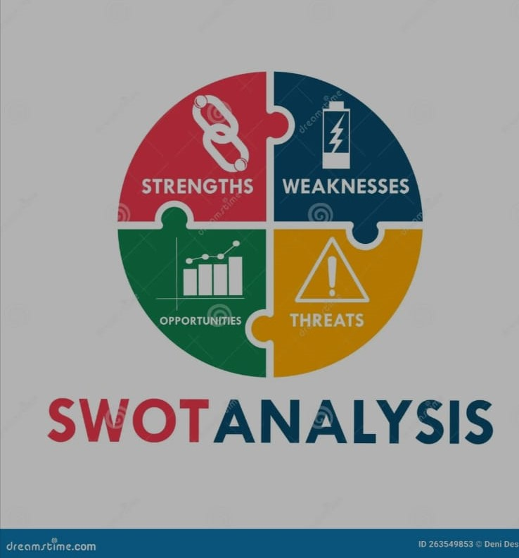

Strength
- Main Streets reputation like popular shopping destinations
- The adaptability to the new destinations
- Local community integration
- Physical store experience offering tactile shopping, where they can test and feel the product before buying them.
Weakness
- Shoplifting vulnerabilities and acts of vandalism
- High cost for the rent in the central area.
- Limited online presence for some retailers
- Vulnerability to external shocks such as economic downturns and crimes waves.
Opportunities
- Create unique experiences for the customers to differentiate offers
- Development of the shopping online to compensate for the loss of pedestrian traffic
- Green and ethical branding
Threat
- The rise of the crimes and shoplifting can decrease the attractiveness of the area
- The political and economical instability is influencing the consumer’s trust
- Online competition with the younger consumers who prefer the digital experience
The SWOT analysis show the internal vulnerabilities, the opportunities and the external threats showing the need for strategical agility.
  - Key Factors in Detail
- E- commerce and Digital transformation
Technological innovation is a double-edged sword. While e-commerce provides new revenue streams and convenience, it intensifies competition. Retailers must develop omnichannel strategies integrating online and offline channels seamlessly (Proctor, 2019) For the high street retailer this external factor represents both a threat and opportunity. Even though the digital channels can extend reach and give a better customer engagement they also intensify the competition and needs a lot of investment. The rapid growth of e-commerce has fundamentally altered the retail landscape. UK consumers now spend a significant proportion of their retail budget online, with estimates suggesting over 25% of retail sales occur digitally (CIPD, 2024)

- Crime and Shoplifting crisis
The Shoplifting represent a major problem affecting the profitability of the retailers. In the dynamic landscape of the retail industry, loss prevention professionals continually grapple with a diverse range of challenges that evolve with the times. Saquella, A. (2024). Some of the shops they have not invested in any extra modern security measures like advanced CCTV and intelligent alarm systems, which makes them more vulnerable. Romeo, J. (2016). An important external challenge is the escalating crime crises in the retail shoplifting. The British Retail Consortium (BRC) reports that shoplifting costs UK retailers billions annually, impacting profitability and operational costs. The rise in the shoplifting is partially determined by social problems and economical difficulties which puts pressure on resources and security measures. As Helms and Nixon (2010) note, external threats like crime necessitate strategic resilience and adaptive security policies.
- Conclusion
The external environment for the high street retailers is characterized by the rapid technological changes in the consumers preferences, economical instability and the challenges in the security measures. The behaviour of the consumer incline towards online, ethical and sustainable choices forcing the retailers to adapt and innovate. The SWOT and PESTEL analysis show that even if opportunities exist in digital transformation there is also threats like online competition, lower pedestrian traffic and the rise in the criminality presents significant risks. In general, the external factors need proactive and flexible strategies to ensure the competition and sustainability of the High Street retailing in the UK
- Recommendations
- Develop strategies focused on personalization and sustainability
To stay in the competition the High Street Retailers should invest in the digital and physical channels. This includes developing online platforms easy to use, mobile applications and digital experiences in the shop. Based on the insights from Hallo (2022), it is essential for organizations to develop strategies that emphasize both personalization and sustainability to enhance leadership decision-making and problem-solving processes. Personalization through analytic data cam make the customers experience better promoting loyalty. Incorporating sustainability into packaging and storing aligns with customers values, making a better reputation of the brand. For example, implementing RFID (Radio Frequency Identification) technology can make the stock take simpler and in real time stock updates, creating a better and more responsive shopping experience. According to Adair (2019), investing in customer-centric innovation can differentiate retailers and boost sales.
- Implement Advanced security measures and programs for community
To address the shoplifting crise the shops need to implement the last generation of CCTV with facial recognition, AI stealing prevention systems and staff training. Partnering with local authorities and community programmes can discourage criminality and encourage goodwill. According to Keough (2019), proactive security combined with community collaboration builds resilience against external threats. Retailers can also adapt strategies like reducing the blind spots in the shop and facilitate a quick response from the staff. Regular awareness campaigns also inform staff about current trends in shoplifting and evolving criminal tactics. Ernesto Lopez, Robert Boxerman. (2023). Also involving with the community initiates social responsibilities which can reduce anti-social behaviours, creating a safer shopping environment. Discouraging should be efficient and with visible consequences for the shoplifters. The CSEW for year ending (YE) December 2024 estimated 2.9 million theft incidents. This is a 13% increase, compared with the previous year (2.6 million incidents) according to the Office for National Statistics. (2025). The limitations in enforcing the law, in some occasions some sanctions for the small theft are easy to avoid, and this is encouraging a delinquent behaviour (UK Parliament, 2025)

REFERENCES

Adair, J.E. (2019) Decision making and problem solving: break through barriers and banish uncertainty at work. Fourth edition. London, KoganPage.
brc.org.uk. (January 2025). Retail Crime Spiralling out of control. [Online]. brc.org.uk. Available
Ernesto Lopez, Robert Boxerman. (2023). Shoplifting Trends: What You Need to Know. [Online]. Council on criminal justice.
Hallo, L. (2022) Holistic view of intuition and analysis in leadership decision-making and problem-solving. Administrative sciences. 12 (1), 1–25.
Helms, M.M. & Nixon, J. (2010) Exploring SWOT analysis - where are we now?: A review of academic research from the last decade. Journal of strategy and management. 3 (3), 215.
Johnson, G., Whittington, R. and Scholes, K. (2017) Exploring strategy: text and cases. Eleventh edition. New York, New York State: Pearson.
Keough, P.D. (2019) Ethical problem-solving and decision-making for positive and conclusive outcomes . Hershey, Pennsylvania :, IGI Global
Marmol, T. del et al. (2015) PESTLE analysis. Translated by C. Probert. Namur: Lemaitre Publishing.
Madecraft (2021) Conducting a SWOT Analysis. J. Belfiore (ed.). Conducting a SWOT Analysis
Office for National Statistics. (2025). Crime in England and Wales. [Online]. Gov.uk. https://www.ons.gov.uk/peoplepopulationandcommunity/crimeandjustice

Pickton, D.W. and Wright, S. (1998) ‘What’s swot in strategic analysis?’, Strategic change, 7(2), pp. 101–109.
Romeo, J. (2016) Preventing loss and preserving the customer experience: retail loss prevention faces numerous challenges in a changing and dynamic retail environment, Security (Newton, Mass.). BNP Media, pp. 60-.
Saquella, A. (2024) ‘Navigating Retail Security Challenges: A Comprehensive Approach’, Security, 61(5), pp. 37–38.
Uk Parliament. (2025). Legislation on theft and organized crime. [Online]. House of Commons Library. Last Updated: March, 2025.

