

Research, build, and deploy a Virtualised Enterprise network

  - By Jac Wilde

Contents
Introduction 3
Task 1 – Research 3
Hypervisor 3
IP Addressing 4
Routing 6
Network Services 6
Task 2 – Technical Documentation 8
Download and Setup 8
Configure IP Addressing 10
Test and Troubleshoot 14
Task 3 – Reflection 18
Bibliography 19

Introduction
This report presents the research and planned implementation of a virtualised network infrastructure for the organisation NOSS2026, which operates across two locations: Swansea and London. As the appointed IT Technician, the objective is to design and deploy a functional virtual network that reflects enterprise-level practices while operating within the defined resource constraints.

Task 1 – Research

Hypervisor
Hypervisors allow you to create many different environments within a single physical system. There are two types of hypervisors (type-1 & type-2). A type-1 hypervisor, also known as a ‘bare-metal’ hypervisor is executed on the system hardware, whilst a type-2 hypervisor is executed within the host OS (operating system) using virtual machines [1].
The type-1 hypervisor controls both the hardware and the guest operating systems, whilst the type-2 hypervisor relies on the host OS to allocate computer resources. Virtual environments within type-1 hypervisors are better isolated in comparison to a type-2 hypervisor. This makes it a more secure option than type-2 hypervisors, where each environment operates on a shared layer [2]. The shared host OS within type-2 hypervisors can be seen as a vulnerability. However, this security concern may be less significant in a controlled laboratory environment where external threats are minimal.
The type-1 hypervisor is also more complex to manage and requires high levels of understanding in system administration. Type-2 hypervisors are installed and managed within a virtualisation application such as ‘VirtualBox’ where the installation process is much simpler.
The type-1 hypervisor is favoured within enterprise networks and can be scaled up to manage several terabytes of RAM and hundreds of CPU cores. However, a type-2 hypervisor consumes far fewer resources and is more efficient than type-1. This means that it can still host many virtual machines (dependant on system hardware) [3]. Type-2 is favoured within testing environments or systems that have a lower workload.
To summarise, type-1 offers better performance, greater scalability and enhanced security. However, type-2 offers simple set ups, lower hardware requirements and it runs on standard computer systems. Although type-1 would be more appropriate in a production enterprise environment such as a large corporation, the resource constraints and ease of set up make type-2 a more practical solution.
For these reasons, the chosen hypervisor for this project is a type-2 hypervisor.

IP Addressing
There are two types of IP addresses in use. IPv4 and IPv6. IPv4 consists of 4.3 billion ($2^{32}$) unique addresses however, due to the increasing number of devices now connected to the internet, we are running out of IPv4 addresses. This is why IPv6 has been introduced. IPv6 consists of $2^{128}$ unique addresses. Each device on a network is assigned a unique IP address to ensure accurate identification and delivery of data packets.
Each IPv4 address involves four octets which results in an address totalling 32 bits in length (e.g. 192.168.10.1). IPv6 consists of eight 16-bit hexadecimal fields, separated by ‘:’ (e.g. 2001:0000:DEAD:3833:0112:0000:0000:FEED). IPv6 addresses can be simplified in writing to remove zeroes (2001:0:DEAD:3833:0112::FEED) [4].
IPv4:
8 Bit | 8 Bit | 8 Bit | 8 Bit
11000000 | 10101000 | 00001010 | 00000001
192 | 168 | 10 | 1

IPv6:
16 Bit | 16 Bit | 16 Bit | 16 Bit | 16 Bit | 16 Bit | 16 Bit | 16 Bit
0010000000000001 | 0000000000000000 | 1101111010101101 | 001110000011001 | 0000000100010010 | 0000000000000000 | 0000000000000000 | 1111111011101101
2001 | 0000 | DEAD | 3833 | 0112 | 0000 | 0000 | FEED

The above tables clearly show the size differences between IPv4 and IPv6.
Within network design, subnetting is a crucial step. Subnetting is the process of dividing larger networks into smaller sub-networks. Subnetting applies primarily to IPv4, allowing for efficient utilisation of IP addresses. IPv6 simply uses the next usable address. IPv4 networks are primarily considered as class A, B, C or classless. Class A ranges from 1.0.0.0 to 127.255.255.255 /8. Class B ranges from 128.0.0.0 – 191.255.255.255 /16. Class C ranges from 192.0.0.0 – 223.255.255.255 /24 [5]. Each IPv4 address will have a subnet mask. The following table from Cisco is useful in understanding subnetting, masks and host addresses [6]:
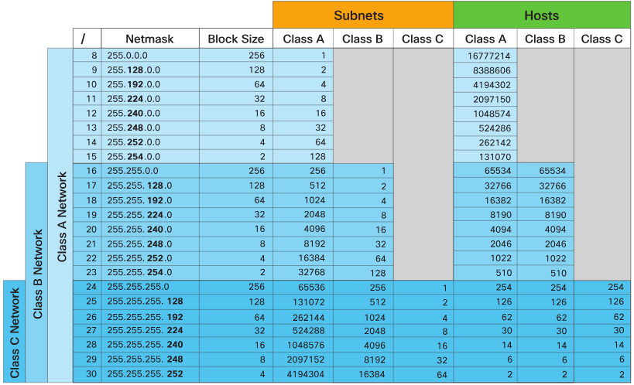
Figure 1- Cisco Subnetting Chart [6]
IP packets are used to exchange information across IP networks. Each packet contains a header for addressing that contains information about the data within. These headers differ greatly between IPv4 and IPv6 [7]. The below diagram from Network Academy shows the difference between the IP headers.
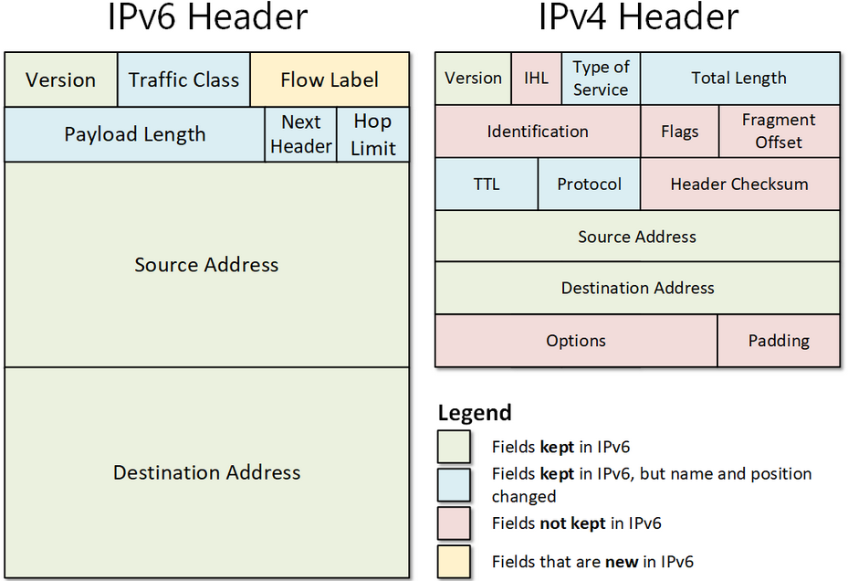
Figure 2- IP Headers [7]
The IPv6 header has fewer fields, making it a more efficient means of data transmission. Despite IPv6 offering greater scalability and efficiency, IPv4 remains widely implemented in enterprise environments due to compatibility and existing infrastructure investments. This makes it a suitable choice for the current small-scale network of NOSS2026.

Routing
The practice of routing within computer networks is the configuration of network devices to define paths and manage IP traffic within or between networks. The primary role of routing is for establishing connections between networks, determining efficient paths for data transmission, and managing network traffic [8].
Two common ways of configuring a router’s routing table are ‘static’ and ‘dynamic’. Static routing consists of manually entering commands, telling the router which interface to send packets with specific destination IP addresses to. Dynamic routing enables the routers on your network to communicate and develop their own routing tables. A common protocol for this type of dynamic routing is OSPF (Open Shortest Path First).
These practices are not mutually exclusive and are commonly used together. Static routes being primarily for sending data out of the network as a default route to the ISP, and dynamic routing within the network. However, if you are maintaining a smaller network with only a few routers, a fully static routing table might be preferred for ease of maintenance.
Another method of dynamic routing is RIPv2 (Routing Information Protocol version 2). This works by highlighting to the router which networks are connected to it. The router then automatically determines the best path to send packets based on the lowest hop count (the number of devices the data must travel through to get to its destination). This method of dynamic routing offers better scalability for larger networks [9].
While dynamic routing protocols such as OSPF and RIPv2 improve scalability and adaptability, they introduce additional configuration complexity. In a limited topology with only two internal networks and a point-to-point link, the implementation of dynamic routing may not be justified for NOSS2026’s network.

Network Services
Virtual Private Networks (VPNs) within a corporate network allow users to remotely access company resources remotely. This is done through ‘tunnelling’. Tunnelling encapsulates packets from the network within another packet that is transported by the second network. This allows packets form the network that is not supported to be encrypted and transported safely through the network [10]. Strong encryption methods such as AES256 would be a best practice.
Dynamic Host Configuration Protocol (DHCP) is a very useful network service. DHCP automatically assigns IP addresses and network configuration settings (subnet mask, gateway, DNS) to devices on a network. This reduces manual configuration errors and simplifies IP management.
Active Directory (AD) is a network service that is used for managing identities, authentication and group policies. A main use is for managing user permissions to network resources [11]. It provides a means to centrally manage the network of devices. However, centralisation also creates a potential single point of failure, meaning redundancy and backup strategies should be considered in enterprise deployment.
A Certificate Authority (CA) issues and manages digital certificates. For example, when accessing a ‘https’ website, it is the CA that issues the certificate to confirm that the site is secure. Best practice for a CA system is to protect private keys with a hardware security module HSM and to keep short certificate lifetimes for security [12]. Improper certificate management can undermine trust models within the organisation, making strict key protection policies essential.

Task 2 – Technical Documentation

Topology + Hypervisor
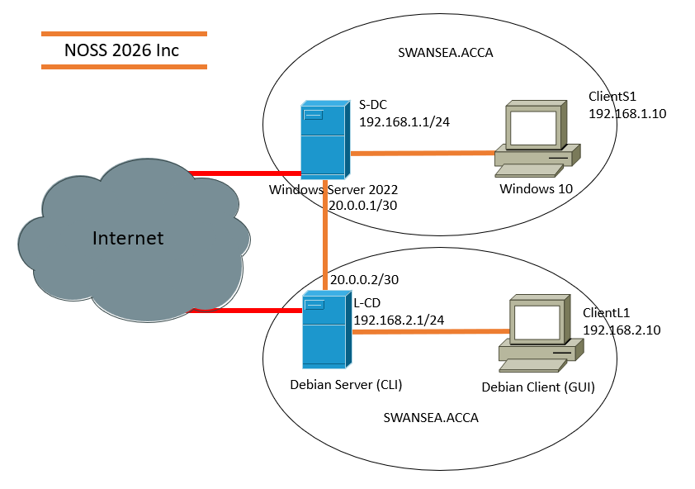
The above screenshot shows the topology for the given scenario. The hypervisor of choice is a type-2 hypervisor. This is primarily due to the lower hardware requirements. The ability to run the systems on the available lab PCs is a considerable advantage to using a type-2 hypervisor.

Download and Setup
Windows Server setup
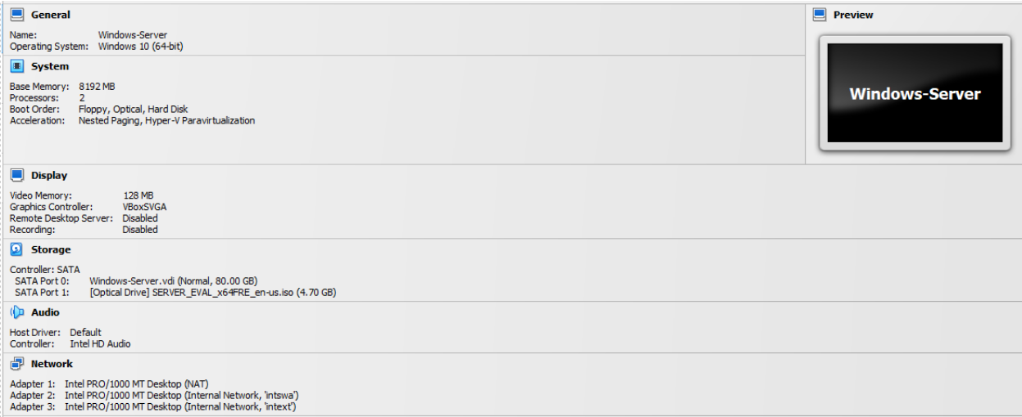
Windows Client setup
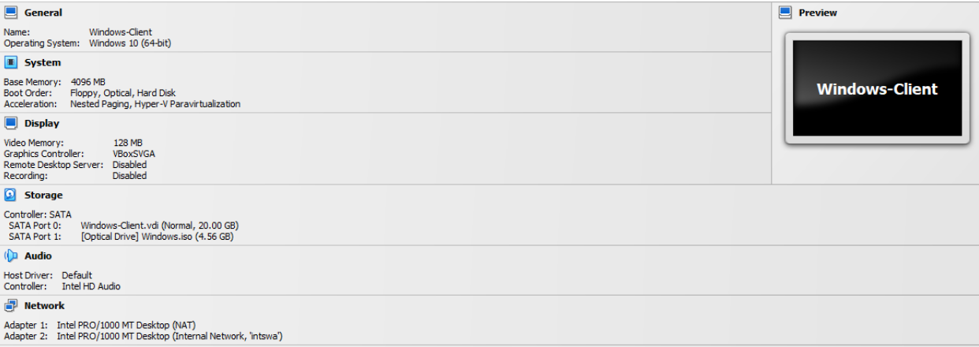
The Windows server is set up using the Windows Server 2022 ISO, which was downloaded from the media creation tool, from the Microsoft Website [13].
The Windows client ISO was also downloaded from the Microsoft Website [14].
Both Windows devices were named in line with the industry standards as taken from the official Microsoft website, where it explains the requirements for DNS host names [15].

Linux Debian Server setup
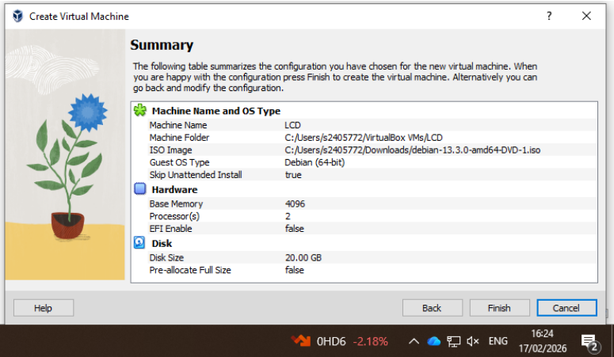
Linux Debian Client setup
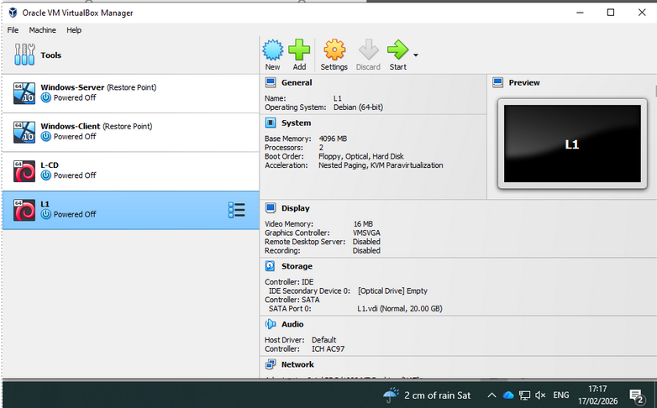
The Debian ISOs were downloaded from the official Debian website [15].

Configure IP Addressing
Windows Server IP Addressing
Below is an example of how the IP addresses were assigned using the Windows GUI on the server:
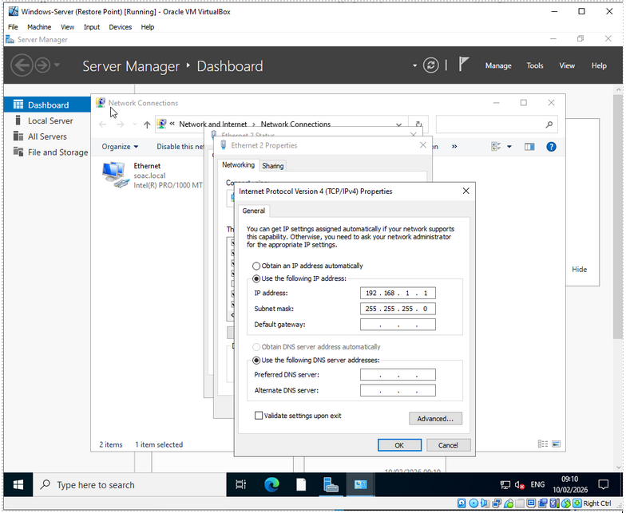
Windows Server – ipconfig
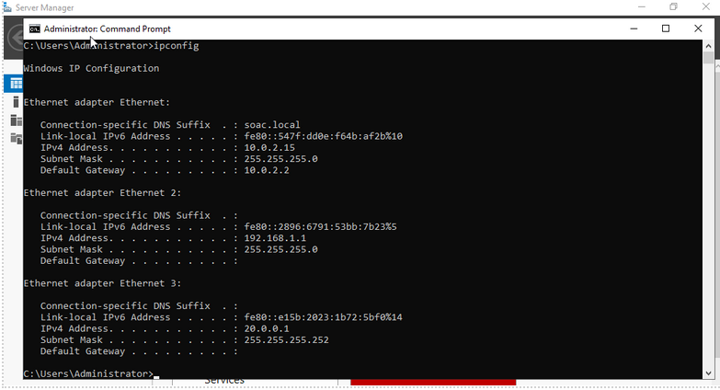
Windows Client – ipconfig
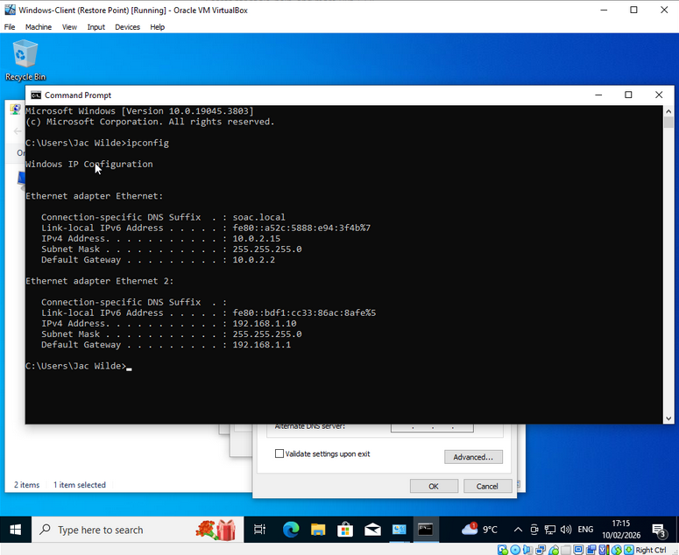

Linux Server IP Addressing
Below is an example of the edited interfaces file that controls the interfaces for the London network:
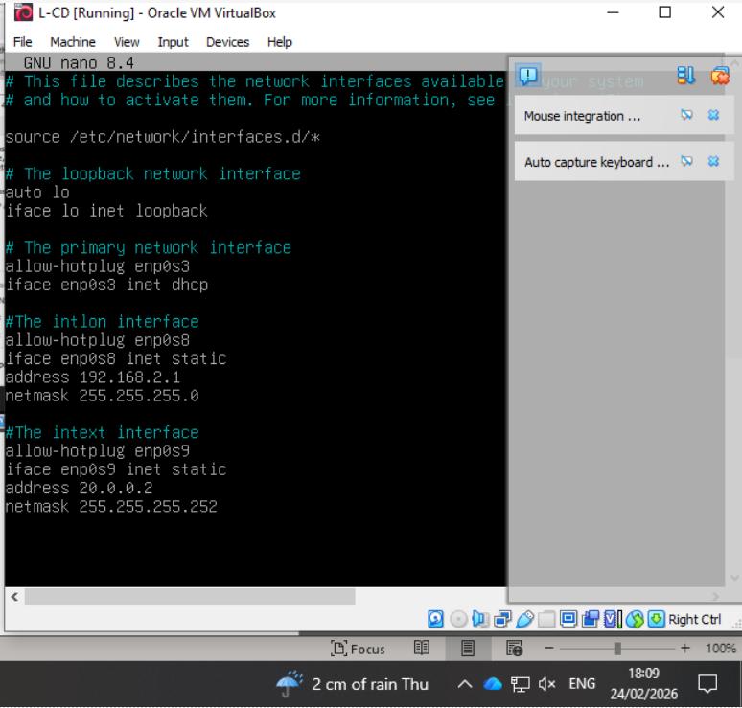
Linux Server – ip a
All interfaces have been assigned IP addresses according to the given topology and are showing as ‘UP’.
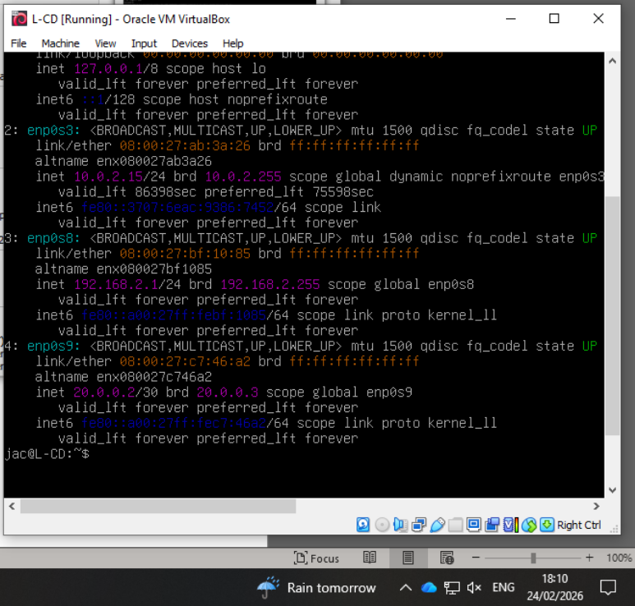
Linux Client
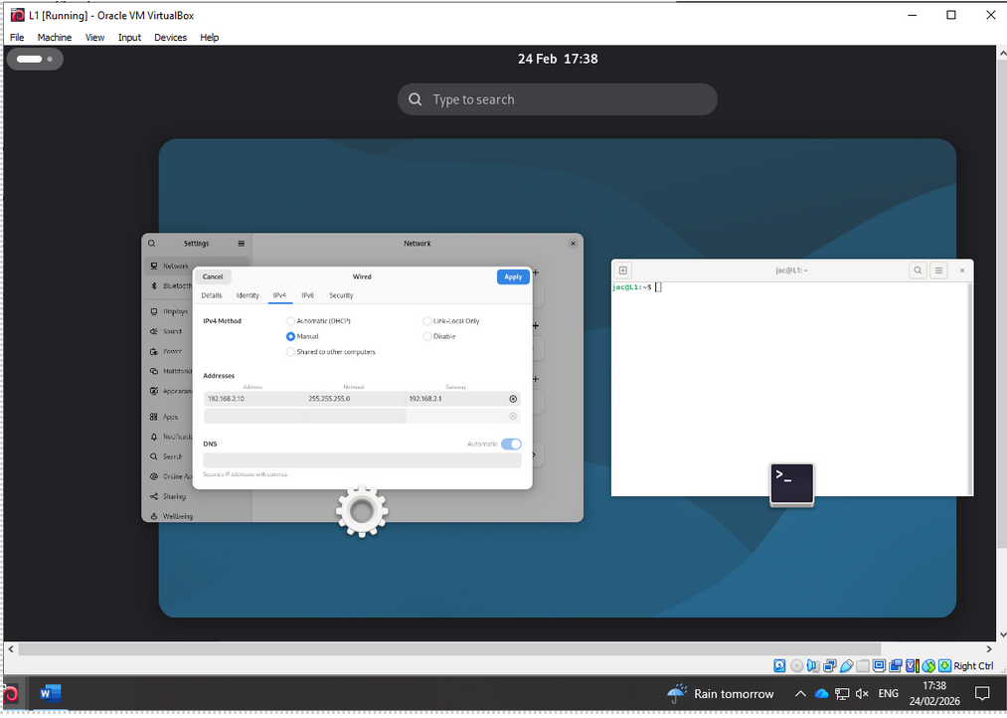

Test and Troubleshoot
Successful Pings:
Windows Server to Windows Client
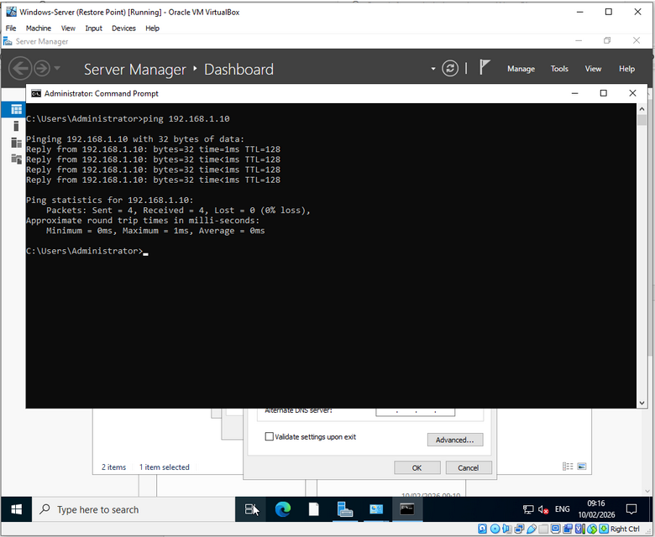
Windows Client to Windows Server
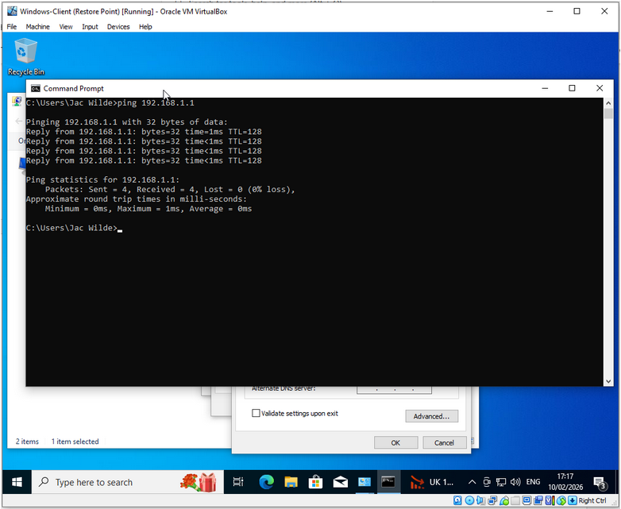
Linux Server to Linux Client
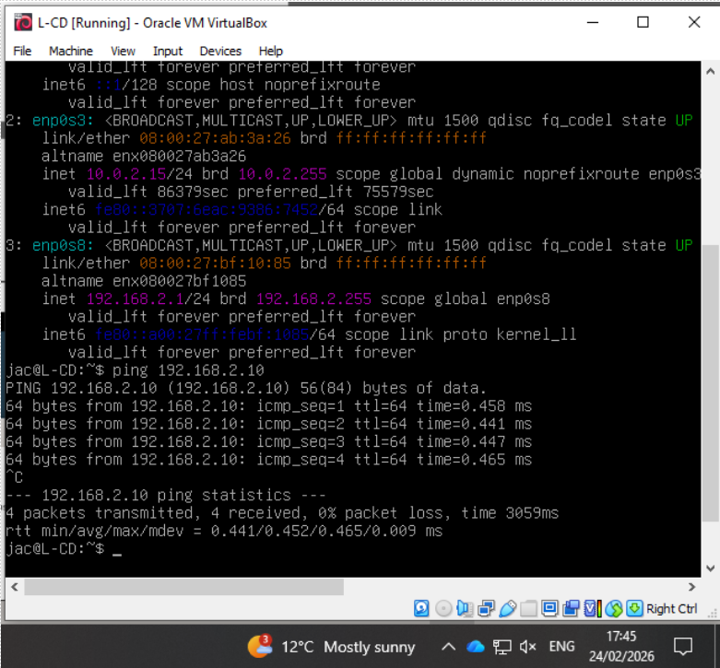
Linux Client to Linux Server
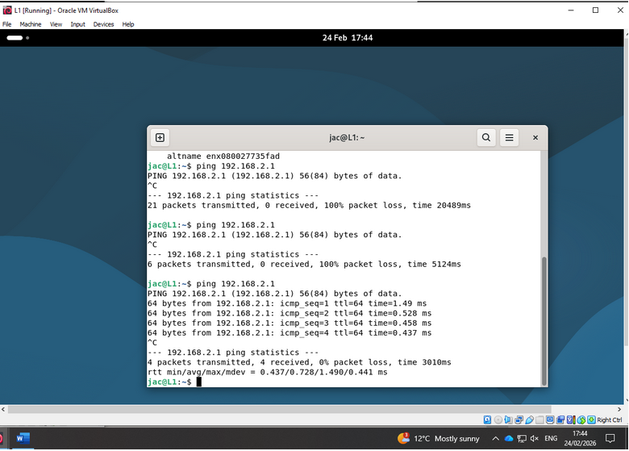
Windows Server to Linux Server
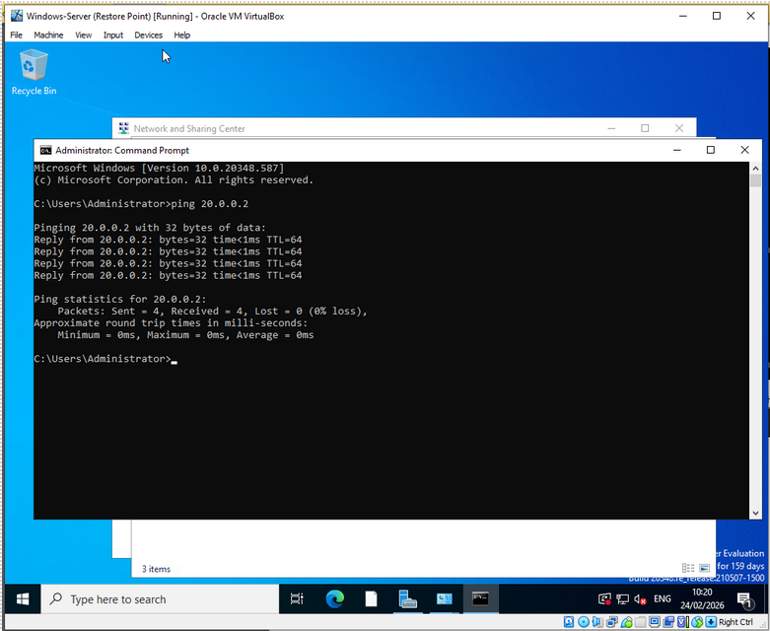
Linux Server to Windows Server
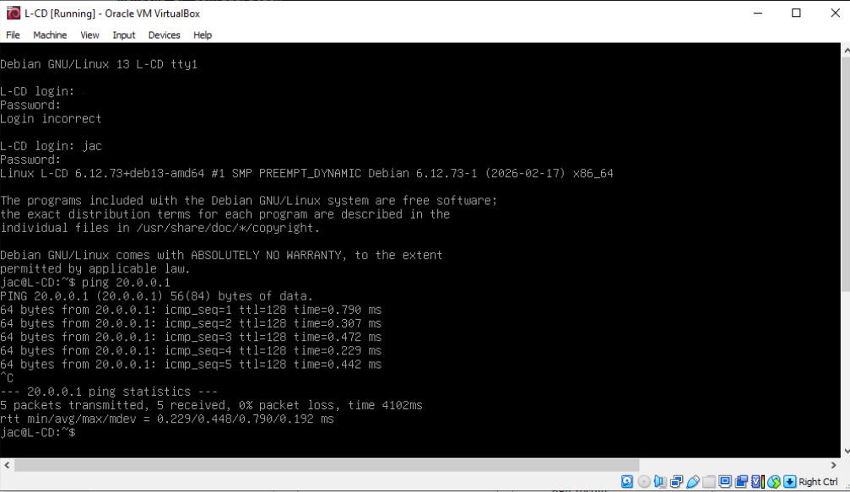
Troubleshooting
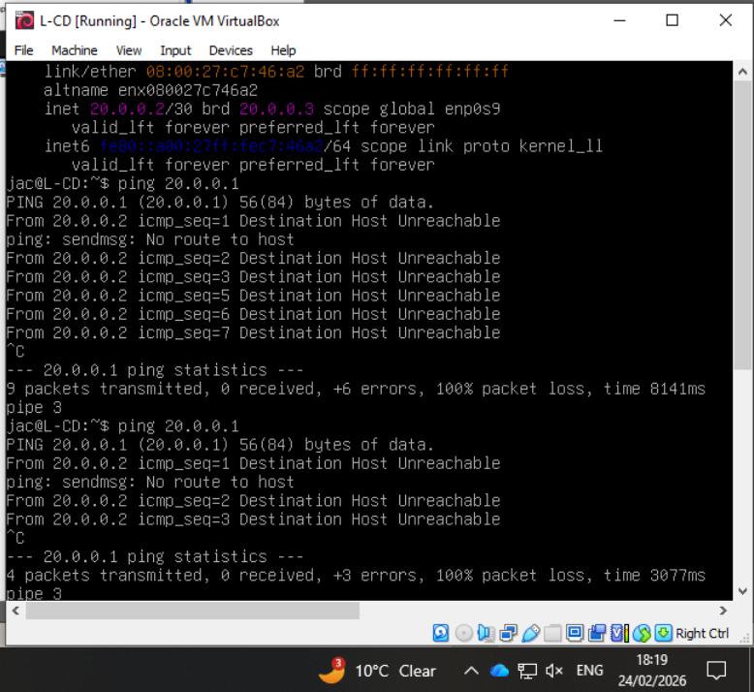
As shown in the above screenshot, I was receiving an error when attempting to ping from the Linux server to the Windows server. The error was ‘Destination Host Unreachable’. After verifying that the IP addresses were assigned correctly along with subnet masks, and that all interfaces were up, I realised the issue must be coming from the Windows firewall. After disabling this, the ping could reach the windows server successfully.
Another issue that was experienced involved unsuccessful pings form the Windows client to the Windows Server. This was discovered to be a typing error when entering the default gateway.

Task 3 – Reflection
Researching hypervisors, IP addressing, routing, and network services strengthened my understanding of how individual technologies integrate to form a functional enterprise network. The practical implementation element reinforced the importance of planning before deployment. The decision to use a type-2 hypervisor allowed for the project to be completed smoothly, without the need for any hardware upgrades. The IP addressing scheme used was also suitable for the task, allowing for expansion within both the Swansea and London networks. However, the network connecting both the Swansea and London servers has a /30 mask. Meaning it can only have 2 usable IP addresses. This does not allow for any further expansion.
Whilst considerable planning was completed, there were also some issues when configuring the network. The primary issue being unsuccessful pings. However, through experience and practice, these issues were able to be diagnosed and resolved. The issues faced were a result of misconfigured default gateways and packets being blocked by the windows firewall. Overcoming these issues helped to considerably develop my technical abilities
Overall, this assignment enhanced both my technical knowledge and problem-solving abilities. It demonstrated how theoretical research directly informs practical implementation, preparing me for real-world scenarios where structured planning, security awareness, and technical ability are essential.

Bibliography

[1] | B. Dordevic, S. Gucunja, N. Kraljevic and N. Davidovic, “Performance comparison of different hypervisor versions of the type-2 hypervisor VirtualBox,” in 2023 10th International Conference on Electrical, Electronic and Computing Engineering , East Sarajevo, 2023.
[2] | Amazon Web Services, “What’s the Difference Between Type 1 and Type 2 Hypervisors?,” Amazon, 2026. [Online]. Available: https://aws.amazon.com/compare/the-difference-between-type-1-and-type-2-hypervisors/. [Accessed 24 February 2026].
[3] | S. J. Bigelow and B. Kirsch, “What's the difference between Type 1 vs. Type 2 hypervisor?,” 7 March 2024. [Online]. Available: https://www.techtarget.com/searchitoperations/tip/Whats-the-difference-between-Type-1-vs-Type-2-hypervisor. [Accessed 24 February 2026].
[4] | A. Shiranzaei and D. R. Z. Khan, “A Comparative Study on IPv4 and IPv6,” International Journal of Advanced Information Science and Technology (IJAIST), vol. 4, no. 1, pp. 1-9, 2015.
[5] | Cisco, “Configure IP Addresses and Unique Subnets for New Users,” 7 July 2023. [Online]. Available: https://www.cisco.com/c/en/us/support/docs/ip/routing-information-protocol-rip/13788-3.html. [Accessed 24 February 2026].
[6] | Cisco Learning Network, “IPv4 Subnetting Reference Chart,” 19 August 2021. [Online]. Available: https://learningnetwork.cisco.com/s/article/ipv4-subnetting-reference-chart. [Accessed 24 February 2026].
[7] | Network Academy.io, “IPv4 vs IPv6 - Understanding the differences,” Network Academy, [Online]. Available: https://www.networkacademy.io/ccna/ipv6/ipv4-vs-ipv6. [Accessed 24 February 2026].
[8] | Cisco, “What is routing?,” Cisco, [Online]. Available: https://www.cisco.com/site/us/en/learn/topics/networking/what-is-routing.html. [Accessed 24 February 2026].
[9] | RST Forum, “RIPv2 or Routing Information Protocol version 2,” RST Forum, 2026. [Online]. Available: https://rstforum.net/knowledge-base/ripv2. [Accessed 26 February 2026].
[10] | V. Mulder, A. Mermoud, V. Lenders and B. Tellenback, Trends in Data Protection and Encryption Technologies, Zurich: Springer, Cham, 2023, p. 149.
[11] | B. I. Mokhtar, A. D. Jurcut, M. S. ElSayed and M. A. Azer, “ Active Directory Attacks—Steps, Types, and Signatures,” Electronics, vol. 11, no. 16, p. 1, 2022.
[12] | J. Chaudhry, K. Saleem, P. Haskell-Dowland and M. H. Miraz, “A Survey of Distributed Certificate,” Annals of Emerging Technologies in Computing (AETiC), vol. 2, no. 3, pp. 1-12, 2018.
[13] | Microsoft, “Evaluate Windows Server 2022,” 2026. [Online]. Available: https://info.microsoft.com/ww-landing-windows-server-2022.html.
[14] | Microsoft, “Download Windows 10,” 2026. [Online]. Available: https://www.microsoft.com/en-gb/software-download/windows10.
[15] | Debian, “Downloading Debian,” 2026. [Online]. Available: https://www.debian.org/download.

