  Component One:  What are the key skills required when working in the housekeeping team? 750 words (+/- 10%)  Contribution to Overall Module Assessment: 25% | Student No: | Daniela Gabriela Vartolomeu  2130495
 | Module Title: | Operating Hotel Facilities
 | Module Code: | BMIH4006
 | Lecturer: | Tristan Hawkins
Keeping guest rooms and common spaces neat and clean is a primary responsibility of housekeeping staff in the hotel sector (Singh, 2015). While working as part of a housekeeping staff, it's important to have a wide set of talents and traits to provide excellent service and keep guests happy.
Management of time
Most housekeepers work alone; however, others operate in small teams (Bardi, 2021). Each day, they are expected to clean a certain number of rooms. Housekeepers require strong time-management and organisational skills to get their work done on schedule. They also need to show up on time for scheduled cleanings and wrap out the job within the allotted time limit.
Communication
Housekeepers should maintain open lines of communication with customers, colleagues, and managers to ensure that each cleaning is performed to the highest standards (Rutherford, 2021). A housekeeper's ability to communicate with their customer is crucial to completing their cleaning tasks.
Social abilities
Housekeepers need strong interpersonal and collaborative skills since they often interact with customers. Housekeepers often need to demonstrate reliability, collaboration, and accountability as part of their interpersonal skills.
Flexibility
In order to accommodate their clients, many housekeepers must work irregular hours. If a housekeeper is responsible for cleaning an office building, for instance, they may not be able to get started until after all of the workers have gone home for the day. It's not uncommon for housekeepers to put in late-night or early-morning shifts (Bardi, 2021). One way a housekeeper might increase her earnings is by increasing her availability to take on different types of cleaning assignments.
Customer service
Customer service abilities are crucial for success in this line of work, and housekeepers must possess these qualities to execute their jobs well. This is because a housekeeper's income depends on their customers' satisfaction with their job, therefore it's in their best interest to keep their clients happy at all times.
Working in the hospitality industry, I've learned that these abilities are crucial for a cleaning position to be successful. When I worked as a front desk clerk, for instance, I coordinated with cleaning to make sure that guests' rooms are ready for them when they arrive (Chalupa et al., 2021). The smooth operation of the hotel depends on the cleaning staff's ability to communicate effectively and to pay close attention to detail. In addition, I know from personal experience that being physically healthy and having good time management skills are crucial for productive and quality work.
Application of theoretical knowledge whilst working in the industry
Knowledge of the underlying ideas and principles of a sector or business cannot be achieved without first acquiring a solid theoretical foundation (Chalupa et al., 2021). It's a blueprint for figuring out what goes on, why, and how things might be improved. But, academic prowess on its own is insufficient for achieving professional success. In order to provide value and address pressing issues in the real world, it must be implemented in appropriate contexts.
- Real-world relevance helps make theoretical concepts more approachable and less intimidating (Andrade et al., 2021). This necessitates an in-depth familiarity with the field and the setting of the theory's application.
- One of the most difficult parts of putting theory into practice is making the leap from theoretical notions to real-world contexts. To do so, one must be able to isolate the most important ideas and principles that apply to a certain circumstance.
- For theoretical knowledge to be useful in practice, the capacity to think critically is crucial. To get the optimal answer, it is necessary to examine existing assumptions, analyse available data, and weigh competing viewpoints.
Importance of housekeeping in the hospitality industry
In the hospitality industry, housekeeping is an essential service that ensures visitors have a pleasant and relaxing stay (Al-Msallam, 2015). The following are just a few of the many ways in which housekeeping contributes to the success of the hotel industry:
- One of the most important ways to keep guests happy is to keep their rooms neat and tidy at all times (Andrade et al., 2021). It is important to have a qualified cleaning staff to guarantee that visitors have a pleasant stay.
- The cleaning staff's duties extend beyond the rooms in which guests stay to include the common spaces of the hotel, such as the lobby, corridors, and restaurants. Guest satisfaction, the hotel's reputation, and repeat bookings are all boosted by prompt and thorough maintenance.
- The housekeeping staff is responsible for both keeping the facility clean and making sure all health and safety regulations are followed (Rosemberg and Li, 2018). The use of the right cleaning supplies and tools, as well as compliance with applicable legislation and standards, all play a part in ensuring a clean and healthy work environment.

Word Count | 794

Component Two:
Contribution to Overall Module Assessment: 25%
In this scenario – You have just been promoted to the team leader for a floor within the hotel. A guest complains that on their arrival, their room had not been properly cleaned. Create an action plan and answer the following questions.

Problem | Why did it happen? | What are you going to do? | How will you prevent this from happening in the future? | What measures would you introduce to improve team effectiveness?
Dirty Towels | There is a possibility that housekeeping made a mistake or neglected to clean the towels, which resulted in the towels being stained. | I will apologise to the guest and ask that the soiled towels be changed out as soon as possible (Chan and Lam, 2013). In addition, I would provide the visitor with a discount or other kind of remuneration to show my gratitude for their support. | Housekeeping staff training sessions should stress the need for thoroughness and attention to detail to avoid such incidents in the future (Li, Ye and Law, 2013). | Regular training courses on the necessity of keeping the hotel clean and how to clean and replace towels would be instituted by me.
Dirty Bed Sheets | As the staff were getting the room ready, it's possible that they either made a mistake or just failed to launder the bed sheets. Both of these scenarios are possible. | I would like to extend my apologies to the visitor and ask that housekeeping promptly change the soiled sheets with new ones. | To avoid such incidents in the future, I would stress the need for meticulousness and attention to detail during cleaning staff training (Li, Ye and Law, 2013). | I would propose adopting a list for housekeeping staff to utilise when preparing rooms to ensure that every aspect of a guest's room has been thoroughly cleaned and inspected before their arrival (Li, Ye and Law, 2013).
Dusty Closets | The dusty closets were the result of a lack of time or care while preparing the room for the visitor, or both. | Since this is an inconvenience for the visitors, I will request that housekeeping clean the wardrobe as soon as possible (Chan and Lam, 2013). | In order to prevent this issue in the future, I would make it a priority to ensure that the cleaning crew is properly taught to be very thorough and attentive to the smallest of details (Janković, 2013). | In order to make sure that every component of the room is completely cleaned and inspected before a guest's arrival, I would implement criteria for housekeeping workers to follow (Rao and Sahu, 2013).
Dirty Washroom | It is possible that the untidy lavatory was the result of rushed cleaning efforts or a lack of time before the guest's arrival. | I will apologise for the trouble and ask that the toilet be cleaned right away to the satisfaction of the visitor by housekeeping (Kim and Chung, 2022). In order to demonstrate my appreciation for the guest's business, I would also provide them with a concession or some other kind of compensation. | When teaching individuals to clean, I think it's important to stress the significance of being thorough and paying attention to detail so that accidents like this don't happen again in the future (Chan and Lam, 2013). | To guarantee that every component of each room is meticulously cleaned and examined before a guest's arrival, I will propose instituting a checklist for housekeeping personnel to utilise during room preparation (Rao and Sahu, 2013).

Component Three:
Contribution to Overall Module Assessment: 50%
Your task is to create and prepare a presentation following the detailed scenario provided below.

As the floor housekeeping manager and given the recent guest complaints you need to put together a basic training presentation for your colleagues within the housekeeping team to get the best out of them, ensure that brand standard is being achieved and that Health and Safety procedures are also being followed.

Introduction
As the floor's housekeeping manager, it is my responsibility to consider recent comments from guests and provide core training for the cleaning team. By providing everyone with the information and practice they need, this training will guarantee that the establishment is always clean and that guests always leave satisfied.
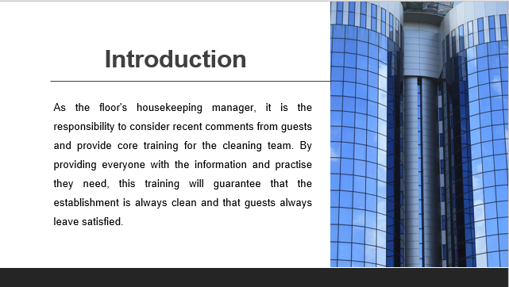
Training Notes:
Noise
Hotel rooms may be noisy for a number of reasons, including neighbouring construction, noisy HVAC systems, weak walls, and boisterous guests (Mohajerani and Miremadi, 2013).
- Provide the guest’s earplugs or noise-cancelling headphones to help them get a good night's rest and avoid being disturbed by outside noise.
- Place guests in rooms that are distant from busy streets or ongoing construction. Guests will have a more restful stay if they are assigned to rooms with less background noise.
- Soundproofing the walls, floors, and ceilings is something to think about. A room's ability to filter out noise from other rooms or from outside the building may be improved by using these materials.
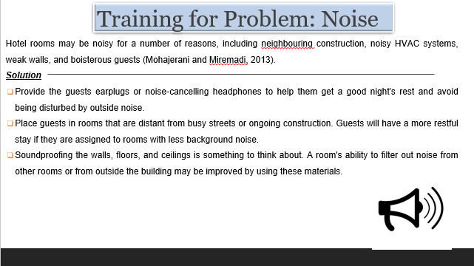
Training Notes:
Poor cleanliness
Dirty linens, soiled carpets, filthy restrooms, and dusty surfaces are all potential problems that hotel guests may encounter throughout their stays.
- All surfaces and furnishings in the room should be cleaned and disinfected to create a healthy and clean environment for the guests (Prayag and Hosany, 2015).
- Maintaining a clean and presentable room includes routinely inspecting the linens and towels and replacing them if they are stained.
- Carpets and upholstered items benefit from regular steam cleaning to get rid of smells, filth, and stains.
- Mould and mildew development should be looked for and treated immediately since they might lead to health issues for visitors and musty scents.
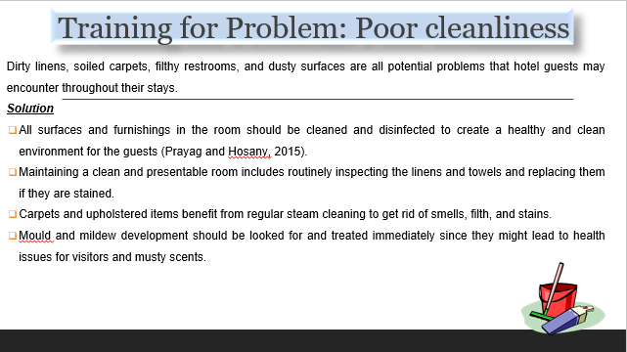
Training Notes:
Uncomfortable beds
Some hotel guests may feel the bed to be overly hard, while others may find it to be too soft, both of which might disrupt their sleep.
- Provide a selection of pillows so that visitors may choose one that suits their needs. Having a range of cushion firmness is helpful since different visitors have different preferences.
- Think of offering foam cushioning or mattress toppers so that the level of hardness may be adjusted. Guests who find the bed to be overly hard or soft might benefit from this.
- Bedding and mattresses should be replaced regularly as they get worn or outdated (Tra, 2020). Bedding and mattresses lose their original softness and support with time, which may make visitors uncomfortable and disrupt their sleep.
Training Notes:
Malfunctioning amenities
Problems with in-room conveniences like the air conditioner, television, and Wi-Fi connection are unfortunately not unheard of.
- Check the condition of the room's furnishings on a regular basis and fix or replace anything that needs it so that visitors may relax and enjoy their stay (Prayag and Hosany, 2015).
- Give the guests easy-to-understand guidance on using the facilities and fixing common problems: For that reason, visitors will be able to make better use of the facilities.
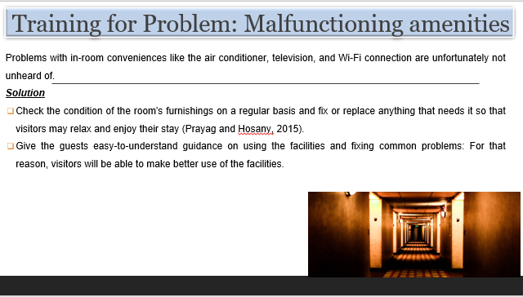
Training Notes:

Inadequate lighting
It might be frustrating for visitors if they have trouble seeing reading, working, or moving about a space due to inadequate illumination (Tarí et al., 2014).
- Brighter bulbs or more lighting fixtures may assist visitors to see better, making it easier for them to read, work, and move about the space.
- Guest rooms should have task illumination, such as reading lights. In this way, visitors may focus the illumination precisely where it's needed.
- Provide blackout curtains so visitors may regulate the amount of light coming into the room; this is especially helpful if the room is in a very loud or bright region (Hamid et al., 2020).
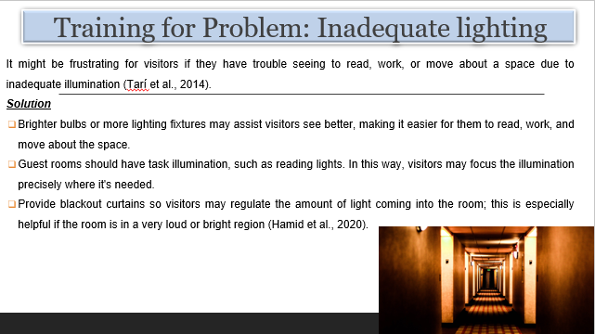
Training Notes:
Lack of privacy
Some hotel rooms may not provide enough privacy because of their proximity to busy streets or because their drapes are too flimsy to prevent others from peering in.
- For the comfort and privacy of your visitors, use thicker drapes or blinds to block out light and outside noise (Benavides-Velasco et al., 2014).
- Provide accommodations that are far from busy thoroughfares and public places to lessen the impact of outside noise and foot traffic.

Training Notes:
Limited storage space
Visitors may find it difficult to stow their bags and other belongings in the little space available in their hotel room.
- Give the guests the choice of using the space beneath their beds or some extra shelf units. Guests will appreciate being able to better store their stuff and have additional floor space as a result (Arachchi and Dahanayake, 2020).
- Please remind the guests to utilise the baggage racks provided to keep their bags off the floor. The space will be easy to clean and less likely to accumulate clutter if people do this.
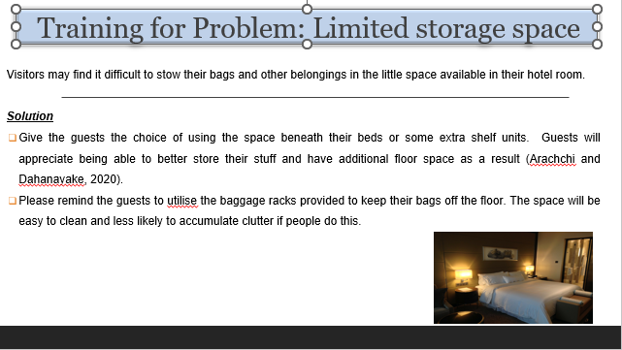
Training Notes:
Unpleasant odours
Guests may have a less-than-desirable stay if their hotel room has an unpleasant stench (Olimovich et al., 2020). They may be caused by things like tobacco smoke, excess moisture, or mould growth.
- Clean and disinfect all surfaces and objects in the room to remove potential odour sources.
- Installing air purifiers or dehumidifiers may help manage humidity, which in turn can help prevent the formation of mould and mildew, both of which can contribute to unpleasant musty scents.
- Instate a zero-tolerance policy for smoking.
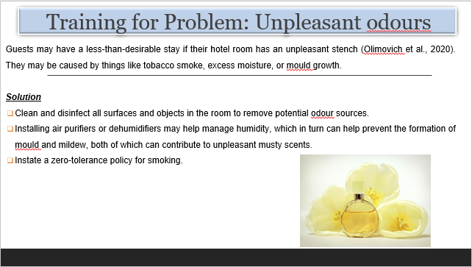

Training Notes:
Brand Standards and Health and Safety procedures
By addressing frequent guest complaints about issues such as noise, poor cleanliness, uncomfortable beds, broken amenities, inadequate lighting, lack of privacy, lack of storage space, and unpleasant odours, housekeeping staff can ensure that brand standards are met and that Health and Safety protocols are followed (Chalupa et al., 2021). There are a lot of different things that hotels can do to make their guests more comfortable, such as providing earplugs or headphones with noise cancellation, providing thorough cleaning and disinfection procedures, providing mattress toppers or foam padding to adjust the firmness of the bed, providing blackout curtains to control the amount of light that enters the room, providing thicker curtains or blinds to ensure that guests' privacy is maintained, providing additional storage options, installing air purifiers, and so on (Ambardar and Raheja, 2017). By prioritising the comfort, satisfaction, and well-being of the guests, the housekeeping staff may ensure that the hotel is in compliance with all of the established brand standards and health and safety regulations.

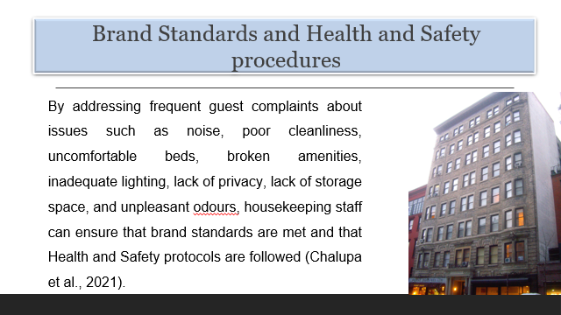
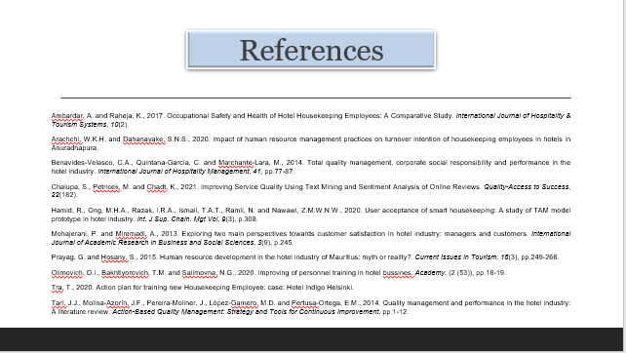

References
Al-Msallam, S., (2015). Customer satisfaction and brand loyalty in the hotel industry. International Journal of Management Sciences and Business Research, 4.
Ambardar, A. and Raheja, K., (2017). Occupational Safety and Health of Hotel Housekeeping Employees: A Comparative Study. International Journal of Hospitality & Tourism Systems, 10(2).
Andrade, M.S., Miller, D. and Westover, J.H., (2021). Job satisfaction factors for housekeepers in the hotel industry: a global comparative analysis. International Hospitality Review, 35(1), pp.90-108.
Arachchi, W.K.H. and Dahanayake, S.N.S., (2020). Impact of human resource management practices on turnover intention of housekeeping employees in hotels in Anuradhapura.
Bardi, J.A., 2021. Hotel-Front-Office-Management.
Benavides-Velasco, C.A., Quintana-García, C. and Marchante-Lara, M., (2014). Total quality management, corporate social responsibility and performance in the hotel industry. International Journal of Hospitality Management, 41, pp.77-87.
Chalupa, S., Petricek, M. and Chadt, K., (2021). Improving Service Quality Using Text Mining and Sentiment Analysis of Online Reviews. Quality-Access to Success, 22(182).
Chan, E.S. and Lam, D., (2013). Hotel safety and security systems: Bridging the gap between managers and guests. International Journal of Hospitality Management, 32, pp.202-216.
Hamid, R., Ong, M.H.A., Razak, I.R.A., Ismail, T.A.T., Ramli, N. and Nawawi, Z.M.W.N.W., (2020). User acceptance of smart housekeeping: A study of TAM model prototype in the hotel industry. Int. J Sup. Chain. Mgt Vol, 9(3), p.308.
Kim, C. and Chung, K., (2022). Measuring customer satisfaction and hotel efficiency analysis: An approach based on data envelopment analysis. Cornell Hospitality Quarterly, 63(2), pp.257-266.
Li, H., Ye, Q. and Law, R., (2013). Determinants of customer satisfaction in the hotel industry: An application of online review analysis. Asia Pacific Journal of Tourism Research, 18(7), pp.784-802.
Marković, S. and Raspor Janković, S., (2013). Exploring the relationship between service quality and customer satisfaction in the Croatian hotel industry. Tourism and Hospitality Management, 19(2), pp.149-164. Marković, S. and Raspor
Mohajerani, P. and Miremadi, A., (2013). Exploring two main perspectives towards customer satisfaction in the hotel industry: managers and customers. International Journal of Academic Research in Business and Social Sciences, 3(9), p.245.
Olimovich, D.I., Bakhtiyorovich, T.M. and Salimovna, N.G., (2020). Improving personnel training in the hotel business. Academy, (2 (53)), pp.18-19.
Prayag, G. and Hosany, S., (2015). Human resource development in the hotel industry of Mauritius: myth or reality? Current Issues in Tourism, 18(3), pp.249-266.
Rao, P.S. and Sahu, P.C., (2013). Impact of service quality on customer satisfaction in the hotel industry. IOSR Journal of Humanities and Social Science, 18(5), pp.39-44.
Rosemberg, M.A.S. and Li, Y., (2018). Effort-reward imbalance and work productivity among hotel housekeeping employees: a pilot study. Workplace Health & Safety, 66(11), pp.516-521.
Rutherford, D.G., (2021). Hotel management and operations.
Singh, A., (2015). Hotels Housekeeping Innovative Trends and Modern Practices-An overview. Journal for Studies in Management and Planning, 1(3), pp.540-548.
Tarí, J.J., Molina-Azorín, J.F., Pereira-Moliner, J., López-Gamero, M.D. and Pertusa-Ortega, E.M., (2014). Quality management and performance in the hotel industry: A literature review. Action-Based Quality Management: Strategy and Tools for Continuous Improvement, pp.1-12.
Tra, T., (2020). Action plan for training new Housekeeping Employee: case: Hotel Indigo Helsinki.

