
assignment 1 – Security analysis, Techniques and procedures (acca7030)
The University of Wales Trinity Saint David

October 14, 2022
Dawid trochim
1900457

Table of Contents
Contingency policy 1
1. Introduction 1
2. HPC’s critical server infrastructure. 1
2.1 Potential threats and vectors 2
2.2 The most critical vulnerabilities and the way of exploitation 3
2.3 MITRE ATT&CK and OWASP Top 10 Framework 4
2.4 Penetration testing tools 4
2.5 Types of attacks 4
2.6 Vulnerabilities targeted 6
2.7 Tools used 6
2.8 Protocols involved in the attack 7
2.9 Process of launching the attacks 7
2.9.1 Success / failure 8
3. Recommendations / Solution 8
3.1 Possible configuration changes that can be made to the system 9
3.2 Defence strategy to prevent the attacks 10
4. Cost of implementing the solution / recommendations 10
5. Timescale of what has been done 10
6. Forenics report based on Nera Star HPC case: 11

List of acronyms

HPC – Healios Pharmaceutical Company

DDoS – Distributed Denial of Service

OT - Operational Technology

PLC - Programmable Logic Controller

HMI - Human-Machine Interface

WAF - Web Application Firewall

CDN - Content Delivery Network

OWASP ZAP - Open Web Application Security Project Zed Attack Proxy

DVWA - Damn Vulnerable Web Application

SQL – Structured Query Language

2FA – Two-Factor Authentication

OS – Operating System

HTTP - Hypertext Transfer Protocol

SMTP - Simple Mail Transfer Protocol

POP - Post Office Protocol

IMAP - Internet Message Access Protocol

ORM - Object-Relational Mapping

Contingency policy

Purpose:
This policy identifies the actions that will be executed in the event that a security vulnerability is identified during a penetration test.
Scope:
This policy applies to all systems and applications that are affected by penetration testing.
Policy:
- After completion of a penetration test, the security team will go through the results.
- Vulnerabilities will be prioritised based on their potential impact and likelihood of exploitation.
- A plan will be created to address each vulnerability, including measures to stop the impact, fix the vulnerability, and prevent future occurrences.
- The plan will be presented with relevant parties, including the security team, IT department, and any affected business units.
- Progress on fixing vulnerabilities will be located and reported until resolution.
- If a high-risk vulnerability is located, additional protective measures may be applied, such as temporary controls or initiating a security incident response.

Introduction

This assignment will focus on providing a systematic understanding of a wide range of current research and technological advances in a cyber security incidents and defensive techniques. Aspects like information security assessments, analysing, security tools, methodologies, cyber security activities within the organisation will be discussed in depth.

HPC’s critical server infrastructure.

Protecting essential server infrastructure is vital for a number of reasons. To protect the privacy of sensitive data kept on the server is one reason. Protecting the server infrastructure helps avoid the possibility of unauthorised individuals having access to this information. Maintaining the accuracy of the data kept on the server is another justification. Data corruption or manipulation caused by attacks on vital server infrastructure may have detrimental effects on the enterprise. This can be avoided by protecting the server infrastructure. Preventing service interruptions and downtime is a third justification. Critical server infrastructure may be open to cyberattacks that cause these issues if it is not secured.
The organisation may be dependent on the availability of the server infrastructure for its operations, which could have major ramifications.
Here is how the HPC has their critical server infrastructure designed:
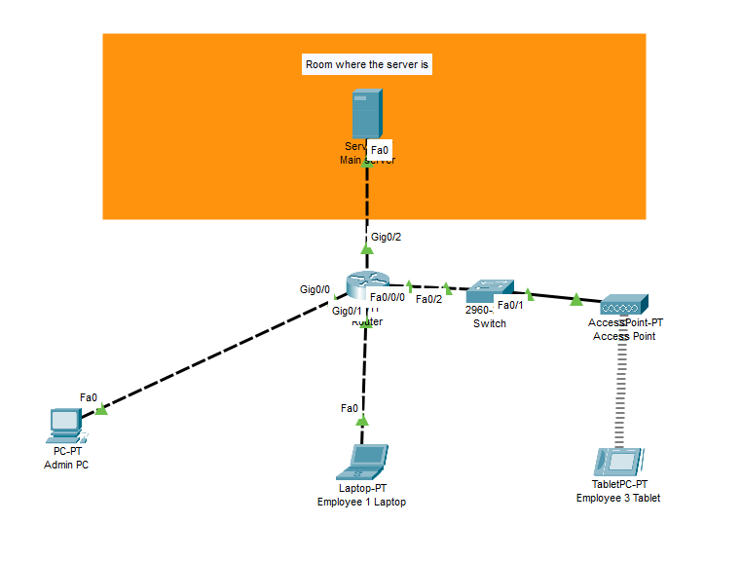
Figure 1 – Simulated network topology

It has the server in a secure room connected to the router where switch and access point are a foundation to establishing connection by the admin and the rest of employees.

Potential threats and vectors

Phishing - According to Li et al. [1] Phishing is a form of online scam when an attacker pretends to be a reliable entity or person in an electronic contact, usually through email or instant messaging. In order to obtain sensitive information, such as login passwords, financial account numbers, or other personal information, a phisher must deceive the recipient into thinking that the message is authentic..
Phishers generally utilize social engineering strategies to try to persuade their targets to respond quickly and without thinking, such as feigning urgency or using persuasive language. To try and obtain this information, they might use create fraudulent websites or other techniques. When receiving unexpected or suspicious contact, it's crucial to exercise caution and to confirm the sender's identity before responding or divulging any personal information. In order to trick the victim, a false and crucial email has been prepared that makes it appear as though someone has signed into the victim's Google account from another site where the files are stored (Google Drive). This email appears to be urgent and needs to be read right away.
DDoS attacks [2] – This kind of attack has tremendous power, such as the ability to destroy the targeted company's public cloud infrastructure, which also results in financial and reputational losses because of the limited availability and effects on the procedures used to maintain the critical infrastructure in the cloud. This attack can be carried out in a variety of ways, and there are only a few effective and ideal defences. Once the attempt is successful, a domino effect of harm begins; the system will become slow or unavailable, requests will time out, and there will be financial loss. Because attackers have created numerous variations of this assault, it is challenging for IT (Information Technology) specialists to determine which traffic originates from a hostile source and which traffic is legitimate and healthy.
Malware attacks [3] – The loss can be avoided by paying a big sum of money, typically using cryptocurrencies like Bitcoin because it is impossible to trace it back, and the loss is capable of causing financial loss, data loss, unrecoverable equipment, and even the removal of the admins from the network. Stuxnet, Shamoon, and Dark Seoul are three examples of malware that has caused significant harm in the past. As a result, this is a potential danger and the most exposed point in the critical server infrastructure. There are many ways to protect the system from that; updating the operating system, implementing anti-malware, purchasing reliable firewalls, and appropriately configuring them can all have a significant impact on the security as a whole. Access controls, proper employee training and patch-management policies can decrease the chance of any malware attack from happening.
Web Application attacks [4] - Due to their availability via remote access and growing network connectivity, traditional OT systems, including as programmable logic computers (PLC) and human-management interfaces, are particularly vulnerable (HMI). Systems that are exposed and are not protected may be subject to SQL injection and cross-site scripting attacks. Businesses need to use Web application firewalls (WAF) and content delivery networks (CDN), share crucial assets with managers, and perform regular security audits to identify vulnerabilities. As a result, this can be recognised to be one of the numerous threats. This free online SQL injection checker has been adopted because it makes use of OWASP ZAP to determine whether the DVWA is susceptible to an attack employing SQL Injection.

The most critical vulnerabilities and the way of exploitation

As was previously indicated, there are several vulnerabilities. Some of these vulnerabilities are more hazardous than others, and as a result, they are divided into non-priority and high priority categories. Gaining from weaknesses is mostly done for financial and geopolitical reasons. The underlying causes of the vulnerabilities' continued exploitation include a flawed system design, user mistake, and configuration issues. Each vulnerability is connected to the others, such as Attackers can enter if the security system is down, and once inside, they can lose data that can result in financial gain, among other things. As a result, the company must have an experienced security team that can come up with a cross-domain solution to the security problems.
Why is human mistake considered to be one of the most serious vulnerabilities? It's because [5] hardware and physical security are handled by humans, and if a mistake is made from the start, an attacker might consider that as a chance to enter, for example. The barriers separating the business from the outside world may be weak, easy to breach, the biometric system may not be properly configured, the devices may not be correctly set up, the security system may not be activated, and there are countless other possibilities that make human error the most dangerous factor. The devices and configurations can also have an error even if configured properly but the chances of that are smaller than human error.

MITRE ATT&CK and OWASP Top 10 Framework

A database called MITRE ATT&CK [6] provides data on the strategies and tactics employed by cyber adversaries. It is used to help businesses defend themselves against these strategies and obtain a better understanding of how adversaries operate. The ATT&CK framework classifies techniques as the particular ways in which certain tactics are carried out while classifying tactics as high-level acts conducted by adversaries.
OWASP [7] Using a methodology called Top 10, online application security vulnerabilities are ranked from most prevalent to most serious. It is made to help enterprises prioritise their work to increase web application security. To represent the most recent online application security vulnerabilities, this same OWASP Top 10 architecture is routinely updated.
Phishing and SQL injection appear to be the best fits for the objectives of this report because launching a Phishing attack against a company employee could result in the interception of crucial information stored in the cloud and the password used for the cloud could potentially be used for other purposes. The server's web application is compromised by SQL injection.
SQL injection is a strategy that is classified as a "Exploitation Technique" in the MITRE ATT&CK architecture. The "Initial Access" method includes the technique of phishing. SQL injection is one of the top 10 online application security concerns in the OWASP Top 10 architecture, while phishing is not officially mentioned as a problem but can be leveraged to deliver other sorts of attacks.

2.4 Penetration testing tools

There are numerous penetration testing tools available that can be applied to execute the attack to affect the crucial server infrastructure, but the tool "Z-phisher" appears to be a great option as this is capable of doing what is required in a very effective way, which is intercepting the information stored on the server. The SQL injection commands are responsible for obtaining crucial data from the web application used by the company.

2.5 Types of attacks

A phishing attack [8] is a type of cybercrime that occurs when a perpetrator tries to deceive a victim into disclosing sensitive information, such as passwords, credit card numbers, or account login information, by posing as a reliable party in an electronic communication, like an email or text message. Email, social networking, and instant messaging are just a few of the platforms where phishing attempts can be launched.
The following best practises should be known in order to prevent phishing assaults [9]
1. Be careful when opening unsolicited emails and communications, especially if they ask for sensitive or private information or include links or attachments.
2. Prior to replying to a mail or by clicking on a link, make sure the sender is who they say they are.
3. Refrain from opening attachments or clicking on links coming from unidentified sources.
4. Make sure your web browser is secure and up to date.
5. Whenever practical, enable two-factor authentication (2FA) on your accounts.
6. For all of your accounts, use solid, one-of-a-kind passwords, and think about utilising a password manager to help you keep track of them.
7. Always update your operating system and antivirus software.

By following these best practices, you can help protect yourself from phishing attacks and other types of cyber threats.
A phishing assault [10] may be harmful to a server since it may jeopardise both the server's security and the data it holds. An attacker may be able to access the server without authorization and potentially steal or change sensitive data if a phishing victim unintentionally gives their user credentials to the attacker. Additionally, the attacker might be able to utilise the hacked server as a launchpad for additional attacks on other networks or systems, ultimately resulting in extensive harm.

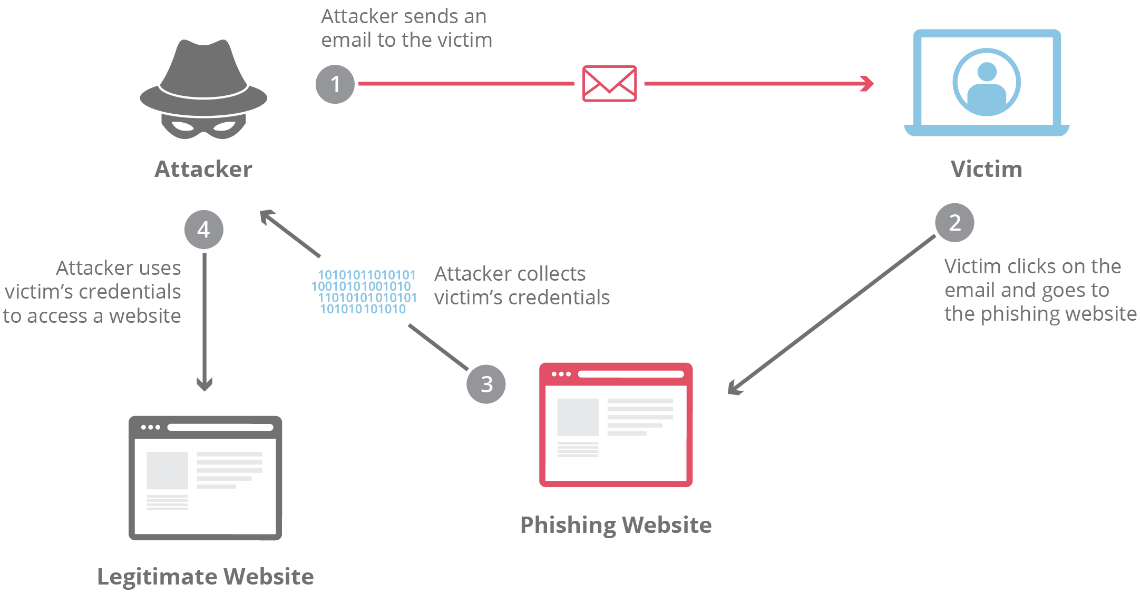
Figure 2 - Representing how the phishing attack carried out in this report was executed

An attacker can insert malicious script into a web application's database using an input field in a cyberattack known as SQL injection [11]. With the help of this method, an attacker can access confidential information without authorization, such as login passwords and financial data, as well as edit or delete database data.
Because they can provide an attacker access to sensitive data kept on the server and give them the ability to change or delete it, SQL injection attacks [12] are frequently used to breach systems. Additionally, an attacker can access other components of a server's architecture, such the os version or network resources, by using SQL injection. By doing this, the attacker may be able to further undermine the server's security and maybe obtain access to other networks or systems.
An instance of a SQL injection attack that uses error messages generated by the database server to retrieve data from the database is known as an error-based SQL injection attack [13]. When an attacker submits a malicious SQL query to a server, the server will respond with an error message if the query is invalid. The attacker can then extradite sensitive data by deducing the database's structure from the information provided in the error message. The company's online application has been hacked by this kind of SQL injection attack.
An SQL injection attack known as a union-based SQL injection involves inserting a malicious SQL query that combines the output of several SELECT statements using the UNION operator. By combining a SELECT statement that collects the necessary data with a SELECT statement that obtains unimportant data from another table, the attacker can use this approach to harvest confidential data from the database. The company's online application has been hacked by this kind of SQL injection attack.

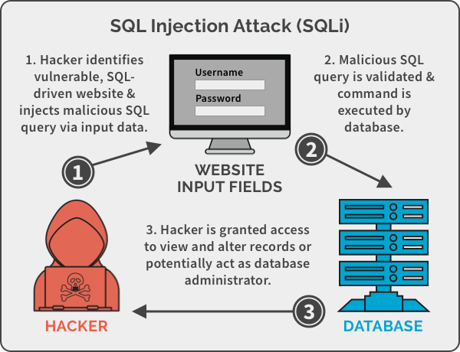
Figure 3 - Diagram representing the process for launching the SQL injection attack in this document

2.6 Vulnerabilities targeted

A phishing attack typically aims to attack vulnerabilities in an individual's or organization's security practices, rather than technical vulnerabilities in software or hardware. For example, an attacker may deliver a malicious email that may appear to be from an approved source, such as a bank or online retailer, in an attempt to trick the recipient into disclosing sensitive information, such as login credentials or financial information. In this case, cloud credentials have been targeted.
Other common techniques used in phishing attacks include creating fake websites that pretends to be the legitimate one, and using social engineering methods to manipulate or trick victims into revealing sensitive information.
SQL injection attacks typically target vulnerabilities in web applications that allow an attacker to inject malicious code into a database through an input field. These vulnerabilities typically are created when web applications do not properly filter user input or do not use prepared statements and parameterized queries to stop unauthorized SQL queries from being deployed. In this case, extracting passwords and usernames was carried out successfully.

2.7 Tools used

SQL Injection commands – SQL Injection is a type of attack that exploits the lack of input validation in the SQL query. This vulnerability can be exploited by hackers to steal data from the database. It is done by sending a SQL command to the database and seeing if it gets back with any error messages. The commands that were executed are visible in the appendix.

Z-phisher - The tool Z-Phisher is utilised in phishing attacks. Phishing attacks are a type of social engineering attack in which the criminal tricks people into disclosing confidential data through email or a fake website. With the use of the Z-Phisher features, phishing assaults can be automated, making it even easier and quicker for attackers to gather information from potential victims.

There are two ways to use the Z-Phisher tool:
1) To produce email templates and other files necessary for carrying out the attack
2) To regularly send emails and go to fake websites in order to collect data from possible victims

2.8 Protocols involved in the attack

SQL Injection protocols – In most SQL injection attacks, malicious code is injected into a database via an input field in a web application using the Structured Query Language (SQL). For maintaining and modifying data in relational databases, SQL is a common computer language.
A SQL injection attack's precise protocols will vary depending on the environment it is being done in. For instance, a web application that interacts with a database via a network using the Structured Query Language (SQL) and the Hypertext Transfer Protocol (HTTP) may be the target of a SQL injection attack. The HTTP protocol was utilised to initiate this attack.
Z-phisher protocols - Attacks including phishing can be carried out using a variety of platforms, including email, social media, and instant messaging. Depending on the channel being used, several phishing protocols could be used.
For instance, the Simple Mail Transfer Protocol (SMTP) may be used in an email phishing attack to send the fake email to the victim's email address. The victim can then interact with the message by obtaining it from their email server using the Post Office Protocol (POP) or the Internet Message Access Protocol (IMAP). The SMTP was the target of this attack.

2.9 Process of launching the attacks

By inserting malicious script into an input field in a web application, SQL injection attacks can be used to compromise the security of a database and the information it stores. The targeted database and the attacker's objectives determine the specific steps in starting a SQL injection attack. The steps to execute the attack of SQL injection are as following:
1. Locating a web application that is weak and uses user input fields to interface with a database
2. Constructing a malicious SQL injection payload and inserting it into a web application's input field.
3. Using the web application to send the payload and running the malicious script in the database.
4. Modifying or removing confidential data from a database
The particular steps involved in conducting a phishing attack vary on the channel being utilised and the attacker's objectives. But the following could be typical steps in the procedure:
1. Choosing a potential victim and learning as much as you can about them to enhance the attack's authenticity.
2. Creating a fake message that comes from what looks to be a reliable source, such a bank or online retailer, and providing a link or attachment to lure the victim into revealing personal information or doing another action that would benefit the attacker.
3. Utilizing the selected channel to deliver the fake message to the victim.
4. Monitoring the victim's behaviour and making an effort to learn more or take more action in response to it.
The steps above have been followed in order to launch the attack in this report.

2.9.1 Success / failure

Both attacks have been carried out successfully, please refer to the appendix to see the outcome of both attacks.

3. Recommendations / Solution

The company should take into account various recommendations in order to stop new attacks like the ones described in this document. The following recommendations must be put into practise immediately, as there are thousands of cyberattacks every day. The following suggestions are in relation to phishing attacks:
- Use parameterized queries [14]: These are queries where the parameters are predefined and separated from the SQL statement itself. By doing this, attackers may be prevented from including dangerous code in the query.
- Use stored procedures [15]: Pre-compiled SQL statements are saved in the database as stored procedures. By isolating the SQL code out from input data, they can assist in the detection of SQL injection attacks.
- Validate user input [16]: Verify that all user input is genuine to make sure it is in the right format and free of dangerous code.
- Use web application firewalls [17]: By examining incoming traffic and preventing malicious requests, web application firewalls (WAFs) can assist in defending against SQL injection attacks.
The likelihood of being targeted by SQL Injection attacks conducted out in this text report will be significantly decreased by putting the security precautions indicated above into reality.
However, phishing attacks are among the most widely used attacks because they are simple to carry out and have a high percentage of success and effectiveness. The following suggestions can be used to protect the firm against phishing attacks in general and from the ones described in this document:
- Educate employees [18]: Make sure to train your employees about the signs that indicate the phishing attacks and how to identify and report them.
- Use anti-phishing software [19]: Anti-phishing software can help prevent phishing attacks by detecting and blocking phishing emails.
- Use multifactor authentication [20]: Multifactor authentication (MFA) enables users to complete multiple forms of authentication, such as a password and a code delivered to their phone, in order to access their accounts. In the case of a successful phishing attempt, this can assist in preventing unauthorised access.
- Use a secure web browser [21]: Secure web browsers can help prevent phishing attacks by giving users a warning when they are about to / entered a phishing website.

3.1 Possible configuration changes that can be made to the system

All of the above-mentioned changes for preventing SQL injection attacks can be applied to the system, but there are several other adjustments that can be made as well to further safeguard it and make it more challenging for hackers to gain access. Here is a list of further system modifications that can be made in response to SQL injection attacks.

- Use prepared statements [22]: Prepared statements are SQL statements that have already been pre-compiled and are ready to use. By isolating the SQL code from the input data, this can help stop SQL injection attacks.
- Use object-relational mapping (ORM) tools [23]: By automatically producing secure SQL code based on the user's input, ORM technologies can assist in the prevention of SQL injection attacks.
- Use input sanitization [24]: User input is cleaned during input sanitization to just get rid of any potentially harmful characters or code. By verifying that user input is secure for use in SQL queries, this can assist in the prevention of SQL injection attacks.
- Use least privilege [25]: By restricting the varieties of queries that users can run, granting them only the privileges necessary to carry out their duties, administrators could help to prevent SQL injection attacks.
As hackers discover new techniques to carry out phishing attacks every day, there are numerous strategies to further prevent phishing. The following are additional system modifications that can be made in response to phishing assaults:
- Use spam filters [26]: Spam filters can assist in preventing the delivery of phishing emails to employees by filtering emails which are considered to be spam or that satisfy specific requirements (e.g. containing certain keywords).
- Use email encryption [27]: Email encryption makes it more challenging for hackers to collect and read email messages, which can assist prevent phishing attacks.
- Use domain name system (DNS) filtering [28]: By restricting access to domains that are known to be dangerous, DNS filtering can assist stop phishing attacks.
- Use anti-malware software [29]: By identifying and preventing dangerous software that might be used in phishing attempts, anti-malware software can aid in the prevention of phishing attacks.

3.2 Defence strategy to prevent the attacks

Strong security measures, such firewalls, antivirus programs, and systems for intrusion detection and prevention must be put in place to safeguard servers against phishing attacks and other online dangers. Additionally, it's critical to implement procedures for identifying and responding to possible attacks, as well as to inform users on how to recognise and avoid phishing attacks. Organizations can help safeguard their servers and the important information they contain by taking these safeguards.
In web applications, it's crucial to employ prepared statements and parameterized queries, as well as input validation and sanitization to make sure that user input is appropriately filtered, to guard against SQL injection attacks. Additionally, it's critical to deploy strong security measures like firewalls and systems for intrusion detection and prevention as well as to maintain databases and web application frameworks current with the most recent security patches. Organizations can help safeguard their servers and the important information they contain by taking these safeguards.

4. Cost of implementing the solution / recommendations

The first recommendation which is providing all the employees with a good and essential phishing training depends on how many employees are there in the company, going with 51-100 employees – it would cost £18.00 for 100 licenses according to itgovernace which is a good and verified source of providing training and cyber security solutions and this is the cost for the most basic E-learning awareness training. However, this is not enough and launching a simulated phishing attack against the company and provide additional training may cost between £1000-1900 depending on what type of service the company would like to go for (Standard, Professional and Enterprise.) and this can be provided by PhishingBox.
In relation to recommendations for SQL injections attack, the company could implement the Barracuda Web Application Firewall 960 in order to protect the company by monitoring and controlling the incoming and outgoing database traffic, it is possible to configure it to block harmful websites and queries and filter it to only accept harmless requests. This is quite expensive as Barracuda Web Application Firewall 960 starts at $53.000.00 or $14.820.00 depending on the needs of the company. Implementing SQL Injection awareness programme might cost from $500 up to $5000 for in person training but this will depends on how long the session is, location and the amount of people taking the training.

5. Timescale of implementing the solution

In terms of implementing the solution for phishing, it will might take a little less time than SQL injection since there is a hardware installation involved:
  - E-learning basic awareness training: 1 week
  - Simulated phishing attack & training: 2 weeks
  - Installing secure browser & anti phishing software: 3 hours
In terms of implementing the solution for SQL injection, it will take a little less than Phishing:
  - Implementing the Web Application Firewall 960: 1 week
  - Configuring the Web application firewall to suit the company needs: 1 week
  - Educating the employees using the SQL Injection awareness training: 2 weeks
Total for Phishing: 3 weeks and 3 hours
Total for SQL injection: 4 weeks

6. Forensics report based on Nera Star HPC case:

A full FTK report is attached as an additional file
Through the course of the investigation, the following evidence was recorded:
- Interviews with relevant employees revealed that Nera had a recent altercation with management and was unhappy with being passed over for a promotion.
- Forensic analysis of Nera's computer showed that the research documents in question had been deleted within a short time frame before her departure from the company.
- Analysis of Nera's computer activity showed that she had accessed the research documents shortly before deleting them.
Based on this evidence, it is our conclusion that Nera Star is responsible for the sabotage and deletion of the research documents.
Forensics Methodology:
In order to attempt to recover the deleted documents, the following forensics methodology was used:
- A forensic image of Nera's computer was created and examined for deleted files.
- Deleted files were searched for using keywords related to the case.
- Any recovered files were analysed for their content and relevance to the research project.
Result of Forensics Analysis:
Through the use of forensic techniques, it was possible to successfully recover the deleted research documents. The recovered documents included 270 pages of sensitive formulae and mathematical codes, as well as any related data. All recovered documents have been verified as being complete and unaltered.

Recommendations:
- Nera Star should be terminated for her actions.
- Steps should be taken to secure all company systems and prevent future sabotage attempts. This may include additional security measures, employee training, and stricter policies and procedures.
- The company should consider implementing regular backups of all critical data to prevent data loss in the future.

Conclusion:
The investigation has determined that Nera Star was responsible for the sabotage and deletion of the research documents. Fortunately, the documents were recoverable. Appropriate disciplinary action has been recommended, and measures have been put in place to prevent future incidents of this nature.

Appendix

Phishing attack:
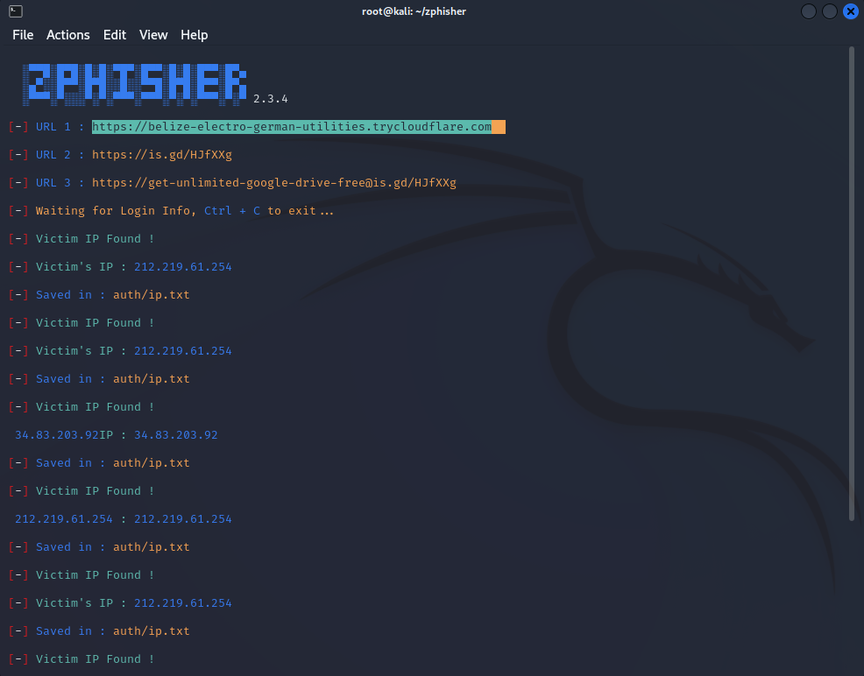
Figure 4 - Representation of generating a malicious link

This screenshot represents the tool “Z-Phisher” generating a phishing link that will be delivered to the victim.

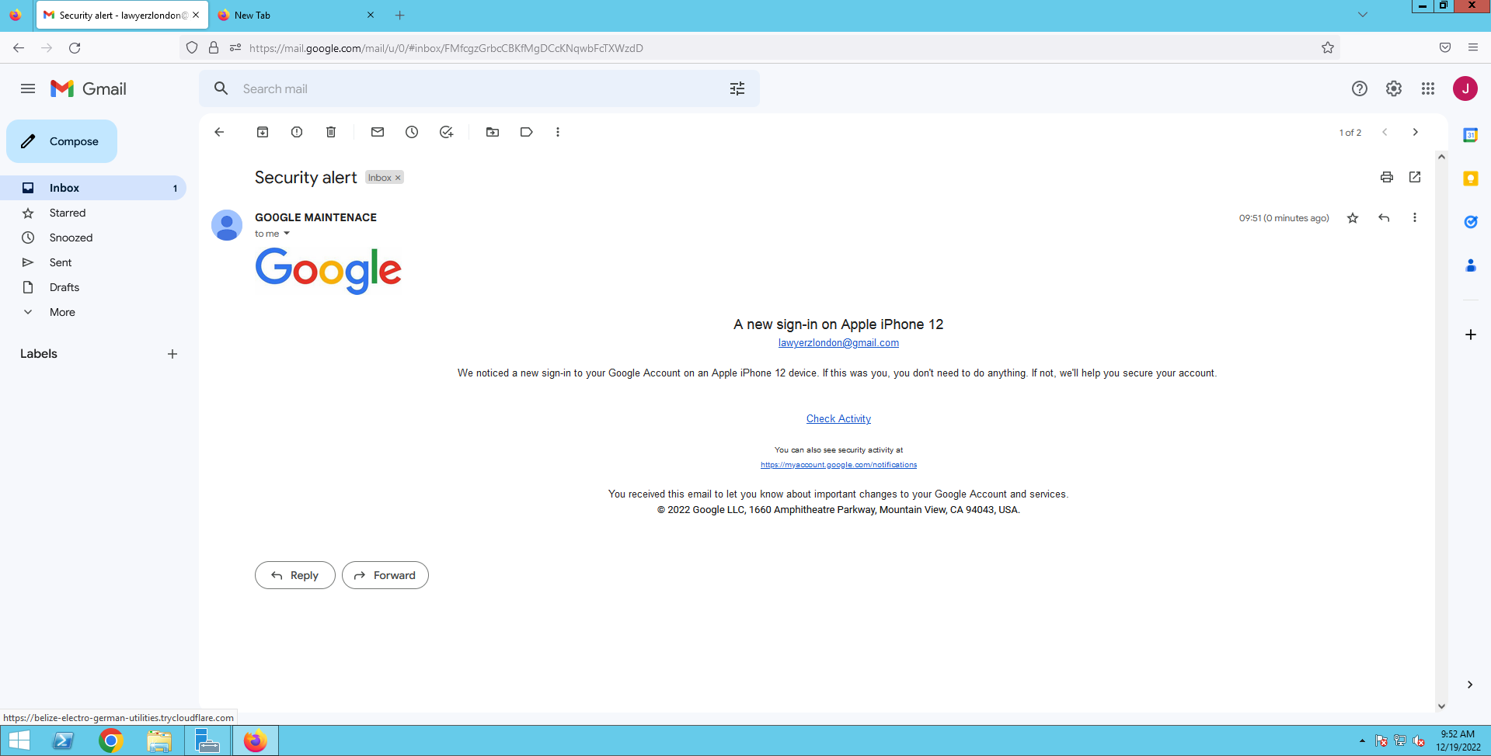
This is the fake email message received from fake Google account that I have created for the purposes of this. It is recreated almost identically except the logo is centred to the left. It is visible that after hovering over the “Check Activity” button, there is a link in the bottom left corner which will be visited if the users clicks on “Check Activity”.
Figure 5 - Representation of a fake email being delivered to the victim

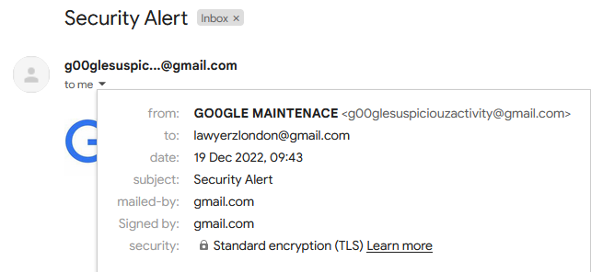
Here are some details of the message that was sent from the fake email to the victim.
Figure 6 - Representation of the email details from which the fake email has been sent
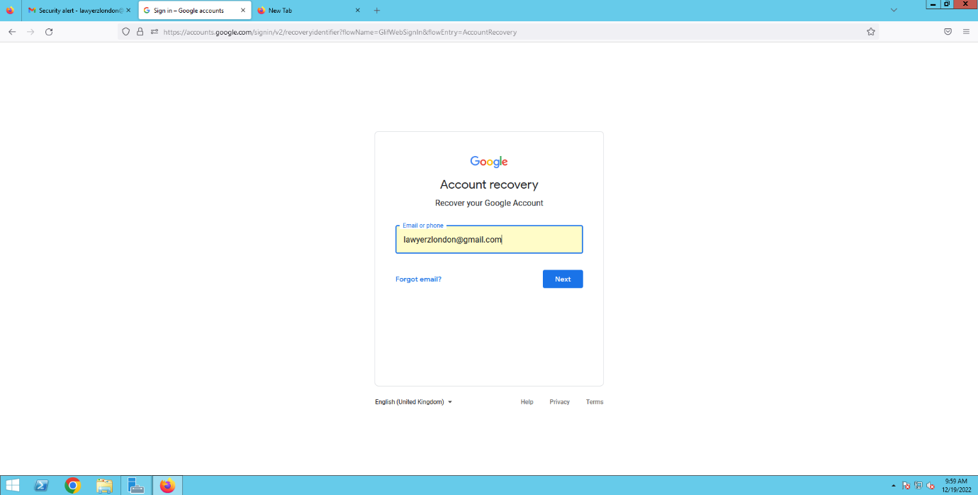
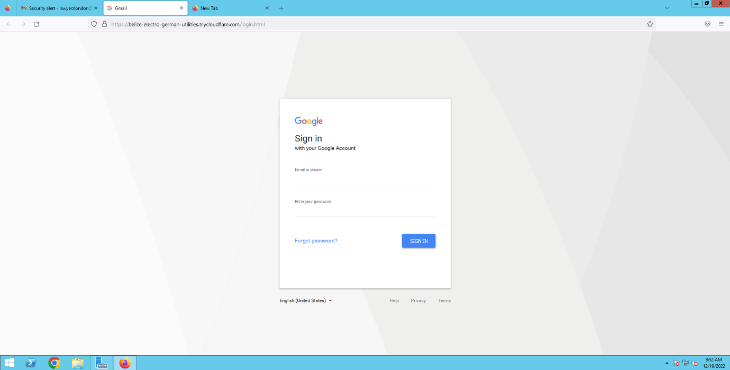
This screenshot represents a website which appears after clicking on “Check activity”, it is a Google sign-in page.
Figure 7 - Representation of a fake Google sign-in page after clicking "Check Activity"

This screenshot represents the page that appeared after the victim entered the details into a fake Google sign-in page.
Figure 8 - Representation of a page that appeared after the victim has submitted the details

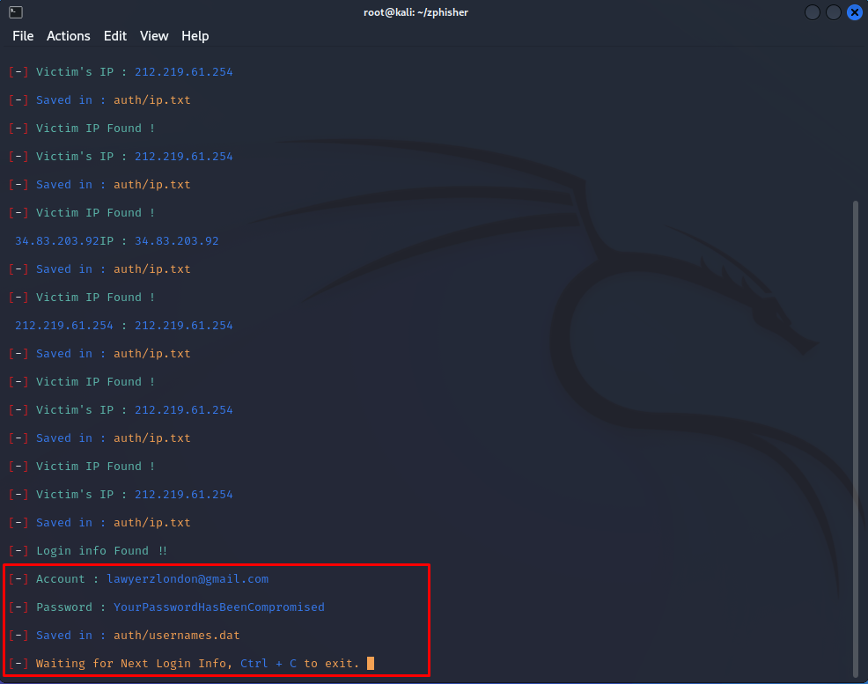
This screenshot represents the details that have been entered by the victims and are now in attacker’s hands.
Figure 9 - Representing the evidence of collecting the credentials
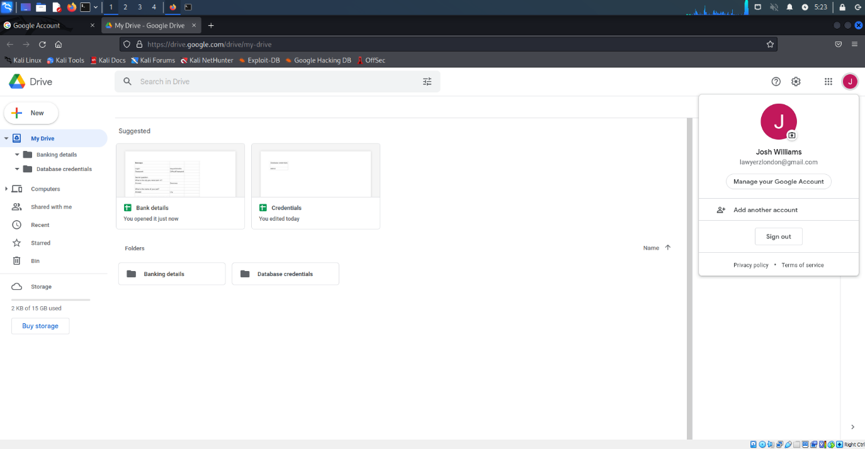
This screenshot represents the files that are stored on the server (Google drive), it has some sensitive data such as bank details and credentials.
Figure 10 - Representation of the files stored on the server (Google Drive)
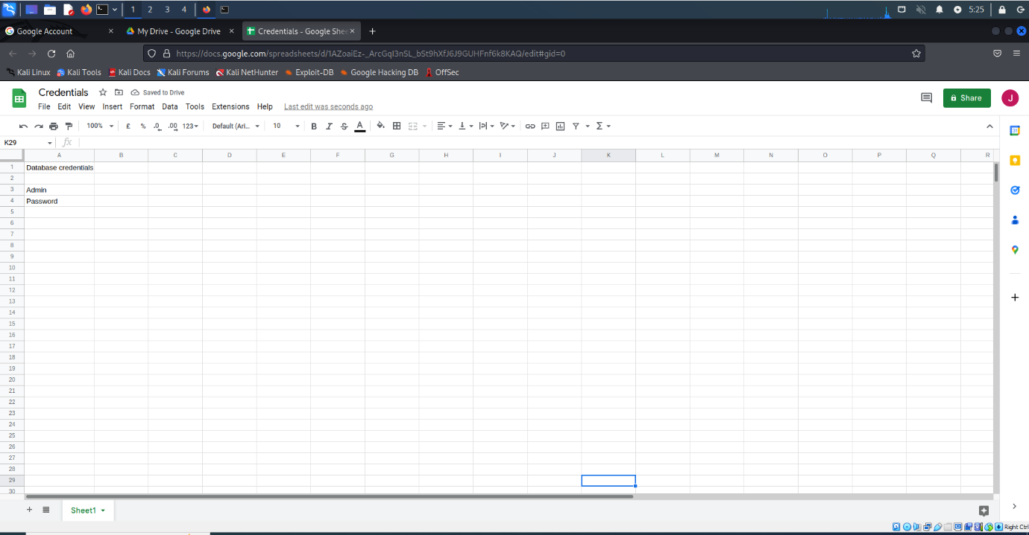
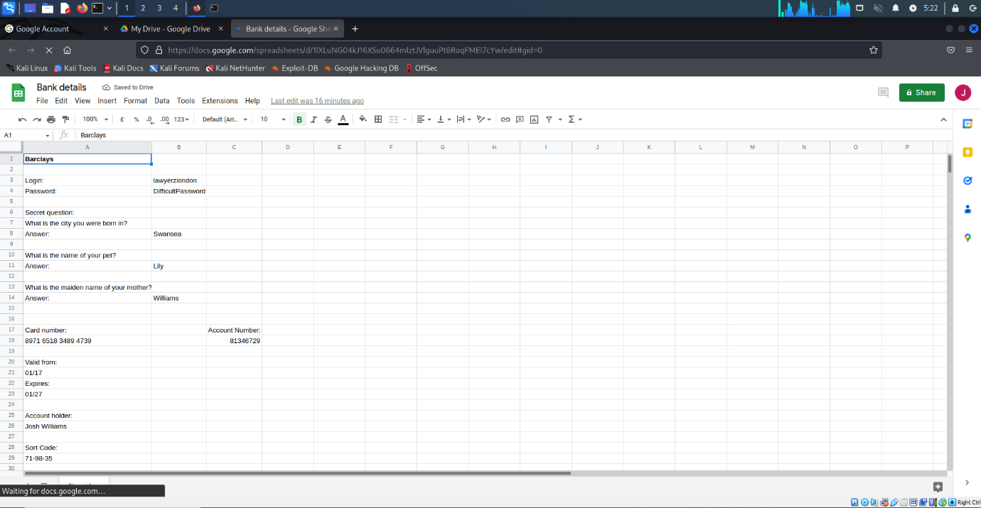
Here the attacker is accessing bank details file stored on the server with all the details such as login, password, memorable words, bank details.
Figure 11 - Representation of the details that are used for logging into web application
Figure 12 - Representation of accessing the bank details

This screenshot represents the details for the web application used by the company.

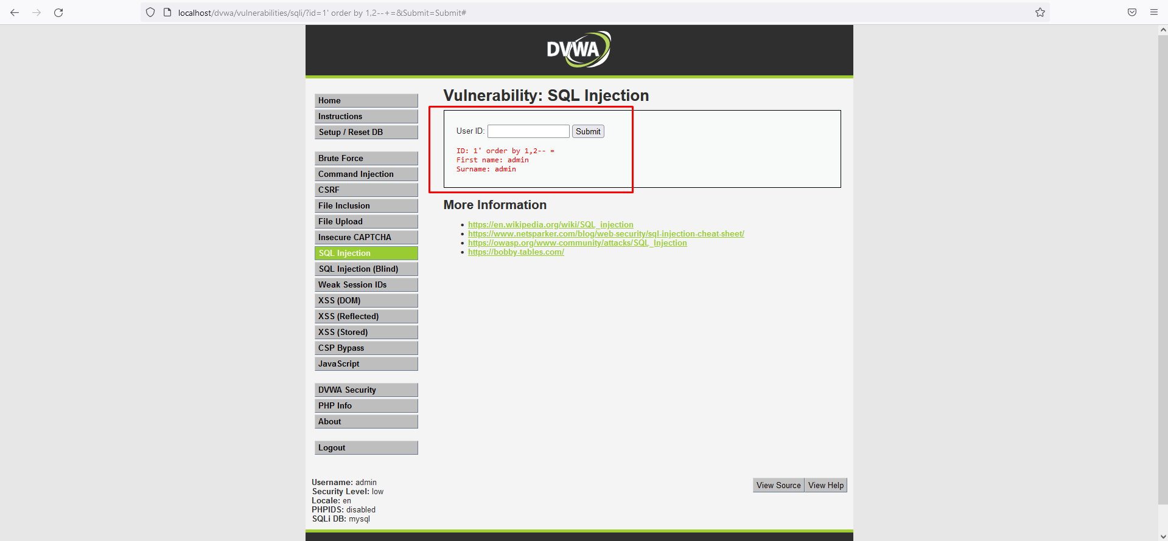
SQL Injection attack:
Figure 13 - This represents a command that'll modify the ORDER BY of a SELECT statement
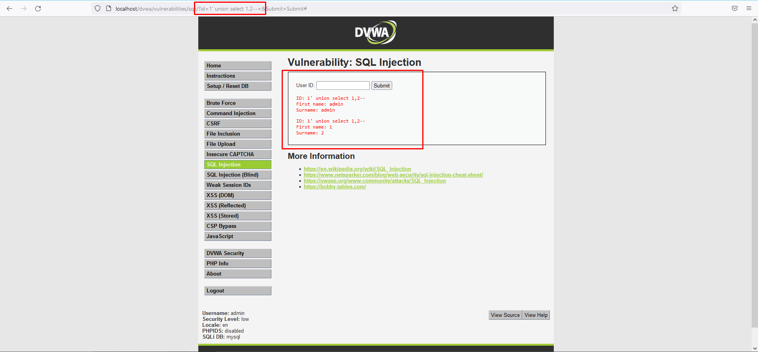
The SQL command used in this screenshot is “?id=1' order by 1,2--+” and will modify the ORDER BY clause of a SELECT statement. This ORDER BY is used to filter the result of a query using a specific columns or a set of them. 1 and 2 after ORDER BY will attempt to add an extra columns to the query and possibly gather more data.
Figure 14 - This screenshot represents a command which will use UNION operator to combie two or more SELECT statements
The SQL command used in this screenshot is “?id=1' union select 1,2--+” and it will use UNION operator to mix two or more of SELECT statements results into one result. 1,2 in the command checks for retrieval of an extra information from the database.

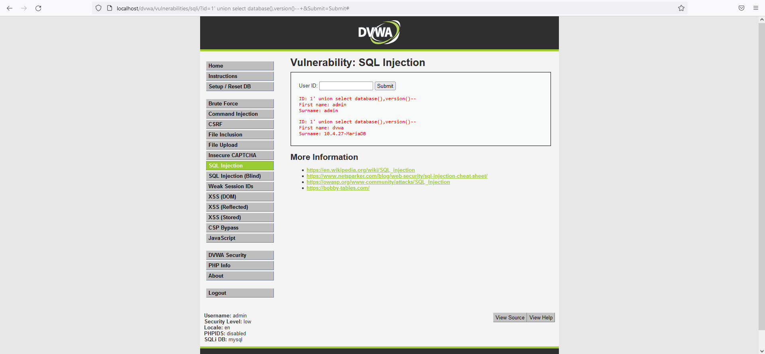
The SQL command used in this screenshot is “ ?id=1' union select database(),version()--+” and it will retrieve the name of a current “Database Management Sysstem” (DBMS) and also the version used.
Figure 15 - This screenshot represents a command which will retrieve the name of a current DBMS
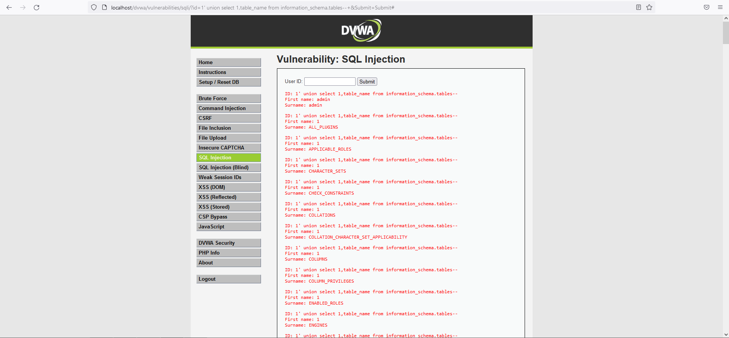
Figure 16 - This screenshot represents a command which will retrieve every table name in the database and the UNION will allow to collect the name of every table
The SQL command used in this screenshot is “?id=1' union select 1,table_name from information_schema.tables--+” it will retrieve all the names of every table in the database. The ‘information_schema.tables’ consists of a row for every table in the database and the ‘table_name’ contains the name of every table. The UNION operator and ‘1,table_name’ after it will let the attacker to gather the names of every table in the database.
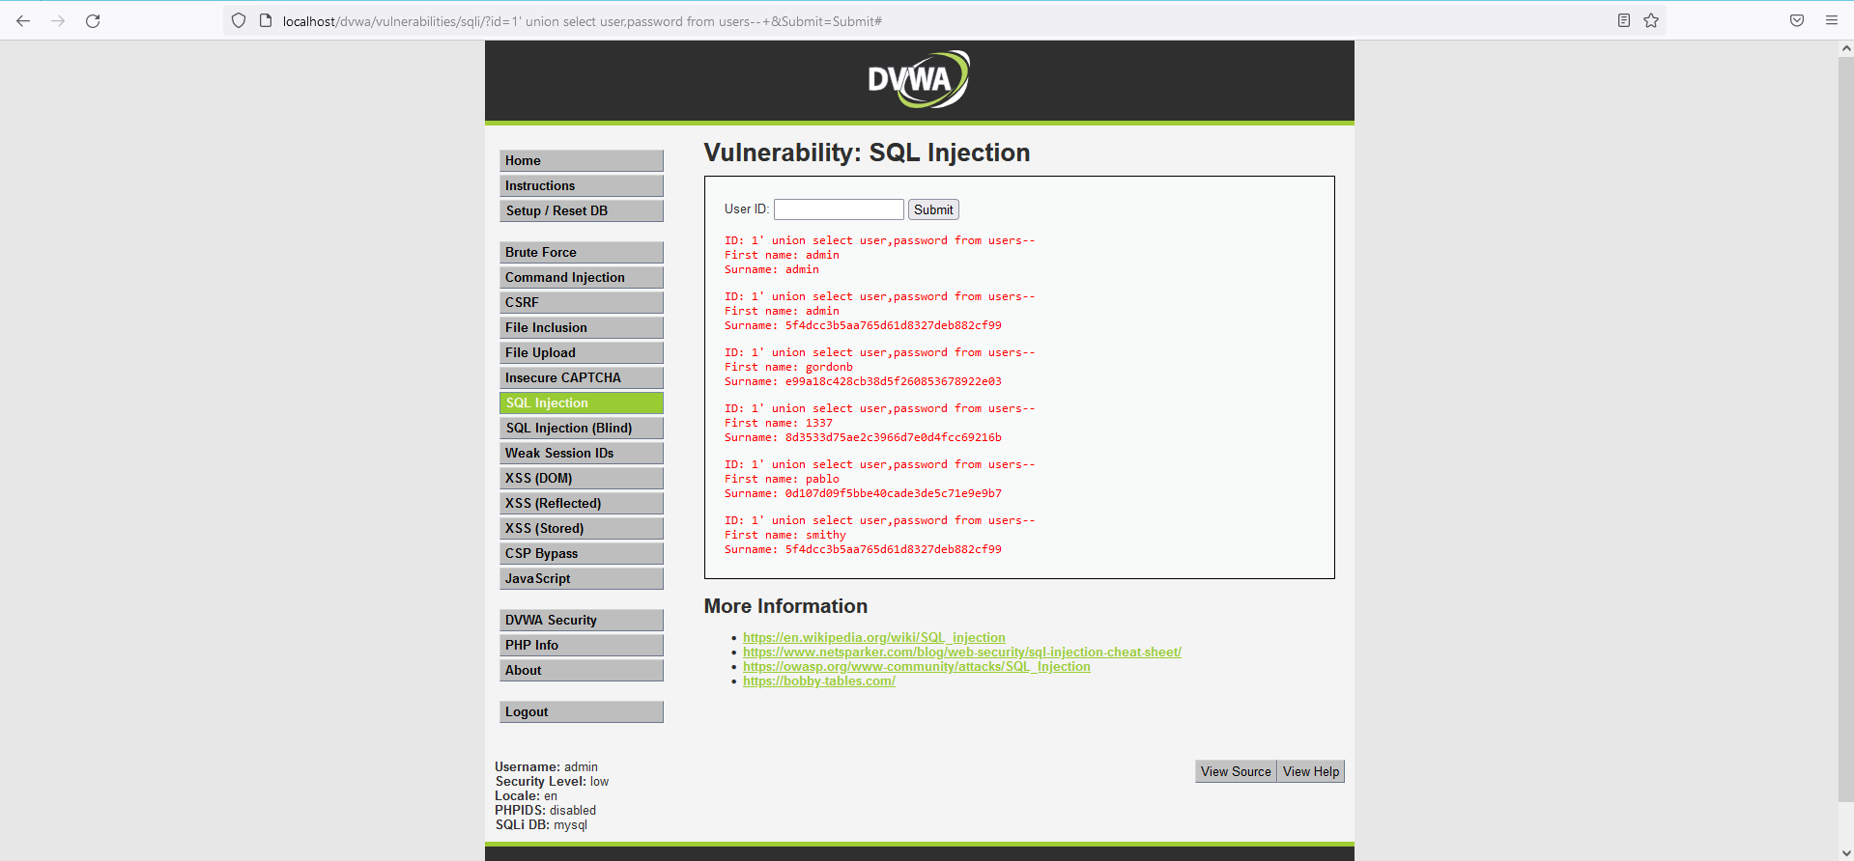
The SQL command used in this screenshot is “?id=1' union select user,password from users--+” and will retrieve the values of ‘user’ and ‘password’ from a table called “users”. Both columns – ‘user’ and ‘password’ consist of login credentials. The UNION operator and ‘user,password’ after it will allow the attacker to retrieve values in these columns.
Figure 17 - This screenshot represents a command which will retrieve the 'user' and 'password from relevant tables, UNION allows for collecting the information
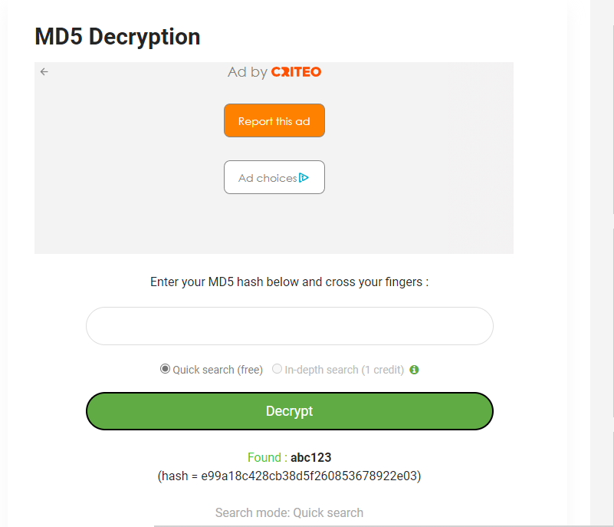
Figure 18 - MD5 tool for decrypting hashed assets

This is an online tool used for MD5 decryption and it appears that “abc123” was hashed.

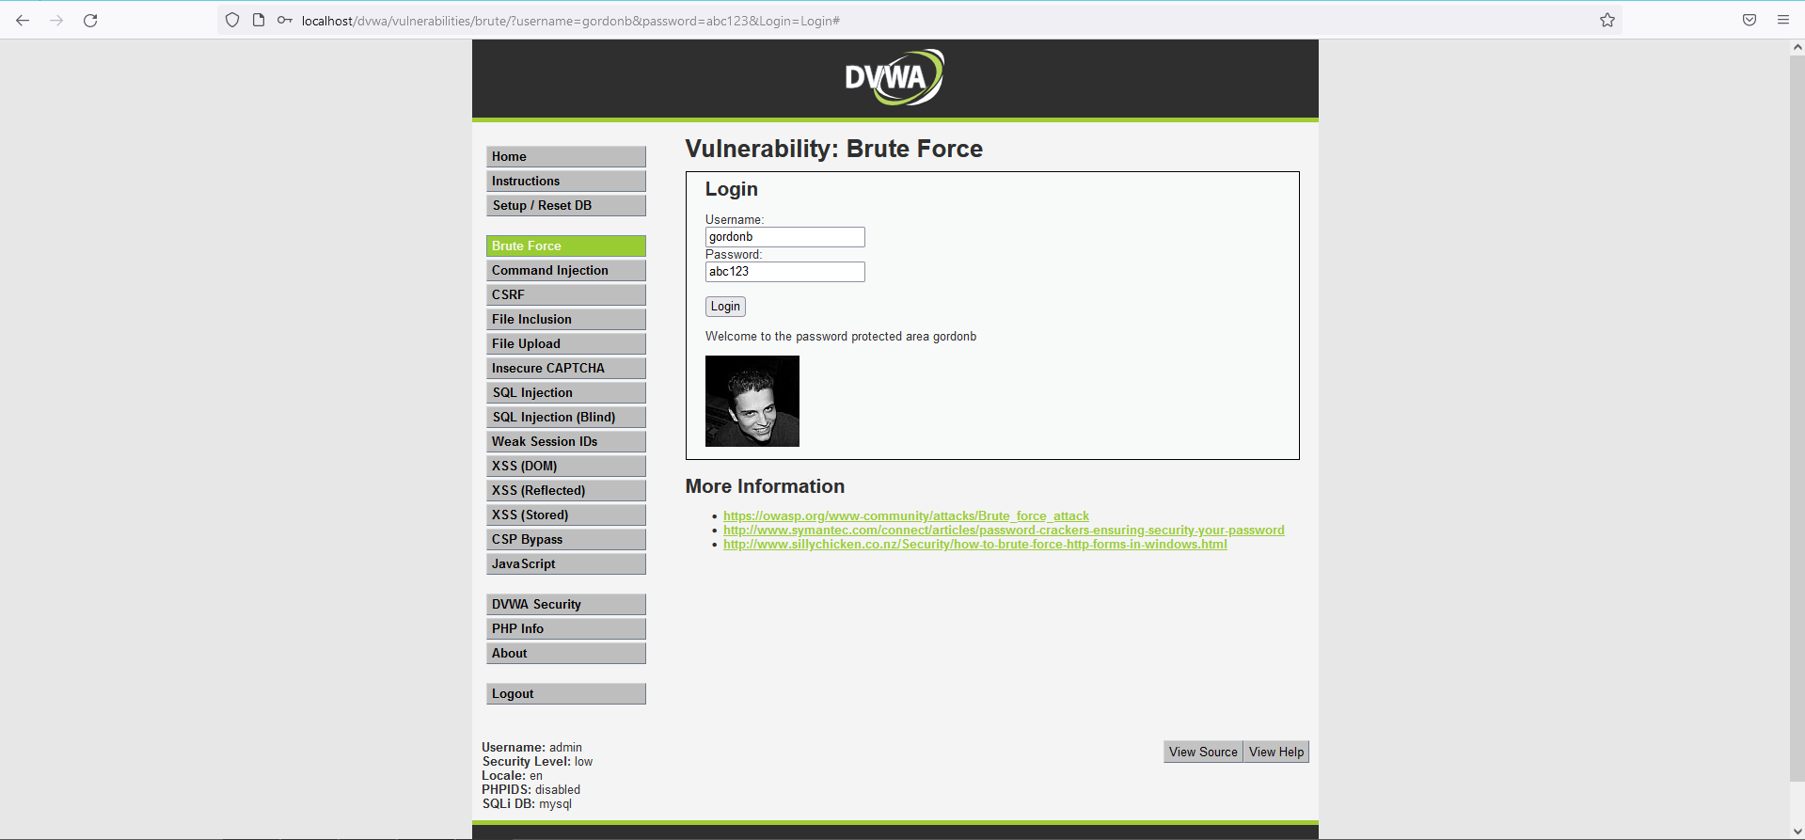
The decrypted password was “abc123”, this password is related to the account with a name of “gordonb” and the login is successful.
Figure 19 - Decrypted password used to log in

References

[1] | S. H. L. T. a. K. K. R. C. K. F. Li, “A systematic review of phishing attacks and defenses,” IEEE Access, vol. 7, pp. 1-1, 2019.
[2] | N. S. Q. M. William Hurst, “2015 IEEE International Conference on Computer and Information Technology; Ubiquitous Computing and Communications; Dependable, Autonomic and Secure Computing; Pervasive Intelligence and Computing,” in Predicting the Effects of DDoS Attacks on a Network of Critical Infrastructures, Liverpool, 2015.
[3] | Z. W. H. C. Aaron Zimba, “ICT Express,” Multi-stage crypto ransomware attacks: A new emerging cyber threat to critical infrastructure and industrial control systems, vol. 4, no. 1, pp. 14-18, 2018.
[4] | K. D. a. L. Iliadis, “Cognitive Web Application Firewall to Critical Infrastructures Protection from Phishing Attacks,” Journal of Computations & Modelling, vol. 9, no. 2, pp. 1-26, 2019.
[5] | M.-k. C. E.-s. C. S.-s. K. G.-c. P. J.-H. L. Rosslin John Robles, “Common Threats and Vulnerabilities of Critical Infrastructures,” International Journal of Control and Automation.
[6] | MITRE, “MITRE ATT&CK,” [Online]. Available: https://attack.mitre.org/. [Accessed 2 January 2023].
[7] | OWASP Foundation, “OWASP Top 10,” [Online]. Available: https://owasp.org/www-project-top-ten/. [Accessed 2 January 2023].
[8] | M. A. I. M. O. F. a. A. R. M. Imran, “Phishing: A Review,” Journal of Network and Computer Applications, vol. 61, pp. 1-14, 2016.
[9] | M. T. M. I. a. M. A. I. M. Adnan, “A Review on Phishing Attacks and Countermeasures,” Journal of Network and Computer Applications, vol. 70, pp. 99-113, 2017.
[10] | M. A. I. M. O. F. a. M. I. A. Shaikh, “Phishing Attacks: A Review,” Journal of Network and Computer Applications, vol. 48, pp. 1-14, 2015.
[11] | M. A. I. M. O. F. a. M. I. M. Tariq Masood, “SQL Injection Attacks and Defense Mechanisms,” Journal of Network and Computer Applications, vol. 47, pp. 34-44, 2014.
[12] | M. E. R. a. M. Z. Iqbal, “SQL Injection: A Threat to Web Security,” Journal of Network and Computer Applications, vol. 35, pp. 992-1001, 2012.
[13] | M. A. I. M. O. F. a. M. I. A. Ali, “SQL Injection: A Review,” Journal of Network and Computer Applications, vol. 53, pp. 1-10, 2015.
[14] | J. S. a. M. Shema, “Preventing SQL Injection attacks,” Preventing SQL Injection Attacks," IEEE Security & Privacy, vol. 8, pp. 76-79, 2010.
[15] | M. E. R. a. M. Z. Iqbal, “SQL Injection: A Threat to Web Security,” Journal of Network and Computer Applications, vol. 35, pp. 992-1001, 2012.
[16] | R. Dewhurst, “SQL Injection: A Beginner's Guide to Injection Attacks,” OWASP, [Online]. Available: https://www.owasp.org/index.php/SQL_Injection_Prevention_Cheat_Sheet.
[17] | M. A. I. M. O. F. a. M. I. M. T. Masood, “Web Application Firewalls,” Journal of Network and Computer Applications, vol. 36, pp. 1759-1770, 2013.
[18] | T. R. a. S. Seshadri, “Phishing Prevention: A User Education Perspective,” IEEE Security & Privacy, vol. 3, pp. 78-81, 2005.
[19] | M. T. M. I. a. M. A. I. M. Adnan, “Anti-Phishing Software,” Journal of Network and Computer Applications, vol. 70, pp. 71-79, 2017.
[20] | M. A. I. M. O. F. a. M. I. M. Tariq Masood, “Multifactor Authentication,” Journal of Network and Computer Applications, vol. 47, pp. 1-12, 2014.
[21] | M. T. M. I. a. M. A. I. M. Adnan, “Secure Web Browsers,” Journal of Network and Computer Applications, vol. 70, pp. 114-124, 2017.
[22] | M. J. a. Z. Ramzan, “Using Prepared Statements to Prevent SQL Injection Attacks,” IEEE Security & Privacy, vol. 2, pp. 85-87, 2004.
[23] | M. A. I. M. O. F. a. M. I. M. Tariq Masood, “Object-Relational Mapping (ORM) Tools,” Journal of Network and Computer Applications, vol. 47, pp. 1-12, 2014.
[24] | M. T. M. I. a. M. A. I. M. Adnan, “Input Sanitization,” Journal of Network and Computer Applications, vol. 70, pp. 55-63, 2017.
[25] | M. A. I. M. T. M. a. M. I. M. O. Farooq, “Least Privilege,” Journal of Network and Computer Applications, vol. 47, pp. 1-12, 2014.
[26] | M. A. I. M. O. F. a. M. I. M. Tariq Masood, “Spam Filters,” Journal of Network and Computer Applications, vol. 47, pp. 1-12, 2014.
[27] | M. A. I. M. O. F. a. M. I. M. Tariq Masood, “Email Encryption,” Journal of Network and Computer Applications, vol. 47, pp. 1-12, 2014.
[28] | M. T. M. I. a. M. A. I. M. Adnan, “DNS Filtering,” Journal of Network and Computer Applications, vol. 70, pp. 91-98, 2017.
[29] | M. A. I. M. O. F. a. M. I. M. Tariq Masood, “Anti-Malware Software,” Journal of Network and Computer Applications, vol. 47, pp. 1-12, 2014.
[30] | A. Mallik, “MAN-IN-THE-MIDDLE-ATTACK: UNDERSTANDING IN SIMPLE WORDS,” Jurnal Pendidikan Teknologi Informasi, vol. 2, no. 2, pp. 109-134, 2018.
[31] | J. Nazario, “Network Security,” DDoS attack evolution, vol. 2008, no. 7, pp. 7-10, 2008.
[32] | M. A. I. M. O. F. a. M. I. M. T. Masood, “Anti-PhishingTools,” Journal of Network and Computer Applications, vol. 70, pp. 114-124, 2017.

Figure 1 – Simulated network topology 4
Figure 2 - Representing how the phishing attack carried out in this report was executed 8
Figure 3 - Diagram representing the process for launching the SQL injection attack in this document 9
Figure 4 - Representation of generating a malicious link 16
Figure 5 - Representation of a fake email being delivered to the victim 17
Figure 6 - Representation of the email details from which the fake email has been sent 17
Figure 7 - Representation of a fake Google sign-in page after clicking "Check Activity" 18
Figure 8 - Representation of a page that appeared after the victim has submitted the details 18
Figure 9 - Representing the evidence of collecting the credentials 19
Figure 10 - Representation of the files stored on the server (Google Drive) 20
Figure 11 - Representation of the details that are used for logging into web application 21
Figure 12 - Representation of accessing the bank details 21
Figure 13 - This represents a command that'll modify the ORDER BY of a SELECT statement 22
Figure 14 - This screenshot represents a command which will use UNION operator to combie two or more SELECT statements 22
Figure 15 - This screenshot represents a command which will retrieve the name of a current DBMS 23
Figure 16 - This screenshot represents a command which will retrieve every table name in the database and the UNION will allow to collect the name of every table 23
Figure 17 - This screenshot represents a command which will retrieve the 'user' and 'password from relevant tables, UNION allows for collecting the information 24
Figure 18 - MD5 tool for decrypting hashed assets 24
Figure 19 - Decrypted password used to log in 25

