

The Design of Rectenna Energy Harvesting Photoplethysmography (PPG) Monitor with Bluetooth Connectivity

by
Joshua J Port

Supervisor: Steve Mosey
Second Marker: Gary Jones

Project submitted as part of the requirements for the award of BEng (Hons) Electrical and Electronics Engineering

April 2025

Student Name: |  | Joshua J Port |  | Student Number: |  | 2114468

Module: |  | Independent Project |  | Module Code: |  | ACCA6020

Project Title: |  | Rectenna Energy Harvesting Photoplethysmography (PPG) Monitor with Bluetooth Connectivity

Project Tutor: |  | Steve Mosey
Word Count |  | 10,100
Submission: |  | 29/04/2025

Declaration
I, Joshua James Port, declare that I am the sole author of this project; that all references cited have been consulted; that I have conducted all work of which this is a record, and that the finished work lies within the prescribed word limits.
This work has not previously been accepted as part of any other degree submission.
Form of Consent
I, Joshua James Port, hereby consent that my project, submitted in candidature for the BEng (Hons) Electrical and Electronics Engineering degree, if successful, may be made available for inter-library loan or photocopying (subject to the law of copyright), and that the title and abstract may be made to outside organisations.

Abstract
This project was established to design and produce a functioning photoplethysmography monitor which holds the ability to harvest 2.4 GHz energy from the ionosphere and utilise a rectifier circuit to convert the electromagnetic wave alternating current into a direct current as a power source for the design. The main aims of this project are to have a design which can be easily operated by all age groups to ensure the design is equal and diverse, to read the users heart rate and display it on a LCD display, have a communications link between the circuit and another user operated device and create a 2.4 GHz antenna which can capture floating electromagnetic waves and convert them into energy for the model. Research on PPG monitors has shown that a device like this has never been created or put onto the market. Most of the predesigned models require either a charging port or wireless charging pads. This makes this design the first of its kind.
In order to achieve these aims and objectives multiple methods of design and testing were implemented. The varied software systems consist of CST for the antenna design and functionality, Arduino IDE to test the simplistic function of the PPG sensor, CCS for the creation of a tailored circuit board for operational procedures and proteus for circuit simulation analysis and design. These software systems allowed the project to be fully created and tested before any implementation to hardware was made. This also meant that any adaptations required to make the operation of the circuit run smoothly could be added easily before the manufacturing stage of the project.
The project shows a delivered functioning simulation design using c code and a functioning heart rate sensor design utilising an Arduino set up. It was found that testing the design first with the Arduino IDE software proved to be a valuable step in establishing a communication between the device and the LCD. This code could then be replicated into the final design which is done in C. This would also allow a setup for the Bluetooth communication links.
Overall, the design prototype in simulation was a complete success, with a design that can be transferred to a PIC being created and an Arduino hardware setup being operational. Some of the main considerations that need to be taken further are, making the systems more comfortable for the user, having a secondary charging source such as wireless charging for easy powering of the design and finalising the integration of the antenna into the tailored circuit to make the rectenna circuity operational.
Contents
Figures 7
Chapter 1 – Introduction 1
Chapter 2 – Research and Review of Literature 3
Backgrounds on Rectennas 3
Antenna Design Elements 3
Previous Design Models 4
Fitbit 4
Whoop 4
Apple Watch 5
Previous Design Comparison 6
Bluetooth Connectivity 7
Chapter 3 – Research and/or Development Methodology 8
Review of the Questionnaire 8
Bus Pirate Testing 9
Arduino Test Setup 10
Hardware Requirements 11
Hardware Serial Numbers and Versions 13
Laws and Legislations 13
Chapter 4 – Design and Implementation 16
Project Requirement Details 16
I2C Protocols 16
UART Protocols 17
Rectifier Circuit Using Proteus 17
PPG Sensor Diagram with Proteus 19
Liquid Crystal Display (LCD) Set Up 21
Rectenna Design Elements 23
Printed Circuit Board 27
Chapter 5 – Evaluation 31
Chapter 6 – Conclusions and Recommendations 35
Chapter 7 – Reflection 37
References 39
Chapter 9 - Bibliography 42
Appendix 45
PPG Completed Surveys (Chapter 3) 46
CCS Chip Specifications (Chapter 4) 51

Figures
Figure 1 - Rectenna Circuit Design Layout 1
Figure 2 - Fitbit Designs [4] 4
Figure 3 - Whoop Design [6] 5
Figure 4 - Apple Watch Series 10 5
Figure 5 -Bus Pirate Setup Commands 9
Figure 6 - Bus Pirate Protocol Check 9
Figure 7 - Sensor Configuration Code. 10
Figure 8 - Arduino PPG Sensor without User Interaction 10
Figure 9 - Arduino PPG Sensor with User Interaction 11
Figure 10 - Soldering Risk Assessment 14
Figure 11 - I2C Bus Communication Protocol 17
Figure 12 - Proteus Rectifier Circuit 18
Figure 13 - Proteus Rectifier Circuit Code 18
Figure 14 - Proteus PPG Simulation with a Potentiometer 19
Figure 15 - I2C Communication Link Read Functions 20
Figure 16 - I2C Communication Link Write Functions 20
Figure 17 - Bluetooth UART Virtual Terminal 20
Figure 18 - UART Heart Rate Check and Signals 21
Figure 19 - Include External LCD Code 22
Figure 20 - LCD Port Assignment 22
Figure 21 - Antenna Design Specifications 23
Figure 22 - Antenna Design Using CST 24
Figure 23 - Antenna Mechanical Drawing 25
Figure 24 - S1,1 Parameters for the Antenna 25
Figure 25 - Antenna Radiation Pattern 26
Figure 26 - Antenna Azimuth Plane 27
Figure 27 - Antenna Elevation Planes 27
Figure 28 - CCS Schematic Design for PCB 28
Figure 29 - PCB Final design Schematic 29
Figure 30 - Top side of the PCB Board 3D Model 30
Figure 31 - Bottom Side of the PCB Board 3D Model 30
Figure 32 - Anechoic Chamber [33] 33
Figure 33 - Finalised Gantt Chart 34
Figure 34 - Final Gantt Chart Timescale 38
Figure 35 - PPG Survey Brief Page 45
Figure 36 - Participant 1 Survey 46
Figure 37 - Participant 2 Survey 47
Figure 38 - Participant 3 Survey 48
Figure 39 - Participant 4 Survey 49
Figure 40 - Participant 5 Survey 50
Figure 41 - Chosen PIC Construction in CCS 51

Table 1 - Previous Design Models Comparison Table [8] 6
Table 2 - Questionnaire Results Table 8
Table 3 - Overall Costing for the Rectenna PPG Model 12
Table 4 - Serial and Version Number for All Components 13

Equation 1 - Wavelength Calculation 23
Equation 2 - Wavelength Calculation with Variables 24
Equation 3 - Half Dipole Calculation 24

Chapter 1 – Introduction
This developmental project was set up to design, create and produce a next generation photoplethysmography (PPG) monitor. Unlike other heart rate monitors, this design will have the ability cross compare the users heart rate to that of the normal acceptable range, in order to send out an alert to their friends or next of kin warning them of the possible need for medical attention or of an underlying medical condition. This watch will not use the conventional methods of charging but instead will use a rectifier circuit paired with a 2.4 GHz (Gigahertz) antenna in order to harvest energy from free space. This will allow for a more ecofriendly charging method.
The overall aim of the project outlined below is to create a way to use photoplethysmography to monitor the users heart rate whilst being comfortable as well as, easy to operate by users of all ages. This level can then be tested utilising Beats Per Minute (BPM) calculations in order to benchmark the current heart rate of the user over a selective period of time. The aim of this functionality is to assist medical practices with patients who may have heart conditions, users who want to keep on track of their fitness and for general awareness. Due to the monitor being wrist worn; the watches design must be kept to as minimal of a size as possible.
The design will feature a technique called energy harvesting which takes advantage of a rectifier circuit to convert an Alternating Current (AC) from the Bluetooth 2.4 GHz ISM band into a Direct Current (DC) which can be used to charge the battery for circuitry operations. The rectifier circuit shown below uses 4 diodes set in an order which allows the current to only flow in one specific direction allowing a convergence of the alternating current. This method of ecofriendly charging will both improve the ethical considerations of this product as well as the ease of use for all users.
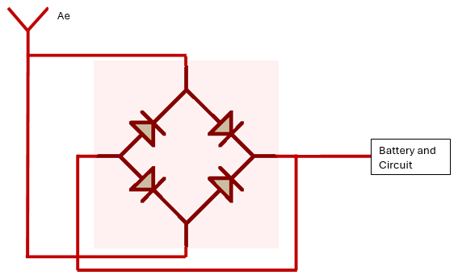
Figure 1 - Rectenna Circuit Design Layout
The main objective detailed below is to design a functioning version 1 prototype of a lifesaving photoplethysmography monitor within a six-month timeframe, using energy harvesting as a power charging source for the device. A progress plan will be drawn up with each critical component having a deadline to ensure constant progression is made and the design will be ready within the allocated timeframe. This project can easily be achieved by sticking to the timeframe and ensuring enough time to allow a built product to be constructed and tested. By the end of the project, a prototype of a PPG monitoring system with energy harvesting will be designed.
The report below will outline and detail the integral elements for the development of the PPG sensor. These sections will include a survey of the current models on the market, the software used to program the model, the hardware implementation used to operate the sensor, the communication links and the overall costing of the model. This design has been made as a software and hardware prototype version one design which may change for future iterations.

Chapter 2 – Research and Review of Literature
This chapter discusses the background information and research which has been conducted in regard to the important elements required within this project. One of these elements consist of the process in which the rectenna is able to obtain / receive a 2.4 GHz signal and utilise the process of rectification to convert the alternating current to a direct current to charge and power the circuit. Results from previous testing will be taken into consideration to ensure the newer development model in this paper is both accurate and has the potential to do the relevant task. This chapter will also cover current design models on the market, and how this developmental model can be adapted to be a better design.

Backgrounds on Rectennas
The rectenna was first brought to light in late 1964 as part of a receiver for the transmission of microwave power by William C Brown [1]. This study discussed the use of harvesting solar energy from the ionosphere through a receive antenna and using a rectifier diode circuit (bridge) to convert the electromagnetic wave alternating current, into a direct current which can be used directly to power a battery for circuitry operations. William Brown was conducting research that was derived from Tesla regarding radio wave transmissions but channelled the study toward the conversion of energy to a direct current [1].
The rectenna was first designed and tested during 1963 where the antenna being tested produced a 7 watt output at a 40% efficiency rate [1]. Being the first ever test conducted on this methodology, a 40% efficiency rate was considered a large step towards renewable energy via rectenna energy harvesting. Unfortunately, due to a lack of funding in this domain, the testing on rectennas within receive antennas stopped in the early 1980’s.

Antenna Design Elements
Another study on rectenna energy harvesting has recently been conducted using a microstrip patch antenna instead of the previous half wave dipole array antenna. This study, like the study by William Brown, focussed on the capture and use of the ISM band 2.45 GHz for conversion to direct current for energy usage. The microstrip antenna has been set up to using the same materials as a PCB board to allow easy design and manufacturing processes. The antenna was measured using CST simulation software at the university of Hargeisa and showed the reflections (S1,1 parameters) at being -20 at 2.45 GHZ which is considered way below the acceptable range [2].
The design laid out by the university study showed that the rectenna could be made to be both efficient and low profile, perfect for use within smaller design models such as phones or radios. This method could then be altered for independent use within smaller devices such as watches or paired with recharging battery packs. The overall design was made being 36.3 mm by 27.9 mm which was chosen due to the electrical length that was required for 2.45 GHz transmission and receive [2]. By using these sizing requirements or those of a similar nature, a rectenna could be made for heart rate monitors.

Previous Design Models

Fitbit
The Fitbit monitor is widely known for its extensive product range it provides when users are selecting the right fitness monitor to use for everyday life or gym workouts. There are many variations of the Fitbit with some being low profile and others having extremely wide LED screens. The original Fitbit tracker was designed in 2007 by Eric Friedman and James Park, who came up with the idea of a personal worn fitness tracker which would reinvent the methods of tracking fitness levels from heart rate to SP02 (blood oxygen saturation) [3]. This new idea paved the way for future design capabilities in personal worn fitness monitors including ones we see today with further developments now expanding to ring, finger worn, fitness trackers.
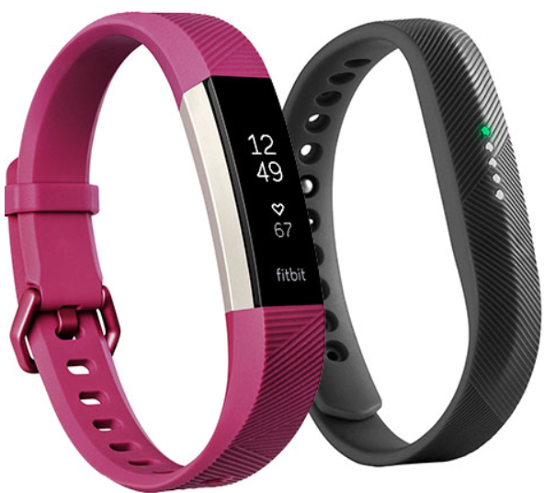
Figure 2 - Fitbit Designs [4]

Whoop
The whoop wearable watch is one of the newest fitness monitors on the market, superseding the power and intellect of that of its predecessor: the Fitbit. One of the main differences between the Fitbit and the whoops is that the whoop does not come with a built-in touch screen feature. Although this means it slightly harder to operate for the older age groups, it makes the design a lot more slimline and low profile which is preferred by a lot of users. The whoop is used to measure 3 main metrics for the user: their heartrate, their sleep and their recovery time (how long is needed to recover after exercise) [5].
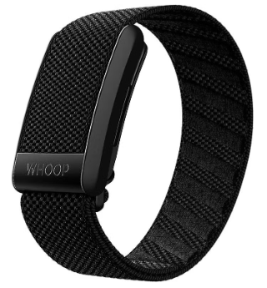
Figure 3 - Whoop Design [6]

Apple Watch
The apple watch generation one was designed to be a step above the rest in next generation wrist worn technologies and heart rate monitors. It was first brought to the public in late 2014 by apple under the supervision of the current CEO Tim Cook as the first watch that could make and receive phone calls using LTE and cellular networking [7]. This invention took all the aspects of a fitness tracker, crossed them with the capabilities of a smart phone, and produced a watch that is both sleek, as well as small and comfortable. Apple, even though they had the newest generation of wrist worn technology, still used conventional method of Bluetooth for communication links between the wrist worn watch and the user’s personal electronic device i.e. phone or tablet.
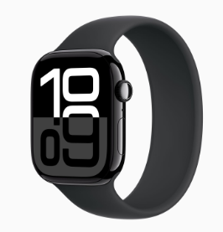
Figure 4 - Apple Watch Series 10

Previous Design Comparison
No. | Category | Fitbit | Whoop | Apple | Best Fitness Tracker
1 | Size | Varying sizes. Newer designs have the option to add a display or to just come with connectivity. | One specific design that is thin (Thickness) but wide in size. | Varying sizes but always using a screen increasing the size dramatically. | Fitbit
2 | Price | A wide range of prices to suit multiple users. £60 - £300 | One design at an average of £250 -£300. | Increasingly expensive from £300 to £1000 | Fitbit
3 | Capability | Sleep patterns, exercise, heart rate and SP02. | Sleep patterns, exercise, heart rate and SP02. | Sleep patterns, exercise, heart rate and SP02 plus cellular calling. | Apple
4 | GPS | No GPS included with any model. | No GPS included in this model. | GPS Included in all models. | Apple
5 | Bluetooth | Bluetooth Connectivity Included. | Bluetooth Connectivity Included. | Bluetooth Connectivity Included. | Fitbit, Whoop, Apple
6 | Waterproofing | Waterproof to 30+ meters (on some models). | Waterproof to 30+ meters. | Waterproof to 30 meters. | Fitbit, Whoop
7 | Subscriptions | No subscription required. | Subscription Required. £200 per Annuum | No subscription required. | Fitbit, Apple
8 | Compatibility | Android and IOS | Android and IOS | Android and IOS | Fitbit, Whoop, Apple
9 | Comfort | Rubberised texture for comfort. | Regular fabric style band but can be changed to a rubber band. | Increased variability to suit the user. | Apple
Table 1 - Previous Design Models Comparison Table [8]
Overall, it can be determined from Table 1 that the Fitbit and the Apple watch are comparable in some capabilities but are not equal in other areas. Whilst both the watches maintain the ability to utilise Bluetooth, have no subscriptions and are waterproof, the cost of the apple watch however, supersedes that of its competitors making it an unviable option for many users. The whoops watch being a constant subscription price, puts a lot of users off buying their product. Due to the fact whoop has only been brought to the market within the last few years means there could be room for developmental changes and improvements before future versions come out which could possibly compete with the evolving Fitbits and Apple watches.

Bluetooth Connectivity
Bluetooth was first invented by Dr. Jaap Haartson when studying a way to connect two dedicated radios together, over a small distance through free space [9]. It is now used by millions of people on a daily basis for applications such as connecting to headphones to play music, wireless computer accessories and even communication links for a wide variety of vehicles. Bluetooth has been classified over two decades using version control. These versions of Bluetooth are based on three main factors: the speed at which the data can be transmitted, the power requirements to transmit this data and the range at which the data can be transmitted over [10]. Bluetooth 5.0 (the newest version) is able to change the data rate higher or lower, depending on the message being transmitted. With a lower data rate, the range at which the message can be transmitted increases at least two times since the development of Bluetooth 4.0.
By researching previous sources, it can be determined that for this project to succeed, a series of factors must be implemented. Thes factors mainly consist of, using new generation Bluetooth 5.0 to increase the range of transmission, ensuring the rectenna design fits nicely into the circuitry to minimise space and maintain the ability to charge the battery as well as, the decision on whether to add a lcd display to the model. The chipsets that are widely used in today electronics equipment, have been designed to be incorporated easily within small devices which makes them perfect for communication from a small wrist worn device to a user’s phone.

Chapter 3 – Research and/or Development Methodology

Review of the Questionnaire
To ensure that the design within this paper would be of interest and suitable for use in a day to day capacity, a research questionnaire was set up to find the key elements that a selective group would like to see for the watch. The questions were designed to ensure that they could be easily answered with most being yes or no questions with the chance to elaborate if the volunteer would like to. These answers would help to establish what needs to be added to the design as well as what elements need to be tested to ensure the model is designed to the specifications required by the users. The table below shows the collation from the questionnaire. This questionnaire was completed by 5 people of different age, race and active fitness to keep the testing and analysis as fair as possible.
Question | Yes/No | Consensus
Do you go to the gym more than once per week? | 1 Yes, 4 No | The volunteers don’t use the gym often.
Have you ever worn a PPG / heart rate monitor? | 4 Yes, 1 No | Most people have at least tried a heart rate monitor.
If yes to Q2, do you wear the monitor on a daily basis? | 3 Yes, 1 No, 1 N/A | Most people decide to track their fitness on a day to day basis.
Are heart rate monitors easy to use? | 4 Yes, 1 N/A | Most users find the interface easy to operate.
Should a PPG monitor have a screen? | 4 Yes, 1 N/A | Most people would like to see a screen on the watch, but some feel a phone connection is adequate.
Is the best place for a PPG monitor on the wrist? | 4 Yes, 1 No | The wrist is the best place nut other options could be explored.
Should the monitor connect to the user’s phone? | 4 Yes, 1 N/A | Yes, it should but some believe a screen would be enough.
Should you have to pay a subscription to use a heart rate monitor and app? | 4 No, 1 N/A | The volunteers preferred that there should be no subscription on top of the watch price.
Table 2 - Questionnaire Results Table
Overall, the volunteers for the questionnaire believed that the model should come with an inbuilt display for ease of use, there should be no long-term payment plans (such as subscriptions to use) and that there should be an option for connectivity to another device i.e. a phone or tablet.

Bus Pirate Testing
The original testing set was conducted on a bus pirate 5 to ensure the communication protocol (I2C) was able to be initialised and can communicate with the chipset or Arduino when the design infrastructure is made. The aim of the bus pirate is to scan the ppg sensor device to give the read, write and chip address values which can be initialised within the design (Figure 5). The bus pirate is set up to be a direct representation of a pic chip with the required voltage being transmitted via a usb to the device.
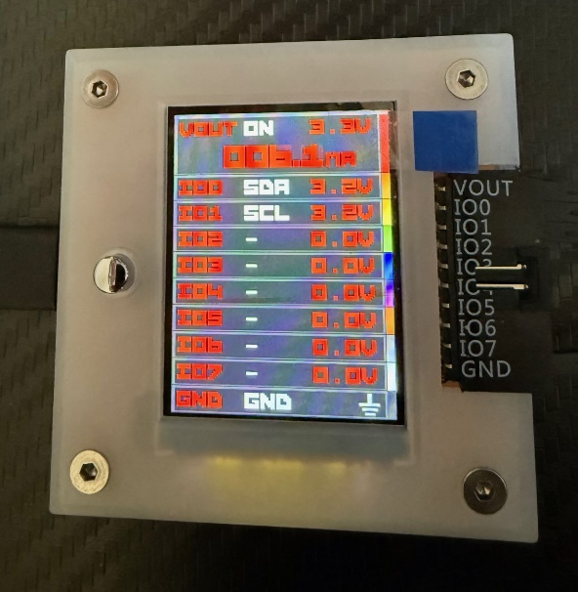
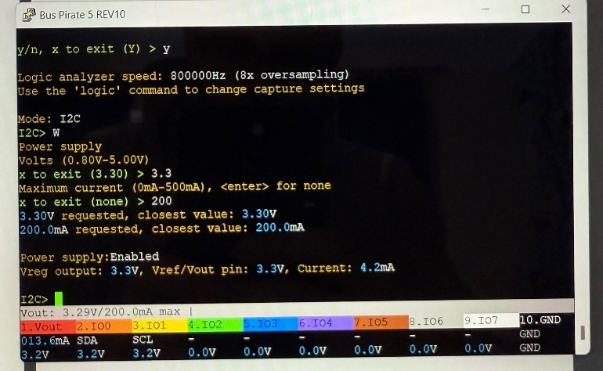
The bus pirate can be set up easily with only a few steps needed to test the communication protocols. After plugging in the terminal to the laptop, a list will appear showing the protocols that can be tried and tested. For this design I2C can be selected. Once selected, command “W” can be used to initialise the set up including, the power voltage required (3.3v), the maximum current which will be drawn from the circuit (200 mA) and the baud rate (115200) which is the number of characters or symbols which can be transferred per second [11].
Figure 5 -Bus Pirate Setup Commands
Figure 6 here to the left shows that the power has been transmitted to the PPG device, and a signal can be shown being transmitted and received by the bus pirate. This is shown on pins IO0 and IO1 with a voltage of 3.2 volts. This initialisation step is imperative to the development of this project due to its ability to test if the chip can use communication protocols such as I2C and UART to write and read the information being provided by the PPG chip. If this step had not been completed, there is a possibility that the design will be made without its appropriate function. This testing can directly be linked to protocols within Arduino code, Proteus as well as, the CCS simulation software.
Figure 6 - Bus Pirate Protocol Check

Arduino Test Setup
The next step of testing was to initialise the selected protocols on the PPG sensor using a baseline Arduino Uno R3 user programmable board. The Arduino comes with predetermined libraries to help with the setup and coding of the communications between the required chipset and the computer. Firstly, the previous design library needs to be added to the sketch file. These files (header files) contain the predesigned variables and addresses for the MAX30102 chip, which allows the user to pull in variables and setup code that can be ported straight across to the user sketch code ultimately initialising the components within the sensor. One of the main variables within this file is the sensor configuration variable that contains, the led brightness, the sample rate, the sample average, the tailored led mode, and the analogue to digital conversion range/rate.
Figure 7 - Sensor Configuration Code.
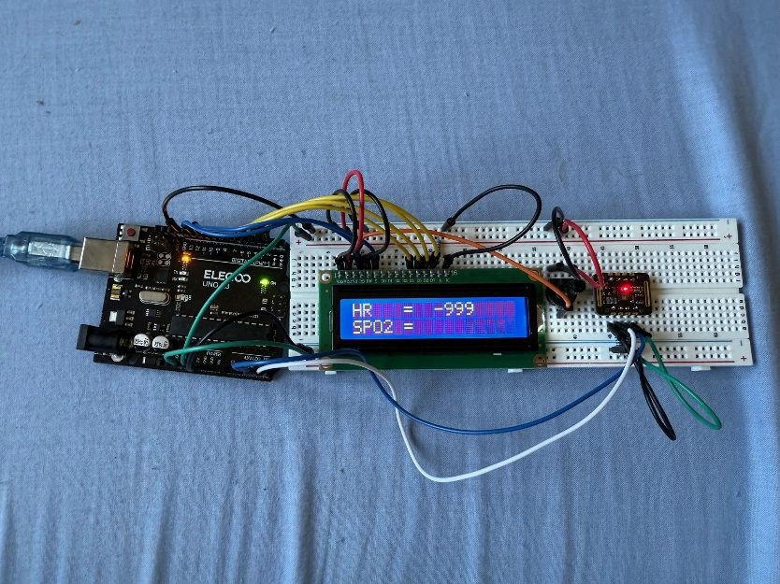
Figure 8 - Arduino PPG Sensor without User Interaction
Figure 8 shown above demonstrates how the connections are made from the Arduino board to the breadboard containing the liquid crystal display and the PPG sensor. Like the bus pirate previously, the 3.3 volts line is used to power the PPG sensor whilst the 5 v or the 3.3 v power line can be used for the LCD. The display should be (without the user’s finger on the sensor) displaying the value of -999, showing it is active and awaiting a test object. This testing is made possible by transferring the designed code from the computer IDE terminal onto the main Uno R3 processing chip. This chip will constantly loop the system to allow multiple readings to be taken with a new reading calibrating and displaying every 5 seconds (half of the normal read rate).
The second figure demonstrates what the lcd should display when a plethysmography reading is taken using the red mode on the sensor set up. The red light is emitted into the skin with no damage to the user and a receiver module is used to see how much of that light has been absorbed by the red blood cells and how much has been reflected back from the operator. This raw reading is then calculated using a heart rate calculator, within the header file, to produce the finalised reading of the heart rate.
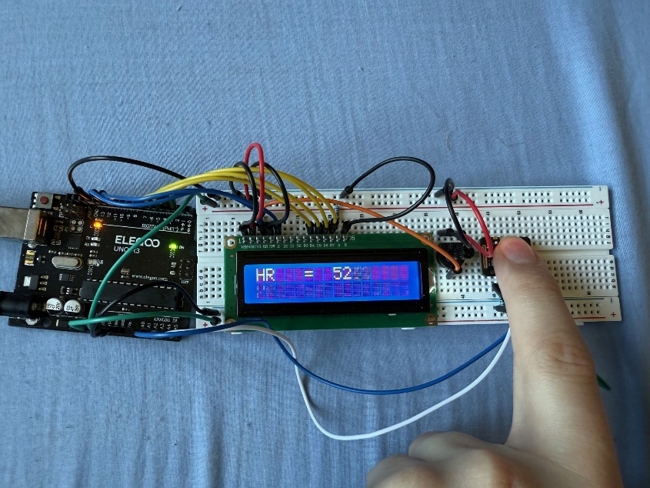
Figure 9 - Arduino PPG Sensor with User Interaction
This method of prior testing is needed to ensure that the module can be operated and is working optimally with a predetermined header file. The Arduino can then be directly replaced with a newly made circuit operating with a PIC18F chipset. The drawback to this testing is that the production timeline is widely increased for the first iteration due to multiple codes needing to be designed and more board tests conducted. However, some of the main advantages of doing this testing method is that the addresses of the chip can easily be found, header files can be used to complement user code and the codes from each test bench only need slight adjustments to get the final model code and operations.

Hardware Requirements
The main development in this report is based around captures of the user’s heartrate utilising photoplethysmography. For this functionality, a heart rate monitor will be required with a predesigned led and sensor system inbuilt into the design. This hardware is essential to the operation and capability of the selective device, as without it, the heart rate of the user cannot be taken and cross correlated with the heart rate average levels.
The chip that controls the operations within the ppg senor module is called the MAX30102 which is widely used within the ppg testing field. The data rate for this specific chip is a variable range which can be user set between 50 and 3200 samples per second [12]. The MAX30102 chip communicates via the I2C command protocol which allows the connection between the main microcontroller, in this case the PIC18F45K50, and the sensor module.

Component | RS Stock Number | Data Sheet | No. of Items Required | Costing Per Unit | Total Cost (Exc. VAT)
PIC | 786-3915 | [13] | 1 x pack of 5 | £3.15 | £15.75
Bluetooth Module | 247-3227 | [14] | 2 x pack of 1 | £3.78 | £7.56
Capacitor | 191-8126 | [15] | 1 x pack of 5 | £0.23 | £1.11
Diode | 764-5521 | [16] | 1 x pack of 10 | £0.29 | £2.83
Resistor | 131-772 | [17] | 1 x pack of 10 | £0.12 | £1.17
PPG | 247-3241 | [18] | 2 x pack of 1 | £12.95 | £25.90
Battery | 144-9405 | [19] | 2 x pack of 1 | £11.83 | £23.66
I2C Memory 24LC00 | 454-107 | [20] | 1 x pack of 500 | £0.17 | £82.00
 |  |  | Respective Totals: | £32.52 | £159.98
Table 3 - Overall Costing for the Rectenna PPG Model

Hardware Serial Numbers and Versions
Component | Components serial Number | Version Number
PIC | 23300RB | V1
DFRobot DFR0781 Bluetooth Module Bluetooth 5.0 | 42319240621 | BT401 V3
Capacitor | 20263411 | V1
Diode | 20689195 | SA5.0A
Resistor | 20786274 | V1
PPG | 36220231114 | V2
PPG V8520 Chip | A763613.12126 | V1
Battery | FT103450P | V1
Table 4 - Serial and Version Number for All Components
Shown above in table 4 is the version number and serial numbers of all of the components which were used within the PPG project. The serial numbers are pivotal to a project as they are effectively the technologies fingerprints [21]. If there’s a fault with a selective group of components, the serial number is used to recall those products to ensure there are no more malfunctions. The same rules are applied here with a project design made from multiple components.
Alongside the hardware already shown above, other elements are needed to finalise the project and ensure its operation. One main piece of equipment / hardware which is needed is copper clad boards on FR4 substrate. This material is used to create circuit boards and will be the easiest and most efficient way of placing the 2.4GHz antenna into the design. FR4, otherwise known as Flame Retardant 4, is widely used within printed circuit board (PCB) designs for its durability, reliability, flame resistivity and its capability to self-extinguish open flames when they are close [22]. These factors make it the ideal substrate for small or large electronics.

Laws and Legislations
Throughout this project, a number of key laws and regulation had to be followed to firstly ensure the safety of the user and secondly the safety of the other individuals close to the user. In order to create a safe model, the Office of Communications (OFCOM) and Radiation Hazard (RADHAZ) guidelines had to be adhered to. OFCOM regulations state that they must be contacted to use licenced bands, and they will check the over the air transmission for that frequency either denying or allowing usage [23]. For this project only 2.4 GHz Ultra High Frequency (UHF) is being use which is categories under their legislations as a licence free public band.
The second’s legislation is regarding the radiation levels which the body can be exposed to when transmitting or receiving with this model. RADHAZ is used to check the power which is being used and spreads it out over a course of six minutes. If the level exhibited are higher than ethically allowed over this timeframe the power used is too high to be put into public manufacturing. The model shown within this report utilises upwards of 100 milliwatts of power constantly over the 6 minutes period. For the model to have dangerous implications with non-ionising radiation at a minimum the power output from the antenna would have to exceed at least 10 watts consistently showing this model is well under the proposed guidelines for safe radiation.
Ethical considerations were a key part of this project due to its non-ionizing radiation potential fundamentals. The levels of emission for radiation were studied and tested during the simulation process of this project to ensure the power used and RADHAZ levels were in accordance with the current guidance and legislation of OFCOM. The design also uses the minimal number of materials to ensure no waste is created during the production processes.
Throughout the project, one of the key aims, was ease of and broad user appeal. The design has been made to allow any user to operate it easily as well as, being neutral colours to allow it to appeal to everyone. The price of the design has also been kept to a minimum in order to have a broad appeal for all income groups of people. Including these factors in the designs ensures that the equality and diversity act is closely followed.
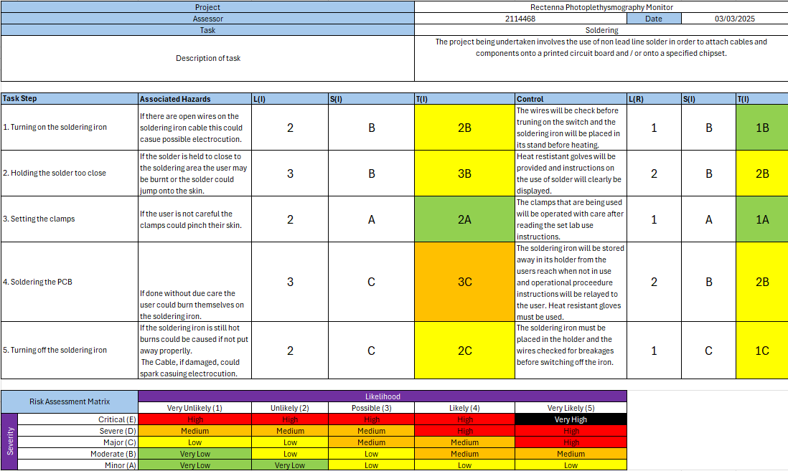
Figure 10 - Soldering Risk Assessment
When carrying out a high-risk activity, a risk assessment must be put in place to try to mitigate any damage which could be caused by misuse. The risk assessment above has been designed for the manufacturer when creating this product in order to keep in coordination with health and safety regulations as stated under the health and safety at work act 1974. By following this guidance closely, a safe working practice can be put in place to assist the manufacturer and clearly outline the main risks of the design process. The risk categories are split up into 5 main sections. These sections detail whether the risk is very low, low, moderate, high or very high. If the activity overall is at one of the higher levels (high and very high) the product could not be carried out due to a breach in health and safety in the workplace. As shown above, none of the risk categories exceed moderate on the inherent risk and once a control measure has been put in place, no practice in this project exceeds a low risk. This implies that the project meets both ethical and safety legislations.

Chapter 4 – Design and Implementation

Project Requirement Details
To ensure that the project is a success, requirements and aims needed were set for completion upon the required tasking date. Before the project started, there were capabilities that needed to be identified which had to meet both user requirements and ethical considerations. This meant that the background research conducted needed to be precise and factual from regulated sources. All of the requirements that are stated below have been created and established utilising these methods to be in accordance with legal statues.
- To create a photoplethysmography monitor which can have the same capability as some of the current market devices whilst being a fraction of the current costs.
- Ensure the PPG monitor can relay data to and from a light up display and store this data for future use should it be needed using an I2C memory chip.
- To create a communication link between the circuit board containing the PPG sensor and another device utilising 2.4 GHz Bluetooth 5.0 chip.
- Create a 2.4 GHz antenna which is low profile to obtain / capture free space frequency and combine this with a rectifier to convert the power from AC to DC in order to charge the battery providing green energy.

I2C Protocols
Inter-Integrated Circuit (IIC), or as it’s commonly known: I2C, is one of the main protocols that is used within this model to provide a smooth operation of use [24]. I2C is knows as a type of computer bus which uses addresses to create a virtual link between a known master chip and one or more slave chips. This means it can be used to communicate between the chosen PIC and the selected I2C memory block to read, write and store transmitted data [25].
I2C is controlled using two ports. The first port is the Serial Clock (SCK) which creates a parallel connection to the clock on the main chip (PIC18F45K50) and allows the clocks to both work in synchronous state, furthermore, enabling the data to be sent in the same time domain without delay. The second port used in I2C is the Serial Data (SDA) pin which is used to transmit the data between the two chips using an 8 bit binary system. This 8 bit data transmission is split into two specified parts. The first bit of the read is the master chip selecting the slave chip the data will be written to or read from whilst the 7 following bits contain the programmable data which is being transmitted between the chips [26]. This ensures the data is being transmitted to the right chip before sending the data.
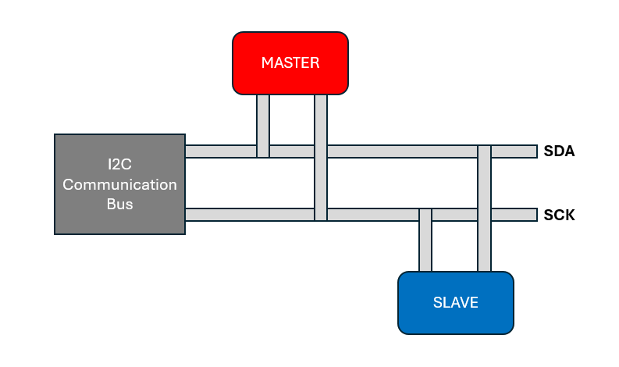
Figure 11 - I2C Bus Communication Protocol

UART Protocols
Universal Asynchronous Receiver Transmitter (UART) is a hardware based communication protocols mainly used for transmitting single source data from one chip to a second [27]. Unlike other communication protocols UART communication is linked by physical wires rather that an over the air transmission between the two chips. Much like the I2C communication protocol, UART uses the first bit of the sent data to select the receiver chip allowing the required process to be carried out by the required chip, however, UART’s data packages can be anywhere from six bits up to 10 bits (including this start bit). One of the main differences between this protocol and others is that it also contains a parity bit. Parity is a bit at the end of the bit stream which can add either a 1 or 0 to make the chip transmit the same way at which the data was originally received [28]. This ensure that the data can easily be read, transmitted and received between the master and the slave chips.

Rectifier Circuit Using Proteus
Using proteus, a design for the rectifier circuit could be drawn up with a test set of code to establish its functionality and accuracy within the project design. This was critical to the design element due to its importance with converting alternating current to direct current for the chipsets to run on. This simulation was designed and carried out in proteus due to this software being easy to use and its simplistic coding functions.
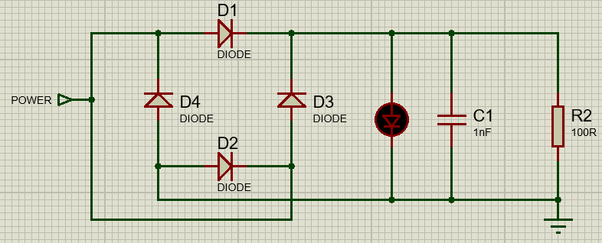
Figure 12 - Proteus Rectifier Circuit

Using the circuit above, a simplistic code was created to pulse the led, similar to the one on the PPG board, on and off in intervals of 10 seconds as stated within the normal time range of operation for PPG sensing. This was set up by powering the circuit with 5 volts and running a flag code setting the selected pin on the pic high or low with a 10 second delay between the operations. Shown below is the code used to operate this circuit.
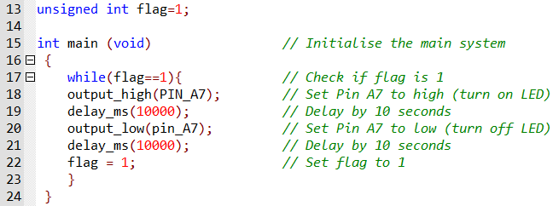
Figure 13 - Proteus Rectifier Circuit Code

PPG Sensor Diagram with Proteus
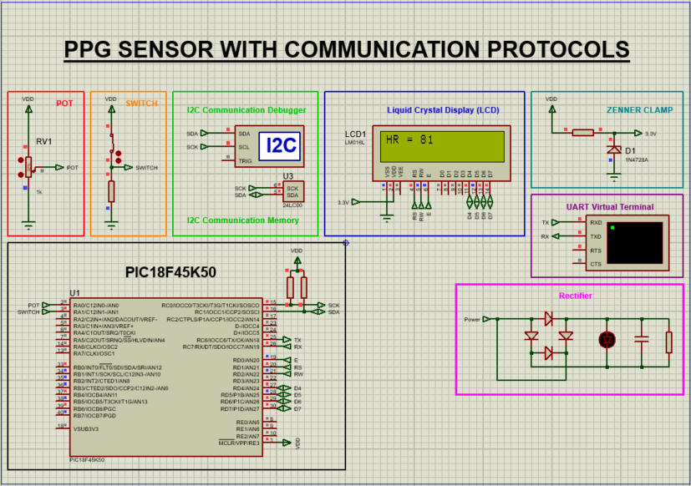
Figure 14 - Proteus PPG Simulation with a Potentiometer
Figure 14 above shows the finalised simulation model for the Photoplethysmography monitor including both communication protocols and user adaptive operations. In this design, due to proteus having no library for the MAX30102 chip, the potentiometer in red is a direct simulation of the output that the PPG sensor will emit. This output byte is then sent to the main programmable chip (PIC18F45K50) to be documented and sent to the memory. The connection between the PIC and the memory chip is solely based on an I2C communication protocol link utilising the SDA and SCL ports on the chip as previously stated.
I2C is used within this model to send and receive a variable read from the external chip, in this case being the PPG sensor. To start the transmission an address is sent from the main chip to the PPG sensor to acknowledge a connection which can be written from or read, to display the data received. A secondary address (0xAE) is then sent to the main chip initialising a write function in order to send the previously collected data, of up to and including 32 bytes, to be stored in the I2C Electrically Erasable Programmable Read Only Memory (EEPROM) chip [29]. The PIC then sends out another I2C start pulse and a read function to obtain the data and send it back to the PIC to show the data has been successfully stored. This data is then taken and transferred across Data four through 7 to be accurately displayed on the liquid crystal display for the user to see.
Shown below in Figure 15 is the code process in proteus which is used in order to create the read and write functions to and from the chip to display the data. The data is stored under various variable names shown here with variable pot for the PPG and variable Val for the value of data which has been collected.
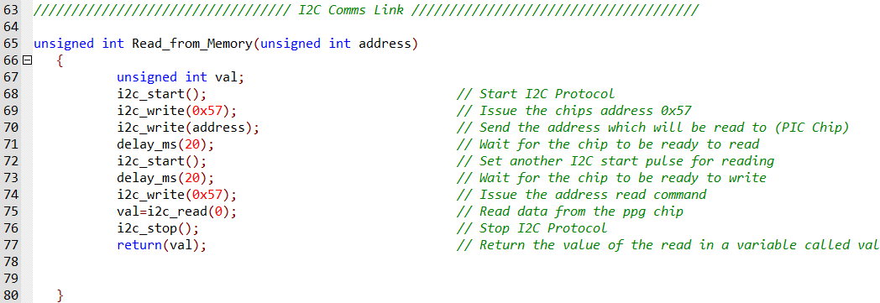
Figure 15 - I2C Communication Link Read Functions

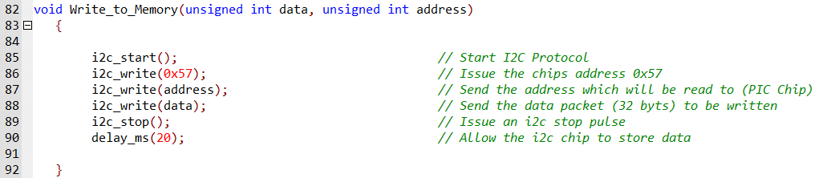
Figure 16 - I2C Communication Link Write Functions

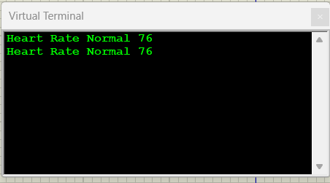
Shown in figure 17 is the confirmed communication link from the chip to the external device utilised the Tx and Rx pins for both transmission and receiving respectively. The communication works by first obtaining the value of the sensor from the EEPROM memory block using I2C. This data is then transmitted to the main master chip to be crossed against the heart rate average of the United Kingdom. The normal resting heart rate for an adult is on average in the realms of 60 to 100 beats per minute (BPM) [30]. Although this is the main average, this does not include people who are active and go to the gym where the users heart rate could be up to and including 140 BPM. For this report and design the users limit has been set to between 60 and 120 beats per minute.
Figure 17 - Bluetooth UART Virtual Terminal
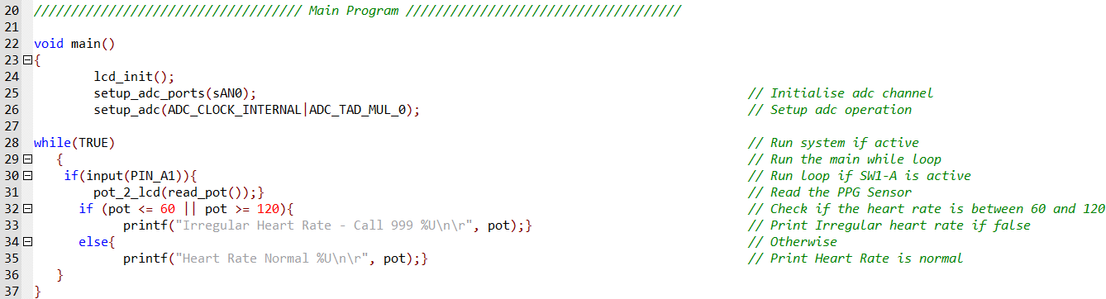
Figure 18 - UART Heart Rate Check and Signals
The main program chip cross checks the users heart rate and tasks UART to send one or two pulses depending on the levels that have been received. If the users heart rate lies either below the 60 beats per minute or 120 beats per minute a pulse is sent to the Bluetooth chip to communicate a message across onto the user’s phone displaying that they may need medical care dues to an irregular heart rate. This was found to be what a lot of users would want to see within the design model specifications. The second instance is if the heart rate is at optimal range. If this is the case then a pulse is sent to the Bluetooth chip and logged onto the phone however, this does not alert the user to the extent of if the user is in danger.

Liquid Crystal Display (LCD) Set Up
The LCD display requires a specific set of connections in order to first activate the lines that need to be used and secondly, obtain the correct data packages that have been sent to be displayed. Like most devices, the LCD first starts off by having a power input between 2.4 and 5 volts and a ground to ensure current can flow through and not build causing electrical discharge. The LCD uses three primary ports run and decide operations. These ports are RS (Register Select), RW (Read/Write) and E (Enable). The register select is responsible for either being set in a low state meaning a command has been given to the LCD that will be followed or alternatively, being set high which issues the LCD to print the data onto the screen [31]. The RW port tells the lcd to write data into the register is low and read the memorised data from the lcd if set high [31]. The last port is the enable pin which, when set as a 1, executes the process of reading the data from the D pin data lines and then print it onto the corresponding lines of the LCD.
Data is transferred to and from a 2 line 16 column LCD using 4 data line pins. For bigger LCDs, 8 data pins may be used to allow for higher data transferal and more utilisation on the LCDs display. For this project 4 data line pins have been used. The pins are connected in a common order with data lines for a 2 line LCD being pin 4 through 7 and can be connected to any analogue input / output (I/O) pin as selected by the designer. These connections must be bidirectional to allow the data to be both read and written, too and from the crystal display. This caused a major problem at the start of the project as the pins were set out in an input state. This was checked in the CCS firmware software where it was found that the initial LCD code would not work without RS 232 communications setting the pins to bidirectional I/O as shown below in figures 19 and 20.
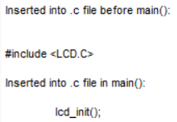
Figure 19 - Include External LCD Code
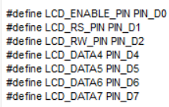
Figure 20 - LCD Port Assignment

Rectenna Design Elements
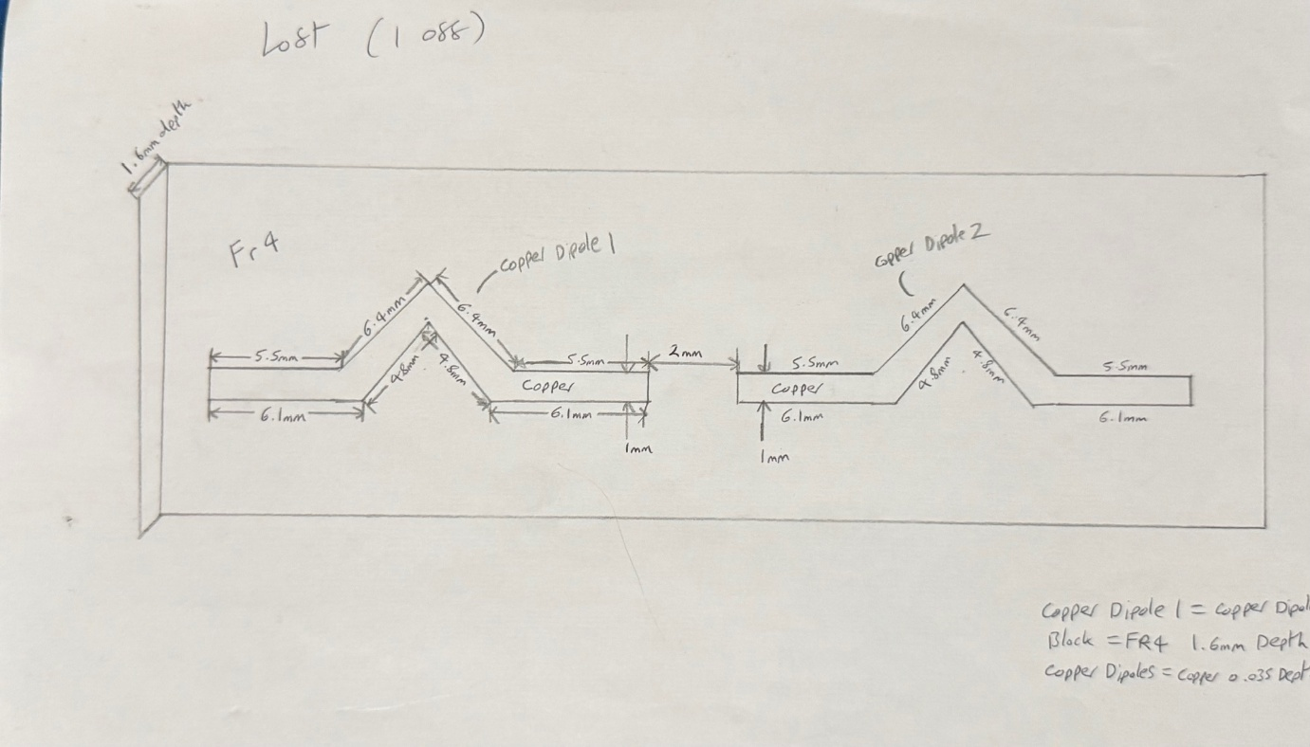
Figure 21 - Antenna Design Specifications
Shown above is the design of the antenna used within the rectenna portion of the project including, the dimensions, spacing, thickness and materials which have been used to allow the antenna to operate in its functional format. The antenna, to allow it to sit onto the circuit board without modification, has been made from the original materials a PCB board would be printed from. These materials are Fire Retardant 4 (FR4) which is used as the substrate at which the elements can sit on and copper lining which has permittivity close to 1 for the radiating elements. The permittivity is important in an antenna model as it gives the indication of how much energy the electric field of the model can hold [32]. Due to this design being small and radiating at a low level a high permittivity is not needed. The antenna will be connected by simple soldering and will be an input to the rectifier to transfer the energy directly from the antenna to the battery in order to power the circuit.
The size of the antenna has been designed from pervious frequency calculations for the required 2.4 GHz band as shown below.
$$λ=\frac{C}{F}$$
Equation 1 - Wavelength Calculation
𝜆=𝑊𝑎𝑣𝑒𝑙𝑒𝑛𝑔𝑡ℎ
𝐶 = 𝑆𝑝𝑒𝑒𝑑 𝑜𝑓 𝐿𝑖𝑔ℎ𝑡 = 3 * 10^8
𝐹 = 𝑅𝑒𝑞𝑢𝑖𝑟𝑒𝑑 𝐹𝑟𝑒𝑞𝑒𝑢𝑛𝑐𝑦 = 2.4 𝐺𝐻𝑧 = 2.4 * 10^9
$$λ=\frac{3*10^8}{2.4*10^9}=0.125 m=125 mm$$
Equation 2 - Wavelength Calculation with Variables
Dipoles operate at ½ lambda.
𝜆/2 = 125/2 = 62.5
Equation 3 - Half Dipole Calculation
Each dipole has then been set with the length of 23.8 which is just under the length of the ½ dipole to ensure the best frequency models could be created. The length can be varied like this due to the changes in the thickness of the material, the length of the substrate, the separation distance and the thickness of the substrate.
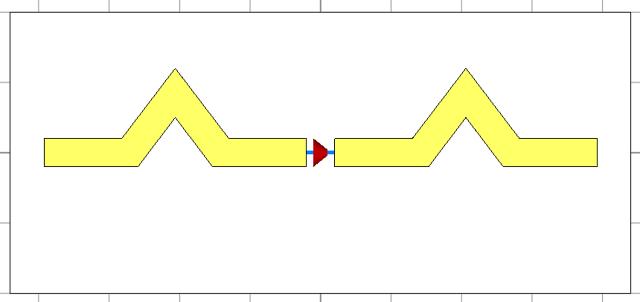
Figure 22 - Antenna Design Using CST
Using CST simulation software, a simulation of the antenna which has been proposed in this model can be drawn up and tested to ensure the frequency is working and the directionality can be approved before a hardware model is produced. This simulation system helps to understand any changes which need to be made to provide a working antenna. The design is shown to be bent in the middle even though the length could easily be straight on the substrate. This is because the design would have to be as small as possible but still operational to fit into a small watch model which can be done by keeping the same electrical length of the radiating elements regardless of the structural design.
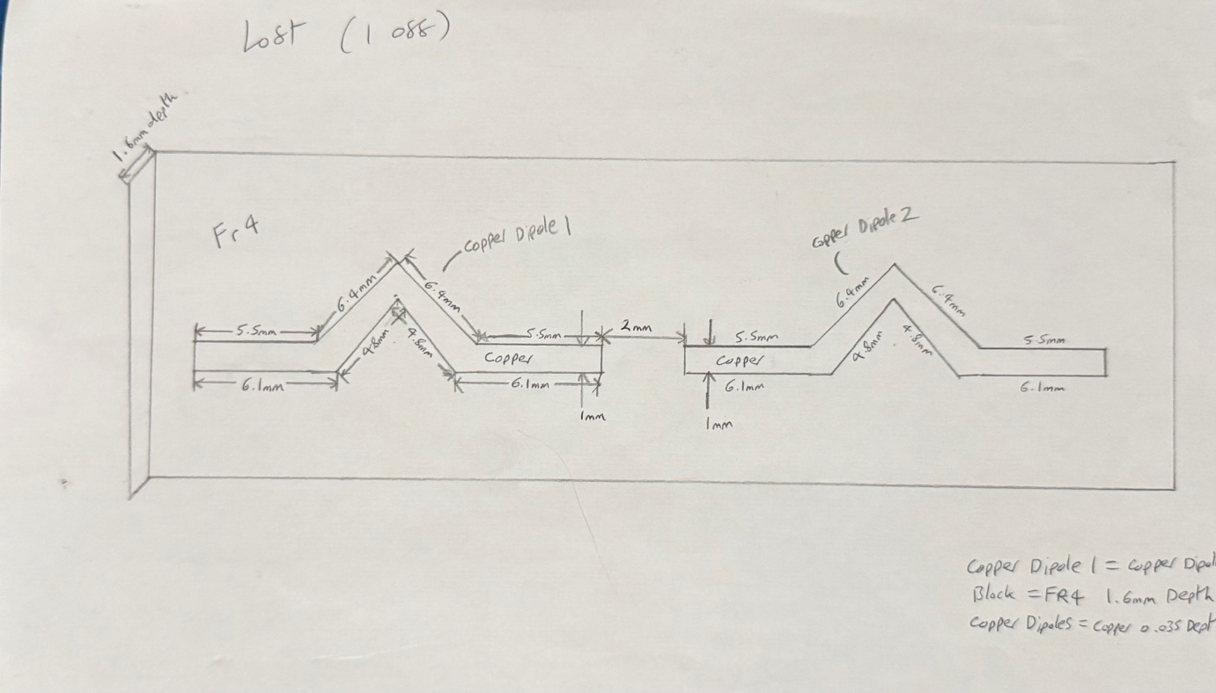
Figure 23 - Antenna Mechanical Drawing
As shown below, the antenna is operational at the required set frequency of 2.4 GHz.
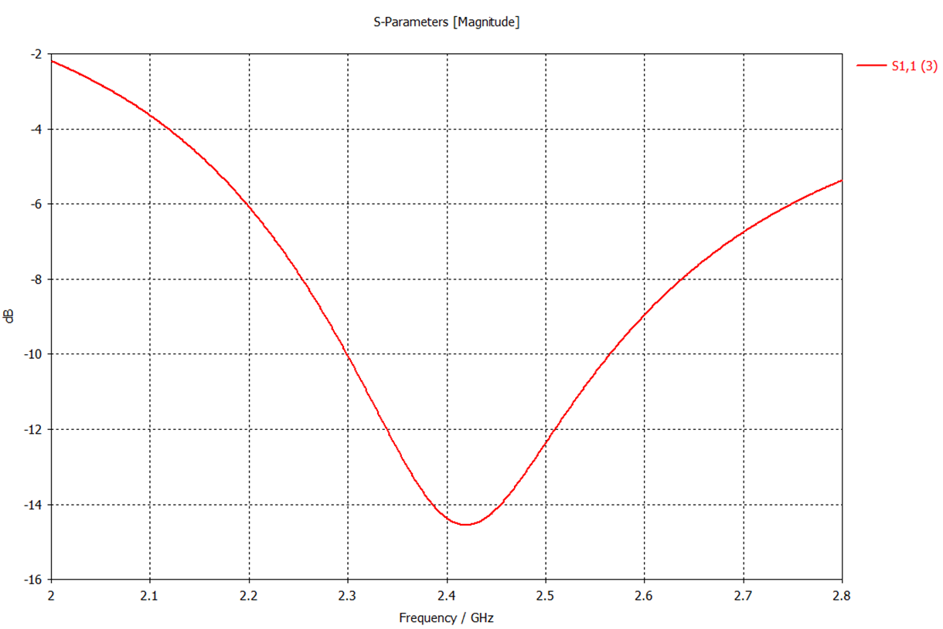
Figure 24 - S1,1 Parameters for the Antenna
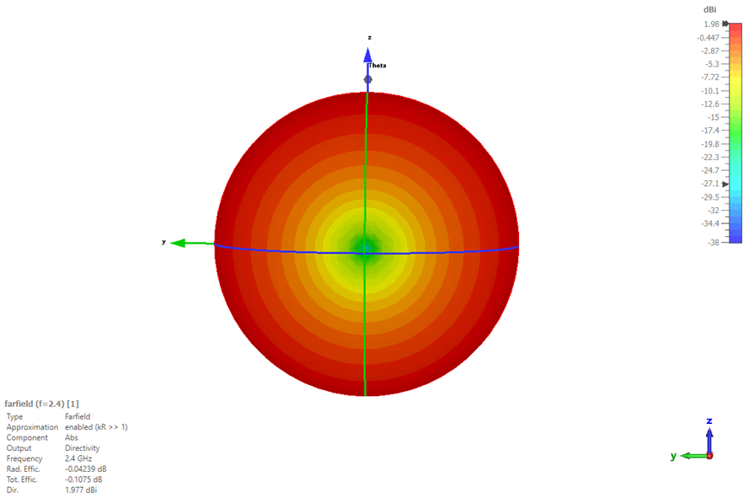
Figure 25 - Antenna Radiation Pattern
The above radiation pattern shows that the dipole is operating in an omnidirectional capacity. Omni directional means that the gain of the antenna, as seen here at around 2 dBi, is radiated at almost all angles through 360 degrees. With this it can be determined the levels are acceptable so that the user is not at harm from radiation burns. The field is shown without a reflective plate behind the back of it. This reflective plate will cause the radiation pattern to become more of a broadside beam shape with the back lobe being far smaller than that if the main lobe. This means the directionality will change slightly from omni directional however, it will not change enough to cause the antenna to fault or not pick up the 2.4 GHz signals. The 1D Azimuth and Elevation planes below demonstrate the axis at which the patterns will be radiating in the prototype and final model.
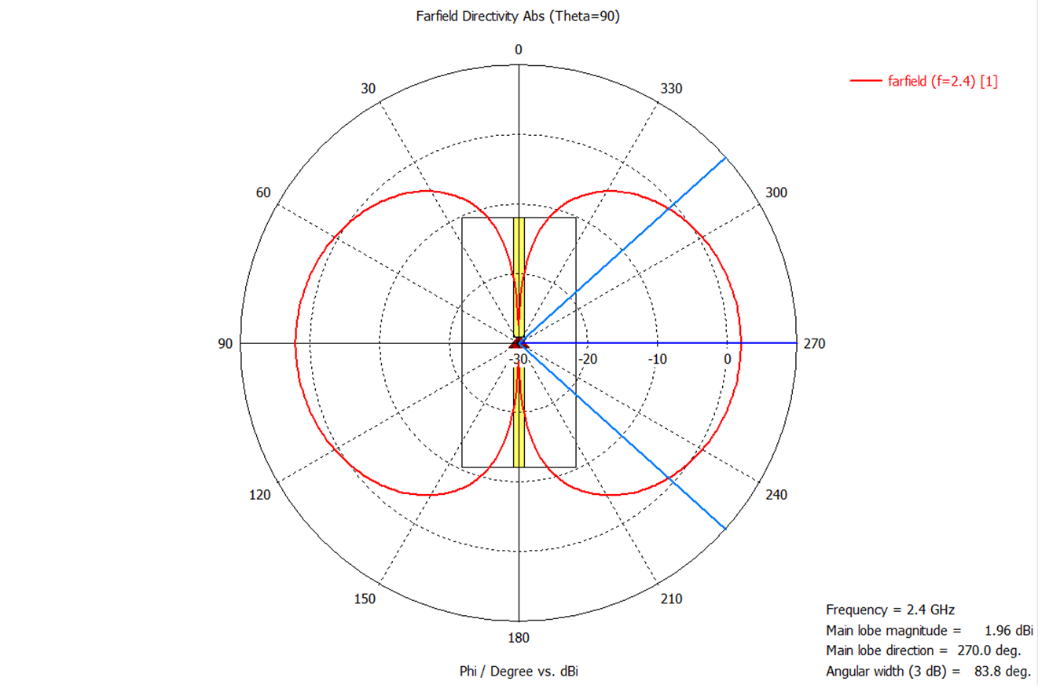
Figure 26 - Antenna Azimuth Plane
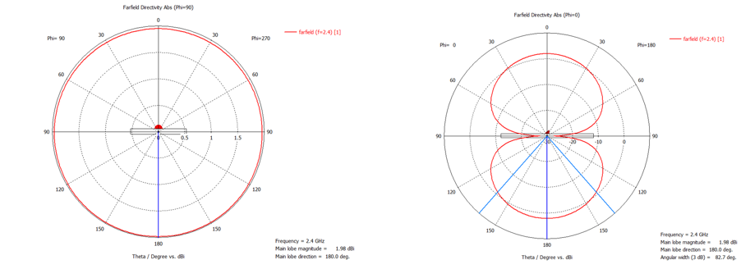
Figure 27 - Antenna Elevation Planes

Printed Circuit Board
The last step of the design was to create and manufacture a printed circuit board which could hold and run all of the components. The circuit board needed to be designed in a way which would allow the light from the PPG monitor to sit next to and shine into the skin whilst the LCD is on the top of the board for reading the heart rate value to the user. The design was made using the simulation software CCS which was used due to its easy compile time, its simplistic nesting and its easy error detection functionality.
The first step to designing the circuit board was to gather the components and place them into a schematic. This schematic would allow testing to be done by placing different net values to correspond with the specified connection point on the chip and the lcd console. It was imperative that during this stage the wires were not crossed over short circuiting any of the components and possible causing a catastrophic failure of the circuit. If this happens then there may be a higher risk to the user that needs to be mitigated. The way the schematic is designed is to be almost directly matched to the previous proteus design model. This will allow a copy of the simulation prototype to be made which can then be translated into a 3D PCB design model to do a visual check before it can be sent off to be manufactured. Shown here is the first iteration of the PCB schematic design.
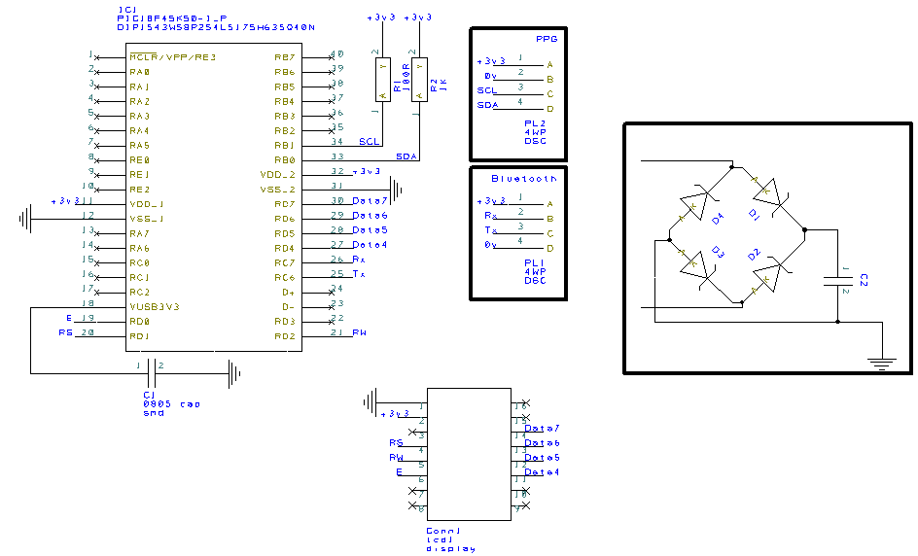
Figure 28 - CCS Schematic Design for PCB

As stated above, once the PCB schematic has been finalised it can be translated to a full board PCB design model. This translation forwards all of the prior nets, connections and components forward to start building the final design structure. This structure follows the same design rules and changes as the schematics and the previous figure above.
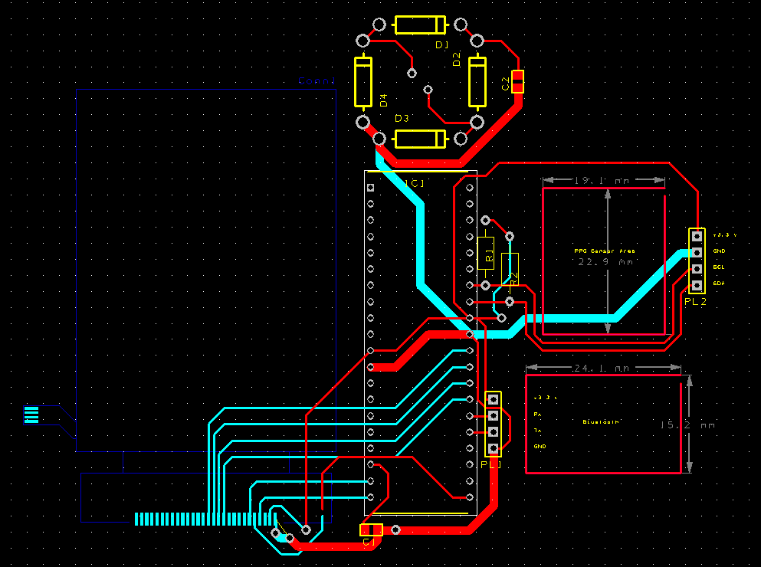
Figure 29 - PCB Final design Schematic
The red connections on the board above and set out along the top copper layer of the board which holds most of the through hole components. The blue wires are the copper lining which tracks along the underside of the board. This is spaced out to adhere to the design constraints of having the LCD on one side of the board and the PPG sensor on the other side. The gaps shown by empty wire nets are placeholders for the PPG sensor and the Bluetooth chip to be inserted into the design. This design element will be hand done to avoid complication or oversizing. The first figure below shows the top side of the board which will be face down towards the user. The second figure shows the back of the PCB board which will have the LCD screen on for the user to see. The design has been made this way to be visually appealing to the user as well as for comfort.
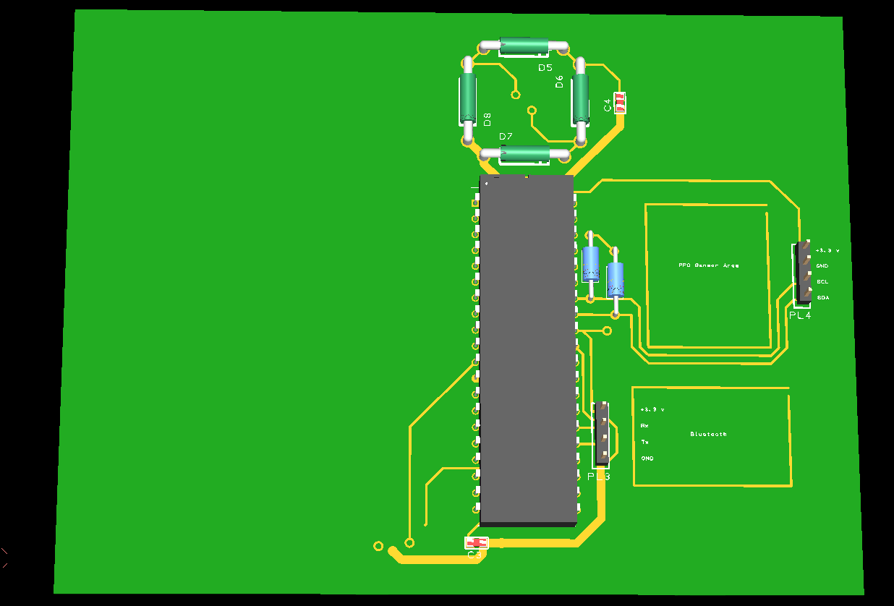
Figure 30 - Top side of the PCB Board 3D Model
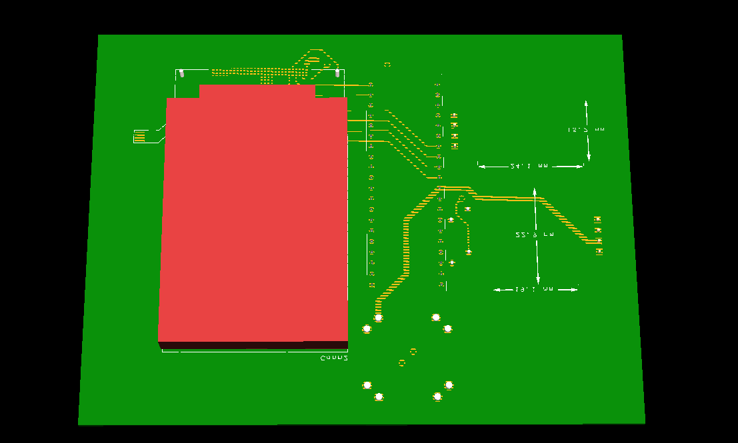
Figure 31 - Bottom Side of the PCB Board 3D Model

Chapter 5 – Evaluation
It can be determined from the data above and throughout this report that the current models on the market are working optimally but are increasingly expensive for the users. The design has been made to cost a fraction of the price but still perform the relevant tasks of getting the heart rate and SP02 values and displaying them for the user. It can also be determined from prior testing on the physical Arduino that the Bluetooth and PPG sensor can work in tandem with each other and won’t cause any power deviation or drainage within the model. This ensures that the model will still require low power for operation and will not exceed the maximum limitations to cause hard to the user.
Another element which was tested was the possible coupling from the Bluetooth antenna and the Rectenna due to them operating on the same frequency. As shown in the previous PCB models, the Bluetooth antenna has been placed on the horizontal plane whilst the antenna for energy harvest will be positioned vertically along the open space of the FR4. Due to the antennas being on different axial planes, their near and far fields do not couple with each other allowing both systems to operate simultaneously with no efficiency drawbacks. This proves that the background knowledge of coupling antennas is in direct alignment with this project.
Further research on I2C communications shows that the communication link between chips can sometime be temperamental if the data being transmitted is of a large packet size. To try and combat this, a consistent level of 32 bits maximum has been used. This research finding allowed the project hardware to be operated in an optimal capacity and function like other predesigned models. The design will not require any additional payment for a subscription or an app as it was found through multiple sources that the main factor, user’s do not choose higher end monitors is due to ongoing prices for its operation. This prohibitive cost factor, if implemented, would then restrict the user base which in turn would go against one of the main aims of the project being that the design attractive for users of all ages and socio economic backgrounds.
The project, overall, covered most of the aims and objectives set out to completed over the six-month timeframe, however, not all of the aims were met due to certain setbacks. The main aim of the project was to develop a functioning version one prototype of the PPG sensor which could be easily operated by the user and within a good price range to be accessible to all users. A version one prototype has been made however due to the timescale and manufacturability of the design, the model has only been designed using a predesign Arduino as the main protocol command chip instead of the PIC. Regardless of this fact the design is incredibly easy to use and only requires the user to place the device on their wrist to start reading their heart rate. This means it can be easily operated by all ages. To add to this, the total cost of one design model to produce is an estimated £32.50 which is at the same price range as the lower end Fitbit designs. This implies that it can slot into the gap in the market for cheaper operational heart rate monitors and is affordable for a range of potential customers.
The device, as a prototype, would not be suitable for a user as there is no protective layer, like rubber, between the device and the user’s wrist to stop any rubbing or discomfort to the user. This could easily be overcome by adding a supportive layer and wrist band which would hold the device in place whilst monitoring the heart rate. Another factor which could affect this is the current size of the model. The prototype at the moment is around two times the size of what it should be for a wrist worn monitor. This is due to a fatal error when ordering the materials. When producing the final prototype, all of the components that were bought were through hole mount instead of being surface mount. Although this has no effect on the model’s overall capability, it does make it considerably larger which is not ideal for some of the user base.
Simulation testing was conducted on the antenna using the CST software which can establish the operational frequency, any reflectivity back to the device (s2 1), the power transmission levels (s2 2) and the beam patterns which are exhibited when the port is excited. This allowed the theoretical model to be 100% accurate to the capability and frequency requirements of this project. Due to delay time in manufacturing an integrated antenna was unable to be produced however, after further testing, this will be a requirement for the future design elements of this project. The integrated design when manufactured will sit alongside the PIC on the circuit board due to the size of the elements enabling an easy placement for the model.
One area which was not tested during this project due to time constraints is the power consumption of the circuit and the power absorption from the antenna. In order to establish if the circuit could function solely off of the power harvested from the atmosphere, a test would have to be conducted to check the energy levels of the incoming electromagnetic waves. This test would be done in a controlled environment such as an anechoic chamber (as shown below) to ensure that the only signal within the area is 2.4 GHz. A signal generator would be put at one end of the chamber putting 2.4 GHz into the environment with the PPG sensor design at the other end. The charge levels could then be monitored, and the ac or dc current could be shown with volt meters. Future developments will include this test set to provide evidence that the antenna can draw enough power to power the PPG sensor, LCD and Bluetooth chipset.
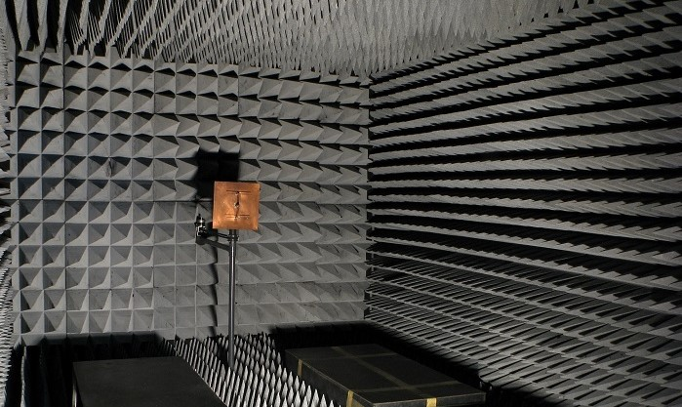
Figure 32 - Anechoic Chamber [33]
During this project it was found that sometimes charging types can be quite temperamental and may possibly have issues in the long term. Due to this prototype only requiring the one antenna to allow a charging capability, it makes it quite vulnerable to degradation or possible power failure. To combat this in future designs a backup wireless charging pad can be placed on the underside of the monitor allows an alternative method to charging that purely relying on the antenna obtaining enough power day in day out. Although this will change the ideology of this prototype being completely green energy, it will be more adaptable to the current market as well as, making it more desirable to the user base.
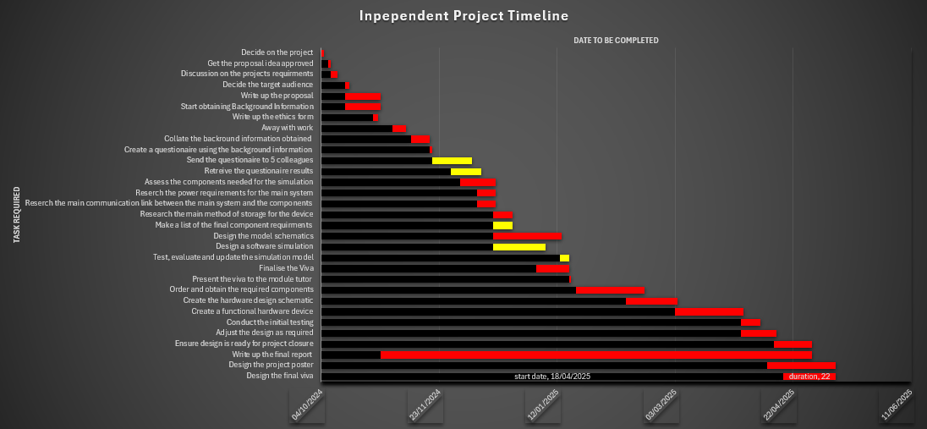
Figure 33 - Finalised Gantt Chart
Highlighted above in yellow are the five areas of the project at which the time taken to achieve was slightly longer than originally anticipated. Due to colleagues being away on annual leave at the time, conducting the questionnaire to establish what elements were a must in the project, was both handed out and received late. This did not stop or alter the project as other systems and prior testing was conducted during this time in place of the questionnaire analysis. The other main drawback of the project was not fully understanding the time it would take for a software simulation to be created and pre prototype testing to be completed. For future prototype developments, more time will be allocated for the software simulations and holiday / annual leave will be checked prior to setting dates for the questionnaire to be released.
Sizing was one of the main factors with this design model due to its capability. Most fitness bands / watches come with a sleek look and design to encase a small processing chip for its operational procedures. This means that the user does not have something incredibly heavy on their wrist and can maintain the mobility whilst wearing the watch which is one of the key points that sports teams look for when getting fitness trackers. In order to facilitate this point, some adaptability from the version 1 prototype would have to be made such as using surface mount components instead of through hole components. Surface mount components are, on average, four time the normal size of their through hole counterparts, however they still maintain the same capacity to control the desired circuit. By making this adjustment in future, the design would sit much nicer on the user’s wrist and make it a much smaller comfortable design for everyone.

Chapter 6 – Conclusions and Recommendations
This development project has produced a way to create a heart rate photoplethysmography sensor utilising atmospheric energy harvesting for use within a personal medical setting or for fitness level tracking. With careful planning, the project was able to meet most of the aims and objectives which have been set out, including, creating a new energy harvesting PPG sensor, making the model easy to use to be equal for all, create communication links both internal and external to the design as well as, retain most of the capabilities that other market monitors currently have.
Throughout the project, one of the key aspects was to work on the individual steps of the plan separately to ensure their operational procedures were correctly working and to the standard of the outcomes of the project objectives. By doing this, compartmentalisation of tasks could be achieved, and the project would have a flow of operations ensuring no aspect was missed or incorrect. This process started by setting a code utilising previously designed file structures and altering them to achieve the correct transmission rate, data packets and communications. Once this had been completed, the file could be adapted to work in a common C code program. Using this prior testing, the project was able to be compiled together and slotted like a jigsaw to achieve minimal complications for the final project design.
Once the project code had been completed, the system could be transferred onto the Arduino board for pretesting. This system test would show if when the chipsets are all in place they could work together concurrently, and the design could become fully operational. This test was a complete success demonstrating that the code that was written could successfully operate the device under test (DUT). Unfortunately, due to project timing constraints a printed circuit board could not be manufactured in time. For future developments on this project, the code can be transferred onto the PIC18 chip and would function the exact same as if it was still on the Arduino board showing a complete success in the project’s capability.
Another area which needs to be improved is the energy levels of the device being that all of the power is currently obtained via energy harvesting. Although this device uses small amounts of power, to keep the sensor running for extenuated periods of time, a second charging source (as stated above) may need to be implemented. This adaptation would be an easy fix with the only change needing to be made is a charging plate for wireless energy transfer positioned at the underside of the board. This adaptation could allow more intricate advanced capabilities to be added into the final future design.
After researching the capabilities and critically analysing the results from transmission testing and energy usage, it can be determined that rectifier energy harvesting could be a way to create both a cleaner atmosphere as well as, creating a heart rate monitor which is on par with the current counterparts but at a fraction of the cost. With further developments into this area, a more sustainable source of energy capture, using this energy harvesting method, could be adapted in order to provide a sustainable way of renewable energy for all electronic devices not just PPG sensors.

Chapter 7 – Reflection
Over the course of this project, I have made consistent progress towards my academic, professional and personal life. When writing up this report I could see the progress / developments that I had made due to the flow of the wording. Before this project my work and writing would be dis jointed and bounce from subject to subject. By approaching the process like a story, I am able to explain the working proceedings in a more in depth way which can not only be easily followed by the user or an external reading the report but can also allow each topic to be covered in a more sophisticated manner.
Looking at all of the resource findings of this project really made me think about my own current fitness levels and where I would like to see myself a few years down the line. After reviewing my own heart rate, I made the decision to start eating and drinking healthier and creating a better mindset for myself which has dramatically improved my concentration, focus and my overall energy levels by getting more sleep and focusing on a newer outlook on life. This has helped me to become a better person from both a professional and personal standpoint.
Before the project I was unsure if I was able to work at the standards which would give me the best outcome from higher and further education. Throughout the course and this project, I have proved to myself again and again that hard work and commitment pays off towards developing myself as a person. Learning more and more about coding, systems of operation and ethical considerations gave me an insight of the background that goes into creating products which I use every day and make me more appreciative of some of the nicer things that I have in life.
Learning about the underlying processes and protocols used in most everyday items allowed me to explore more technical approaches to the current work I am conducting as well as, allowed me to think outside of the box in certain situations. I used to start to give up when the project used to get tough or ask for help with most things, but after proving that I can do the project by myself with little guidance, I know that I can push myself to think in a problem-solving capacity and utilise previous methods of work to improve my own designs. Understanding how people work around problems or are able to solve them has given me a good perspective on what I should be doing to produce the best work I possibly can, all whilst assisting others. I have also learnt that it’s okay to ask for help sometimes and can vastly increase my output by brainstorming multiple ideas instead of just latching onto just one idea.
One of the main processes I learnt within this project was the design, development and implementation of a newly designed circuit board. Utilising simulation software, I was able to create a full simulation of the design and interpret what would be needed to ensure the system could operate in a natural capacity. Using a timeline and system of process really helped me to complete this project and output a design which could be slightly altered and put into production. Understanding the process of creating a design and then putting it into production gave me an insight into how operations work from a simple idea into an everyday item.
Overall, the project went well with most of the areas on my timeline being covered at the appropriate time. This has helped increase my awareness for time dependent projects and understanding areas within the design process, which in future, will require more time to complete. The project has allowed me to develop my professional thinking, problem solving and time management skills which can be used in a day to day capacity. Shown below is the final ghantt chart timescale which was used for this project including areas which were not met and the reasoning behind these issues.
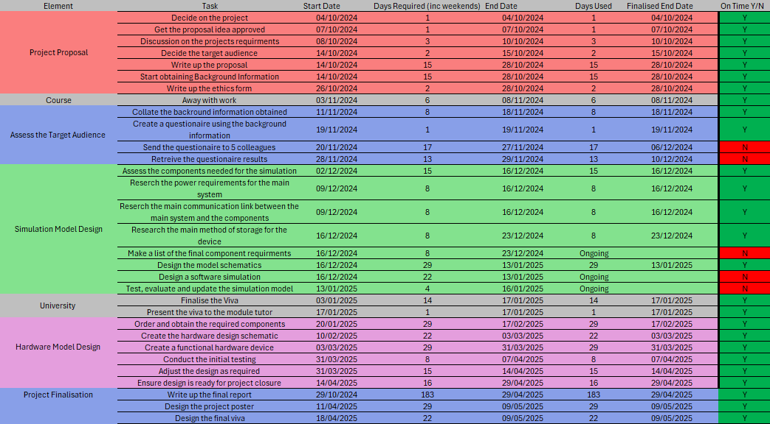
Figure 34 - Final Gantt Chart Timescale

References

[1] | J. S. P. P. M. G. A. C. F. X. P. K. P. J. B. M. P. R. D. J. R. a. N. M. A. E. Donchev, “The Rectenna Device - from theory to practice (A review),” Materials Research Society, London, 2014.
[2] | N. A. a. E. M. A. M. Shire, “Design of Rectenna for Wireless Energy Harvesting,” IEEE Student Conference on Research and Development (SCOReD), Malasiya, 2016.
[3] | Verizon, “A timeline and history of Fitbit.,” Verizon, 05 September 2023. [Online]. Available: https://www.verizon.com/articles/Accessories/history-of-fitbit/#:~:text=Founded%20in%202007%20by%20James,easy%20to%20track%20fitness%20goals.. [Accessed 04 March 2025].
[4] | Macys, “What Is A Fitbit and How do you use it?,” 2025. [Online]. Available: https://www.macys.com/ce/watches-buying-guide/what-is-a-fitbit. [Accessed 31 March 2025].
[5] | L. K. A. M. G. G. Riham Khodr, “Accuracy, Utility and Applicability of the WHOOP Wearable Monitoring Device in Health, Wellness and Performance - a systematic review,” MedRxiv, Yale, 2024.
[6] | C. Strunck, “Is the Whoop band worthit?,” 30 April 2024. [Online]. Available: https://www.harpersbazaar.com/uk/beauty/fitness-wellbeing/a60633062/whoop-band-review/. [Accessed 31 March 2025].
[7] | Apple, “Apple Unveils Apple Watch—Apple’s Most Personal Device Ever,” 9 September 2014. [Online]. Available: https://www.apple.com/uk/newsroom/2014/09/09Apple-Unveils-Apple-Watch-Apples-Most-Personal-Device-Ever/. [Accessed 7 April 2025].
[8] | A.-C. Christine Luff, “Fitbit vs. Apple Watch: Which Fitness Tracker is Better?,” Very Well Fit, 17 July 2024. [Online]. Available: https://www.verywellfit.com/fitbit-vs-apple-watch-7099233. [Accessed 7 April 2025].
[9] | Auris, “The History of Bluetooth,” Auris, 2025 . [Online]. Available: https://theauris.com/blogs/blog/the-history-of-bluetooth?srsltid=AfmBOoqocyFleYKA8eq-LCmoY27kCr8ZFp31J1VkU8674EtnViLhNJMG. [Accessed 20 Feburary 2025].
[10] | A. Nguyen, “Bluetooth 1.0 vs 2.0 vs 3.0 vs 4.0 vs 5.0 - How They Compare | Symmetry Blog,” Symmetry Electronics, 18 April 2018. [Online]. Available: https://www.symmetryelectronics.com/blog/bluetooth-1-0-vs-2-0-vs-3-0-vs-4-0-vs-5-0-how-they-compare-symmetry-blog/?srsltid=AfmBOorcu7bD7vyq0orsVtyYz94j-tWf7gTL-k9ESDqzTqQttz9-j0LO. [Accessed 21 Feburary 2025].
[11] | N. Phongchit, “What is Baud Rate and Why is it Important?,” 4 January 2016. [Online]. Available: https://www.setra.com/blog/what-is-baud-rate-and-what-cable-length-is-required-1. [Accessed 31 3 2025].
[12] | Maxim intergrated Technologies, “High-Sensitivity Pulse Oximeter and Heart-Rate Sensor for Wearable Health,” 2018. [Online]. Available: https://www.analog.com/media/en/technical-documentation/data-sheets/max30102.pdf. [Accessed 14 March 2025].
[13] | RS, Microchip, “Microchip PIC18F45K50-I/P, 8bit PIC Microcontroller, PIC18F, 48MHz, 32 kB Flash, 40-Pin PDIP,” 2014. [Online]. Available: https://docs.rs-online.com/c238/0900766b813835fd.pdf. [Accessed 4 April 2025].
[14] | RS, DFRobot, “A700000008916395.pdf,” 2025. [Online]. Available: https://docs.rs-online.com/e4db/A700000008916395.pdf. [Accessed 4 April 2025].
[15] | RS, Rubycon, “Minature Aluminium Electrolytic Capacitors,” 2025. [Online]. Available: http://docs.rs-online.com/f8b3/0900766b80029b9d.pdf. [Accessed 4 April 2025].
[16] | RS, Littelfuse, “Transient Voltage Suppression Diodes,” 2025. [Online]. Available: https://docs.rs-online.com/6264/0900766b810f4ec1.pdf. [Accessed 4 April 2025].
[17] | RS, TE Connectivity, “Carbon film fixed Resistors,” August 2015. [Online]. Available: https://docs.rs-online.com/85d2/A700000012777702.pdf. [Accessed 4 April 2025].
[18] | RS, DFRobot, “A700000008916391 SEN0344,” 2025. [Online]. Available: https://docs.rs-online.com/2bea/A700000008916391.pdf. [Accessed 4 April 2025].
[19] | RS-Pro, “RS PRO, 3.7V, 53.5 x 35 x 10.4 mm, Lithium Polymer Rechargeable Battery, 1.8Ah,” 2025. [Online]. Available: https://docs.rs-online.com/42f4/A700000008874152.pdf. [Accessed 4 April 2025].
[20] | Microchip, “128-Bit I2C™ Bus Serial EEPROM 24AA00/24LC00/24C00,” 2011. [Online]. Available: https://docs.rs-online.com/09ba/0900766b80b0475d.pdf. [Accessed 4 April 2025].
[21] | R. Bratucu, “How a serial number works and why you should use it,” RENTman, 2025. [Online]. [Accessed 7 April 2025].
[22] | S. Sharma, “FR4: Understanding the Material and Its Applications in PCB Design,” Wevolver, 13 Feburary 2025. [Online]. Available: https://www.wevolver.com/article/fr4. [Accessed 7 April 2025].
[23] | OFCOM, “What is Ofcom?,” OFCOM, 21 Jun1 2010. [Online]. Available: https://www.ofcom.org.uk/about-ofcom/what-we-do/what-is-ofcom/. [Accessed 11 April 2025].
[24] | S. Y. Caixia Huang, “A mini I2C bus interface circuit design and its VLSI implementation,” The Journal of Supercomputing, vol. LXXX, no. 16, pp. 23794-23814, 2024.
[25] | Computer Hope, “Bus,” Computer Hope, 31 July 2022. [Online]. Available: https://www.computerhope.com/jargon/b/bus.htm. [Accessed 8 April 2025].
[26] | D. Stefan, “Multiple Serial Device Interfacing to the I2C Bus,” in Electronic Design, Sunnyvale, Nashville, Endeavor Business Media, 2001, p. 60.
[27] | M. G. L. Eric Peña, “UART: A Hardware Communication Protocol,” Understanding Universal Asynchronus Reciever/Transmitter, vol. LIV, no. 4, pp. 1 -2 , 2020.
[28] | E. H. Rahul Awati, “What is parity in computing?,” TechTarget, July 2024. [Online]. Available: https://www.techtarget.com/searchstorage/definition/parity. [Accessed 9 April 2025].
[29] | RS, “A Guide to EEPROM,” RS, 24 January 2023. [Online]. Available: https://uk.rs-online.com/web/content/discovery/ideas-and-advice/eeprom-guide. [Accessed 8 April 2025].
[30] | B. H. Foundation, “Your Heart Rate,” British Heart Foundation, July 2022. [Online]. Available: https://www.bhf.org.uk/informationsupport/how-a-healthy-heart-works/your-heart-rate. [Accessed 9 April 2025].
[31] | CD-Team, “LCD 16×2 Pinout, Commands, and Displaying Custom Characters,” ElectronicsForU, 25 August 2023. [Online]. Available: https://www.electronicsforu.com/technology-trends/learn-electronics/16x2-lcd-pinout-diagram. [Accessed 11 April 2025].
[32] | BYJU'S, “Permittivity and Permeability,” BYJU'S, 2025. [Online]. Available: https://byjus.com/physics/permittivity-and-permeability/. [Accessed 11 April 2025].
[33] | Everything RF, “What is an Anechoic Chamber?,” 10 January 2021. [Online]. Available: https://www.everythingrf.com/community/what-is-an-anechoic-chamber. [Accessed 22 April 2025].
[34] | Tanya, “Free Risk Assessment Template,” Spire Safety, 14 January 2024. [Online]. Available: https://spiresafety.com.au/resources/free-risk-assessment-template/. [Accessed 24 April 2025].

Chapter 9 - Bibliography

[1] | J. S. P. P. M. G. A. C. F. X. P. K. P. J. B. M. P. R. D. J. R. a. N. M. A. E. Donchev, “The Rectenna Device - from theory to practice (A review),” Materials Research Society, London, 2014.
[2] | N. A. a. E. M. A. M. Shire, “Design of Rectenna for Wireless Energy Harvesting,” IEEE Student Conference on Research and Development (SCOReD), Malasiya, 2016.
[3] | Verizon, “A timeline and history of Fitbit.,” Verizon, 05 September 2023. [Online]. Available: https://www.verizon.com/articles/Accessories/history-of-fitbit/#:~:text=Founded%20in%202007%20by%20James,easy%20to%20track%20fitness%20goals.. [Accessed 04 March 2025].
[4] | Macys, “What Is A Fitbit and How do you use it?,” 2025. [Online]. Available: https://www.macys.com/ce/watches-buying-guide/what-is-a-fitbit. [Accessed 31 March 2025].
[5] | L. K. A. M. G. G. Riham Khodr, “Accuracy, Utility and Applicability of the WHOOP Wearable Monitoring Device in Health, Wellness and Performance - a systematic review,” MedRxiv, Yale, 2024.
[6] | C. Strunck, “Is the Whoop band worthit?,” 30 April 2024. [Online]. Available: https://www.harpersbazaar.com/uk/beauty/fitness-wellbeing/a60633062/whoop-band-review/. [Accessed 31 March 2025].
[7] | Apple, “Apple Unveils Apple Watch—Apple’s Most Personal Device Ever,” 9 September 2014. [Online]. Available: https://www.apple.com/uk/newsroom/2014/09/09Apple-Unveils-Apple-Watch-Apples-Most-Personal-Device-Ever/. [Accessed 7 April 2025].
[8] | A.-C. Christine Luff, “Fitbit vs. Apple Watch: Which Fitness Tracker is Better?,” Very Well Fit, 17 July 2024. [Online]. Available: https://www.verywellfit.com/fitbit-vs-apple-watch-7099233. [Accessed 7 April 2025].
[9] | Auris, “The History of Bluetooth,” Auris, 2025 . [Online]. Available: https://theauris.com/blogs/blog/the-history-of-bluetooth?srsltid=AfmBOoqocyFleYKA8eq-LCmoY27kCr8ZFp31J1VkU8674EtnViLhNJMG. [Accessed 20 Feburary 2025].
[10] | A. Nguyen, “Bluetooth 1.0 vs 2.0 vs 3.0 vs 4.0 vs 5.0 - How They Compare | Symmetry Blog,” Symmetry Electronics, 18 April 2018. [Online]. Available: https://www.symmetryelectronics.com/blog/bluetooth-1-0-vs-2-0-vs-3-0-vs-4-0-vs-5-0-how-they-compare-symmetry-blog/?srsltid=AfmBOorcu7bD7vyq0orsVtyYz94j-tWf7gTL-k9ESDqzTqQttz9-j0LO. [Accessed 21 Feburary 2025].
[11] | N. Phongchit, “What is Baud Rate and Why is it Important?,” 4 January 2016. [Online]. Available: https://www.setra.com/blog/what-is-baud-rate-and-what-cable-length-is-required-1. [Accessed 31 3 2025].
[12] | Maxim intergrated Technologies, “High-Sensitivity Pulse Oximeter and Heart-Rate Sensor for Wearable Health,” 2018. [Online]. Available: https://www.analog.com/media/en/technical-documentation/data-sheets/max30102.pdf. [Accessed 14 March 2025].
[13] | RS, Microchip, “Microchip PIC18F45K50-I/P, 8bit PIC Microcontroller, PIC18F, 48MHz, 32 kB Flash, 40-Pin PDIP,” 2014. [Online]. Available: https://docs.rs-online.com/c238/0900766b813835fd.pdf. [Accessed 4 April 2025].
[14] | RS, DFRobot, “A700000008916395.pdf,” 2025. [Online]. Available: https://docs.rs-online.com/e4db/A700000008916395.pdf. [Accessed 4 April 2025].
[15] | RS, Rubycon, “Minature Aluminium Electrolytic Capacitors,” 2025. [Online]. Available: http://docs.rs-online.com/f8b3/0900766b80029b9d.pdf. [Accessed 4 April 2025].
[16] | RS, Littelfuse, “Transient Voltage Suppression Diodes,” 2025. [Online]. Available: https://docs.rs-online.com/6264/0900766b810f4ec1.pdf. [Accessed 4 April 2025].
[17] | RS, TE Connectivity, “Carbon film fixed Resistors,” August 2015. [Online]. Available: https://docs.rs-online.com/85d2/A700000012777702.pdf. [Accessed 4 April 2025].
[18] | RS, DFRobot, “A700000008916391 SEN0344,” 2025. [Online]. Available: https://docs.rs-online.com/2bea/A700000008916391.pdf. [Accessed 4 April 2025].
[19] | RS-Pro, “RS PRO, 3.7V, 53.5 x 35 x 10.4 mm, Lithium Polymer Rechargeable Battery, 1.8Ah,” 2025. [Online]. Available: https://docs.rs-online.com/42f4/A700000008874152.pdf. [Accessed 4 April 2025].
[20] | Microchip, “128-Bit I2C™ Bus Serial EEPROM 24AA00/24LC00/24C00,” 2011. [Online]. Available: https://docs.rs-online.com/09ba/0900766b80b0475d.pdf. [Accessed 4 April 2025].
[21] | R. Bratucu, “How a serial number works and why you should use it,” RENTman, 2025. [Online]. [Accessed 7 April 2025].
[22] | S. Sharma, “FR4: Understanding the Material and Its Applications in PCB Design,” Wevolver, 13 Feburary 2025. [Online]. Available: https://www.wevolver.com/article/fr4. [Accessed 7 April 2025].
[23] | OFCOM, “What is Ofcom?,” OFCOM, 21 Jun1 2010. [Online]. Available: https://www.ofcom.org.uk/about-ofcom/what-we-do/what-is-ofcom/. [Accessed 11 April 2025].
[24] | S. Y. Caixia Huang, “A mini I2C bus interface circuit design and its VLSI implementation,” The Journal of Supercomputing, vol. LXXX, no. 16, pp. 23794-23814, 2024.
[25] | Computer Hope, “Bus,” Computer Hope, 31 July 2022. [Online]. Available: https://www.computerhope.com/jargon/b/bus.htm. [Accessed 8 April 2025].
[26] | D. Stefan, “Multiple Serial Device Interfacing to the I2C Bus,” in Electronic Design, Sunnyvale, Nashville, Endeavor Business Media, 2001, p. 60.
[27] | M. G. L. Eric Peña, “UART: A Hardware Communication Protocol,” Understanding Universal Asynchronus Reciever/Transmitter, vol. LIV, no. 4, pp. 1 -2 , 2020.
[28] | E. H. Rahul Awati, “What is parity in computing?,” TechTarget, July 2024. [Online]. Available: https://www.techtarget.com/searchstorage/definition/parity. [Accessed 9 April 2025].
[29] | RS, “A Guide to EEPROM,” RS, 24 January 2023. [Online]. Available: https://uk.rs-online.com/web/content/discovery/ideas-and-advice/eeprom-guide. [Accessed 8 April 2025].
[30] | B. H. Foundation, “Your Heart Rate,” British Heart Foundation, July 2022. [Online]. Available: https://www.bhf.org.uk/informationsupport/how-a-healthy-heart-works/your-heart-rate. [Accessed 9 April 2025].
[31] | CD-Team, “LCD 16×2 Pinout, Commands, and Displaying Custom Characters,” ElectronicsForU, 25 August 2023. [Online]. Available: https://www.electronicsforu.com/technology-trends/learn-electronics/16x2-lcd-pinout-diagram. [Accessed 11 April 2025].
[32] | BYJU'S, “Permittivity and Permeability,” BYJU'S, 2025. [Online]. Available: https://byjus.com/physics/permittivity-and-permeability/. [Accessed 11 April 2025].
[33] | Everything RF, “What is an Anechoic Chamber?,” 10 January 2021. [Online]. Available: https://www.everythingrf.com/community/what-is-an-anechoic-chamber. [Accessed 22 April 2025].
[34] | Tanya, “Free Risk Assessment Template,” Spire Safety, 14 January 2024. [Online]. Available: https://spiresafety.com.au/resources/free-risk-assessment-template/. [Accessed 24 April 2025].

Appendix

Figure 35 - PPG Survey Brief Page

PPG Completed Surveys (Chapter 3)
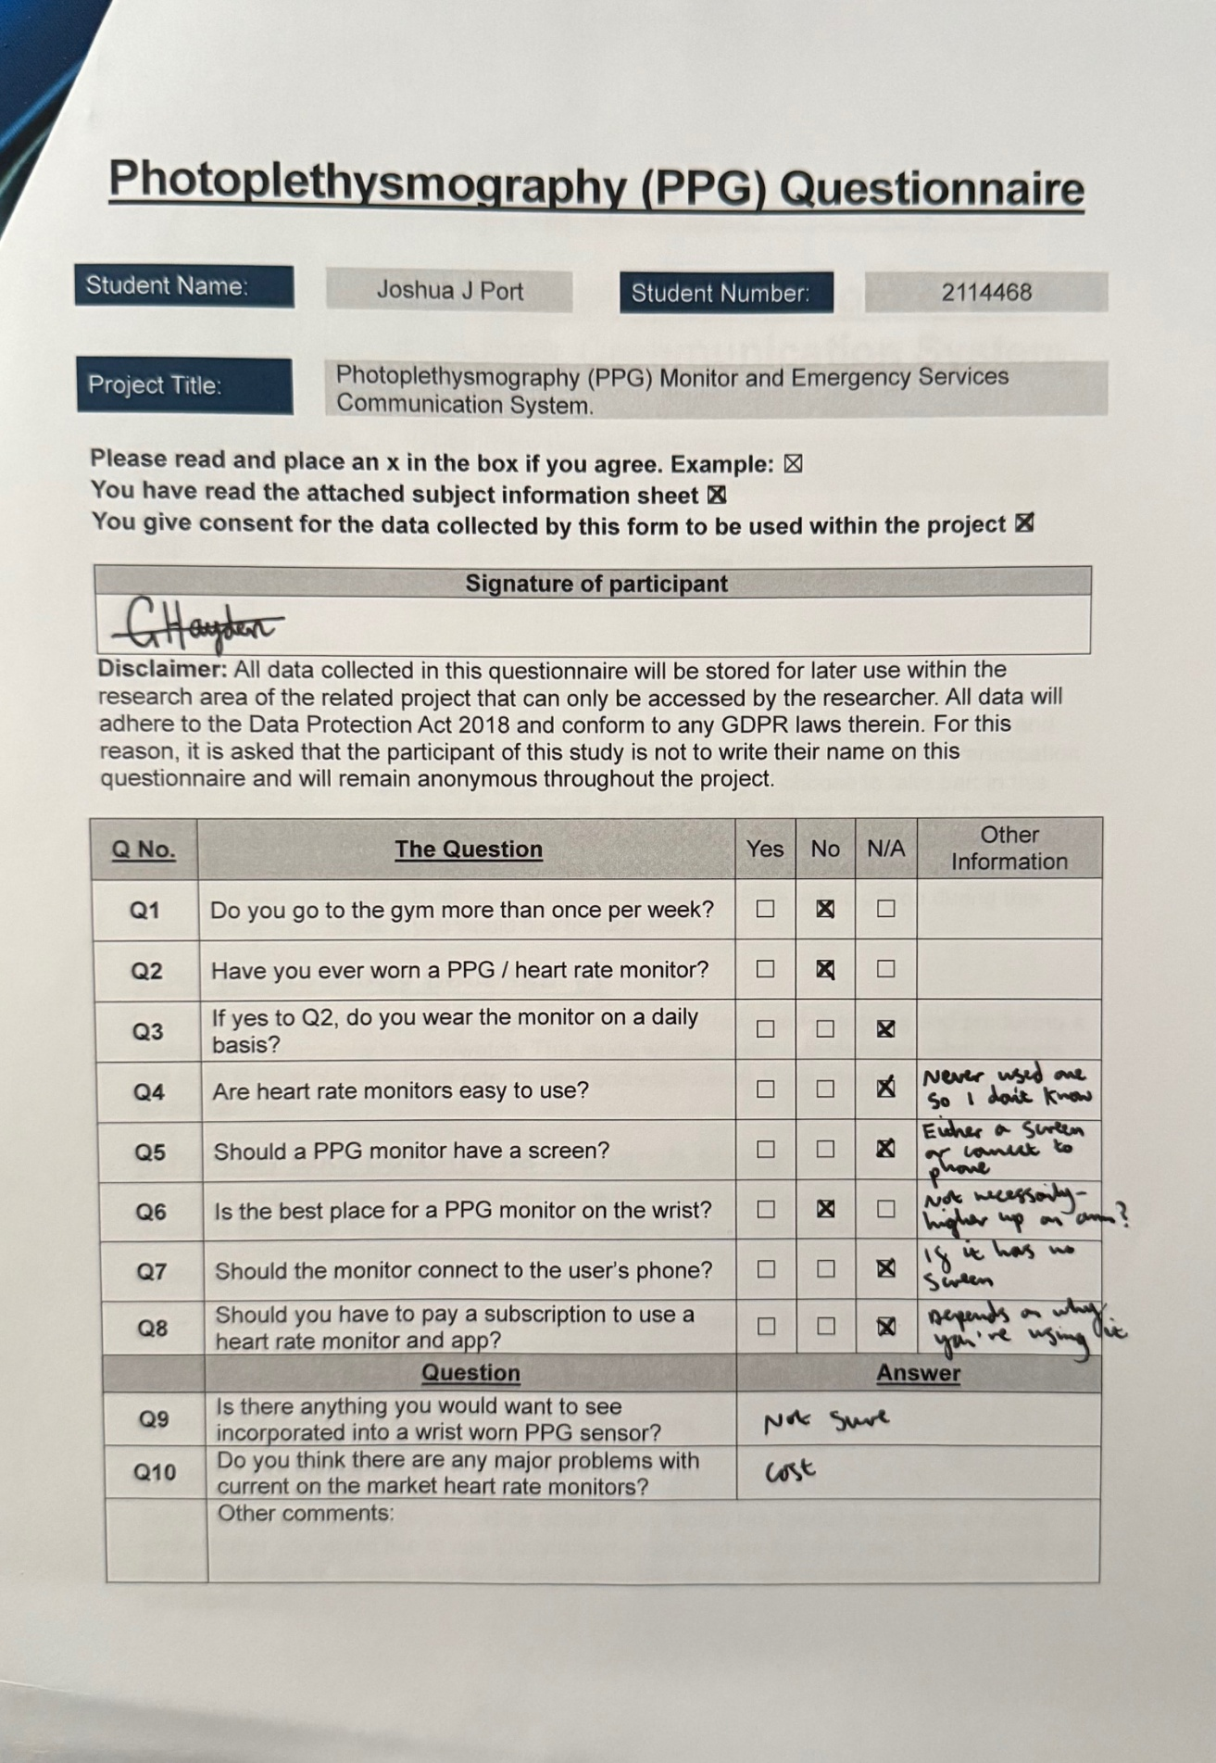
Figure 36 - Participant 1 Survey
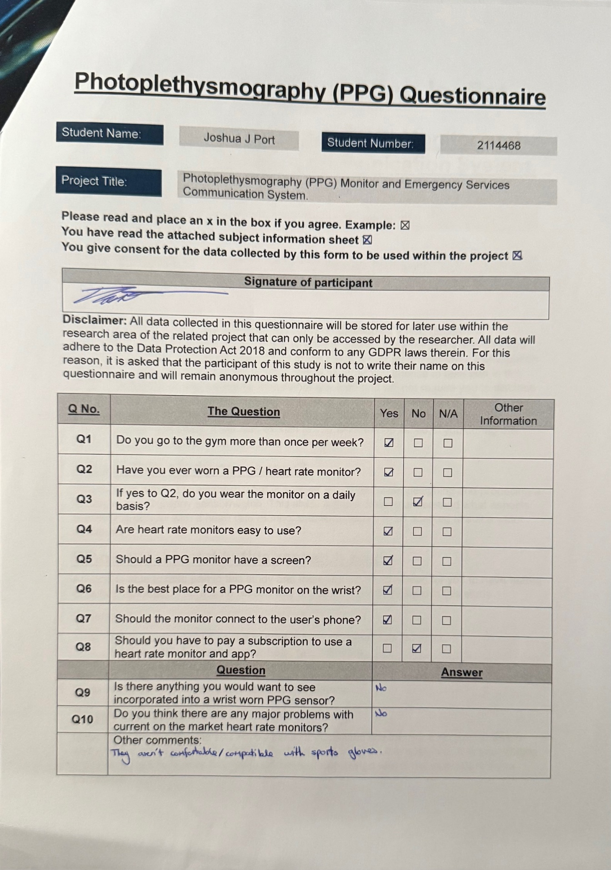
Figure 37 - Participant 2 Survey
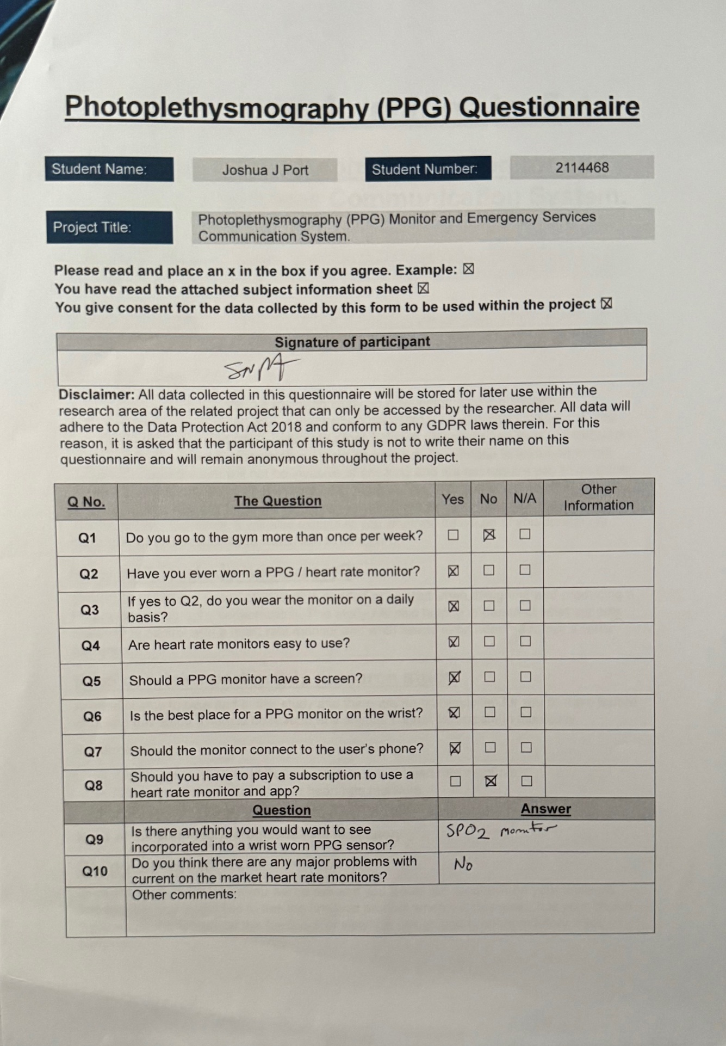
Figure 38 - Participant 3 Survey
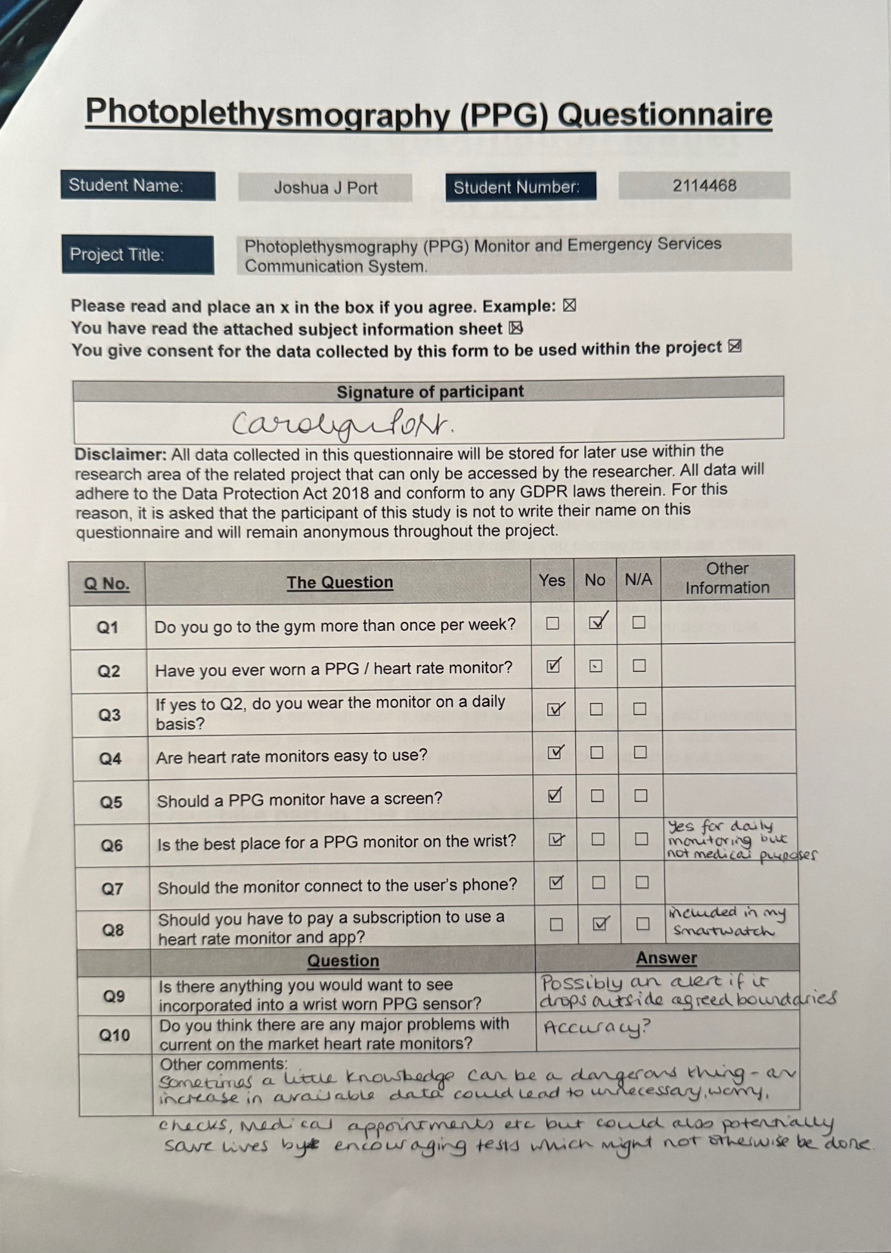
Figure 39 - Participant 4 Survey
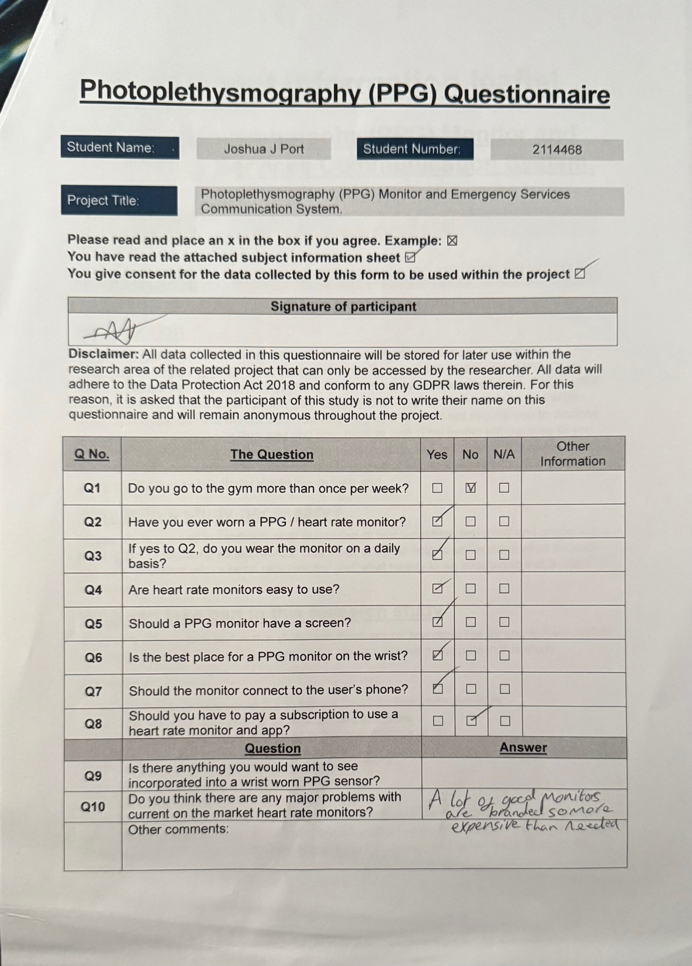
Figure 40 - Participant 5 Survey

CCS Chip Specifications (Chapter 4)

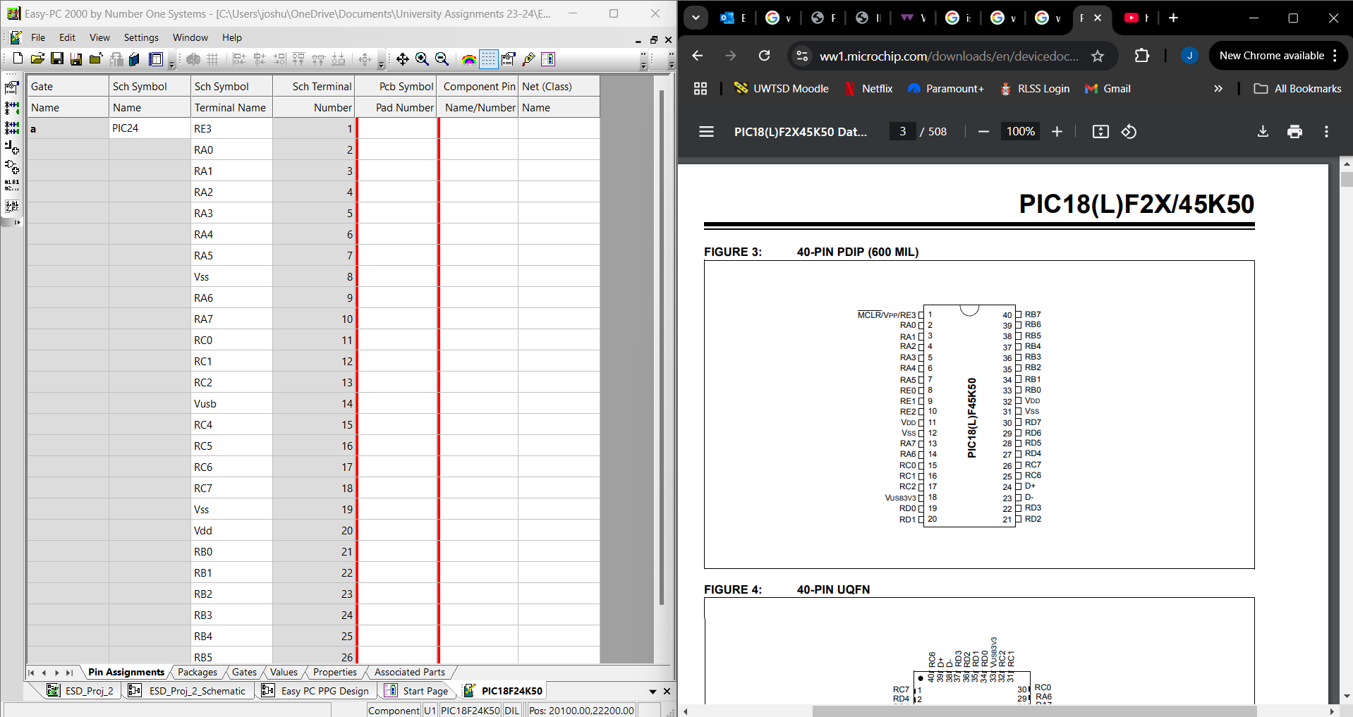
Figure 41 - Chosen PIC Construction in CCS

