Activity 2 and 4

Activity 2

The HR Role is built around integrity, transparency, and trust. People professionals need to be seen to champion ethical practices and work with the wider business to ensure the best possible outcomes for people throughout. HR professionals should role model ethical practice.

Making difficult decisions quickly and under pressure is a risk factor for unethical behavior. Individuals must take an ethical approach for the best possible outcome. Business are under pressure and will be likely to be publicly scrutinised and called out when they behave unethically. Social wellbeing is a focus. HR professionals need support from leaders to create practices that support their workforces especially in unprecedented times (CIPD, 2020)

Companies strive to have a culture, which in turn, improves morale. Good relationships with customers lead to an ethical reputation. This will enable companies outperform their piers financially in the long term (CIPD, 2020). The success of organisations relies on trustful relationships with employees, suppliers, customers, and community.

The ‘say/do gap’ can cause serious risk when leaders say one thing but do another. This is detrimental and can cause employees to be disengaged. HR professionals play a part in ensuring an organization’s ethical values and expectations are set out to enable employees to reflect this in their behaviors.

The CIPD Profession Map has been designed to guide the HR professional in relation to activities, knowledge and behaviors needed for success. The map has four bands. These bands define the contribution that professionals make at every stage of their HR career.; -

- The Client relationship that the HR professional have
- The activities that need to be performed by the Professional
- Where the time is spent
- Client services
- How to measure success

Band One – This band is a support mechanism for processes of administration, the individual would customer orientated data and information.

Band Two – Would give advice on HR related issues in the HR function and would have some knowledge/understanding of solutions available.

Band Three – Consultant or Partner in this field and would address HR challenges in the long-term

Band Four – Would be a leader in a specific professional area(s) and would take responsibility for all HR strategies development and delivering.

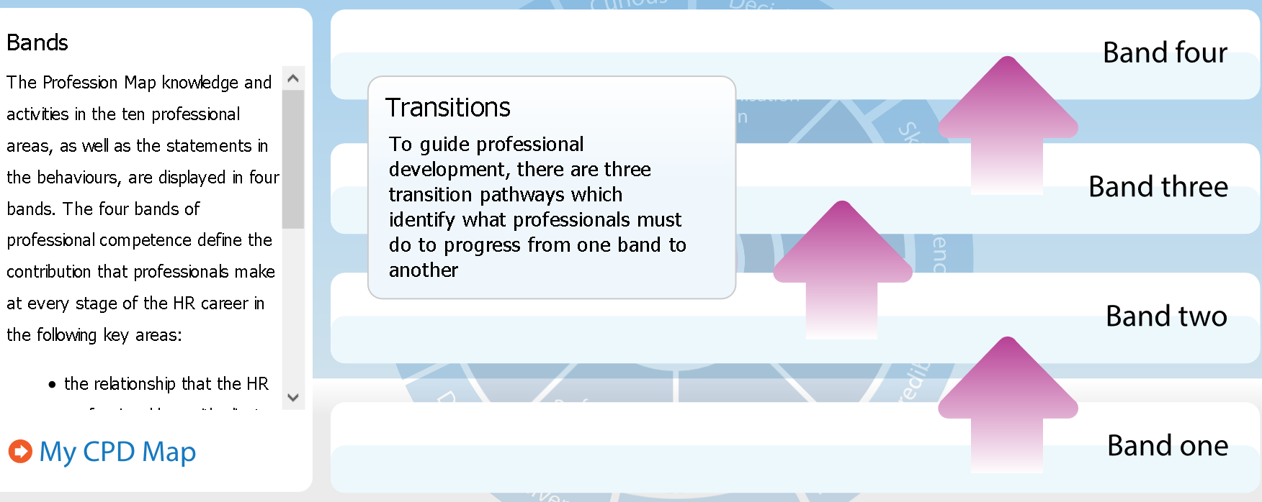

A ‘professional’ is someone that completes their job role to a high standard. HR has many dimensions. There are many elements that can be summerised to concentrate on as the ‘four concentric circles of HR professionalism’: - (Taylor and Woodhams, 2017).

- Managing Self – Managing your own skills, knowledge, and behaviors.
- Managing in Groups/Teams – To be able to network in tams or groups, working with other HR professionals to brainstorm solutions.
- Managing Upwards – To be able to work with senior professionals within organisations. To be able to implement specific strategies and plans with the wider organisational strategies.
- Managing across the organisation – To be able to set plans in motion across the organisation. Influence and communicate to Line Managers. Promote the benefits that can arise from successful cooperative HR activity.

The CIPD Profession Map states that there are ten professional areas set out in four bands of competence. These set out activities and knowledge for each area. Insights, strategy, and solution sit at the heart of the Map. There are Eight areas that identify what activities and knowledge needed to provide specialists HR support (CIPD, 2020)

The Eight behaviors within the CIPD Profession Map detail how to carry out activities and/or make contributions for success. Each behavior has been described within the four bands of competence. Within each behavior there is a contra-indicator illustration of negative manifestations. This will enable everyone to identify what good looks like and recognise the behaviors that are hindering development. The eight behaviors are – (CIPD, 2020)

- Driven to Deliver - Demonstrates determination, resourcefulness, and purpose.
- Courage to Challenge - Shows courage and confidence to speak up skillfully, challenging others even when confronted with resistance or unfamiliar circumstances
- Role Model - Consistently leads by example. Acts with integrity, impartiality, and independence, balancing personal, organisation and legal parameters.
- Curious - Is future-focused, inquisitive, and open-minded; seeks out evolving and innovative ways to add value to the organisation.
- Decisive thinker - Demonstrates the ability to analyse and understand data and information quickly. Uses information, insights, and knowledge in a structured way to identify options, make recommendations and make robust, defendable decisions.
- Skilled influencer - Demonstrates the ability to influence to gain the necessary commitment and support from diverse stakeholders in pursuit of organisation value.
- Personally credible - Builds and delivers professionalism through combining commercial and HR expertise to bring value to the organisation, stakeholders and peers.
- Collaborative - Works effectively and inclusively with a range of people, both within and outside of the organisation.

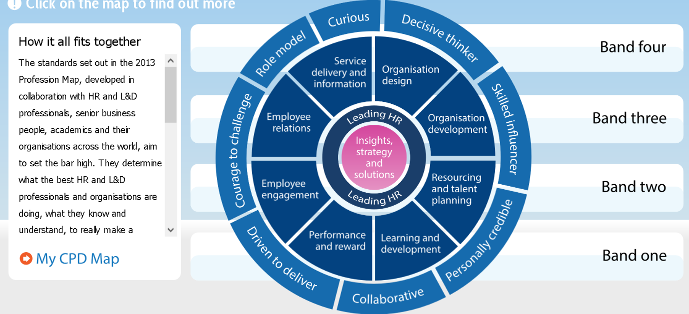

The behaviors set out from the Profession Map are essential to a HR Professional as it provides the individual ‘with the strongest foundation yet for effective decision making’. The behaviors outline ‘what it takes to be an effective People Professional in an uncertain world of work’ (salestrainingint.com, 2020). I believe the CIPD Profession Map is a continuous ongoing development tool which can be used in all stages of professionalism during a career. It provides the tools to improve personal challenges and/or provide you with knowledge and strategies to influence constructively and confidently. In an ever-changing high-pressured environment, the behaviors set out in the CIPD Profession Map, including the self-reflection tool keep values at the heart of any decision making and strive to encourage the practice of ethical principles. This will encourage the Professional to behave, act and champion better working environments.
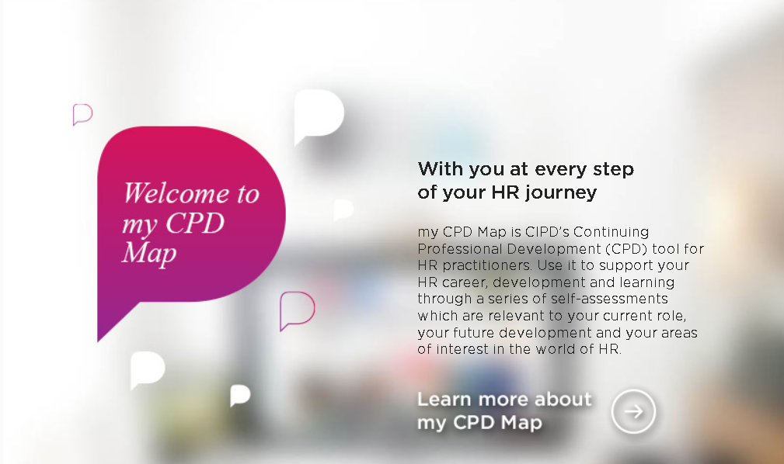
(Screenshot of PDP tool, 2020)
References

CIPD Profession Map available at; -
https://www.cipd.co.uk/learn/career/profession-map

Corona virus and the workforce – doing the right thing, available at: -
https://www.cipd.co.uk/news-views/changing-work-views/future-work/thought-pieces/coronavirus-workforce-crisis

CIPD 8 behaviors of the successful HR professional available at; -
https://www.salestrainingint.com/wp-content/uploads/2019/02/CIPD-8-behaviours-of-the-successful-HR-professional1.pdf

Taylor, s. (2017) 'chapter 4', in Perkins, G. (ed.) Studying Human Resource Management. Great Briton: CIPD, Pg. 75-78.

Word count - 926

Activity 4 – 1082 words.
Group dynamics is a set of behavioural and psychological processes that occur within a social group or between groups. It refers to the "nature of groups, the laws of their development, and their interrelations with individuals, other groups, and larger institutions" (Cartwright and Zander, 1968).
Group leaders and team members can contribute to a negative group dynamic (Mindtools, 2020)
- Weak leadership: This team man does not have a clear leader and often a strong member of the team will naturally take the lead. It may cause lack of focus and direction or to focus on the wrong points
- Excessive deference to authority: Colleagues may want to ‘People Please’ the leader and agree with every suggestion, therefore not having their own opinion.
- Blocking: Team members can be disruptive. Such as:
  - The aggressor: this person often disagrees with others or is inappropriately outspoken.
  - The negator: this group member is often critical of others' ideas.
  - The withdrawer: this person does not participate in the discussion.
  - The recognition seeker: this group member is boastful or dominates the session.
  - The joker: this person introduces humour at inappropriate times.
Free riding: some group members may make no contribution and have a lack of or no input. Free riders tend to work hard on their own but limit their contributions in group situations; this is known as "social loafing."
Evaluation apprehension: Perceptions can also create a negative group dynamic. Members can feel self-conscious, therefore not contributing from embarrassment.
To strengthen your team's dynamics, these strategies may be useful.
- Know your team.
- Tackle problems quickly with good feedback.
- Define roles and responsibilities.
- Break down barriers.
- Focus on communication.
- Pay attention.
Observing how your group interacts is an important part of your role as a leader. Many of the behaviours that lead to poor dynamics can be overcome and resolved at the earlier stages (mindtools, 2020).
Psychologist Bruce Tuckman developed a model that is widely used. It describes elements of group dynamics. There are five stages in the model. The first four were written and developed in 1965 with the fifth being added in 1977 (toggl.com, 2020). The example of the stages is described below; -
Forming Stage
A newly introduced team, all are pleasant and well mannered. It can be very exciting to start a new project. The first meeting format could be.
- Member’s skills, background, and interests
- Project goals
- Timeline
- Ground rules
- Individual roles
When the group familiarise themselves, roles and responsibilities will begin to form. It is crucial for team members to develop relationships and understand what part each person plays for clear understanding going forward.
At this stage, the team is more likely to get to know each other and productivity would be low.
Storming Stage
The storming stage can be a daunting as the size/need of the project/task this can be clearer. Self-doubt can creep in which can snuff out the excitement and politeness. This can also be interpreted as the Danger Zone” (Tesco, 2013)
Many personalities my not see eye-to-eye and there could be disagreement on how to complete tasks. Will call out team members if they think they are not contributing enough. Sometimes, the Group Leader is questioned over their leadership style.
It is important to remember that this is normal and most groups experience conflict. Members of the team/group need to understand that this behaviour/feeling is normal.
Conflict is a natural occurrence; however, some teams try not to acknowledge this stage. This avoidance usually makes the problem escalate until it is unmanageable later. Best practice is to recognise conflicts and resolve them as soon as they arise.
Norming Stage
Strengths of team members become recognised and appreciated. The team starts to settle. All members are contributing and working unitedly.
Storming has been known to be part of the norming stage. When a new task arises, it can unbalance the team and provoke a little conflict. It can be easier to address this if you have dealt with minor conflicts at the previous stage.
Performing Stage
The team is motivated which brings confidence and familiarity. The team will most likely have very little guidance/supervision. Everyone is like minded and driving towards the goal set at the beginning.
The performing stage is what all groups strive to reach. Conflict can make teams fail if it is not overcome and therefore do not make it to this stage.
Adjourning Stage/Mourning
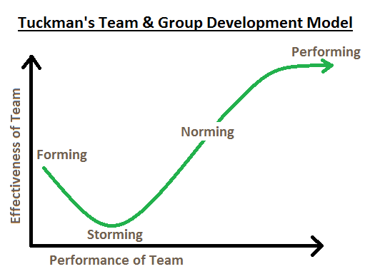
Tuckman added a fifth stage called adjourning in 1977. When a project comes to close, the team disbands. It can also be known as mourning. Teams grow close and can feel a loss when the experience has been completed to the full.

I have worked with a successful team within Morrison’s delivering a ‘Service Success’ presentation aimed at Customer Service Managers from 24 Stores. I quickly realised when preparing for the presentation that leading a group of professionals to the same goal was going to have characteristics of the Bruce Tuckman model.
Forming - I led a team of 4 People Managers. We met to discuss the aim and to delegate roles and responsibilities that the individuals were to have. Each Manager contributed and delivered a different part during the presentation.
Storming – One People Manager was not happy with their role, we discussed what the reasons for this were. We came to a compromise within the group and negotiated a different role. The pressures of the time constraint contributed to the storming stage. This was resolved with a clear time scale for each module.
Norming – We met to confirm the content of the presentation and were happy with the content that each member had contributed.
Performing – A video link meeting was held to share content for the final draft of presentation. The presentation was successfully delivered on time.
Adjourning – The presentation was a success; the team were happy with the result. There was sadness that the project had ended when the team disbanded to enable them to focus on other projects within the business.
Recognising Group Dynamics and Group Behaviours will strengthen and benefit any organisation. Organisational politics are a natural result of the fact that people think differently and want to act differently (Hrmars, 2020). It is important to point out at every stage that this process is ‘normal’. The HR professional is integral to this. Coaching /guiding and formal training is an imperative role within the business and will contribute to drive success throughout.

References

Effect of Organizational Politics on Organizational Goals and Objectives, Available at; -
https://hrmars.com/papers_submitted/1877/Effect_of_Organizational_Politics_on_Organizational_Goals_and_Objectives.pdf

Improving Group Dynamics available at; -
https://www.mindtools.com/pages/article/improving-group-dynamics.htm

Five Stages of Team Development -Understanding team development process Available at;-https://toggl.com/track/stages-of-team-development/

Group Dynamics: it’s characteristics, stages, types, and other Details | Management available at; -
https://www.yourarticlelibrary.com/management/group-dynamics-its-characteristics-stages-types-and-other-details-management/5363

Words 1067

