Module: Academic And Employability Skills
Module code: BMSW4001
Assignment Title: ACE Practical Portfolio
Module Leader: Sylvia Hoffmann
Student name: Shawaiz Ahsan
Student ID: 21344042
Table of Contents
Task-1: Presentation. 1
Task 2: Report 7
References 13

Task-1: Presentation.
Slide 1: Title.
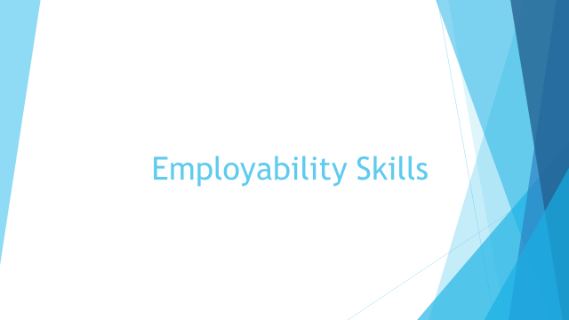
Slide 2: Table of Contents.
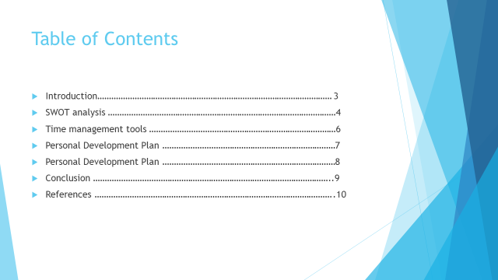
Slide 3: Introduction.
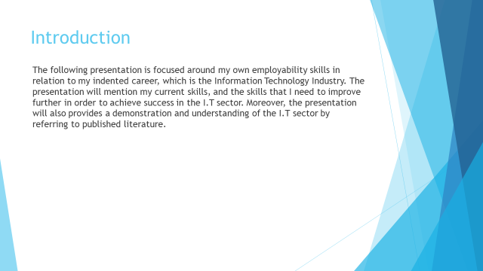
Slide 4: SWOT analysis.
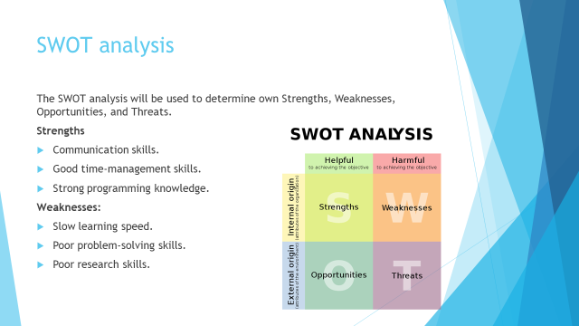
The I.T industry is one of the fastest growing sectors in the world, which as of now is valued at over £5 trillion (Iacono and Wigand, 2018). The personal SWOT analysis will be used for analysing my own strengths, weaknesses, opportunities, and threats, and match them with the requirements of the I.T sector.
Strengths:
- Communication skills: Working in an IT business will require strong communication skills as the projects must be communicated properly with team members to avoid errors or misunderstandings (James, 2019). I have strong communication skills which will be very beneficial for me when pursuing a career in the I.T sector. This skill will enable me to effectively communicate with my clients and co-workers, which in turn will reduce complexity and reduce errors.
- Time management skills: Time-management skills is another requirement of the I.T sector, as organizations have to complete multiple projects within a limited time. Therefore, with my strong time management skills, I will be able to prioritize my tasks using different techniques, such as the time management matrix, and complete my tasks before the deadlines.
- Programming knowledge: This is one of the primary requirements in I.T business and organizations, as, without proper programming knowledge, an employee will be unable to code or develop programs or work with I.T related software. Therefore, with my strong programming knowledge, I should be able to get a job in an I.T organization easily and help them to develop or maintain their I.T systems.
Weaknesses:
- Slow learning speed: The I.T industry is one of the most complex sectors due to new technologies and software, therefore, employees must possess a fast learning speed so that they can keep up with the changes. However, I have a slow learning speed, and this can hinder my ability to adapt to changes in a short time.
- Poor problem-solving skills: Due to the complexity of programming, machine learning, artificial intelligence, and so on, I.T business requires employees with strong problem-solving skills (Bihunova, Vorobiova and Fridrikh, 2019). However, I do not possess strong problem-solving skills, hence I cannot solve complex problems in a short time.
- Poor research skills: Lastly, I.T companies also look for candidates with strong research skills, as this sector depends on continuous research and innovation (Molyneux, 2018). However, I have poor research skills, and this can reduce my chances of working in a highly innovative company.

Slide 5: SWOT analysis
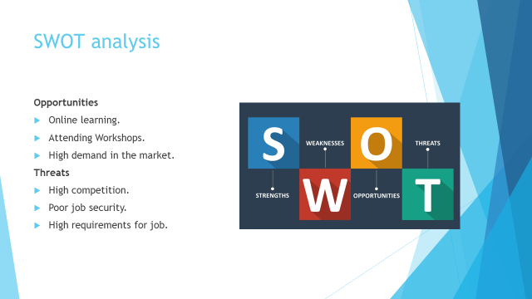
Opportunities:
- Online learning: Due to innovations in technology, it is now possible to take online courses at any time (Swan, 2019). This provides me with the opportunity to improve my skills further by taking courses on programming languages, improving my problem-solving skills, and so on.
- Attending workshops: Similarly, various workshops are often conducted in various different places, and by attending these workshops, I will be able to gain knowledge from industry experts and professionals, which will help to improve my programming skills (Murray, 2018).
- High demand in the market: Lastly, there is a high demand for skilled workers in the I.T sector, as organizations nowadays require information management systems to function in this modern world. Therefore, I have a high chance of finding a job with my current skills.
Threats
- High competition: There is high competition in the I.T sector as organizations provide high-position jobs with a good compensation structure, and as a result, the competition is very high, and people with higher skills will also compete with me for the same position.
- Poor job security: The I.T sector has one of the poorest job security due to the high volatility of organizations in the I.T sector (Tyugu, 2020). As a result, I might lose my job in an economic crisis, or my organization performs poorly.
- High requirements for the job: Lastly, the skill requirement of I.T businesses are very high, and they prefer individuals with years of experience over fresh graduates. As a result, I might find it difficult to find a job in an established company.
Slide 6: Time management tools
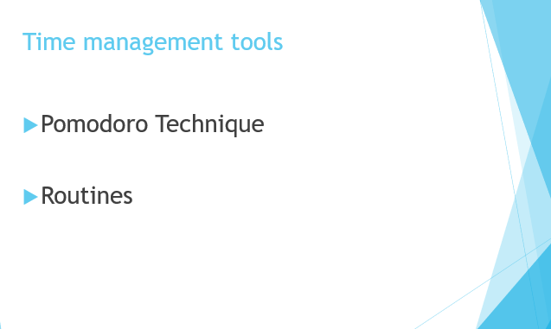
Pomodoro technique: It is a technique where a person breaks a large task and completes the task using a timer (Shah, Jepsen and Bankins, 2022). For instance, a student breaks down a large assignment and gives a timer of ten minutes to focus on finishing as much as possible. Then take a break of around 10 minutes and start again. Using this technique, I can also learn a coding language. As it is a tedious task, the Pomodoro technique will assist me in learning coding without getting bored which will ultimately help in excel in the IT sector.
Routines: It is a sequence of actions followed regularly by a person (Altahtooh, 2016). Using a daily routine, I can accomplish studying data science and ethical hacking. Maintaining a proper routine will assist me in learning both concepts regularly by making a balance of work. So, this will assist me in getting a good job in the IT sector by learning those concepts.
Slide 7: Time management tools (Continued)
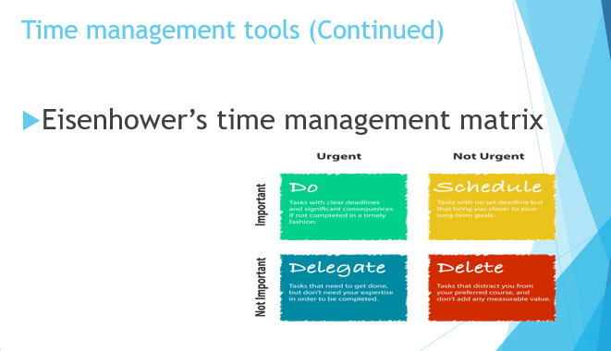
Eisenhower’s time management matrix: This matrix assists in identifying which tasks are important and which tasks are not important and then develops a routine to accomplish these tasks (Cotton, 2019). Using this matrix, I can identify that problem-solving skills are important in the IT sector. So, learning this skill is important in excelling in the IT sector which
I can find using the Eisenhower matrix.
Slide 8: Personal Development Plan
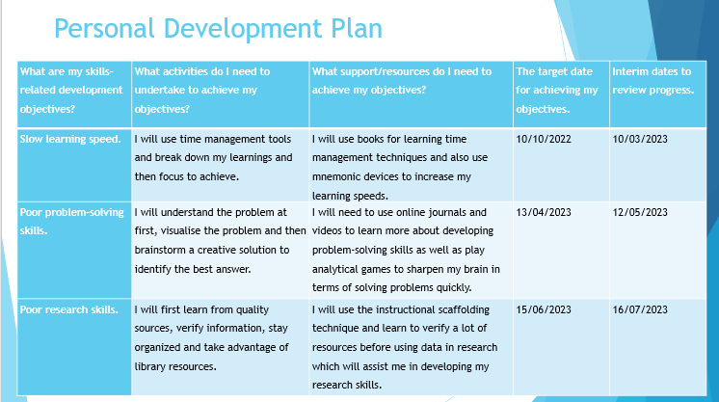

Slide 9: Conclusion
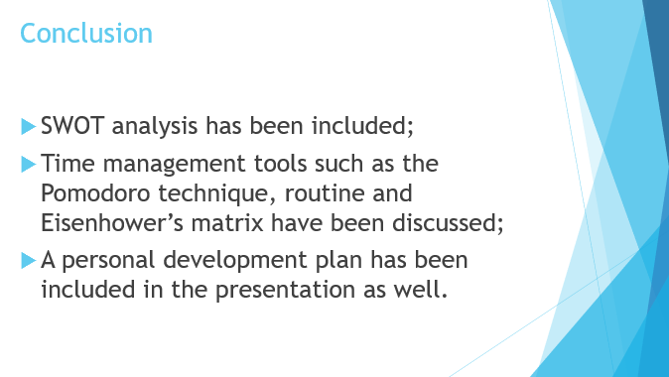
From the SWOT analysis, it has been identified that communication skills and proper time management are the strengths and problem-solving and research skills are the weakness. Using time-management tools, the person can develop the lacking skill to excel in the IT sector. Lastly, a personal development plan has been developed and outlined in the presentation as well.
Slide 10: References
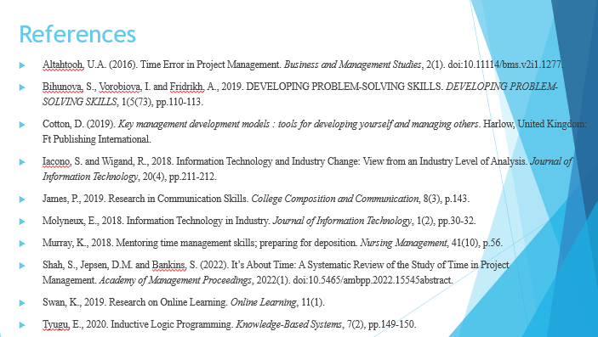

Task 2: Report
Introduction
The report will include a reflection on learners' skills by using Gibb’s reflective learning cycle. Gibb's reflective learning cycle will provide eth opportunity to describe the skills of a learner within six stages description, feelings, evaluation, analysis, conclusion, and action plan.
Gibb’s reflective learning cycle
To reflect on my learning from the module, Gibbs's reflective model is going to be applied. Gibbs's reflective model was developed by Professor Graham Gibbs in 1988. This model was developed to provide insights from experience and improve the activity for the future. The model had six stages. These stages are – description, feelings, evaluation, analysis, conclusion, and action plan (Jacobs, 2016). Using this model, a reflection on my understanding of organising the study, academic writing, paraphrasing, public speaking and giving presentation is given below.
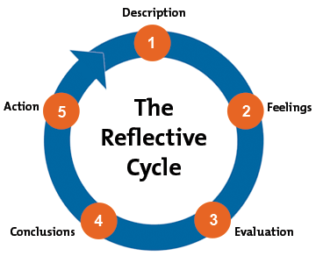
Figure-1: Gibbs reflective cycle.
Source: (Thorpe, 2018).
Description: Through the module, I have developed my understanding and skills in organizing study. With the help of this understanding, I am now able to make a schedule for particular subjects to study and other academic activities. The skill of academic writing was also developed in this module. With that, I can write various academic papers in a standard format. This skill helped me to improve my grades academic grades as my assignments and reports format met the lecturer's requirements. The lecturer of this module has contributed greatly to developing this skill as he provided guidelines and advice frequently on where to improve and how to format the writing (Gupta, 2019). Next, I learn paraphrasing skills and gathered an understanding of it. I learned that it was prohibited to copy someone else work. The module helped me to understand that I can use the funding of other works and use that only by paraphrasing them. However, as paraphrasing requires some skills such as – vocabulary understanding and grammatical implementation, I was also able to develop them with the help of this module. Moreover, I was able to combine my paraphrasing understanding and skill with my academic writing. Therefore, learning these skills and gathering an understanding of them was very much beneficial for me as a student. Along with these skills, I was also able to develop my understanding and skills in personation and public speaking. These skills helped me to overcome my introversion and made me confident to speak up with my voice. I have also learned how to make professional PowerPoint slides and also learned how to formally present a topic to the audience (Dougan, 2019). I was also able to get support and feedback on my presentation and public speaking skills from my instructor which helps me improve my skills even further. My understanding of formal appearance was also developed while practising my presentation and public speaking skills.
Feelings: This section of Gibbs’s reflective writings represents the factors of how I experienced the process of my learning and the feeling of my activities during my learning process. All the skills were great achievements for me as I was not efficient with such skills as organising my study not I can easily arrange my lessons plan and topic on my own. Before that, it was a regret for me that I must have to take the suggestions of others and make requests to make a lesson plan or study schedule for me but now it is a matter of pleasure for me that I can make my work direct my organising methods. Side by side my writing was not enough better compared to the other students in such case though my preparation was good marks were not satisfactory but now for my writing skills I am enough satisfied and without frequent queries now I can able to complete my research papers (Timmins et al., 2018). Now I feel flexible enough and motivated to upgrade my skills more than I can afford. In my previous session due to the plagiarism issues, I had to face lots of complaints but for my paraphrasing skills now I able to learn many critical phases and works including grammatical uses. In the process of gathering paraphrasing skills, I enjoyed the session very much and a different encouragement also works in mind that after gaining these skills I will be able to overcome my lackings in various reports and my writing can be proved as unique and my used source will be proved as appropriately abundant for good markings. After all, the process of practising was not easier for me because I had to practice multiple skills at a time which take enough time and lots of my other work I kept pending due to my practising. The pending skill mine was my great achievement as I had a personal hobby to join a debate club and the skill of public speaking and presentation practising makes me overqualified for this achievement (Johnson and Szczupakiewicz, 2019). During the process of my skill practising, I have overcome lots of spelling mistakes and some verbal communication methods. In the starting, I faced some complications to do error-free practice but after a period I had to make myself comfortable and get into the finalizing process of my skill development.
Evaluation: In each process of learning there must be some aspects of good and bad concerns and this step of Gibbs reflective learning will describe my every learning's good and bad experiences. Organising study skills is a great achievement for my study career as for this I can save my time more efficiently than before and now I can able to overcome my lack of coordination (Johnson and Szczupakiewicz, 2019). These skills also make me acknowledge the research method for each subject in a short time. but these learnings of mine also take much time from my daily life. I have to make a crate workplace by avoiding my daily routine and had to create a space in my home where I can do my practices comfortably this was a little expensive for me. On the other side academic writing make me able to prove an efficient writer in my class as well as for my writings I achieved some scholars in my education centre. But for this, I have to sacrifice many efforts and watch many videos and case studies on how I can implement some strategies for better writing concepts. Some professional writers I had to contact for gaining the key aspects like what should I use or not use in my writing those situations were quite hassled for me. For paraphrasing skill learning I have acquired many notes and read enough journals and paragraphs which were rare online even in some cases I had to get some premium memberships of some books for my evaluations of understanding (Timmins et al., 2018). These were not easy for me but the skills help me enough as this skill develops my memory performance and makes me learn many synonyms as well. last but not least for gaining public speaking skills I had to research a lot which consumes much time and even I was about to miss my exam once for overtime practising and researching. Although these skills make me gain enough knowledge that I had to know about my audience and target their attention gathering to be better in my future aspect of skill development.
Analysis: The analysis is the fourth stage of Gibb’s reflective learning cycle that refers to presenting the reasons for the good and bad aspects identified about the learning experiences of the learners (Jacobs, 2019). Organizing study skills of mine is giving me many benefits like I could overcome my coordination of the study, I was successfully able to organise my routines, and I can prepare myself for the examination effectively with my organising study skill. The reason for the good aspects of my organizing study skill of mine is that I practice ht organizing skills more and more in my academic practices along with my life activities. Like I practice my organizing skills by organising the timetable for my studies which helps me to coordinate between my studies. Also, I practice my organising skills within ta my home by organizing all the activities properly to manage time for my study. So, practising more and more organizing skills help me to get good aspects of these skills as a learner. But the bad aspect of organizing skills is that I have to spend more time organizing my studies and that delay my daily activities. The reason for the bad aspect of the organising skill is that I d not able to maintain my time during organising study and other activities because without proper concern for the time it creates issues in time management. The good aspect of academic writing is that I am good at paraphrasing and also I get the opportunity to improve my grammar, spelling, and synonyms. The academic skill provided me with good experience because of the hard work that I did to get these skills. Like I have to read enough journals and have to keep notes that help me in my academic writing. The bad aspect that I have to face during trying to gain the skill of public speaking and giving presentations is that I had to miss one of my examinations. But the reason for this bad aspect is that I have a lack of time management knowledge which is making delays in all of my activities. Also, the bad aspect is that I fail to manage my time properly which is creating issues for me. This lacking of time management within the mine is because of my lack of practice to manage time properly in all the activities may be organising anything, practising academic writing, public speaking and giving presentations. The good aspect of my public speaking and giving presentation skills is that I effectively represent presentations among the audience whenever I do any group presentation or individual presentation. Because I have practised hard and also sacrifices many examinations during practising my public speaking and giving presentation skills.
Conclusion: Conclusion is the fifth stage f Gibb’s reflective learning cycle that refers to summarising the learning experiences and also identifying the changes that need to be made for improving further learning experiences (Royds, 2020). As a learner, I gained the learnings of time management skills, organising skills, public speaking and giving presentation skills, and academic writing skills. I have achieved those skills by practising them more and more but I failed to maintain a proper timetable during practising those skills. That causes me to have to sacrifice my examination because I could not manage my time to attend the examination. But to improve the further learning experiences I need to make changes in my habits like I have to improve my time management skill more so that I could manage time properly and not have to sacrifice any essential aspects. So, I have to gain knowledge of the time management methods like the Pomodoro and Eisenhower models to manage the timetable for different activities.
Action plan: The action plan is the last stage of Gibb’s reflective learning cycle that refers to the practices of the learning experiences in professional practices and also the identification of activities that learners will do to face a similar situation in future (Thorpe, 2018). So, the as a learner I implement my learnings in my professional practice like when I will be an employee within any organization I will implement my organising skill to organize aspects of the organization to achieve goals. Will manage time properly and will implement my most significant skill that is public speaking and giving a presentation during describing any project among the subordinates to my clients. But to face a similar situation in future I will develop my time management skill by improving my knowledge about the use of Pomodoro and Eisenhower's model of time management. Also, I will prepare a schedule or timetable to face a similar situation in future because preparing a schedule will help me to manage my time properly.
Conclusion
As a learner, I gained learning on significant skills like time management skills, public speaking and giving presentation skills, organizing skills, and academic writing skills. But I have to improve my time management skills by improving my knowledge about the Pomodoro and Eisenhower time management models to avoid the difficulties of time management and also to face similar situations in future. I could apply my skills in my professional practices whenever I will do a job within any organization.

References
Altahtooh, U.A. (2016). Time Error in Project Management. Business and Management Studies, 2(1). doi:10.11114/bms.v2i1.1277.
Bihunova, S., Vorobiova, I. and Fridrikh, A., 2019. DEVELOPING PROBLEM-SOLVING SKILLS. DEVELOPING PROBLEM-SOLVING SKILLS, 1(5(73), pp.110-113.
Cotton, D. (2019). Key management development models : tools for developing yourself and managing others. Harlow, United Kingdom: Ft Publishing International.
Dougan, M. (2019). Presentation skills. Nursing Standard, 29(45), pp.61–61.
Gupta, Dr.B. (2019). Academic Writing Skill. Indian Journal of Applied Research, 3(4), pp.125–126.
Iacono, S. and Wigand, R., 2018. Information Technology and Industry Change: View from an Industry Level of Analysis. Journal of Information Technology, 20(4), pp.211-212.
Jacobs, S. (2016). Reflective learning, reflective practice. Nursing, 46(5), pp.62–64.
Jacobs, S., 2019. Reflective learning, reflective practice. 46(5), pp.62-64.
James, P., 2019. Research in Communication Skills. College Composition and Communication, 8(3), p.143.
Johnson, J.R. and Szczupakiewicz, N. (2019). The public speaking course: Is it preparing students with work related public speaking skills? Communication Education, 36(2), pp.131–137. doi:10.1080/03634528709378653.
Molyneux, E., 2018. Information Technology in Industry. Journal of Information Technology, 1(2), pp.30-32.
Murray, K., 2018. Mentoring time management skills; preparing for deposition. Nursing Management, 41(10), p.56.
Royds, K., 2020. Using reflective practice to learn from good and bad experiences. Learning Disability Practice, 13(5), pp.20-23.
Shah, S., Jepsen, D.M. and Bankins, S. (2022). It’s About Time: A Systematic Review of the Study of Time in Project Management. Academy of Management Proceedings, 2022(1). doi:10.5465/ambpp.2022.15545abstract.
Swan, K., 2019. Research on Online Learning. Online Learning, 11(1).
Thorpe, K. (2018). Reflective learning: From concept to practice. Reflective Practice, 5(3), pp.327–343.
Thorpe, K., 2018. Reflective learning journals: From concept to practice. Reflective Practice, 5(3), pp.327-343.
Timmins, F., Murphy, M., Howe, R. and Dennehy, C. (2018). Gibb’s Reflective Cycle: Experiences of Supporting Students’ Reflective Practice in the Context of Student’s Public Commentary. Procedia - Social and Behavioral Sciences, 93, pp.1371–1375. doi:10.1016/j.sbspro.2013.10.046.
Tyugu, E., 2020. Inductive Logic Programming. Knowledge-Based Systems, 7(2), pp.149-150.

