

EXAMINING THE LECTURERS’ READINESS TO EMBRACE COLLABORATIVE TEACHING TOOLS WITHIN CLASSROOMS AT UWTSD

REDHWAN AL-AMRI
2218136

Action Research Project (ECPT6009 & ECPT7006)

University of Wales Trinity Saint David

ABSTRACT

Embarking on the journey to cultivate a technologically enriched learning environment, this study delves into the readiness of University of Wales Trinity Saint David (UWTSD) lecturers to embrace collaborative teaching tools, employing the Technology Acceptance Model (TAM) as the guiding theoretical framework. Systematically investigating factors such as perceived ease of use, perceived usefulness, and perceived enjoyment, the research explores their influence on lecturers' intentions to incorporate collaborative tools in classrooms at UWTSD. Employing a quantitative research method, the study utilises online surveys answered by 29 full-time lecturers at UWTSD's Swansea Campus, providing valuable insights into lecturers' attitudes, practices, and technological readiness. The findings robustly support all proposed hypotheses in this research, underscoring the significance of the examined factors in shaping lecturers' readiness to embrace collaborative teaching tools.

Keywords: Classroom, Collaborative tools, Lecturers, TAM, Teaching, Readiness, UWTSD

Table of Contents
ABSTRACT ii
Table of Contents iii
List of Figures v
List of Tables vi
CHAPTER 1: Introduction 7
1.1 Introduction 7
1.2 Motivation 8
1.3 Problem Statement 8
1.4 Research Questions 8
1.5 Research Objectives 9
1.6 Research Scope 9
1.7 Research Significance 9
1.8 Research Hypothesis 10
CHAPTER 2: Literature Review 11
2.1 Pedagogy 11
2.2 Collaborative Teaching Tools in Modern Pedagogy 11
2.3 Related Research 12
2.4 Related Research Summary 14
CHAPTER 3: Research methodology 16
CHAPTER 4: Finding and Analysis 18
4.1 Data Screening 18
4.2 Descriptive Analysis 18
4.2.1 Demographic Profile of the Respondents 18
4.3 Measurement Model Assessment 20
4.3.1 Construct Reliability and Validity 21
4.3.2 Convergent Validity 21
4.4 Structural Model Assessment 22
4.4.1 Hypotheses Testing Results 23
CHAPTER 5: Conclusion 25
5.1 Research Summary 25
5.2 Research Recommendations 26
5.3 Research Limitation 27
5.4 Future Research 27
5.5 Conclusion 28

List of Figures
Figure ‎3-1 Adapted Theoretical Model (TAM) 16
Figure ‎4-1 Participants’ Gender 19
Figure ‎4-2 Participants’ Age 20
Figure ‎4-3 Level of Education 20

List of Tables
Table ‎4-1 Demographics of Respondents 18
Table ‎4-2 Cronbach’s alpha and Composite Reliability 21
Table ‎4-3 Average Variance Extracted 21
Table ‎4-4 Hypotheses Test Results 23

Introduction

Introduction
In the dynamic landscape of higher education, the integration of technology has become increasingly pivotal to enhance teaching and learning experiences (Alamri, Watson and Watson, 2021). As traditional pedagogical approaches evolve, educators are faced with the challenge of adapting to innovative instructional methods (French, Imms and Mahat, 2020). One such transformative shift involves the incorporation of collaborative teaching tools within classrooms, fostering interactive and engaging learning environments (Demir, 2023).
Additionally, the contemporary educational ecosystem is witnessing a proliferation of digital resources designed to facilitate collaborative learning (Haleem et al., 2022). From virtual collaboration platforms to interactive whiteboards, these tools offer a myriad of opportunities to augment the educational process (Handley, 2023). However, the successful implementation of these tools relies heavily on the willingness and readiness of educators to incorporate them seamlessly into their teaching methodologies (Crum and Hatcher III, no date). Understanding lecturers' perspectives and readiness becomes imperative in ensuring the effective integration of collaborative teaching tools and harnessing their full potential to enrich the learning environment (Bokolo Jr et al., 2020).
As such, this research aims to explore the multifaceted dimensions of lecturers' readiness for the integration of collaborative teaching tools, addressing factors such as perceived ease of use, perceived usefulness, and perceived enjoyment over the intention to use. By examining these critical elements, this research aims to provide insights into the challenges and opportunities associated with adopting collaborative teaching tools within the context of UWTSD.

Motivation
This investigation aims to contribute valuable insights into the current state of technological integration within UWTSD classrooms, fostering a comprehensive understanding of the opportunities and obstacles faced by educators in embracing collaborative teaching tools. Moreover, embarking on this exploration, we recognise the pivotal role that lecturers play in shaping the educational experiences of students. Investigating their readiness to embrace collaborative teaching tools not only contributes to the scholarly discourse on technology integration in education but also holds implications for the broader transformation of pedagogical practices in response to the evolving needs of the modern learner.

Problem Statement
In the rapidly evolving landscape of higher education, the integration of technology has become synonymous with innovation in teaching methodologies (Rana and Rana, 2020). Collaborative teaching tools offer a promising avenue for fostering interactive and dynamic learning environments (Gupta and Pathania, 2021). However, the extent to which lecturers are prepared to embrace these tools within the classrooms in the UK and more specifically at the University of Wales Trinity Saint David (UWTSD) remains an understudied and critical area. This research seeks to address the nuanced factors influencing lecturers' readiness to adopt collaborative teaching tools, shedding light on the specific challenges and opportunities within the unique context of UWTSD.

Research Questions
- Does perceived ease of use has any influence on the intention to use collaborative teaching tools within classrooms at UWTSD?
- Does perceived usefulness has any influence on the intention to use collaborative teaching tools within classrooms at UWTSD?
- Does perceived enjoyment has any influence on the intention to use collaborative teaching tools within classrooms at UWTSD?

Research Objectives
This research aims to examine the lecturers’ readiness to embrace collaborative teaching tools within classrooms at UWTSD. To achieve this, the following research objectives are formulated:
- To examine the effect of perceived ease of use on the intention to use collaborative teaching tools within classrooms at UWTSD.
- To examine the effect of perceived usefulness on the intention to use collaborative teaching tools within classrooms at UWTSD.
- To examine the effect of perceived enjoyment the intention to use collaborative teaching tools within classrooms at UWTSD.

Research Scope
This research thoroughly examines UWTSD lecturers' readiness to adopt collaborative teaching tools. Through surveys, it delves into attitudes, perceptions, and practices across diverse disciplines. The research explores dimensions like ease of use, usefulness, and enjoyment, and their effect on the intention to use. Focusing exclusively on the UWTSD Swansea campus, it aims to uncover institutional dynamics affecting technology adoption, providing valuable insights for tailored strategies and interventions.

Research Significance
This research addresses a critical gap in understanding the dynamics of technology adoption within this specific academic setting. The findings are poised to offer practical insights into the challenges and opportunities associated with the integration of collaborative teaching tools, providing a foundation for informed decision-making and strategic planning at UWTSD. The significance of this research extends beyond the institution, contributing to the broader discourse on effective technology incorporation in higher education. Ultimately, the research’s outcomes are anticipated to pave the way for the development of tailored interventions, enhancing the overall quality of teaching and learning experiences at UWTSD and serving as a model for educational institutions navigating similar technological transitions.

Research Hypothesis
This research establishes three research hypotheses, providing a foundational framework to achieve the objectives outlined. These hypotheses are as follows:
Hypotheses 1: Perceived Usefulness (PU) has positive effect on the Intention (INT) to use collaborative teaching tools within classrooms at UWTSD.
Hypotheses 2: Perceived Ease of Use (PEOU) has positive effect on the Intention (INT) to use collaborative teaching tools within classrooms at UWTSD.
Hypotheses 3: Perceived Enjoyment (PE) has positive effect on the Intention (INT) to use collaborative teaching tools within classrooms at UWTSD.

Literature Review

Pedagogy
Pedagogy, the art and science of teaching, serves as the guiding philosophy and methodology that shapes the educational experience (Hawari and Noor, 2020). Rooted in the principles of understanding how students learn best, pedagogy encompasses the strategies, techniques, and approaches employed by educators to facilitate effective learning (Archambault, Leary and Rice, 2022). It extends beyond the mere transmission of information to encompass the creation of an inclusive and engaging learning environment. Pedagogy acknowledges the diverse needs, learning styles, and backgrounds of students, emphasising active participation, critical thinking, and the cultivation of essential skills (O’Reilly, Devitt and Hayes, 2022). Informed by research and educational theories, pedagogy evolves alongside advancements in technology and the understanding of cognitive processes, continuously adapting to meet the demands of a changing educational landscape (Abulibdeh, Zaidan and Abulibdeh, 2024). Ultimately, effective pedagogy not only imparts knowledge but also inspires a lifelong love of learning and equips students with the tools they need for intellectual and personal growth (Kayumova, 2023).

Collaborative Teaching Tools in Modern Pedagogy
The integration of collaborative teaching tools has become a cornerstone in modern pedagogy, reshaping the educational landscape by fostering dynamic and interactive learning environments (Cruz et al., 2023). These tools leverage technology to facilitate seamless communication, cooperation, and knowledge-sharing among students and educators. The application of collaborative tools, such as virtual whiteboards, online document editing platforms, and video conferencing, promotes active student engagement and participation. Instructors can create collaborative spaces where students collectively explore, analyse, and create content, transcending traditional boundaries of time and space (Kavanagh et al., 2022).
Furthermore, collaborative teaching tools address the diverse learning preferences of students, accommodating various styles and modes of interaction (Tambunan, Silitonga and Sidabutar, 2021). Students can contribute to projects, provide feedback, and engage in discussions in real-time, fostering a sense of community and shared responsibility for learning outcomes (Kim et al., 2021). These tools also facilitate the seamless integration of multimedia content, enabling educators to diversify their teaching methods and appeal to different learning modalities.

Related Research
Over the past decade, there has been a notable surge in academic exploration aimed at unravelling the intricate factors that impact lecturers' readiness to seamlessly incorporate collaborative teaching tools into conventional classroom environments (AlGerafi et al., 2023). This heightened scholarly interest reflects a growing recognition of the transformative potential these tools hold in shaping modern pedagogical practices (Sitopu et al., 2024). Within this evolving landscape, this literature review seeks to amalgamate and distil key themes stemming from recent research endeavours.
Studies consistently advocate for targeted interventions, workshops, and sustained support mechanisms, positioning them as crucial components in fostering both technological proficiency and pedagogical skills (Miller, 2023). These initiatives serve as dynamic platforms where lecturers can engage with emerging technologies, share best practices, and explore innovative pedagogical approaches (Tlili et al., 2021). By investing in such professional development endeavours, institutions not only empower their lecturers to navigate the ever-evolving technological landscape but also cultivate an environment conducive to the effective integration of collaborative teaching tools, thereby advancing the overall quality of education (Mansueto et al., 2024).
Moreover, the allocation of resources, both in terms of financial investment and technological infrastructure, serves as a tangible demonstration of the institution's dedication to facilitating a conducive environment for tool adoption (Mohsin et al., 2023). Beyond the tangible aspects, the intangible yet influential factor of a supportive organizational culture comes to the forefront (Azeem et al., 2021). A culture that encourages experimentation, values innovation, and provides a safety net for educators willing to explore collaborative teaching tools can significantly impact their readiness (Oke and Fernandes, 2020). Collectively, these facets of institutional support form a critical scaffold, shaping the decisions and attitudes of lecturers as they navigate the landscape of educational technology integration (Wei, 2023).
Furthermore, researchers are increasingly delving into the intricate interplay between disciplinary nuances and the acceptance of collaborative teaching tools, aiming to uncover patterns, preferences, and potential barriers that may be characteristic to fields of study. This emerging trend not only enriches our understanding of the complex dynamics surrounding technology adoption but also sets the stage for the development of targeted interventions that cater to the diverse needs of educators across different academic domains.
Similarly, researchers, recognising the symbiotic relationship between educators' readiness and student experiences, are increasingly probing into the intricate dynamics that underlie this correlation (Derakhshan et al., 2023). The investigations centre on understanding how the preparedness of lecturers to embrace collaborative teaching tools translates into tangible benefits for students (Agava, Selvam and Pete, 2021). This includes, but is not limited to, heightened student participation, the cultivation of collaborative learning experiences, and an overall enhancement in academic performance.
Recently, scholars are exploring the transformative impact of collaborative teaching tools on pedagogy, dissecting the ways in which these tools reshape the very fabric of classroom dynamics (Suárez-Escudero et al., 2020). These studies delve into the nuanced alterations in instructional design, classroom activities, and overall teaching strategies, shedding light on the innovative practices that emerge as educators harness the potential of collaborative tools. The focus extends beyond the mere incorporation of technology; it extends to understanding how these tools catalyse pedagogical evolution, fostering an environment where students actively participate, collaborate, and construct knowledge in novel and meaningful ways (Andrin et al., 2024).

Related Research Summary
The extensive body of literature amassed over the past decade signifies a burgeoning awareness and exploration of the nuanced factors that intricately shape lecturers' readiness to adopt and integrate collaborative teaching tools within the educational milieu (Masri et al., 2023). The culmination of these research endeavours represents a significant stride towards comprehending the multifaceted landscape surrounding technology integration in higher education. The synthesis of diverse findings not only illuminates the challenges that educators encounter but also unveils the myriad opportunities that lie within the realm of collaborative teaching tools (Sitopu et al., 2024).
The overarching narrative that emerges from this synthesis contributes to a holistic understanding of the dynamic interplay between lecturers, technology, and the educational environment (Sitopu et al., 2024). It unravels the intricacies of factors such as institutional support, disciplinary variations, and the transformative impact on pedagogy, shedding light on the challenges that educators navigate and the solutions they employ. This comprehensive insight is particularly invaluable for educational institutions as they navigate the ever-evolving landscape of technology adoption.
The collective knowledge derived from this literature review serves as a compass for institutions seeking to foster a culture of innovation and effectiveness in integrating collaborative teaching tools. The discernment of challenges allows for the development of targeted strategies to overcome hurdles, while the identification of opportunities empowers educators and institutions to leverage technology for enhanced teaching and learning experiences (Nor, Yusuf and Arabi, 2024). In essence, the synthesis of these research findings stands as a valuable resource, providing a roadmap for educational institutions keen on promoting the judicious and effective adoption of collaborative teaching tools in the modern educational paradigm (Nazir et al., 2023).

Research methodology

This research employed a quantitative research method to meticulously investigate the readiness of lecturers at UWTSD in embracing collaborative teaching tools within classroom settings. It utilised the Technology Acceptance Model (TAM) as an underpinning theory with the integration of perceived enjoyment as an independent variable (Zaineldeen et al., 2020). The proposed model will aim to examine the effect of those independent variables on the dependent variable which is the use of collaborative teaching tools within classroom at UWTSD. The proposed adapted theoretical model is presented in Figure 3.1.
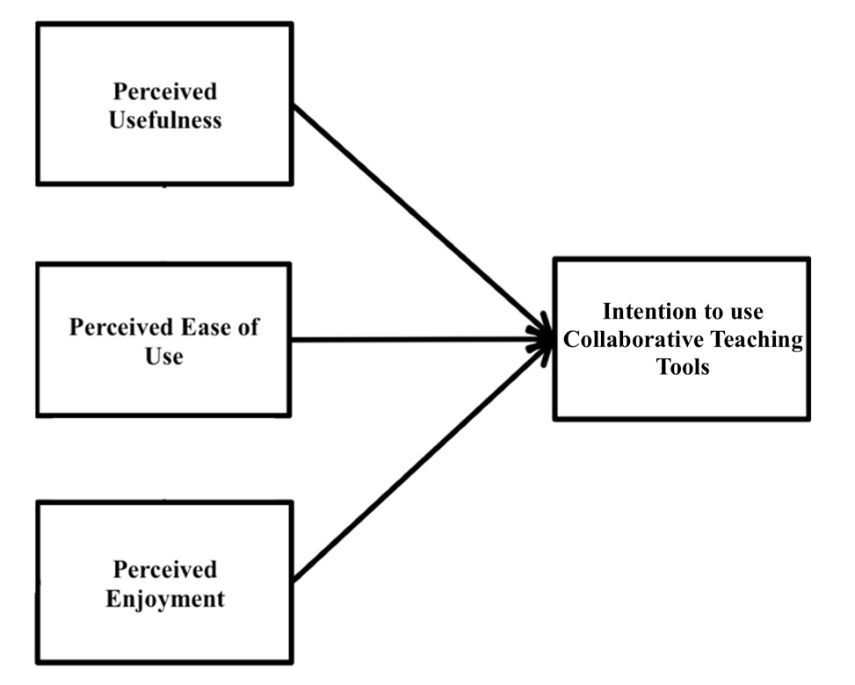
Figure ‎3-1 Adapted Theoretical Model (TAM)
The data collection process relied on a self-administered questionnaire, renowned for its efficacy in predicting individual efficiency and capturing a spectrum of perceptions, behaviours, beliefs, and opinions (Yalcinkaya, 2007). The questionnaire design incorporated measurement items carefully adapted from previous research, ensuring alignment with the specific behaviours expected from UWTSD lecturers in their readiness to embrace collaborative teaching tools within classrooms. Respondents utilised a five-point Likert scale, spanning from "strongly disagree" (1) to "strongly agree" (5), to articulate their agreement with provided statements. Additionally, nominal, and ordinal scales were employed to gather background data (Phakiti, 2020). The surveyed sample comprised 29 full-time lecturers based on Swansea Campus, all of whom were qualified in their respective roles.
The selection of convenience sampling, a non-probability technique, was deliberate, given the researcher's limited knowledge about the population and the flexibility it provides in data collection (Collis and Hussey, 2013). Despite potential limitations, this approach was deemed appropriate, considering the research objectives and available resources. To mitigate potential bias, a randomly selected subset of the population was chosen, aligning with the positivist nature of the study.
Structural Equation Modelling (SEM) techniques using SmartPLS were employed for data analysis (Urbach and Ahlemann, 2010). This method facilitates the examination of multiple relationships between independent and dependent variables, providing a comprehensive understanding of the intricate interplay within the proposed theoretical model. The integration of SPSS and SmartPLS ensures a robust and multifaceted approach to data analysis, contributing to the overall validity and reliability of the study (Field, 2024).
In short, the chosen research methodology and sampling approach were meticulously crafted to elicit relevant data from potential UWTSD lecturers. This comprehensive investigation aims to yield insights into their readiness to adopt collaborative teaching tools within classroom settings, contributing to the broader discourse on effective technology integration in higher education.

Finding and Analysis

Data Screening
Data screening is a vital initial step in the analysis process, encompassing a thorough examination of the dataset to identify and rectify potential issues like missing values, outliers, data entry errors, and inconsistencies. This process also involves assessing variables' distributional properties, such as skewness and kurtosis, to gauge if transformations are needed for statistical test assumptions. By ensuring the dataset's cleanliness, data screening minimizes the risk of drawing inaccurate or biased conclusions in subsequent analyses.

Descriptive Analysis
Descriptive data analysis presents a clear understanding of the numerical values and their significance in the context of this research. This section covers the respondents' demographic profile, including gender, age, education, marital status, and occupation.

Demographic Profile of the Respondents
Regarding the gender distribution among respondents, approximately 37% of the participants identified as male, while 63% identified as female. The respondent’s gender is depicted in Figure 4.1 and Table 4.1.
Table ‎4-1 Demographics of Respondents
Demographic Profile | Percentage
Gender
Male | 37%
Female | 63%
Age Group
18-29 | 8%
30-39 | 42%
40-49 | 38%
Above 50 | 12%
Level of Education
Diploma | 6%
Bachelor’s degree | 54%
Master’s degree | 32%
Ph.D. | 18%

Figure ‎4-1 Participants’ Gender
In terms of the respondents’ age distribution, the most significant portion, approximately 8%, falls within the age group of 18-29 years. Following this, the 30-39 age group accounts for 42% of the total respondents, while the 40-49 age group also comprises approximately 38%. Finally, respondents over 50 years were 12%. These statistics is shown in Figure 4.2.

Figure ‎4-2 Participants’ Age
Figure 4.3 provides insight into the educational background of the 332 respondents. About 6% of respondents hold Diploma. While 54% of the respondents with bachelor’s degree, and 32% with master’s degree. Finally, 18% holds a PhD.

Figure ‎4-3 Level of Education

Measurement Model Assessment
Measurement Model Assessment is crucial for evaluating the reliability and validity of instruments or models across diverse fields. It aims to gauge how well a model captures intended constructs or variables. In this research, statistical techniques like tests for multicollinearity, construct reliability, validity, convergent validity, discriminant validity, and structural equation modelling (SEM) will be utilised. These methods collectively ensure the consistency and accuracy of measurements in the developed theoretical model.

Construct Reliability and Validity
The variables' reliability was evaluated using both Cronbach’s Alpha and Composite Reliability (CR). Results show that all CR values surpassed the recommended threshold of 0.7. As depicted in Table 4.1, Cronbach’s Alpha also exceeded the 0.7 threshold. Furthermore, CR values ranged from 0.869 to 0.921, indicating high internal consistency (Hair Jr et al., 2021).
Table ‎4-2 Cronbach’s alpha and Composite Reliability
 | Cronbach’s alpha | Composite reliability (rho_c)
PU | 0.911 | 0.989
PEOU | 0.921 | 0.897
PE | 0.889 | 0.912
INT | 0.869 | 0.879

Convergent Validity
Following the criteria established by (Hair Jr et al., 2021), it is essential for item factor loadings to exceed 0.70 to establish convergent validity. Consequently, convergent validity is considered satisfactory when the Average Variance Extracted (AVE) for each construct surpasses the threshold of 0.50 (>0.50). The findings, detailed in Table 4.2, indicate AVE values ranging from 0.798 to 0.923, affirming the presence of convergent validity.
Table ‎4-3 Average Variance Extracted
 | Average variance extracted (AVE)
PEOU | 0.923
PE | 0.918
INT | 0.884
PU | 0.798

Structural Model Assessment
The subsequent phases involve evaluating the structural model to analyse hypothesised relationships. Direct relationships are assessed using bootstrapping with 5000 samples to establish path significance, estimate standard errors, and determine 95% confidence intervals (Sarstedt et al., 2020; Hair Jr et al., 2021). A path coefficient close to or above 0.5 signifies a large effect, 0.3 a medium effect, and values near or below 0.1 represent a small effect. Additionally, a path coefficient exceeding 0.2 suggests a partially significant effect size relationship, as indicated by (Purwanto, 2021). Figure 4.4 presents the findings of the structural model testing.
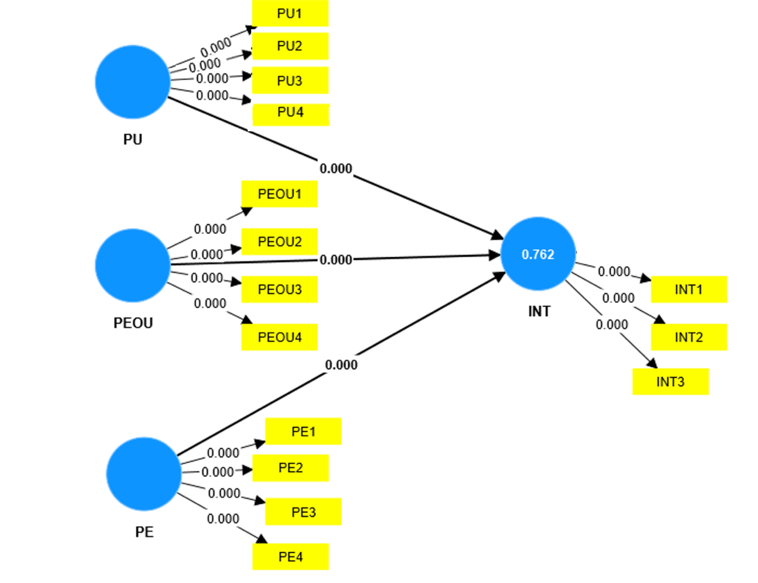
Figure ‎4-4 Structural Model Testing Findings

Hypotheses Testing Results
The findings of hypothesis testing are outlined in Table 4.3. Hypothesis (H1) focuses on the effect of perceived usefulness (PU) on the intention (INT) to use collaborative teaching tools within classrooms at UWTSD. The analysis yields compelling evidence supporting a positive influence of PU on INT. This is proven by a noteworthy beta coefficient of 0.267, a statistically significant t-value of 5.177, and a p-value below 0.001. These findings underscore the robust relationship between the perception of usefulness and the intention to adopt, emphasising PU's significance as a driving factor influencing user intentions in the context of this research.
Hypothesis (H2) investigates the impact of perceived ease of use (PEOU) on the intention (INT) to use collaborative teaching tools within UWTSD classrooms. The results reveal a positive relationship between PEOU and INT, supported by a substantial beta coefficient of 0.378, a highly significant t-value of 8.898, and a p-value below 0.001. These findings present compelling evidence that PEOU positively influences the intention to use collaborative teaching tools within UWTSD classrooms.
Hypothesis (H3) was formulated to explore the connection between perceived enjoyment (PE) and the intention to use collaborative teaching tools within UWTSD classrooms. The analysis results strongly support the presence of a positive effect of PE on INT, evidenced by a substantial beta coefficient of 0.387, a notably high t-value of 7.223, and an exceptionally low p-value below 0.001. These outcomes underscore the pivotal role of perceived enjoyment in influencing the intention to use collaborative teaching tools within UWTSD classrooms.
Table ‎4-4 Hypotheses Test Results
Hypothesis | Relationship | Beta Coefficient (β) | t-value | p-values | Decision
H1 | PU > INT | 0.267 | 5.177 | 0.00 | Supported
H2 | PEOU > INT | 0.378 | 8.898 | 0.00 | Supported
H3 | PE > INT | 0.387 | 7.223 | 0.00 | Supported

Conclusion

Research Summary
This research delves into the readiness of lecturers to adopt collaborative teaching tools within classrooms at the University of Wales Trinity Saint David (UWTSD). The study successfully achieved its objectives, focusing on three crucial aspects:
- To examine the effect of perceived ease of use on the intention to use collaborative teaching tools within classrooms at UWTSD.
The research thoroughly investigated the impact of perceived ease of use on lecturers' intention to embrace collaborative teaching tools at UWTSD. Through robust analysis, the findings revealed a substantial positive relationship between perceived ease of use and intention, as demonstrated by a noteworthy beta coefficient of 0.267, a highly significant t-value of 5.177, and a p-value below 0.001. These results underscore the influential role of perceived ease of use in shaping lecturers' intentions to adopt collaborative teaching tools.
- To examine the effect of perceived usefulness on the intention to use collaborative teaching tools within classrooms at UWTSD.
Another key focus was on understanding how perceived usefulness influences lecturers' intentions to use collaborative teaching tools. The research meticulously examined this relationship and provided compelling evidence of a positive impact, substantiated by a substantial beta coefficient of 0.378, a highly significant t-value of 8.898, and a p-value below 0.001. This outcome emphasizes the critical role of perceived usefulness as a driving force behind lecturers' intentions to incorporate collaborative teaching tools.
- To examine the effect of perceived enjoyment the intention to use collaborative teaching tools within classrooms at UWTSD.
The research also aimed to unravel the connection between perceived enjoyment and lecturers' intentions to use collaborative teaching tools. The analysis yielded robust findings, indicating a positive and significant influence of perceived enjoyment on intention. The substantial beta coefficient of 0.387, notably high t-value of 7.223, and exceptionally low p-value (below 0.001) underscore the pivotal role of perceived enjoyment in shaping lecturers' intentions to integrate collaborative teaching tools within UWTSD classrooms.
In short, this research provides valuable insights into the factors influencing lecturers' readiness to embrace collaborative teaching tools at UWTSD. By achieving its objectives, the study contributes to the broader discourse on technology adoption in higher education, offering practical implications for fostering a more collaborative and technologically advanced learning environment.

Research Recommendations
Based on the findings of this research, it is recommended to focus on lecturers' proficiency in utilising collaborative teaching tools, by designing and implementing focused professional development programs. This initiative should go beyond theoretical understanding, offering practical and hands-on experiences through workshops, training sessions, and continuous support. Workshops can serve as immersive environments where lecturers engage with diverse collaborative tools, gaining practical insights into their functionalities and applications.
Furthermore, incorporating interactive elements and real-world case studies can enhance the learning experience, catering to varying levels of technological familiarity among lecturers. The training sessions should be tailored to the specific needs of educators, addressing their unique pedagogical contexts and disciplines. Ongoing support mechanisms, including mentorship programs and resource repositories, are crucial to sustain and reinforce the acquired skills over time. By providing a comprehensive and dynamic professional development framework, institutions can empower lecturers at UWTSD to seamlessly integrate collaborative teaching tools into their classrooms, ultimately enriching the educational landscape.

Research Limitation
While this research has provided valuable insights, it is crucial to acknowledge certain limitations. Firstly, the study's focus on a specific academic institution may limit the generalisability of findings to a broader context. The results are primarily applicable to the unique dynamics and characteristics of UWTSD, and caution should be exercised when extrapolating them to other educational settings. Additionally, the research relies on self-administered questionnaire collected from Swansea Campus only, introducing the potential for response bias and social desirability effects. Despite these limitations, the research provides a foundation for future inquiries into technology adoption in higher education settings.

Future Research
Future research could enhance our grasp of technology integration in higher education by pursuing various avenues. A longitudinal study tracking lecturers' attitudes and practices over time could provide insights into the sustainability of technology adoption. Comparative analyses across different academic institutions would offer valuable insights into the contextual factors influencing lecturers' readiness. Examining students' perspectives alongside lecturers' views would yield a more comprehensive understanding of the collaborative teaching tool landscape, capturing the reciprocal dynamics in education.
Furthermore, qualitative research method, such as in-depth interviews or focus groups, could uncover nuanced aspects of lecturers' experiences, illuminating the intricacies of their readiness for collaborative teaching tools. Future research in these areas will contribute to a more holistic comprehension of technology integration in higher education.

Conclusion
In conclusion, the research on lecturers' readiness to embrace collaborative teaching tools at UWTSD sheds light on the intricate dynamics of technology adoption in higher education. Examining factors like perceived ease of use, usefulness, and enjoyment, the study underscores the importance of these elements in lecturers' intentions to integrate such tools. It emphasises the necessity for targeted professional development to enhance lecturers' proficiency. Overall, this research lays a foundation for cultivating a technologically enriched learning environment at UWTSD and beyond.
REFERENCES
Abulibdeh, A., Zaidan, E. and Abulibdeh, R. (2024) ‘Navigating the confluence of artificial intelligence and education for sustainable development in the era of industry 4.0: Challenges, opportunities, and ethical dimensions’, Journal of Cleaner Production, p. 140527.
Agava, S., Selvam, S. G. and Pete, J. (2021) ‘University preparedness for online teaching and learning amid COVID-19 in Kenya’, in New student literacies amid COVID-19: International Case Studies. Emerald Publishing Limited, pp. 83–100.
Alamri, H. A., Watson, S. and Watson, W. (2021) ‘Learning technology models that support personalization within blended learning environments in higher education’, TechTrends, 65(1), pp. 62–78.
AlGerafi, M. A. M. et al. (2023) ‘Unlocking the potential: A comprehensive evaluation of augmented reality and virtual reality in education’, Electronics, 12(18), p. 3953.
Andrin, G. et al. (2024) ‘Borderless Learning Environments: Impacts on Educational Management Strategies’, International Multidisciplinary Journal of Research for Innovation, Sustainability, and Excellence (IMJRISE), 1(2), pp. 43–49.
Archambault, L., Leary, H. and Rice, K. (2022) ‘Pillars of online pedagogy: A framework for teaching in online learning environments’, Educational Psychologist, 57(3), pp. 178–191.
Azeem, M. et al. (2021) ‘Expanding competitive advantage through organizational culture, knowledge sharing and organizational innovation’, Technology in Society, 66, p. 101635.
Bokolo Jr, A. et al. (2020) ‘A managerial perspective on institutions’ administration readiness to diffuse blended learning in higher education: Concept and evidence’, Journal of Research on Technology in Education, 52(1), pp. 37–64.
Collis, J. and Hussey, R. (2013) Business research: A practical guide for undergraduate and postgraduate students. Palgrave macmillan.
Crum, T. and Hatcher III, J. W. (no date) ‘Teachers’perceptions Regarding The Use Of Interactive Whiteboards To Enhance Elementary Literacy Development’, COGNITION AND EXPLORATORY LEARNING IN THE DIGITAL AGE (CELDA 2021), p. 323.
Cruz, R. A. Dela et al. (2023) ‘Empowering SHS STEM Students through Fishbone-Based Advanced Computational Thinking Pedagogy’, Excellencia: International Multi-disciplinary Journal of Education (2994-9521), 1(6), pp. 376–386.
Demir, Y. Y. (2023) ‘Activities And Tools For Working Collaboratively And Independently’, Key Concepts in Online Learning: A Comprehensive Guide for Pre-service and In-service Teachers, p. 101.
Derakhshan, A. et al. (2023) ‘Towards innovative research approaches to investigating the role of emotional variables in promoting language teachers’ and learners’ mental health’.
Field, A. (2024) Discovering statistics using IBM SPSS Statistics. SAGE Publications Limited.
French, R., Imms, W. and Mahat, M. (2020) ‘Case studies on the transition from traditional classrooms to innovative learning environments: Emerging strategies for success’, Improving Schools, 23(2), pp. 175–189.
Gupta, A. and Pathania, P. (2021) ‘To study the impact of Google Classroom as a platform of learning and collaboration at the teacher education level’, Education and Information Technologies, 26(1), pp. 843–857.
Hair Jr, J. F. et al. (2021) Partial least squares structural equation modeling (PLS-SEM) using R: A workbook. Springer Nature.
Haleem, A. et al. (2022) ‘Understanding the role of digital technologies in education: A review’, Sustainable Operations and Computers, 3, pp. 275–285.
Handley, H. (2023) ‘Best Practices for Using Online Interactive Whiteboards’.
Hawari, A. D. M. and Noor, A. I. M. (2020) ‘Project based learning pedagogical design in STEAM art education’, Asian Journal of University Education, 16(3), pp. 102–111.
Kavanagh, S. S. et al. (2022) ‘Breaking the fourth wall: Reaching beyond observer/performer binaries in studies of teacher and researcher learning’, Cognition and Instruction, 40(1), pp. 126–147.
Kayumova, S. (2023) ‘DEVELOPMENT OF STUDENTS’READING LITERACY THROUGH TRIZ PEDAGOGY’, Science and innovation, 2(B10), pp. 157–160.
Kim, Y. A. et al. (2021) ‘Responsive teaching in online learning environments: using an instructional team to promote formative assessment and sense of community’, Journal of College Science Teaching, 50(4), pp. 17–24.
Mansueto, D. et al. (2024) ‘Leadership Impact on Literacy: Principals, Synergistic Partnerships, and Progressive Pathways for School Improvement’, International Multidisciplinary Journal of Research for Innovation, Sustainability, and Excellence (IMJRISE), 1(2), pp. 50–56.
Masri, A. et al. (2023) ‘Effects of Reading Strategy Instruction in English as a Second Language on Students’ Academic Reading Comprehension: A Study in Jordan’, Research Studies in English Language Teaching and Learning, 1(5), pp. 209–218.
Miller, D. (2023) ‘Embracing the technological metamorphosis: Envisioning higher education for generation alpha in a shifting educational landscape’, International Journal Software Engineering and Computer Science (IJSECS), 3(2), pp. 88–96.
Mohsin, H. J. et al. (2023) ‘The impact of digital financial technologies on the development of entrepreneurship: evidence from commercial banks in the emerging markets’, Corporate \& Business Strategy Review, 4(2), pp. 304–312.
Nazir, A. et al. (2023) ‘Advancing IoT security: A systematic review of machine learning approaches for the detection of IoT botnets’, Journal of King Saud University-Computer and Information Sciences, p. 101820.
Nor, A., Yusuf, M. and Arabi, I. (2024) ‘Strategies for Improving the Professionalism of Islamic Education Teachers at University’, Tafkir: Interdisciplinary Journal of Islamic Education, 5(1), pp. 41–61.
O’Reilly, C., Devitt, A. and Hayes, N. (2022) ‘Critical thinking in the preschool classroom-A systematic literature review’, Thinking skills and creativity, 46, p. 101110.
Oke, A. and Fernandes, F. A. P. (2020) ‘Innovations in teaching and learning: Exploring the perceptions of the education sector on the 4th industrial revolution (4IR)’, Journal of Open Innovation: Technology, Market, and Complexity, 6(2), p. 31.
Phakiti, A. (2020) ‘Likert-type scale construction’, in The Routledge handbook of second language acquisition and language testing. Routledge, pp. 102–114.
Purwanto, A. (2021) ‘Partial least squares structural squation modeling (PLS-SEM) analysis for social and management research: a literature review’, Journal of Industrial Engineering \& Management Research.
Rana, Kesh and Rana, Karna (2020) ‘ICT Integration in Teaching and Learning Activities in Higher Education: A Case Study of Nepal’s Teacher Education.’, Malaysian Online Journal of Educational Technology, 8(1), pp. 36–47.
Sarstedt, M. et al. (2020) ‘Structural model robustness checks in PLS-SEM’, Tourism Economics, 26(4), pp. 531–554.
Sitopu, J. W. et al. (2024) ‘The Importance Of Integrating Mathematical Literacy In The Primary Education Curriculum: A Literature Review’, International Journal of Teaching and Learning, 2(1), pp. 121–134.
Suárez-Escudero, J. C. et al. (2020) ‘Teaching and learning anatomy. Pedagogical methods, history, the present and tendencies’, Acta Médica Colombiana, 45(4), pp. 48–55.
Tambunan, H., Silitonga, M. and Sidabutar, U. B. (2021) ‘Online and face-to-face composition in forming the professional competencies of technical teacher candidates with various learning style types’, Education and Information Technologies, 26, pp. 2017–2031.
Tlili, A. et al. (2021) ‘Towards utilising emerging technologies to address the challenges of using Open Educational Resources: a vision of the future’, Educational Technology Research and Development, 69, pp. 515–532.
Urbach, N. and Ahlemann, F. (2010) ‘Structural Equation Modelling in Information Systems Research Using Partial Least Squares’, Journal of Information Technology Theory and Application, 11(2), pp. 5–40.
Wei, Z. (2023) ‘Navigating Digital Learning Landscapes: Unveiling the Interplay Between Learning Behaviors, Digital Literacy, and Educational Outcomes’, Journal of the Knowledge Economy, pp. 1–31.
Yalcinkaya, R. (2007) Police officers’ adoption of information technology: A case study of the Turkish POLNET system. Citeseer.
Zaineldeen, S. et al. (2020) ‘Technology acceptance model’concepts, contribution, limitation, and adoption in education’, Universal Journal of Educational Research, 8(11), pp. 5061–5071.

APPENDICES

