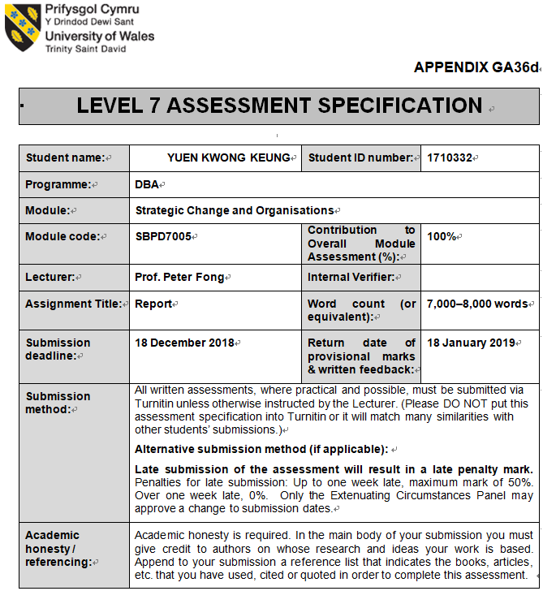

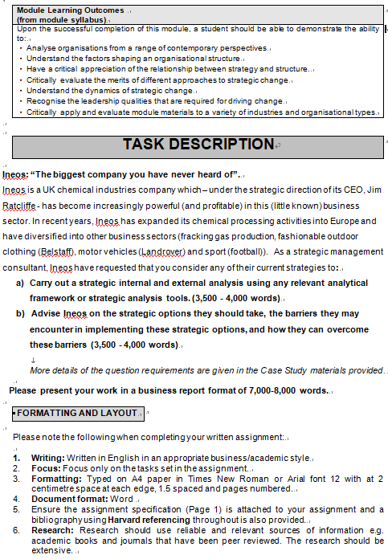

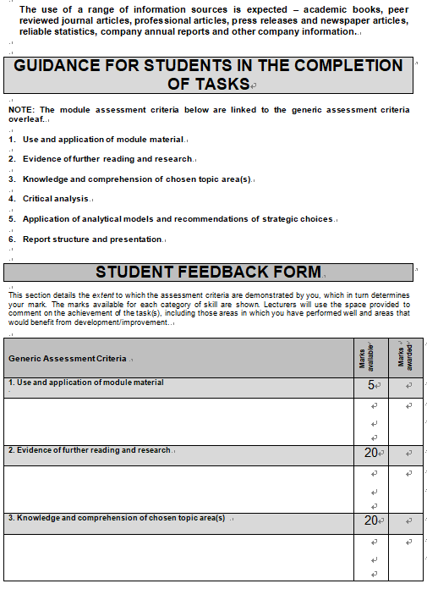

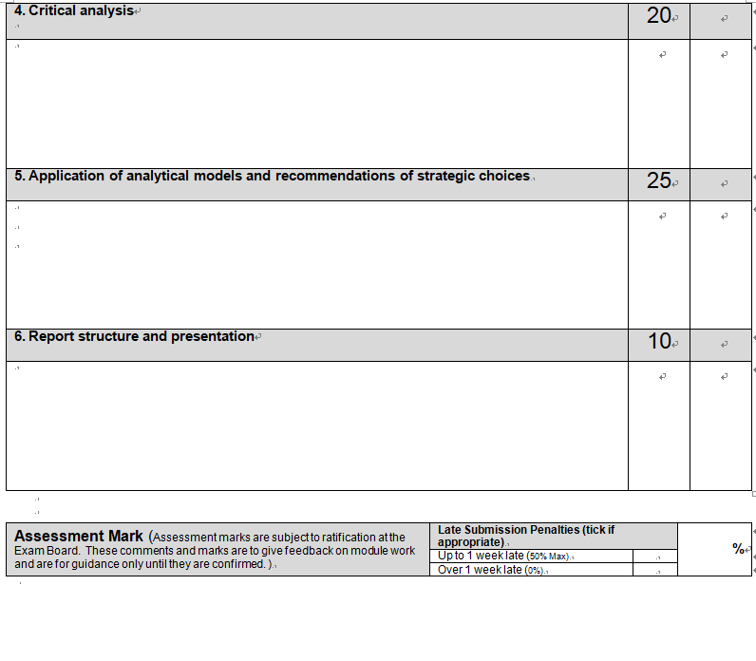

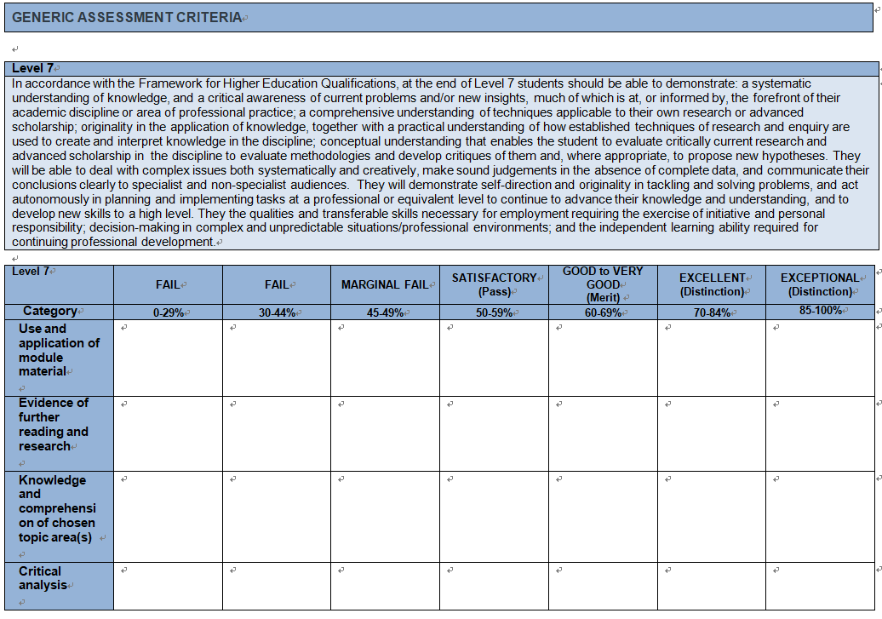

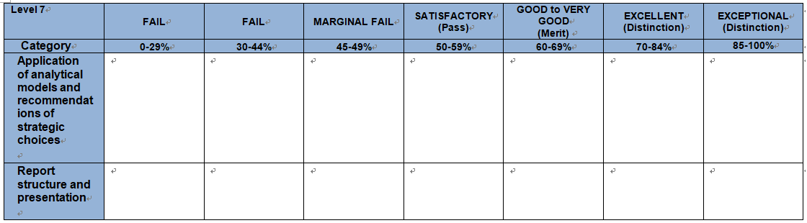

Analysis of the strategies of Ineos

Presented to

Mr. Jim Ratcliff
Chief Executive Officer of Ineos

Prepared by

YUEN KWONG KEUNG
STUDENT OF DBA UWTSD
MODULE TITLE: SRATEGIC CHANGE AND ORGANISATONS
MODULE CODE: SBPD7005
STUDENT NUMBER 1710332

18th December 2018

Memorandum

Date: 18th December 2018
TO: Mr. Jim Ratcliffe
Chief Executive Officer of Ineos

FROM: YUEN KWONG KEUNG
STUDENT OF DBA UTWSD
STUDENT NUMBER 1710332
SUBJECT:

Here is the report you requested on 10th November 2018. It relates to carry out analysis (i ) the external audit and internal audit on Ineos’s strategy; (ii) the strength, weakness, opportunity and threats to Ineos will be found; (iii) advise and recommend Ineos the change of strategy and implementation of the new strategy or modified the old strategy; (iv) Ineos should solve the problem of pollution by setting up the research and development department for developing new technology to reduce the toxic gas polluting the environment and climate. Otherwise, the petrochemistry industry will disappear in the world as pollution is a big problem to the whole world.
Please contact me at telephone number 34202828 if you have any query

Executive summary
Purpose and method of this report
The purpose of this report is to analyze the strategy of Mergers and Acquisitions adopted by Ineos throughout the past ten years which is very successful. As competitions in Petrochemical Industry become more, Ineos need to change its strategy whether by diversification of its business or continuation to adopt the strategy of Mergers and Acquisitions in a different manner.
Findings and conclusions
The findings are that Ineos continue the strategy of Mergers and Acquisitions to extend the petrochemical industry in the markets in China which will support Indeos’s business in China because it is a big market. However, the transportation costs are high. Moreover, the policy of China may change subject to the politic atmosphere in the world.
Ineos fails to protect the environment, climate and safety of the workers. Food & Water Europe indicated that Ineos could not extend its petrochemistry unless it can improve to to protect the environment, climate and safety of the workers.
Ineos has diversified its business by buying companies like vehicle manufacture; motorcycle wear or football team of which such companies are not within the same industry but different industry that Ineos is belonging to. Ineos raise funds from bank with the security of partnership. The banks may not offer bank facilities to Ineos’s future investments of Ineos is big but the secured assets are not significant.
Recommendations
In this report, it is recommended that Ineos needs to continue the strategy of Mergers and Acquisitions by buying the existing competitors companies or potential competitors companies in order to sustain competitors advantages and decrease the numbers of competitors. Ineos needs to extend its business to the markets of China by its experience and technology know-how in the petrochemical industry. Ineos should not try to diversify its business to other industry which Ineos is not familiar and has no experience to avoid any loss. Ineos has to decide whether it will be listed in the Stock Exchange so as to enhance the management of Ineos and to obtain better bank facilities. After Ineos became a public company, the management has to follow and observe the regulations of the government of different countries so as to avoid unnecessary of non-compliance or non-performance of the regulations of different countries.
Ineos should solve the problem of pollution, its operations and plants in many countries cause pollution to the environment and climate for which those countries object Ineos to expand its business. As petrochemistry industry caused pollution to the world, it can foresee that such industry may not be existing because the environment and climate is hurt.
Table of contents
Memorandum…………………………………………………………………………1
Executive summary……………………………………………………………………2
Introduction…………………………………………………………………………4-5
1.1 Strategies…………………………………………………………………………….6-12
1.2 Purpose of this study…………………………………………………………………..12
1.3 Scope of this study……………………………………………………………………..13
1.4 Sources and methods……………………………………………………………………13
2. Conclusions…………………………………………………………………………14-16
3. Recommendations…………………………………………………………………..17-18
4. Findings and discussion…………………………………………………………….19-20
4.1 Findings…………………………………………………………………………….19-20
4.2. Discussion………………………………………………………………………….19-20

- Introduction

Ineos is formed by Mr. Jim Ratcliffe and his partners in 1998. Ineos is very successful in running its business in the previous ten years. According to the information in respect of Ineos, it acquired more than 20 operations from big companies. The operations of Ineos are large units and integrated units situate in Germany, France, America and United Kingdoms.

Ineos manufactures chemical products like plastics, acids, lubricants etc., by refining the same from oil and natural gas. However, pollutants, fire accident, release of toxic waste and gases, which caused injuries to the workers and damages to the environment have been taken place during the production

Due to competition, Ineos has to sustain competitive advantages from the competitors and in order to avoid the policy of the governments of the countries in Europe against Ineos, Ineos start to develop its petrochemistry Industry in China. However, China has its own policy in respect of pollution caused by petrochemistry industry. Ineos’s extension of its business in China may be successful in the first beginning. After the operation and plants are built in China, the pollution may be serious, China could change its policy to avoid pollution. Ineos has to comply with the regulations of China. If Ineos could not comply with the regulations. China will force Ineos to leave China or stop the operations in China. Ineos may not carry out the mergers and acquisitions in China as the companies law in China is different to the western countries. Ineos has to set up its own companies for which case there may be criteria from China for setting up company on condition that Ineos has to share its technology know-how with China. After the companies of China obtained the technology know-how of Ineos, Ineos may be isolated from the petrochemistry industry in China.

In this study, it will look into which strategies have been used by Ineos throughout the years, including adopting the SWOT to find out the Strength and Weakness by carrying out the internal audit and external audit; the issues of opportunity and threats. To investigate the strategy of Mergers and Acquisitions used by Ineos in the past if the same is still applicable in nowadays. Also, the recommendation to the strategy of diversification of business using by Ineos or other strategy can be used in future.

It will discuss the method of funding of Ineos’s investment by senior debt through bank loans. The possibility of becoming a public company by floating on the Stock Exchange.

Ineos is also advised to solve the problem of pollution, its operations and plants in many countries cause pollution to the environment and climate for which those countries object Ineos to expand its business. As petrochemistry industry caused pollution to the world, it can foresee that such industry may not be existing because the environment and climate is hurt.

  - Strategies

External Audit

Opportunity

- Buying DOW chemical worldwide ethanolmines（EOA）business which strengthen your organisation’s position as a global player in the product of ethylene.
- The business of Ineos is mainly focused in Europe (60%) and North America (30%).
- The market in China is foreseen to be an advantage to Ineos as the market share to be obtained by Ineos in China will be large.
- Ineos produces the products in China or Europe for which the end customers are located to void the high transportation costs.
- The polyolefin technology is successful in China and it demonstrates technology practically.
- There are many opportunities in Middle East petrochemistry Industry.

Threats

- As stated in Ineos’ chequered Envirnotal Track Record in Europe. Foodandwatereurope.org, Ineos was blamed to cause damages to the environment and the climate by its operations and plants in the UK, France, Italy, Sweden, Germany and Norway. Furthermore, the damages to the environment climate are caused by greenhouse gas. Fire and accident of the plants which hurt the workers and the communities. As a result, the governments of the countries where the plants of Ineos situated punished Ineos by imposing penalty.
- Ineos intends to develop Shale gas industry in the U.K., it needs to use the technology of fracking in order to drill for shale gas which result will pollute the water and release toxic waste affecting the environment and climate. The authority of Food & Water Europe strongly objects Ineos’s shale gas industry development and suggested actions to be done that: (i) fracking should be prohibited; (ii) Ineos should not expand its business in petrochemistry because it did not or does not protect the environment and climate; (iii) Ineos’ application for hydrocarbons exploration be refused and the relevant licences be withdrawn; (iv) United States should stop from exporting fossil fuel.
- For the matters aforesaid, Ineos is facing the problems and negative impacts of damaging the environment and climate which are caused by the operations and its plant in its petrochemistry industry.
- Ineos could not expand its business unless the problems of damaging the environment and climate are solved.
- Ineos application for fracking and developing shale gas industry in the U.K. are suggested by Food & Water Europe to be refused and all licenses to be withdrawn.
- The competition in Middle East including Saudi Arabia made your Organisation to produce more difficult and more complicated polymenes to avoid imitation from the competitors and then the products of Ineos can be protected.
- Pollution caused lawsuit in Scotland.
- Policy of the country where the operations locate my affect the business of Ineos.
- There will be saturation of demand of the products of petrochemistry because there are many competitors.
- The costs of production of petrochemical products in Middle East are low but pollutions are serious.

Internal Audit

Strength

- In the period between 2000 – 2018, Ineos acquired more than 20 operations from big companies.
- Ineos extended to gain market shares by running largest units and integrated units in German, United Kingdoms, France and in United States.
- Acquisition of large operations gaining both financial efficiency and tax efficiency.
- Ineos did produce the petrochemical products such as ethylene, propylene, polypropylene, etc to become the large scale petrochemical business.
- Ineos did gain more market shares in the production of polyolefin – specialty polyolefin and produce very special polymer for special use be developing for customers.
- Ineos produced more difficult and more complex product so as to avoid imitation and to protect the organization.
- To develop business in polyolefin technologies with China which is successful and a long-term investment and it demonstrate practical technology. The organization manages its own plants and shows the customers how they work and that they are powerful.
- Good technologies and market position for the products such as phenol which is a significant project in China.
- Ineos is a private company of which the shareholders are also managers for which every decision can be made quickly.
- Sales are generated by cyclical, commodity business.
- Ineos’s equity is 100% owned by the employees and is financed with public debt.
- The positive mission of the CEO, Mr. Jim Ratcliffe : “To be truthful, I am surprised at low quickly it has all happened” “But if you are acquisitive, you can never predict how you are going to grow” affect the perceptive of the employees.
- The policy of acquiring business regardless of whether they have synergies with existing operations shows the big resources and capabilities of the organization.
- Ineos ’s financial focus is strong and driven by earnings before interest, tax, depreciation and amortization (EBITDA).
- Ineos double the average EBITDA over a five-year-period that means paying “sensible, market prices” for acquiring assets.
- EBITDA will deliver revenue growth and costs saving measure.
- The policy of buying commodity business than specialties and walking away from a deal if it is not comfortable.
- Ineos is exposed to the commodity sector, which is cyclical, capital-intensive and highly competitive. The exposure will be mitigated by diversifying the products, end-market and geographic presence.
- Ineos’s original MBO is financed by senior loan facilities, high yield bonds and senior debts. The interest is paid during the life time of the bond which in result fit the cyclical earning stream.
- Mr. Jim Ratcliffe left U.K. and lived in Switzerland and bought an expensive yacht. Mr. Ratcliffe’s purpose is more convenient for him and his control team to travel to the operations quickly for making the decisions. Mr. Ratcliffe should be transactional leadership as he and other four persons control Ineos and make decision by them quickly.
- The resources and capabilities of Ineos are strong.

Weaknesses

- Trade Union pressured by striking action for more salaries and welfare.
- Oil spill and pollution problems are disasters to the industry and will harm Ineos. Ineos was blamed to cause damages to the environment and the climate by its operations and plants in the UK, France, Italy, Sweden, Germany and Norway. Ineos failed o protect the environment climate which are mainly caused by greenhouse gas. Fire and accident of the plants which hurt the workers and the communities. As a result, the governments of the countries where the plants of Ineos situated punished Ineos by imposing penalty. Green strategy has to be used by Ineos in the process of production. Moreover, the costs of carrying on green strategy are expensive
- Accident should be avoided by well trained engineers. There are costs implication of the engineers.
- There are over 18,000 employees of Ineos throughout the world. The managements of the operations are complex and experienced managers who should be well trained.
- Diversification by buying companies like vehicle manufacturing; motorcycle wear; football team is not in petrochemical industry. In result of such mergers and acquisitions of such companies, it will foresee that the problems of organization fit, that is, different management practices, culture of management, different style of staff. They are not easy for the management to fit a suitable theory for managing the target company as acquired.
- There is also the issue of strategic fit due to strengthen and complement the strategy of Ineos, new strategy for the target company is needed.
- There may be over-estimate of the potential synergy, its profits or loss which cause loss of the mergers and acquisitions.
- Ineos fails to protect the environment and climate, its petrochemistry business could not expand and its application for shale gas industry and import of fossil gas to U.K. are suggested by Food & Water Europe to the U.K. government to refuse its application and withdraw its relevant licenses.
The PESTEL Analysis
1. Political
Ineos is a private company formed in the U.K., its operations and plants are situated at many countries. Therefore, Ineos has to attend the policies of the government in other countries. Food & Water Europe observed that Ineos fails to protect the environment and climate, its petrochemistry business could not expand. Despite the accuse from Food & Water Europe, Ineos tried to explain that the pollution in proper in petrochemical industry. Ineos should admit the liability of pollution to the environment and climate try its endeavor to comply with the regulations of these policy but not excuse from the allegations of Food & Water Europe. The pollution problem is affecting the whole world. It is not a matter if Ineos is earning money but it has responsibility not to harm the people in the world. If Ineos does not resolve the problem, the policy of the countries where the operations and plants of Ineos are situated will be harsh to direct Ineos to deduct the number of its operations and plants by closing the same or impose penalty for non-compliance. Ineos has many operations and plants in the Europe for which the EU may set up the relevant law and enforce the law against Ineos for non-compliance. As a result, Ineos has to close its operations in Europe and leave.
2. Economic

The customers of Ineos are the customers around the world because its products include plastic, coating, lubricants, etc. all of which are in relation to the daily life of ordinary people. The economic atmosphere will not affect the business of Ineos as its products are necessary for the daily life of the people in the world.
However, the people in the world may object to use the products of Ineos because the environment and climate was and is hurt by the toxic gas released in the progress of production of Ineos’s product and the greenhouse gas hurt the climate. It may be a trend when the temperature is increasing, the climate becomes improper, a lot of hurricane happened, much more ice is in the North Pole and South Pole. The governments of major countries will work together to stop the harm to the climate in order to save the people in the world. As such, the petrochemistry industry or the shale gas industry or the fracking industry must be disappeared and no longer existing.
3. Sociological
Ineos is and was blamed for damages to the environment and climate. The government of different countries are avoiding the petrochemistry industry to expand their business and to build infrastructure for their plants. Therefore, the sociologic will like to decrease the numbers of operations and plants of the petrochemical industry to save the world because the greenhouse gas damages the climate. The society in various countries do know the pollution of the environment and climate caused by the petrochemistry industry in the process of production of their products. They may advise their residents to stop to purchase or use the products of Ineos so as to avoid further pollution. As a result, Ineos has to consider to deduct the amount of production of its product.
4. Technological
Ineos with its research and development department tries to produce complex and difficult to imitate products with high technology. Further, Ineos has well trained engineers to avoid accidents to the workers in the process of running the plants. Ineos did not or does not develop the technology to stop the pollution caused by its products in the cause of producing the same. The technology Ineos uses is just for production of its products but Ineos should be also responsible for the pollution and stop the pollution to the environment and climate.

5. Environmental
It is again the matter of pollutant to the environment and climate by emitting hazard gas and releasing toxic waste in the progress of production of Ineos’ products. Ineos’ green strategy is not good enough. Obviously, the petrochemical industry in any event causes a lot of pollutant to the environment and climate. It is a result when the pollution is serious or very serious, the United Nations will set up and announce the law to force the petrochemistry industry to stop its business and stop their operations and plants. This needs the co-operation of the major countries in the world.

6. Legal
Because of the failing to protect the environment and climate, Ineos have been fined by different governments in several countries. Also, lawsuit is commenced in Scotland for non-compliance with regulations in respect pollution. Ineos has to observe the laws of different countries. Nevertheless, the petrochemical industry is not accepted in many countries as it caused pollution to the environment and climate. Many countries set up various laws to prohibit the pollution caused by petrochemical industry. Therefore, petrochemical industry may not exist in many countries in future.

  - Purpose of this study

The purpose of this study is to analyze the strategies using by Ineos in the previous ten years and to see if anything should be changed including by measuring the internal audit and external audit. It is used the theory of SWOT to see the strength and weakness of Ineos. The diversification strategy used in year 2010 that is: acquirement and development of vehicle, acquirement of luxury motorcycle wear maker; acquirement of football team. Also, the opportunity issue and threats issues are being investigated.

  - Scope of this study

The scope of this study is investigating the strategies of Ineos in the previous ten years by reading the press reports regarding the business of Ineos. It is to investigate which kinds of strategy theory adopted by Ineos. It then looked at the present strategies Ineos is using and advise whether it is suitable and applicable for Ineos to substain competitives advantage.

  - Sources and methods

As mentioned aforesaid, the information in respect of Ineos are obtained from published journals for strategies analysis and articles reported in the press. In this report, the SWOT analysis has been used for finding the strength and weakness of Ineos, the opportunity and threats by internal audit and external audit of Ineos. The results show that Ineos is a strong company but the opportunity issue is limited as the petrochemical industry is refusing by many countries due to pollution, the petrochemistry is reducing but big companies like Ineos may not be affected. Regarding threats issue, many countries are objecting the expansion of Ineos and its application for exploring such as fracking industry which causes a lot of pollution like releasing toxic gas which the environment and climate is polluted, the water is contaminated. Also, PESTEL Analysis is also used to analyze Legal, Environmental, Technological, Political, Economic and Political issues. It is observed that the Legal, Environmental, Political and Political issues all of which affects Ineos due to pollution. It is not easy for Ineos to maintain its petrochemical products if the problem of pollution cannot resolve or reduce.

2. Conclusions

By analysis of the given information, Mr. Jim Ratcliffe is aggressive and is willing to set up his own business in his belief but it is risky. Mr. Jim Ratcliffe’s success is not lucky but he relies on his working experience with BP and then joined ESSO as a trainee accountant and later got the degree of Master of Business Administration. He was armed with certain experience in running the Petrochemistry industry.

However, Mr. Jim Ratcliffe’s mission: “unfashionable or unsexy facilities owned by large corporations where you would know they would be sloppy with the fixed costs” , by buying the operations of large corporations, he made the profits and in result, he continues the strategy of Mergers and Acquisitions. There are issues of Strategy Fit and Organizational Fit in the strategy of Mergers and Acquisitions. Ineos is an emergentist when it buy companies by Mergers and Acquisitions. The motives of Mergers and Acquisitions are including: consolidation, that is, increasing the scale, efficiency and market power of Ineos; achieving financial efficiency and tax efficiency, increasing Ineos’ capabilities by enhancing the technology know-how of Ineos. However, the issues of Strategy Fit will not strengthen and complementation of the strategy of Ineos and Organizational Fit will not matched due to different culture management practices and the staff’s style are different to those of Ineos. Sometimes, the over-estimate of the assets of the acquired company cause a sell of a bit of the company due to assets stripping. If Ineos bought the companies in the same industry it belongs to. The problems may not exist but if the companies are come from other industries, the problems are foreseen to exist. However, pursuant to the speech of Mr. Tom Crotty, a director of Ineos, he said

“The logic is commitment to manufactory and broadening our case from just chemicals and oil and gas into a completely different area of manufacture”

Tom Crotty

Swiss football club represents fresh challenge to Ineos founder.

Mr. Tom Crotty further said

“This has to make money and Jull will be the first person to say ‘if this is not working, we will close it down. ”

From the information given by the press report in relation of Ineos, the corporation is success in the petrochemical industry. Due to competitions, Ineos has to sustain competitive advantages by incorporating its business with China on its knowledge and technology know-how in petrochemistry. Market in China is great, Ineos should extend its business to China. The competitors in China are not much. If Ineos sets up its business by production of the petrochemical products in China early and set up its plants and operations prior to the competitors, Ineos will lead the petrochemical industry in China and becomes the leader.

The advantage of the Mergers and Acquisitions is that you can choose the options of diversification, internationalization or innovation. From the given information, Ineos diversified its petrochemical business to other industry such as vehicle production, motor cycling wear production and even owing a football team. Regarding innovation, Ineos tried to develop its products to more difficult and more complex to avoid intimation by the competitors. However, the costs of the development may be excessive. The financial motives of the Mergers and Acquisitions by Ineos should be of that Ineos diversify its business with the intent to effect financial efficiency and tax efficiency. Also, Ineos could maximise assets values by selling off parts of the acquired company. However, the strategy of Mergers and Acquisitions is risky as it is not within the petrochemistry industry, Ineos has to decide whether the companies bought are making profits. Ineos has to wait to see in several years the assets of those companies are still valuable. Otherwise, it may be difficult to sell those companies which in return made a loss. Although Ineos’ financial focus is strong and driven by earnings before interest, tax, depreciation and amortization (EBITDA). Furthermore, it will try to double the EBITDA in a period of five years to see if the companies so bought are profitable. There is no guarantee that it can double the EBITDA for which it is a problem to sell or keep those companies.

From the information given by the journal in relation of Ineos, the corporation is success in the petrochemical industry. Due to competitions, Ineos has to sustain competitive advantages by incorporating its business with China based on its famous knowledge and technology in petrochemistry. Therefore, it is opined that China is a suitable place for developing the petrochemistry industry by Ineos at an early stage but it will be saturated when the demand of the products decrease.

The diversification of business by Ineos is a strategy of Mergers and Acquisitions but they acquired various companies which are not in petrochemical industry. One can be seen that the leadership of Ineos is transactional ie. Offering incentive to obtain extra performance of the employee, there is no permission of doing wrong, if there is, a penalty. We can see that there are only five persons in control of Ineos which is a private equity company. Powers have been delegated to the managers (who has equity in Ineos) in the operations bought or developed. Ineos has been dragged in the strike by the workers in different countries. Therefore, policy of the government in different countries affect Ineos’s business.

Furthermore, oil spill and pollution are disaster to petrochemical industry. According to Ineos’ chequered Environmental Track Record in Europe, it stated that plastic production, petrochemical industry and fracking harm the environment and people. Spills and accident caused by frack industry contaminated water underground. Ineos chemical plants produced hazardous pollutants and the fire accident and leaking injured the workers and harmed the environment. The relevant authority therefore recommended that fracking should be stopped in the world; Ineos’ application for exploration of hydrocarbon will be rejected with the relevant licence to be revoked; Ineos is not permitted to expand its empire without the responsibility to protect the climate and environment. It is further recommended that the fossil fuel and oil should be stopped for manufacturing which is crucial for production of the non-biode-gradable plastic products. As such, most governments of the countries in Europe elected to enforce the enacted Aggressive Energy Conservative Policies which cause further development of the petrochemical industry to slow down or stop. Further, Ineos did not or does not attend to green strategy so that Ineos’s plants and operations in Europe would not release toxic chemical or gas, contaminated water which caused damages to the environment and climate. Fire and explosion killed and injured the workers.
Ineos is therefore advised to solve the pollution by developing new technology to stop or reduce the pollution caused the environment and climate immediately as Ineos is liable for the pollution and responsible to stop the pollution to the world. Otherwise, it foresee that the petrochemistry industry is prohibited to carry on its business further in future.

3. Recommendations

In view of the saturation of the demand of the petrochemical products and to sustain competitive advantages in the petrochemical industry, it is worth for Ineos to carry out further Mergers and Acquisitions strategy to buy more companies in the industry so as to gain more market shares in the industry and to decrease the numbers of competitors. The vertical mergers will support fair competition. Ineos through mergers and acquisitions may want to control the values of its products in the market. Ineos bought operations of big companies which performance is high with values. The mergers and acquisitions will increase the values of Ineos’ products that sold to the end purchasers. Ineos bought successful operations from big companies because Ineos performed well in the petrochemical inIt is advised that the market in China is large, it is worth to carry out the acquisition of the petrochemical companies in China so that Ineos may become the 1st large petrochemical producer in China. On the other hand, Ineos could sell or close the operations in other countries which are less profitable to mitigate loss.
Regarding the issue of funding finance, Ineos need to decide a floating on the Stock Exchange in London or other country, the advantage is that once it is a listed company the banks are willing to finance any projects of Ineos to be done. Ineos is a large private company, the stock price will be substantial after it is listed. The capital of Ineos will increase accordingly. The disadvantage will be that many decisions of the board have to be resolved by the directors in meetings.
Ineos becomes the mother company of many subsidiary companies which will be formed for controlling the operations worldwide.
Apart from China, Ineos could decide to carry out the Mergers and Acquisitions in Middle East and Russia so as to decrease the numbers of competitors. Furthermore, Ineos can diversify its business in countries under development in Asia or other countries like Russia, Thailand, Vietnam by developing products they need or buying the relevant companies which producing the relevant products. The diversification should maintain Ineos’s oriental petrochemical products and move to other industry that Ineos is familiar or has interest to invest.
Ineos has to adopt the green strategy so that the environment and climate could be protected. The research and development department needs to develop the strategy to avoid further pollution. Ineos should stop to expand its business by building new plants but it is advised to carry on mergers and acquisitions of the operations of big companies and to pay attention to green strategy so as to decrease the pollution to the environment and climate. Ineos should not import fossil fuel from U.S.A. to the U.K. for fracking that will properly harm the communities. Ineos is a big polluter in the U.K. because it released a large amount of carbon dioxide, Sulphur oxides, nitrogen oxides from 2011 to 2015. Ineos should set up its own risk management teams to study the pollution and the methods to decrease or stop the pollution problems by deduction of the production lines of all operations in the world or control the number of its products to be produced each day. Also, Ineos could close some operations in order to maintain certain number of operations or plants so that the release of toxic waste or gas to the environment could be decreased

4 Findings and discussion

4.1 Findings
Ineos is a successful corporation in the petrochemical industry. In the beginning, Ineos made profit by using the strategy of Mergers and Acquisitions. Its finance is secured by partnership and bank loan. Ineos’ financial focus is strong and driven by earnings before interest, tax, depreciation and amortization (EBITDA). When Ineos grow up to a big company, the number of employees is more than 18,000 working in 20 operations over the world. The decision makers are only five partners who delegate the power to the managers of the operations. The managers and employees all have the equities in Ineos. The purpose of the arrangement seems that all managers and employees should be more responsible for Ineos because they are not simply employees but also the beneficial owners.
Due to the diversification of its business into various kinds of business in other industry than the petrochemical industry. Ineos may face the problem in the management as the managers may not have experience in managing in other industry. Ineos then have to retain other professional and experienced managers to manage the diversified business they bought. The mission of Mr. Jim Ratcliffe will be of no effect to the new business because it is a change of the strategy of Ineos. It is no longer the petrochemical business but other industry that Ineos is familiar. The diversification to other industry is risky because Ineos is not familiar and do not have the relevant experience to manage.
According to Ineos’ chequered Environmental Track Record in Europe, it stated that plastic production, petrochemical industry and fracking harm the environment and people. Spills and accident caused by frack industry contaminated water underground. Ineos chemical plants produced hazardous pollutants and the fire accident and leaking injured the workers and harmed the environment. The relevant authority therefore recommended that fracking should be stopped in the world; Ineos’ application for exploration of hydrocarbon will be rejected with the relevant licence to be revoked; Ineos is not permitted to expand its empire without the responsibility to protect the climate and environment. It is further recommended that the fossil fuel and oil should be stopped for manufacturing which is crucial for production of the non-biode-gradable plastic products. As such, most governments of the countries in Europe elected to enforce the enacted Aggressive Energy Conservative Policies which cause further development of the petrochemical industry to slow down or stop. Further, Ineos did not or does not attend to green strategy so that Ineos’s plants and operations in Europe would not release toxic chemical or gas, contaminated water which caused damages to the environment and climate. Fire and explosion killed and injured the workers.
Ineos is now developing fossil fuel in the U.K., the purpose is to develop in the shale gas industry in the U.K. which is foreseeable damaging the environment and the climate seriously.
4.2 Discussion
In order to diversify, Ineos could carry on the Mergers and Acquisitions strategy by buying the potential and profit making companies in the petrochemical industry to decrease the numbers of potential competitors. When Ineos obtains the major market shares in the industry, that is, Ineos can control the market. Ineos need to decide to list on the Stock Exchange so that it becomes a public company. After it is listed, Ineos will have the banks’ support by offering bank facilities to various projects Ineos proposes. The benefit of a public company would gain more confidence from the government of the countries where the operations situate. Subsidiary companies then will form to manage the operations outside United Kingdoms where the mother company, Ineos are situated. The board of directors of Ineos may consist of more directors. They have to follow the regulations of listing company as set by the government though decision making is slower than before listing.
Ineos should stop to expand its business by building new plants but it is advised to carry on mergers and acquisitions of the operations of big companies and to pay attention to green strategy so as to decrease the pollution to the environment and climate. Of course, it is a big problem the whole world is facing. Ineos should not import fossil fuel from U.S.A. to the U.K. for fracking that will harm the communities. Ineos is a polluter in the U.K. because it released a large amount of carbon dioxide, Sulphur oxides, nitrogen oxides from 2011 to 2015. Ineos should set up its own risk management teams to study the pollution and the methods to decrease or stop the pollution problems by deduction of the production lines of all operations in the world or control the number of its products to be produced each day.

5. References

Balogun, J. Hope Hailey, V. (2016), Exploring Strategic Change, 4th Edn. Pearson.

Carnall, C.A. (2007). Managing Change in Organizations, London : FT Prentice Hall.

Conger, J.A. and Kanungo, R.N. (1998), Charismatic Leadership in organizations.

Emergence of Ineos. Chemical Week, October 3/10, 2001

Hickson, D.S. and Pugh D.S. (2007), Writers on Organizations, Penguin.

Ineos: Sustainable Business on Growth Strategy. China Chemical Reporter October 21st , 2010

Ineos strengthens EU position with purchase of DOW EOA Unit. By: Milmo, Sean, Chemical Market Reporter, 10920110, 02/12/2001, Vol.259, ISSUE 7

Ineos’ chequered Envirnotal Track Record in Europe. Foodandwatereurope.org

Katz, Jonathan. Chemicals Industries Refines its Strategy Industry Week/IW. Feb2011, Vol.260 Issue 2, p40-42. 3p.2

Matthew Day 2017. Demystified: Mergers and Acquisitions, Oil and Gas, Ranging on the Southern Great Plains, 1921-1933@2017 The Author. History @ 2017 The Historical Association and John Wiley & Sons Ltd.

Morgan, G. (2006), Images of Organization, London, Sage.

Pugh, D.S. (2008), Organization Theory: Selected Classic Readings, Penguin.

Swiss football club represents fresh challenge to Ineos founder. Chemical group says FC Lausanne-Sport has formula to challenge. In Europe C@R November 17, 2017

Appendix

