Component 2 - Research Report
Student Name: Fozia Malik
Student Number: 2130819
Lecturer Name: Rebecca Kavanagh
LCHS4002_BIRM
Digital Skills and Research Methods.

Contents
1. Introduction 3
2. Research design 4
2.1. Research Question 4
2.2. Research Method……………………………………………………………………………..4
2.3. Ethical Considerations 5
3. Results 5
4. Discussion 8
5. Conclusion 10
6. Reference List 11
7. Appendix A – A blank copy questionnaire. 11

1. Introduction

This report will explore how do students collaborate at Uwtsd. The aim of this research was to evaluate do students need training to collaborate at Uwtsd. The research was carried out in a group at the university, looking at it from a student’s perspective. The importance of this research, today many universities are using various types of technology to collaborate for example support with assignments.
Various researchers have already explored the importance of collaboration and digital skills. (Youssef et al 2022) researched at three different French universities. Data collected through face-to-face questionnaires administered by 1323 students. Results showing digital divide still exists not everyone has access to internet or been provided with training. (Youssef et al 2022) states to achieve good standard of performance from students you need to introduce new ideas, methods in collaborative use of ICT. According to (Jang 2015) who argues social media and collaboration tools are both recognised important to enable today’s collaborative learning, this is especially with higher education facing millennials who are working with different types of technologies in there day to day lives. (Jang 2015) research was conducted with an on- campus, IT management course designed for final year students in a Canadian university. They examined what drives millennial students’ technology choices and how that impacts their collaborative learning experience and performance. They found millennial students are confident and without teachers’ intervention can chose what technology tool works for them into collaborative learning independently. This is because they are familiar with wide variety of social media and collaboration technologies that helps them. Further studies show (Long and Meglich 2013) examined the use of virtual collaboration in the workplace, how its effecting today’s college graduates and is there a need to provide training for this to students. (Long and Meglich 2013) carried out their research through literature review to collaborate virtually with 66 undergraduate students who attended two different universities in different regions of the USA in order to make this impossible for students to have any face-to-face interaction. They used Zoho portal to facilitate the collaboration. Their results found a lack of communication between students rather than using the online Zoho portal they were more reliant to email, Facebook or even text messaging. (Long and Meglich 2013) states although today’s students can learn technology tools so quickly this does not necessarily mean they know how to use technology effectively to collaborate.

2. Research design
Five students were asked from the Spark hill campus all studying in their first year at higher education in health and social care level 4. Data was collected through face-to-face questionnaire. Six questions were asked. The questionnaire was made on Ms forms and a QR code was created for the students to access the questionnaire on their device.

2.1 Research Question
The research question chosen was Is there a need to provide training on how to use technology to collaborate at Uwtsd? This question was chosen because it was interesting and important to identify if there was a need in this because in theory, training can be vital and when given to students it can surely benefit them in collaborating better at the university as various researchers have already suggested. Also, with today’s effects of the pandemic everything going virtual this research question is more important to find out so students can get the help if required.

2.2 Method
The research method used was the quantitative strategy, this helped to quantify and analyse variables in order to get the results on how this was affecting individual students. Types of questions asked:
2 Closed- offered students limited options to choose from
1. If you were asked to work online with others to create a single power point, would you know how to achieve this? Followed by a yes or no option
2. If you were asked to work online with others to create a single MS word document, would you know how to achieve this? Followed by a yes or no option
2 Rank- offered students a chance to compare and arrange multiple options based on their preferences
1.Rank these applications in order according to which you would like to have training on how to use 1. Ms teams 2. OneDrive 3. Ms word 4. WhatsApp 5. Moodle
2.Rank these applications according to how competent you are in using them to collaborate with others on the one drive (most competent on the top)
Ms PowerPoint 2. Ms Excel 3. Ms Team 4. Ms Forms
1 Likert scale- offered students to answer the question from one extreme to another.
1.I feel that I am able to use a range of different digital tools to collaborate.
Strongly agree, Agree, Disagree, Strongly Disagree

2.3 Ethical Considerations
Being ethical was considered throughout the research. Students asked were of any age, so integrity and fairness were maintained. Student’s names were kept anonymous. Students had a right to withdraw, a code was given to each student for example participant A, Participant B etc. Students were given a voluntarily consent option before proceeding, they were also made aware of what the questionnaire was about. Data collected was securely stored on Ms forms and was not shared with any other organisation was only used for its purpose. The report was conducted accurately.

3. Results
Figure 1 pie chart shows responses to Question 1
I consent to take part in the questionnaire voluntarily?

Figure 1 shows all 5 students gave consent.
Figure 2 pie chart shows responses to Question 2
If you were asked to work online with others to create a single power point, would you know how to achieve this?

Figure 2 shows 4 participants said yes, and 1 participant said no.
Figure 3 Pie chart shows the responses to Question 3
If you were asked to work online with others to create a single MS word document, would you know how to achieve this?

Figure 3 shows 4 participants said yes and 1 participant said no

Figure 4 bar chart shows the responses to Question 4
Rank these applications in order according to which you would like to have training on how to use 1. Ms teams 2. OneDrive 3. Ms word 4. WhatsApp 5. Moodle
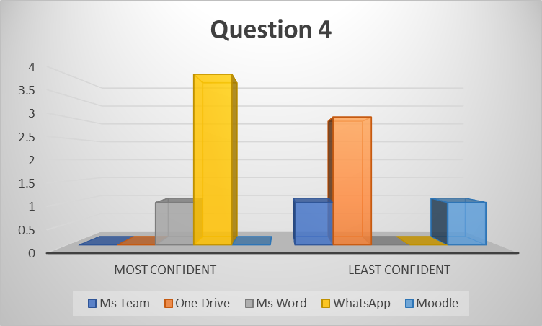
Figure 4 shows participants were least confident with one drive and stated most confident in WhatsApp

Figure 5 bar chart shows the responses to question 5
Rank these applications according to how competent you are in using them to collaborate with others on the one drive (most competent on the top)
Ms PowerPoint 2. Ms Excel 3. Ms Team 4. Ms Forms

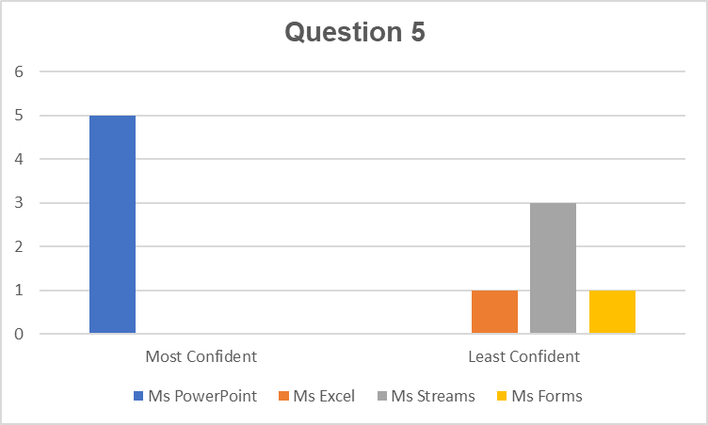Figure 5 shows participants were least confident in Ms streams and all 5 participants stated most confidence in Ms PowerPoint.

Figure 6 chart shows responses to question 6
I feel that I am able to use a range of different digital tools to collaborate.
Strongly agree, Agree, Disagree, Strongly Disagree
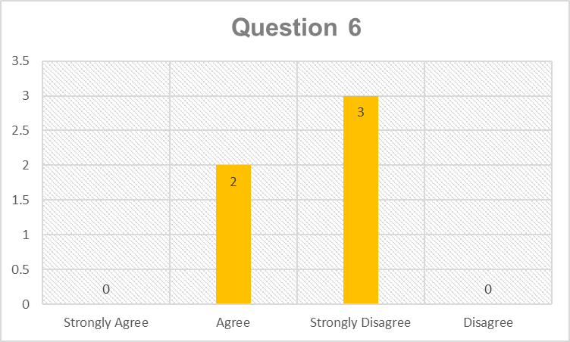
Figure 6 shows 3 participants have strongly disagreed, and 2 participants agreed.

4. Discussion

Results from question 2 figure 2 chart surprisingly shows response rate is 80% who can create power point, whilst response rate 20% could not do this giving us clear evidence more students were confident in doing this. A possible explanation for this might be because students are in their first year towards the end of their first module and may well have been given training on power point or they are most familiar with power point as was hypothesised all students will come from different levels of abilities.
Question 3 figure 3 chart shows us interestingly response rate 80% students can create a single Ms word whilst 20% said could not. Another possible explanation for this can be students are most familiar with single Ms word as it is the first app used in many educational institute’s students may well have used this in primary or secondary education but then with a minority stating they cannot create Ms word this can be because its new them so training will need to be provided for them.
In response to question 4 figure 4 chart shows majority students needed more training on the one drive compared to least training on WhatsApp. This result may be explained by the fact that One drive is a popular app in universities students would want training on this to collaborate better, as was hypothesised students will be determined to want training in order to collaborate better at university and excel in their courses, whereas WhatsApp being the least wanted in training, this maybe because most students will have day to day social media experiences.
Question 5 figure 5 bar graph provides us with data in which showed students are most competent in using Power point and shows less confidence in Ms streams. These results may explain the fact Ms streams is not heard of to these students who need training, so this confirms my hypothesis university apps like Ms streams are new to all students.
Lastly, responses to question 6 figure 6 bar graph indicates majority students strongly disagree with being able to use different types of digital tools to collaborate at Uwtsd. The results to this question help us identify majority students do still need training there are many digital tools to collaborate not all students are confident in using them this could be because they have not used technology before, or further training is required. As mentioned in the literature review not everyone has access to the internet or been provided with training (Yousef et al, 2022).
An initial objective of this report was to identify is there a need to provide training on how to use technology to collaborate at Uwtsd from all responses to the questionnaire, I would say our data collected has been quite successful in answering yes, students do need training. However, students who have indicated they can use certain tools in figure 2 and 3. This still suggests no confidence in other tools either in figure 4 Ms Team, one drive and Moodle, therefore in comparison to figure we take majority expressing their attitude in strongly disagreeing with being able to use all kinds of digital tools, this suggests even if they are good at one tool for instance PowerPoint being most popular shown in figure 2 and figure 5 does not mean they are on other tools for example, not many students indicated their strength in figure 5 Ms streams, Ms forms and Ms Excel. This has been hypothesised as strengths and gaps will need to be identified with each student. Data collected shows not all students have the same abilities and even if they do know how to use an app. Studies confirms this (Long and Meglich 2013) suggested Although today’s students can learn technology quite quickly does not necessary mean they know how to use it effectively to collaborate. Reminding us that extensive training is needed you need to demonstrate effectively in order to achieve success in students learning to collaborate.

5. Conclusion
Overall, this report strengthens the idea students do need training to collaborate at Uwtsd. It is clear my hypothesis matched my results also the findings from this research make several contributions to the current literature first (Yousef et al 2022) identified not all students will have used technology or been given training that confirmed in the questionnaire which identified students level of abilities were different. Second Jang, (2105). Mentions social media and collaboration tools are both recognised as important especially with millennial students who are familiar with a wide variety of social media confirms in why majority students are confident in using power point and Ms word with WhatsApp being least in wanting training in, as these students have this knowledge in their daily social media lives. Third (Long and Meglich 2013) states even if students know how to use a particular app does not necessarily mean they can use it effectively confirms in figure 6 with majority not so confident.
This research should be repeated using a different approach. Next time I might score the aspect of age to give us a clear understanding which students are most effected. Also, a greater number of students should be asked it will enable more results to compare and lastly to approach new students starting university to get a better understanding of their knowledge in collaboration tools as I do think the student’s administered in the present were in their first year this may suggest they could have already been given training in the apps they were most confident.
However, the findings of this research have a number of important implications for future practice. It has been identified students need training on different kinds of apps such as the ones they are least confident with or have no knowledge of and it has been identified most students are not able to use different kinds of digital tools to collaborate effectively. In future lectures need to ensure appropriate systems services and support is given to all students in training them how to use technology to collaborate at university.
6. Reference List
Jang, L. (2015) ‘Convenience Matters: A Qualitative Study on the Impact of Use of Social Media and Collaboration Technologies on Learning Experience and Performance in Higher Education’, for information Education, 31(1-2), pp. 73–98. [online] doi:10.3233/EFI-150948. (Accessed: 5 July 2022).
Long, L.K. and Meglich, P.A. (2013) ‘Preparing students to collaborate in the virtual work world’, Higher education, skills and work-based learning, 3(1), pp. 6–16. [online] doi:10.1108/20423891311294948. (Accessed: 8 July 2022).
Youssef, A.B. Dahmani, M. and Ragni, L. (2022) ‘ICT Use, Digital Skills and Students’ Academic Performance: Exploring the Digital Divide’, Information (Basel), 13(3), p.129–. [online] doi:10.3390/info13030129. (Accessed: 10 July 2022).

7Appendix A – A blank copy questionnaire.
Questionnaire
1.I consent to take part in the questionnaire voluntarily Single choice.
yes
no

2.If you were asked to work online with others to create a single PowerPoint presentation, would you know how to achieve this? Single choice.
Yes
No
Maybe

3.If you were asked to work online with others to create a single MS word document, would you know how to achieve this? Single choice.
Yes
No
Maybe

4.Rank these applications in order according to which you would like to have training on how to use. Required to answer.

MS teams
One drive
MS Word
WhatsApp
Moodle

5.Rank these applications according to how competent you are in using them to collaborate with others on the one drive (most competent) Ranking.
MS PowerPoint
MS Excel
MS Streams
MS Forms

6.I feel that I am able to use a range of different digital tools to collaborate?
 | strongly agree | agree | disagree | strongly disagree
Statement 1
Statement 2
Statement 3
Statement 4
Statement 5
Add new

