
Network Operating Systems and Services
Assignment Title: Research, Build, & Deploy a Virtualized Enterprise network
Student ID: 2311568
Nate Fox

Contents
Introductory Page 3
Task 1 4
Research 4
Hypervisors 4
IP Addressing 4
Routing 5
Network Services 6
Task 2 7
Download & Setup Evidence Structure 8
Task 3 32
Personal & Technical Reflection 32
References 33

Introductory Page

This report focuses on the research, design, and deployment of a virtualised enterprise network for the NOSS2026 scenario, which operates across two locations in Swansea and London. The aim is to explore key networking concepts and apply them in a practical environment to support communication, resource sharing, and system management.
The report combines research with hands-on implementation, covering the selection of suitable technologies, network configuration, and testing. The knowledge gained in this stage forms the foundation for the continued development and management of the network in the next phase of the coursework.

Task 1

Research

Hypervisors
Hypervisors are what make virtualization possible, as they allow multiple operating systems to run on a single physical machine. There are two main types: Type 1 and Type 2. Type 1 hypervisors run directly on the hardware and are typically used in large organisations because they offer strong performance, security, and scalability. Type 2 hypervisors, on the other hand, run on top of an existing operating system and are more commonly used for learning, testing, and smaller environments [1].
For this network setup, a Type 2 hypervisor feels like the most realistic and practical option. The aim is to run Windows Server, Debian Server, and client machines on one physical device, most likely a personal computer with limited memory and processing power. A hosted solution such as VirtualBox or VMware Workstation is easier to install, simpler to manage, and still powerful enough to support a domain-based environment. It also allows different operating systems to run side by side without needing dedicated server hardware.
While Type 1 hypervisors are often considered more secure and better performing, they are usually designed for enterprise-level infrastructure and require more resources. In this case, the priority is flexibility, compatibility, and ease of setup. This approach also supports the enhanced topology in later stages, as additional virtual machines can be deployed without needing major hardware changes. A Type 2 hypervisor provides a good balance by supporting both Windows and Linux systems while allowing the virtual network to be built and expanded in a manageable and realistic way [2].

IP Addressing
IP addressing plays a central role in how data travels from one computer to another across a network. Every device connected to a network is given a unique IP address, which acts like a digital identifier so that routers know where data needs to be sent. When a user sends a request, such as opening a website, the data is broken into packets. Each packet contains the source and destination IP address, allowing routers to forward it step by step until it reaches the correct device. Switches help manage traffic within the same network, while routers connect different networks together and direct traffic between them [3].
IPv4 addresses are structured as four decimal numbers separated by dots, for example 192.168.1.1, whereas IPv6 uses a longer hexadecimal format designed to support a much larger number of devices [4]. Subnetting allows a network to be divided into smaller sections, making it easier to manage traffic and use IP addresses efficiently. This is particularly useful in organisational environments where different departments or locations may operate on separate subnets [4]. This structured approach to addressing will support later configuration of services such as DHCP and domain connectivity.
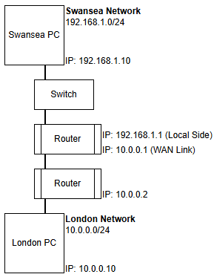
Figure 1: Example of IPv4 addressing and subnetting across two locations, showing how routers enable communication between Swansea (192.168.1.0/24) and London (10.0.0.0/24) networks.
In the context of the topology, IP addressing supports communication between the Swansea and London networks by ensuring each device can be identified and reached. Careful planning of address ranges and subnetting improves performance, reduces congestion, and supports future expansion as more devices are added.
Routing
Routing is the process that allows data to move between different networks, ensuring that packets reach the correct destination. Routers use routing protocols to decide the best path for data to travel based on available network information [4]. These protocols help build routing tables, which store information about where to send traffic. In simple terms, routing allows separate networks, such as the Swansea and London locations, to communicate with each other reliably.
There are two main approaches to routing: static and dynamic [5]. Static routing involves manually configuring routes on each router. It is straightforward and gives full control over how traffic flows, but it requires manual updates if the network changes. Dynamic routing, on the other hand, uses protocols that automatically share information between routers and adjust routes when the network changes. While dynamic routing is more flexible and scalable, it can be more complex to configure and is often used in larger enterprise environments.
For this topology, static routing appears to be the most suitable approach. The network is relatively small, with clearly defined connections between Swansea and London, so manually setting routes is practical and easier to manage. It also reduces unnecessary overhead on the network. The Debian Server acting as a DHCP relay relies on consistent connectivity to the Windows Server, so having stable and predictable routing is important. Static routing provides a controlled and reliable setup that supports communication between the two sites while keeping the configuration simple and manageable.

Network Services
Network services play an important role in keeping an enterprise network secure, organised, and easy to manage. In a multi-site environment such as the Swansea and London setup, services like VPN, DHCP, Active Directory Domain Services (AD DS), and Certificate Authorities help ensure reliable communication and centralised control across the network [4].
A virtual Private Network (VPN) allows two separate locations to communicate securely over the internet by encrypting data as it travels between sites. This is especially important for protecting sensitive information and maintaining privacy when connecting remote networks. DHCP simplifies network management by automatically assigning IP addresses to devices, reducing the risk of manual configuration errors and making it easier to add new machines to the network [6].
Active Directory Domain Services (AD DS) provides centralised management of users, computers, and permissions within a domain environment [7]. It allows administrators to control access to resources, apply security policies, and ensure users can log in from any authorised device. This is essential in an organisational setting where consistency and security are priorities.
Certificate Authorities support network security by issuing digital certificates that verify identities and enable encrypted communication. These certificates are commonly used for secure logins, internal websites, and remote access services [8]. Together, these network services improve efficiency, strengthen security, and support the smooth operation of a domain-based network across multiple locations. Together, these services from the backbone of enterprise network administration and will play a central role in later deployment stages.

Task 2
Hypervisor Selection and Justification
The virtualised NOSS2026 network was deployed using Oracle VM VirtualBox, a Type 2 Hypervisor Running on a host operating system. Although Type 1 hypervisors offer higher scalability for enterprise data centres, VirtualBox was appropriate for the academic deployment die to available hardware constraints and the controlled scope of the topology.
VirtualBox supports both Windows Server and Debian Linux, ensuring compatibility with the required domain environment. It’s internal, host-only, and bridged networking modes enable structured network segmentation and controlled inter-network communication, effectively simulating the multi-site topology. Resource allocation controls and snapshot functionality also supported stable performance and safe configuration testing.
While Type 1 solution would be preferable in production, VirtualBox provides sufficient performance, flexibility, and scalability for this domain-based deployment and future expansion in Coursework 2.

Download & Setup Evidence Structure
This section documents the deployment of the NOSS2026 virtualised enterprise network. Time stamped screenshots evidence structured implementation and systematic configuration. Oracle VM VirtualBox was pre-installed on the university workstation; however, its version and functionality were verified prior to creating Windows Server and Debian Virtual machines to ensure compatibility.

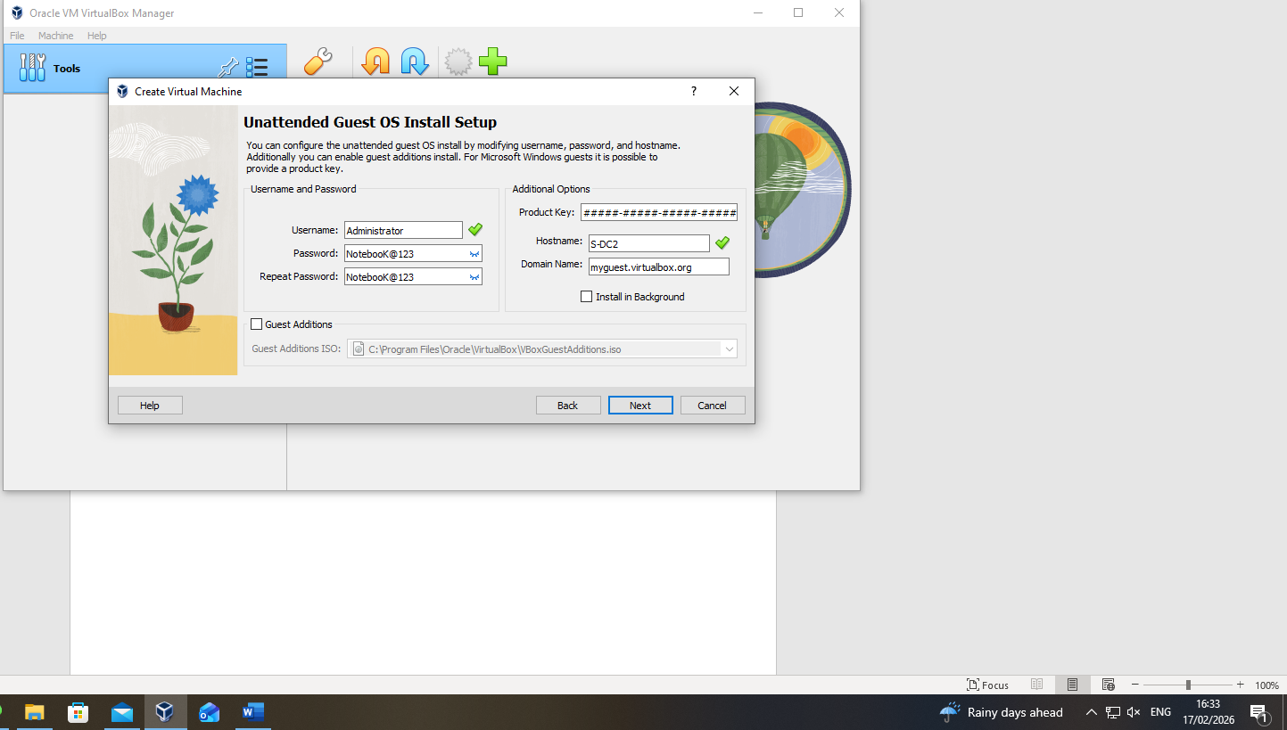
Figure 2: Creation of Windows Server VM (Initial Build S-DC2) - Timestamp Visible
The Windows Server virtual machine was created using Virtual Box’s unattended installation feature. The hostname was temporarily set as S-DC2 during rebuild before being named S-DC1 after removal of the earlier instance.

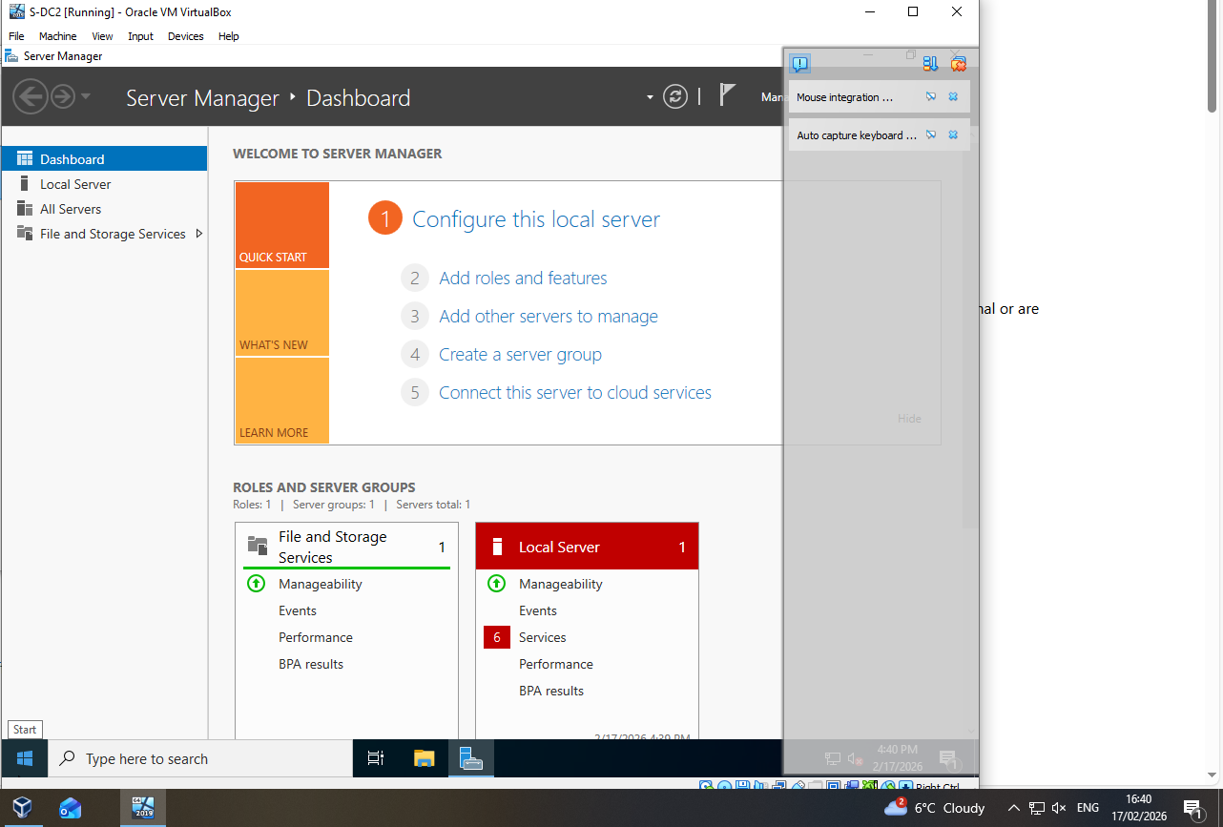
Figure 3: Windows Server Installation Completed - Server Manager Dashboard (S-DC2) - Timestamp Visible
Following unattended installation, the Windows Server booted into the Server Manager Dashboard. Confirming successful deployment. The machine was operational under the temporary hostname S-DC2 before being renamed S-DC1.
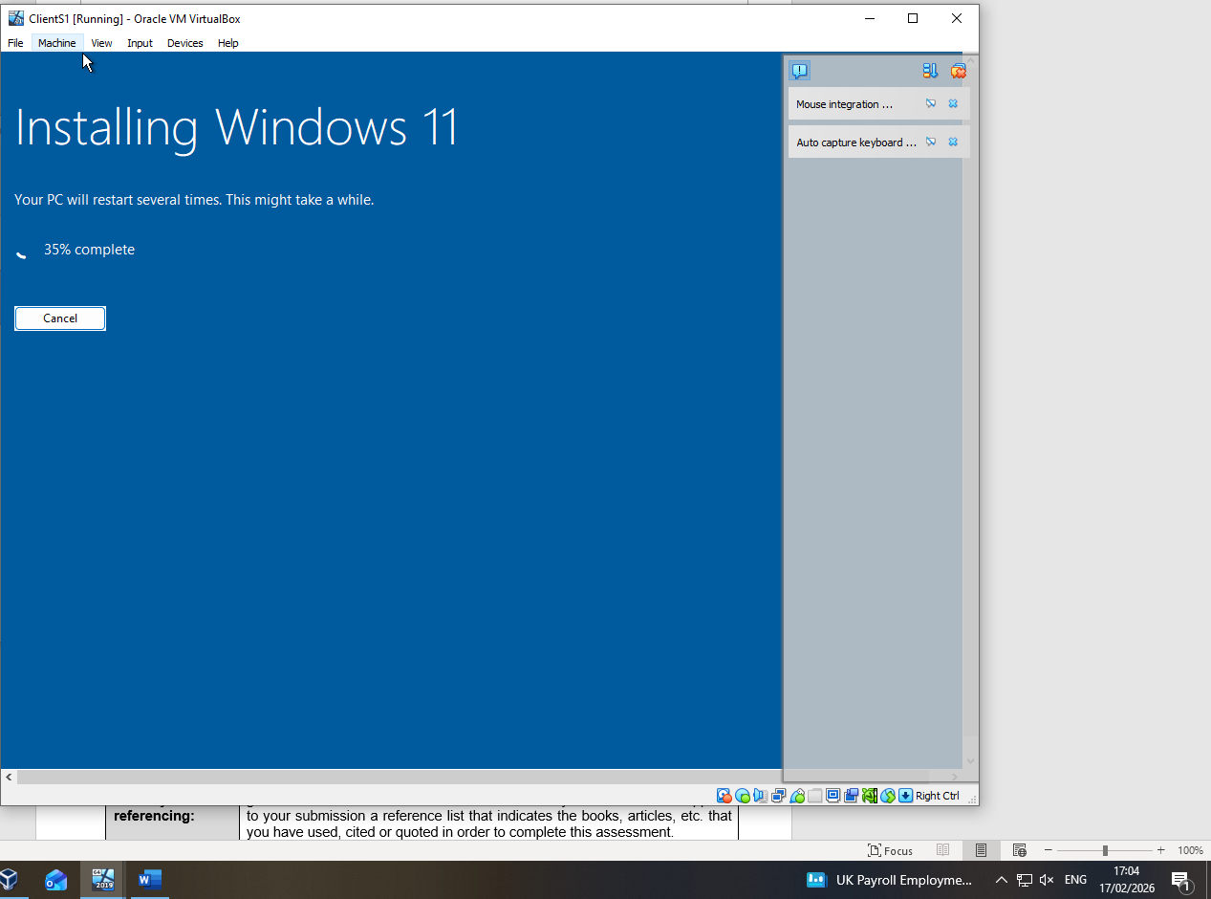
Figure 4: Initial Client VM Deployment - Windows 11 Installation (Client1) - Timestamp Visible
The client virtual machine was initially deployed using windows 11 during early lab configuration. Following review of the coursework topology, it was later reinstalled with Windows 10 to ensure specification alignment.

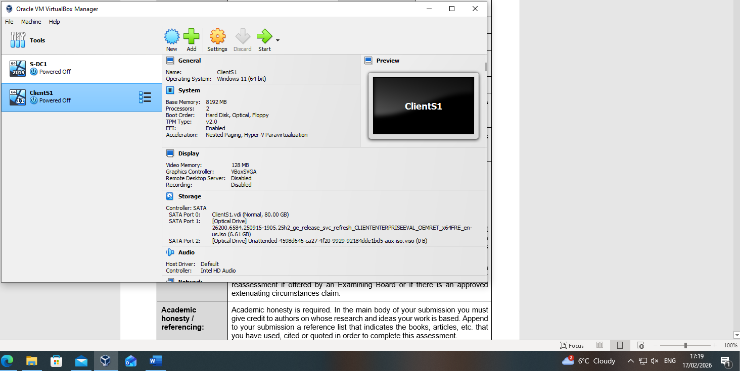
Figure 5: ClientS1 VM Configuration - Windows 11 Initial Deployment - Timestamp Visible
ClientS1 was configured with 8GB RAM, 2 virtual processors, and an 80GB dynamically allocated disk. The Windows 11 ISO was mounted to enable installation prior to later alignment with the Windows 10 Coursework requirement.

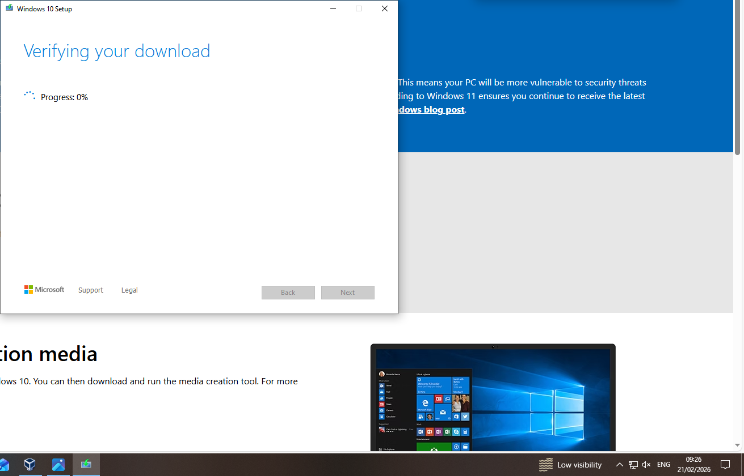
Figure 6: Windows 10 Download and Verification - Official Microsoft Source - Timestamp Visible
Following review of the coursework topology, Windows 10 was downloaded from the official Microsoft website to ensure specification compliance. The installation media was verified prior to client deployment.

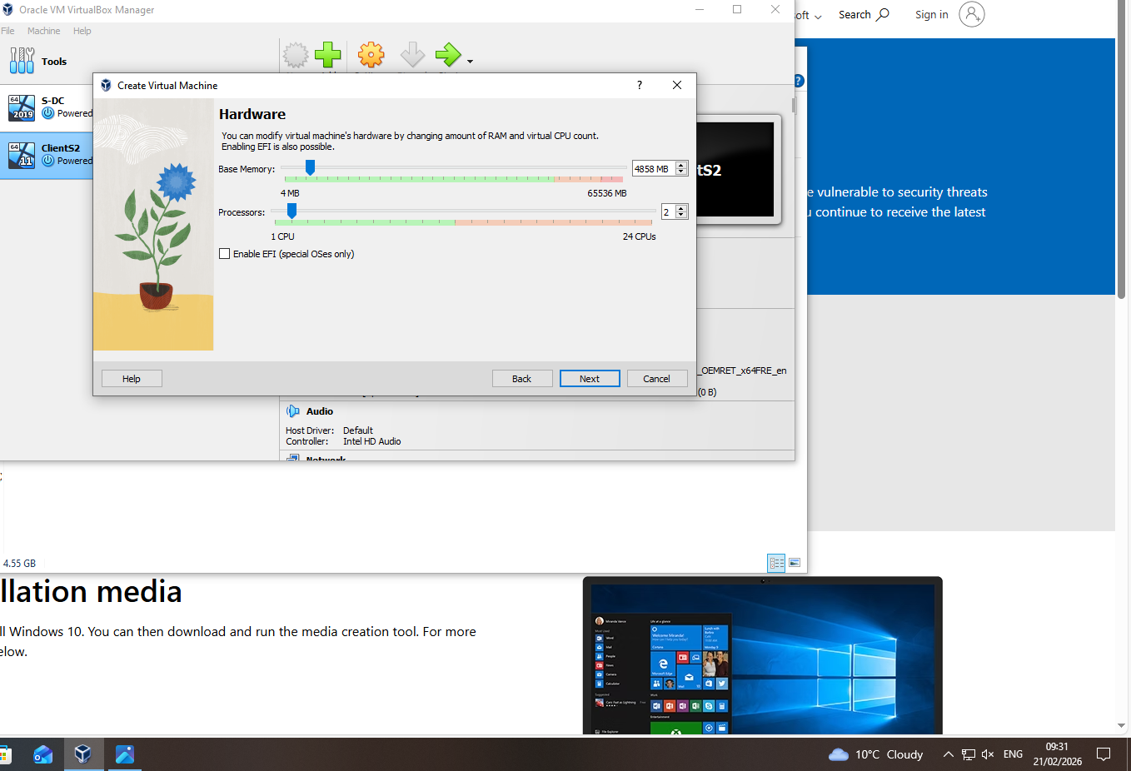
Figure 7: Windows 10 Client VM Creation - Hardware Configuration (ClientS2) - Timestamp Visible
Following review of the coursework topology, the client machine was rebuilt using Windows 10. The previous hardware configuration was maintained, and the instance was temporarily created as ClientS2 before being renamed ClientS1 after removal of the earlier version.

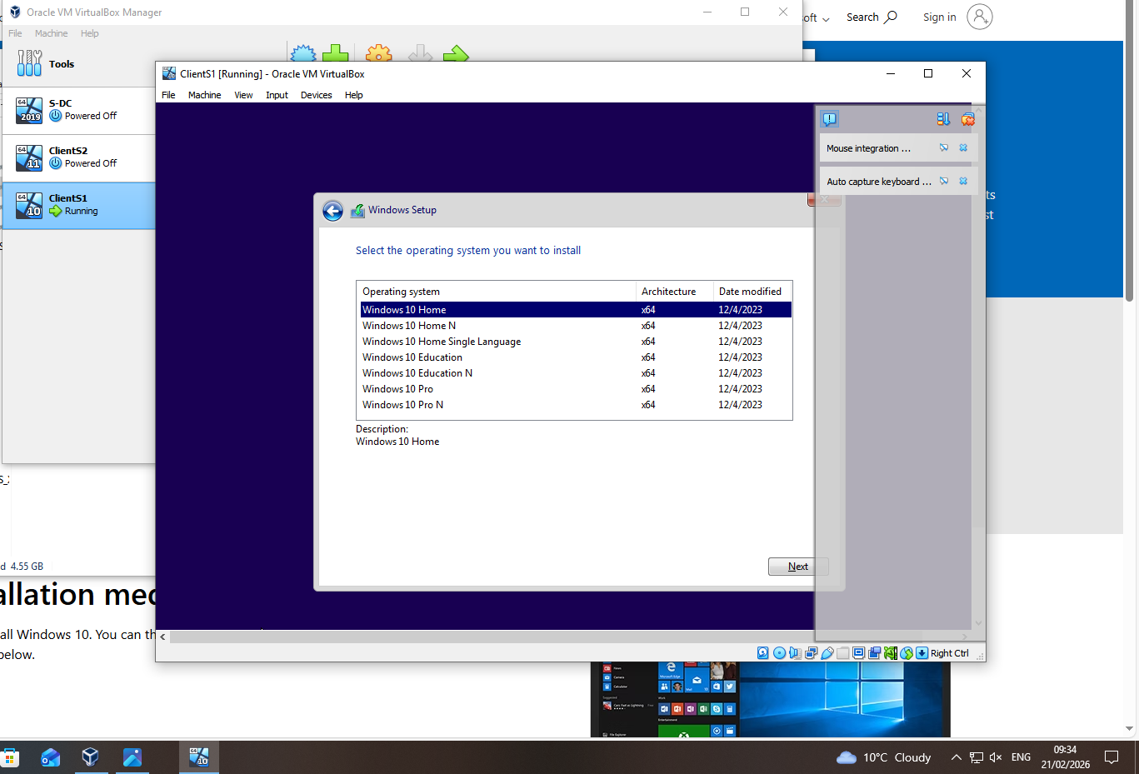
Figure 8: Windows 10 Installation - Edition Selection (ClientS1) - Timestamp Visible
The Windows 10 installation was initiated following virtual machine recreation. The appropriate edition was selected under the corrected hostname ClientS1, confirming alignment with the Coursework topology.

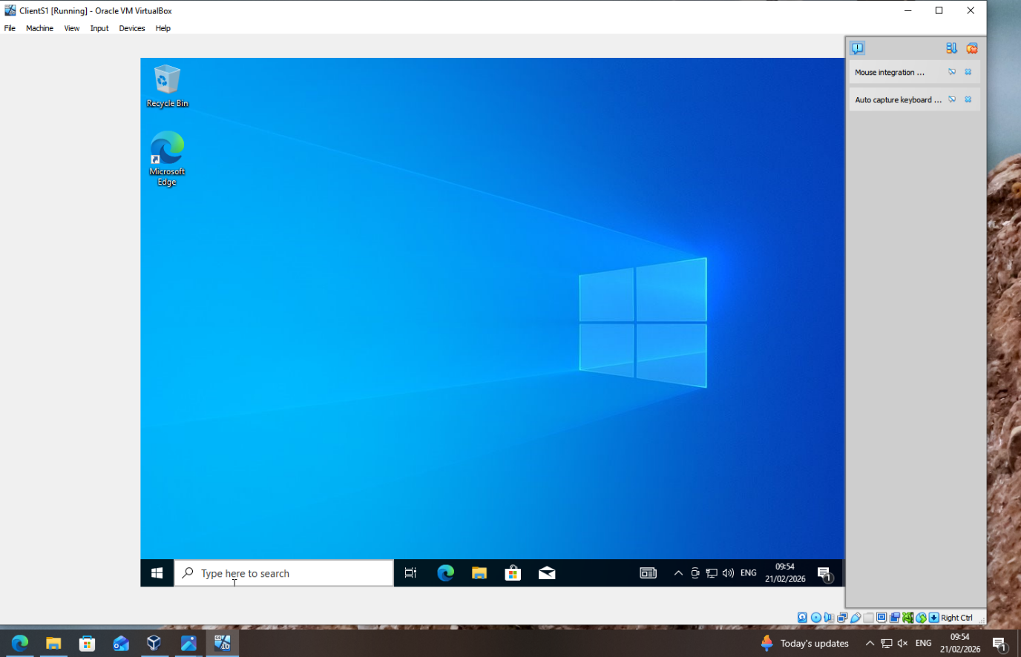
Figure 9: Windows 10 Installation Completed - ClientS1 Desktop - Timestamp Visible
The Windows 10 installation completed successfully, booting to the desktop under the corrected hostname ClientS1, confirming successful redeployment.

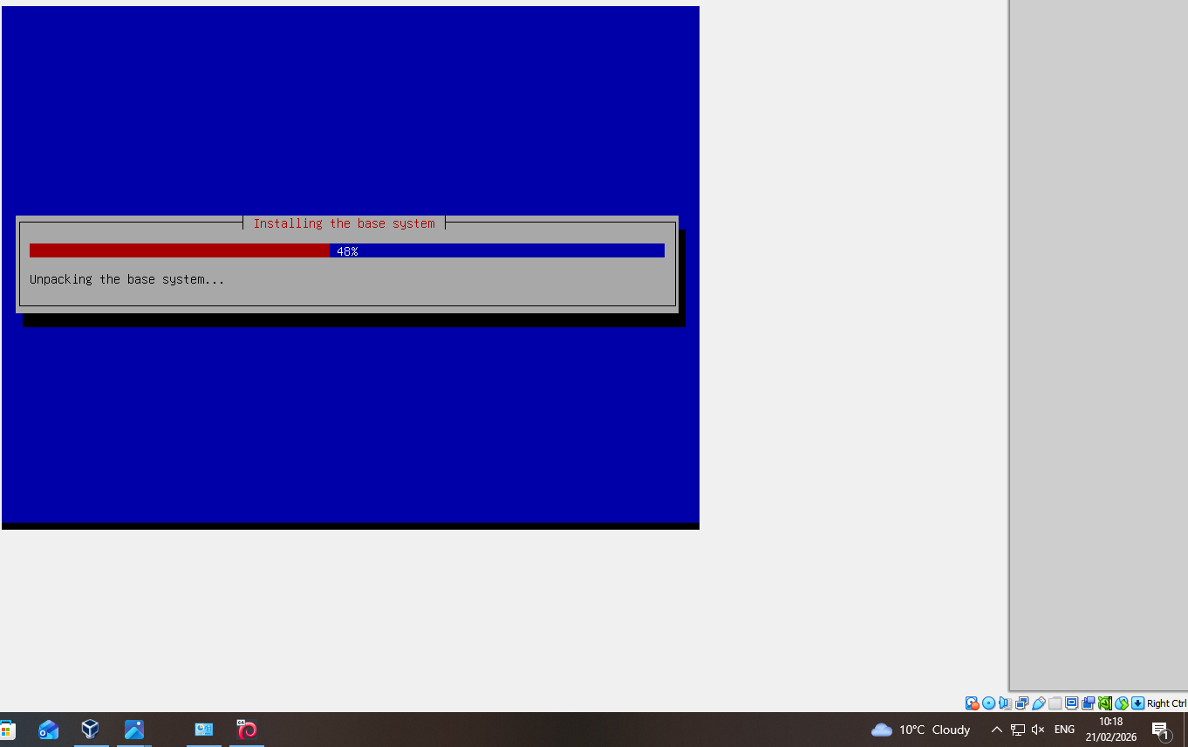
Figure 10: Debian Server Installation - Base System Deployment - Timestamp Visible
The Debian server was deployed to support the London-side infrastructure. Base system installation is shown in progress prior to network and service configuration.

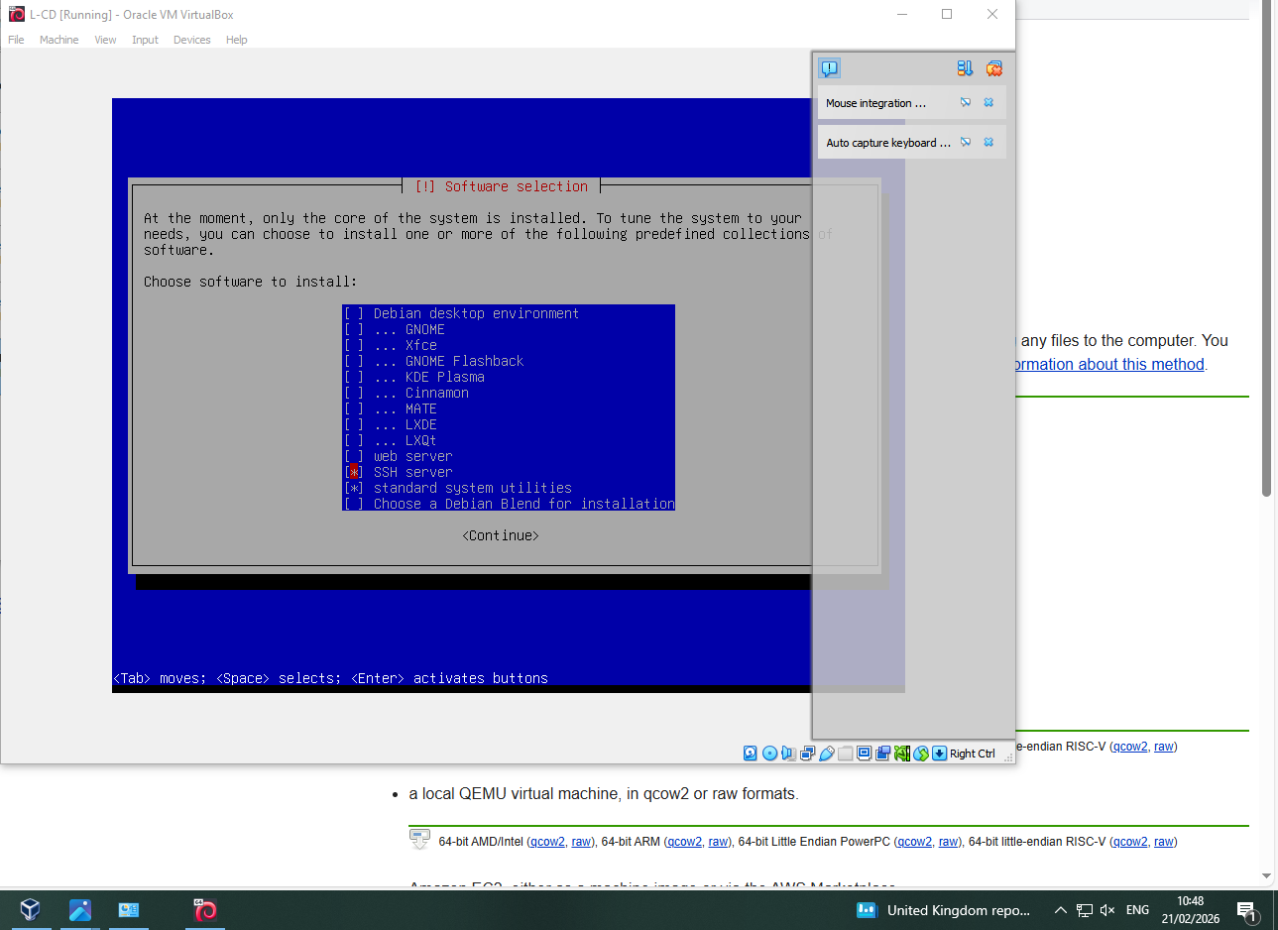
Figure 11: Debian Software Selection - Server Configuration (L-CD) - Timestamp Visible
During Debian installation, only components were selected, including SSH Server and Standard Utilities. No desktop environment was installed, ensuring a lightweight server configuration for the London segment.

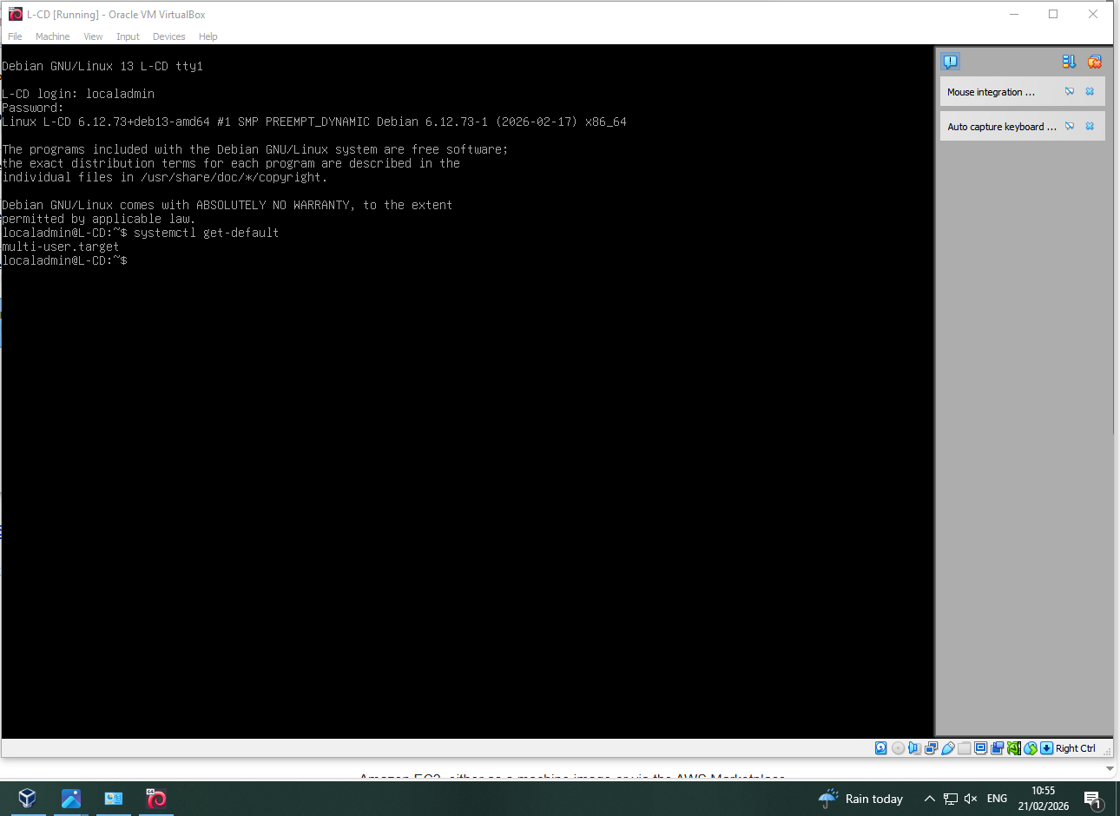
Figure 12: Debian Server CLI Verification L-CD (localadmin) - Timestamp Visible
Following installation, the Debian server booted successfully into the command-line interface. The Initial deployment used the localadmin account but was later reinstalled to correct user configuration and credential issues, confirming server-mode deployment without a graphical desktop.

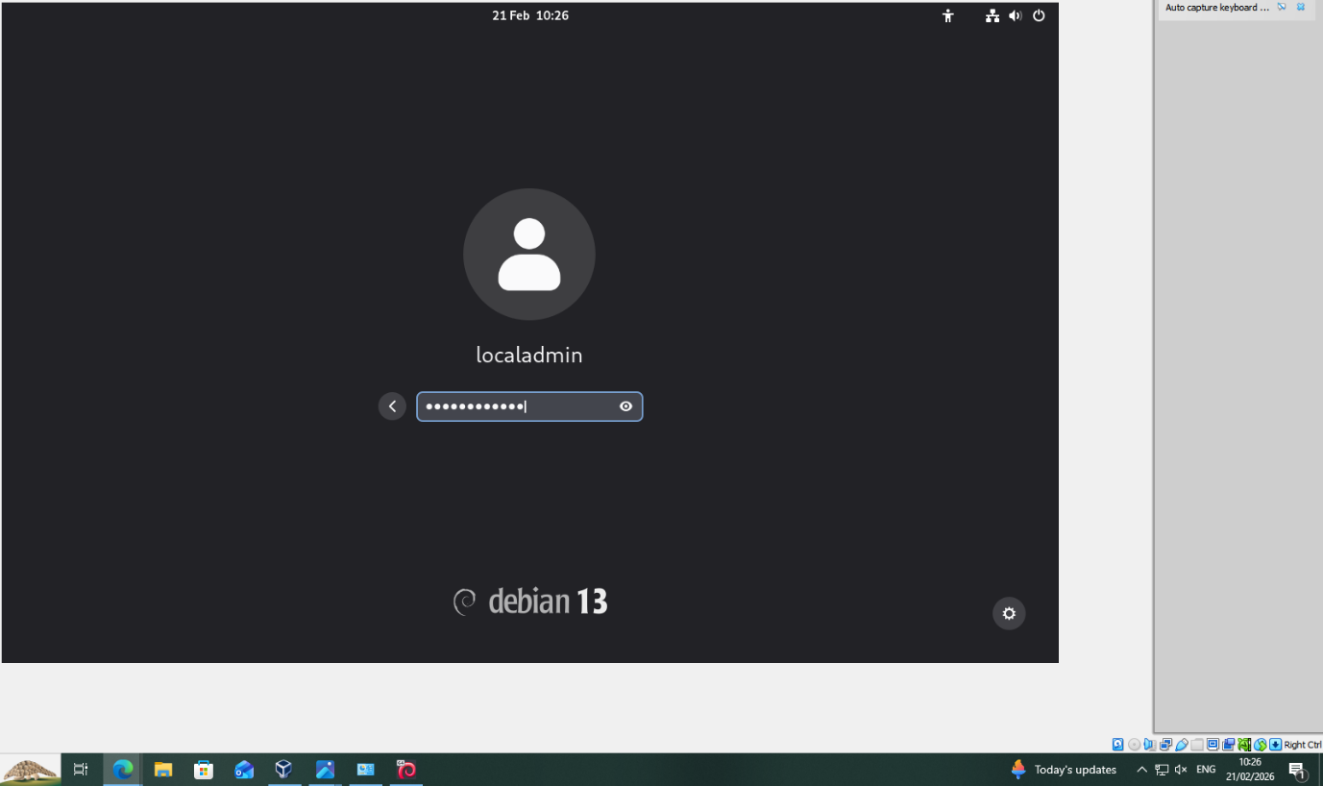
Figure 13: Debian 13 Installation Completed - Login Screen (localadmin) - Timestamp Visible
The Debian installation completed successful, booting to the login interface with the configured localadmin account, confirming successful deployment prior to network configuration.

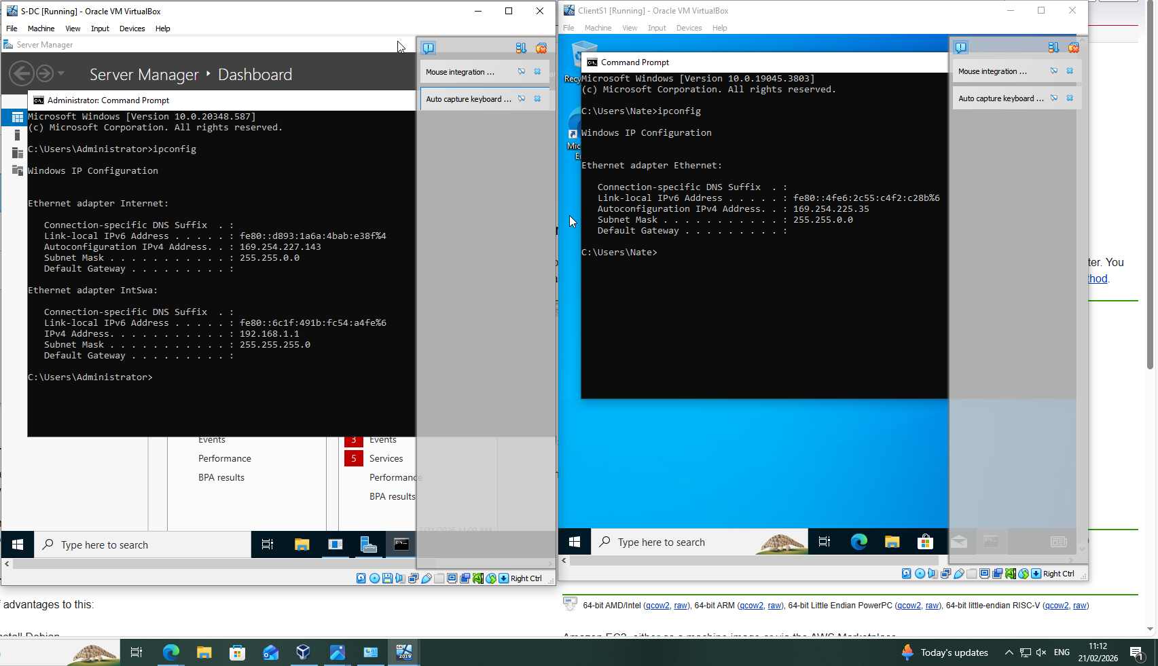
Figure 14: Initial Network Configuration Verification S-DC1 and ClientS1 (ipconfig) - Timestamp Visible
Initial ipconfig verification showed Automatic Private IP Addressing, indicating no DHCP within the isolated environment. The domain controller’s internal adapter was then configured with a static IPv4 address (192.168.1.1/24) to support domain services prior to connectivity testing.
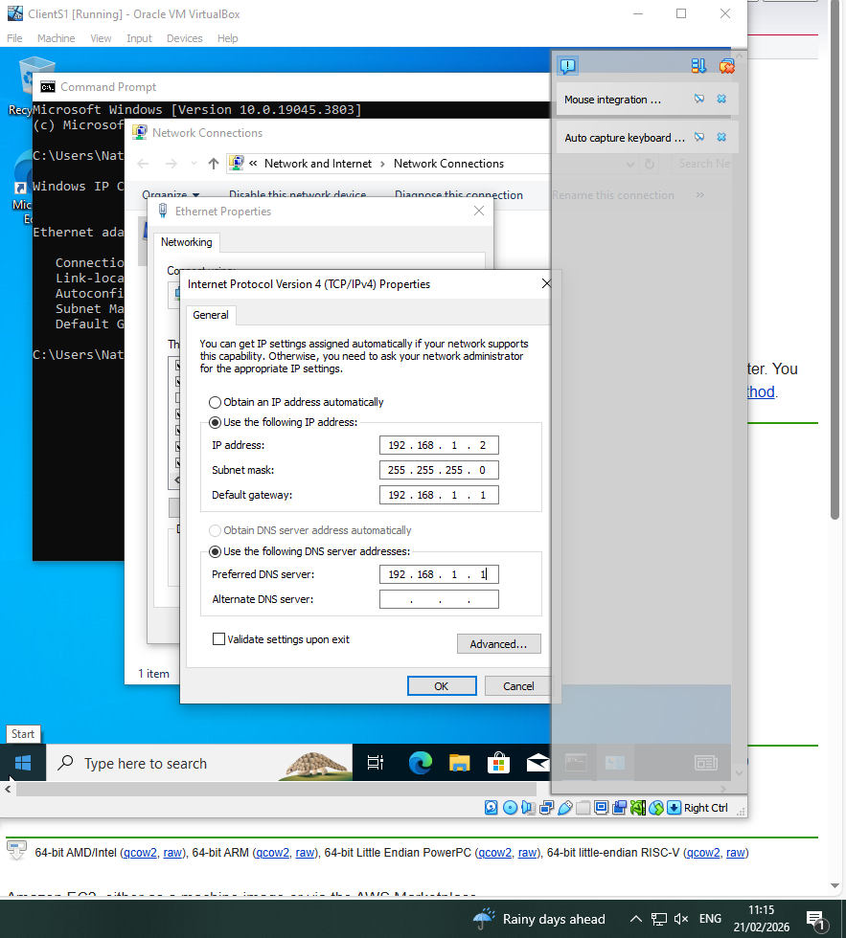
Figure 15: ClientS1 Static IPv4 Configuration - Timestamp Visible
ClientS1 was manually assigned a static IPv4 address (192.168.1.2/24). The default gateway and preferred DNS were set to 192.168.1.1 (S-DC1), enabling internal routing and domain name resolution for Active Directory integration.

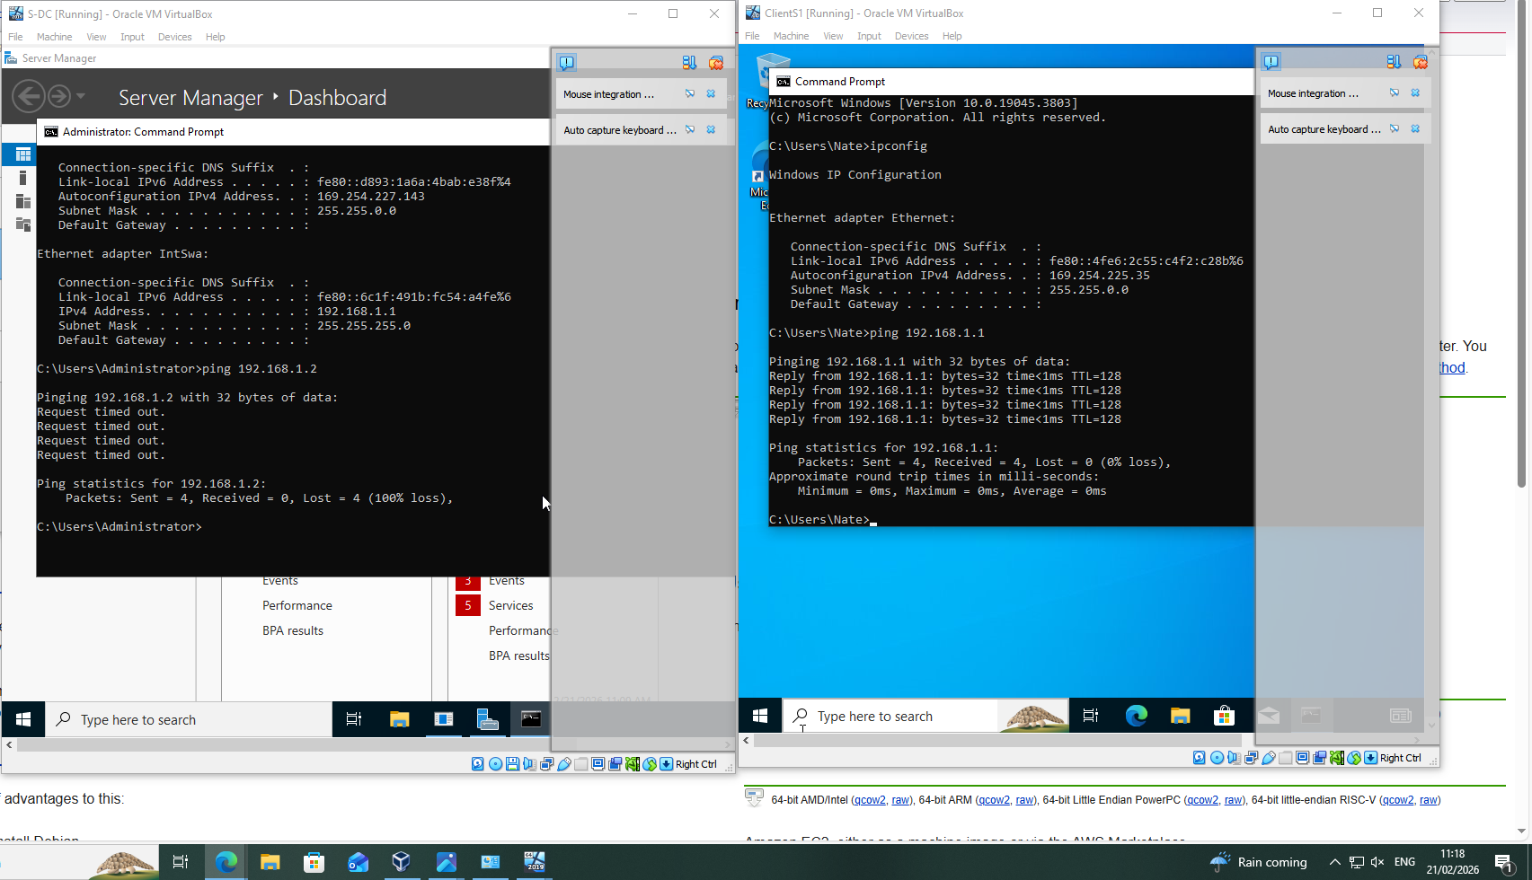
Figure 16: Connectivity Testing S-DC1 and ClientS1 (Ping Verification) - Timestamp Visible
Connectivity testing followed static IP configuration. ClientS1 successfully pinged the domain controller (192.168.1.1) with 0% packet loss. An earlier failed ping from S-DC1 indicated incomplete configuration, resolved through staged troubleshooting.

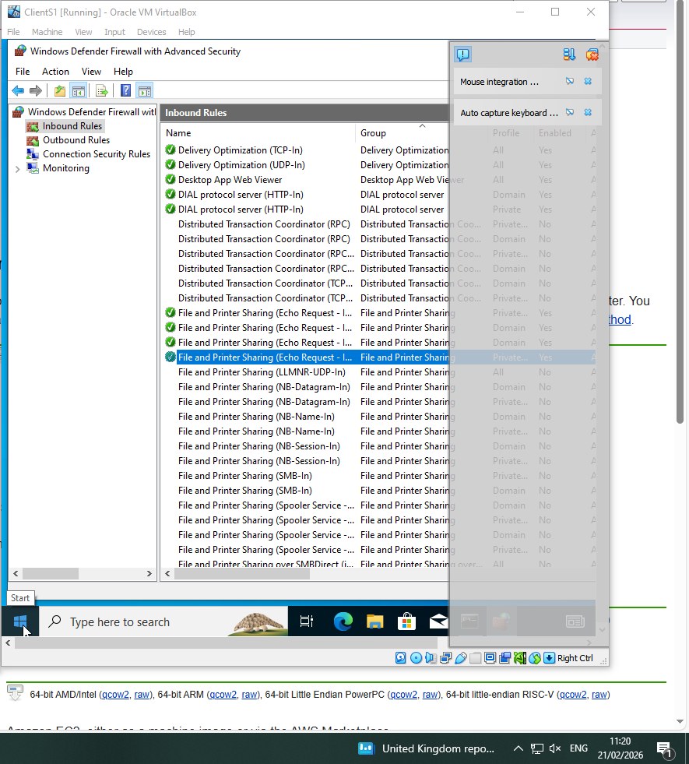
Figure 17: Windows Defender Firewall Configuration - Timestamp Visible
Following failed connectivity testing, Windows Defender Firewall settings were reviewed and the File and Printer Sharing (Echo Request – ICMPv4-In) rule was enabled to permit ping traffic, restoring communication between ClientS1 and the domain controller.

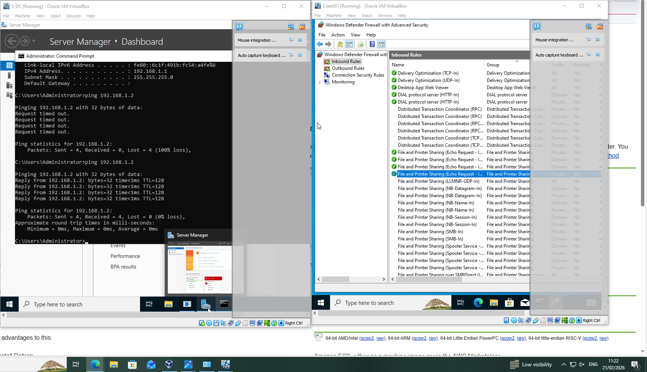
Figure 18: Successful Connectivity After Firewall Configuration - Timestamp Visible
Initial Internet Control Message Protocol echo requests from S-DC to ClientS1 resulted in 100% packet loss. After enabling the inbound firewall rule, testing was repeated and successful replies were received (0% loss), confirming restored communication.

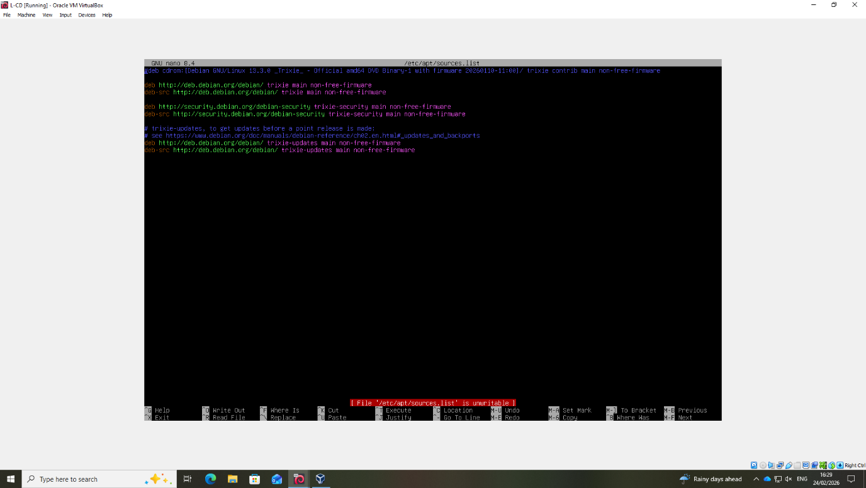
Figure 19: Debian Repository Configuration Using Elevated Privileges - Timestamp Visible
The /etc/apt/sources.list file was modified using sudo to obtain elevated privileges, ensuring the Debian “trixie” repositories were correctly configured for package management and updates.

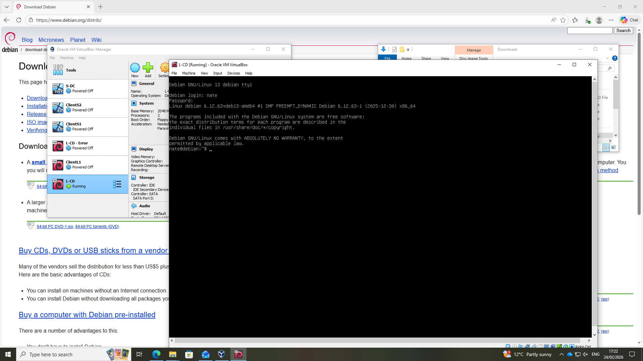
Figure 20: Successful Debian Re-Installation and User Login - Timestamp Visible
Due to credential issue, Debian GNU/Linux 13 was reinstalled and accessed using the correctly configured user account (“nate”). The system booted to the terminal interface, confirming successful installation and authentication.

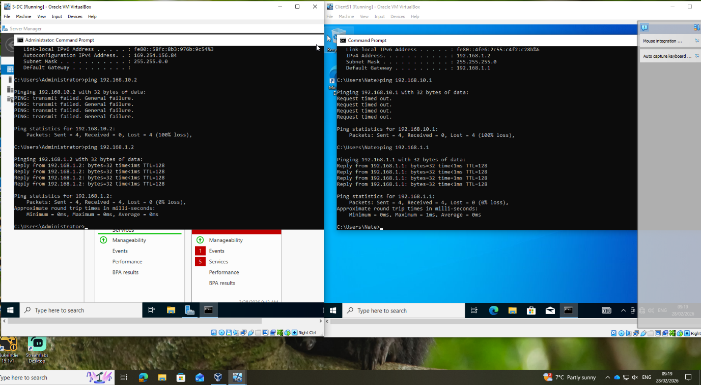
Figure 21: Verified Bidirectional Connectivity Between Reinstalled S-DC and Client1 - Timestamp Visible
Although earlier testing confirmed communication between the initial S-DC and ClientS1, this test validated connectivity following reinstallation. Internet Control Message Protocol echo requests were successful in both directions (0% packet loss), confirming correct IP configuration and subnet alignment.

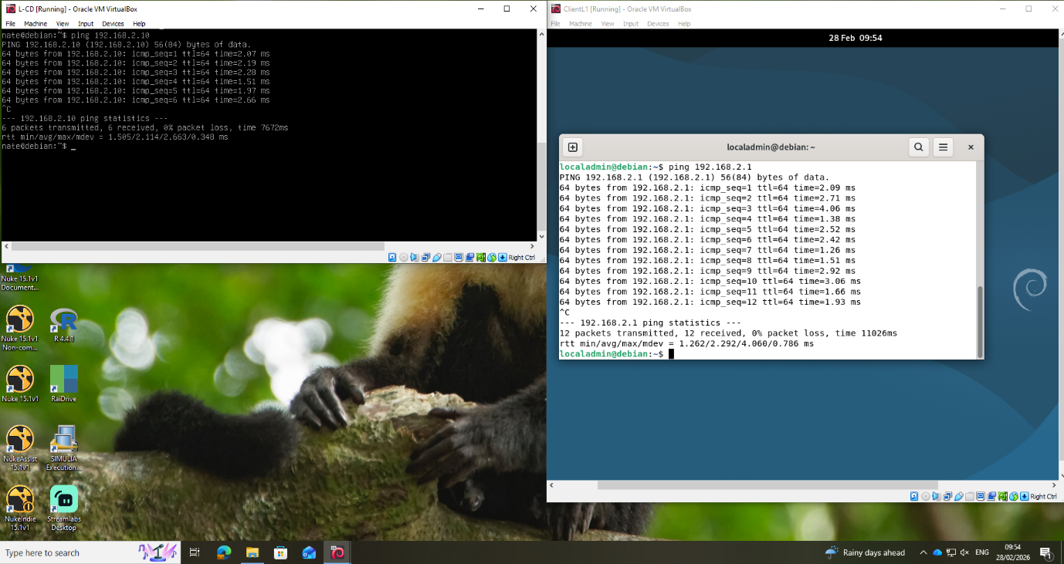
Figure 22: Verified Connectivity Between Reinstalled Debian Server and Client - Timestamp Visible
Following reinstallation, connectivity testing confirmed correct configuration of the Debian server and client. Internet Control Message Protocol echo requests between 192.168.2.10 and 192.168.2.1 were successful (0% packet loss), confirming correct IP configuration and internal communication.

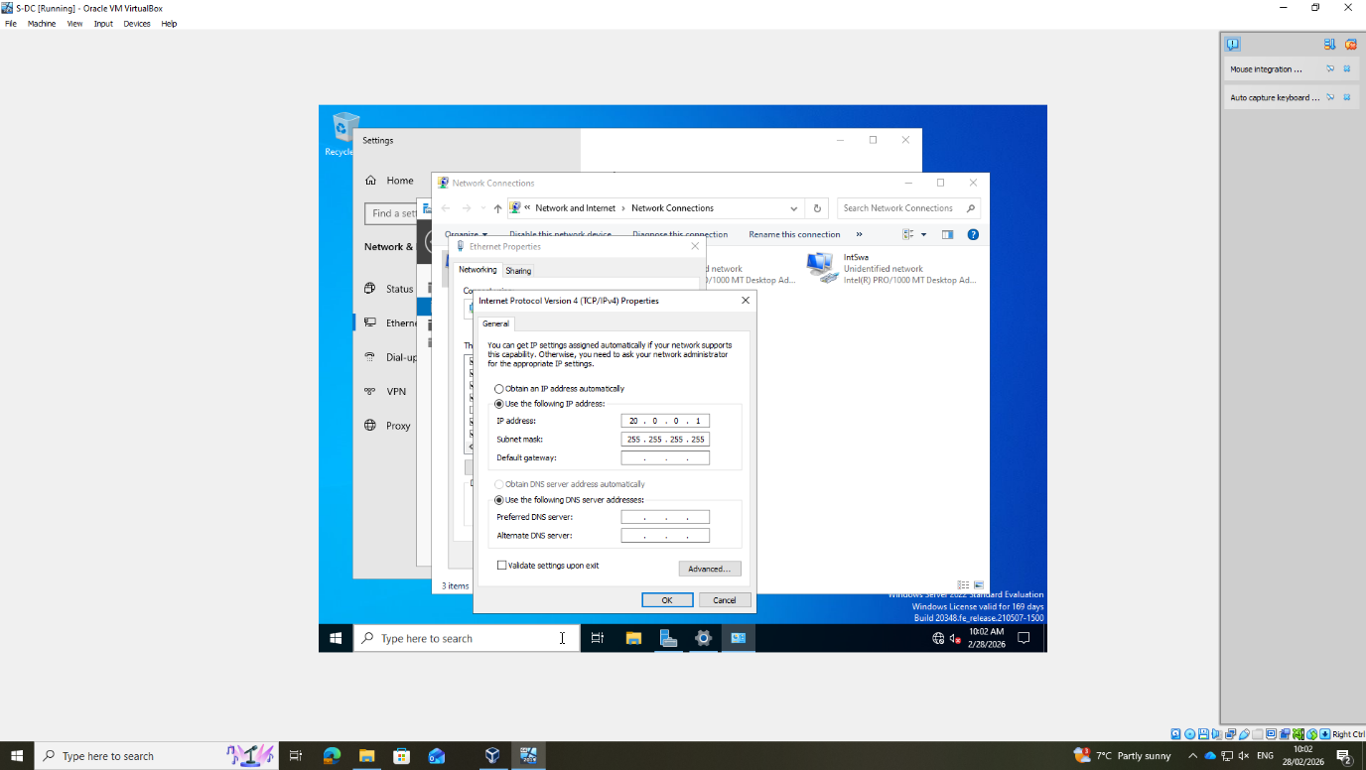
Figure 23: Static IP Configuration for External Interface on Windows Server - Timestamp Visible
The Windows Server external adapter was configured with a static IP (20.0.0.1). An incorrect subnet mask (255.255.255.255) prevented communication and was corrected to 255.255.255.252, establishing a valid point-to-point subnet and restoring connectivity.

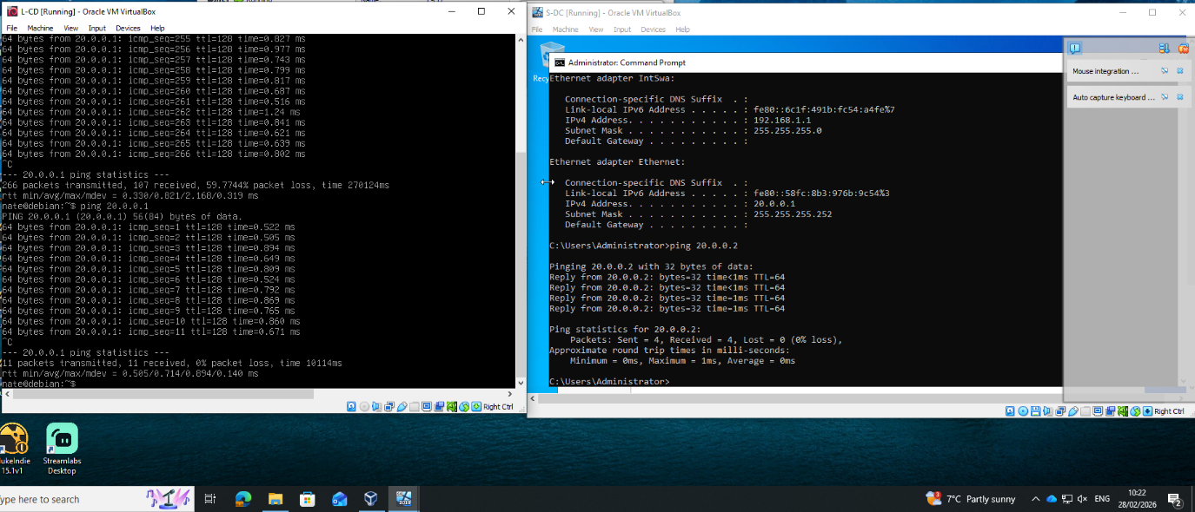
Figure 24: Successful Connectivity Between Windows Server and Debian Host - Timestamp Visible
Following correction of the external subnet (255.255.255.252), connectivity between the Windows Server (20.0.0.1) and Debian host (20.0.0.2) was validated using ICMP echo requests. Successful replies were received (0% packet loss), confirming external communication.

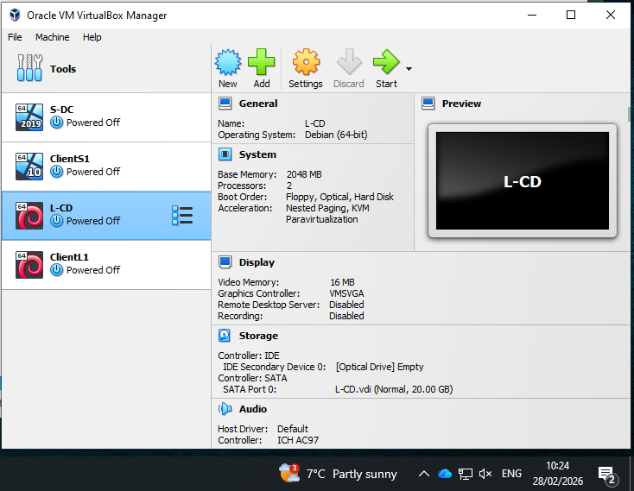
Figure 25: Final Virtual Machine Environment After Removal of Redundant Instances - Timestamp Visible
The VirtualBox was reviewed and redundant virtual machines were removed. The final configuration shows only the required four machines (S-DC, ClientS1, L-CD, and ClientL1), confirming a clean and controlled deployment.

Task 3

Personal & Technical Reflection

The deployment of the NOSS2026 virtualised network required structured planning and iterative troubleshooting. Several technical challenges were encountered, including incorrect subnet mask configuration (255.255.255.255), firewall restrictions blocking Internet Control Message Protocol echo requests, and credential issues during Debian installation. Each issue was diagnosed systematically using command-line tools such as ipconfig and ping, alongside verification of firewall rules and network adapter settings. The subnetting error was resolved by recalculating the appropriate mark (255.255.255.252) to enable point-to-point communication, while firewall rules were adjusted to permit inbound echo requests. Reinstallation of Debian ensured correct user configuration and authentication alignment.
This process strengthened my understanding of OP addressing, subnetting, routing logic, and cross-platform connectivity between Windows and Linux systems. The experience reinforced the importance of validation testing after each configuration change and maintaining a controlled virtual environment. Personally, the iterative rebuilds and corrective actions improved my confidence in independent troubleshooting and decision-making. The structured documentation with timestamps also developed my time management and professional reporting skills, reflecting real-word deployment practices.

Although the brief suggested a limited number of screenshots, additional evidence was included to transparently document the challenges encountered during deployment and the corrective actions taken. In a real-world enterprise environment, stronger security practices would be implemented, including complex password policies, secure credential storage, and hardened virtual machine configurations. However, for demonstration purposes within the controlled academic setting, the use of standardised usernames and passwords aligned with the coursework specification and ensured consistency across the deployed topology.

References

[1] M. Portnoy, Virtualization Essentials. John Wiley & Sons, 2016. Chapter 2 pp 42-53
[2] I. editorial team, “What’s the difference between type 1 and type 2 hypervisors?,” IONOS Digital Guide, Jul. 11, 2024. https://www.ionos.co.uk/digitalguide/server/know-how/hypervisor-type-1-and-type-2/ Accessed on 15 Feb 2026
[3] Fortinet, “What is an IP Address? How it works? How to Locate it?,” Fortinet. https://www.fortinet.com/uk/resources/cyberglossary/what-is-ip-address Accessed on 15 Feb 2026
[4] J. F. Kurose and K. W. Ross, Computer Networking: a Top-Down Approach, 7th ed. Boston: Pearson, 2017. Chapter 4 4.4 pg331-346, Subnet pg340-344, Routing pg308, Network Service Models pg310-313
[5] AWS, “What is Routing - Beginner’s Guide to Network Routing - AWS,” Amazon Web Services, Inc., 2023. https://aws.amazon.com/what-is/routing/ Accessed on 15 Feb 2026
[6] J. R. Ricart, “What is VPN? VPN Definition,” wix-encyclopedia, Jun. 24, 2023. https://www.wix.com/encyclopedia/definition/virtual-private-network-vpn?utm_source=google&utm_medium=cpc&utm_campaign=21928732291 Accessed on 15 Feb 2026
[7] Microsoft, “Active directory domain services overview,” Microsoft, Mar. 11, 2025. https://learn.microsoft.com/en-us/windows-server/identity/ad-ds/get-started/virtual-dc/active-directory-domain-services-overview Accessed on 15 Feb 2026
[8] “IBM i,” Ibm.com, Sep. 29, 2025. https://www.ibm.com/docs/en/i/7.6.0?topic=concepts-certificate-authority Accessed on 15 Feb 2026

