

Assessment component 1

Student Name: Biplob Das
Student ID: 2424763

Programme: Master of Business Administration
Module Name: Human Capital Management
Module Code: LCMB7023

Lecturer: Dr Gladius Kulothungan
Word Count: 2584

Submission Deadline: 17.12.2025

Table of Contents
1. Introduction 3
2. Barclays HRM and IHRM Technological Advancements and their effect on the labour markets 3
3. Demographic and Geopolitical Forces that affect Employment Markets and HR issues facing Barclays 6
4. Addressing Skills Gaps and Talent Shortages Through Strategic HRM at Barclays 8
5. Reflective Report: My Competencies to work in an International and Technological-driven work environment 10
6. Conclusion 12
7. References 13
Presentation 15

1. Introduction
The world labour market is going through a fast change that is brought about by technological disruption, demographic changes and geopolitical unrest. These forces are putting tremendous pressure on the HRM and IHRM functions that organisations need to redesign their workforce strategies in order to stay competitive. The implementation of digital banking patterns, AI-based processes, and remote working technologies has transformed the labour demands of various areas in the case of multinational corporations like Barclays (Deloitte, 2022). With the growing globalisation of labour-markets, the competency of attracting and nurturing specialised talent has become even more difficult, particularly in high-demand sectors like fintech, cybersecurity, and data analytics (World Economic Forum, 2023).
The report will be a critical analysis of four interrelated themes that shape the HR practise in global organisations. It starts with the analysis of the technological breakthrough and its effects on labour markets, then demographic and geopolitical changes are also reviewed. It then analyses organisational strategies so that skills gaps can be filled and then provides a reflective analysis of individual abilities needed in global and technology-intensive workplaces. These analyses, collectively, give clues to how Barclays should negotiate the modern workforce issues to continue with strategic long-term advantage.

2. Barclays HRM and IHRM Technological Advancements and their effect on the labour markets
The technological change, particularly the development of AI, automation, and machine learning and the introduction of digital banking platforms, has drastically reconfigured the global labour market and introduced both opportunities and disruption to organisations like Barclays. The World Economic Forum (2023) asserts that automation will also remove 44 percent of repetitive jobs by 2027 and, in the process, result in a massive market demand of digital and analytical work. This paradigm change compels HRM to change its approach to transactional management of the workforce to strategic capacity building with emphasis on digital literacy, innovation, and flexibility.
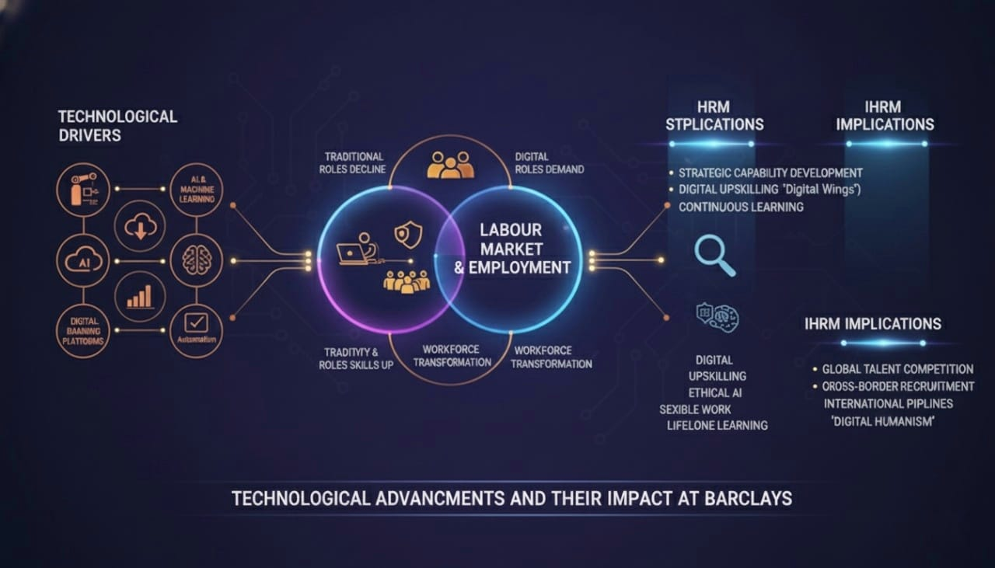
Source: (The World Economic Forum, 2023)
In the financial industry, AI will automate fraud detection, improve risk modelling, and assist consumer-facing operations using chatbots and predictive analytics. Barclays has adopted AI-based systems in compliance, operational risk and customer channels to enhance efficiency and accuracy (Barclays Annual Report, 2024). Although these innovations make the operations processes simpler, they also lead to the reduction of traditional banking positions, which is a source of labour market displacement. According to Deloitte (2022), the effect of digitalisation on the global banking transaction has seen the reduction of transactional banking jobs by 35 percent, with the author asserting that workforce reskilling on the strategic front is required.
The HRM at Barclays needs to then emphasise on agility and continuous learning. Studies indicate that organisations that undertake massive digital upskilling have a better retention and adoption of technology (PwC, 2021). The example of Digital Wings platform at Barclays offers employee development opportunities that are based on technology-oriented training and enable workers to adjust to the changing job needs.
Digital skills are internationally portable, hence making global talent mobility more complex as viewed through IHRM. A remote-work technology enable Barclays to tap into the global talent pools, but also subjects the organisation to increased competition by other global employers who are also after the same expertise. According to McKinsey (2021), the world lacks an adequate number of cybersecurity experts (3.5 million), which makes the competition in fintech talent more intense.
Nevertheless, the use of AI creates moral and psychological issues. In a study, it is implied that algorithmic decision-making makes employees feel more job insecure, in particular, when AI tools are applied in performance monitoring and in hiring (Meijerink et al., 2021). To address these fears, HRM should make sure that there is transparency, ethical governance, and inclusive communication in adopting AI systems.
Moreover, the use of new technology has provided inequalities on the availability of skills on a global scale. Developed economies usually have better digital infrastructure and education base whereas emerging economies are challenged by the obstructions to the creation of digital competence. Successful IHRM strategy should therefore be in tandem with training programmes and local environments as well as regulation provisions.
To conclude, technology is reorganising labour markets and is transforming HRM and IHRM functions. In the case of Barclays, the consequences are the massive talent development, the global labour competition, the necessity of responsible AI management, and the broadening of investing in digital skills. To overcome these challenges, an integrated HR strategy is needed to sustain learning, coordinate the global workforce, and adopt technology in a human-oriented manner.

3. Demographic and Geopolitical Forces that affect Employment Markets and HR issues facing Barclays
The forces of labour market dynamics are largely determined by demographic and geopolitical factors and pose at the same time great challenges to HRM and IHRM in global organisations like Barclays. The availability, skills, and mobility of labour are impacted by demographic ageing of populations, migration patterns, urbanisation, and workforce participation, whereas geopolitical uncertainty, such as trade wars, changes in regulations, and political factors, affect talent acquisition and border workforce planning (OECD, 2022).
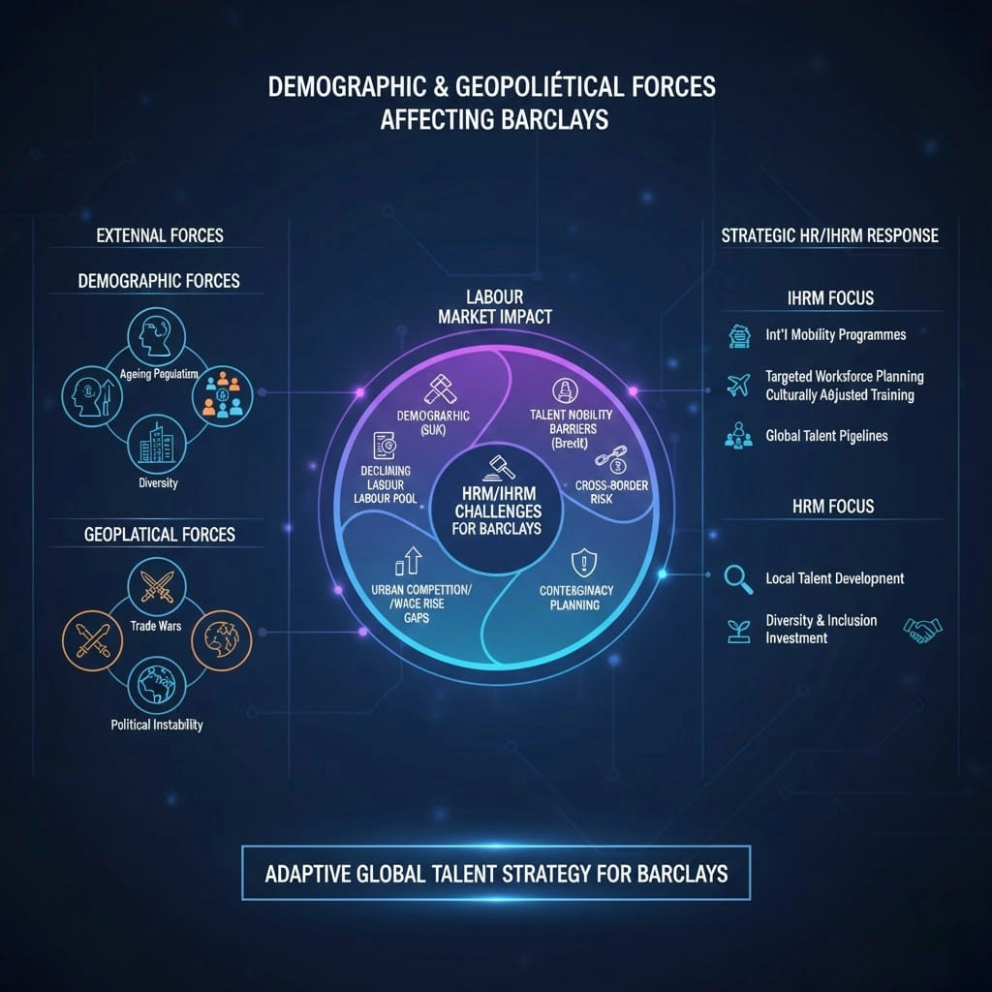
Source: (OECD, 2022)
The ageing populations in developed economies like the UK have had the effect of precipitating skills shortages in major areas of the economy like finance and technology. Several changes in labour market, such as declining labour pool and competition, are becoming a growing challenge to Barclays recruiting mid-to-senior level specialists with the essential digital and financial skills (World Economic Forum, 2023). At the same time, there are new markets with younger populations like India and some regions of Africa that can be potential talent sources. Nevertheless, HRM needs to overcome any labour legislation disparities, cultural differences at the workplace, and education-employment opportunities to leverage this workforce. The corresponding IHRM strategies therefore place more and more emphasis on international mobility programmes, culturally adjusted onboarding and localised training interventions to counter the gap in talents.
Talent supply is also affected by migration and workforce mobility. Due to geopolitical factors like Brexit, the UK has lost access to workers in the EU, which has forced Barclays to revise its recruitment strategies and intensify the use of local talent development efforts (CIPD, 2021). Equally, political unrest or trade barriers in some areas can restrain opportunities of international assignments and necessitate contingency workforce planning.
Demographic trends are linked to gender, diversity, and inclusion considerations. Barclays publicly committed to bettering the gender balance and workforce diversity, but the demographic imbalance in finance, including a lack of women in technology and leadership positions, continues to present a challenge to HR practises at the company (Barclays, 2024). The IHRM practises need to include, inclusive recruitment, retention, and development programmes, so that training opportunities and career advancement are equally provided to different pools of talent.
Availability of skilled labour is affected by urbanisation and geographic concentration of skilled labour too. Financial centres with high demand like London, New York and Singapore have a high rate of competitiveness among specialised workers which increases wage expectations and affects retention practises. On the other hand, local and isolated locations are potentially benefiting in terms of talent untapped, yet necessitating a financial commitment in infrastructure, training, and interaction systems (Deloitte, 2022).
To summarise, the opportunities and limitations to the HRM and IHRM strategies of Barclays are influenced by demographic and geopolitical factors. Greying populations, migration trends, political instability, and labour diversity concerns mean that there is a need to take an active and dynamic stance with regard to global talent management. Some of the strategic responses comprise of targeted workforce planning, international mobility programmes, culturally custom-designed training, and investment in diversity and inclusion programmes. The measures allow Barclays to reduce risks, optimise the distribution of talents and remain competitive in a more complicated global labour market.

4. Addressing Skills Gaps and Talent Shortages through Strategic HRM at Barclays
The gap in skills and lack of talents is a burning issue in the key areas, including finance, technology, and cybersecurity. In the case of a multinational financial institution such as Barclays, these shortages have to be addressed by strategic HRM practises involving active workforce planning with specific recruitment strategy, employee development, and retention strategies.
The rapid technological innovation is one of the major causes of gaps in skills. Barclays works in a very digitalised world, and the needs in cybersecurity, fintech, data analytics, and AI significantly outnumber the number of relevant talents (McKinsey, 2021). These gaps can be bridged by strategic HRM using reskilling and upskilling methods. The Barclays platform Digital Wings reflects the given strategy, as it allows employees to learn specifically designed modules to gain digital skills and develop flexibility towards the new technology. According to research, companies that have invested in organised upskilling initiatives have a greater employee engagement and retention rate, and less pressure in outsourcing (PwC, 2021).
There is also the need to have targeted talent acquisition strategies. Barclays has used the global sourcing and international mobility more to get skilled professionals in the emerging markets such as India, Singapore and Africa. This is aided by IHRM practises that include cross-border recruiting, relocation services and culturally adaptive onboarding which ensures international talent is able to seamlessly fit into the operations of the organisation (Deloitte, 2022). The talent pipeline is also increased with partnerships with universities, coding academies, and fintech incubators that offer access to those with specialised skills, high-potential and early graduates.
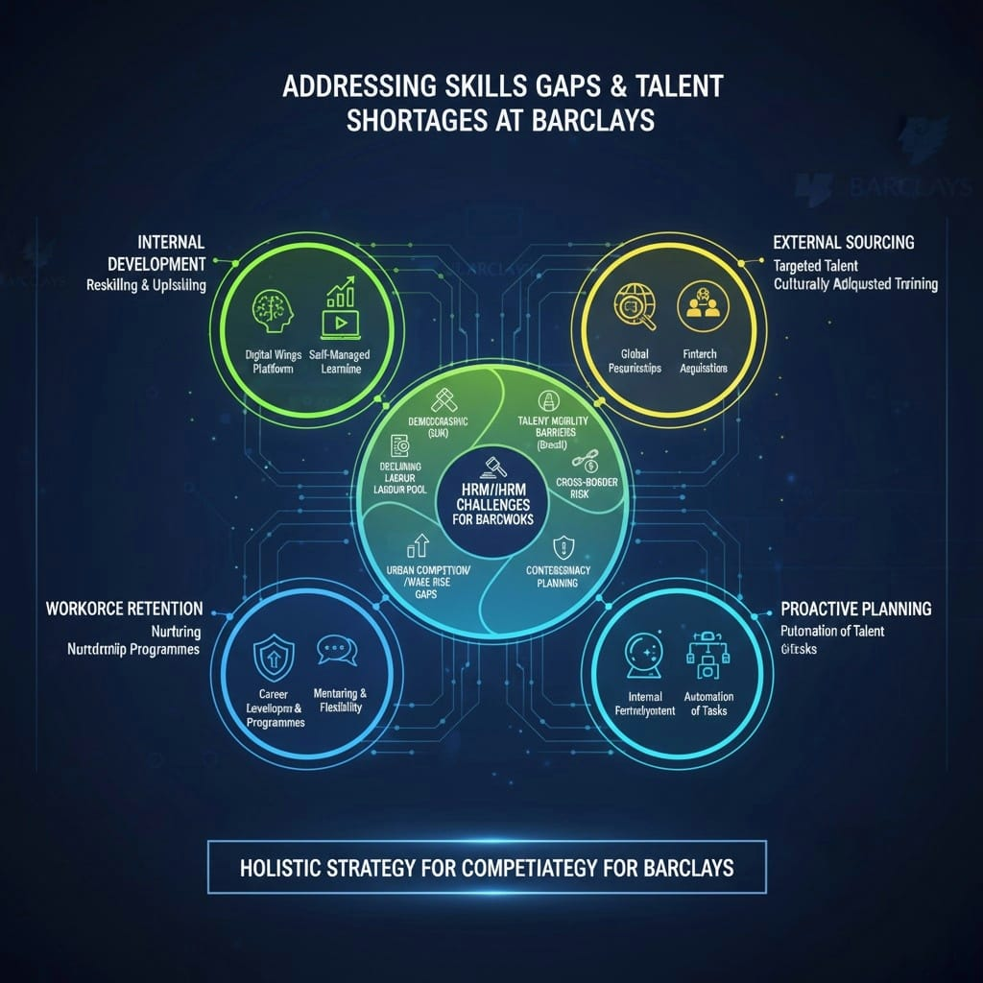
Source: (Deloitte, 2022)
It is also important to retain talented employees. Professionals who are in high demand can also have offers of work in several employers. Career development, mentoring and flexible working policies can help build loyalty and minimise the turnover. Barclays has also put in place organised career and career development schemes especially in critical technology and data sectors so that employees see that they have a way up and down the ladder.
Strategic workforce planning is also connected with the ability to predict the future skills needs. The use of scenario-based planning can help Barclays to forecast potential talent deficits and create preventive solution methods, which include redeployment of talent internally or automation of less skilled jobs to more effectively use the talent available (World Economic Forum, 2023). Lastly, it is essential to have a learning culture. The HRM strategies should promote self-managed learning, innovation, and inter-functional teamwork.
To conclude, the lack of skills and talent at Barclays is addressed with the help of a holistic HRM practise, which involves reskilling/upskilling, international recruitment, workforce retention process, proactive workforce planning, and learning culture practises. These strategic interventions can help the organisation to maintain competitive advantage in an environment that is highly dynamic in terms of technological change and the global race to acquire specialised talent.

5. Reflective Report: My Competencies to work in an International and Technological-driven work environment
In a globalised workforce of the current times, organisations like Barclays are in need of employees who can navigate through multifaceted international settings and exploit technological advancements to propagate business results. When evaluating my current abilities in the given context, I am going to focus on five primary areas, namely, technology, communication, teamwork, leadership, and self-directed learning. An assessment of my areas of strength and weakness in these areas will give me an idea of the ways I can be a valuable contributor to the international activities and digital strategy of Barclays.
Technological Competence: I have experience with digital, data analytics, and collaboration software, which makes me equipped to participate in technology-based workflow. As an example, I have been trained to use Microsoft Power BI, data modelling in Excel, and tools that help collaborate with clients in the cloud, which is what Barclays increasingly depends on in its decision-making and AI-mediated processes (Barclays, 2024). Nevertheless, I am not familiar with advanced forms of AI application and cybersecurity measures. To fill this knowledge gap, I will complete official training on technologies specific to the field of fintech and the basics of cybersecurity and bring my competencies in line with the strategic priorities of Barclays in the field of digital banking and risk management (McKinsey, 2021).
Communication Skills: Communication plays a very crucial role in multinational teams. I am also very competent in written and verbal communication and can modify messages depending on the cultural situation, which is necessary whenever I work with colleagues in the UK, Asia, and Africa. However, I also understand that I have to develop my communication skills related to intercultural communication further, especially in terms of my knowledge of various regulatory, linguistic and professional standards. This will be enhanced by attending cross-cultural workshops and global virtual teamwork simulation courses, which will reinforce the focus of global collaboration that Barclays undertakes (CIPD, 2021).
Collaboration: The experience of working in international teams has helped me to improve my skills in coordination, using different perspectives, and resolving conflicts in a constructive manner, across time zones. I also take an active part in group work and promote participatory decision-making. However, there are situations when I experience difficulties in assigning tasks within highly distributed teams so that it may compromise efficiency. To be better, I will embrace established project management models, including agile approaches, to boost coordination and output of team members in virtual settings (Deloitte, 2022).
Leadership: I have the basic leadership skills, i.e. ability to motivate peers, handling small projects, and creating an atmosphere of teamwork. Nevertheless, it requires strategic vision, being digital, and inspiring remote and culturally varied teammates to lead teams in an international and technology-driven setting. Participation in leadership development programmes, addressing the digital transformation and international HRM related practises, will enhance my ability to lead teams in the global operations of Barclays (World Economic Forum, 2023).
Self-Directed Learning: Here, the continuous learning process is vital in the rapidly evolving industries such as banking and technology. I also make efforts to acquire new skills including online classes, webinars, and professional certifications. However, I am also seeking to institutionalise a formal personal learning plan that will be consistent with the digital and international HR strategy of Barclays. This will involve learning in AI ethics, regulatory compliance at different jurisdictions, and other fintech trends, making me able to adjust to new organisational requirements (Bondarouk and Brewster, 2023).
Comprehensively, my self-evaluation shows that my abilities such as technological savvy, communication, team work, and pursuit of learning would place me in the position to play a valuable role in an international and technology-oriented organisation such as Barclays. Speaking about the weaknesses that have been identified, especially with the use of advanced AI applications, intercultural communication, leadership within virtual teams, and organised learning, will contribute even more to my employability and added value. Through formal training, experience, and reflection, I would be able to align my competencies with the strategic priorities of Barclays, which will help me in terms of innovation, global cooperation, and operational excellence.

6. Conclusion
To sum up, this report has discussed the important role of technological, demographic, and geopolitical factors on the labour markets and HRM/IHRM strategies, particularly in Barclays. The technological changes that will impact the workforce include AI and digital technology forced to continually upgrade, and demographic and geopolitical shifts present an opportunity and a challenge to global talent acquisition. Strategic HRM interventions, such as reskilling, international recruiting, retention approach, and promoting a learning culture, are needed to address skills gaps. Personal reflection brings out that to succeed in the globalised, technology-driven work environment, excellent digital literacy; intercultural communication, teamwork, leadership, and self-directed learning are required. All these observations highlight the importance of flexible, progressive and ethically directed HR in a bid to maintain organisational competitiveness in intricate foreign labour markets.

7. References
- Barclays (2024) Annual Report and Financial Statements 2024. Available at: https://home.barclays (Accessed: 10 December 2025).
- Bondarouk, T. and Brewster, C. (2023) Digital humanism in HRM: Balancing technology and people. Human Resource Management Review, 33(1), p. 100905. Available at: https://www.sciencedirect.com (Accessed: 10 December 2025).
- CIPD (2021) Brexit and its impact on UK labour mobility. London: Chartered Institute of Personnel and Development. Available at: https://www.cipd.co.uk (Accessed: 10 December 2025).
- Deloitte (2022) 2022 Global Banking and Capital Markets Outlook. Available at: https://www2.deloitte.com (Accessed: 10 December 2025).
- McKinsey & Company (2021) The future of cybersecurity employment: Global demand for talent. Available at: https://www.mckinsey.com (Accessed: 10 December 2025).
- Meijerink, J., Bondarouk, T. and Lepak, D. (2021) When AI meets HR: Implications for employee perceptions. International Journal of Human Resource Management, 32(12), pp. 2504–2527. Available at: https://www.tandfonline.com (Accessed: 10 December 2025).
- OECD (2022) Labour Market Trends and Ageing Populations. Paris: Organisation for Economic Co-operation and Development. Available at: https://www.oecd.org (Accessed: 10 December 2025).
- PwC (2021) Hopes and Fears Survey 2021. Available at: https://www.pwc.com (Accessed: 10 December 2025).
- World Economic Forum (2023) The Future of Jobs Report 2023. Available at: https://www.weforum.org (Accessed: 10 December 2025).
- Jones, S. and Manhique, I. (2022) ‘Digital labour platforms as shock absorbers: Evidence from COVID-19’, UNU-WIDER Working Paper 2022/108, Helsinki: UNU WIDER. Available at: https://hdl.handle.net/10419/273892 (Accessed 2 November 2025).
- KPMG (2023) The Future of HR 2023: Human-Led, Tech-Powered. Available at: https://kpmg.com (Accessed: 2 November 2025).
- Locke, E. A. & Latham, G. P. (2019) Goal Setting Theory: The Current State. Organizational Behavior and Human Decision Processes, 152, pp. 69–79.
- Mercer (2025) ‘Aging workforce solutions: Adapting rewards for changing needs.

