DS 1 Template

My Screenshots/Photos
- Please add 4–6 screenshots or photos of your digital life.
- You can use your phone or laptop.
- For each screenshot, write one or two sentences explaining what it shows
Google picture
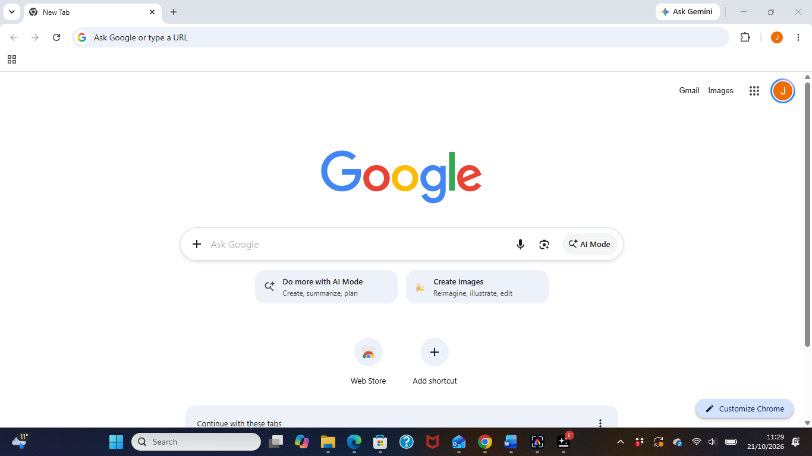
The picture above shows me using Google for research and quick understanding

Outlook picture
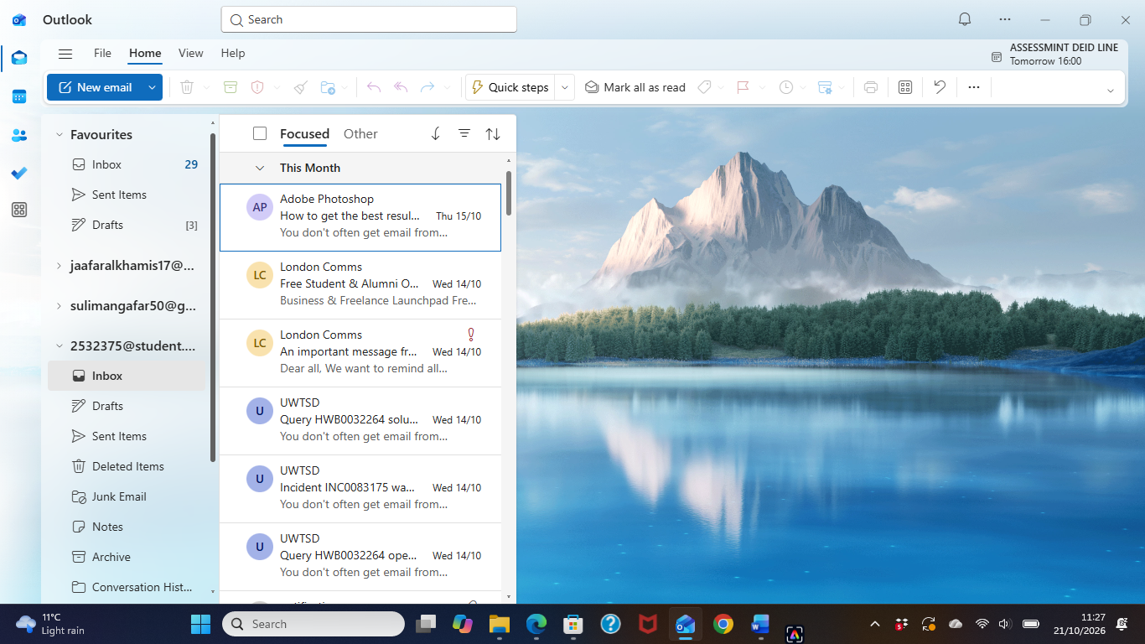
The picture shows me using Outlook for communication.

WhatsApp picture
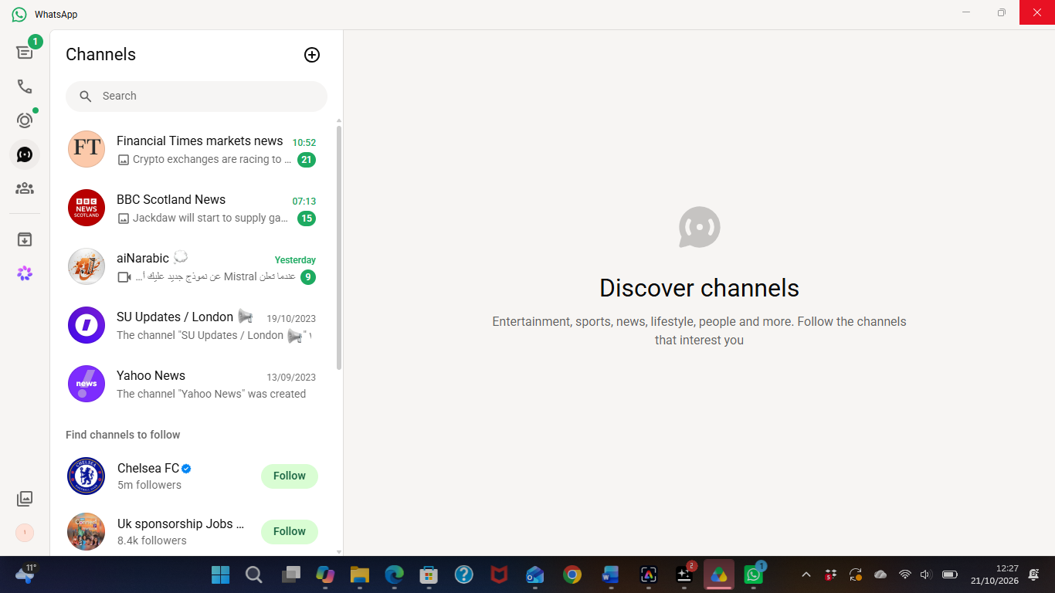
I use WhatsApp to communicate and to read news from different articles

eBay picture
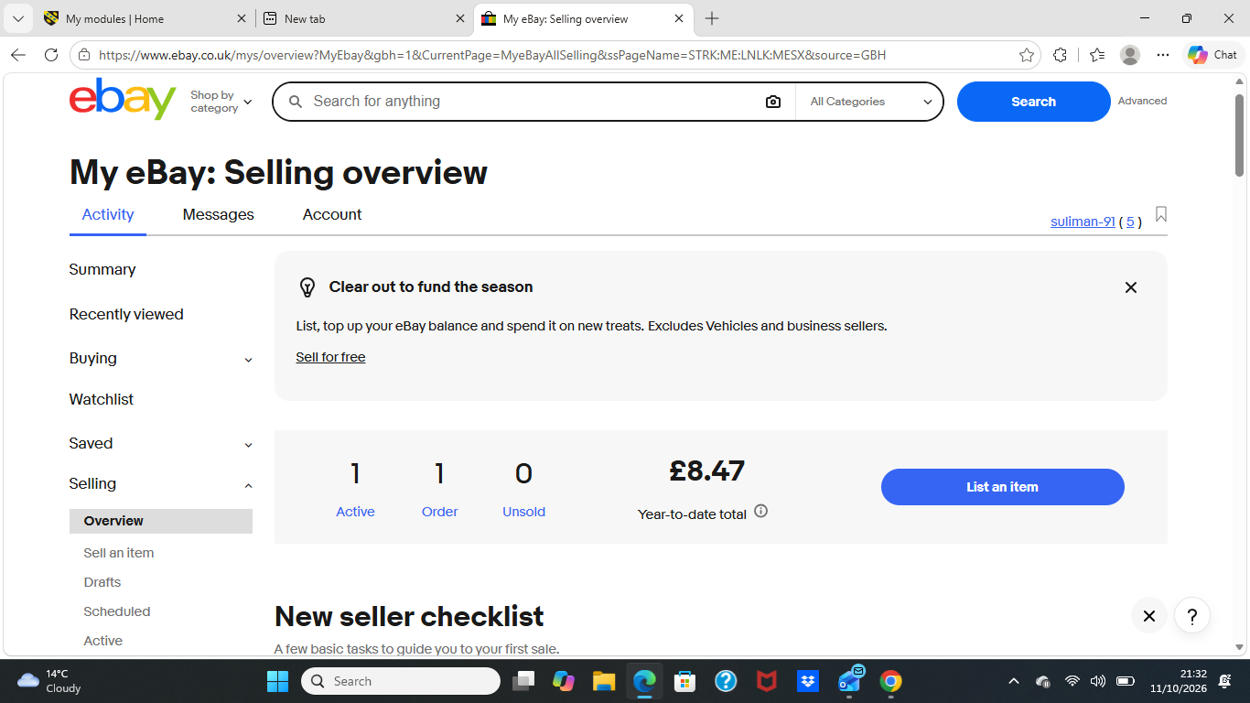
The picture shows I use eBay to sell and pay for items

My Short Reflection
- Write 5–8 simple sentences about your digital life.
- You can use the sentence starters below if helpful.

