

Resonance

BEng Electronics Engineering
ACDB4002 – Electrical & Electronic Principles

Prepared by:
Mr Aaron Hillam
P141233

Submitted to:
Dr Steve Mosey
School of Computing
06/02/2020

Abstract
The purpose of this assignment is to develop the skills and experience in the electronic discipline by conducting exercises including practical measurements and data analysis. This has been completed by setting up two experiments, the first a simulation of an RLC circuit, which uses a signal generator and a virtual oscilloscope to generate ideal readings. The second experiment consists of a physical RLC circuit built on a breadboard; this is then tested using a physical oscilloscope.
The data is then correlated and translated onto logarithmic graphs which show the VLC values, the rate of attenuation and the power output. The data has been used to determine the bandwidth and the quality factor of a signal / frequency.
The results of the experiments have shown that there are many variables in the real world which reduce functioning properties, these can include the resistance within all the materials and the medium transfer / attenuation.
It is determined that the physical circuit needs to be adjusted to compensate for the external factors, by using the simulation as a guide.
The work required to complete this report has resulted in a more general understanding of RLC circuits and its properties.

Contents
1.0 Introduction 5
1.1 Aims and Objectives 5
1.2 Background Research 6
2.0 Equipment 7
2.1 Simulation Setup 7
2.2 Physical Setup 7
3.0 Methodology 8
4.0 Results 11
5.0 Evaluation 20
6.0 Conclusion 21
7.0 References 22
8.0 Appendix 1 23
8.1 Appendix 2 24

Figures and Tables
Figure 1: Simulation Setup 8
Figure 2: Physical Setup 9
Figure 3: Simulation VLC 11
Figure 4: Physical VLC 12
Figure 5: Simulated Attenuation / Frequency 13
Figure 6: Physical Attenuation / Frequency 14
Figure 7: Simulated Q Factor 15
Figure 8: Physical Q Factor 16
Figure 9: Simulated V-Out 18
Figure 10: Physical V-Out 19

Table 1: Q Factor Results Simulated 17
Table 2: Q Factor Results Physical 17
Table 3: Proteus Data 23
Table 4: Breadboard Data 24

- Introduction
This report has been developed for the purpose of improving the experience and skillset within the electronic discipline. It focuses on the deployment of practical measurements and data analysis of an RLC circuit (includes resistors, inductors and capacitors).
An exercise has been completed, which consists of constructing a virtual and a physical RLC circuit, both are tested using virtual and physical testing equipment.
The data is then collected, interpreted and presented by means of suitable graphs and tables.

1.1 Aim and Objectives
The aim is to develop and improve practical electronic / electrical measurement skills and record and analyse data by conducting a laboratory exercise. To guide the development of the skills, the following objectives have been determined:
- Develop and assess a computer simulation of a suitable circuit.
- Develop and assess a physical copy of the simulated circuit.
- Determine and appraise the resonant frequency of the circuit.
- Determine and appraise the Q factor.

1.2 Background Research
The exercise focus on an RLC circuit, this consists of the connection of a resistor, inductor, capacitor and a power source such as a battery. These are typically used within tuning circuits for analogue radios. The RLC circuit can be used either as high pass filter, low pass filter, band pass filter or band stop filter. This can be accomplished by narrowing in on specific radio wave frequencies. [1] [2] [3]
The purpose of the low pass filter is to take in signals and filter the high frequency range. Thus, outputting of low frequencies. [4] [5]
The purpose of the high pass filter is to take in signals and filter the low frequency range. This, outputting of high frequencies. [2] [6]
The purpose of the band pass filter is to take in signals and filter every frequency outside the bandwidth. This function makes it possible to isolate and focus on a specific frequency, by removing the surrounding noise. [2] [6]
The purpose of the band stop is to take in signals and filter every frequency within the bandwidth. This is particularly useful for blocking unwanted signals. [1] [2]
The bandwidth is the frequency range between the low cut-off frequency (Fl) and the high cut-off frequency (FH). The wider the bandwidth is, the more surrounding frequencies are included, this could be interpreted as unwanted noise or wanted noise, dependent on its application. The shorter the bandwidth is, the less surrounding noise there is, again this can be interpreted as wanted or unwanted noise. [4] [5]
The Q factor or quality factor defines the sharpness of tuning. [7]This is expressed as:
$$Q=\frac{Voltage across L or V}{Voltage across R}$$
The sharpness tuning can be accomplished by changing the values within the circuit. Such as, the increase of impedance (Z), which increases the current and narrows the bandwidth, this provides better quality of signal. In principle, to get a sharp signal, the circuit should be used at a high frequency. If the signal is that of music, where a vast range of frequencies is required, then a low frequency is required. [4] [4]The sharpness of tuning can also be expressed as: $Sharpness of tuning= \frac{Operating Frequency}{Bandwidth}$
- Equipment
Throughout the experiment, the following equipment was used for the setup and testing of the simulated and physical RLC circuits:
2.1 Simulation Setup
- Proteus electronic design suite
- Excel (Recording data)

2.2 Physical Setup
- Breadboard
- 1k Resistor
- 1mH Inductor
- 1uF Capacitor
- 4 x Connection wires
- 2 x Passive oscilloscope probes
- Excel (Recording data)
- Tektronix TDS 2002 oscilloscope
- SJ Electronics LTD MKII universal T&M system

3.0 Methodology
Throughout the exercises, both a simulation and a physical setup had been completed.
The simulation setup was conducted to provide a fast and easy method of conducting the exercise. The setup used the proteus electronic design suite, which consisted of the 1kΩ resistor connected to a 1mH inductor and a 1uF capacitor. This circuit was then connected to a virtual signal generator and an oscillator, as shown in Figure 1.
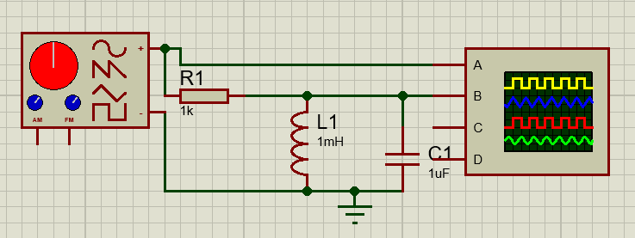
Figure 1: Simulation Setup

The physical setup included a breadboard, with the 1KΩ resistor, a 1mH inductor and a 1uF capacitor connected using connection wires. This setup used an SJ Electronics LTD MK2 universal T&M system, which provided a power supply to the circuit and enabled control over the frequency change. A Tektronix TDS 2002 oscilloscope along with two passive oscilloscope probes were used to monitor and determine the capacitor inductor voltage (VLC). As shown in figure 2.
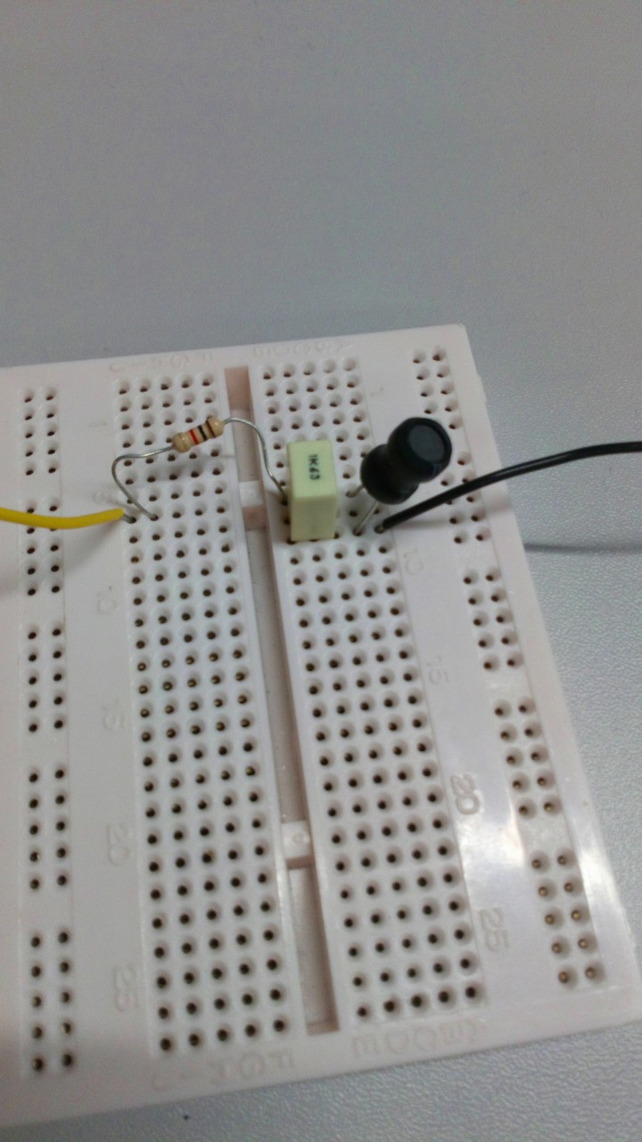
Figure 2: Physical Setup

The virtual and physical oscilloscopes were used to monitor the change in capacitor inductor voltage (VLC), as a range of frequencies from 100Hz up to 20KHz were tested and recorded on to logarithmic scale graph in an excel spreadsheet (see appendix 1 and 2). The corresponding data was added into the following formula, to gain the decibel value (dB).
$$dB=20*LOG10 (\frac{VLC}{Vin})$$
The decibel values were then plotted against the corresponding range of frequencies, to show how the attenuation changes in respect to the frequency.
The graph of attenuation vs frequency was then used to determine the frequency resonance and the Q factor. To determine these values the -3dB line, FL line and FH line are added to the graph and the frequency is then determined using the formula.
$Fres=$ $\frac{1}{2π\sqrt{LC}}$.
The Q factor is then determined using the following formula:
$$Q=\frac{Fres}{FH-FL}$$
To conclude that all aspects of the circuit have been correctly accounted for, the voltage output was then determined. This was conducted by calculating and adding the impedance and the capacitive reactance, using the following formulae respectively:
$$ZI=2πLrLF$$
$$Xc= \frac{1}{2πFC}$$
The sum of these two formulae is then written as:
$$ZLC=ZI+Xc$$
The value of Vout is then calculated using the formula:
$$Vout=Vin*\frac{ZLC}{R+ZLC}$$
The values of Vout were then plotted to highlight how the voltage changes, as the frequency is altered.

4.0 Results

Figure 3: Simulated VLC

Figure 4: Physical VLC

Figure 5: Simulated Attenuation / Frequency

Figure 6: Physical Attenuation / Frequency

Figure 7: Simulated Q Factor

Figure 8: Physical Q Factor

Table 1: Q Factor Results Simulated Table 2: Q Factor Results Physical

Figure 9: Simulated V-Out

Figure 10: Physical V-Out

5.0 Evaluation
Figure 3 and figure 4 represents how the sum of the capacitor / voltage changes against the frequency. The figures show that the VLC value increases exponentially until it reaches resonance. After resonance has been determined, any higher frequencies will lower the VLC value.
The data represented in figure 5 and 6 measures the rate of attenuation as the frequency increases. This is due to a damping effect as a result of the resistance within the circuit as well as an energy loss through the medium.
The data shown on table 1 and 2 represent the half power point (-3dB). The low cut-off frequency (Fl), the high cut off frequency (FH), the frequency resonant frequency (Fres), the bandwidth (BW) and the Q factor.
As previously discussed, the size of the bandwidth controls the quality factor / sharpness of tuning, the narrower the bandwidth is, the less noise surrounds it, the wider the bandwidth increases the amount of noise. With respect to figure 7 and 8 it is clear that the simulation setup has a significantly reduced bandwidth, this is a very high-quality bandwidth. However, the physical setup presents a bandwidth of more than 4 times the size of the simulation. Thus, producing a noisy signal. This is further represented with the Q factor, as shown the quality of the simulation setup is almost 6 times that of the physical setup.
Figures 9 and 10 depicts the remaining voltage output by comparing the voltage-in against the frequency. The data presented in both graphs show a strong correlation in regarding the voltage in and the voltage out, as such, the voltage in for the Proteus setup is double that of the breadboard run, thus the voltage out on the simulation is also double that of the breadboard setup.
By considering the information gathered, it is evident that there are many factors in the real world which affect the overall quality of the circuit. The simulation version provides an ideal example of the circuit. This can then be used to guide modifications within the physical circuit.

6.0 Conclusion
The aim of the assignment was to develop and improve analytical experience and skillset within the electronics discipline.
By conducting the experiments, it does indeed improve experience, first within the software used for simulation (Proteus), secondly using instruments to measure properties within the circuit and thirdly, analysing, interpreting and presenting of data using a suitable spreadsheet such as excel.
The background research into the circuit, has led to the discovery and understanding of oscillator circuits, resonance, bandwidths, damping, quality factors and the variety of filters which can be created using the circuit type.
Further studies have led to the understanding of how the frequencies can be adjusted within the circuit, in order to block or transmit signals, such as those within a radio.
The exercise was successfully conducted and the comparison between the simulated setup and the physical setup has shown there to be many variables which affect the physical setup, these should be taken into account, when developing the circuit to reach close to the simulated / ideal results.

7.0 References

[1] | D. B. Albert Malvino, Electronic Principles, New York: McGraw-Hill Eduction, 2016.
[2] | W. H. Paul Horowitz, The Art of Electronics, New York: Cambridge University Press, 2015.
[3] | J. C. Rawlins, Basic AC Circuits, Woburn: Butterworth-Heinmann, 2000.
[4] | K. S. Kumar, Electric Circuits and Networks, New Delhi: Dorling Kindersley Pvt.Ltd, 2009.
[5] | A. G. A. B. U.A.Bakshi, Electric circuits and electron devices, Pune: Technical Publications Pune, 2009.
[6] | W. A. Gerard kiernan, Electric Circuits Problem Solver, New Jersey: Research & Education Association, 2012.
[7] | I. D. Clive Poole, Microwave Active Circuit Analysis and Design, London: Elsevier Ltd, 2016.

8.0 Appendix 1
Table 3: Proteus Data

8.0 Appendix 2
Table 4: Breadboard Data

