Name: Gurpreet Kaur Cheema

Student Number: 26299

Module Code: BMSW4002

Title: Team working

Lecturer’s Name:

Summary

This assessment is about teamworking, it include a table of the content, an introduction to the task, a brief definition of what is teamworking, the models of experts, team role, strength and weaknesses of Belbin’s team role theory, the discussion about the impact of positive and negative teamworking, a conclusion and my personal experience, and for last the references list.

Table of Contents
Introduction 3
Overview of teamworking 4
Models of team development 5
Tuckman’s model of team development 5
Wheelan’s model of team development 6
Other models of development 6
Which team development model could be considered and why? 7
Team roles 7
Strengths and Weaknesses of Belbin’s team role 8
Why is important to consider team roles when recruiting new staff? 9
Discussion 9
What are the advantages of effective teamworking? 9
What can the impact be of ineffective or poor teamworking? 9
Conclusion 10
References 11

Introduction

In this assignment I am going to define what a team and a group is, give a brief definition, compare them and analyse their strength and weaknesses.
This assignment is based on a case study to read and has been asked to write a report on how student can develop an effective team, the impact effective teamworking can have for team success, the barriers to effective teamwork and the types of roles that are needed to create a cohesive and effective team.
You will come across of some points to theory and some references regarding the topic.
The report will include my professional experience as well.

Overview of teamworking

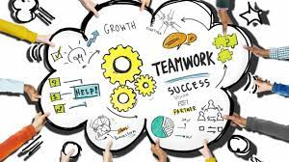

“A team is a group of people working together to achieve a common purpose for which they hold themselves mutually accountable.” (The team Handbook, Peter Scholtes, p. 1.2)
There are two types of groups: Formal and Informal.
A formal group, we call this a team as well, is defined by the organisation’s structure, designed work assignment.
An informal group is not formally structured or organizationally determined.
In a team the number of people is limited and everyone have a task to complete and the selection of these members is crucial, not everybody can be part of a certain team if they don’t have some type of a skill. A team has also a one or more leaders, or sometimes these changes as well and give a chance to other team members to lead the team. They all have a mutual knowledge, understanding and a dynamic interaction.

“To succeed, organisations must rely on the knowledge, skills, experience and prospective of a wide range of people to solve multifaceted problems, make good decisions, and deliver effective solutions.” (The team handbook, Peter Scholtes, p. 1.1)
The key elements to a successful teamwork are: context, composition and process.
Context means adequate resources, a good leadership and defined structure, there should be a climate of rust between team members, a performance evaluation and a reward system.
The composition describes the team such as the abilities of the members, different personalities and backgrounds, their flexibility, their preferences and number of the people in the team.
The process include the common purpose that they have as a team, how efficient they are, the conflict level between the team members and the social loafing.

Models of team development

The groups go through stages called developmental models that explain these stages groups pass through to become effective teams.
In the lesson we have discussed two types of models of team development:
- Tuckman’s model of team development
- Wheelan’s model of team development

Tuckman’s model of team development
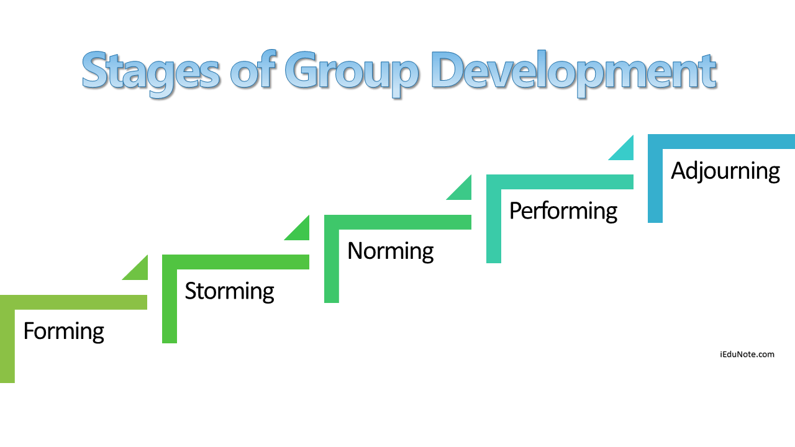

“Tuckman (1965) reviewed fifty-five articles dealing with stages of small group development in an attempt to isolate those concepts common to the various studies and produce a generalizable model of changes in group life over time.” (Stephen Thorpe, stages of small-group development revisited, p.43).
Based on Tuckman’s research, the group goes through five stages before they become an effective team:
- Forming: this is the first stage, the team members are not sure about the goal, structure and leadership. Everyone are strange to each other and they don’t know how to behave.
- Storming: is the second stage where the team members fights to become leaders, they accept the existence of the team but they still don’t feel as a part of the team.
- Norming: in the third stage they feel as a part of the team and they accept the fact that they can achieve the goal only if they accept other member’s point of view.
- Performing: in the fourth stage they start working in an peace full and trusting environment, they know and understand each other.
- Adjourning: in the last stage they move to another direction, the task has come to the deadline, team members celebrate the achievement and others may be depressed over the lost of the friendships gained during the work.

Wheelan’s model of team development
“Wheelan’s (2006) outlines the stages of the groups must go through in order to become a team.”
Based on Wheelan’s research, there are 4 stages that a team go through:
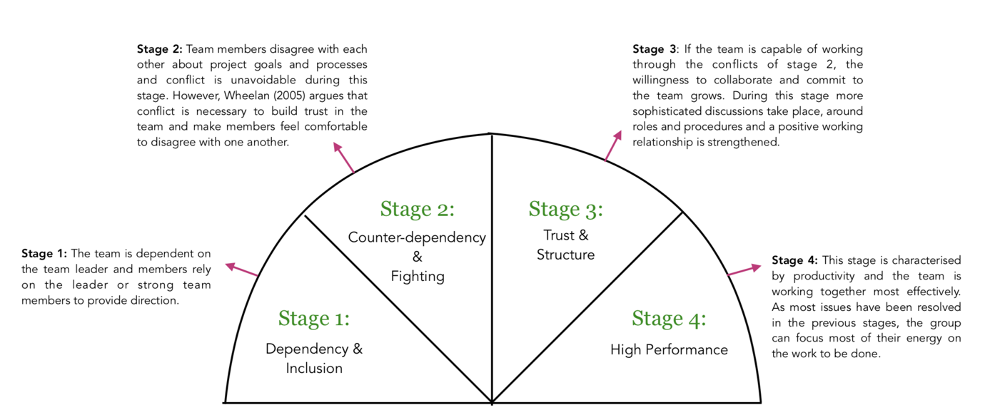

Other models of development

Most of the experts have different point of views and some of them thinks that group development is in phase and not stages.
Gersick also think that teams go through 4 phases of development; Stable phase: this start right after the first meeting, which is very important because people have an idea of the climate, culture and direction of the group. Instability phase: group goes through fights and instability. Stability phase: team has a clear idea of the goal, directions and are determinate to achieve their collective goal.

Which team development model could be considered and why?

In this case, the model that I will consider is the Tuckman’s stage of group development because, it reflects more what I have experienced working in a team at school, college and at work as well, I have been trough the same stages as he has described.
Tuckman’s model describes the relationship of team members during the group development stages.
Gesick’s model instead is more about the task dimension.

Team roles

“a small amount of interpersonal tension can be helpful, too much can engender negative emotional contagion that can sabotage trust and gool will” (Griffiths and Dunham, 2015, p.15).
There are many perspective from different experts that have analysed team roles , the most common theory is Belbin’s nine team role.
He thinks that a team needs a balance of personalities and roles if they are going to be successful. He has made 9 roles dived into 3 categories:

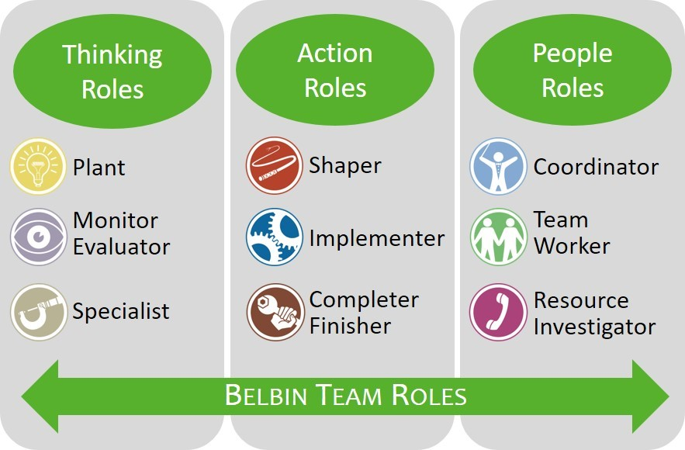

Thinking roles
Plant: they prefer to work alone, innovators and ideas.
Monitor evaluator: separates the good ideas from the ones.
Specialist: they are skilled in a specialist job.
Action role
Shaper: they challenge the norms, take the lead and push the team.
Implementer: executors of plan
Completer finisher: complete the final details.
People roles
Coordinators: they are natural team leaders.
Team worker: these are diplomats that keep team cogs turning.
Resources investigator: they find external resources.

Strengths and Weaknesses of Belbin’s team role

This role also has its strengths and weaknesses, in each role have a contribution and an allowable weakness.
Plant role: people are very creative, imaginative and freethinking. They generate ideas and solves difficult problems but they also ignore incidentals. They are too concerned to communicate effectively.
Resources investigator: people are outgoing, enthusiastic and communicative, they like to explore opportunities and develop contact but they are also over optimistic. Once the initial enthusiastic has passed they loses interest.
Coordinator: they are very confident, mature and identifies new talent. They clarifies goals and delegate effectively but they also can be seen as people that manipulates. They offloads own share of the work.
Shaper: they are very dynamic and thieves on pressure, they have the drive and courage to deal with obstacles but they are prone to provocation and they often offends peoples feelings.
Monitor evaluator: they are very strategic and discerning, they sees all options and judges according to that. Their ability to inspire other is very low and they can be very critical.
Team worker: very cooperative and diplomatic, they listens and averts friction but they are indecisive in certain situations and tries to avoid confrontations.
Implementer: they are very reliable and efficient, they organise work that needs to be done and turn ideas into action but they respond slow to new opportunities and they are inflexible.
Completer finisher: they are very anxious and conscientious, they search out errors but they reluctant to delegate and they are inclined to worry unduly.
Specialist: they are very dedicated and self-starting people. They provide knowledge and skills in rare supply but they dwells on technicalities and contributes only on a narrow front.

Why is important to consider team roles when recruiting new staff?
“While the importance of selecting the right man for the right job seems self-evident, the failure to do so compounds the problems we face” (the journal of accountancy, March 1970).
It’s really important to consider team role when recruiting new staff because you have to be aware of what type of person you need for the company and what skills do they have. If you recruit someone that has no skills or no experience, that could have a negative impact on the company and could also crate problem with other team members because they might not contribute.

Discussion

What are the advantages of effective teamworking?
“Fro the times of our ancestors, the need to succeed has been paramount to our survival, and it should not be much of a surprise to note the more effective the team, the more likely the chances were of surviving.” ([1], p. 5)
The main advantage of effective team working is that the goal that the team has set will be easily achieved.
If we talk about a team in a workplace, we will see an increase of productivity, solving any kind of problem will be easier because the team members communicate effectively and they are able to end a discussion without fights.
Another advantage is that the team will bring new ideas and opportunities and work on it together.
Based on my personal experience I have a job and team working is very important as much as the flexibility because if even one person does something wrong or work slow it effects the whole team, we ask each other’s help and we do help other team members to make sure the work is done properly and on time.

What can the impact be of ineffective or poor teamworking?
“Jones et al (2007) state that understanding the impact of teamwork on performance is important because teamwork is viewed by some researchers as one of the key driving force for improving a firm’s performance.”
One of the biggest impact of poor teamworking in a work place is the failure of achieving the goal, this means the work is not done properly and on time, they will have a decrease in sales and a bad customers rating because their need will not be met. All these factors could lead to the failure of the company and they might have to close if all these issues are not solved.
The poor team working in a school has a bad impact as well, if the team does not work properly or only one person is working as usually happens, the goal that they have to achieve will be impossible because one person only could not work for everyone. The result at the end is negative and the target is not met by anyone. The grades of the student will drop.
Based on my experience, I had worked in a team as well in school and the, we had to present something and outcome was negative because only two people were working on the task and nobody else were communicating. We were unorganised and other team members doesn’t knew what to do. Our presentation es good but we wasn’t able to present and this had a negative impact on my grades because the teacher gave us the same grade because we were working as a team.

Conclusion
In conclusion this assignment covers generally what a team is, some of the theories that the experts has made and I have chosen one of hem and explained the reason based on my personal experience. It also covers the composition of the team and it strengths and weaknesses. Another topic that has been covered is the importance to consider the team role when businesses has to recruit new workers.
For last, this assessment include the positive impact of a good teamworking in workplaces and schools. Also the negative impact on businesses and students when the teamwork is poor or ineffective. It also include 8 references.
I would suggest to make sure you meet the target, the team has to work together and give the chance to everybody to give their own suggestions and ideas, make people talk and work with you if they are not contributing. Communication is the key.

References
The team Handbook, Peter Scholtes, p. 1.2 (https://books.google.co.uk/books?hl=en&lr=&id=ZCW8b3uai04C&oi=fnd&pg=PR15&dq=what+defines+a+team&ots=bGIdIVXotk&sig=Mr6wjycaKgEPIpwGrH1c3ITNfU4#v=onepage&q=what%20defines%20a%20team&f=false)
The team handbook, Peter Scholtes, p. 1.1 (https://books.google.co.uk/books?hl=en&lr=&id=ZCW8b3uai04C&oi=fnd&pg=PR15&dq=what+defines+a+team&ots=bGIdIVXotk&sig=Mr6wjycaKgEPIpwGrH1c3ITNfU4#v=onepage&q=what%20defines%20a%20team&f=false)
Stephen Thorpe, stages of small-group development revisited, p.43 (https://webspace.science.uu.nl/~daeme101/Stages%20of%20Small-Group%20Development%20Revisted.pdf)
Wheelan’s (2006)
Griffiths and Dunham, 2015, p.15
the journal of accountancy, March 1970 (https://www.proquest.com/openview/0a9de17a7578f792ce04f257eada928d/1.pdf?pq-origsite=gscholar&cbl=41064)
Why hospital fails, p.5 (https://link.springer.com/chapter/10.1007/978-3-319-56224-7_8)
Jones et al (2007) Jones, A., Richard, B., Paul, D., Sloane K., and Peter, F. (2007).”Effectiveness of teambuilding in organizations” Journal of Management.

