George Atkins (P144281)

Remote sensing A Littoral Zone Report

Contents
Table of Figures 1
Introduction 1
Approaches to the Problem 1
Approach 1 – Satellite 1
Approach 2 – Aircraft 2
Approach 3 – Drone 3
Recommendation 4
Data Processing 4
Georeferencing 4
References 5

Table of Figures
Figure 1 - Aerial Photograph of Trenches 2
Figure 2 – Example of LiDAR image captured from aircraft 3

Introduction
A data set for a littoral zone in a friendly urban area is required. The data required includes the topography of the area above the neap lowest astronomical tide chart datum, including local structures and accessways within 250 metres of the mean sea level to a resolution of 15cm.
This report shall discuss three approaches to capturing the required data and the advantages and disadvantages of each approach.
A recommendation for the most appropriate approach shall then be made in light of advantages and disadvantages.
Finally a description of how the raw data obtained by remote sensing would need to be processed so as to georeference it to Ordnance Survey 1:1250 scale data and to create a digital terrain relief model at the same scale.

Approaches to the Problem
There are three approaches to remotely sensing the data required that this report shall consider and discuss. The first is using a satellite, the second is utilising an aircraft and third is the use of an unmanned aerial vehicle, or drone.

Approach 1 – Satellite
Satellites can be placed in several types of orbits around Earth. The three common classes of orbits are low-Earth orbit, medium-Earth orbit and high-Earth orbit. Satellites orbiting at 35,786 km are at an altitude at which their orbital speed matches the planet's rotation, and are in what is called geosynchronous orbit (GSO). [1] Low earth and geosynchronous orbits would be best suited to the task at hand as they are closer to the Earth than medium and high earth orbits, which may suffer a loss of resolution due to being further away. The lower orbits are also able to capture data more rapidly than higher satellites.
Several types of sensor can be fitted to satellites which enable them to capture the data required, including the Advanced Topographic Laser Altimeter System (ATLAS) which can detect shallow water features such as coral reefs and ocean waves. [2] which would be useful for mapping the littoral zone required. And also the Geoscience Laser Altimeter System (GLAS) which provides data on global topography. These are just two examples of sensors which can be fitted to satellites. The reality is that if there is a need for data to be captured on earth, there is probably a satellite sensor that is capable of capturing it. This means that the satellite method would be able to capture the topographical data required.
One of the major disadvantages of using satellites to remotely capture data is the cost of getting the satellite into space. With a cost of between 2000$ and 20,000$ per Kg [3] it would be quite expensive to put a satellite into the orbit required for this small survey. Another consideration is whether this satellite could be used in the future for any other tasks, or if it shall be used purely for conducting this survey as the cost vs benefit needs to be considered.

Approach 2 – Aircraft
Manned aircraft have been used to remotely capture data since at least the first world war, with spy planes flying sorties over trenches taking photographs, with successful results, see figure 1. [4]
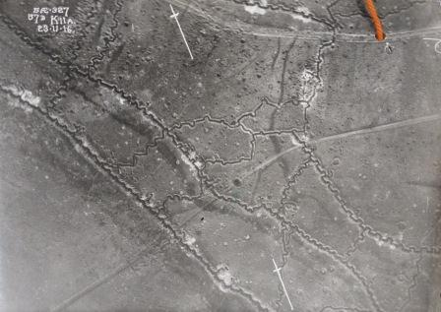
Figure 1 - Aerial Photograph of Trenches
This sort of image will be able to identify structures and features on the ground (such as trenches) but due to the 2D image produced, it may be difficult to discern topography and certainly impossible to map it accurately.
A more modern method of remote sensing using manned aircraft is to fit the aircraft with a Light Detection and Ranging (LiDAR) system rather than a standard camera. LiDAR is a remote sensing method that uses light in the form of a pulsed laser to measure ranges from the aircraft to the Earth, allowing a 3D image to be produced. [5]
An aircraft fitted with LiDAR sensor equipment would be able to make several passes over the littoral zone and build up an accurate 3D model of the topography using all of the data points that it captures, it would be able to do this rapidly due to the speed of the plane and the area of ground it can capture at any moment. Figure 2 shows an example of a littoral zone (Port Talbot) LiDAR map captured from an aircraft. [6]
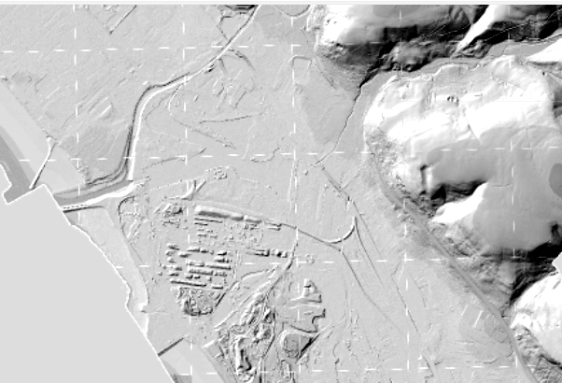
Figure 2 – Example of LiDAR image captured from aircraft
Whilst inevitably cheaper than sending a satellite to orbit, hiring a company to conduct this survey wouldn’t be cheap. The resolution of the images from the manned aircraft would be improved though as the aircraft is at a lower altitude than a satellite. However, the aircraft will be limited to flying on days with good weather as the LiDAR system wouldn’t be able to penetrate cloud, rain or fog.

Approach 3 – Drone
Drones would operate and use the same technology discussed in the manned aircraft section, they can be fitted with high-resolution cameras and LiDAR sensors. Drones however, are much smaller and lightweight and can operate at lower altitudes than manned aircraft. The size of the drones can be a limiting factor too, as the size and therefore weight of the equipment which can be fitted to a drone would be considerably less than what could be fitted to an aircraft.
The issue of weather that effects the manned aircraft would also effect drone use, though potentially to a lesser degree as the drone could operate below the cloud base. The biggest drawback of the drone however is the legislation surrounding their use. In the UK this is governed by the Civil Aviation Authority (CAA) and the type of licence required can be found in the drone and model aircraft code [7]. It would be anticipated that this sort of activity would be in the Specific Category which are described as “Flights that present a greater risk than that of the Open category, or where one or more elements of the flight fall outside the boundaries of the Open category.” [8]
The advantages of drone use are its ability to fly at lower altitudes and reach areas that a manned aircraft would be unable to reach, such as between buildings, under powerlines and even under trees. These factors would allow for more data points to be gathered and a higher resolution image to be gathered.

Recommendation
It is recommended that a combination of manned aircraft and drone would be utilised, to get the best out of both of them. The manned will be most suitable for quickly gathering the data points to give accurate topographical data using its LiDAR, it can also take photographs to give a real world view which the drone pilot can use to identify landmarks on his flight. The drone then could be used after the manned aircraft to fill any gaps that the manned aircraft missed, such as identifying accessways, or improving the resolution of areas which the manned aircraft could not get.
The cost of combining the two methods is probably the most cost effective way of getting all of the data. Using the manned aircraft alone would reduce the resolution of the map, using the drone alone would take a lot longer and therefore cost more.
Satellites would not be able to get the resolution required for this survey and are cost prohibitive.

Data Processing
The raw data obtained through remote sensing, from both the manned aircraft and drones LiDAR systems, needs to undergo several steps for georeferencing to Ordnance Survey 1:1250 scale data and to create a digital terrain relief model at the same scale.
Georeferencing
The first step is georeferencing, defined as “aligning geographic data to a known coordinate system so it can be viewed, queried, and analysed with other geographic data.” [9].
This involves aligning the acquired data points with Ordnance Survey (OS) data. It requires identifiable ground control points from both datasets, aligning the LiDAR data point for the top of a church with that same point on an OS map for example. Techniques such as affine transformations or control point registration can be employed to ensure accurate spatial alignment between the LiDAR data and the OS data.
Affine transformations can include translation, rotation, scale-change, and shearing of data.
Control points are accurately surveyed coordinate locations for physical features that can be identified on the ground. Registering the data point recorded in the LiDAR to the control point will allow the rest of the data to be built up round these control points.
Digital Terrain Model (DTM) Creation
Raw point cloud data obtained from the LiDAR sensors of the manned aircraft and drone and the high-resolution imagery captured from the manned aircraft needs to be processed to create a DTM.
This involves the classification of points (e.g. ground points, vegetation, buildings) and interpolation methods to generate a continuous surface representing the true shape of the bare-earth terrain, and referenced to a common datum. Specialist software is required to create a DTM such as Pix4Dmapper [10].
Scaling to 1:1250 Scale
Once the DTM has been generated, scaling it to the 1:1250 scale involves adjusting the resolution and accuracy of the model to match the standards of the OS data. This might involve resampling or refining the DTM to ensure compatibility.

Works Cited

[1] | NASA, 14 11 2023. [Online]. Available: https://www.earthdata.nasa.gov/learn/backgrounders/remote-sensing.
[2] | NASA, [Online]. Available: https://www.earthdata.nasa.gov/sensors. [Accessed 14 11 2023].
[3] | [Online]. Available: https://ourworldindata.org/grapher/cost-space-launches-low-earth-orbit?time=2017..latest.
[4] | National Archives, [Online]. Available: https://blog.nationalarchives.gov.uk/aerial-photography-first-world-war/.
[5] | [Online]. Available: https://oceanservice.noaa.gov/facts/lidar.html#:~:text=Lidar%20%E2%80%94%20Light%20Detection%20and%20Ranging,Lighthouse%2C%20Dry%20Tortugas%2C%20Florida..
[6] | [Online]. Available: https://www.lidarfinder.com/.
[7] | CAA, The Drone and Model Aircraft Code, CAA, 2023.
[8] | [Online]. Available: https://www.uavhub.com/pages/drone-training-course.
[9] | [Online]. Available: https://support.esri.com/en-us/gis-dictionary/georeferencing.
[10] | [Online]. Available: https://support.pix4d.com/hc/en-us/articles/202560579-How-to-automatically-generate-a-Digital-Terrain-Model-DTM-PIX4Dmapper.

