DS 1 late

My Screenshots/Photos
- Please add 4–6 screenshots or photos of your digital life.
- You can use your phone or laptop.
- For each screenshot, write one or two sentences explaining what it shows.

Screenshot/Photo 1
[Insert Photo/Screenshot below]
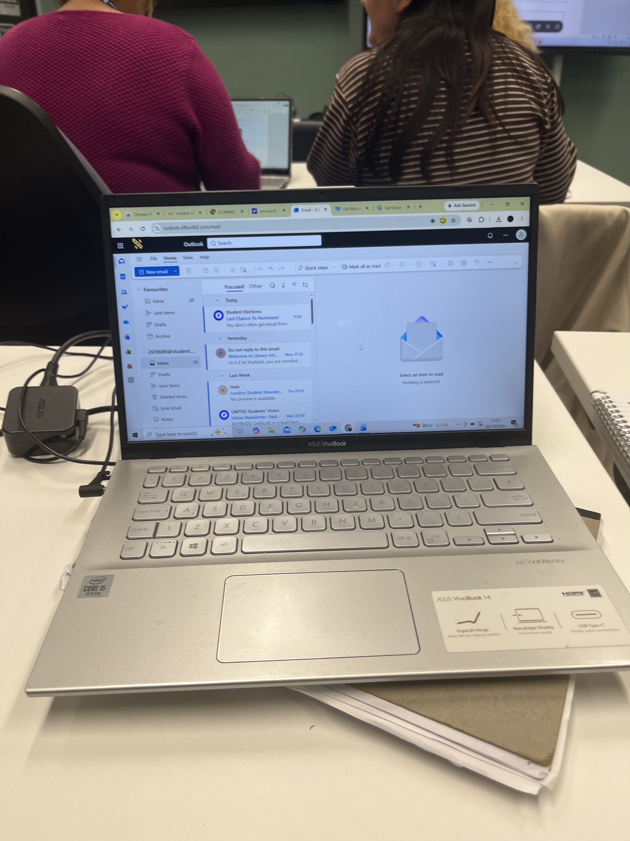 Model
X1404VA
Colour
Gardenia White
Cool Silver
Berry Pink
Operating System
Windows 11 Home - ASUS recommends Windows 11 Pro for business
Processor
Intel® Core™ i7-1355U Processor 1.7 GHz (12MB Cache, up to 5.0 GHz, 10 cores, 12 Threads)
Intel® Core™ i5-1335U Processor 1.3 GHz (12MB Cache, up to 4.6 GHz, 10 cores, 12 Threads)
Intel® Core™ i3-1315U Processor 1.2 GHz (10MB Cache, up to 4.5 GHz, 6 cores, 8 Threads)
Graphics
Intel® UHD Graphics
*Intel Iris Xᵉ Graphics is only available in models with Intel® Core™ i5/i7/i9 processors with up to 80 graphics execution units (EUs) and dual-channel memory.
Intel Iris Xᵉ Graphics
*Intel Iris Xᵉ Graphics is only available in models with Intel® Core™ i5/i7/i9 processors with up to 80 graphics execution units (EUs) and dual-channel memory.
Display
14.0-inch, FHD (1920 x 1080) 16:9 aspect ratio, LED Backlit, Refresh Rate:60Hz, 250nits, 45% NTSC color gamut, Anti-glare(AG) display, TÜV Rheinland-certified, Non-touch screen, - (Screen-to-body ratio)82%
14.0-inch, FHD (1920 x 1080) 16:9 aspect ratio, IPS-level Panel, LED Backlit, Refresh Rate:60Hz, 250nits, 45% NTSC color gamut, Anti-glare(AG) display, TÜV Rheinland-certified, Non-touch screen, - (Screen-to-body ratio)82%
Memory
Total 16GB DDR4 system memory installed.
- Max total system memory up to: 16GB
Storage
512GB M.2 NVMe™ PCIe® 4.0 SSD
Expansion Slots (includes used)
- 1x M.2 2280 PCIe 4.0x4
1x DDR4 SO-DIMM slot
I/O Ports
2x USB 3.2 Gen 1 Type-A (data speed up to 5Gbps)
1x USB 3.2 Gen 1 Type-C (data speed up to 5Gbps)
1x USB 2.0 Type-A (data speed up to 480Mbps), 1x DC-in
1x 3.5mm Combo Audio Jack
1x HDMI 1.4
Keyboard & Touchpad
Backlit Chiclet Keyboard
Chiclet Keyboard, 1.4mm Key-travel, Precision touchpad, support NumberPad
Camera
720p HD camera, With privacy shutter
Audio
Built-in array microphone
SonicMaster, with Cortana voice-recognition support
Network and Communication
Wi-Fi 6E(802.11ax) (Triple band) 1*1 Wireless Card
Wi-Fi 6(802.11ax) (Dual band) 1*1 Wireless Card, Bluetooth® 5.3
(The features and supported version may vary depending on OS support and driver availability.)
Bluetooth® 5.2
(The features and supported version may vary depending on OS support and driver availability.)
Battery
42WHrs, 3S1P, 3-cell Li-ion
Power Supply
ø4.5, 45W AC Adapter, Output: 19V DC, 2.37A, 45W, Input: 100~240V AC 50/60Hz universal, *Whether a charger is included varies according to country, region and model. Please check with your local ASUS retailer for details.
Weight
1.40 kg (3.09 lbs)
Dimensions (W x D x H)
32.49 x 21.39 x 1.79 ~ 1.79 cm (12.79" x 8.42" x 0.70" ~ 0.70")
Built-in Apps
GlideX
ScreenXpert
MyASUS
MyASUS Features
AI Noise Canceling
Live update
TaskFirst
WiFi SmartConnect
Function key lock
Tru2Life
Splendid
Fan Profile
Battery health charging
System diagnosis
ASUS Exclusive technology
ASUS Antimicrobial Guard Plus
Exclusive Subscription Offers
3-Month GoPro Premium+ Subscription, 1-Month Membership of Adobe Creative Cloud All Apps, Individual.

Screenshot/Photo 2
[Insert Photo/Screenshot below]
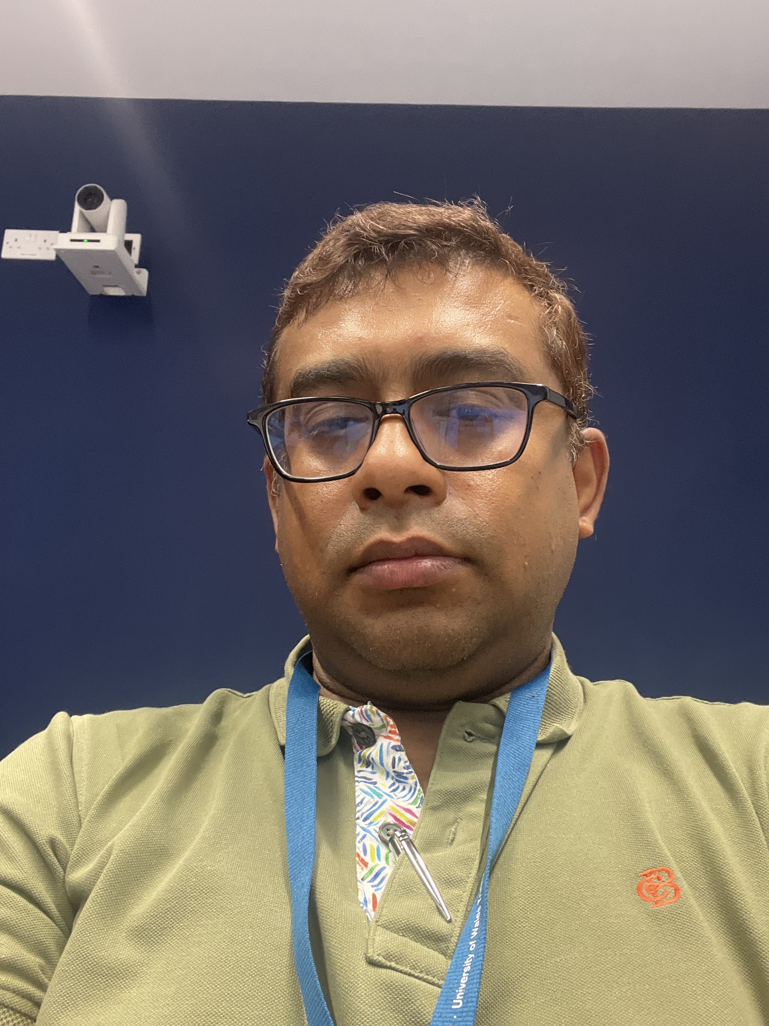
Here is my picture

Screenshot/Photo 3
[Insert Photo/Screenshot below]
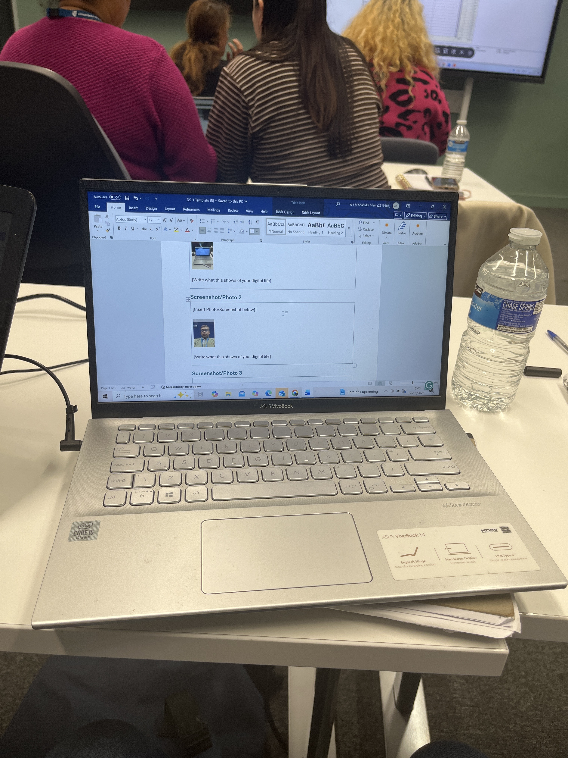
It shows one labtop with 2 picture

Screenshot/Photo 4

Screenshot/Photo 5
[Insert Photo/Screenshot below]
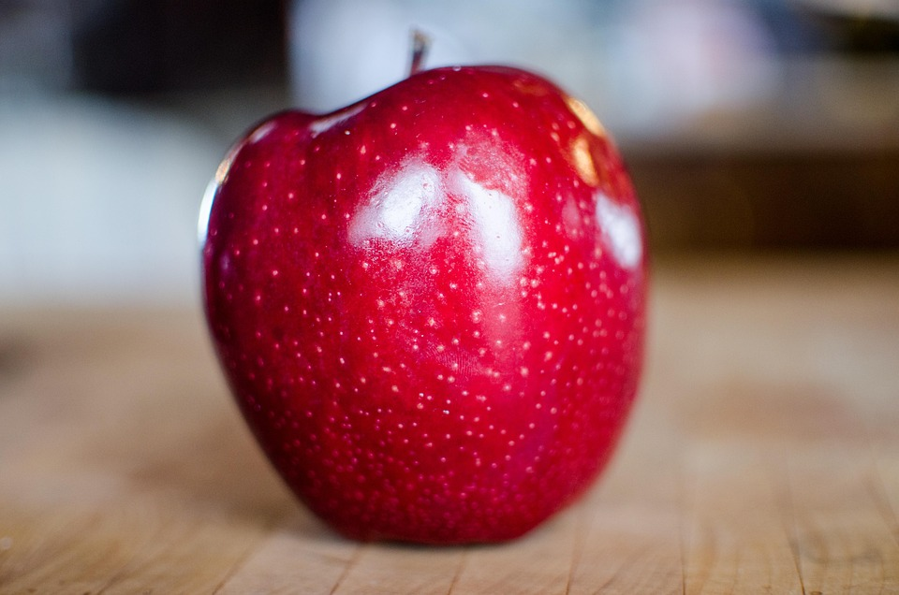
[Write what this shows of your digital life]

Screenshot/Photo 6
[Insert Photo/Screenshot below]

[Write what this shows of your digital life]

My Short Reflection
- Write 5–8 simple sentences about your digital life.
- You can use the sentence starters below if helpful.

Sentence starters
- I use digital tools to …
- I feel confident when I …
- I want to improve …
- I often use these tools: …
- I sometimes feel nervous about …
- I hope this module will help me …
- Digital skills are important for me because …
You can write more if you want.

Submission Checklist
Before you submit, please check:
​​​ ☐ I added 4–6 screenshots
☐ I wrote short sentences for each screenshot
☐ I wrote my short reflection
☐ My work is my own
☐ My file opens correctly
​​☐ My file opens correctly

