

University of Wales Trinity Saint David (UWTSD)
Module Name: Enterprise and Entrepreneurship
Module code: LCLM 4006
Assessment Title:
Component 1: Individual Written Business Plan

CertHE Business Skills for the Workplace
Submitted by:
Ziyneb Mehmed
Student ID: 2435858
Lecturer: Fouziya Farheen
Submission Date: 26/10/2026
Word count: 1503

BUSINESS PLAN
PAWS & SPROUT ECO-GROOMING LOUNGE: A SUSTAINABLE PET CARE ENTERPRISE

Executive Summary
Paws and Sprout Eco-Grooming Lounge is a new upscale pet grooming company that will cater to the needs of responsible pet owners in the suburbs of Birmingham. The company provides relaxing spa treatments, warm hydro baths and coat restoration using non-toxic, plant-based treatments. The company is involved in the companion animal industry in the UK, and it occupies a very clear niche between the ubiquitous, chemically-intensive grooming salons and the growing consumer desire to think more environmentally and provide pets with more gentle treatment.
The lounge is established as a Private Limited Company, which incorporates professional grooming with concepts of a circular economy. The premises have also changed to grey water reclamation, bio-degradable bamboo towels and hair collection program which utilizes hair of shaved dogs in cleaning the environment. Besides their environmental issues, the company has a contract with the local shelters of animals to groom the animals to be adopted.
There will be a start-up capital requirement of £26,500 in the business. This startup capital is utilized in covering high efficiency hydro bath installations, variable height hydraulic tables, leasehold property deposits, opening promotion and initial supply of organic. In six months of operation, the business aims to achieve break-even operation cash flow through digital bookings, referrals in social media, and clinics.

TABLE OF CONTENTS
Executive Summary 3
1. Overview of the Business Idea 5
1.1 Business Concept and Core Services 5
1.2 Target Customer Profile and Unique Selling Proposition (USP) 5
1.3 Legal Structure and Management Hierarchy 5
1.4 Environmental Sustainability and Community Engagement Elements 5
2. Market Research 6
2.1 Macro-Environmental PESTEL Analysis 6
2.2 Local Competitor Analysis 8
3. Marketing Communications 9
3.1 Digital Presence and Social Media Strategy 9
3.2 Localised Community Outreach and Promotional Channels 10
4. Financials 10
4.1 Capital Requirements and Funding Sources 10
4.2 Initial Month 1 Startup Expenditure Breakdown 10
References 12

1. Overview of the Business Idea

1.1 Business Concept and Core Services
Paws and Sprout Eco-Grooming Lounge is a pet grooming local salon in suburban Birmingham that specializes in offering a low sound, relaxing grooming service with non-toxic products. The essential service package includes hydrobath washes, tailored scissor cuts, coatshedding, gentle nail trimming and non-invasive ultrasonic oral care. The salon does not handle pets on an assembly-line basis, but rather one-to-one appointments, thus giving anxious pets more time to relax.

1.2 Target Customer Profile and Unique Selling Proposition (USP)
The target audience consists of urban professionals, young families, and millennial pet owners that view their dogs as family members and buy ethical and organic products. The main competitive edge of the salon is the total dedication to care that is not chemical and recovery of resources. Traditional salons tend to use harsh synthetics and waste a lot of plastic.

1.3 Legal Structure and Management Hierarchy
The company is set up as a Private Limited Company (Ltd) registered at Companies House. This structure forms an autonomous corporate body, which offers the protection of personal assets by limited liability, eases the business banking process, and develops business credibility with the banking and landlords. The Founder works on the day-to-day running as the Managing Director and Head Stylist possessing City and Guilds qualifications in pet styling. The founder also runs a full-time Salon Assistant who oversees animal handling and hygiene with the assistance of a freelance bookkeeper who oversees payroll and accounts.

1.4 Environmental Sustainability and Community Engagement Elements
Both the daily salon work and the environmental care are constructed. Wastewater in the washing bays is filtered in fine-mesh filters and collected to be utilized in the local landscapes to minimize waste of water. The dog fur is removed and shipped to the environmental cooperatives to produce an absorbent mat to clean the coastal oil (Duffett, Cromhout and Steenkamp, 2023).
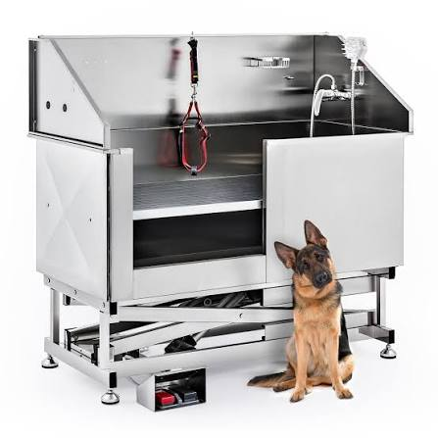
Figure 1: Low-Stress Eco-Hydrobath and Grooming Station Setup
(Source: ubuy.co.in, 2026)

2. Market Research

2.1 Macro-Environmental PESTEL Analysis
Political
- Factor 1: National statutory animal protection standards bring about strict standards of operation in service parlours.
- Business Impact: The regulatory controls require written welfare procedures, adequate ventilation, non-slip floors and constant supervision which increases the initial shopfitting costs but creates high barriers to entry that eliminates lower quality (Morton and Whittaker, 2022).
- Factor 2: Munich achievement goals of trade waste and circular material management of local governments.
- Business Impact: West Midlands borough councils document responsible waste pathways of businesses i.e. special fur-collection recycling and grey water micro-filtration protects the lounge against commercial land fill surcharges (Purdy et al., 2026).
Economic
- Factor: Decreased macroeconomic disposable income and demand of grooming and veterinary services that is inelastic with consumers.
- Business Implication: Household budget limits on overall retail footfall, but companion animal maintenance is non-discretionary among loyal customers (Murray et al., 2025). The higher commercial electricity and utility rates will imply that investments in variable speed dryer and energy-saving water heaters will be required to ensure that the operating profit rates remain at the same level.
Social
- Factor: The cultural change of high rate of pet humanisation and ethical consumerism.
- Business Implication: Pet owners treat companion dogs as the primary family members and they are so keen on making sure that they go to salons where they are handled gently, have serene rooms and are washed using natural products (Ai et al., 2025).
Technological
- Factor: Existing cloud-based salon management system and used pressurized bathing equipment.
- Business Impact: Lost appointments because of SMS messaging and in-advance bookings deposit are minimized with automated mobile scheduling apps like Fresha (Dolak et al., 2025). Water and organic shampoo are mixed in mechanized hydrobaths because it is more effective and requires half the time in the wash and consumes less hot water.
Environmental
- Factor: Urban demands on the utilization of municipal water and chemical greywater effluent.
- Business Effect: Commercial pet salons release huge amounts of contaminated runoff into urban drains (Adjei-Nimoh et al., 2026). Sieving the wash water and applying wholly biodegradable shampoos would guarantee adherence to clean sewer laws, which would attract pet parents that are environmentally conscious.
Legal
- Factor: Legal obligations of care, which are enshrined in the Animal Welfare Act of 2006 as well as health and safety laws in the workplace.
- Business Implication: COSHH-regulated and GDPR-regulated data protection laws will mean that the enterprise is legally liable, as the safety of animals, prevention of injury during drying or scissor work, and safe use of chemicals are considered (Powdrill-Wells et al., 2026).

2.2 Local Competitor Analysis
The market analysis of the pet care providers within the area of five miles of the proposed location shows that there is a divided market.
Direct Competitor 1: The Groom Room (Pets at Home)
A robust corporate chain about brand recognition, retail foottraffic and shared premises. However, the salon is rooted in turnover when it comes to booking, rough shop floors, and using traditional methods of chemical shampoos and this emphasizes their delicate pets and motivates their owners to more laid-back boutique experiences.
Direct Competitor 2: Canine Cuts Boutique
An independent neighbourhood parlour, which has a client base. Their biggest weaknesses are cash only transactions, no online booking and frequent synthetic grooming products not having a green alternative.
Direct Competitor 3: Suds On Wheels Mobile Grooming
A one operator van delivering direct curbside grooming services. They are simple, but have high rates per pet, they struggle to fit big dogs in small vans and have noisy engines that are easily idling.
Indirect Competitor 1: Self-Service Dog Wash Kiosks
Washing coin operated bays on the forecourts of fuel stations. They provide low-cost rinsing to dirty dogs however all the handling, washing and drying is done by owners themselves without professional scissor cuts and hygiene inspections.
Indirect Competitor 2: Local Veterinary Clinics
Animal treatments include a simple claw trim and med baths. They offer more clinical-based services as compared to breed-based styling and have high rates of consultation even in cases of simple maintenance.
Indirect Competitor 3: Home DIY Grooming Kits
Cheap online consumer clippers and home shampoos. Home grooming is a dirty and stressful affair and despite being cheap, most pet owners seek professional help when they feel they cut the coat unevenly or when they find it hard to handle the pet.
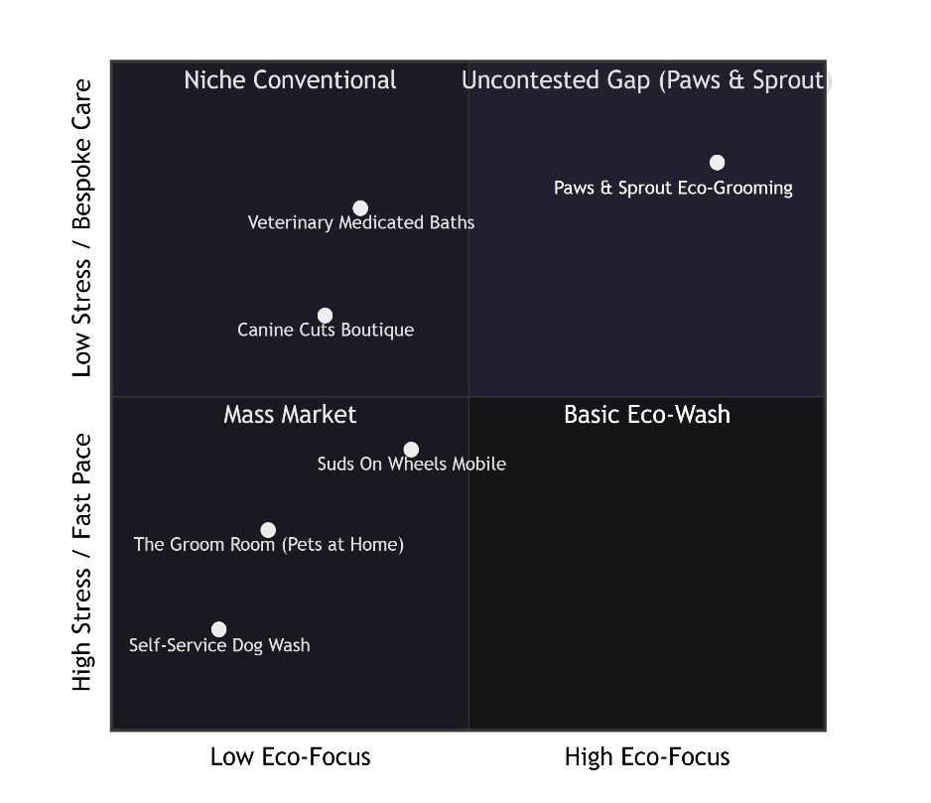
Figure 2: Competitor Perceptual Positioning Map
(Self-Created)

3. Marketing Communications

3.1 Digital Presence and Social Media Strategy
The company will be targeting the pet owners through image based digital-based and local search presence. Instagram and Tik Tok are the social channels, on which the short videos of transformation, relaxing hydrobath, and back-the-scene shots of the everyday salon care will be presented.
The salon site will be operated on a clean and mobile-first platform, which will be directly connected to Fresha. The clients can view a menu of the services, read about prices, select the preferred groomer and make appointments in minutes. Automated text and email confirmations are also sent to the booking platform 48 hours prior to appointments to reduce expensive no-shows and keep daily schedules on time.

3.2 Localised Community Outreach and Promotional Channels
Online campaigns are used to create a local presence in combination with local outreach. The recycled leaflets will be distributed in the local veterinary practices, pet shops and dog cafes. It has a 20% fifth visit loyalty scheme and a weekend open day of the facility with facility tours and a free sample of organic balms.

4. Financials

4.1 Capital Requirements and Funding Sources
This business will require an initial capital of £26,500 pounds to purchase premises, grooming equipment and stock and operating reserves. The founder will play a role in the business as unencumbered equity of personal savings of £6,500. The remaining £20,000 will be procured via the British Business Bank Start Up Loans scheme, the best micro-enterprise option which includes 6% fixed interest rate with a period of five years without any security in terms of property and a period of 12 months free business mentoring.

4.2 Initial Month 1 Startup Expenditure Breakdown
The seed money is broken down systematically between the capital spending and the start-up month operating expenses needed:
- Premises Lease Deposit and Advance Rent: £3,200 (guarantees terms of lease of retail salon and legal lease guarantees).
- Plumbing and Salon Fit-Out: £6,800 (commercial greywater drainage filter fitting, non-slip vinyl floor, acoustic wall panels and reception partitions).
- Professional Grooming Machinery: £7,500 (two low energy hydrobaths, two hydraulic lift tables, variable speed low noise blasters and professional hand shears).
- Initial Stock: £1,800 (bulk certified shampoos, conditioners, organic paw treatments and biodegradable bamboo drying towels).
- Licensing, Legal, and Business Insurance: £1,200 (public liability, business property and trade waste registration).
- Branding and Launch Marketing: £1,500 (website set up, incorporation of booking software, printing signage and promotion opening).
- Working Capital Reserve: £4500 (working buffer held in reserve to cover the first month staff salaries of the first assistant, first month utility bills and emergency cases).
- This budget is £26,500 and will give sufficient liquidity of finances during the initial operations.

References
Adjei-Nimoh, S., Appiah-Effah, E., Akodwaa-Boadi, K. and Gyapong-Korsah, B., 2026. Design and evaluation of a scalable decentralised greywater treatment technology for reuse, towards climate and WASH resilient urban communities. Next Sustainability, 7, p.100246.
Ai, C., Akaichi, F., Glenk, K., Revoredo-Giha, C. and Costa-Font, M., 2025. What drives pet food choices? a systematic literature review. Animals: an Open Access Journal from MDPI, 15(22), p.3235.
Dolák, R., Kajzar, P. and Pellešová, P., 2025. Commercial Online Hotel Reservation Services: Functional Distinctions And Opportunities For Direct Booking Optimization. Prace i Studia Geograficzne, 70(2), pp.125-137.
Duffett, R.G., Cromhout, D.H. and Steenkamp, P., 2023. The value that small business community partners place on a marketing-oriented service learning project. International Journal of Work-Integrated Learning, 24(1), pp. 45–58.
Morton, R. and Whittaker, A.L., 2022. Understanding subordinate animal welfare legislation in Australia: Assembling the regulations and codes of practice. Animals, 12(18), p.2437.
Murray, L., Carroll, J. and Tyson, J., 2025. People and pets in the COVID-19 pandemic and the cost-of-living crisis: Identifying trends in the intake, adoption and return of companion animals during times of uncertainty. Animals, 15(11), p.1584.
Powdrill-Wells, N., Pawson, C., McCormick, W. and Wills, A., 2026. Owners’ Awareness of the Animal Welfare Act 2006 in the United Kingdom and the Association with Owner Demographic Factors. Animal Welfare.
Purdy, R., Hayes, J. and Draper, L., 2026. A Review of Environment Agency Inspections in the Waste Operations and Installations Sector in England. Available at SSRN 6831918.
ubuy.co.in, (2026), Low-Stress Eco-Hydrobath and Grooming Station Setup, Available at: https://www.ubuy.co.in/product/FMZ2JTPJQ-co-z-dog-grooming-tub-50-electric-pro-pet-bathing-station-for-home-salon-vet-kennel?srsltid=AU7gw4X-WdxOGFhIMe8VJcUbiiSzaCI7QxvJF5V301AxmJ70D1TRrINW [Accessed on: 10.10.2026]

