
Programme: | MSc Public Health and Social Care in Practice
Module: | Population Health and Digital Health Promotion
Module code: | LCHS7009
Lecturer: | Dr Ping Wu
Assignment Title: | Component 1: 2 Blogs
Student Name: | MD PIYEL MIA
Student ID: | 2434371

Blog 1: Utilising Mindfulness Applications - Headspace's Digital Transformation in Mental Health Awareness”

The Emerging Crisis: Mental Health in the Digital Era
An unprecedented mental health epidemic has gripped the world, and it is imperative that we find innovative answers quickly. According to the NCD Alliance (2022), over 970 million people throughout the globe, or one in eight persons, have some kind of mental illness.
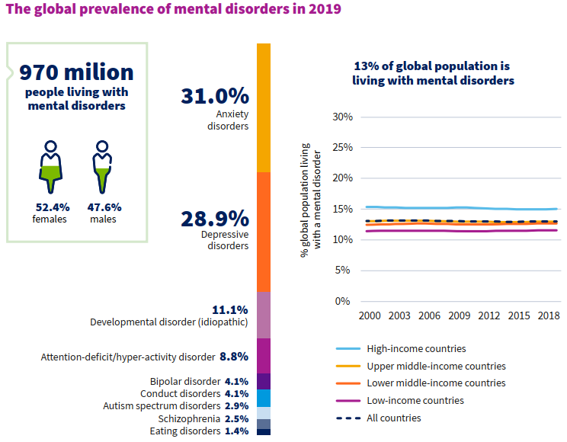
(drroopesh, 2022)
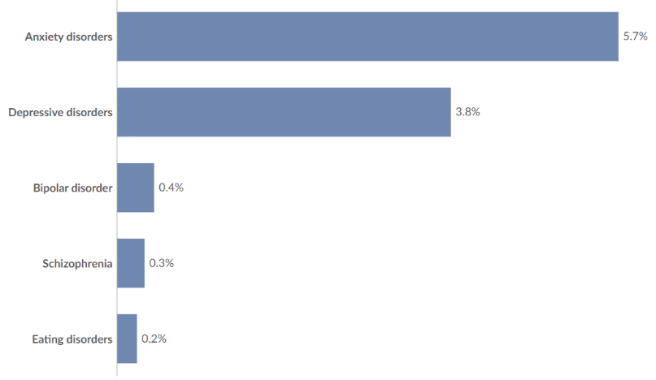
- With 4.4% of the people affected, anxiety disorders are the most common (Ritchie et al., 2023).
- A close second is depression at 4%.
- Children and teenagers' despair and anxiety have risen beginning from the COVID-19 epidemic (Huntington Psychological Services, 2024).
(IHME, 2023)

An Exploration into Digital Mindfulness: The Revolution of Headspace
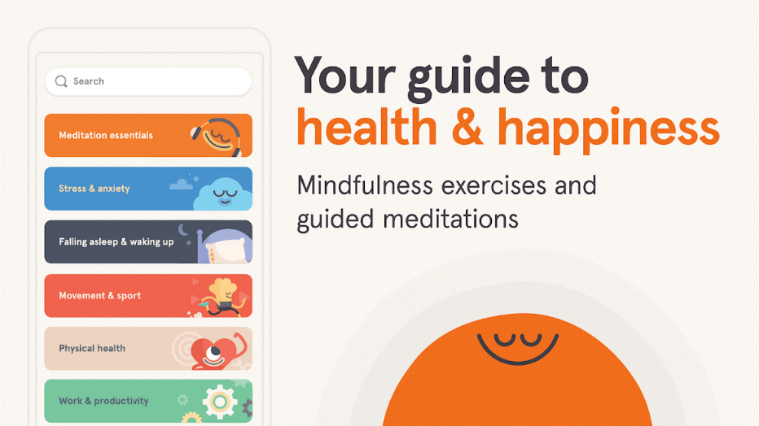
In light of this difficulty, digital health technologies have emerged as powerful resources for promoting mental health. Headspace is in the forefront of mindfulness and meditation app uptake, being one of the most researched and widely used digital mental health platforms (O'Daffer et al., 2022).
Headspace alters mental health intervention delivery and access. The app improves mental health with evidence-based guided meditation, mindfulness, and sleep tales.

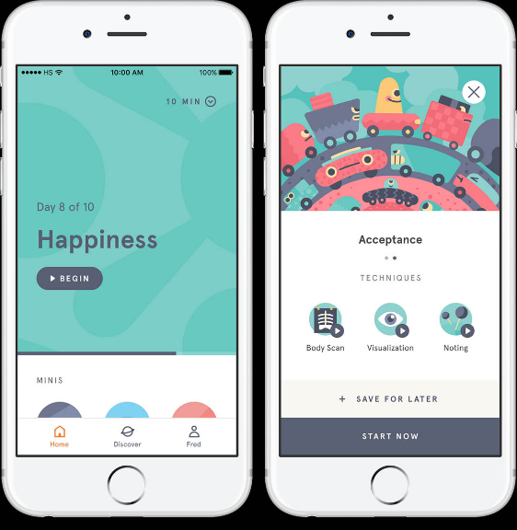
Evidence based Impact: Insights from Research
Research indicated that Headspace enhanced attention a decrease of 14% and an increase in concentration (Callahan et al., 2024). According to Headspace's own research (Gavrilova and Zawadzki, 2023), a study found that after only three weeks of using Headspace, participants' levels of animosity and sensitivity to negative feedback dropped by 57%. One of Headspace's strongest points is its ability to measure psychological benefits.
The Process of Digital Healing
Studies shows the use of mindfulness apps improves mental health by helping with issues including cognitive defusion, attention control, and recurring negative thoughts (Callahan et al., 2024). The accessibility and ease of use of app-based treatments make them effective. Headspace provides round-the-clock access to evidence-based therapies, in contrast to conventional therapy, which is hindered by waiting lists and geographical limitations.

Advantages
- Wide reach and ease of access
- Strong user participation and interaction
- Based on reliable research evidence
- Economically efficient approach
- Ability to tailor content to individual needs

Shortfalls
- Interventions are often conducted over short durations
- High dropout or low retention rates among users
- Potential bias due to competing interests
- Lack of representation across diverse populations

Correcting the Shortfalls: A Strategic Approach
- Use mindfulness apps as a complement to professional mental health support, particularly for more serious conditions.
- Apply advanced algorithms to personalise interventions based on user needs, preferences, and responses.
- Enhance social support features to boost engagement and assist less motivated users.
- Strengthen integration with healthcare services to monitor users and provide timely escalation when needed.

Blog 2: “Designing the Future of Mental Health: An AI-Driven Cognitive Behavioral Therapy Platform”

The Ongoing Issue: Deficiencies in Mental Health Care
Digital mental health applications such as Headspace show potential; nonetheless, the mental health problem remains unresolved. Worldwide, 970 million individuals suffer from mental diseases, with 280 million experiencing depression, underscoring the need for more comprehensive, tailored, and accessible therapies (WHO, 2023).
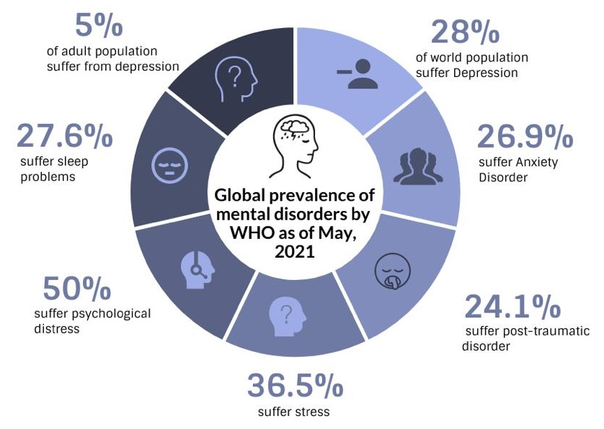
Source: (Premiumtimes, 2023)

Introducing MindfulAI Companion: A Fresh Perspective
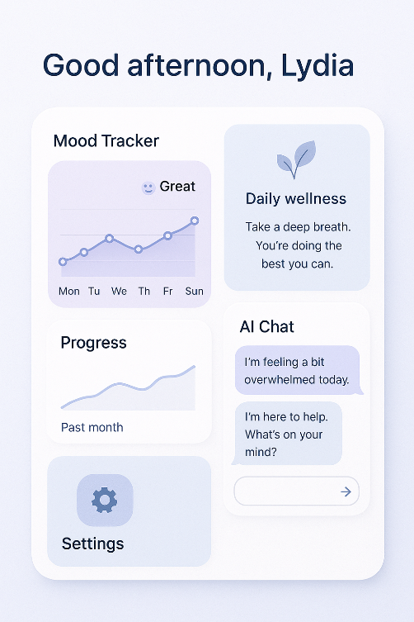
To remedy these shortcomings, I suggest creating MindfulAI Companion, an AI-powered online platform that combines CBT with advanced machine learning, continuous monitoring, and personalised intervention delivery.
Fundamental Design Characteristics and Structure
MindfulAI Companion integrates a wide range of cutting-edge technology and therapeutic approaches that have been shown to work:
Artificial Intelligence-Driven Personalisation System: The software tailors therapy according to user behaviour and symptoms using sophisticated machine learning algorithms. Artificial intelligence enhances the timing, content selection, when administering treatments, with research showing that tailored interventions have larger effects (Koh et al., 2021).
Synchronised Biometrics: Unlike self-reported apps, MindfulAI Companion employ wearable tech and smartphone sensors to track physiological signs of mental wellness.
Cognitive Behavioural Therapy Module System with Adaptation: To provide treatments based on evidence-based cognitive behavioural therapy, interactive modules adapt to the user's progress and engagement.
A Digital Helper for Health: Conversational agents powered by artificial intelligence use natural language processing to provide psychoeducational material, intervention suggestions, and therapeutic conversations 24/7.

How MindfulAI Companion Tackles Mental Health Issues
Urgent Crisis Assistance
In order to identify signs of suicidal ideation or major deterioration, the platform's sophisticated crisis detection algorithms examine user inputs, behavioural patterns, and physiological data.
Individualised Treatment Plans
The adaptive treatment programs on the platform are based on user response patterns and are driven by research on the effectiveness of digital CBT (Martinengo et al., 2021).
Resolving Health Inequalities

For those on waiting lists for critical professional care, MindfulAI Companion provides evidence-based support. Using a mobile app while waiting for a mental health appointment was shown to considerably reduce anxious and depressive feelings, according to research (Stark et al., 2022).
(Oceane Duboust, 2024)

Advantages
- The platform takes a multi-pronged approach to mental health, drawing from cognitive behavioural therapy (CBT), mindfulness, and behavioural activation, all of which have the potential to increase therapeutic efficacy.
- When compared to standalone apps, MindfulAI Companion's integrated professional supervision and escalation mechanisms provide consistent treatment.
- The platform can support an unlimited number of users with personalised experiences, unlike traditional mental health services that struggle with scale.

Obstacles
- Privacy and Data Security Concerns: AI personalisation requires gathering enormous amounts of data, which poses privacy risks.
- Users risk developing an unhealthy reliance on apps instead of learning to cope on their own.
- Determining the platform's effectiveness for serious mental health issues would need extensive and costly clinical studies, which may take years to complete.

Correcting the Shortfalls: A Strategic Approach
- Data protection and security systems
- Reducing bias and ensuring fairness
- Integration with professionals and staff training
- Clinical testing and validation processes
- Enhancing accessibility for users
- Ethical governance and monitoring systems

References
Callahan, C., Kimber, J., Hu, E., Tanner, L. and Kunkle, S. (2024). The Real-World Impact of App-Based Mindfulness on Headspace Members With Moderate and Severe Perceived Stress: Observational Study. JMIR mHealth and uHealth, [online] 12, pp.e52968–e52968. doi: https://doi.org/10.2196/52968.
drroopesh (2022). In 2019 almost a billion people were living with a mental disorder: World Mental Health Report (17 June 2022). [online] communitymedicine4all. Available at: https://communitymedicine4asses.wordpress.com/2022/06/19/in-2019-almost-a-billion-people-were-living-with-a-mental-disorder-world-mental-health-report-17-june-2022/.
Gavrilova, L. and Zawadzki, M.J. (2023). Examining How Headspace Impacts Mindfulness Mechanisms Over an 8-Week App-Based Mindfulness Intervention. Mindfulness, 14(9), pp.2236–2249. doi: https://doi.org/10.1007/s12671-023-02214-4.
Headspace (2024). Meditation and Mindfulness Made Simple - Headspace. [online] Headspace. Available at: https://www.headspace.com/.
Huntington Psychological Services (2024). The latest mental health statistics: What the numbers say about the state of our minds in 2024 | huntington psychological services. [online] Huntington Psychological Services. Available at: https://huntingtonpsych.com/the-latest-mental-health-statistics-what-the-numbers-say-about-the-state-of-our-minds-in-2024.
IHME (2023). Mental illnesses prevalence. [online] Our World in Data. Available at: https://ourworldindata.org/grapher/mental-illnesses-prevalence.
Koh, A., Swanepoel, D.W., Ling, A., Ho, B.L., Tan, S.Y. and Lim, J. (2021). Digital health promotion: promise and peril. Health Promotion International, 36(Supplement_1), pp.i70-i80.
Martinengo, L., Stona, A.-C., Griva, K., Dazzan, P., Pariante, C.M., von Wangenheim, F. and Car, J. (2021). Self-guided Cognitive Behavioral Therapy Apps for Depression: Systematic Assessment of Features, Functionality, and Congruence With Evidence. Journal of Medical Internet Research, 23(7), p.e27619. doi: https://doi.org/10.2196/27619.
NCD Alliance (2022). 20 things you should know about mental health today. [online] NCD Alliance. Available at: https://ncdalliance.org/news-events/news/20-things-you-should-know-about-mental-health-today.
O’Daffer, A., Colt, S., Wasil, A.R. and Lau, N. (2022). Efficacy and Conflicts of Interest in RCTs Evaluating Headspace and Calm Apps: A Systematic Review. JMIR Mental Health, 9(9). doi: https://doi.org/10.2196/40924.
Oceane Duboust (2024). Nearly 2 in 5 European workers are at risk of poor mental health. [online] euronews. Available at: https://www.euronews.com/health/2024/11/27/nearly-40-of-european-workers-are-at-higher-risk-of-poor-mental-health-according-to-new-su [Accessed 26 Jul. 2025].
Premiumtimes (2023). [online] Premiumtimesng.com. Available at: https://www.premiumtimesng.com/news/headlines/489202-world-mental-health-day-how-outdated-legislation-covid-19-worsen-situation-in-nigeria.html?tztc=1.
Ritchie, H., Roser, M., Dattani, S. and Rodes-Guirao, L. (2023). Mental health. [online] Our World in Data. Available at: https://ourworldindata.org/mental-health.
Stark, A.L., Geukes, C. and Dockweiler, C. (2022). Digital health promotion and prevention in settings: scoping review. Journal of Medical Internet Research, 24(1), p.e21063.
World Health Organization (2023). Depressive disorder (depression). [online] World Health Organization. Available at: https://www.who.int/news-room/fact-sheets/detail/depression.

