
University of Wales Trinity Saint David
School of Computing
Mathematics for Software Development
Kieran John Ayres (P149775)
12/03/2019
Mathematics/ACDA4003

Introduction
The focal point of this assignment is to prove mathematical theory. The reason this is being proved so it can be shown.

Introduction
The focal point of this assignment is to program the exercises given, while doing this there will be test scheduling, to show the process of testing the exercises. These will also be listed into the list of difficulty to code, these exercises will also be accompanied by diagrams that were drawn to show the development process for the programs.

Exercise 1

Here is the diagram, this is what the designer used to get an idea on how to design the program, this works as a basic diagram as an outline of what to follow in the process of writing the code. This is a way of giving an idea to follow before going forward and trying to do the code
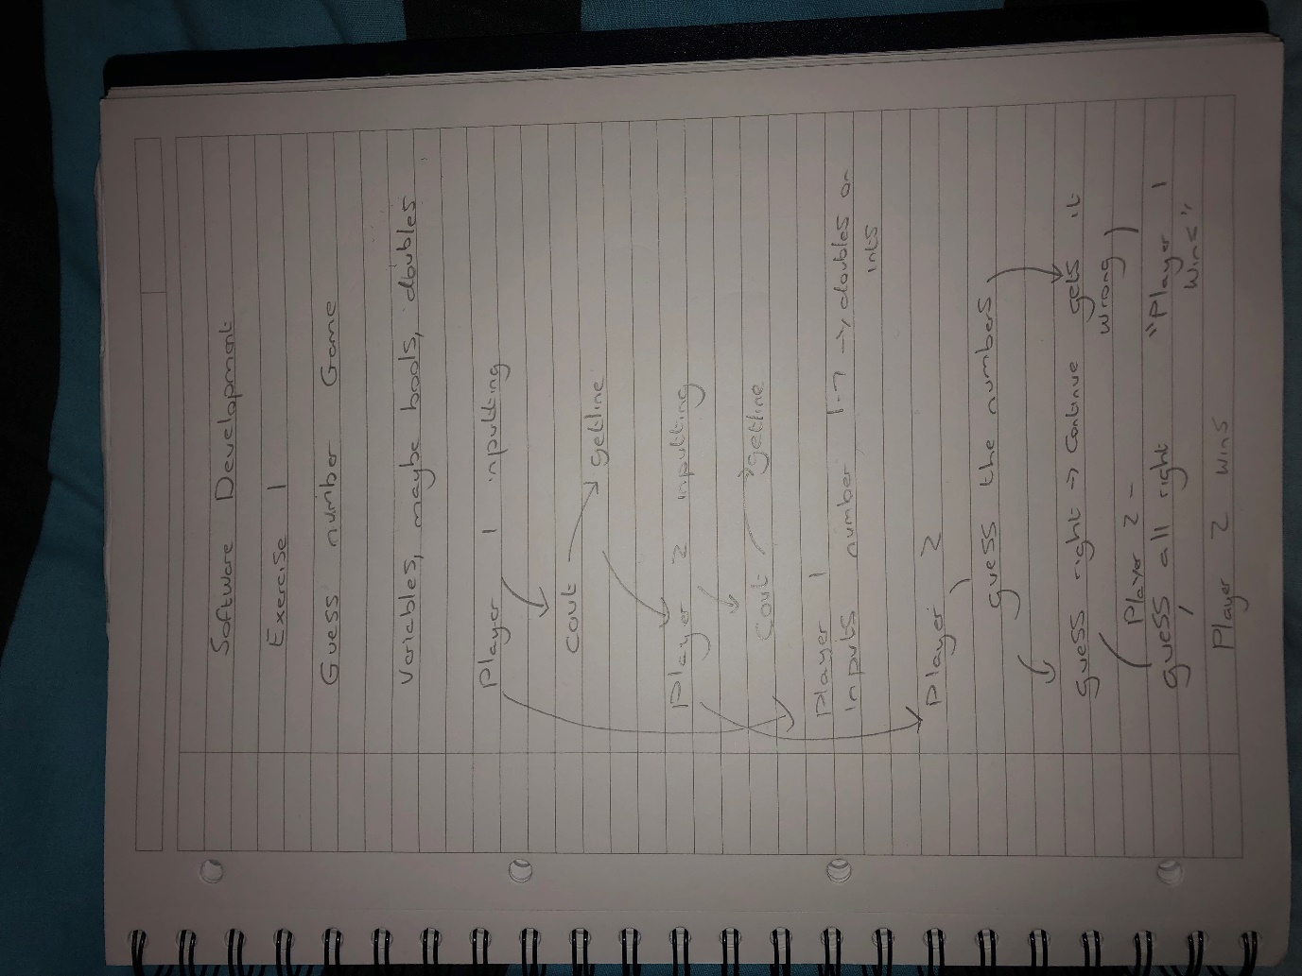
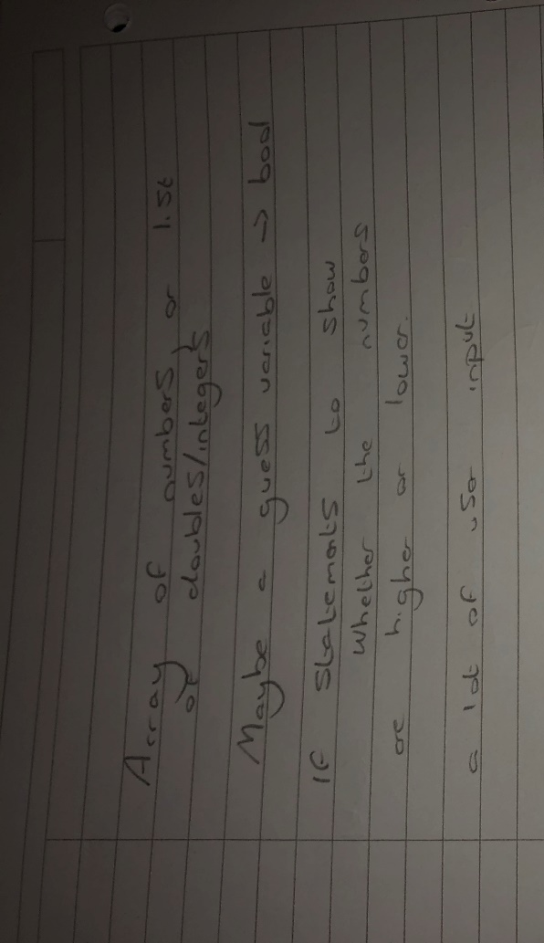These are also some written notes of the methods identified to use when writing the program.

This is the program running:
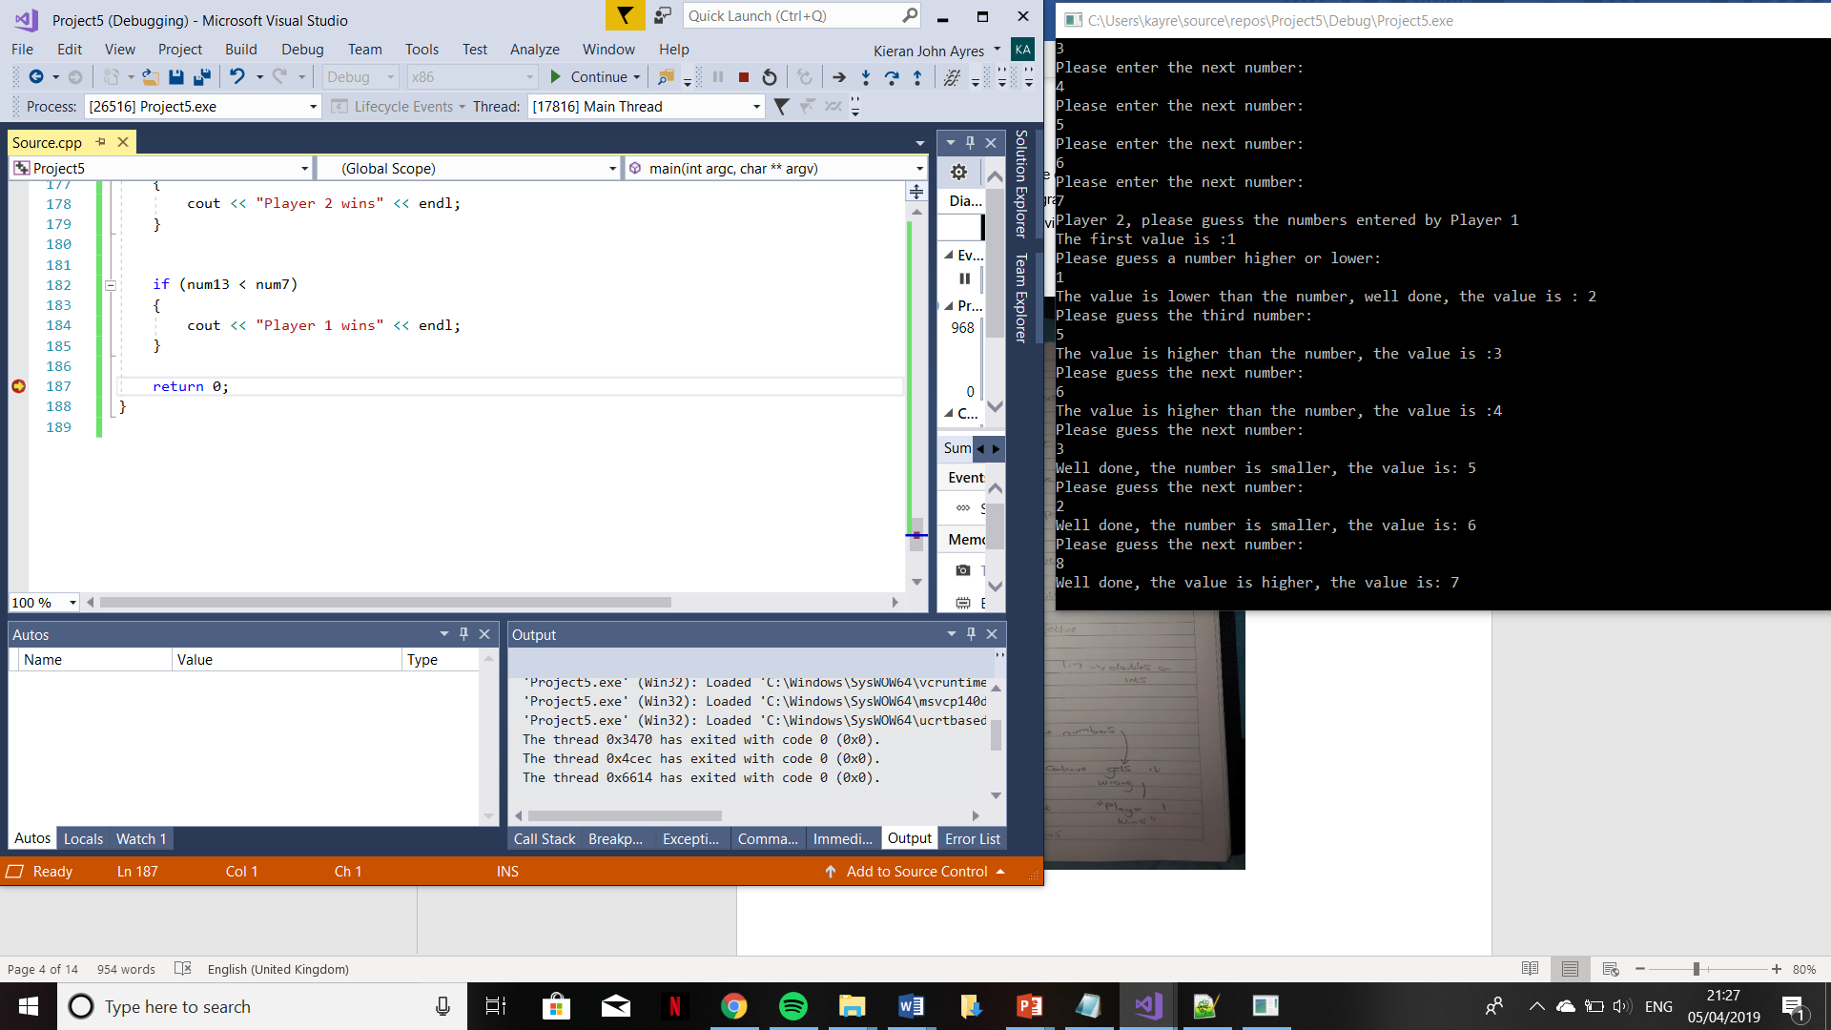

Exercise 2
This one was more challenging, it required more programming methods to be used and there was an idea for it to have a display with a map, so this was a challenging process. The two images below show a diagram to show an outline process of how the program may go, some written notes identifying possible methods to use.
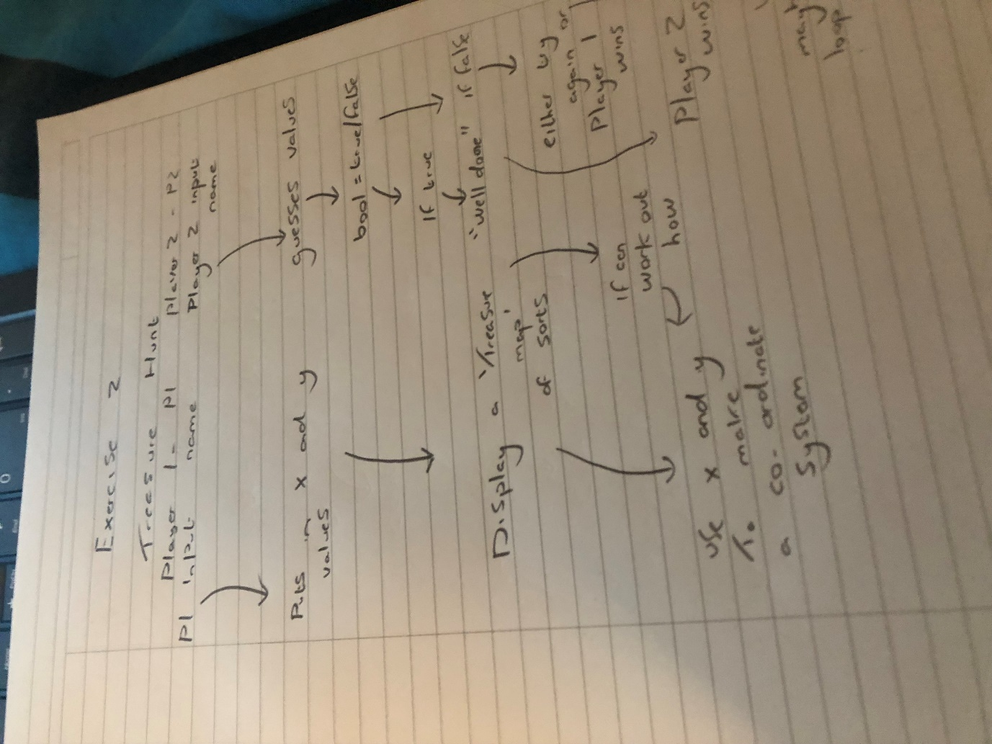
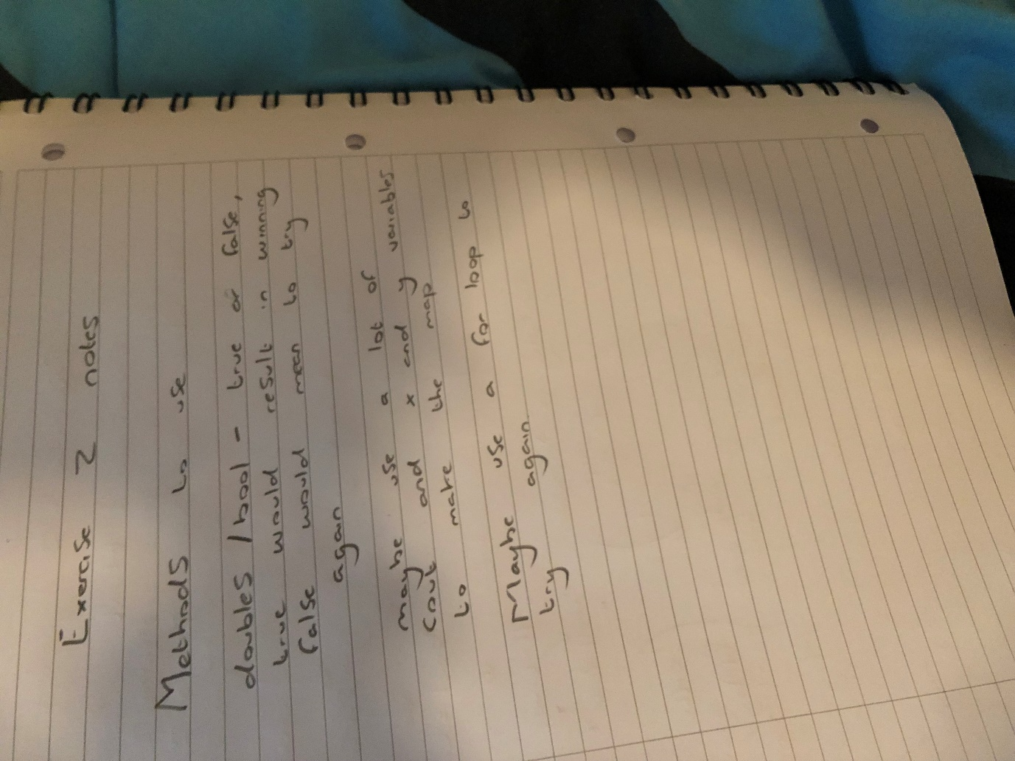

The next screenshot is to show some of the development process that the program went through. This is to show that one of the first methods had been implemented, the following image shows the program running with the loop:
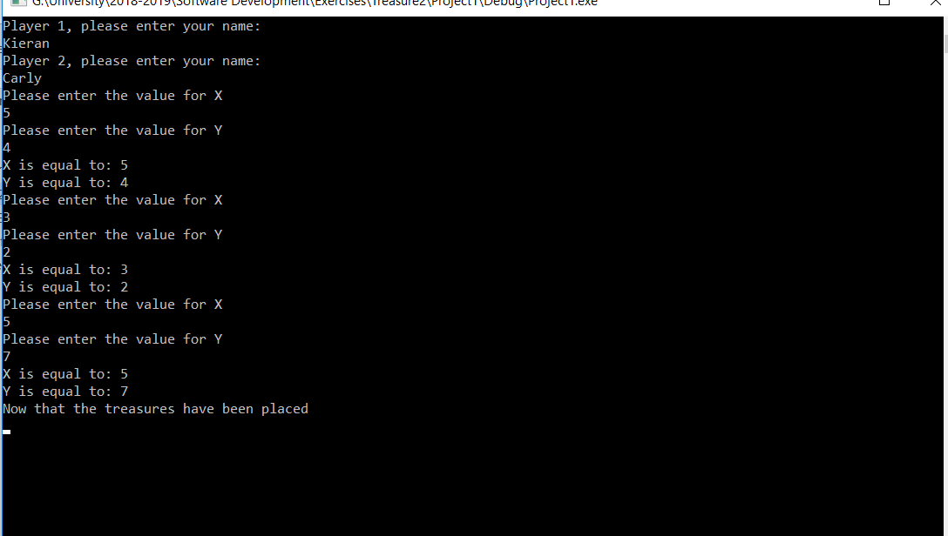
Upon doing this, the designer realised that this wasn’t practical, because by having a loop, it stopped the user being able to guess, the accurate values. Instead they reverted-back to using the same block of code three times and changing the variables where appropriate.

These are the basics of the program running
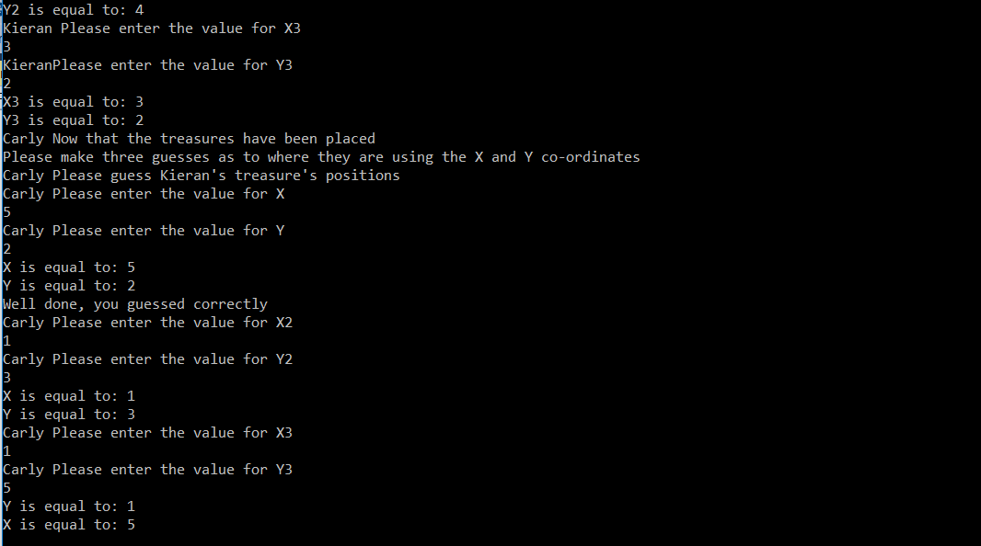

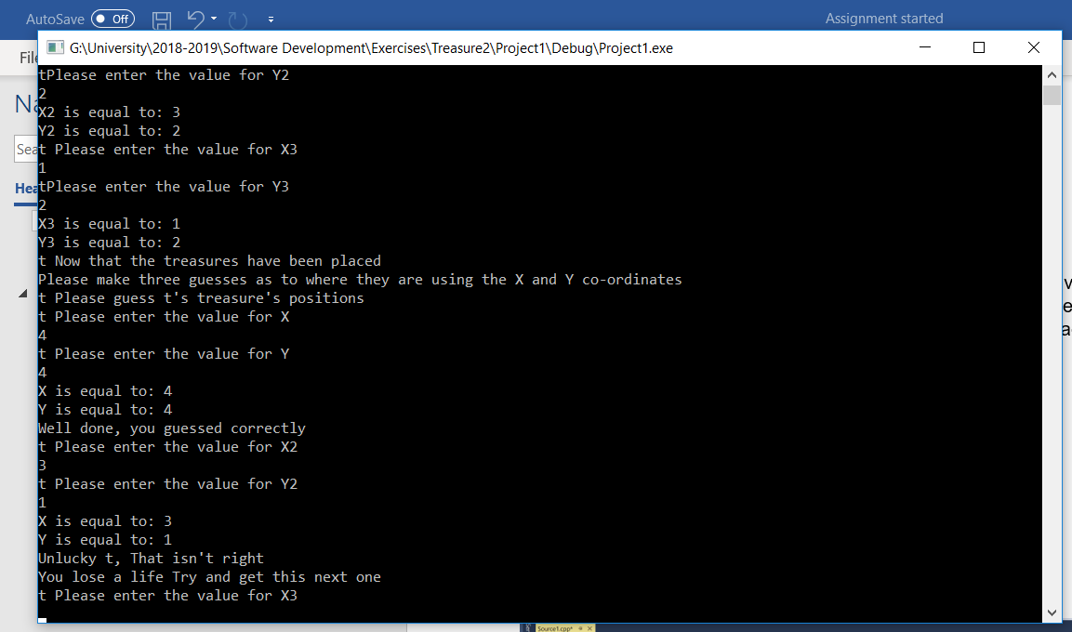
This is a rough draft of the game to show before adding the more interesting things such as the life system or the grid.

Exercise 3
This exercise was by far the most challenging, it required a loop until the game finished, it needed a lay out to mirror that of the game, connect 4.
Here is an image of a rough draw/diagram of the game
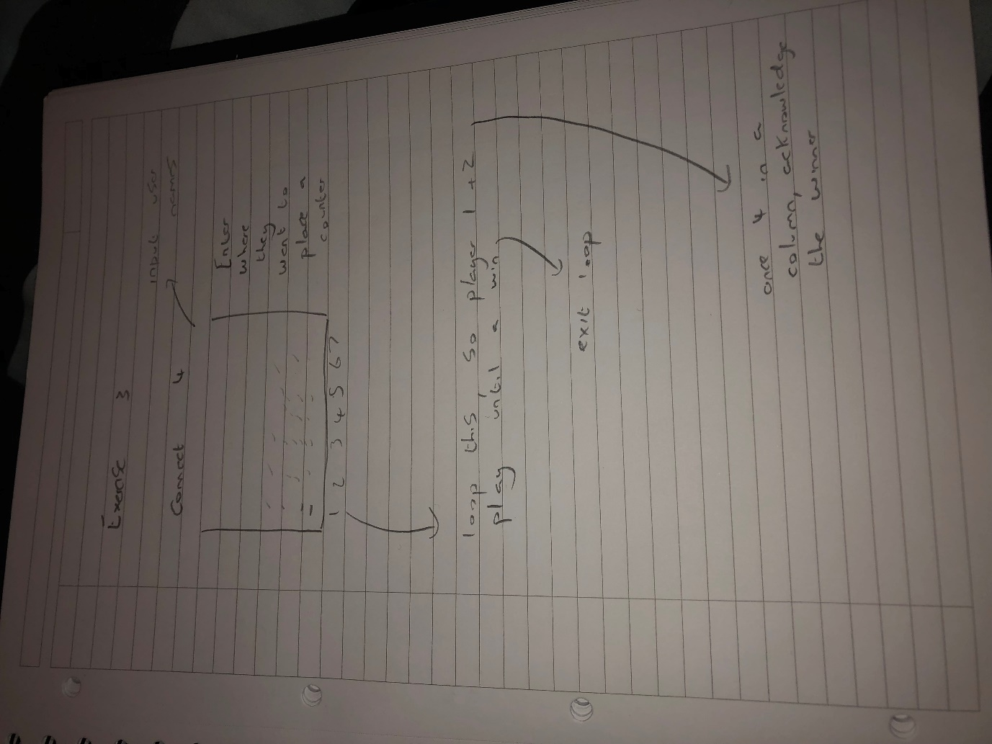

List of Difficulty to Code

The following exercises have been listed easiest to hardest, they were all challenging, here’s how they were ranked:
- Exercise 3
- Exercise 1
- Exercise 3

Test Schedule
Test Number | Description | Expected Result | Expected Outcome | Pass/Fail
1 | Exercise 1, Player 1 can input all the numbers | Inputs Correctly | As, expected | Pass
2 | Exercise 1, program runs | Runs smoothly | Didn’t run | Fail
3 | Exercise 1, lets player 1 win | Runs smoothly | As, expected | Pass
4 | Exercise 2, test the for loop | The loop goes around 3 times | As, expected | Pass
6 | Exercise 2, player 1 enters values | Enters values, program continues | As, expected | Pass
7 | Exercise 2, player 2 guesses some values correctly | Program acknowledges that they were right | As, expected | Pass
8 | Exercise 2, shows that if you guess it wrong it will acknowledge it | Acknowledges it was wrong | As, expected | Pass

Test 1
As you can see from this, player 1 can input all, of the numbers
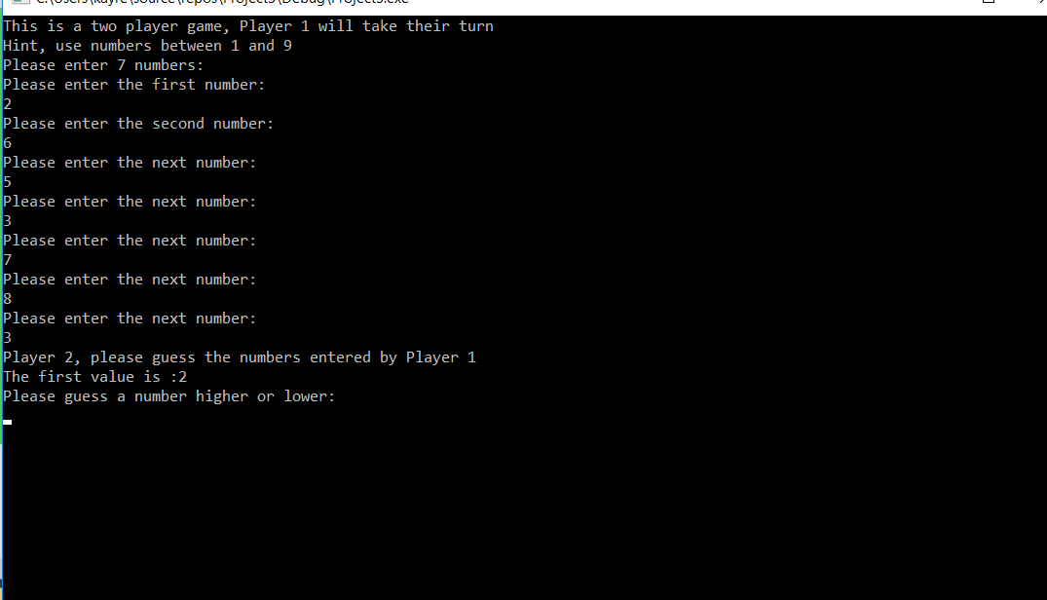

Test 2
The second test didn’t run as smoothly as originally intended, the value of the first array is returning as a decimal point number. Another fault that is worth mentioning is that there was a mistake, one of the guess number features were at the start by accident.
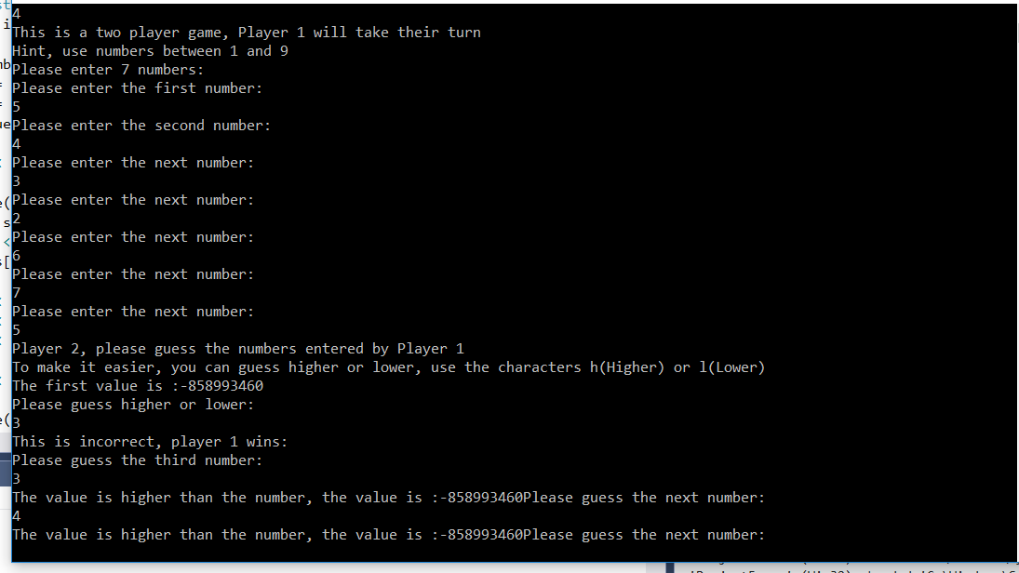
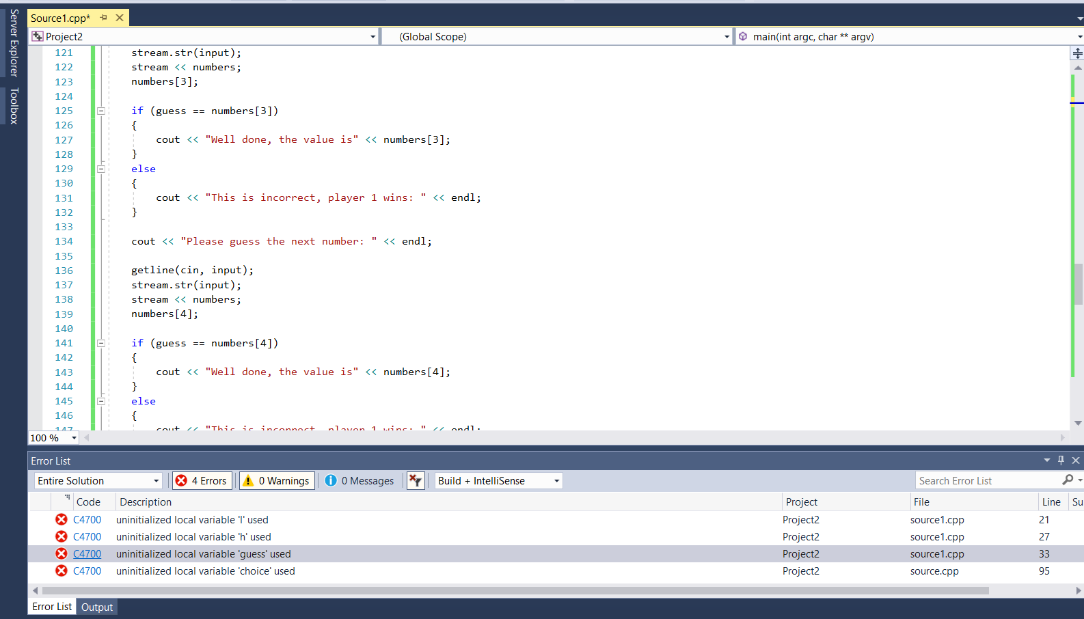
This is the program, not running, this was due to the variables not initialising.
Test 3
This shows the program running smoothly and Player 1 wins when it is guessed wrong.

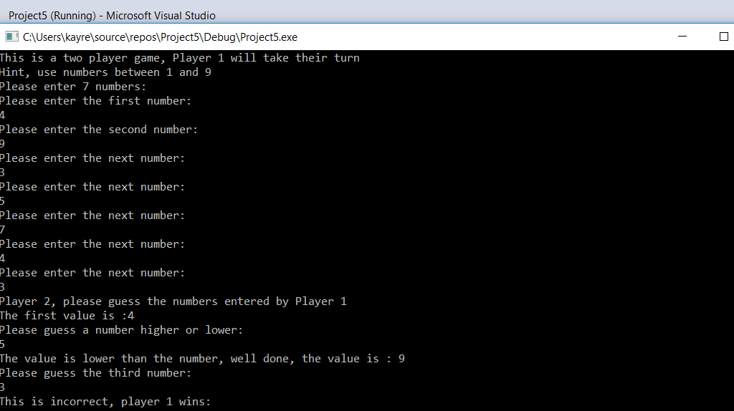

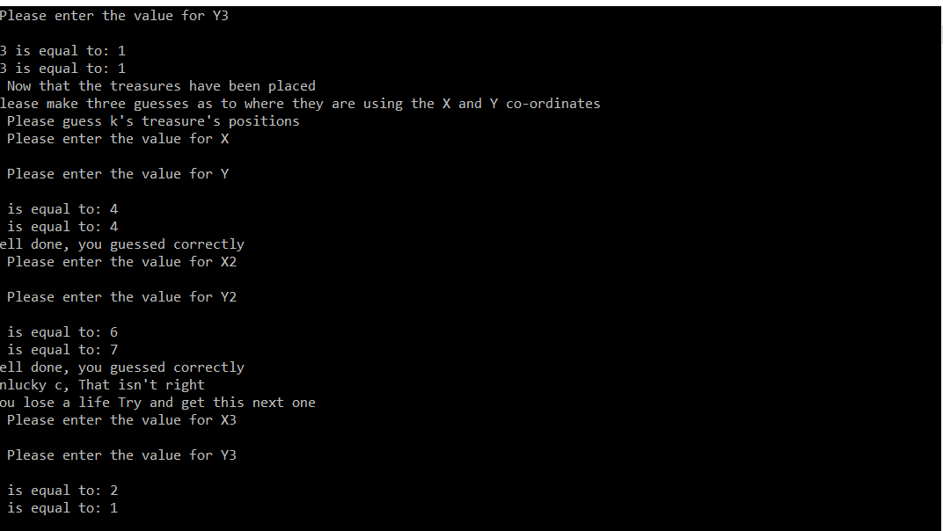
Test 6 and 7

Test 8
Showing that the program acknowledges if you have guessed wrong
Shows values being entered from Player 1 and Player 2 then enters their values and the programme acknowledges this.

Conclusion
In conclusion, this assignment has been very challenging, it has challenged the engineer on how to persevere with their work, it has also taught them that they need thorough testing in every program that they write.

Appendices

Here is the code for Exercise 1
//exercsise 1

//libraries

#include <iostream>
#include <sstream>
#include <stdio.h>

using namespace std;

int main(int argc, char** argv)
{
stringstream stream;
string input = "";

double num1, num2, num3, num4, num5, num6, num7, num8, num9, num10, num11, num12, num13;

//game will start with having player 1 entering their 7 numbers
cout << "This is a two player game, Player 1 will take their turn" << endl;
cout << "Hint, use numbers between 1 and 9" << endl;
cout << "Please enter 7 numbers: " << endl;

cout << "Please enter the first number: " << endl;

getline(cin, input);
stream.str(input);
stream >> num1;
stream.clear();

cout << "Please enter the second number: " << endl;

getline(cin, input);
stream.str(input);
stream >> num2;
stream.clear();

cout << "Please enter the next number: " << endl;

getline(cin, input);
stream.str(input);
stream >> num3;
stream.clear();;

cout << "Please enter the next number: " << endl;

getline(cin, input);
stream.str(input);
stream >> num4;
stream.clear();

cout << "Please enter the next number: " << endl;

getline(cin, input);
stream.str(input);
stream >> num5;
stream.clear();

cout << "Please enter the next number: " << endl;

getline(cin, input);
stream.str(input);
stream >> num6;
stream.clear();

cout << "Please enter the next number: " << endl;

getline(cin, input);
stream.str(input);
stream >> num7;
stream.clear();

cout << "Player 2, please guess the numbers entered by Player 1" << endl;

cout << "The first value is :" << num1 << endl;

cout << "Please guess a number higher or lower: " << endl;

getline(cin, input);
stream.str(input);
stream >> num8;
stream.clear();

if (num8 < num2)
{
cout << "The value is lower than the number, well done, the value is : " << num2 << endl;
{
if (num8 > num2)
{
cout << "This is incorrect, player 1 wins: " << endl;
exit;
}

}

}

cout << "Please guess the third number: " << endl;
getline(cin, input);
stream.str(input);
stream >> num9;
stream.clear();

if (num9 > num3)
{
cout << "The value is higher than the number, the value is :" << num3 << endl;
}
else
{
cout << "This is incorrect, player 1 wins: " << endl;
exit;
}

cout << "Please guess the next number: " << endl;

getline(cin, input);
stream.str(input);
stream >> num10;
stream.clear();

if (num10 > num4)
{
cout << "The value is higher than the number, the value is :" << num4 << endl;
}
else
{
cout << "This is incorrect, player 1 wins: " << endl;
exit;
}

cout << "Please guess the next number: " << endl;

getline(cin, input);
stream.str(input);
stream >> num11;
stream.clear();

if (num11 < num5)
{
cout << "Well done, the number is smaller, the value is" << num5 << endl;
}
else
{
cout << "This is incorrect, player 1 wins: " << endl;
exit;
}

cout << "Please guess the next number: " << endl;

getline(cin, input);
stream.str(input);
stream >> num12;
stream.clear();

if (num12 < num6)
{
cout << "Well done, the number is smaller, the value is: " << num6 << endl;
}
else
{
cout << "This is incorrect, player 1 wins: " << endl;
exit;
}

cout << "Please guess the next number: " << endl;

getline(cin, input);
stream.str(input);
stream >> num13;
stream.clear();

if (num13 > num7)
{
cout << "Well done, the value is higher, the value is: " << num7 << endl;
}
else
{
cout << "Player 2 wins" << endl;
}

if (num13 < num7)
{
cout << "Player 1 wins" << endl;
}

return 0;
}

Here is the code for Exercise 2
#include<stdio.h>
#include<sstream>
#include<iostream>

using namespace std;

int main(int argc, char** argv)
{

stringstream stream;
string input = "";
string player1;
string player2;
//the guessing process
bool guess1 = true;
bool guess2 = true;
bool guess3 = true;
int lives = 3;

cout << "Player 1, please enter your name: " << endl;
getline(cin, input);
stream.str(input);
stream >> player1;
stream.clear();

cout << "Player 2, please enter your name: " << endl;
getline(cin, input);
stream.str(input);
stream >> player2;
stream.clear();

//if guess equals to true, player 2 wins, however if they don't, the x and y co-ordinates are marked off

//X Co-Ordinates

cout << player1 << " Please enter the value for X" << endl;

double x;
getline(cin, input);
stream.str(input);
stream >> x;
stream.clear();
//please enter the co-ordinates for y
cout << player1 << "Please enter the value for Y" << endl;

double y;
getline(cin, input);
stream.str(input);
stream >> y;
stream.clear();

cout << "X is equal to: " << x << endl;
cout << "Y is equal to: " << y << endl;

cout << player1 << " Please enter the value for X2" << endl;

double x2;
getline(cin, input);
stream.str(input);
stream >> x2;
stream.clear();
//please enter the co-ordinates for y
cout << player1 << "Please enter the value for Y2" << endl;

double y2;
getline(cin, input);
stream.str(input);
stream >> y2;
stream.clear();

cout << "X2 is equal to: " << x2 << endl;
cout << "Y2 is equal to: " << y2 << endl;

cout << player1 << " Please enter the value for X3" << endl;

double x3;
getline(cin, input);
stream.str(input);
stream >> x3;
stream.clear();
//please enter the co-ordinates for y
cout << player1 << "Please enter the value for Y3" << endl;

double y3;
getline(cin, input);
stream.str(input);
stream >> y3;
stream.clear();

cout << "X3 is equal to: " << x3 << endl;
cout << "Y3 is equal to: " << y3 << endl;

cout << player2 << " Now that the treasures have been placed" << endl;
cout << "Please make three guesses as to where they are using the X and Y co-ordinates" << endl;

cout << player2 << " Please guess " << player1 << "'s treasure's positions" << endl;

cout << player2 << " Please enter the value for X" << endl;

double x4;
getline(cin, input);
stream.str(input);
stream >> x4;
stream.clear();
//please enter the co-ordinates for y
cout << player2 << " Please enter the value for Y" << endl;

double y4;
getline(cin, input);
stream.str(input);
stream >> y4;
stream.clear();

cout << "X is equal to: " << x4 << endl;
cout << "Y is equal to: " << y4 << endl;

if (x4 == x)
{
if (y4 == y)
{
cout << "Well done, you guessed correctly" << endl;
}
else
{
cout << "Unlucky " << player2 << ", That isn't right" << endl;
//life system, user loses a life
lives - 1;
cout << "You lose a life" << " Try and get this next one" << endl;
}
}

cout << player2 << " Please enter the value for X2" << endl;

double x5;
getline(cin, input);
stream.str(input);
stream >> x5;
stream.clear();
//please enter the co-ordinates for y
cout << player2 << " Please enter the value for Y2" << endl;

double y5;
getline(cin, input);
stream.str(input);
stream >> y5;
stream.clear();

cout << "X is equal to: " << x5 << endl;
cout << "Y is equal to: " << y5 << endl;

if (x5 == x2)
{
if (y5 == y2)
{
cout << "Well done, you guessed correctly" << endl;
}
else
{
cout << "Unlucky " << player2 << ", That isn't right" << endl;
//life system, user loses a life
lives - 1;
cout << "You lose a life" << " Try and get this next one" << endl;
}
}

cout << player2 << " Please enter the value for X3" << endl;

double x6;
getline(cin, input);
stream.str(input);
stream >> x6;
stream.clear();
//please enter the co-ordinates for y
cout << player2 << " Please enter the value for Y3" << endl;

double y6;
getline(cin, input);
stream.str(input);
stream >> y6;
stream.clear();

cout << "Y is equal to: " << x6 << endl;
cout << "X is equal to: " << y6 << endl;

if (x6 == x3)
{
if (y6 == y3)
{
cout << "Well done, you guessed correctly" << endl;
}
else
{
cout << "Unlucky " << player2 << ", That isn't right" << endl;
//life system, user loses a life
lives - 1;
cout << "You lose a life," << " be careful" << endl;
}

if (lives == 0)
{
cout << "Unlucky " << player2 << "You lost" << endl;
}
}

return 0;

}

