Awakened
Conscience

Ryan Thomas

-

BA Documentary Photography and Photojournalism

Module: Independent Inquiry (ADAD6001)
Date: 10/12/2019
Word Count: 6855
Contents

List of Illustrations/Photographs
Introduction
Chapter 1: The Great Migration
PART 1
PART 2
PART 3
Chapter 2: The Next Step
PART 1
PART 2
PART 3
Chapter 3: A New Age in Communication
PART 1
PART 2
PART 3
Conclusion
Bibliography
Plagarism Disclaimer

List of Illustrations/Photographs

- View from the Window at Le Gras, Nicéphore Niépce, 1826–1827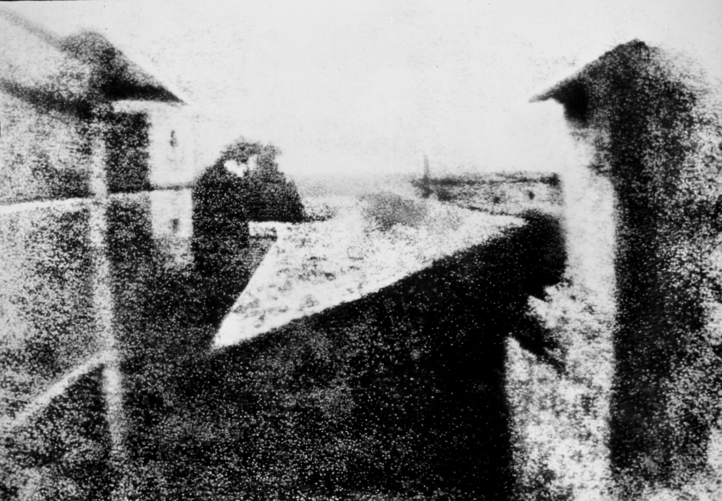
- Ancient History Encyclopedia, Jan van der Crabben, 2012

- Egyptian Hieroglyphs
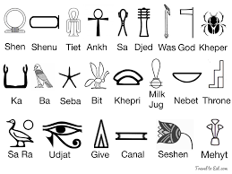
- Ambassadors, Holbein, 1533
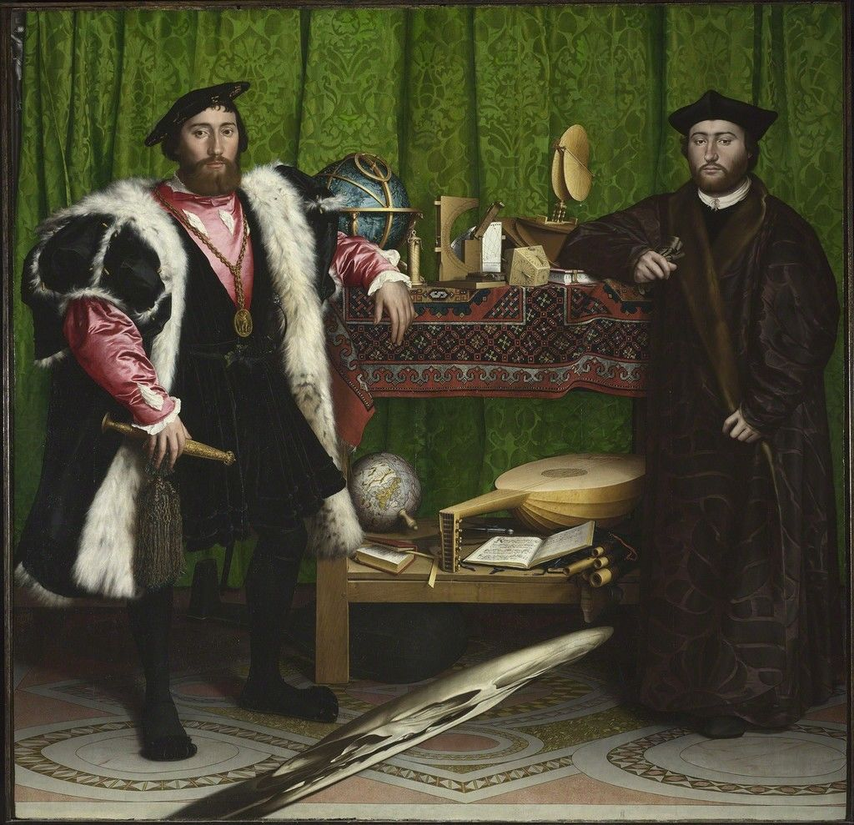
- Still Life with a Lobster, De Heem, 1648
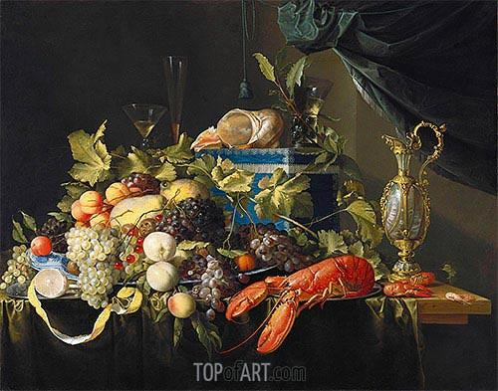
- Lincolnshire Ox, George Stubbs, 1790
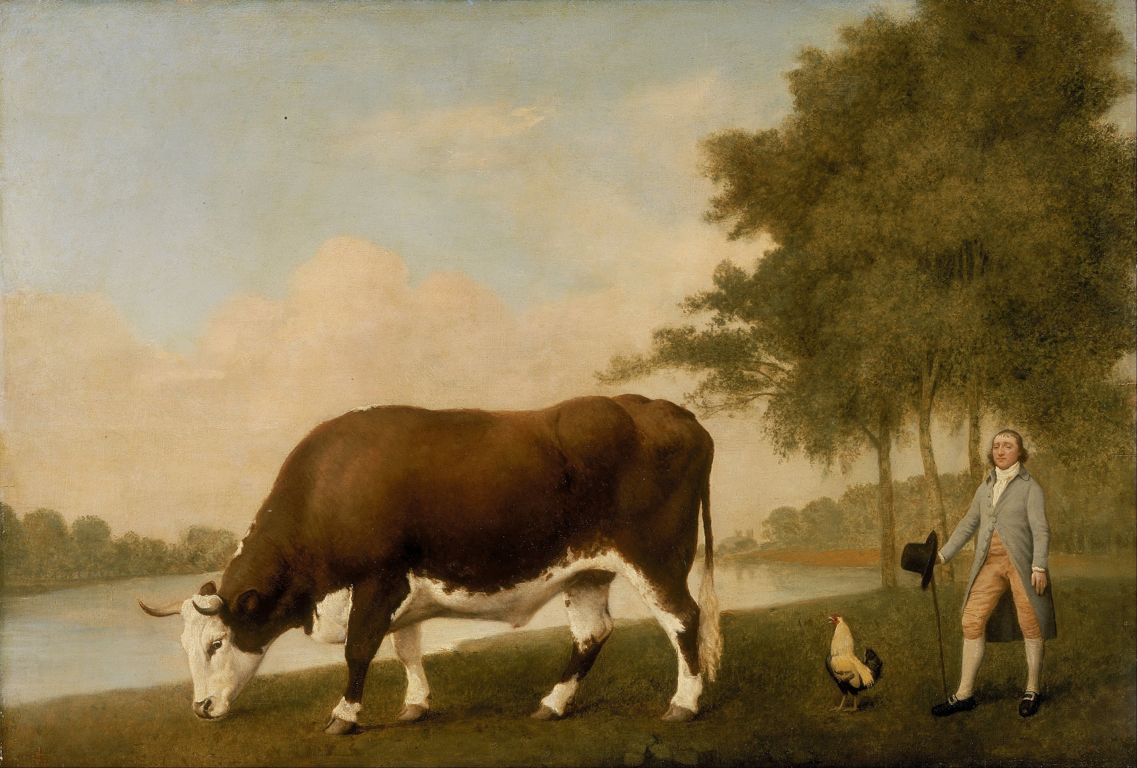
- The Bramham Moor Hounds at Weeton Whin, Sir Alfred Munnings, 1929
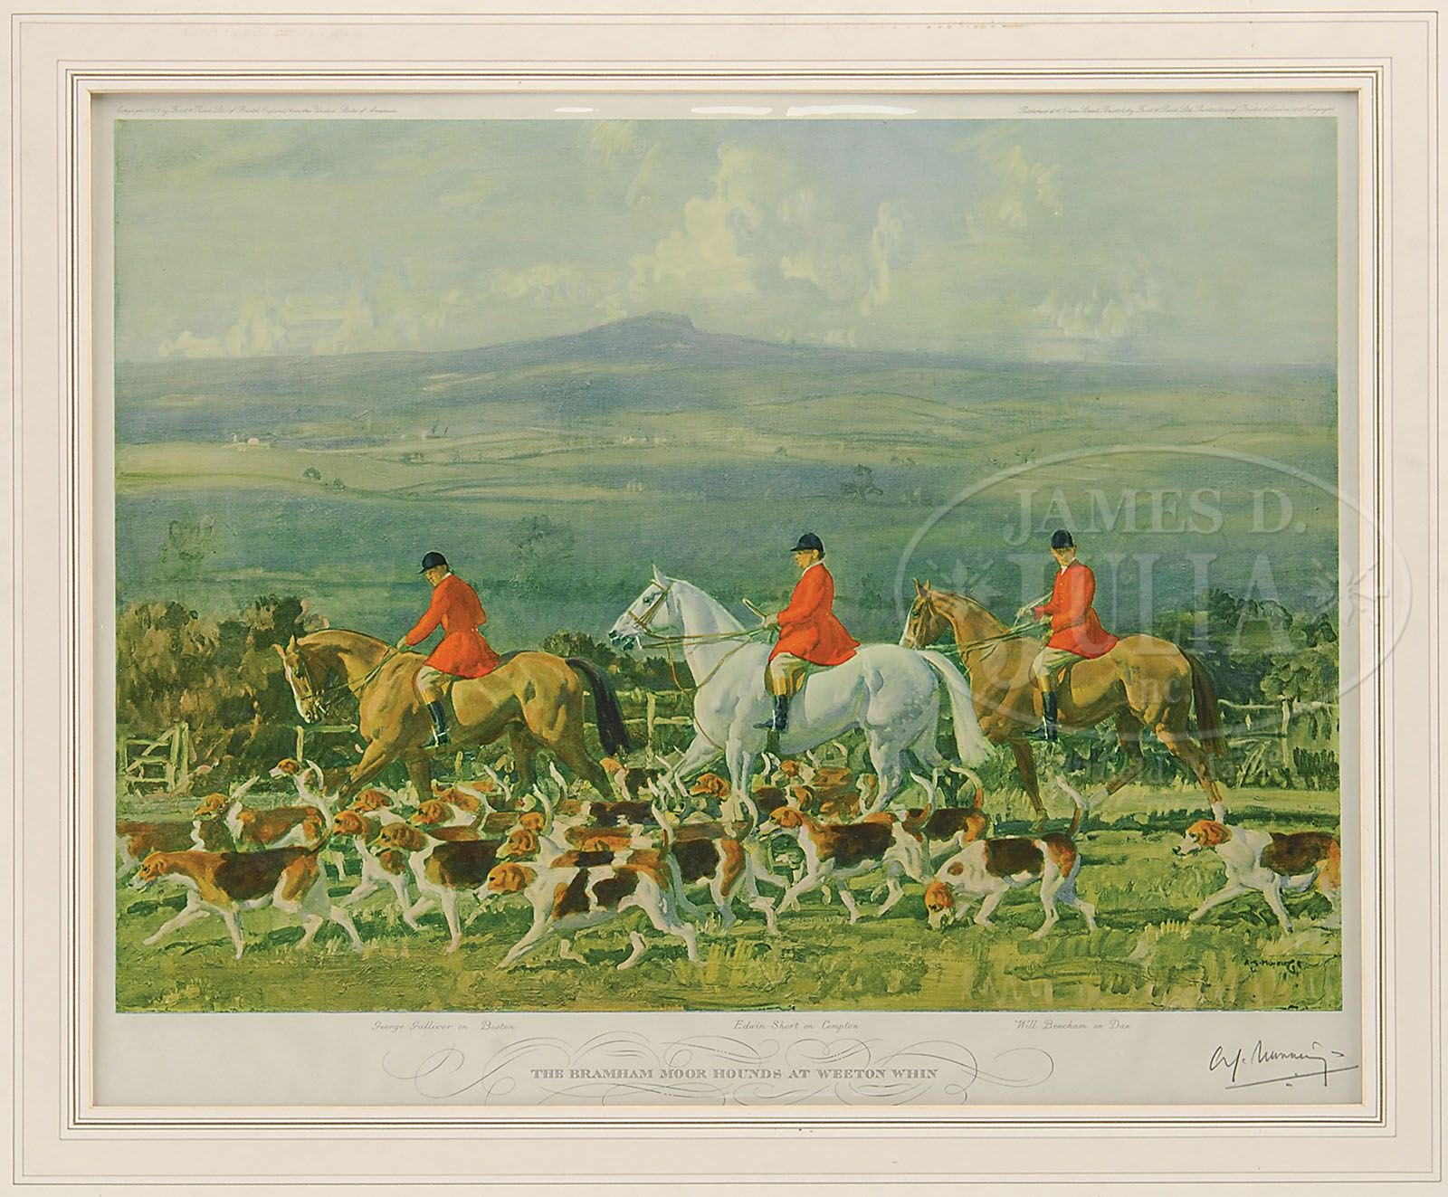

- Eclipse, George Stubbs, 1782
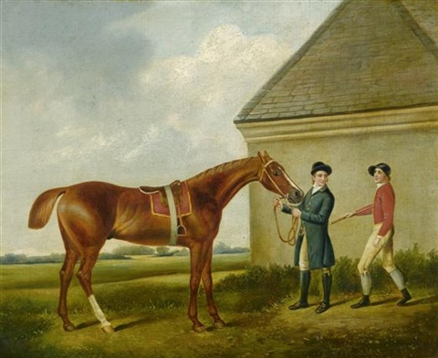
- Mr and Mrs Andrews, Thomas Gainsborough, 1748
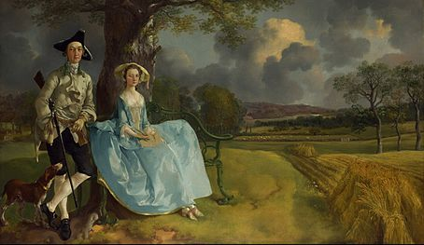
- The Ascension, Dosso Dossi, 16th century
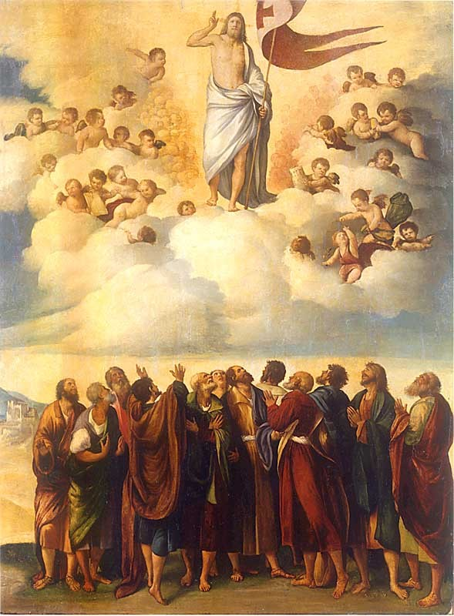

- The Discovery of Honey, Bacchus
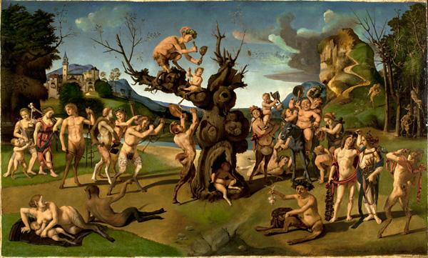
- Expulsion from Paradise, Michaelangelo, 1508-12
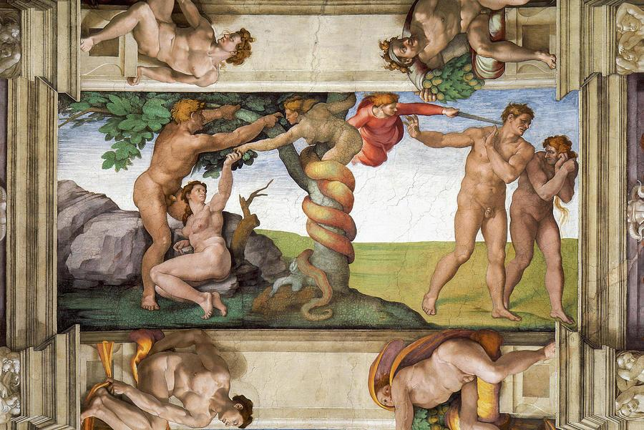
- Young Woman Holding a Mirror, Giovanni Bellini, 1515
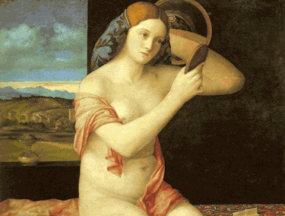

- View of the Boulevard du Temple, Louis Daguerre, 1838-1839
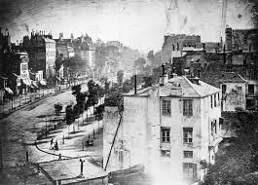
- Nelson's Column Under Construction, Henry Fox Talbot, 1843
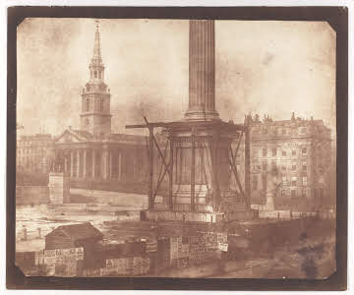
- The Fading Smile of Closing Day, Janet Reid
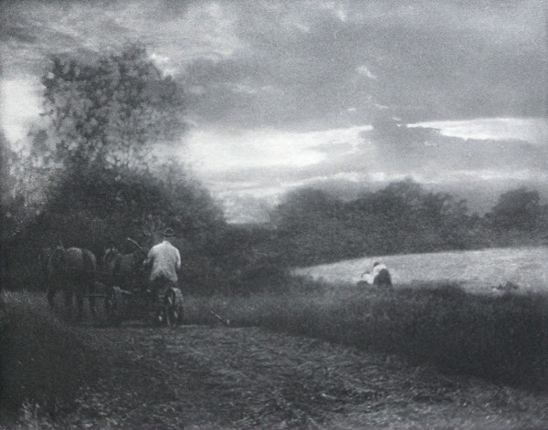
- Clearing Winter Storm, Yosemite National Park, Ansel Adams, 1937
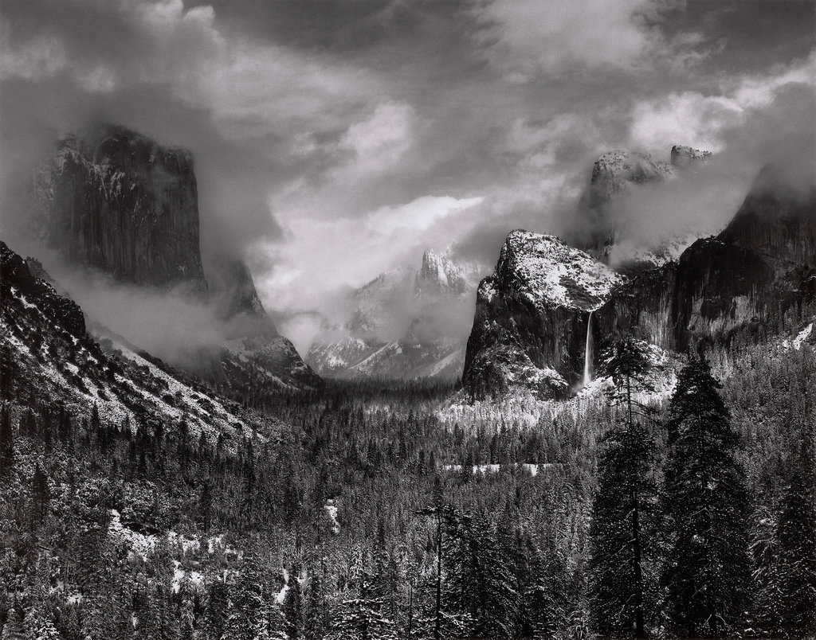
- JG AUTOGRAPHS
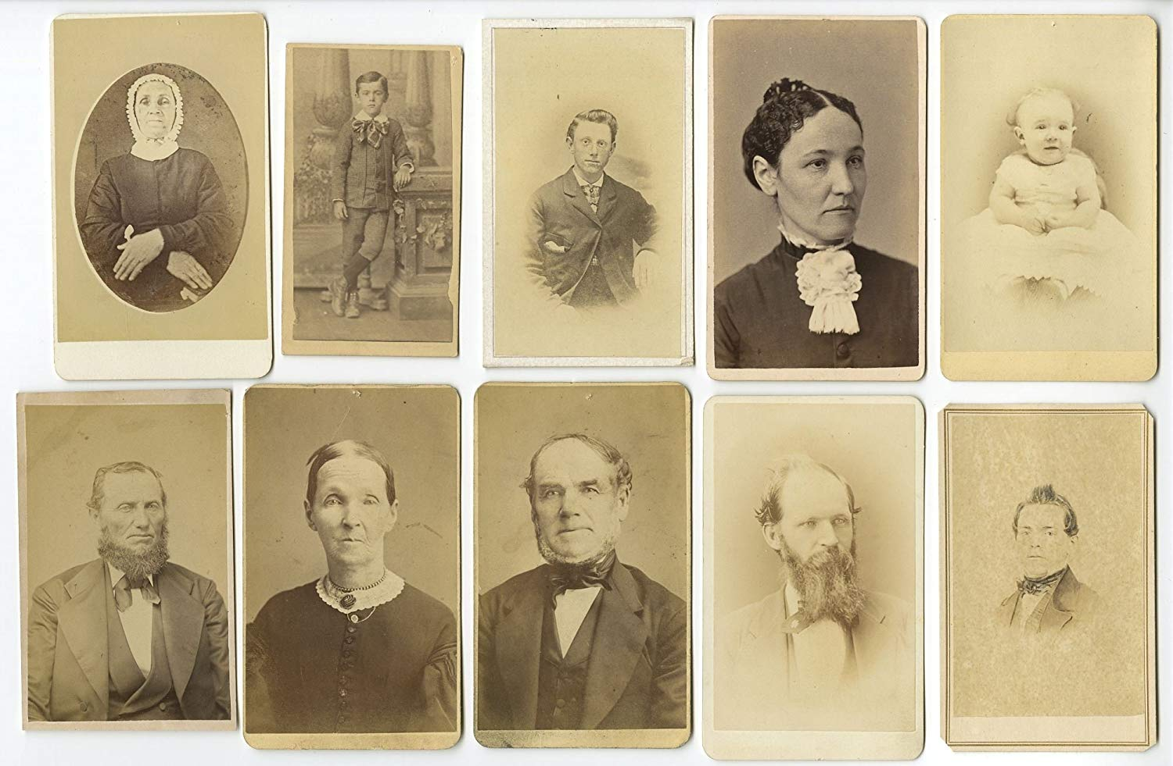
- Smithsonian
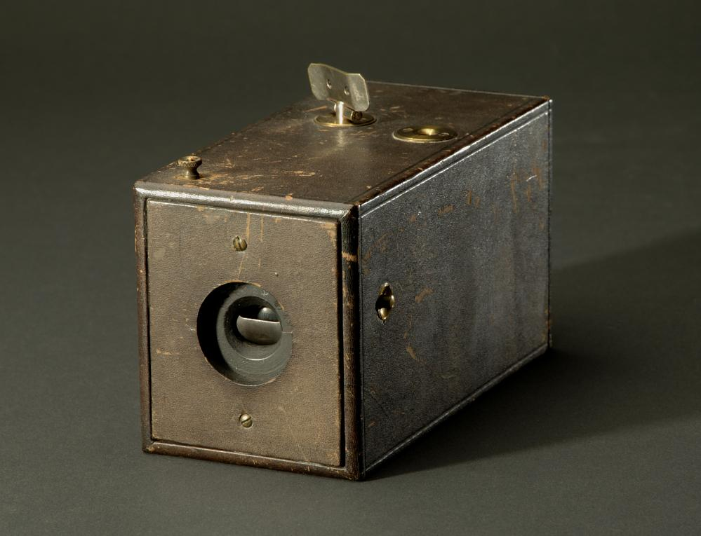
- Napalm Girl ,Nick Ut, 1972
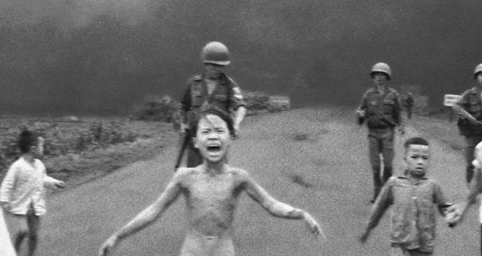
- Lodgers in a Crowded Tenement, Jacob August Riis, late 19th century
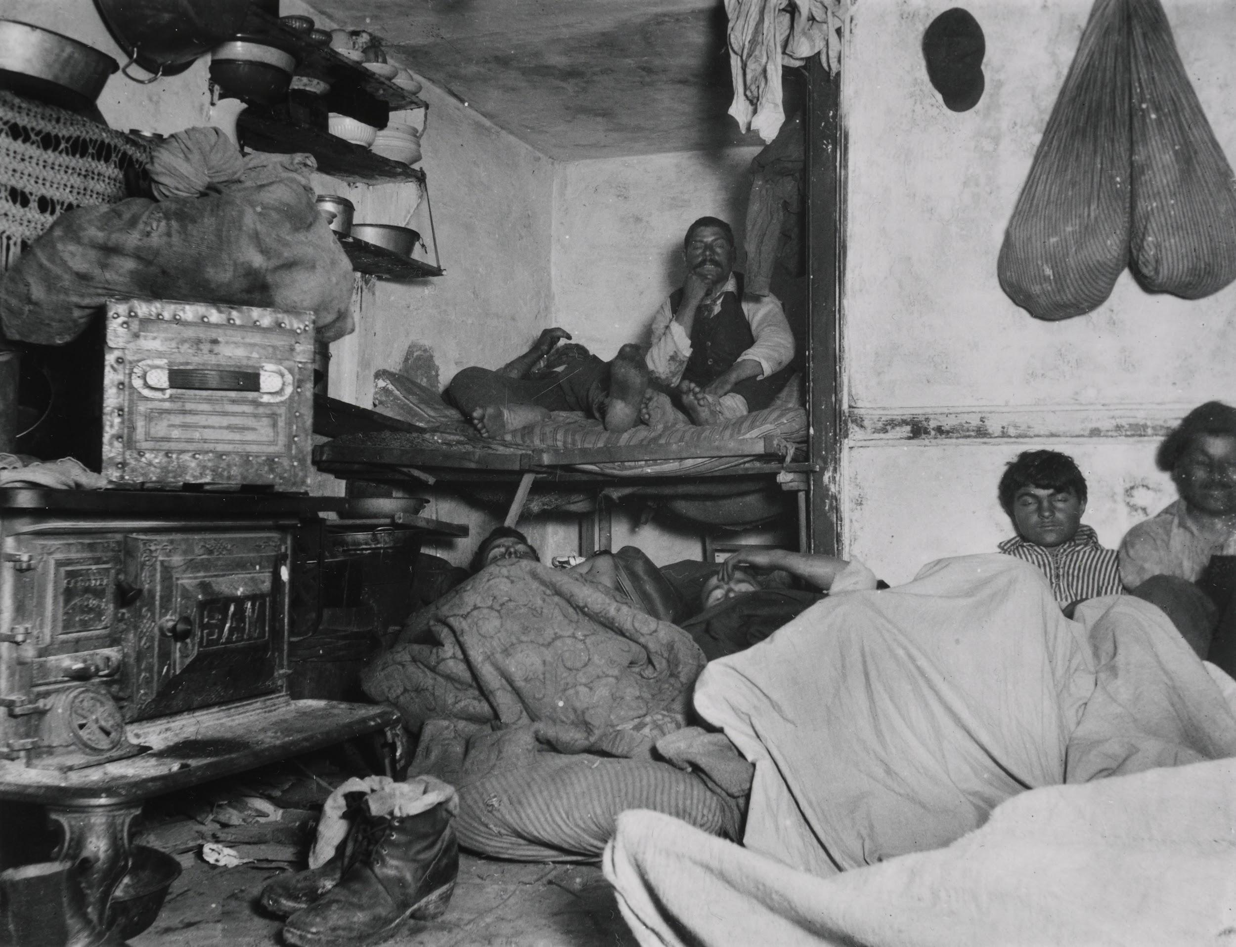
- Screaming Girl, Will Counts, 1957
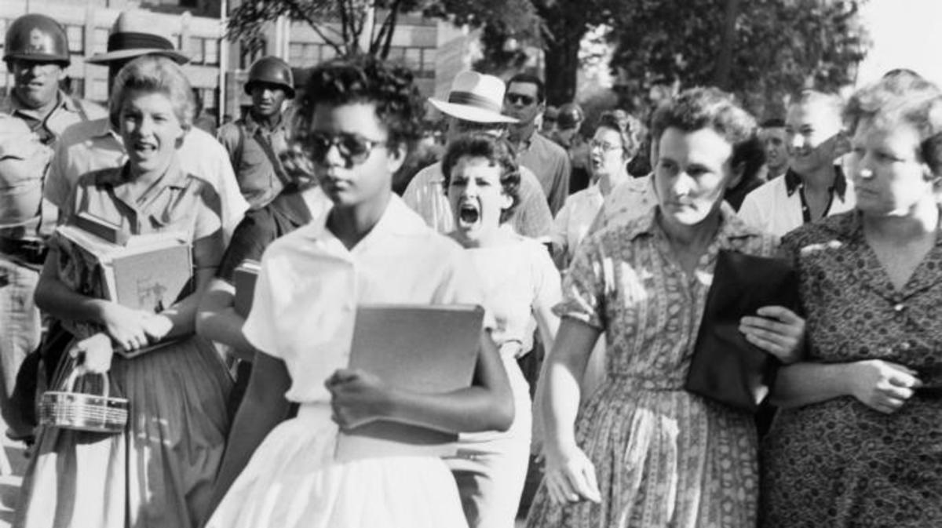
- Starving Child and Vulture, Kevin Carter, 1993
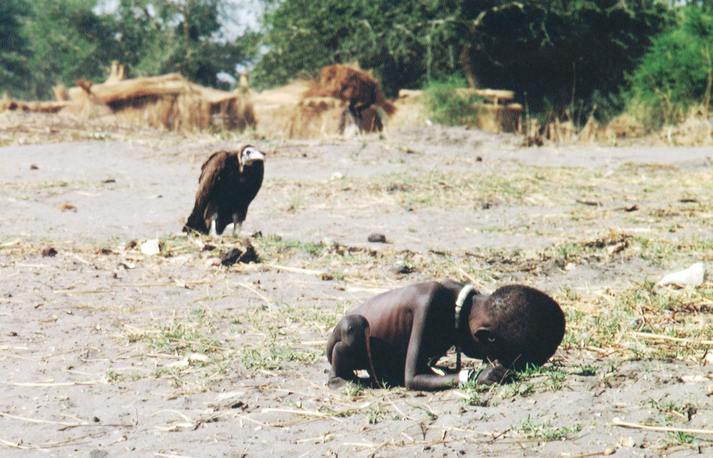
- The Dead of Antietam, Alexander Gardner, 1961
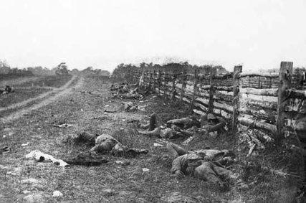

- Bosnia, Ron Haviv, 1992

- Famine in Somalia, James Nachtwey, 1992
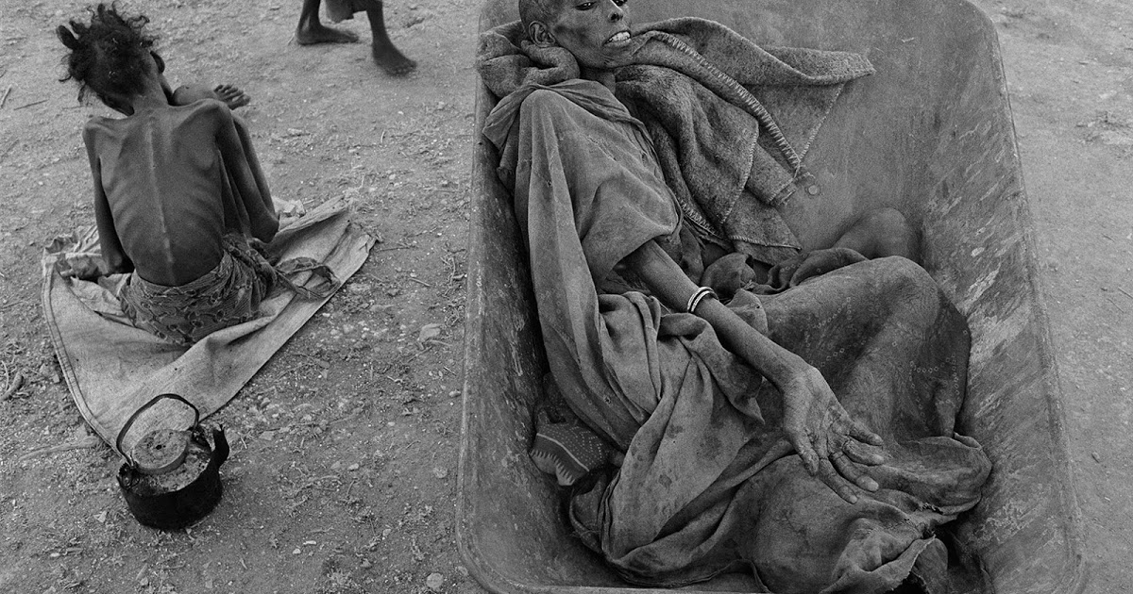
- Alan Kurdi, Nilüfer Demir, 2015
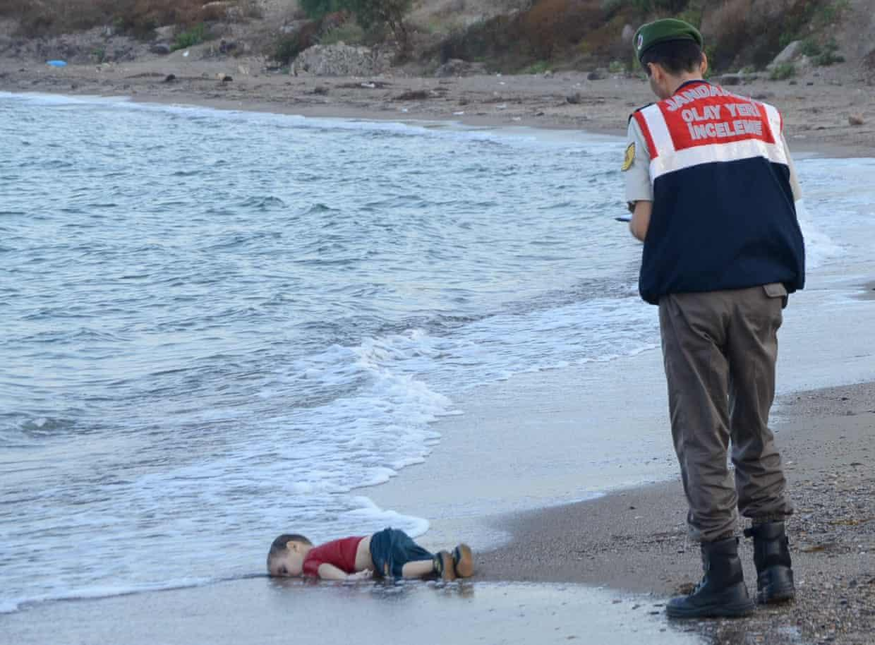

- The Falling Soldier, Robert Capa, 1936
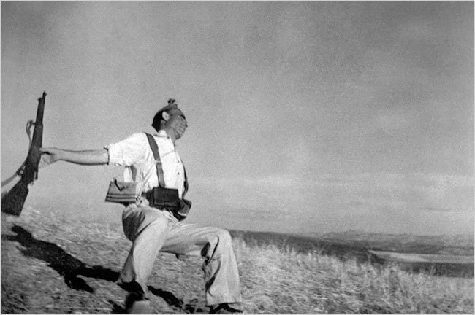
- Valley of the Shadow of Death, Roger Fenton, 1854
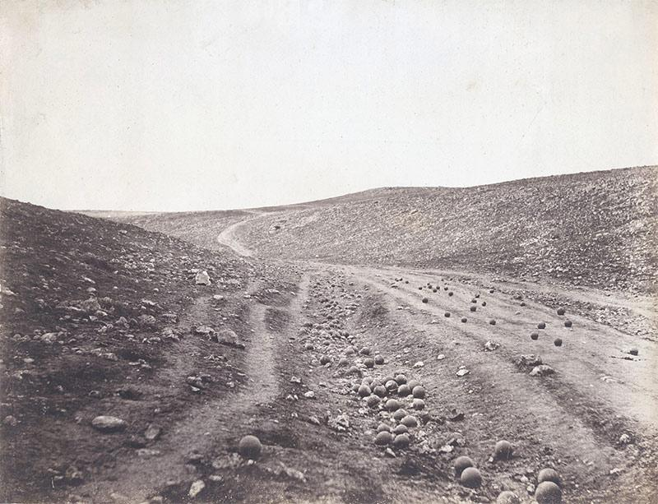
- Illustrated London, 1842
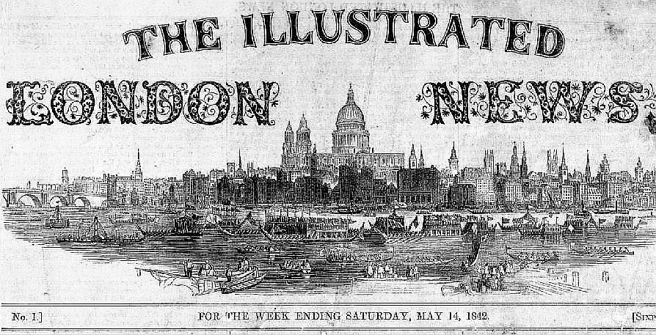

- Illustrated London, 1880
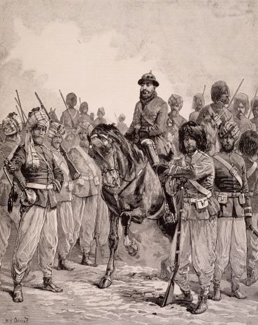
- Illustrated London, 1875
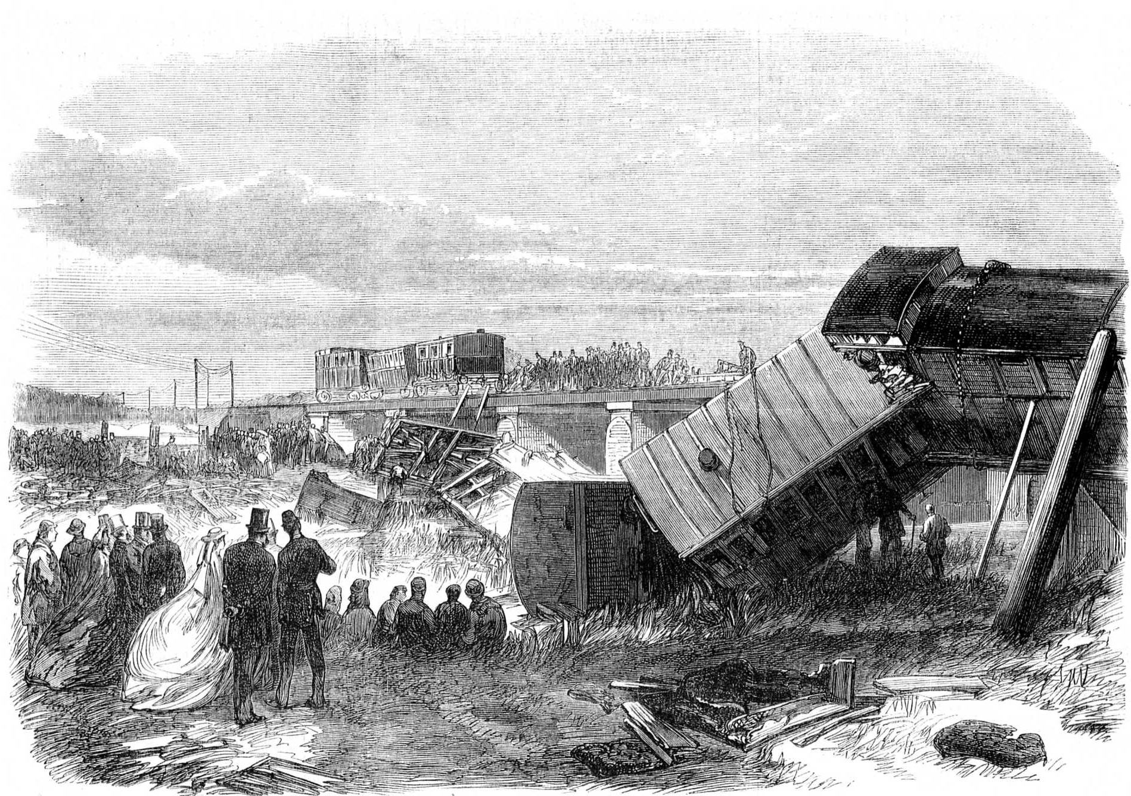
- Power house mechanic working on steam pump, Lewis Hine, 1920)
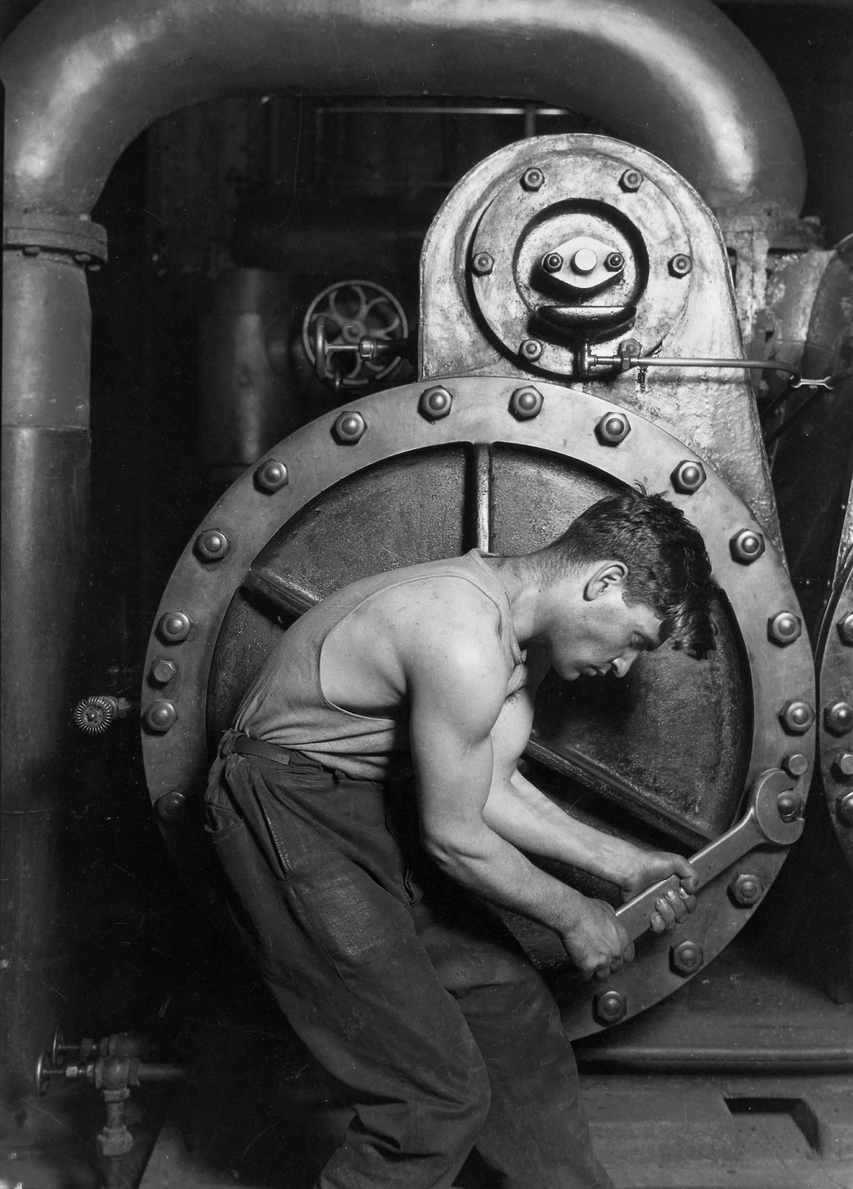

- Lucky Strike Advertising
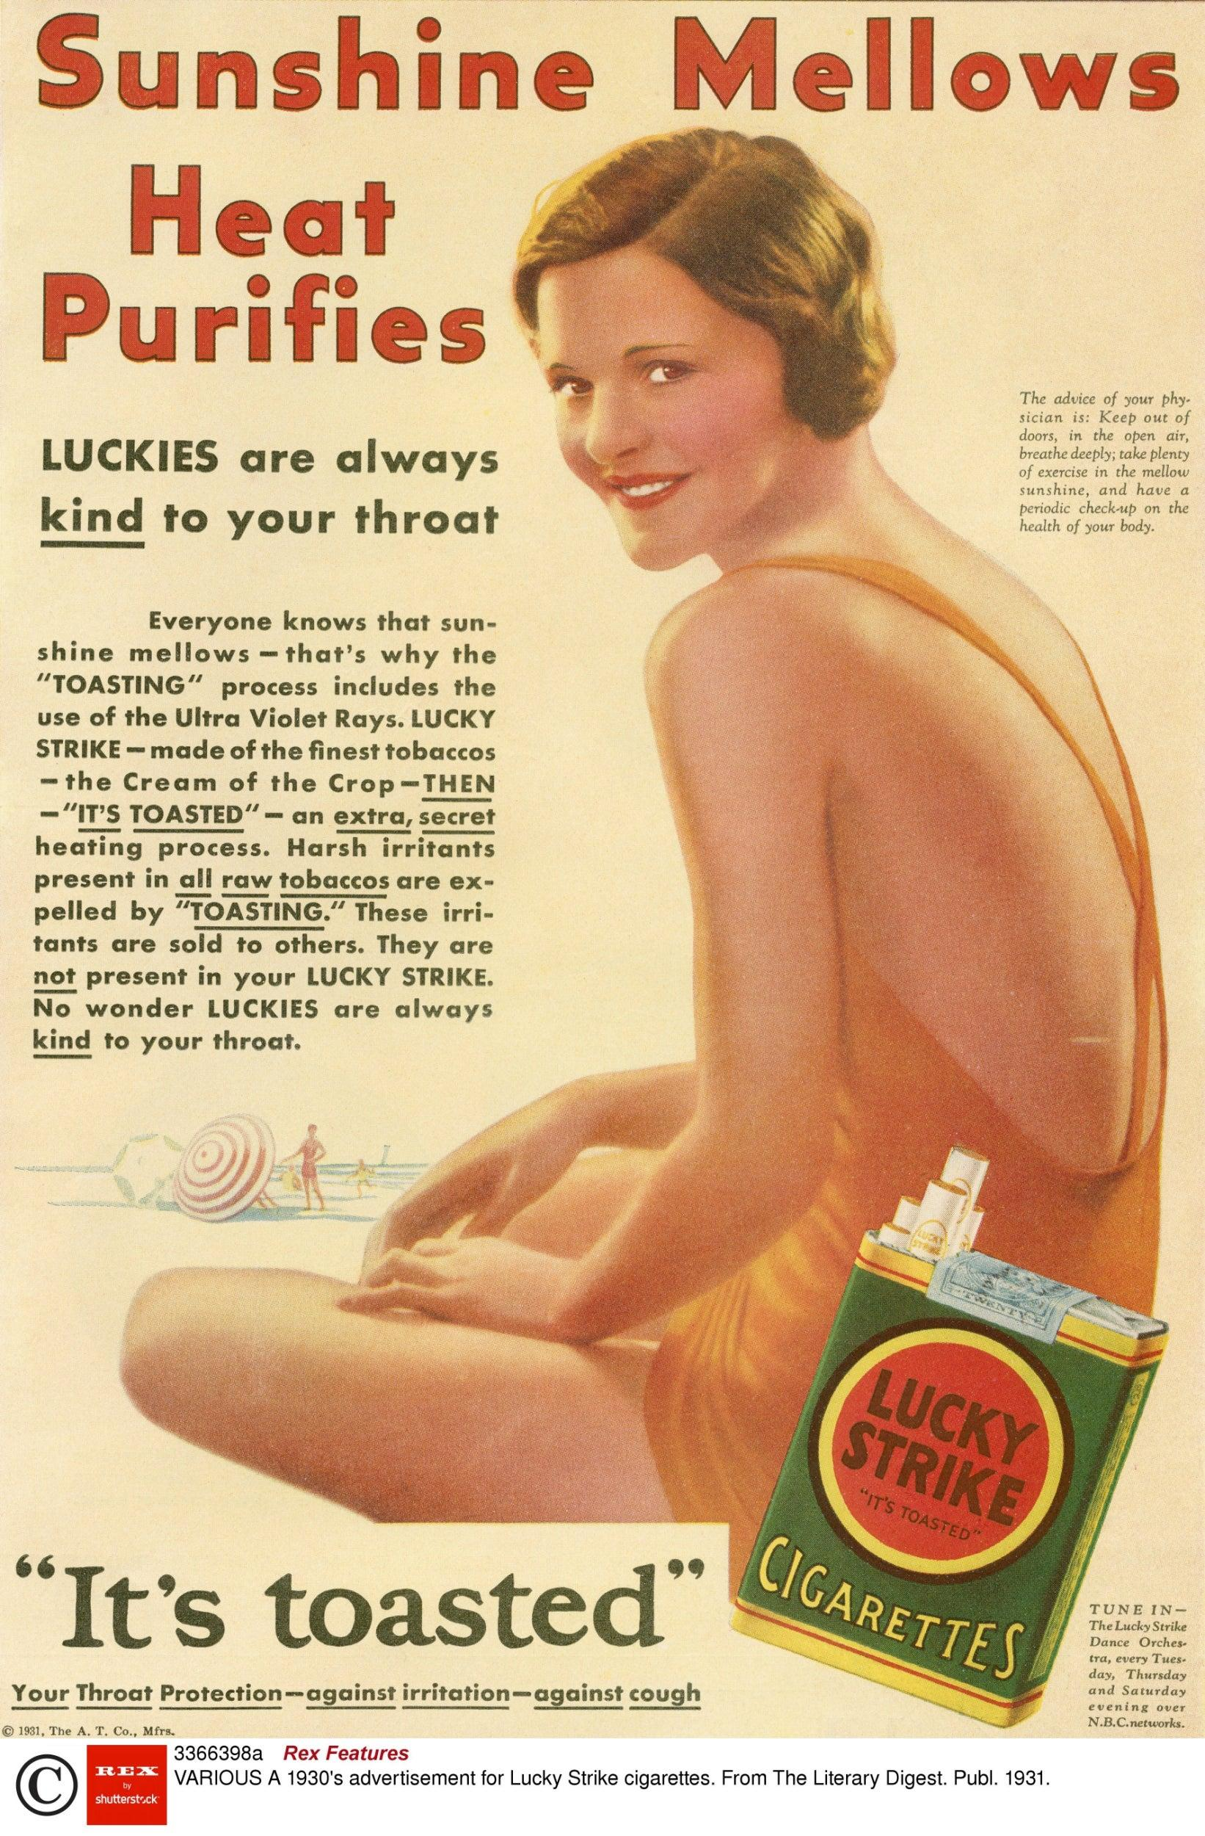
- Munsing Wear
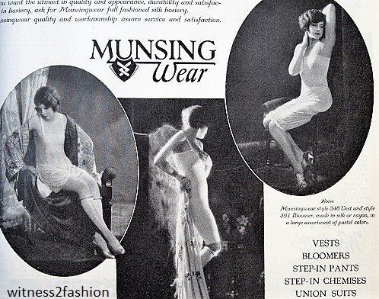
- Members of the public recording events at Baroness Thatcher's funeral, 2013
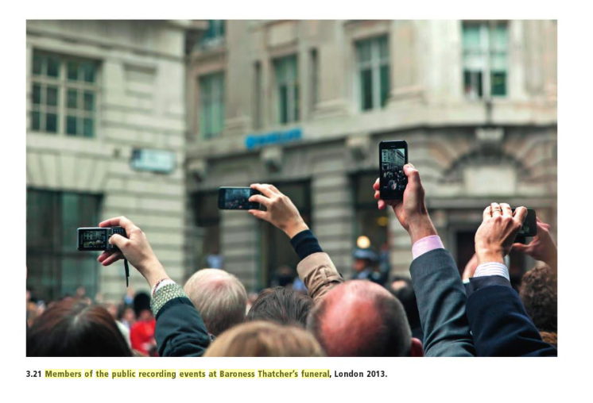

Introduction

For as far back as 40,000 years, humans have documented what we see in the world. The earliest cave paintings found in France are evidence that our furthest descendants used their ability to understand the world around them and record it. Not only does this show an intellect not found in any other species, but the capacity to have free thought to create tools, social webs, languages and art, that is all thanks to millions of years of evolution. The way we see things is ultimately affected by what we know or believe, and an image is an appearance that has been pulled from reality to be preserved by the spectator for eternity. (Cape, London, 1970) The early Mesopotamians, as well as the ancient Egyptians, were known for their sophisticated art sculptures of leaders and gods including but not limited to pallets of great story-telling art through pictograms, that would pave the road for their cultural voice that would spread to neighbouring civilizations.

Fast forward, 10’s of thousands of years, it is evident that in Europe, that the aptitude for art completely changed with creative movements such as the medieval, renaissance, romanticism, realism, impressionism, among many others. These eras are examples of ways we have progressively developed our art due to social, political, economic, and cultural changes and can be looked upon as one of the most important developments in human history. Religion and the contrast between male and female pretences are explored extensively. Both of these ideas, provoke the way the spectator feels about the work, and how they view themselves among the rest of the world. Art has always tended to serve the “ruling” classes ideological interests according to John Berger in a Ways of Seeing, but as I provide evidence, this is eventually ruled out in later centuries with the invention of the camera.

In 1826, inventor Joseph Nicephore Niepce developed the earliest of all surviving snapshots in history (figure 1). This was the initial push that would lead us to an awakened sense of who we are in the world and what happens around us. Using centuries of science from the first camera obscura, Niepce, was able to expose light to a hardened plate of bitumen that would be the first example of how we could aesthetically copy the world we view, but in a true to life manner. The camera changed the way man saw due to the fact that every painting or drawing before originally proposed that the spectator was the unique centre of the world, the camera changed this by paving the road for how we would eventually live our day to day lives. Today, 2 in 3 people around the world own a camera phone (Bank My Cell, 2019) that fits in their pocket just two hundred years after the invention of the camera. These gadgets have completely changed the way we interact with others as it allows us to share our lives, and receive critically important news. This mirrors our distant ancestors’ cave paintings and major art movements over thousands of years in the way it shows we find worth in sharing our perspective on the world in a conceptual way to fulfil our own, personally creative desires.

Chapter 1: The Great Migration

In this chapter, I will explore the early steps we took from learning to write, to developing deep thinking and socially challenging works of art based during the European time of enlightenment. I discuss how the invention of writing significantly played a role in early forms of art and how it supported the expanding Christian reformation that would lead major art movements in Europe following the “Dark Ages”. Art depicting the wealthy and secular, is challenged with the use of symbolism, as well as examine how both men and women are perceived due to later secular paintings. The aim of this chapter aims to construct an argument that over time and up to the end of the 19th century, art had been primarily for the higher classes that had influence over the perception of those below them whether in wealth, religious status or gender.

Part 1.1

Ever since we could walk, we have looked to the stars for inspiration. We have created gods in the way we would imagine such a spiritual entity and therefore have used inspiration from these ideas to create works of art for thousands of years. Not only has this had a social impact on the way we view the world but if you look at modern countries such as Iran that calls itself the “Islamic Republic”, disputed land in the West Bank of Palestine, sister countries like India, Pakistan and Bangladesh that underwent partition according to religion, it is evident that it plays a major role in the political structure of the world. Not only did we see gods in the starry sky but a way of survival that would become key to a major change in our history. According to EarthSky, as far back as 40,000 years ago, cave-dwellers in what’s now Turkey, Spain, France and Germany all used a method of date-keeping based on the reading of the stars to predict the coming of the winter season as well as the migration of wild herds, which were key to survival. (Cosmos: A Spacetime Odyssey, Neil deGrasse Tyson, 2014) Eventually, our ancestors learned how to domesticate both cattle and crops, to shape our environment in a way that would allow us to settle down in one place. This meant that for the first time we could produce and source more goods such as food, water, materials used to build things and fortify defences from enemies in a way we never could before. With all these extra valuables it would be essential to keep track of how much we had.

The people of Sumer were the first inhabitants of any major city developments in the world and these cities with so many valuables required complex administration. Places of religious importance were not only used for worship but as the repositories the communities collective wealth in the case of leaner years. As people made contributions to the communities storage, scribes had to quickly come up with ways to record how much they had, this in time developed the first form of writing we know as cuneiform script (“cuneus” in Latin means “wedge”). The first form of this abstract pictogram style writting was done from top to bottom but as cities grew and the writing simplified, it was changed to go from left to right. (Plantagenet Somerset Fry, 1998) Many people originally opposed this as it was a major change they were not able to understand, so to combat this issue and make it easier for the reader, the scribes rotated the words 90 degrees, doing this only made the images more abstract until eventually, the pictograms vanished entirely and were replaced by the familiar wedge-shaped style writing that is cuneiform. (Extra Credits, Youtube, 2016) (figure 2)

Eventually, many of Sumer’s neighbours adopted these forms of writing that would lead to cultural revolutions that would develop new cultures and empires. Most of these well-known forms of ancient writing can be traced to civilizations such as the Egyptians, Chinese, and Incans. With the creation of these pictograms, Egyptians were able to develop their own culturally diverse art and for the first time, we could document our thoughts and aspirations, record history, and mass-produce religious ideas in the form of writing. (figure 3)

The Egyptians had their own gods, leaders, and values that are evidence of these early texts. Symbolism pervaded Egyptian art and played an important role in establishing a sense of order by providing a kind of conduit for the spiritually divine, playing a highly illustrative figure among animals, and as an intermediary between the gods and royally elite. (Khan Academy, Egyptian Art, 2017)

Part 1.2

This concept that the rich and secular played a major role in ancient art, didn’t stay hidden in the past but can be claimed as the main concept for most of the art movements of the 16th, 17th,18th and 19th centuries. Martin Kemp’s 2007 Imitations, Optics and Photography Some Gross Hypotheses study aims to explore the dominant goal of progressive Western art from 1300 to 1880. Painters such as Leonardo Da Vinci and Jan Van Eyck have been noted among the most influential and imaginative artists of this era, and seem to have sought to imitate the scientific and intrinsic as closely as possible but also remained secular in their work. As I stated in my introduction, the words of John Berger, “the art of any period tends to serve the ideological interests of the ruling class” (John Berger, Ways of Seeing, 1972), as you can see in such examples as The Ambassadors by Holbein (figure 4). This oil painting does a great job of defining the real with its texture, and the consistency of what it represents. As with many oil paintings, it has the potential for filling space with texture, colour and space with symbolic objects that fill the entire space. In this case, The Ambassadors, exhibits a significant use of symbolism that indicates the men in the photo are of higher status, as well as their certain presence. It is safe to say from the objects (from the silk and furs, to the navigational tools, and gold) and the way the men appear in their stance that this was aimed to demonstrate the desirability of wealth and how it will reward the touch of the observer. The men in the painting are haughty and confident, they represent that they cannot be matched in worth and despite the objects that surround them, are in an environment that they wish to exclude themselves from. Still Life with a Lobster by De Heem (figure 5) is an example of how early use of gold-leaves were previously used in medieval but then used in oil paintings of 16th-19th centuries to demonstrate how merchandise could be used to denote what wealth could bring the spectator. This confirms the artists affluent behaviour that is also consistently found among artists during this time period. The use of animals, objects, and buildings to emphasize someone's wealth or to support the appearance of their nobility. A supportive example of this conjecture is Lincolnshire Ox by George Stubbs in 1790 (figure 6). In this painting, the aim is to showcase, once again, the social status of the owner. The owner wanted to display his prize-winning rooster and his exceptionally large, pedigree ox. To list more oil paintings from this time with parallel themes, The Bramham Moor Hounds at Weeton Whin by Sir Alfred Munnings (figure 7), Eclipse by George Stubbs (figure 8), and Thomas Gainsborough’s Mr and Mrs Andrews (figure 9). These paintings make it clear that, within the logic of the oil painting, there is nothing that can't be possessed, not even things typically considered "wild".

Part 1.3

The perception of wealth and the way people understand their place among the world is similar to the secular themes of both male and female subjects in paintings, sculptures and other works of the time. Religion had played a major role in the majority of art up to the 20th century, but various themes about who we are are critical to the argument that I am attempting to produce.

For centuries, religion had been a main part of every person's life, so it is not a surprise when the majority of art was centred around religious figures our ideologies in Europe at the time. Painters such as Michaelangelo, Botticelli, Raphael, and Titan to name a few, were credited with producing such works of art in this 15th-19th centuries. Jesus obviously playing a central role in most paintings, as well as Moses, God himself, and Adam & Eve. In many of the paintings, the presence of a religious personality and the verisimilitude of the work, tend to make the viewer assume he is within touching distance of the subject, an established intimacy that would allow the viewer to feel closer to God (figure 10), and therefore a more devoted Christian. Many view this period of time as a “rebirth” in political, philosophical, economic, and cultural growth following the Middle Ages, a time of great hardship for the people of Europe. (History Channel, Renaissance, 2018) The Renaissance encouraged the revelation of classical philosophy, literature and art. Some of the greatest thinkers, authors, statesmen, scientists and artists in human history thrived during this era such as Leonardo DaVinci, Michelangelo, Martin Luther, Niccolo Machiavelli, Galileo, Raphael, Nicholaus Copernicus, among many more. While global exploration opened up new lands and cultures to European commerce in the Americas, Africa and Asia. The era known as the “Dark Ages,” is often branded as that after the fall of the Roman Empire and was a time of war, ignorance, famine and pandemics such as the Black Death and Europeans made very few advances in science, technology, or art during this time. The Renaissance, therefore, is credited with bridging this gap between the “Dark Ages” and modern civilization.(The Renaissance – Why it Changed the World, The Telegraph) (The Renaissance, History World International) Although religion had been so important to those before, the Renaissance brought in new ways of thinking that allowed people to interpret ideas fully and to closely examine and critique their religion.

Social presences have always been different between men and women. The religious oil paintings during this era questioned the conventional pretence that men exercise a certain amount of power in the world and that women are born within a confined space that forces them to be surveyed for their worth. Many artists used nude depictions of women (also men) in these paintings to question the way the viewer surveys the social structure of how women and men are portrayed in society (figure 11). Adam and Eve from the story of the Garden of Eden (figure 12) is one of the first European artistic depictions of men and women in the nude and has been analyzed by many artists the world over for holding that the nakedness in the story of Adam and Eve was as a result of different ways in which man and woman would eventually look at each other following the eating of the fruit from the tree of knowledge. After consciously understanding their déshabillé, this would lead to the ensuing subordination of women to mans rule. (Cultural Reader, 2011) Numerous Renaissance paintings depict a 3rd person view of the two covered in fig leaves. According to John Berger from Ways of Seeing, it is evident that Eve's embarrassment is retained in secular art with the woman's awareness for the fact that she is being viewed by a spectator. This is the difference that Berger explains between the nude and nakedness, she (Eve) “is not naked for herself; she is naked as the viewer sees her”. It is also noted that despite women were frequently painted in a way to be gazed at by men, they are hypocritically critiqued for being painted with a mirror, a symbol of vanity (figure 13). This constant judgement on the way we view ourselves or others is extremely challenging but is common among art of the era.

The transition from ancient writing to oil paintings of the European Enlightenment period following the so-called “Dark Ages” manifests the ability to assimilate itself among cultures and peoples conceptual beliefs. People of religion and capital status had great influence over the way people viewed images and therefore over social expectations of themselves. As you will read in the next chapter, evidence will be provided that reasons that art becomes less of an exclusivity amongst the higher classes and more of an advantage to bring free thought and equality amongst the lower.

Chapter 2: The Next Step

In the last chapter, I explored how the nobility, as well as the artists, were responsible for how the public perceived them or the world around them but the dissemination of ideas around the world, a rapid evolution in technology, and a shift in cultural values to a modern and more democratic society are factors that can possibly explain the transition from painting to contemporary photography. It is important to consider whether or not photography imitates painting in the artistic progression of documenting the world we observe and the customs we bring into question because of such challenging art. The initial use of the camera obscura and optical devices in painting as well the origins of the first cameras and how they used painting as aid to imitate a photo-realistic look with expressive gestures.

Part 2.1

In the late 18th-century, major developments were occurring in the world of art. For the first time, social changes enveloped to suit a more modern and democratically responsible Europe and North America. With such astonishing speed of innovation occurring, many people thought of themselves in the forefront of a technological revolution. Emerging technologies such as new electrics, optics, and chemistry were responsible for what would lead to the greatest development in modern communication - photography. Commended initially as a piece of modern technology, photography quickly became the topic of discussion. Although the camera is viewed today as a vital part of the aesthetic world we live in, it was hotly criticized for the way it would change art. According to Gerry Badger in Genius of Photography: How Photography Has Changed Our Lives, “Almost from the day in 1839 that the invention of the medium was announced, the contingent, unformed aspect of photography was perceived as a problem.” Many people believed the camera to be mechanical and free of discriminations of the human eye and that the nature of the photography was to produce work that was soulless and repetitive. Many critics assumed early photographers lacked the compositional creativity due the photos inability to record in an unemotional way and precise accuracy. One Paris-based poet and critic, Charles Baudelaire, was one that embraced modernism but was fervently opposed to photography as an artistic medium and technical transcription (Liz Wells, Photography a Critical Introduction, 2009, 12). In the french journal, La Lumiere, Baudelaire noted that “if photography is allowed to deputize for art in some of art’s activities, it will not be long before it has supplanted or corrupted art altogether” (Baudelaire, 1859, 297). A counter to this statement, Fred Ritchen states in his book Bending the Frame, that “a photograph, no matter how unfamiliar or grotesque its depiction, was difficult to refute given its status as a reliable trace of the visible and real.” (Fred Kitchen Bending the Frame: Photojournalism Documentary and the Citizen, 2010). Although this comment notes what is thought of photography as a medium centuries after Baudelaire made his, it rings true when additionally supported by the inventor, Louis-Jacques-Mandé Daguerre, who called the photo the “mirror of nature”. Daguerre was responsible for introducing the process of the daguerreotype , which was a sophisticated process of using chemicals to expose light to a copper plate that resulted in the first example of how to retain the world in an exact aesthetic. In Daguerre’s image, View of the Boulevard du Temple, Paris, 1838-1839 (figure 14), the demonstration of both limitations and virtues are apparent, but also everything looks awkwardly scruffy, unfinished and disappointingly even, something that photogenic drawings didn't have to deal with was reality. This doesn’t mean that they were judged by everyone as anything but art. In fact, William Henry Talbot’s calotype to faithfully copy the world was something prized (figure 15). (Gerry Badger, Genius of Photography: How Photography Has Changed Our Lives, 2007, 16) Many people of the time began to view the “absolute material accuracy” of photography as hallmark due to its ability to produce a complete and faithful image of its subject. (Liz Wells, Photography a Critical Introduction, 2009, 14).

Photographers of the 1800’s, responded to fierce critics such as Baudelaire either by accepting that photos were the mechanical, soulless medium of an intrinsic science that forfeited the owner of any compositional imagination, or they could explore the possibilities of how photography could be more than the former and that it could be worked upon to create work that in some way resembles the same aesthetic of paintings. Deliberately defecting their images, photographers found ways to separate their photos from the perfect mechanical frame by producing works that were out of focus, fuzzy and scratched to give the impression it was all done on canvas, as well as producing images containing secular subjects. These photographers were known to be Pictorial (figure 16).

On the other side of it all and often regarded as an early form of direct documentary, the aim of straight photography was to depict a scene in sharp focus and detail, in accordance with the qualities that distinguish photography from other visual media. (SUMMARY OF STRAIGHT PHOTOGRAPHY) (figure 17). Early examples of such work: Talbot’s calotypes, although very fuzzy originally aimed to treat the medium with accuracy and formal status of paintings while also concentrating on the organic properties as a mechanical tool. (Henry Talbot)

Part 2.2

The ability to create a photo-perfect copy of what the photographer saw was interested in many people initially with the ability to do portraitures. Photography and paintings can bring various kinds of strengths and weaknesses, and as Andre Bazin claims when describing the realistic expression of photography, “photographs are the unique way to be extraordinarily or realistic. It can realistically show the objects beyond the reach of paintings.” (Tony Yeung, Epistemological Realism: The major distinction between Photography and Painting, 2013) The fact that photographs were also more affordable than painted portraits and required far shorter sitting times for the subject, attracted many people to have their images shot instead of brushed. (The Art of the Portrait) The ability to produce photos became much more popular in the mid to late 19th century and would eventually spread among the classes, as Andre-Adolphe Disderi claimed, “such portraits are to be found in everybody’s hands”. Disderi had invented the carte-de-visite by 1854 (the name comes from the French translation of visiting cards) for those among the ‘leisure’ classes (figure 18). These small prints were easily accessible and would allow for multiple copies and is the first example of an attempt of mass producing images for the home in everyday life. In this figure, you can see first hand just how the photograph had made its way into people's homes as early as 20 years from the first Daguerreotype. (PBS, 2017)

To further discuss themes explored from the first chapter, it is important to understand that paintings (portraits) were originally reserved for the wealthy and powerful. These carte-de-visites were so-called to be found widely among the classes were not “family albums” (figure 18) after all, but volumes of photos of those of wealth and power such as royalty, celebrities, and politicians. This direct correlation of early photography would eventually break down and the medium would become more available “among the classes” as originally advertised. By the late 19th century and the early 20th, people were able to photograph their family and creatively shoot their fantasies. The Original Kodak camera introduced by George Eastman in 1888, placed the power of photography “in the hands of anyone who could press a button.” (Smithsonian) (figure 19) Looking back at how this affected the class system, it was evident that art was slowly becoming less of a rarity among the lower and middle classes. Without photography, it is said that the urgency and relevancy of an event, the difficulty of getting people to act may have been called into question prior. (Fred Kitchen Bending the Frame, 2010) This is exactly why photography resonated amongst all the classes. According to an account by photographer of the mid-1800’s, Lady Elizabeth Eastlake states, “Photography has become a household word and a household want; is used alike by art and science, by love, business, and justice” and that “is found in the most sumptuous saloon, and in the dingiest attic—in the solitude of the Highland cottage, and in the glare of the London gin-palace—in the pocket of the detective, in the cell of the convict, in the folio of the painter and architect, among the papers and patterns of the mill owner and manufacturer, and on the cold, brave breast on the battle-field”. (Eastlake 1857; 94) Eastlake’s observation simplified that the so-called old hierarchies of art had eventually broken down following the invention of photography, and had become a popular means of communication. Following the turn of the 19th century, photography would become the main source of artistic medium for documenting the world, sharing our family's lives, and recording history.

Part 2.3

The late 19th and early 20th centuries saw a massive progression in the development in ways photography could be used to record the world we live in. As recently discussed, we were earlier led to believe that we, the spectators, were the centre of the universe. (Berger, Ways of Seeing, 1972) This perspective drastically changed with the invention of photography, solely due to the fact that because photography was so easily available to the masses, it became collective when published in a newspaper or magazine. This can be supported by the statement that “photos act as windows that demand one look through them as a prerequisite of citizenship and as a moral obligation” (Fred Ritchen, Bending the Frame, 2009, 9). This concept that photography provoked amongst the art community goes to show that art could be used to bring injustice into question among political policies. These injustices were exposed through gender and hierarchical classes in paintings during the renaissance and are also followed by many photographers in the 20th century. The main contrast between the two mediums, however, goes on to show that where photography aims to thoroughly expose these wrongdoings, the paintings of the renaissance were for the elite, therefore not exposing but to display for the gaiety of those fortunate to view them. It is also important to point out that whereas paintings solely reflect the painter's perspective, photography is able to freeze a single, true moment in time. Famous photos such as that of a young girl after being napalmed during the Vietnam war (figure 20), Jacob August Riis’s Lodgers in a Crowded Tenement (figure 21), and the photo of African-American highschool student, Elizabeth Eckford, being screamed at by fellow white students (figure 22), are all examples of how photographers have attempted to use their perspective in a way that does not centralize themselves as the viewer but to paint a broader picture that photography is able to be used a societal scribe.

The problem with this, however, is that it also portrays ineluctable voyeurism amongst the artist, because without conflict there would be nothing to produce. Many modern photographers feel there should be a certain level of social responsibility that should be regarded within the medium, but there are many that challenge this notion. Photographs such as Kevin Carter’s Starving Child and Vulture (figure 23) is one that brings to question whether our ability to share wrongdoing and misfortune in the world is truly ethical. It should be noted that it is equally important to mention that because the photographers artistic duty is to manipulate the elements of a photo by knowing where to place the camera, how to work with both natural and artificial lighting, and how to operate their modern camera, it is easily just as questionably moral how the photographer manipulates a photograph as it is to actually shoot a subject that may be deemed in an unruly manner. If there is one thing modern photography does, it's to challenge these perceptions.

Chapter 3: A New Age in Communication

Before the invention of colour photography, the nature of light and how we perceive colour had to be clearly understood. While the fundamental theory may have been comprehended, a practical method of colour photography remained elusive. The initial use of photography to literally recopy the world was seen as mechanically taking the soul of those it shot, but with colour photography, you could bring the detail, blemishes, and imperfections to life. To add to this, technology was experiencing its fastest growth in human history during the later part of the 20th century. In this final chapter, I bring to question the ethics of modern photography, today’s technology that allows us to take more photos every two minutes than in the whole of the 19th century, and how the future of photography will once again change art and how we perceive the world conceptually.

Part 3.1

With the end of the 1800s, photography started to shift from solely as an experimental method among scientists to a tool to explore the social classes of the world in an artistic nature. Modern photographers such as Cartier Bresson, Robert Capa, Robert Doisneau, Paul Strand, Chris Killip, and Tony Ray-Jones were responsible for developing work that captivated the social classes and explored injustices in the world.

Almost every aspect of life has been explored through the use of photojournalism, whether that be social, political, economic, or personal, but one major factor that has consistently drawn photographers is war. It was Scottish-born photographer Alexander Gardner that “established a painfully potent visual precedent” for the way modern-day war photographers document the violence and brutality subjected around the world. Labelled, The Dead of Antietam (figure 24), Gardner’s exhibition was the first to showcase images of war casualties in history. Several wounded and dead Union soldiers were photographed that would be revealed as an unfiltered reality of the fratricide that occurred during the American Civil War.

Other critically important war photographers such as Robert Cappa, James Nachtwey, Ron Haviv, Paul Hansen, Roger Fenton, Don McCullin, and Nick Ut to name a few are all responsible for bringing us the reality of war, something that could never be felt unless directly involved. Not only does war photography set itself aside from any other genre of photography, but its influence over journalism and its ability to cause repugnance among the public has made it an important tool for communication in the modern world.

It is important to note that while we may ask ourselves why some of these images stand out to us more than others, it is suggested that their status is due to the fact they evoke a perception about the culture of the place the photographer shot. Critic, Michael Griffin, puts it plainly, “The enduring images of war are not those that exhibit the most raw and genuine depictions of life and death on the battlefield, nor those that illustrate historically specific information about people, places, and things, but rather those that most readily present themselves as symbols of cultural and national myth.” (Griffin, 1999: 123)

While it may be recognized, the usefulness and importance of war photographers, it is also worth touching upon the presence of the morality and limit of war photography and what is deemed ‘okay’ in society. Here are a few examples of when the photographer was critiqued by the media for ‘crossing the line’ so to speak. (figure 25) (figure 26) (figure 27) (figure 28) In each of these, it is important to question whether or not it was appropriate to exploit the subject for the purpose of the story the photographer was trying to share. It is solely down to the reader to determine whether or not it was morally right for the photographer to shoot such a delicate subject, however.

Part 3.2

The quintessential documentary project aims to draw the attention of the audience to a social, cultural and/or political situation of a very particular subject. Early documentary photographers aimed to achieve this goal by producing many images with written texts for contextual information to be provided in multiple photos as well as the authenticity of a written narrative. Although the announcement of information has been around since ancient times and newspapers have been around for centuries, the use of the word journalism is one that has only existed since the early 19th century. It seems that photography was suitably able to compliment written text during this time as publishers wanted to cater to the newly literate at the time while linking an intimately organized graphic that could validate the truth in a simplified way for their publication. With this information, it is safe to say that journalism was born as a profession with the addition of photography as an important form of communication during a critical age of modernism in which photography was able to undermine conventional narrative by providing visual details (Liz Wells, Photography a Critical Introduction, 2009, 12). As discussed in part 3.1, war photography arose during the Crimean (figure 29) and American Civil War, the same time as when popular illustrated newspapers and magazines began to be published, this would prove to be incredibly popular among all classes of people, with the Illustrated London (figure 30) selling 26,000 copies of its first issue in 1842, 60,000 a few months after, and selling an even more impressive 300,000 weekly print run by 1863. According to an article online and photos found here (figure 31) (figure 32), “The first edition included pictures of the war in Afghanistan, a train crash in France, a steam-boat explosion in Canada and a fancy dress ball at Buckingham Palace.”

Photojournalism was also particularly useful for its ability to tell a narrative with photographic illustrations and well-known features commonly exhibited among these primarily documentary-style “photoessays” such as “A Day in the Life of…” (figure 33). These were a simple and light-hearted look on modern life that became very popular among people of the 1920s and ’30s due to the ever-changing view on modernism, that would lead to new social trends, entertainment, consumerism, redefined values, and individuality. (Gerry Badger, Genius of Photography: How Photography Has Changed Our Lives, 2007, 68), (Traditionalism vs. Modernism) (figure)

This perception of personal freedom that grew after the first war, was challenged by older traditionalists that thought that established customs and values brought order to society. With major developments in entertainment and advertising, the photograph too became influenced by its social and economic context of the time. To refer back to part 1.3, not only was nude painting, a way to signify the way men perceived women and how women perceived men, but it was used to justify religious elitism during the renaissance. Similar trends began to arise when commodity culture hit the mass media, with the advertising for such products. (figure 34) (figure 35) The theme of nakedness and the role women play within society has been evident since the painting of Adam of Eve and with the exploitation of capitalism, businesses were able to reach people of all classes with the ideology that women’s nakedness was something to be gawped at and justify men’s power. (John Berger, Ways of Seeing, 1972) The use of the camera was commercialized through the use of advertising of this materialistic culture during the early 20th-century and capitalism’s ability to exploit control over the mass media made visual imagery critical.

Part 3.3

The use of photography in advertising started in as early as the beginning of the 20th century, but today, it is a part of our daily lives. With the advancement in technology, we are now able to take as many photos every two minutes than all of human history in the 1800s. The evolution of the cell phone is responsible for the constant stream of news and advertising to our brains. The cell phones ability to not only allow us to communicate with others but the ability to take an almost unlimited amount of photos are our disposable, means that information is passed about almost seamlessly (figure 36) and without consideration. Decades ago, we could take a photograph, have it printed and place it into the photo album we had bought, whereas today we can shoot a dozen or so more, and have the ability to share them online within seconds while forgetting about them just as quickly. It is our throwaway culture that has created a less sentimental relationship with a photo today.

Today, a great advancement in innovations means that phones are able to take photos that rival cameras worth hundreds, even thousands. Filmmaker Henry Jacobson states, “the smartphone, in its nature, is a device that is not for photography, it's a device that is for communication. It makes perfect sense that a new kind of photography would evolve from that.” (TIME, 2014, Krystal Grow) Looking back at a time when photographs were exclusive among the wealthy, to today, where two out of three people own a mobile phone. Not only is owning a cell phone something early photographers would have been perplexed by but the constant monitorization of society through CCTV would surely have done just the same. Perhaps to counter my argument that cameras have been used to free the less fortunate classes is that they have also been used to trap us under a constant eye using face detection, something George Orwell could be responsible for predicting in his 1949 book, 1984. (Orwell, 1984, 1949) It is without a sense of irony that cameras were once for the wealthy as all art had been until the early 20th century, then was affordable to those of all classes with the invention of the Kodak and Polaroid cameras, used to point out injustice from the world in the hopes to alleviate those less fortunate than others, then to a world consumed by capitalistic necessity fed by photographic advertising, and eventually to a world under perpetual surveillance and control.

This isn’t to tarnish the good modern cameras can do, however. It is simply to state the effect that advancing technology and changing social behaviour as well as values can have on photography and how its social context changes over time.

Conclusion

This study was set to point out that from the early days of pictogram writing to modern digital photography, humanity has been capable of developing conceptual art themes according to their ever-changing political, economic, social, technological, and secular circumstances. I went into the study by exploring ancient forms of writing how it developed the culture and symbolism that would be a direct theme for future illustrations and contexts amongst philosophers. The renaissance played an important role not only in pulling the world from the so-called “Dark Ages” into an age of challenged religion but as a foothold in the modern world in regards to the way we challenged religion and social norms of the time through artistic mediums. The exploration of ancient writing assists in supporting the evidence provided by renaissance art but discussing religion and how early writing had been a way to tell stories about the gods of our earliest ancestors such as the Mesopotamians and Egyptians.

Later it is established that art during both middle ages and renaissance were exclusive to the religious hierarchy and wealthy, and I develop the idea by claiming the people that could view art, saw themselves as the center of the perspective. With evidence from various sources such as John Berger’s book Ways of Seeing and other online texts, the reader can decide whether or not these themes are thoroughly defined and outlayed in this essay. The notion that nakedness played a role among the religious paintings of the time, was also touched upon for the sake that it strengthened the argument that the powerful were able to control the perceptions of the classes below them (especially gender).

With the invention of the camera, the idea that only the affluent had access to such artistic luxury remained true until the late 19th century until after the mass production of the Kodak camera. This affordable artistic tool available among the masses made it possible to share memories of your family, allowed the less fortunate classes to be involved among the artistic community, as well as the ability to mass produce a tool that could be used to exhibit wrong doings and injustices in the world (war, famine, political inequality).

By the end of the 20th century and into the early 21st however, it can be said that in a world where camera phones allow us to share information and communicate imagery instantly, we are watched 24/7 by millions of CCTV cameras and flooded with modern advertising. The development of art through advances in technology and social context are evident through the evidence provided in this essay, and can be explored through various themes over the course of different technological eras. The main aim of this altogether however is to immerse the reader into deep thinking about how photography as a medium is influenced by these early forms of art and how modern technology and changes in social norms will change the ethics of photography, how photojournalism as a profession looks to the future, and whether or not the invention of the cell phone will influence artistic movements of the future as its distant technological ancestors have made to modern perceptions on art today.

Bibliography

“10 MODERN WAR PHOTOGRAPHERS.” HybridTechCar, 5 Nov. 2019, hybridtechcar.com/2013/12/06/10-modern-war-photographers/.
“The 15 Tweaks That Made Us Human | BBC Earth.” BBC News, BBC, www.bbc.com/earth/bespoke/story/20150311-the-15-tweaks-that-made-us-human/index.html.
“175th Anniversary of the Illustrated London News.” Read the Latest News, blog.britishnewspaperarchive.co.uk/2017/05/14/175th-anniversary-of-the-illustrated-london-news/.
Adhikari, Saugat, et al. “The 10 Oldest Ancient Civilizations That Have Ever Existed.” Ancient History Lists, 20 Nov. 2019, www.ancienthistorylists.com/ancient-civilizations/10-oldest-ancient-civilizations-ever-existed/.
Anirudh, and Learnodo Newtonic. “Anirudh.” Learnodo Newtonic, 15 July 2019, learnodo-newtonic.com/famous-religious-paintings.
“Art History Timeline: Western Art Movements and Their Impact.” Invaluable, 4 Nov. 2019, www.invaluable.com/blog/art-history-timeline/.
“The Art of the Portrait.” Photoconsortium Association, www.photoconsortium.net/all-our-yesterdays/the-art-of-portrait/.
“BA Photography Dissertation: Interpreting Charged Imagery.” Scribd, Scribd, www.scribd.com/doc/97578200/BA-Photography-Dissertation-Interpreting-Charged-Imagery?doc_id=97578200&order=483605189.
Badger, Gerry. The Genius of Photography: How Photography Has Changed Our Lives. Quadrille, 2014.
Berger, John, et al. Ways of Seeing: Penguin, 2008.
Blakemore, Erin. “The Story Behind the Famous Little Rock Nine 'Scream Image'.” History.com, A&E Television Networks, 1 Sept. 2017, www.history.com/news/the-story-behind-the-famous-little-rock-nine-scream-image.
Brabant, Meghan. “A Brief Timeline of the History of Photography!” Dickerman Prints - Your San Francisco Custom Photo Lab, Dickerman Prints - Your San Francisco Custom Photo Lab, 8 Sept. 2016, www.dickermanprints.com/blog/a-brief-timeline-of-the-history-of-photography.
Caponigro, John Paul. “Photography Has Changed -- Again.” HuffPost, HuffPost, 7 Dec. 2017, www.huffpost.com/entry/photography-has-changed_b_489108.
Castella, Tom de. “Five Ways the Digital Camera Changed Us.” BBC News, BBC, 28 Feb. 2012, www.bbc.com/news/magazine-16483509.
“The Dead of Antietam | 100 Photographs | The Most Influential Images of All Time.” Time, Time, 100photos.time.com/photos/alexander-gardner-dead-of-antietam.
“Documentary Photography (1860-Present).” Documentary Photography: Characteristics, History, www.visual-arts-cork.com/photography/documentary.htm.
The Editors of Encyclopaedia Britannica. “Carte-De-Visite.” Encyclopædia Britannica, Encyclopædia Britannica, Inc., 10 June 2016, www.britannica.com/technology/carte-de-visite.
The Editors of Encyclopaedia Britannica. “Wet-Collodion Process.” Encyclopædia Britannica, Encyclopædia Britannica, Inc., 18 Oct. 2019, www.britannica.com/technology/wet-collodion-process.
“Egyptian Art.” Khan Academy, Khan Academy, www.khanacademy.org/humanities/ap-art-history/ancient-mediterranean-ap/ancient-egypt-ap/a/egyptian-art.
“Famous People of the Renaissance: .” Biography Online, www.biographyonline.net/people/famous/renaissance.html.
“Famous People of the Renaissance: .” Biography Online, www.biographyonline.net/people/famous/renaissance.html.
Floyd, Emily. “Carte De Visite Photograph Album.” MAVCOR, 22 Nov. 2019, mavcor.yale.edu/conversations/object-narratives/carte-de-visite-photograph-album.
Gernsheim, Helmut Erich Robert, and Andy Grundberg. “Photography's Early Evolution, c. 1840–c. 1900.” Encyclopædia Britannica, Encyclopædia Britannica, Inc., 4 Oct. 2019, www.britannica.com/technology/photography/Photographys-early-evolution-c-1840-c-1900.
Good. “How Your Phone Changed Photography, Forever.” GOOD, GOOD, 1 Aug. 2019, www.good.is/articles/how-your-phone-has-changed-photography-forever.
History.com Editors. “Renaissance.” History.com, A&E Television Networks, 4 Apr. 2018, www.history.com/topics/renaissance/renaissance.
Hobbs, Amy. “[Stats] How Many Photos Have Ever Been Taken?” Fstoppers, 20 Sept. 2012, fstoppers.com/other/stats-how-many-photos-have-ever-been-taken-5173.
“How the Camera Changed the World.” Camera House, www.camerahouse.com.au/blog/how-camera-changed-world/.
“John Berger – ‘Ways of Seeing’ – Summary (3): Nakedness and Nudity.” John Berger – "Ways of Seeing" – Summary (3): Nakedness and Nudity, culturalstudiesnow.blogspot.com/2011/05/john-berger-ways-of-seeing-summary-3.html.
Jones, Jonathan. “Consciences Awakened by the Camera | Jonathan Jones.” The Guardian, Guardian News and Media, 22 July 2011, www.theguardian.com/commentisfree/2011/jul/22/consciences-awakened-camera.
Kuroski, John. “Reliving The Civil Rights Movement, In 55 Powerful Photos.” All That's Interesting, All That's Interesting, 28 Sept. 2018, allthatsinteresting.com/civil-rights-movement-photos.
Launder, Mimi. “15 Iconic Pictures of Women Fighting for Their Right to Vote.” indy100, indy100, 6 Feb. 2018, www.indy100.com/article/votes-for-women-suffragettes-iconic-pictures-womens-suffrage-emmeline-sylvia-pankhurts-london-new-8196571.
Mark, Joshua J. “Cuneiform.” Ancient History Encyclopedia, Ancient History Encyclopedia, 6 Dec. 2019, www.ancient.eu/cuneiform/.
Metmuseum.org, www.metmuseum.org/toah/hd/dagu/hd_dagu.htm.
National Science and Media Museum. “A Short History of Colour Photography.” National Science and Media Museum Blog, 1 June 2009, blog.scienceandmediamuseum.org.uk/a-short-history-of-colour-photography/.
“Original Kodak Camera, Serial No. 540.” National Museum of American History, americanhistory.si.edu/collections/search/object/nmah_760118.
“Photography Dissertation Topics.” UKEssays.com, www.ukessays.com/dissertation/topics/photography.php.
“Prehistoric Cave Art Suggests Ancient Use of Complex Astronomy.” EarthSky, earthsky.org/human-world/prehistoric-cave-art-suggests-ancient-use-complex-astronomy.
Ritchin, Fred. Bending the Frame Photojournalism, Documentary, and the Citizen. Aperture, 2013.
Rosenblum, Naomi, et al. “History of Photography.” Encyclopædia Britannica, Encyclopædia Britannica, Inc., 4 Oct. 2019, www.britannica.com/technology/photography.
Sanderson, David. “'Phallic Signs' in Mr and Mrs Andrews Betray Thomas Gainsborough's Venom.” News | The Times, The Times, 10 Oct. 2017, www.thetimes.co.uk/article/phallic-signs-in-mr-and-mrs-andrews-betray-thomas-gainsborough-s-venom-6j2sxdzpj.
Simkin, John. Spartacus Educational, Spartacus Educational, spartacus-educational.com/Jillustrated.htm.
“Starving Child and Vulture | 100 Photographs | The Most Influential Images of All Time.” Time, Time, 100photos.time.com/photos/kevin-carter-starving-child-vulture.
“Straight Photography Movement Overview.” The Art Story, www.theartstory.org/movement/straight-photography/.
time.com/3811490/smartphone-photography-at-woodstock/.
“Traditionalism vs. Modernism.” Roaring Twenties, takenol.weebly.com/traditionalism-vs-modernism.html.
Turner, Ash. “1 Billion More Phones Than People In The World! BankMyCell.” BankMyCell, 2 Dec. 2019, www.bankmycell.com/blog/how-many-phones-are-in-the-world.
Tyson, Neil D. “Cosmos.” Nat Geo, www.youtube.com/watch?v=gNVY4i7ougU.
“View from the Window at Le Gras.” Wikipedia, Wikimedia Foundation, 19 Sept. 2019, en.wikipedia.org/wiki/View_from_the_Window_at_Le_Gras.
Wells, Liz. Photography: a Critical Introduction. Routledge, Taylor & Francis Group, 2015.
www.quora.com/Whats-the-difference-between-painting-and-taking-a-photograph.
Yeung, Tony. “Epistemological Realism: The Major Distinction between Photography and Painting.” Medium, Pictures & Photography: Tips, Practices ,Showcases, 29 July 2013, medium.com/photography-tips/epistemological-realism-the-major-distinction-between-photography-and-painting-45ad305677c7.
“‘Photography Has Become a Household Word and a Household Want ...".” Image on Paper, 6 Oct. 2013, imageonpaper.com/2013/10/06/photography-has-become-a-household-word-and-a-household-want-2/.

