

Assignment Title: How do organisational beliefs, attitudes, and value systems affect workplace behaviour? Also, how will tailoring workplace changes for the post COVID mindset tackle the challenges we face now, and create more resilient businesses in the future?”

Student name- Titilola Fadina
Student No- 1913881
Module Name- Developing Workplace Critical Thinking (BMSW 5101)
Module Tutor- Molly Jack

Executive Summary:
Economic uncertainty, climate change, political upheaval, change in legal requirements, present risks in the modern workforce, and it is an employee's critical thinking skills that will enable a business to assess these hazards and act on them.
According to Cerruti, K and Godoski, L (2020), all around the world, COVID-19 has radically redefined how human beings relate to space and to each other. Compared to March of 2020, today, face masks are now an everyday accessory, and hand sanitisers have joined the essential items in people’s pockets, handbags, and workspaces. People waited in two meters spaced queues to access grocery stores during the lockdown without thinking twice about it. And when crossing the street, people purposely avoid other people to protect their health and that of others. Human values, attitudes, and behaviour have been documented to be permanently altered by prolonged periods of adversity. To be successful, pandemic mitigation necessitates a large-scale, coordinated shift in behaviour.
As people return to offices post lockdown in 2021, we should expect those who have adapted to social distancing and working from home to bring a set of new concerns, expectations and even unconscious reactions to situations that previously seemed harmless and normal. Because business continuity is so important during the pandemic, employers must reconfigure the workplace to make employees feel safe, supported, and capable of doing their jobs well. The reality is that workplace adaptation is compulsory. The task is to create a workplace that responds to the complete spectrum of learned behaviours and attitudes that have evolved because of the COVID-19 crisis, not only to fear and anxiety or the invisible threat of germs.
Employers have increasingly prioritised employee wellbeing, particularly mental health, in the last decade, realising that happiness and productivity are inextricably linked. Many firms are starting workplace evaluations to see where physical changes can help reduce germs. They will succeed in building an effective support tool for worker morale, public health, and business continuity if they take one step further and assess the situation holistically from the user's perspective, taking into consideration COVID-19-related attitude and behavioural changes.
While there is no perfect solution or perfect working environment, the current crisis offers opportunities to reshape the workplace and create spaces that are meaningfully centred on the human experience. Adapting workplace changes for the post-COVID mindset will deal with the challenges we face now and create more resiliency for businesses in the future.

Table of Contents:
- Introduction of report: A brief introduction about the organisation of my choice and importance of critical thinking within the organisation taking Covid -19 situation into consideration.
- Main Body: Discussion and analysis of the difference between beliefs, attitudes, and values within a workplace context.
- Main Body: Critical assessment of the organisation’s own beliefs, attitudes and value systems and their impact on workplace behaviour during this pandemic.
- Main Body: Application of the critical assessment of an appropriate management theory to evaluate how someone with different beliefs, attitudes and values might interpret the theory differently.
Some of the management theories:
Human Relations Approach
JIT
Scanlon
- Main Body: Apply some critical thinking model/s e.g.
RED Model
DE BONO’S 6 THINKING HATS METHOD,
- Main Body: Recommendation
- Conclusion
- Bibliography

,

Introduction of Report
The main aim of this report is to examine critical thinking models – the RED Model, and De Bono’s Six Thinking Hats; analyse management theories – Human Relations Approach, JIT, and Scanlon Plan. The report will also cover the attitudes, beliefs and values that influences the decision-making process in the organisation before and after the COVID-19 pandemic.
Introduction of Chosen Organisation
Owl Financial Services is a UK-wide financial advice business that is focused on helping people secure the right level of financial protection cover. Owl Financial Services is a trading style of Openwork Limited, one of the largest financial advice networks in the UK. Openwork is a professional community with more than 3,500 financial advisers at its heart and has been present in the UK financial advice market for more than 40 years.
Owl Financial Services (OWL) is an organisation that is licensed by the Financial Conduct Authority (FCA), to provide advisory services to individuals with respect to financial services and products such as insurance policies, retirement plans, investments, and overall wealth management.
OWL recruits and trains advisers with a cleared security check, licenced by the FCA to represent the organisation in the marketplace as protection advisers. Owl Advisers are trained to a high standard and the quality of the advice they provide is constantly assessed. Advisers work within strict guidelines to ensure the advice they give and the products they recommend to clients are appropriate for their needs. The advisers are supported with training programmes and quality assurance assessments throughout the year.
“We pride ourselves on delivering a professional, face-to-face service” was the pre-pandemic slogan.
At Owl Financial, there is a firm believe in the value of personalised advice. OWL advisers traditionally use face to face meetings to carry out consultations and advisory appointments either in the client’s home, office, or in the adviser’s office. Also, clients were given paper copies of any agreements or forms the client had to sign during the appointment. Applications for products were completed and submitted online by the consultant via the OWL system on the computer.
However, with the advent of the lockdown due to COVID-19, the organisation was compelled to shift to digital methods of meeting with clients who were comfortable with any of the available digital meeting platforms like Skype, GoogleMeet, Zoom, and Cisco Webex. Electronic signature was developed to replace the signatures that clients provided on paper forms. This opportunity to meet online instead of in a physical space, brought some advantages; for example, no cost was incurred for transport by the advisers, travelling time for the adviser reduced to zero, and this in turn increased the number of client meetings that an advisor could meet in a day from an average of two a day to four a day. Consequently, the organisation’s growth increased in market share, recruitment, and income.
Post lockdown, OWL Financial has adopted a blended system of service delivery consisting of digitalised forms and meetings, and face to face appointments if deemed safe, and cannot be conducted online. The back-office staff have returned to the office in batches; different teams are taking turns on different days of the week to meet physically in the office. This strategy has been adopted to keep the staff safe whilst more permanent working arrangement is being worked out for the future.

Discussion and analysis of the difference between beliefs, attitudes, and values within a workplace context.
Values, beliefs, and attitudes are important components of what is known as human dimensions information. Attitudes arise out of core values and beliefs we hold internally. Beliefs are assumptions and convictions we hold to be true based on past experiences. Values are worthy ideas based on things, concepts, and people. Behaviours are how these attitudes, beliefs and values are expressed.
Values help shape people's behaviour in every situation they face by determining what they value in their daily lives. Values serve as a form of personal compass for employee conduct in the workplace because they often have a profound influence on both attitude and behaviour.
According to Anderson & De Silva (2009), a belief is an internal feeling that something is true, even though that belief may be unproven or irrational. For example, I believe that there is a second life and I can reincarnate as whatever I fancy after death. Also, Anderson & De Silva (2009) define value as a measure of the worth or importance a person attaches to an object, person, or behaviour; our values are often reflected in the way we live our lives and interact with other people. For example, I value respect. In addition, Anderson & De Silva (2009), define an attitude as the way a person expresses or applies their beliefs and values, and is expressed through words and behaviour. For example, I am strongly against domestic violence.
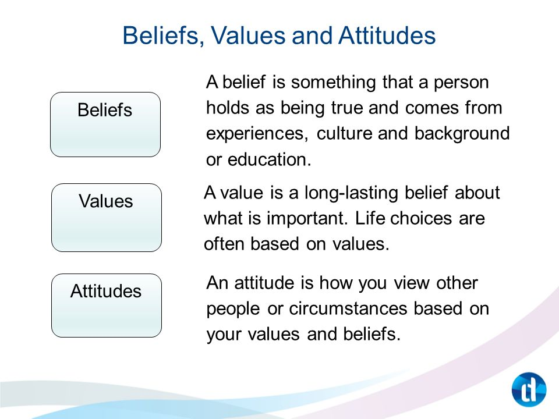

In the article, “The Relationship Between Beliefs, Values, Attitudes and Behaviours”, Kumar, M. (2018), attitudes are defined as a “construct of internal beliefs and value systems”. He goes on to state that “in our various roles, our beliefs, values and attitudes are constantly interacting with those of our peers, friends, family or teachers. We seem to instinctively 'like' the individuals who share our core values and beliefs. Harmonising our value systems is what makes a relationship successful, be it personal, educational, or professional.”
He goes on to argue that only by acquiring the necessary knowledge and skills can one's performance be improved. Our motivation, intention, and engagement with a task can all be influenced by having the correct value and belief systems. We may come across people who appear to have the knowledge and skills to perform a task, but motivation, engagement, and intention to complete the task will only come from a good attitude toward the task.
He further asserts that assumptive constructs that indicate a person's likes or dislikes for something have been termed as attitudes. The 'attitude object' is the subject of an attitude assessment (a person, place, task, event, skill, etc.). Attitude-based judgments might be favourable, negative, or neutral. Attitudes are formed by a set of values and ideas that have evolved over time. Attitudes are formed by a set of values and ideas that have evolved over time. Carl Jung (1971), in his essay on psychological types, defines attitude as "the readiness of the psyche to act or react in a certain way,"
According to Clay-Warner and Robinson (2008), emotions are intense relatively short-lived feelings that affects our behaviours. Emotions, behaviours, and thoughts all contribute to one's attitude. These three components can also be described as the 'ABC' model: affective, behavioural, and cognitive. In the workplace, emotions can affect attitude, consequently affecting productivity and work relationships in the short term, leaving a pathway for development or disengagement in the future if not critically assessed.
According to Kumar, M. (2018), the 'affective' response is one's emotional response to a task or an entity. The 'behavioural' response is the displayed verbal or behavioural tendency to a task or entity, whereas the 'cognitive' response is the cognitive evaluation of the entity based on an internal belief system. Kumar concludes that there is considerable overlap in the semantics of beliefs, values, and attitudes, however, these are also distinct constructs. ( Illustrated below).
Kumar, M (2018), asserts one of the most important truths to take away is that we are at the mercy of our own actions. We ‘assume' attitudes in ourselves and others based on observed behaviour. Someone who is frequently late, for example, may be regarded as disorganised and unreliable. This same person, on the other hand, may be caring for someone who is gravely ill, and their personal time spent providing this care may interfere with their timely arrival at work or school. They may be perceived in a new light now that they have this new information.
Kumar, M (2018), reasons that our judgments will be coloured by our attitudes regarding witnessed behaviour. For example, if someone shows up for an interview in shabby clothing, we may assume they have not taken the time to prepare. If, on the other hand, the person believes that it is by their aptitude and talents that they should be recognised, rather than their looks, this perspective affects their attitude toward dressing smartly and, as a result, their behaviour.
Kumar, M (2018), further states that behaviours can also be deceptive. When a person needs a positive assessment or believes they are being scrutinised for performance, they may demonstrate false deference and ritualistic behaviour. This could indicate a particular attitude, but the observer must distinguish between a genuine attitude and a falsely indicating one.
A person who is continuously fawning and agreeing with everything their superior says may or may not agree, but fawns to get favour. Now, this is a common scenario in the workplace.

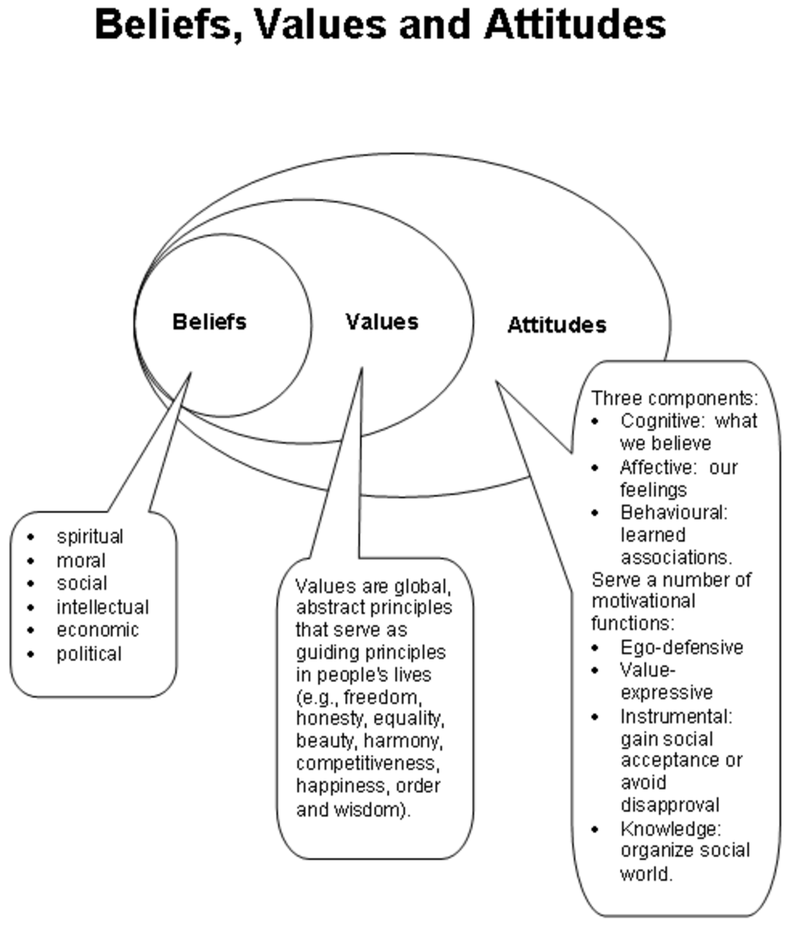
Also, Kumar, M (2018), writes that it is necessary to be aware of capability when analysing behaviour. There have been instances where a person's tone of voice or absence of explicit idioms and phraseology, such as "thank you" and "please," has been seen as "rude." However, if the individual or people being observed have never been taught how to modulate their speech pattern or how to understand the idioms and phraseology of the language they are speaking in, they may not be able to express the appropriate behaviour in the scenario. Those who have the potential to express more suitable behaviour may interpret this as having a "poor attitude."
Kumar, M (2018), concludes that positive attitudes are needed in an individual for them to be motivated and engaged in a task. Attitudes arise out of core values and beliefs we hold internally. Beliefs are assumptions and convictions we hold to be true based on past experiences. Values are worthy ideas based on things, concepts, and people. Behaviours are how these internalised systems of attitudes, beliefs, and values are expressed.
Critical assessment of OWL Financial beliefs, attitudes and value systems and their impact on workplace behaviour during this pandemic.
The core value of OWL Financial is that their advisers should be a pillar of every community by providing quality financial protection advice to anyone who needs it whenever they need it. The OWL Adviser is trusted to help people choose the most appropriate financial products to provide financial stability if life should take an unexpected turn. Clients should be given time to make an informed decision, the OWL adviser should be friendly and answer questions honestly, be professional, helpful, and informative to make the experience stress free for the client. The ideal OWL Adviser candidate is determined and resilient; ready for a new challenge; they are outgoing and active being respected in the community; is inspired and desires to be the best; is friendly and personable being able to make people feel comfortable; is energetic and enthusiastic, keen to learn regardless of experience; confident and optimistic; believes that anything is possible. To check the OWL Adviser’s competency and quality, the adviser is obliged to inform the client that a quality call is going to be placed to them after the appointment to assess the conduct of the adviser.
Thus integrity, professionalism, respect, and excellent interpersonal skills are at the core of the OWL Financial business culture. The training and assessment programmes run throughout the year with controls put in place to ensure that all are carried along and self-improvement is achieved every year. There is also a rewards programme and career path into management roles for those advisers that are interested in managing the performance of others. Overall, the generous compensation and reward schemes motivates all staff and advisers to be the best that they can possibly be.
Because of the Coronavirus pandemic, Critical Thinking has become an evident necessity. Businesses require reasoning and analytical skills to face the uncertainties that have resulted from major shutdowns in various nations throughout the world. Since most employees now work remotely, businesses may have concerns about their employees' critical thinking and abilities if they have not received sufficient training or orientation. (Harvard Business Review ,2019).
At OWL Financial being exposed to authentic and required information is the best strategy to promote critical thinking in the job. The pandemic has sparked a lot of excitement in the media, but many people are being misled. As a result, individually informing team members about pertinent news or via an intranet has ensured that knowledge is successfully disseminated and that the team can make educated judgments rather than being persuaded by prejudices or inaccuracy. Also, information is shared with peers, as this can promote good debates and, as a result, improve their general comprehension of the issue. In addition, teams are encouraged to brainstorm about issues like remote working, digital skills and how to generate sales leads in a pandemic. They come up with solutions which then are used to improve the business process.
Critical thinking, when properly cultivated in the workplace, can help businesses overcome challenges and achieve their goals by employing innovative problem-solving techniques. Organizations can build effective remote work as a team to recover adequately and be ready for post-epidemic business using Critical Thinking, as seen during the recent pandemic.
Application of the critical assessment of an appropriate management theory to evaluate how someone with different beliefs, attitudes and values might interpret the theory differently.
Human Relations Theory
Individual needs and the resulting behaviours of individuals and groups are the subject of Human Relations Theory. When it comes to managing people, it takes an interpersonal approach. It depicts the company as having both formal and informal features. The structure of an organisation is made up of formal elements. Individual interactions are among the organization's more informal characteristics. The organisation is thus a form of social system. Individual job satisfaction and, as a result, individual motivation should be managed using this system. Particular attention is paid to how individuals interact within groups and how this affects group behaviour and performance.
The basic elements of Human Relations Theory are as follows:
- The emphasis is on people rather than machinery or economics.
- The organisational setting is not a structured social setting.
- Human relationships play a significant role in encouraging people.
- Motivation is based on collaboration, which necessitates coordination and cooperation among the participants.
- Individual and organisational objectives must be met simultaneously through human connections within teams.
- Individuals and businesses want to be efficient, meaning they want to get the most out of their resources. Personal and organisational objectives must be met simultaneously through human connections within teams.
- Individuals and businesses want to be efficient, meaning they want to get the most out of their resources.
- The concept of individual motivation is also crucial to comprehending Human Relations theory.
However, this theory's flaw is that it necessitates the acceptance of several assumptions about human behaviour.
Elton Mayo, best known for his contribution to human connection management through the Hawthorne experiments, and Mary Parker Follet, who employed psychological techniques to study the efficient use of people, are two of the most important contributors to Human Relations Theory.
In the Hawthorn experiments, Mayo examined workers' attitudes and psychological responses in the workplace. It started with a look at how different lighting levels affect worker productivity. The research was eventually extended into the early 1930s, and it covered a wider spectrum of labour situations. However, the findings revealed a distinct descriptor of group performance: attention. Regardless of the settings, both the control and experimental groups increased their performance. Individuals perform better when they are given special attention, according to the Hawthorne Effect theory. Other key topics addressed in the study include individual vs. group job performance, employee motivation, and the impact of technology on the workplace.

The findings were as follows:
- Social factors (group dynamics) are significant predictors of job performance and productivity.
- Individual members have their own standards and beliefs, but groups have their own.
- Individuals are not exclusively motivated by monetary rewards; the key predictors of output are the perceived significance and relevance of one's work.
- Instead of command and control, employees desire a cooperative approach from their bosses.
- To understand employee difficulties, communication between management and employees is critical.
- Regardless of the criteria imposed by managers, the workplace culture determines output standards.
Mayo's Hawthorne studies contributed to a better understanding of the roles of group behaviour and individual psychology in management practice.
Mary Parker Follet studied classical management ideas in terms of human factors. Using psychology, she was able to better understand employee interactions and encourage the effective utilisation of people in the workplace.
Follet applied psychology to many areas of the organisational environment in her collection of writings, Dynamic Administration. Her suggestions are below:
- Workers must be able to participate in the decision-making process through established lines of communication.
- Employees want to be a part of the decision-making process rather than being under management's direction and control.
- Working in a group is often more efficient than working alone.
- In an organisation, authority and order should be de-personalized. The basis of power and responsibility in a situation is determined by the circumstances of the situation.
- Managers must incorporate employee participation into dispute resolution to benefit all parties involved.
- It is preferable to have integration amongst departments or groups within a company
However, there are some issues with Human Relations Approach. They are as follows:
- There is a lack of research and data to support relationships that are based on meeting needs and providing fulfilment.
- Managers maintain control due to a fear of management abuse and manipulation.
- There is an issue with the link between employee satisfaction and productivity.
An example of a Program that stress team management and employee involvement is the Scanlon Plan. This Plan integrate leadership, complete workforce education, and widespread employee participation with a performance-based compensation structure. The Scanlon plan is a profit-sharing scheme in which employees partake in pre-determined cost savings in exchange for their efforts.
Disadvantages: A Scanlon plan is difficult to research, organise, and install. Therefore, it is time consuming. Scanlon plans are heavily reliant on the leaders. To be effective, they must be implemented by skilled persons. They must also undertake regular financial analyses to guarantee that the plan is profitable for the organisation.
Advantages: The profit-sharing aspect of Scanlon plans is not just limited to an increased work effort; they also value fresh ideas that can help save money. The company would then receive input or ideas from a diverse group of employees. Intelligent contributions are critical to a company's success. The company has a better chance of getting these contributions if they had a Scanlon plan.

Application of a Critical thinking Method: De Bono’s 6 Thinking Hats
Invented in the 1980’s by Dr. Edward De Bono. Corporations all over the world have used it with a well-defined and explicit Return On Investment. Workers can learn to divide their thoughts into six distinct functions and roles. A colourful symbolic "thinking hat" is used to identify each cognitive role. Workers can effortlessly focus or redirect thoughts, conversations, or meetings by mentally donning and switching "hats."


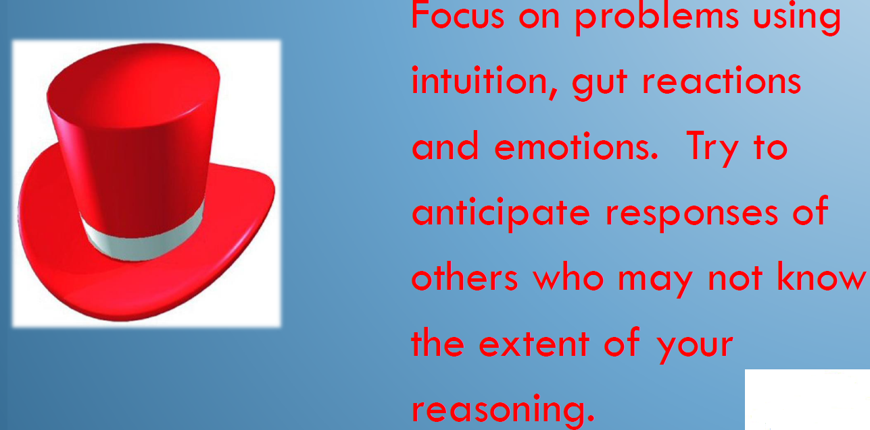
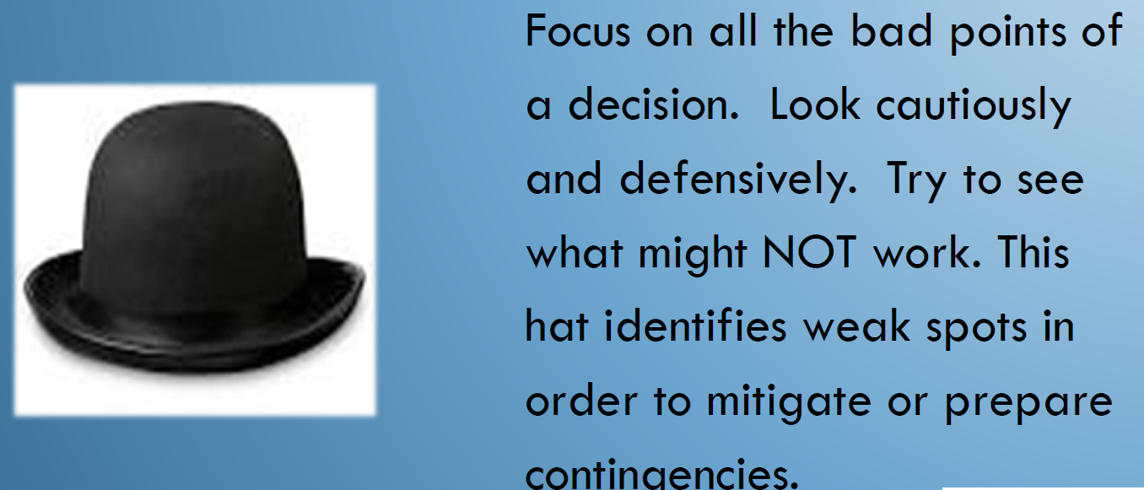

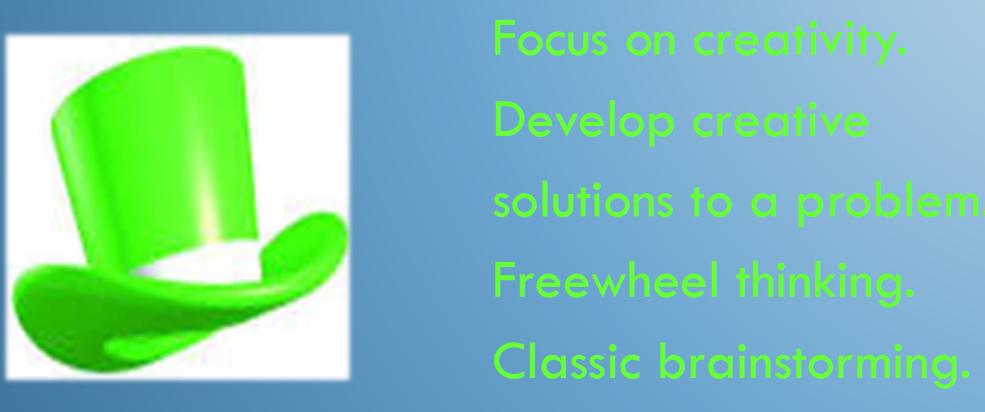
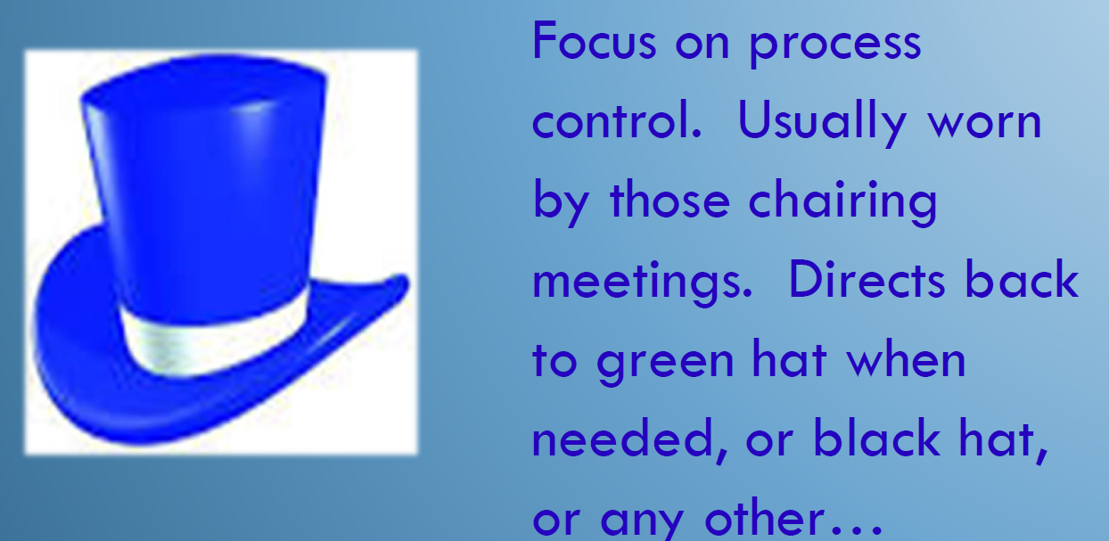

RED model of Critical Thinking
R = Recognise assumptions. It is all too simple to listen to a comment or a presentation and think the information delivered is correct, even if no evidence is provided to support it. Observing and challenging assumptions can help identify information gaps or faulty thinking. We must also investigate assumptions from many perspectives.
E = Evaluate arguments. Analysing information objectively and properly, challenging the quality of supporting evidence, and understanding how emotion effects the issue are all part of the art of analysing arguments. Common roadblocks include favouring information that supports an existing point of view or allowing emotions to get in the way of objective judgement.
D = Draw conclusions. When deciding, it is critical to bring together a variety of data to come to conclusions that logically follow from the evidence. People that can do this are careful not to extrapolate beyond the evidence, and they are willing to change their minds when the data merits it. They are frequently described as having "sound judgement."

Recommendations Post COVID 19: One year after the start of the pandemic, employers have a new challenge in regaining the trust of employees who do not want to return to work. While workplace confidence was a concern prior to the pandemic, the lockdown has made individuals feel more "affected" by some situations. The worry caused by the pandemic, the insecurity of work positions, and the uncertainty of the months ahead are among the reasons. One year later, many executives are faced with the challenge of ensuring comfort, safety, and easing the transition for employees returning to the office after working remotely for a year.
Confidence is a soft skill, a state of mind that evolves through time and, like any other habit, deteriorates when not used. Employees have created new work patterns and lifestyles after working from home for 6-8 months, and this has become their new "normal." Employees will engage more in hard tasks and move outside of their comfort zone if they have a healthy balance.
Employers must take special efforts to ensure trust, safety, and comfort at work for the purpose of rebuilding the confidence lost during the pandemic.
Due to the pandemic, many organisations had to cut their workforces, causing ongoing worry among employees who were concerned about losing their jobs and not being able to find new ones. In several industries, the unemployment rate grew at an exponential rate. As a result, businesses should concentrate on avoiding potentially stressful circumstances and on their employees' well-being. Encouraging the team to speak openly, outline priorities, and reassure the workforce to generate a strong sense of confidence are all ways to do this.
Employees who were productive while working remotely during the lockdown will continue to be productive and perform well in a hybrid approach. This concept combines work from home and work from the office. Higher personal and professional performance can be achieved by striking a good balance between the two working modes.

Conclusion: This report has covered the importance of critical thinking within the organisation that I work for taking COVID-19 lockdown and the attendant shift in ways of working for the organisation. The report also discussed and analysed the difference between beliefs, attitudes, and value systems within a workplace context. In this report, the beliefs, attitudes and value systems and their impact on the workplace behaviour during this pandemic was assessed. In the report, a critical assessment of the Human Relation Management Theory evaluated how someone with different beliefs, attitudes and values might interpret the theory differently. In addition, the critical thinking models - RED model and De Bono’s 6 thinking hats were assessed and applied to the workplace situations during the pandemic.

Bibliography :

A Short Guide To Building Your Teams Critical Thinking Skills, October 11, 2019, Harvard Business Review. (online) available https://www.stramer.com accessed 24.08.2021
How To Hire And Develop Critical Thinkers, April 27, 2017, Forbes. (online) available https://www.stramer.com accessed 24.08.2021
Regaining a Sense of Control at Work Post-Covid, April 2021, Ezra. (online) ) available https://www.stramer.com accessed 24.08.2021
How HR Can Inspire Teams And Rebuild Confidence In 2021, February 2021, Forbes. (online) available https://www.stramer.com accessed 24.08.2021
How Organisations Can Rebuild Confidence, Trust in The Workplace Post-Covid19, October 2020, HRFuture. (online) available https://www.stramer.com accessed 24.08.2021
Covid-19 And The Employee Experience: How Leaders Can Seize The Moment, June 2020, McKinsey&Company. (online) available https://www.stramer.com accessed 24.08.2021
Cerruti, K and Godoski, L 2020 "Five Post-COVID Behaviors(sic) and Attitudes that will Reshape the Workplace" in Workdesign Magazine [Online] Available: https://www.workdesign.com/2020/06/five-postcovid-behaviors-and-attitudes-that-will-reshape-the-workplace/
Kumar, M. (2018) The Relationship Between Beliefs, Values, Attitudes and Behaviours. (online) Available at http://www.owlcation.com. Accessed 25.08.2021
Jung, C.G. [1921] (1971). Psychological Types , Collected Works, Volume 6, Princeton, NJ: Princeton University Press. ISBN 0-691-01813-8
Knowles, M. (1975). Self-Directed Learning. New York: Association Press.

References:

Appendix

