Academic and Employability Skills
Task 2 – Reflective report
Student Name : Melitsa Beyhan Ahmed
Student number :2111603

Contents
Introduction 3
Reflection on Own Knowledge and Experience via Using Gibb’s Reflective Cycle 4
Personal Development Plan (PDP) 9
Conclusion 12
Reference 12

Introduction
The term "reflective report" is used to describe a student's final paper that summarises their critical thinking on a topic (‌Cheah et al., 2018). Contemplation of the challenges encountered during a specific event aids students in developing a strategy for personal growth (Hair et al., 2021). Using Gibb's reflective cycle, I will reflect on my growth and development as a student and professional during the course of this programme. My reflections on the academic report writing for assignment one and the group work for the week eight activity. Finally, I will create a personal development plan (PDP) based on my areas of weakness, as shown via integrating the comments of my peers in the eighth week's exercise.

Reflection on Own Knowledge and Experience via Using Gibb’s Reflective Cycle
One of the most well-known circular forms of reflective leadership, Gibb's reflective cycle consists of six stages—description, emotions, assessment, analysis, conclusion, and action plan—through which people may reflect on their own unique experiences (Wu et al., 2018). The model has six steps that allow users to assess their current level of professional competence, determine where they need improvement, and take the necessary steps to do so (Hanafiah, 2020).
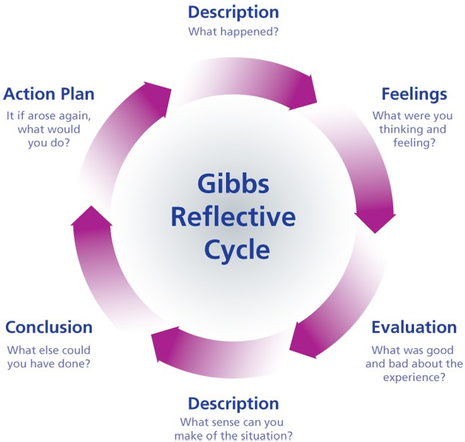
Figure: Gibb's reflective cycle (Fook, 2019)
Description:
The goal of the Academic and Employability Skills module is to help students improve their academic and professional abilities. Academic skills such as research, writing, referencing, reflective and creative thinking, critical analysis, presentation, etc. were the primary emphasis of this module. Skills like communication, teamwork, time management, technology, problem-solving, and decision-making, etc., were also emphasised. The goal of the module was to assist students in developing academically and professionally by enhancing their employability and academic abilities.
Have completed an academic report on the subject of motivation for the first assignment. In this study, I have defined motivation and discussed its many forms, including extrinsic and intrinsic motivation. In this first exercise, I have described the drivers behind the two motivational strands. In the report, I've also highlighted some of the obstacles I've encountered while trying to inspire my team. Finally, I discussed various strategies that businesses may use to inspire their staff.
We gave a presentation for our weak 8 activity. The presentation was a group effort between myself and two other students. Are faculty and students comfortable collaborating through technological means? was the subject of the talk. Together, we were able to finish the presentation on schedule. Our commander mandated that we utilise Emails as our primary means of communication, so that's what we did. As a group, we overcame a snag in the presentation by encouraging and motivating each other to keep writing.
Feelings:
I had my doubts that the Academic and Employability Talents module would be helpful in identifying the academic and employability skills I already have. I was concerned that instructors wouldn't have enough time to get to know their students' strengths and weaknesses and help them improve. Having finished the module, however, I realised that none of my preconceived notions about it were correct. The instructors had paid close enough attention to us and had encouraged us to appreciate the significance of the skills being taught.
In the beginning of Task 1, I was certain that I would need assistance from someone else in order to do it, but as I worked, I began to believe that I could really accomplish it on my own. It was challenging for me to learn about motivation since it is such an important idea that I needed a solid grasp of it in order to complete the assignment. In preparation, I did extensive research on the topic of motivation and discussed its many facets. Now that I have finished the first assignment, I feel like I have more mental bandwidth to devote to improving the sentence structure.
Before we began our group presentation, I wasn't sure how well I was doing in comparison to my teammates. I was worried that I wouldn't fit in with the group and that nobody would help me out. As we continued, we discovered that everyone was helpful and encouraging. We were relieved to have finished the presentation and move on to other things.

Evaluation:
During my time in the Academic and Employability Abilities curriculum, I encountered both helpful and frustrating aspects of learning and using these skills. One of the best things about this session was learning the difference between academic talents and employability abilities. I didn't realise there was a distinction in the abilities until I completed the session. In my experience, my classmates did not assist me in mastering the module's abilities, which was a major setback. Since then, I've known that I had to talk to my instructor whenever I got stuck.
I think it was a good idea to do some research on what drives people to finish Task 1, and I have done just that. In depth knowledge of extrinsic and intrinsic motivation gained via study has aided my understanding of human behaviour. Thanks to these experiences, I now understand the difficulties of staying motivated while working. My inability to do enough research, writing, and citing has been a major setback. As a result, I went through a great deal of pain and anguish while writing the report.
We prepared for the group presentation by learning about tools used for teamwork in schools. It was useful since I learned about the tools they use most often for teamwork, such as WeTransfer, WhatsApp, Emails, and so on. Due to my lack of research ability, I had to endure a lot of pain while attempting to learn about the issue. Even I was unable to master Microsoft PowerPoint. One of my teammates suggested that I work on my presenting, technology, and research abilities.
Analysis:
I found learning about the individual talents to be enlightening since it allowed me to evaluate whether or not I already have them. With this experience, I learned how these abilities may help me advance in my career. The programme allowed me to hone academic and employability abilities that would serve me well as my career progresses. Due to the harm caused by my peers' actions, I see my lack of assistance as a bad experience. I may have gained insight into their skill development had they assisted me. As a result, I would be able to hone my abilities to their fullest potential.

My research for Task 1 has given me a solid foundation in the topic of motivation, and I feel more equipped to write an engaging report on the topic in the future. It's a certain way to boost my academic performance. To top it all off, I'll know just what kind of inspiration will click with the staff at the company where I'll soon be working. As a result, I will be able to inspire people to greater heights of performance, which will allow me to have a positive impact on the organization's bottom line. I had a lot of trouble and wasted a lot of time writing the paper, finding reliable sources, and properly citing them all because of my poor research, writing, and reference abilities.
Thanks to the group presentation, I now understand the many ways in which faculty and students communicate and share files (WeTransfer, Emails, WhatsApp, etc.). Having no prior knowledge of these technologies, this has been a really educational experience. While preparing the presentation, I learned a lot about the technology at play. I, too, have come to see the value of preserving a piece's veracity and scholarly standing. I wasted a lot of time looking for reliable sources due to my lack of research skills. On the other hand, we may have been able to wrap up the presentation sooner as a team. Unfortunately, I was not able to add to the presentation's overall appeal since I lacked the necessary presenting and technological skills.
Conclusion:
After completing this subject, I am more aware than ever of the need of honing both my academic and employability abilities for future success in my chosen fields. I have improved many of the skills necessary for academic and professional success, including reference, research, reflective and creative thinking, and critical and problem-solving abilities. The knowledge I've gained from this course will help me succeed in both my academic and professional endeavours in the future. It has also been clear to me that I need to concentrate on improving my weaker areas, such as my writing, critical thinking, teamwork, communication, time management, and technological competence. I won't ask my friends for aid with problems in the future since I don't want to put myself in harm's way.

Success in my career will benefit from the insights I obtained about motivation in assignment 1 because I will be able to put those insights to use in my current position. I will inspire my staff by using proven strategies that take into account the difficulties we may encounter. This will lead to increased productivity on their part. The process of completing the assignment has helped me become a better researcher, writer, and bibliographer. Putting my abilities to good use will improve the appeal, credibility, and overall quality of my future output.
Making the group presentation was a great opportunity for me to practise working with others, and I'm glad I took it. Working together, we will achieve greater success. Integrity and honesty are two qualities I've learned are crucial to a successful career, and I vow to constantly strive to uphold them in my own endeavours. So that we don't waste time struggling with our study again, I plan to ask for assistance from my classmates and instructor. I want to enlist the aid of my fellow workers in order to master the art of creating visually appealing presentations in Microsoft PowerPoint.
Action Plan:
I plan to enhance my abilities in areas such as writing, speaking, managing time, and using technology. I plan on reading literature and talking to my instructor to learn how to best hone these abilities. I'm looking forward to the training that will provide me with the knowledge and ability to use technology effectively.
My inadequacies as a writer, researcher, and reference were exposed in the first exercise. I want to improve my skill set by concentrating on it. I plan to improve my writing abilities by exercising my ability to construct and present beautiful phrases. To hone my research abilities and ensure that my work is properly referenced, I plan to spend more time searching the internet for reputable sources. Because of this, I will be able to produce higher-quality academic papers in the future.

Personal Development Plan (PDP)
Skills I will develop | Activities I will undertake for developing the skills | Needed assets | Timeline
Communication Skill | -Will be conscious about my body language  -Will brief my speech and talk to the point  -Will choose my words carefully  -Will listen properly before speaking or answering  -Will practice writing business letter, mails and applications  -Will write carefully by following all rules that will make my writing attractive | -Books on how to develop the skill  -Internet  -Online sources that guides how to develop the skill  -Mentor or supervisor to guide me  -Advice and tips from the people who have expertise in the skill  -Self assessment | 05 February, 2023
Research Skill | -Will find out authentic sources on internet to take information  -Will use Books written by scholars  -Will utilize library resources properly  -Will provide references properly | -Books on how to develop the skill  -Internet  -Online sources that guides how to develop the skill  -Mentor or supervisor to guide me  -Advice and tips from the people who have expertise in the skill  -Self assessment | 05 May, 2023
Presentation Skill | -Will choose authentic information  -Will use grammatically correct sentences  -Will use MS Power Point properly  -Will concentrate fully on the presentation | -Mentor or supervisor to guide me  -Advice and tips from the people who have expertise in the skill  -Scope to practice  -Self assessment | 05 July, 2023
Time Management Skill | -Will start working without wasting time  -Will utilize time properly  -Will divide tasks for different time on the basis of their importance  -Will make effective schedule to follow  -Will use technology to make time management easier | -A proper planned schedule  -Guidance on prioritizing tasks  -Advice and tips from the people who have expertise in the skill  -Self assessment | 05 September, 2023
Technology Skill | -Will have training on using technology  -Will concentrate on learning the use of technologies  -Will use different technology to enhance the skill | -Course on using technologies  -Books on how to develop the skill  -Internet  -Online sources that guides how to develop the skill  -Mentor or supervisor to guide me  -Advice and tips from the people who have expertise in the skill  -Self assessment | 05 November, 2023

Reference
‌Cheah, J. H., Memon, M. A., Chuah, F., Ting, H., & Ramayah, T. (2018). Assessing reflective models in marketing research: A comparison between pls and plsc estimates. International Journal of Business & Society, 19(1).
Fook, J. (2019). Reflective models and frameworks in practice. Methodologies for practice research: Approaches for professional doctorates, 57-76.
Hair, J. F., Hult, G. T. M., Ringle, C. M., Sarstedt, M., Danks, N. P., & Ray, S. (2021). Evaluation of reflective measurement models. In Partial Least Squares Structural Equation Modeling (PLS-SEM) Using R (pp. 75-90). Springer, Cham.
Hanafiah, M. H. (2020). Formative vs. reflective measurement model: Guidelines for structural equation modeling research. International Journal of Analysis and Applications, 18(5), 876-889.
Wu, L., Chen, Z., Long, C., Cheng, S., Lin, P., Chen, Y., & Chen, H. (2018). Parameter extraction of photovoltaic models from measured IV characteristics curves using a hybrid trust-region reflective algorithm. Applied Energy, 232, 36-53.

