Therapy Assistant Practitioner:
Demonstrating Practice Logbook



This logbook was completed by:

Mentor’s name: Anna Belotti Mentor’s signature: …Date: …9/2/26……………

Learner’s name: Marian Morris Learners’ signature: M E Morris Date: …9/2/26…………….

The content page includes a list of evidence to be collected as part of your portfolio:

- Log of supporting documents: | Details to include (including criteria): | Date of completion: | Mentors signature: | Appendix / page
- An observation of your practice | A supporting document from your mentor of your compliance with person centred practice (1.2 & 4.3). | 9.2.26 |  | Appendix 1  Page 3
- Evidence of reading and learning related to role | A minimum of 2 examples of your engagement with researching and learning on topics related to your role (8.4). | 9.2.26 |  | Appendix 2  Pages 4-5
- Log of a wide range of assessments. | A minimum of three anonymised assessments completed by you, demonstrating a range of skills and tools (1.2). | 9.2.26 |  | Appendix 3  Pages 6-14
- Copy of a recent Personal Development Appraisal Review (PDAR). | A copy of the most recent PDAR document completed with supervisor / mentor (8.1 & 8.3). | 9.2.26 |  | Appendix 4  Pages 15-22
- Copies of your recent supervision records. | A minimum of two supervision records, demonstrating attendance and contribution to supervision and agreement to actions (4.2). | 9.2.26 |  | Appendix 5  Pages 23-28
- A copy of a risk assessments you have undertaken | A formal or informal risk assessment that you have completed. This can be a case note entry, DATIX, incident report or an assessment completed due to risks (such as a falls risk assessment) (4.3) | 9.2.26 |  | Appendix 3  Pages 13-14  Appendix 6  Pages 29-32
- Examples of any training you have participated in or delivered | A minimum of five examples of evidence that you attended or delivered training within the last 12 months (8.4). | 9.2.26 |  | Appendix 7  Pages 33-35
- Evidence of your compliance with mandatory training | A minimum of 5 examples of your mandatory training compliance over the past 12 month (4.1). | 9.2.26 |  | Appendix 8  Page 36
***The following pages are where you can start to include your evidence:
Appendix 1(Page 3) (to be completed by your mentor) - Supporting document:
Give a brief description of your relationship with the learner and a typical activity that you have overseen the learner complete:
My Name is Catherine Jones Occupational Therapist B6, I work alongside Marian Morris every 9 weeks when working a weekend.
Marian and I completed a washing and dressing assessment with a patient who had recently had a left Corona Radiata Infarction. Marian has a wealth of experience, adapts her practice to meet the needs of her patient. Her warm compassionate nature puts the patient at ease and supports the building of professional relationship. Marian practices in the best interest of the patient demonstrating client centred approach to support patient to attain person centred goals. Marian is confident and competent and educates patients on techniques/exercises to promote safety and independence when completing tasks.
Does the learner demonstrate the following performance in their day to day practice: | - Yes | - No | - N/A | Signature
- Person-Centred Practice
- Actively listens to patients/carers to understand goals and concerns | Yes |  |  | CLJones
- Adapts communication style to meet patient needs (such as cognitive, language, sensory) | Yes |  |  | CLJones
- Respects patient dignity, respect, and personal preferences | Yes |  |  | CLJones
- Involves patients in decision making and provides clear explanations | Yes |  |  | CLJones
2. Professionalism & Accountability | Yes |  |  | CLJones
- Arrives prepared, punctual, and appropriately presented for the clinical task. | Yes |  |  | CLJones
- Follows organisational policies, procedures, and scope of practice | Yes |  |  | CLJones
- Accurately reports and escalates clinical concerns to qualified therapists | Yes |  |  | CLJones
- Accepts responsibility for actions and learns from feedback | Yes |  |  | CLJones
- Maintains appropriate boundaries and therapeutic relationships | Yes |  |  | CLJones
3. Safe & Competent Clinical Practice
- Delivers treatment sessions as prescribed by supervising clinicians | Yes |  |  | CLJones
- Demonstrates safe handling, mobility, and equipment use | Yes |  |  | CLJones
- Uses standardized assessments correctly and ethically | Yes |  |  | CLJones
- Identifies and reports risks (falls, safeguarding, deterioration, environmental hazards) | Yes |  |  | CLJones
- Documents interventions and outcomes accurately and timely | Yes |  |  | CLJones

Appendix 2 (pages 4-5): This section includes two examples of recent reading and learning I have undertaken.

Age–Related Macular Degeneration (AMD)
Below is an abstract on age-related macular degeneration (AMD). I researched this condition in greater depth after being allocated a patient diagnosed with AMD, as I wanted to better understand the disease and its implications for patient care.
AMD is a condition that affects the retina, specifically the macula. The macula is responsible for sharp, central vision, which is needed for tasks such as reading, driving, and recognising faces. AMD usually develops gradually and often starts with small changes in the retina, including a build-up of fatty deposits called drusen. Depending on the type of AMD, vision loss can happen slowly (dry AMD) or more quickly (wet AMD). Although AMD does not cause total blindness because peripheral vision is usually preserved, it is the leading cause of sight loss in the UK and mainly affects people over the age of 50. Risk factors include ageing, family history, smoking, an unhealthy diet, high blood pressure, and obesity. AMD is diagnosed through detailed eye examinations and imaging tests such as optical coherence tomography (OCT) and fluorescein angiography. There is currently no cure, but treatments can help slow the condition. Wet AMD is often treated with anti-VEGF injections, while dry AMD is managed with lifestyle changes and nutritional supplements. With the right support, including vision aids, rehabilitation services, and regular monitoring, many people with AMD can remain independent and maintain a good quality of life.
Reference
Macular Society (2025) What is macular degeneration? Available at: What is macular degeneration? Causes, symptoms and treatment options - Macular Society (Accessed 12 December 2025).

Abstract on Lumbar Spinal Stenosis
Below is an abstract on lumbar spinal stenosis. I researched this condition in greater depth after being allocated a patient diagnosed with lumbar spinal stenosis, as I wanted to better understand the disease and its implications for patient care.
Lumbar spinal stenosis is a condition where the spinal canal in the lower back becomes narrower over time. This narrowing can put pressure on the spinal nerves, leading to pain, nerve symptoms, and difficulty with movement. This is mainly caused by age-related changes in the spine, such as wear and tear from osteoarthritis. It mainly affects people over the age of 50, although some people are born with a narrower spinal canal or develop it due to other spinal conditions. Common symptoms include lower back pain, pain or tingling that spreads into the legs (often called sciatica), numbness, weakness, and reduced mobility. In severe cases, lumbar spinal stenosis can lead to cauda equina syndrome, which is a medical emergency. This can cause loss of bowel or bladder control and severe nerve problems. Diagnosis is usually based on a physical assessment, X-rays, CT scans, or MRI scans. There is no cure for spinal stenosis, but symptoms can often be managed well with treatments such as physiotherapy, pain relief medication, lifestyle changes, and, in some cases, surgery. These treatments can help improve function and quality of life.

Reference
John Hopkins Medicine (2025) Lumbar Spinal Stenosis. Available at: Lumbar Spinal Stenosis | Johns Hopkins Medicine (Accessed 12 December 2025).

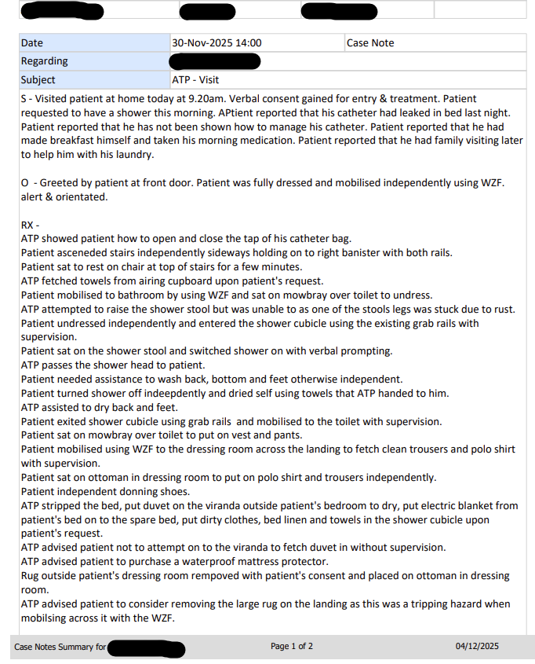
Appendix 3 (pages 6-13): This section provides evidence of four assessments I completed with three different patients, all of which correspond to the reflections included in Assignment 1. The assessments comprise a shower assessment (documented as a case note), a Tinetti balance assessment, a community therapy assessment, and a bed lever risk assessment.

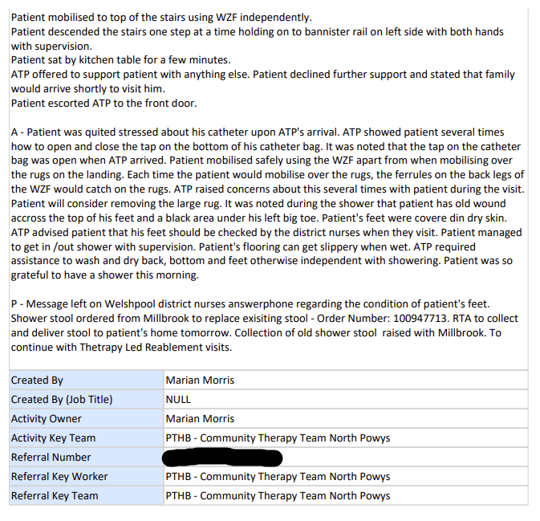

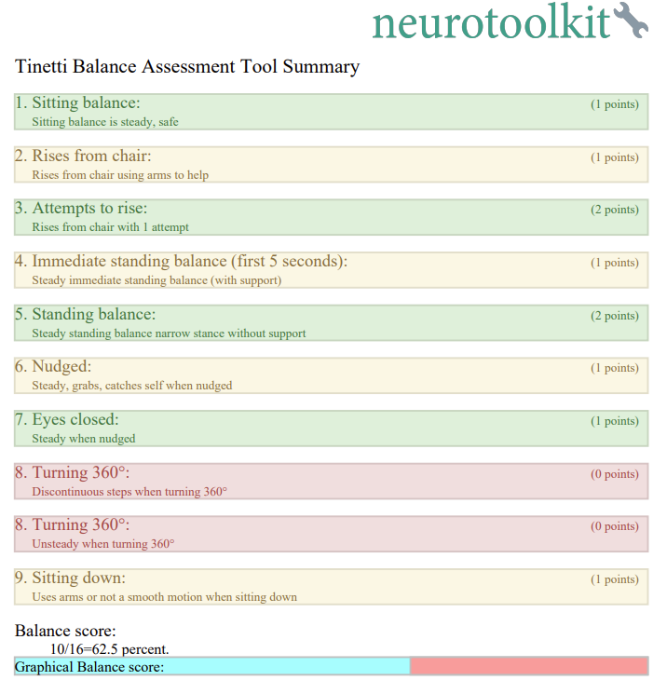
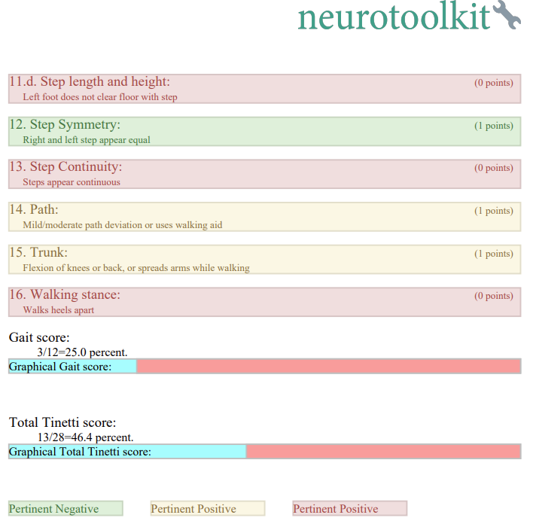
Below is a Tinetti balance assessment.

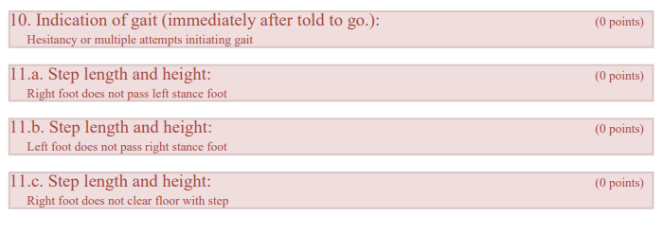
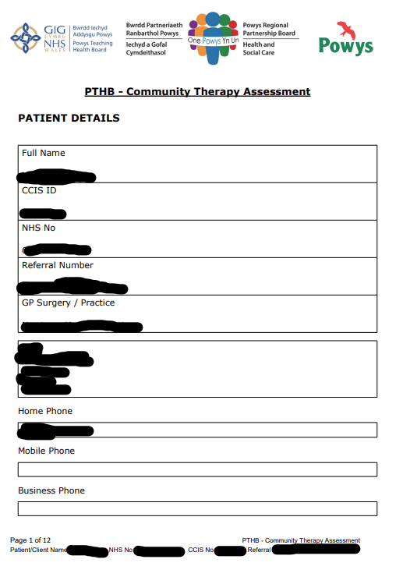
Here is a community therapy assessment.
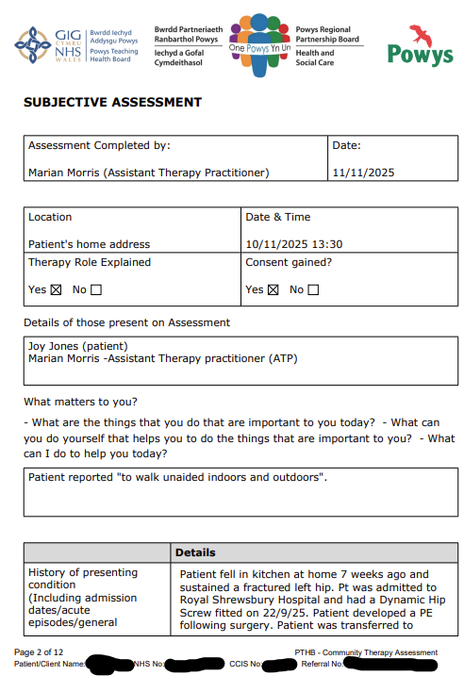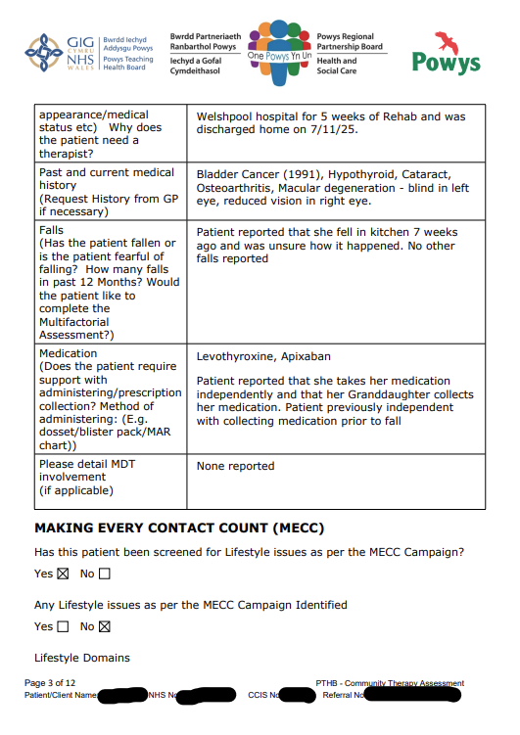

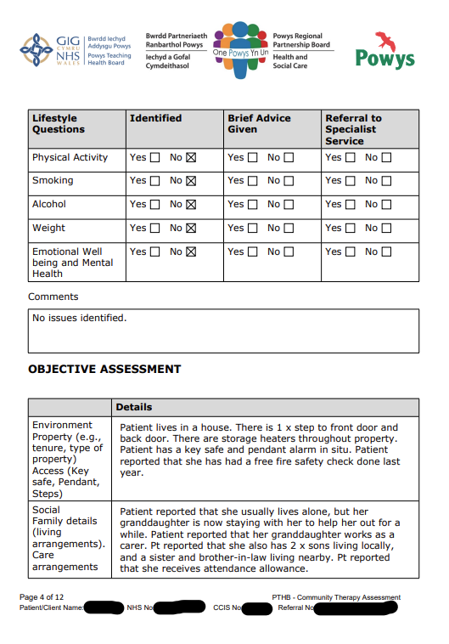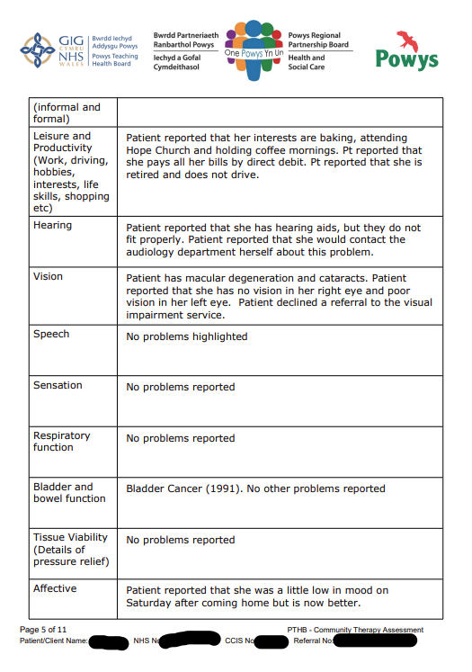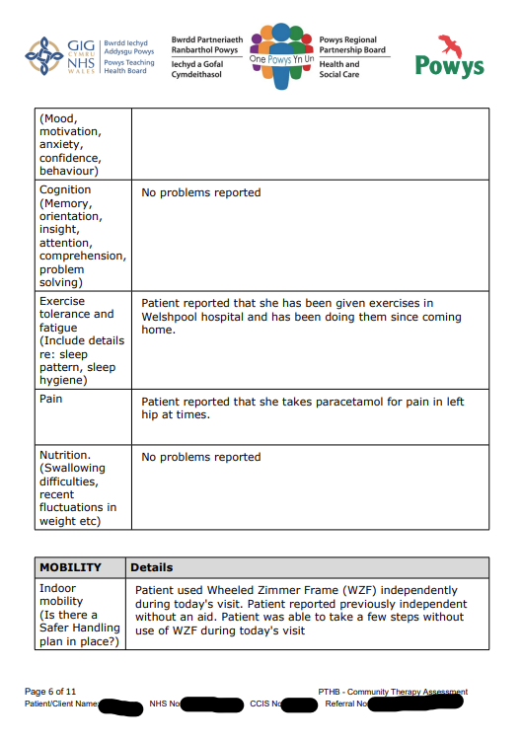

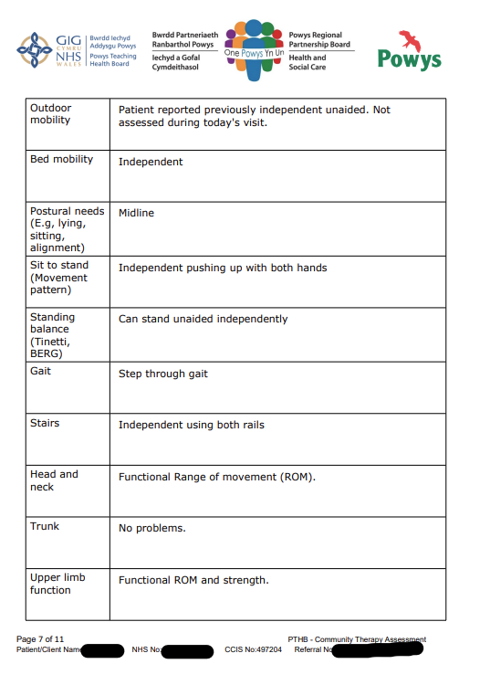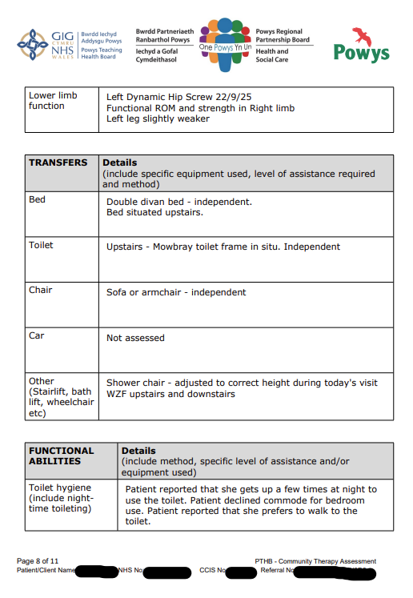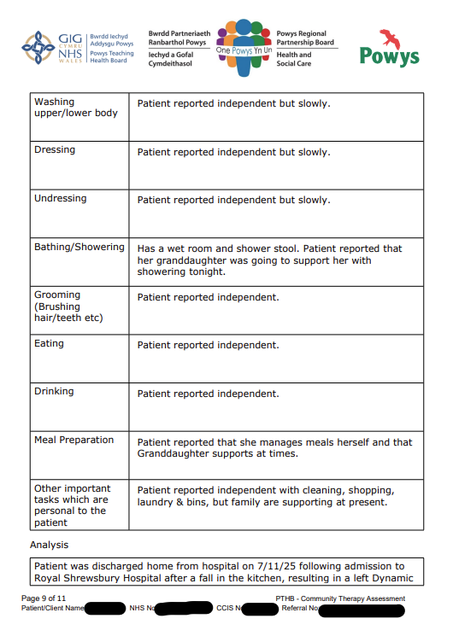
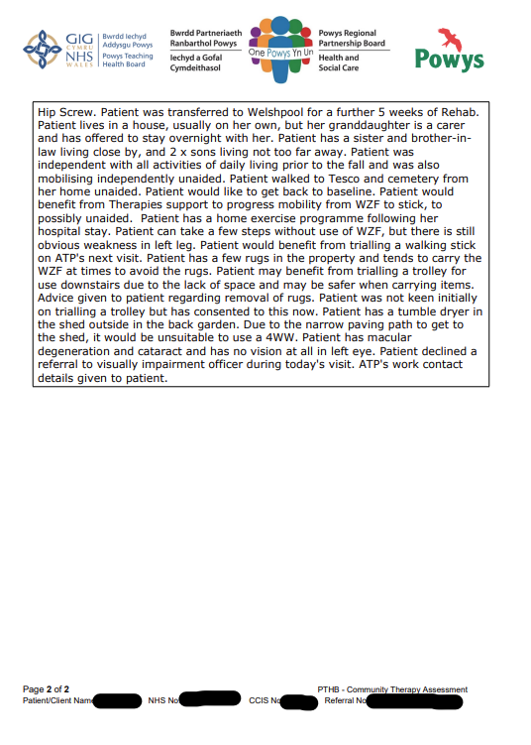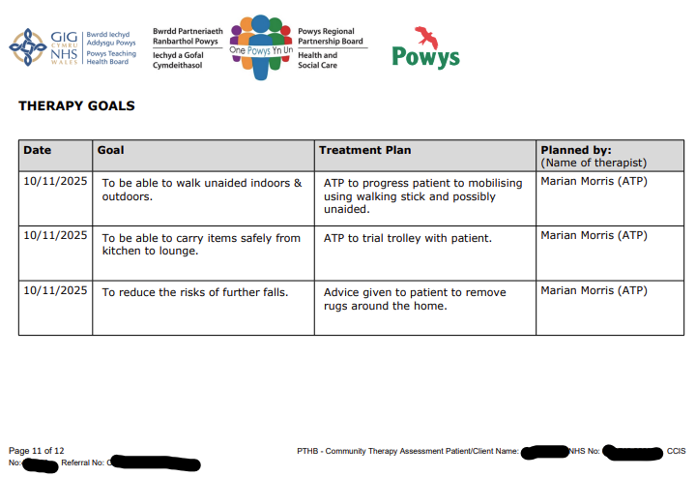

Here is a copy of a bed lever risk assessment.

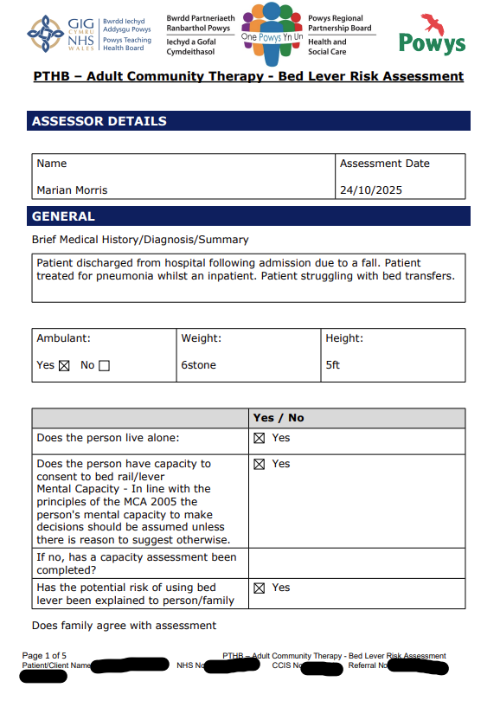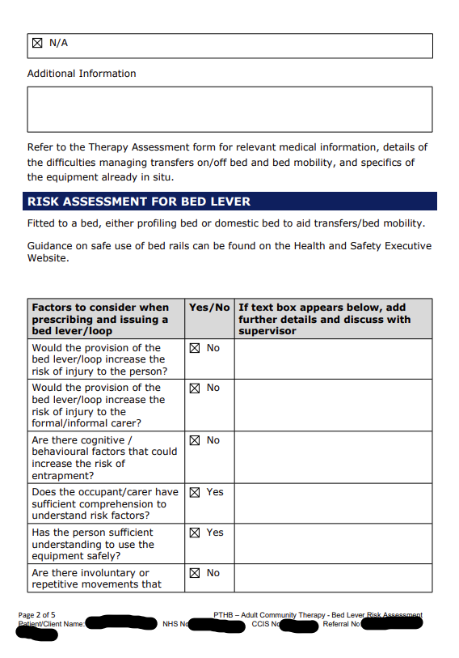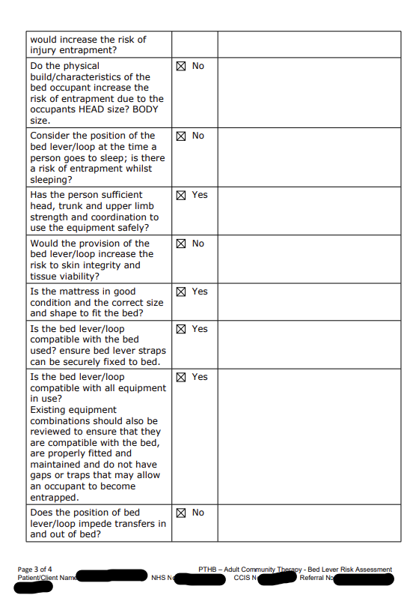
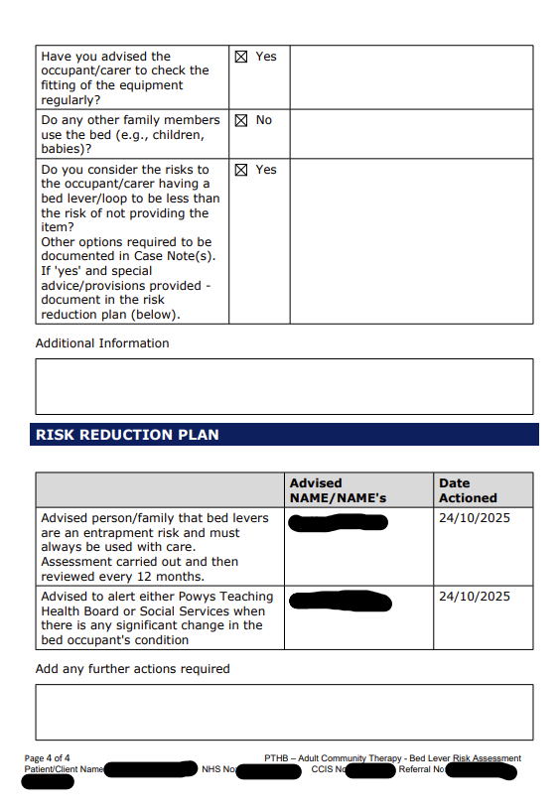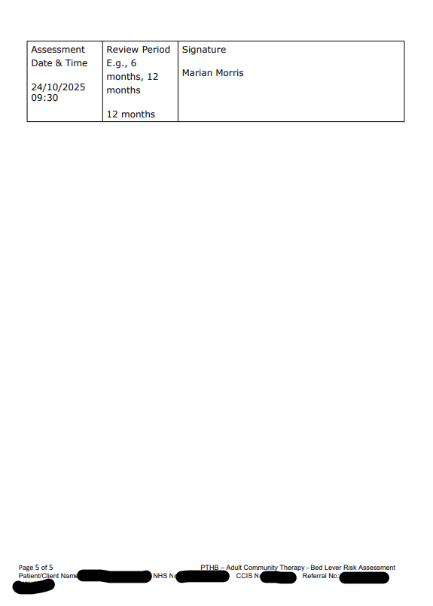

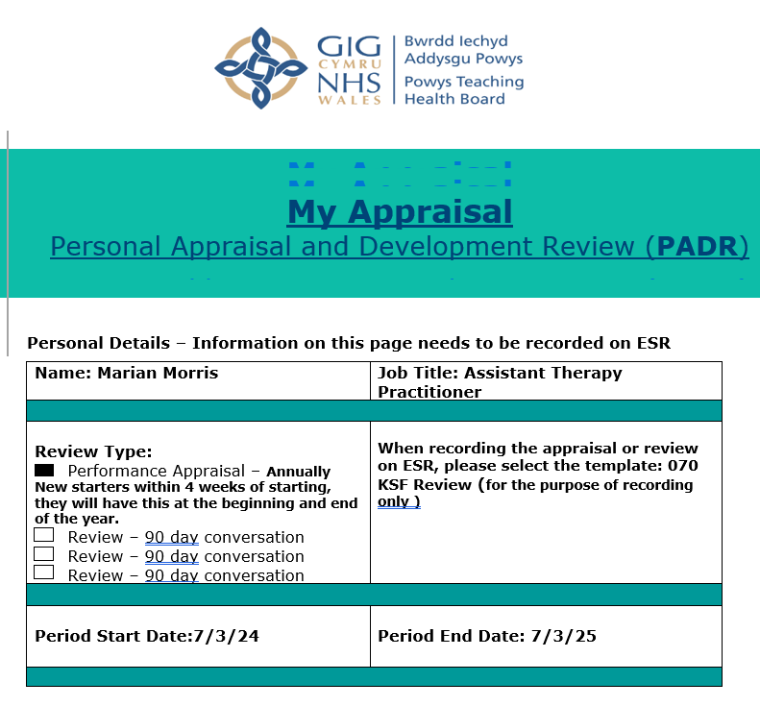
Appendix 4 (pages 15-22): This is copy of my recent completed PADR.

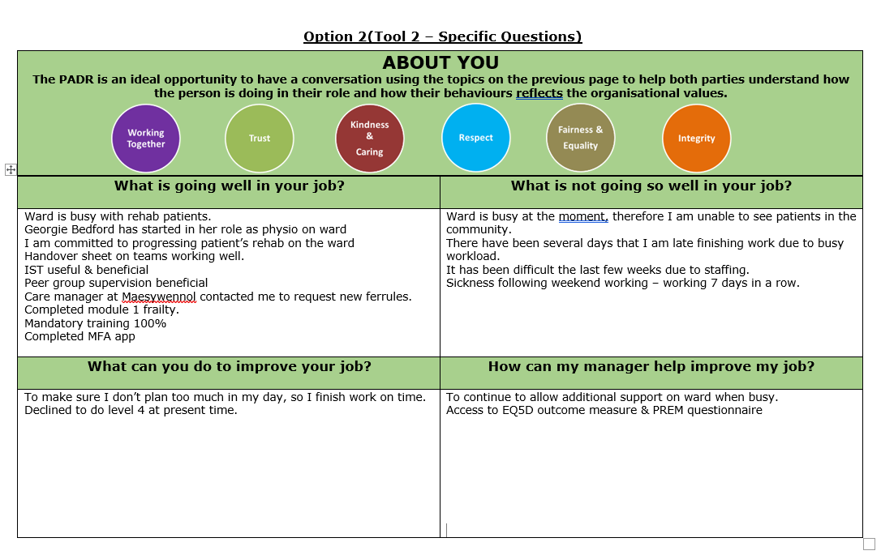
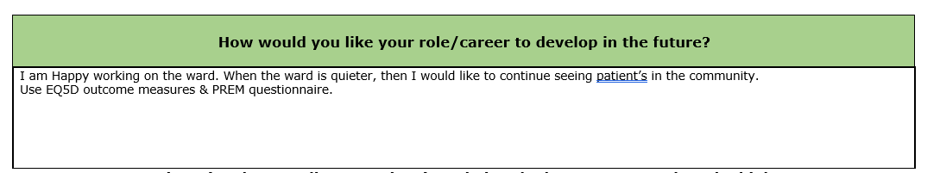

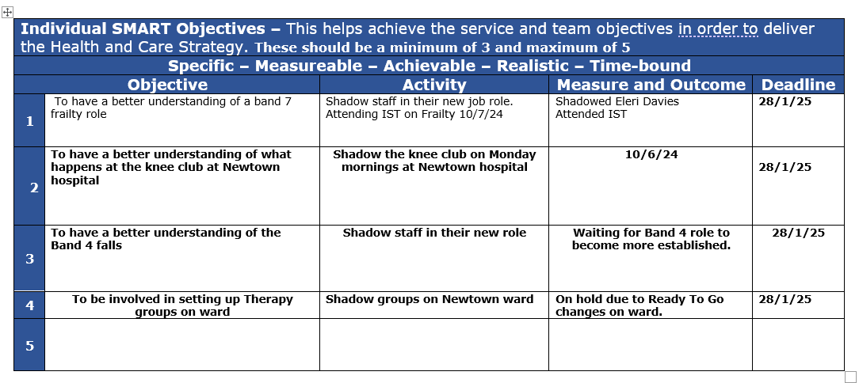
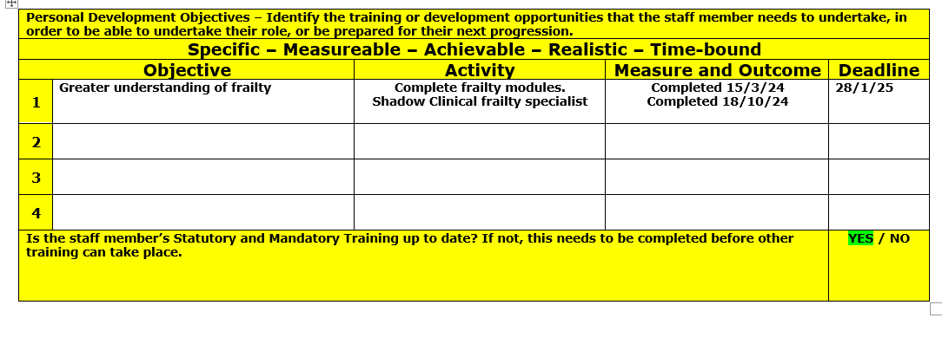
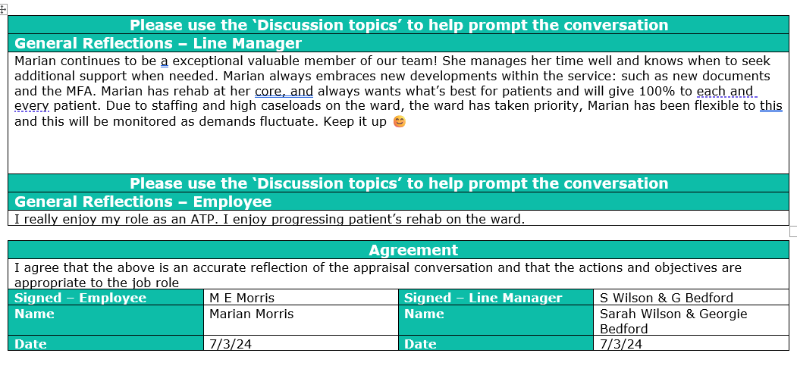

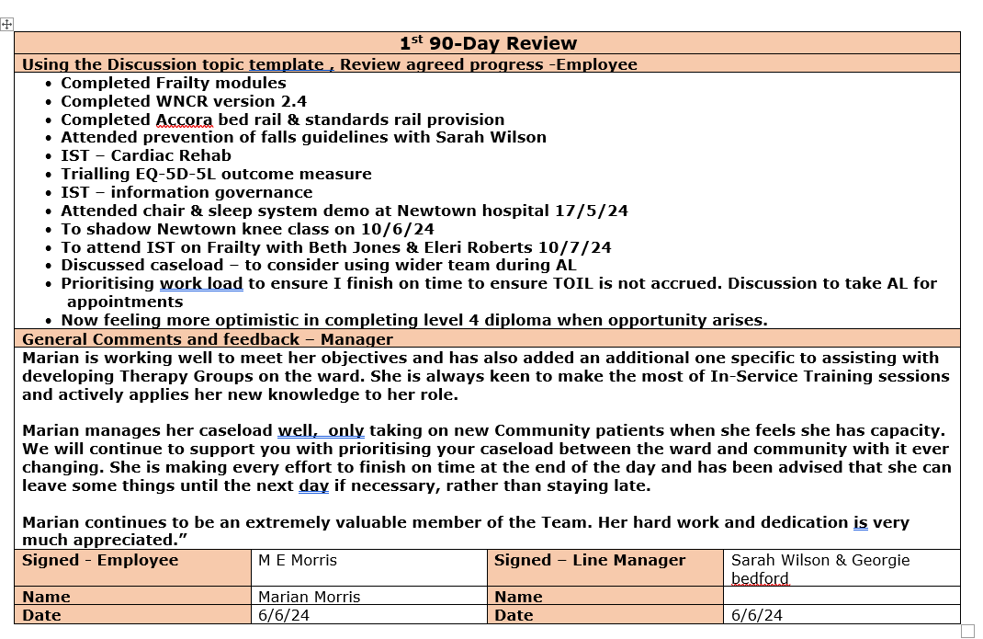
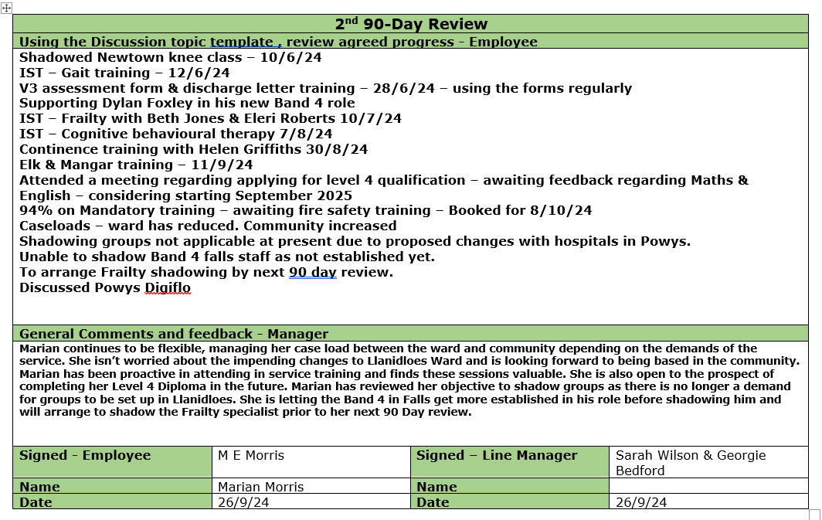
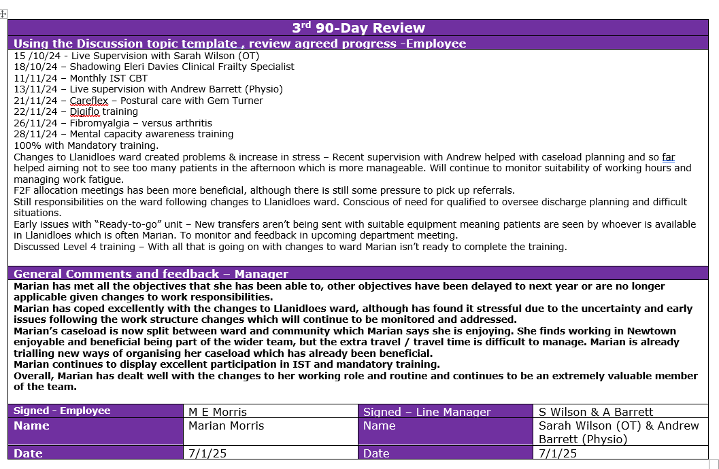
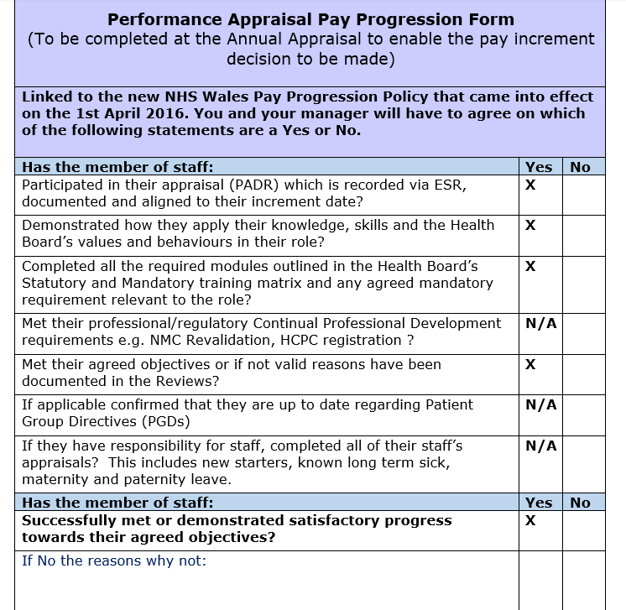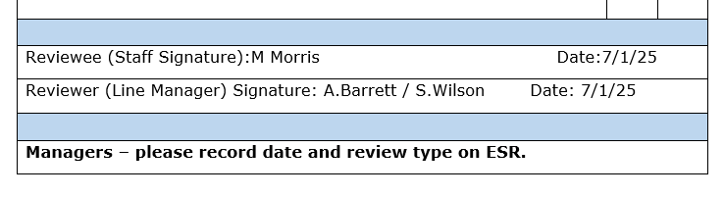
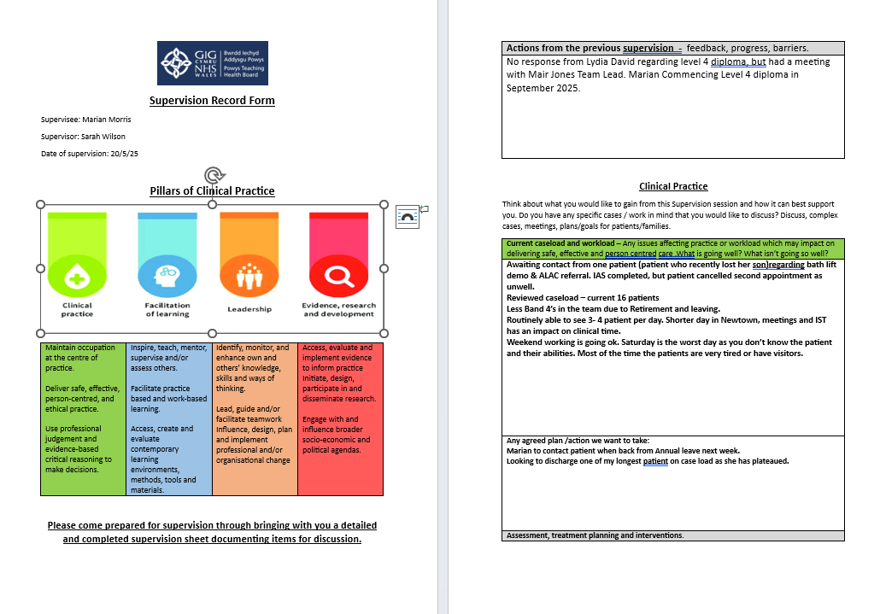
Appendix 5 (pages 23-28): These pages provide evidence of my individual supervision record and peer group supervision documentation.
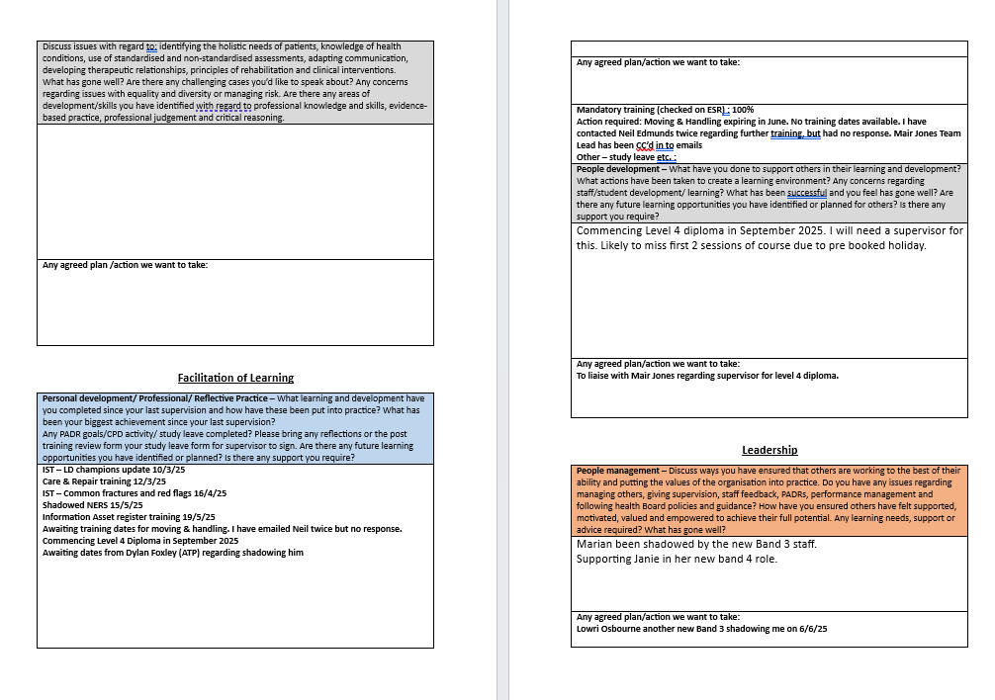
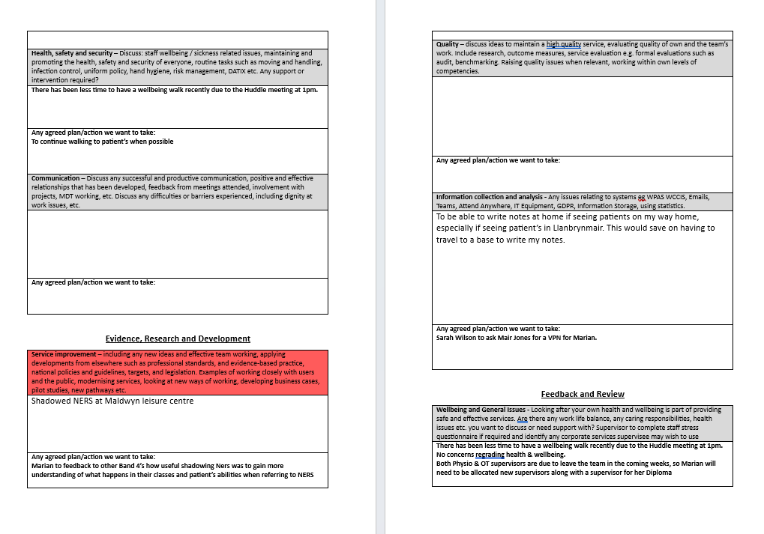
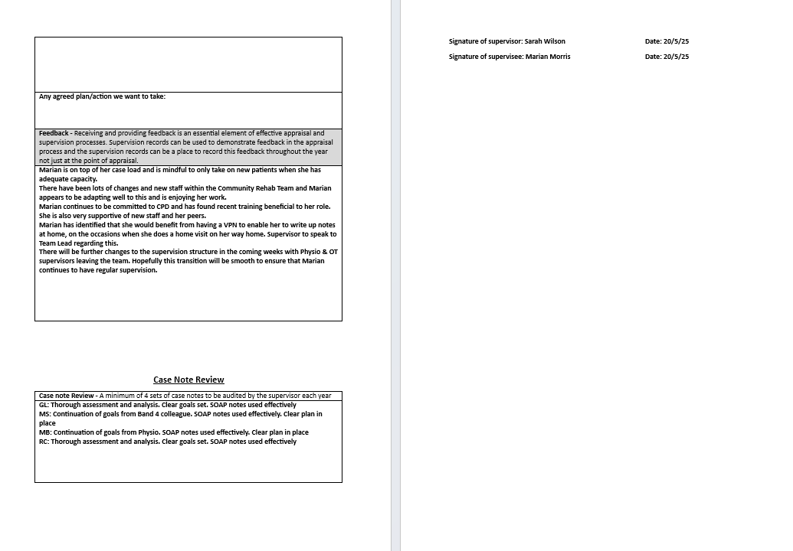
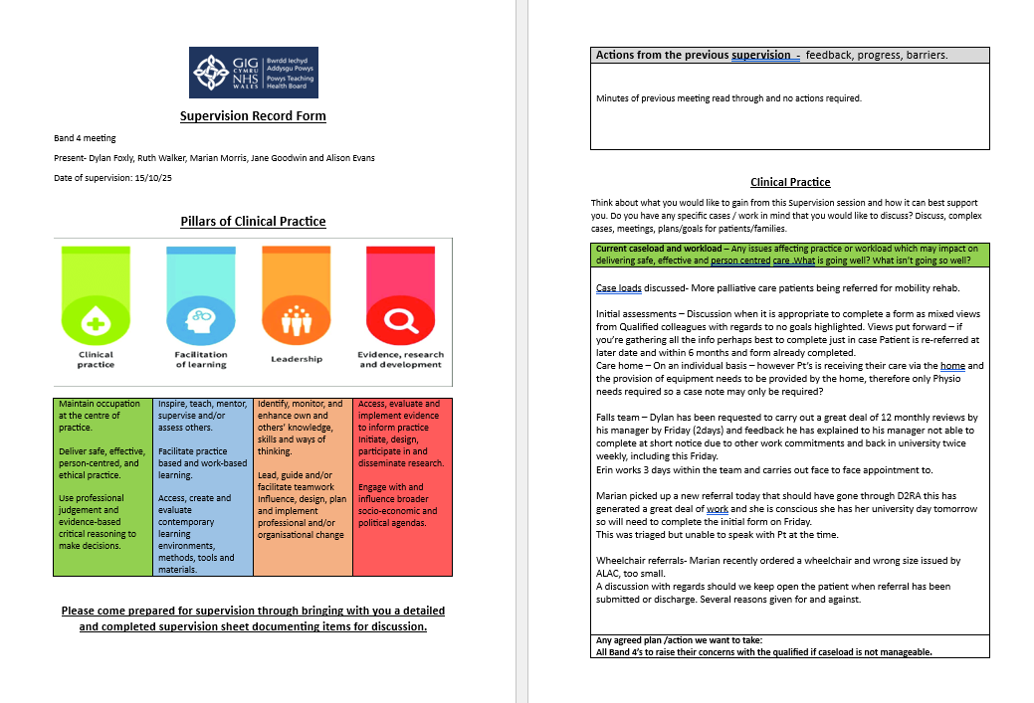
Below is a copy of my peer group supervision record form.
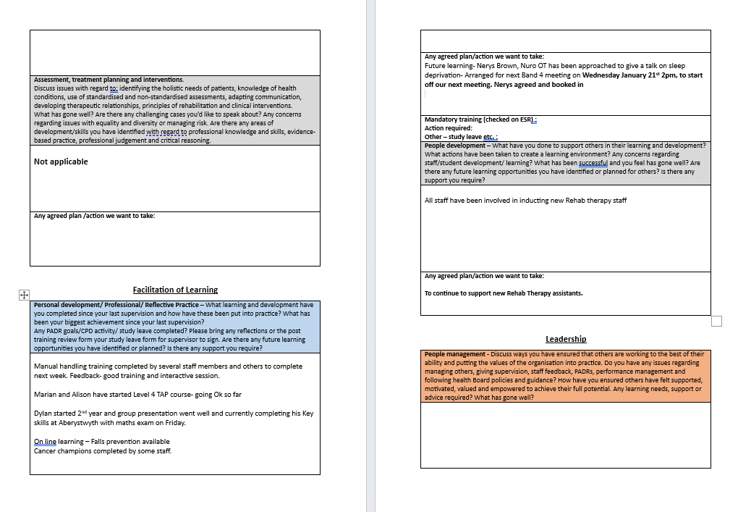
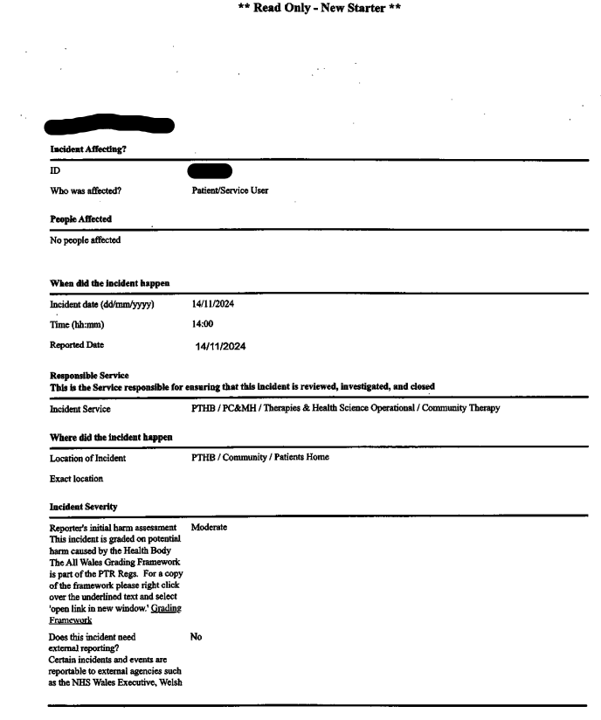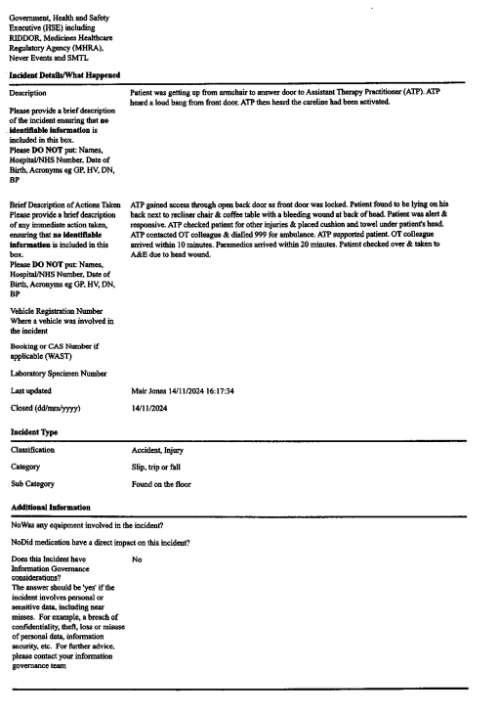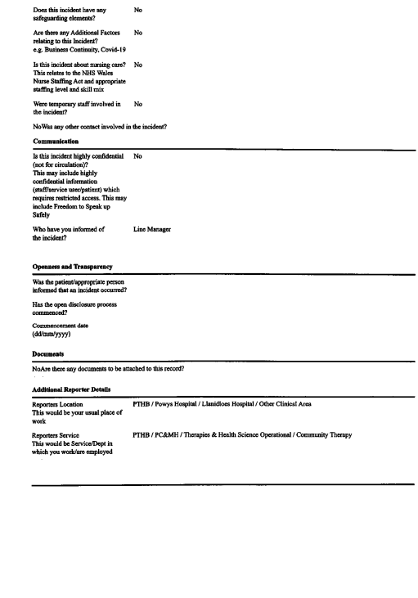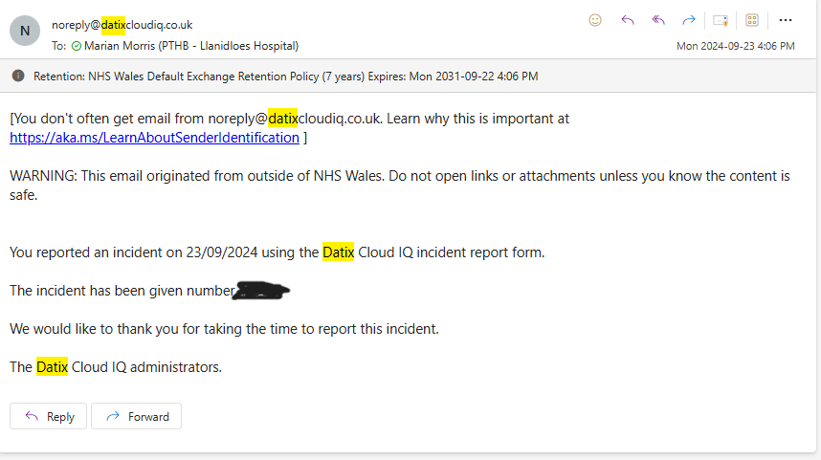
Appendix 6 (pages 29-32): This section includes supporting documentation relating to three Datix reports I submitted during 2024.

This is a copy of the receipt confirming submission of the Datix report I submitted.
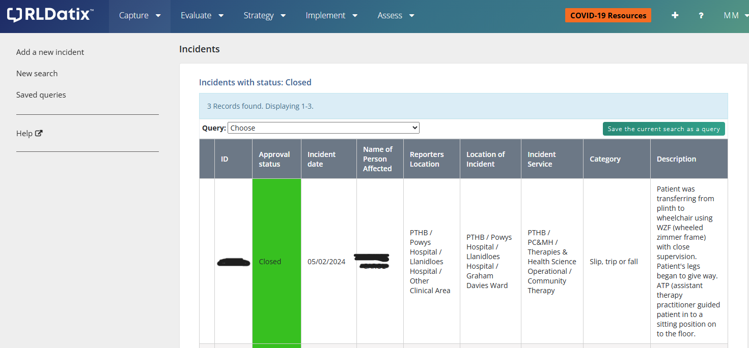

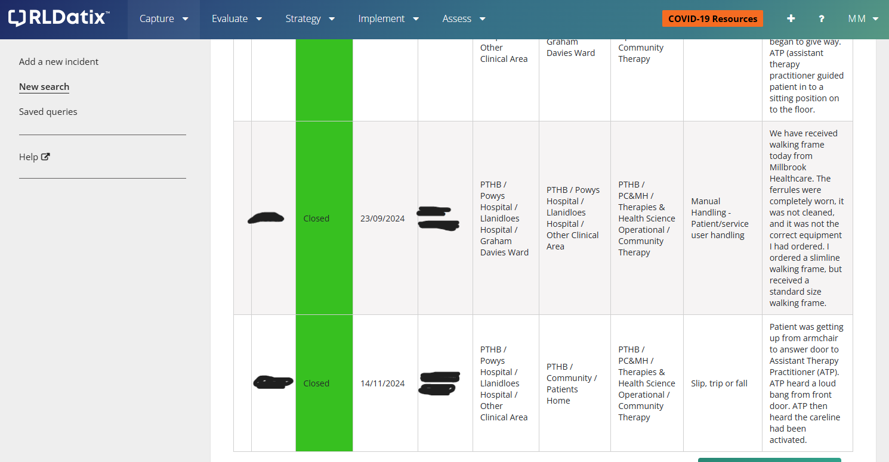

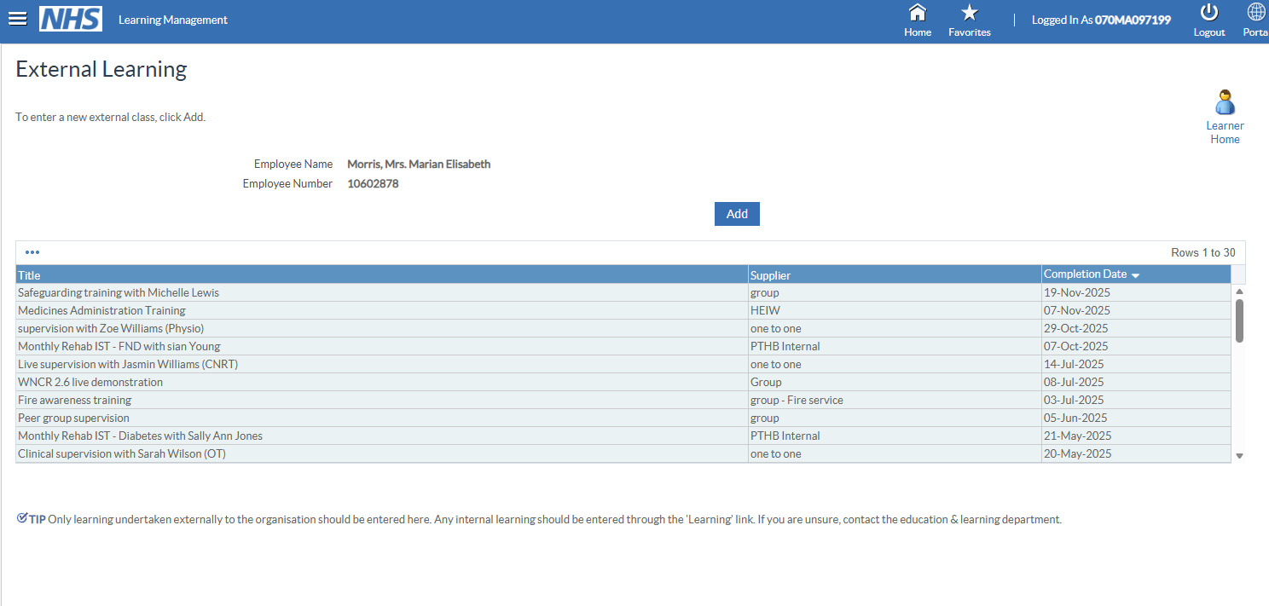
Appendix 7(pages 33-35): This section shows evidence of training I have participated in the last year. The training has been highlighted in yellow for ease of clarity.

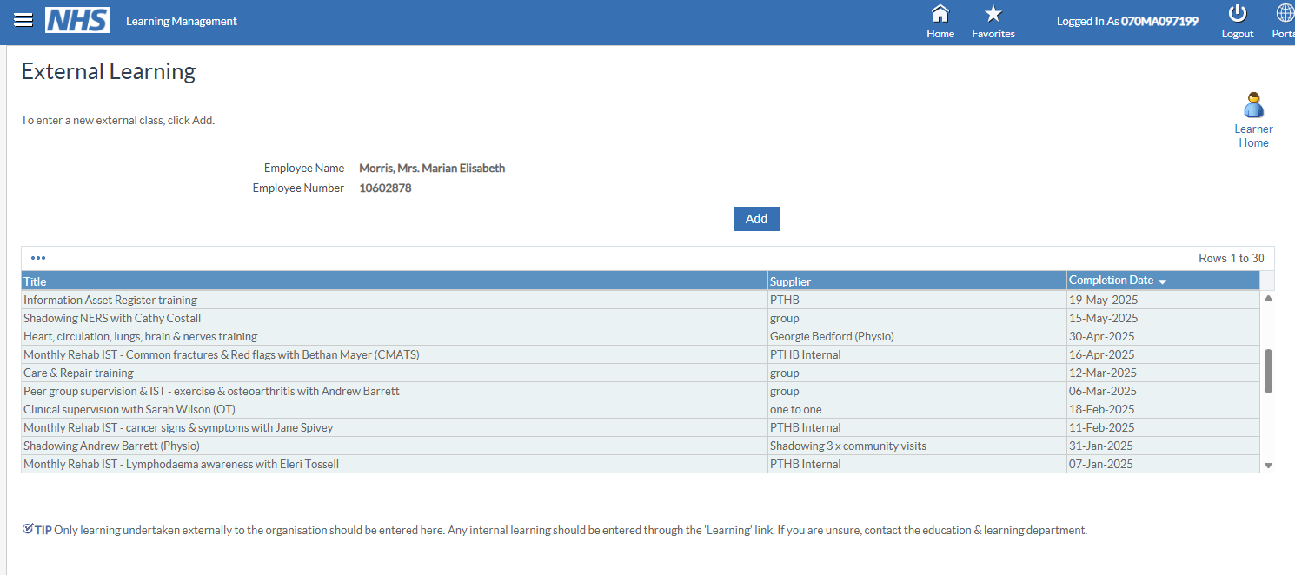

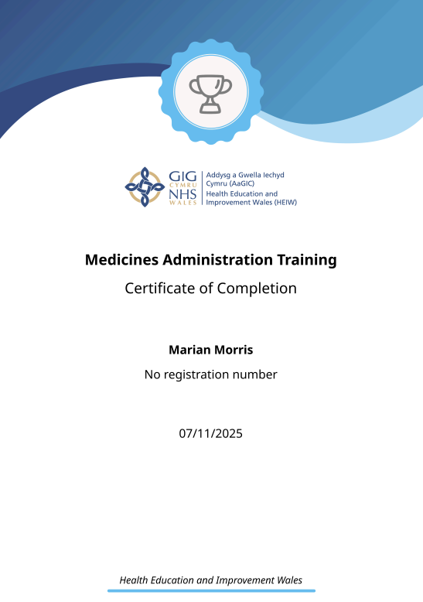
This is a copy of my medicines administration training certificate.
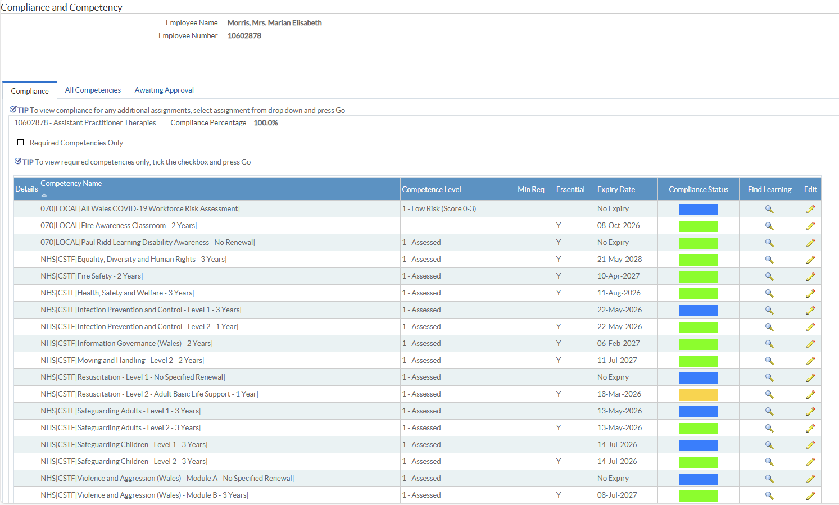
Appendix 8 (page 36): This page shows my compliance with mandatory training taken from my Electronic Staff Record (ESR).

