

Task 1 – Reading Task Template
Upload your photo of your A3 in-class notes here:
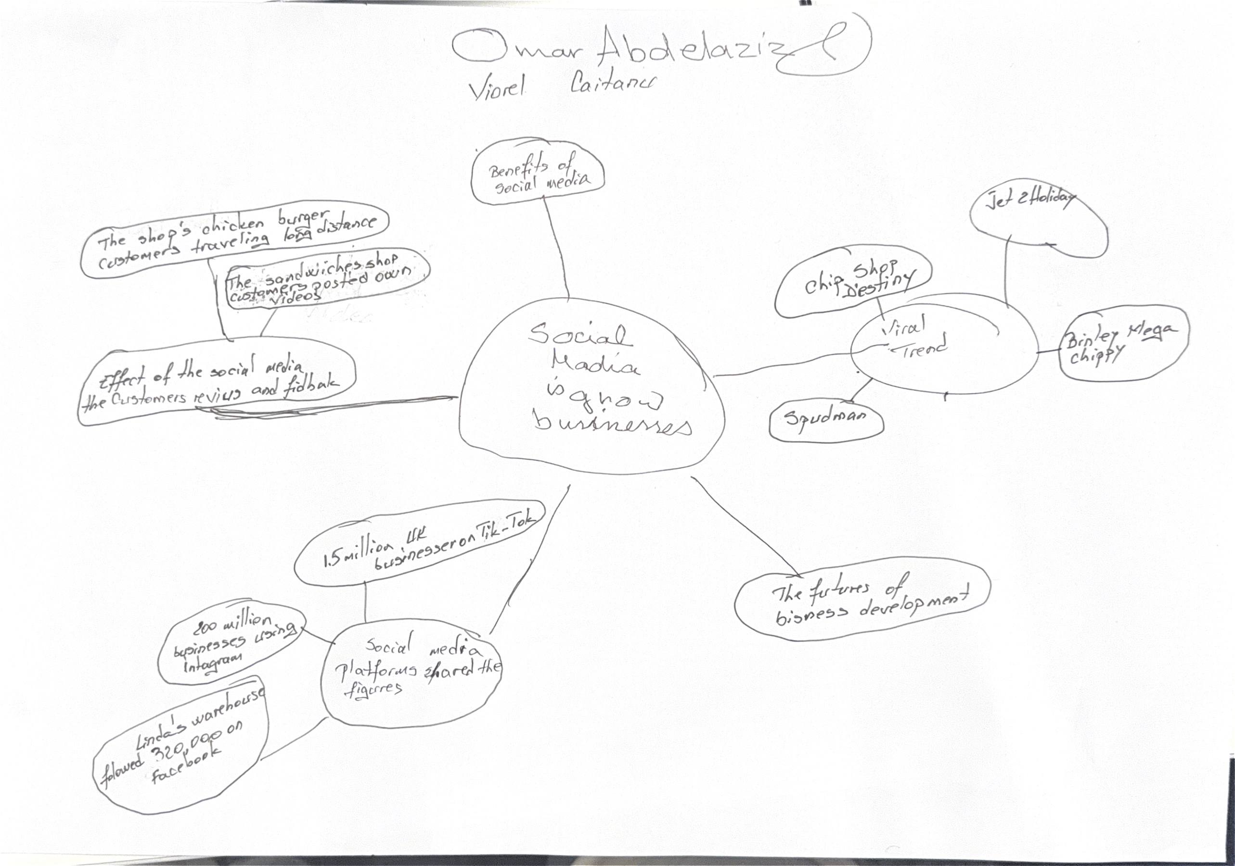

1. Answer these questions using the sentence starters below
a. What is the main idea of the text?
The main idea is that the effect of social media in business success
b. What are two key points?
One key point is how the social media viral trend -for example Tik Tok, Instagram and Customer reviews.
Another key point is Business growth -for example More Sales. higher profits and new opportunities
c. What part of the text did you find most important? Why?
The most important part is the introduction of the article which gives in some opinions of business owners and employees because it shows that social media helps small businesses to become successful by attracting many new customers which main increasing sales and profits.
d. Was anything unclear or difficult to understand?
I was not sure about some paragraphs in the article because the idea wasn’t clear enough
e. How did your group help you understand the text better?
My group helped me by discussing with the group and making the mined map and sharing different opinions regarding the important ideas in the article beside teamwork is important to understand easily the article.

3. One sentence reflection.
Predicting, skimming and scanning is important to understand, evolute and solve the cases.

Question: What did you find challenging about this task? Reading and writing notes about the task and as well sharing ideas and drawing the mined map to make conclusion for main idea and other important ideas
The hardest part was to read all article to determined main idea, important ideas and evidence with figures

