Nathan Price (1700540)

M4X02101
Academic & Industry Skills
Review of Industry Skills
Travel & Tourism Industry

Executive summary
This report details the skills required to succeed in any workplace; with specific detail regarding skills necessary to work in the tourism industry. Skills such as communication, problem-solving and many more are classified under basic skills, while job advertisements from positions in the tourism industry are analysed. An outlook into the specific skills needed to work as a holiday representative and travel agency manager are provided and discussed regarding importance and usefulness in the ever-growing industry.

Contents
Executive summary 1
Introduction 3
Content analysis 4
Discussion 5
Foreign languages 5
Resilience 5
Enthusiasm 6
Conclusion 7
References 8
Appendices 9

Introduction
The tourism sector is a vast industry that has been one of the fastest growing in recent years. Back in 2013, VisitBritain formulated a report stating that 3.1 million individuals worked within the industry, a total of 9.6% of all jobs within the United Kingdom (VisitBritain, 2013). However, it’s not only in the UK where the tourism industry thrives, with more individuals exploring the globe each year, leading to further employment in tourism industry sectors such as entertainment, food and beverage, accommodation, transportation and ancillary services in all areas. It is clear that the industry is a prominent feature in everyday lives and thus, this report will analyse the key skills and specific skills required to obtain work and succeed within the tourism industry. An overview of typical job advertisements in this industry will also be researched and discussed.

Content analysis
Like almost all jobs available, there are several key skills that are required to work within the tourism industry. These are often thought to be basic skills and should therefore be obtained by all for entry level (or higher) jobs. According to Trought (2017), in an adaptation of key employability skills required for any workplace, the main skills needed by all individuals looking for work are: ‘self-management, communication and literacy, team-working, application of numeracy, business and customer awareness, application of information, technology (IT), problem-solving, positive attitude and entrepreneurship/enterprise’ (Trought, 2017). It is these skills that are said to be used daily when at work and therefore, are vital requirements in all jobs, not just those specifically within the travel and tourism industry. However, there are specific skills that are needed primarily for employment opportunities within the tourism industry, along with those listen above.
A popular job in this industry is that of a holiday representative. These individuals are often placed in accommodation providers across the globe, providing knowledge, help and guidance for tourists on their holidays/trips. Skills required for this field of work can include a sense of humour, stamina and enthusiasm, common sense, to have flexible working hours, friendliness, foreign languages, planning, organisation, confidence and commitment (AGCAS, 2018).
The role of a travel agency manager can vary from location and store, but all necessitate skills that are specific to the role. A travel agency manager should hold skills that consist of diplomacy, resilience to deal with pressure and long working hours, a keen interest in travel, sound judgement, innovation and attention to detail (AGCAS, 2016). It is clear from these two job roles alone that the tourism industry relies upon employees obtaining a vast amount of differing skills to make the industry unique, knowledgeable and current; that aims to serve individuals from around the world with ease.

Discussion
Each of the key skills for jobs within the tourism industry (as stated above) are necessary for a purpose. Without such skills, it may be difficult for an individual to succeed and understand their position within a company, thus showing the importance of obtaining such skills when required to do so. Below are discussions regarding the importance of employees gaining tourism specific skills for work.

Foreign languages
Perhaps the most important skill to have when working in the tourism industry, the use of foreign languages by employees can lead to success and understanding in all areas of the world. The use of foreign language skills by employees ‘is crucial for entering into intercultural dialogue’, state Sindik and Božinović (2013), who further point out that ‘multilingual competence will undoubtedly contribute to the establishment of more efficient communication’. With the tourism industry operating worldwide each day and spanning many differing sectors, the use of foreign language skills can be the difference between an effective workplace and a struggling one. Without the foreign language skill, employees of jobs such as holiday representatives and food/beverage staff can lack understanding of their clients, thus creating a bad name for the organisation.

Resilience
Although tourism is a vast and secure industry to work within, it can often produce demanding situations to deal with, showing the importance and need for resilience by employees. More employers today are looking for employees whom have shown resilience in their previous career, remaining engaged and being focused individuals. In an industry where situations can change in an instance and customers rely upon you to make memories, being resilient is key to amounting to success (Ransley, 2017).
Flexibility
Chaita (2016) discusses the skill of flexibility; ‘the best managers are flexible and can modify their approach depending on the situation and the people they are dealing with’. Not only in the case of managers, but becoming a flexible employee creates opportunities for growth in the workplace, as this skill incorporates many of the key basic skills (communication, problem solving). However, this can be argued, as flexibility can often create a sense of uncertainty for consumers and employees in the workplace, whom may not understand the rules and roles they play in the company. Overall, in the tourism industry, many jobs rely upon flexible staff to work differing hours each week and use this skill to cater to specific customer needs, thus showing the importance of the skill in the industry.

Enthusiasm
The skill of enthusiasm is one that can determine whether an employer decides an applicant is right for the job. In fact, this skill is required in almost all working environments, as ‘many employers would rather provide job skills training to an enthusiastic but inexperienced worker than hire someone with perfect qualifications but a less-than-positive attitude’ (United States Department of Labour, 2018). Enthusiasm and positivity link with one another and this skill within the tourism industry can lead to elevated levels of success. If an individual can portray enthusiasm and positivity in all aspects of work, even when times are tough, then both customers and managers pick up on this and provide rewards and repeat custom. Within the tourism industry, where most jobs are customer facing, this skill is crucial for any individual looking for work.
There are many more key skills that are required to work in the tourism industry, with the above being prominent skills found on job applications. Without such skills, potential job seekers could fail to find employment. To expand and identify key skills in industries, it is important that research is done by individuals looking for work, while work-based learning classes, internships and workshops can also provide knowledge and guidance to people looking to become employed in the ever-growing tourism industry (Minnesota State Career Wise Education, 2018).

Conclusion
It is clear the basic skills of communication, listening, problem-solving, numeracy and many more as stated in the report are vital to all job types. However, for those wishing to seek employment in the industry of tourism, it is important for individuals to research jobs they wish to enter and gain experience from lower level jobs/internships to produce and develop skills. Tourism is worldwide and thus should be considered when determining the skill level required by individuals when applying for work in this industry. Without specific job skills for roles such as holiday representatives and travel agency managers, these sectors would not be as large and prominent as they are today. These are skills not only required for the duration of employment at a company, but for life.

References
AGCAS. (2016), ‘Job profile: Travel agency manager’, [Online]. Available: https://www.prospects.ac.uk/job-profiles/travel-agency-manager, Last Accessed: [2018, April, 22].
AGCAS. (2017), ‘Job profile: Holiday representative’, [Online]. Available: https://www.prospects.ac.uk/job-profiles/holiday-representative, Last Accessed: [2018, April, 22].
Cottrell, S. (2015), ‘Skills for Success: Personal Development and Employability’, (Third Edition), London: Palgrave Macmillan.
Chaita, M. (2016), ‘Developing Graduate Employability Skills: Your Pathway to Employment’, Florida: Universal-Publishers, p. 89.
National Careers Service. (2016), ‘Travel agency manager’, [Online]. Available: https://nationalcareersservice.direct.gov.uk/job-profiles/travel-agency-manager, Last Accessed: [2018, April, 22].
National Careers Service. (2017), ‘Resort Representative’, [Online]. Available: https://nationalcareersservice.direct.gov.uk/job-profiles/resort-representative, Last Accessed: [2018, April, 22].
Ransley, V. (2017), ‘Resilience – an attractive skill for employers and your career’, [Online]. Available: https://blogs.surrey.ac.uk/careers/2017/08/17/resilience/, Last Accessed: [2018, April, 22].
Sindik, J and Božinović, N. (2013), ‘Importance of foreign languages for a career in tourism as perceived by students in different years of study’, 15:31, p. 6.
Trought, F. (2017), ‘Brilliant Employability Skills: How to stand out from the crowd in the graduate job market’, (Second Edition). Oxon: Pearson, p. 4 – 5.
United States Department of Labour. (2018), ‘Mastering Soft Skills for Workplace Success’, [Online]. Available: https://www.dol.gov/odep/topics/youth/softskills/Enthusiasm.pdf, Last Accessed: [2018, April, 22].
VisitBritain. (2013), ‘Britain’s visitor economy facts’, [Online]. Available: https://www.visitbritain.org/visitor-economy-facts, Last Accessed: [2018, April, 22].

Appendices
Appendix 1 – Holiday representative job advertisement
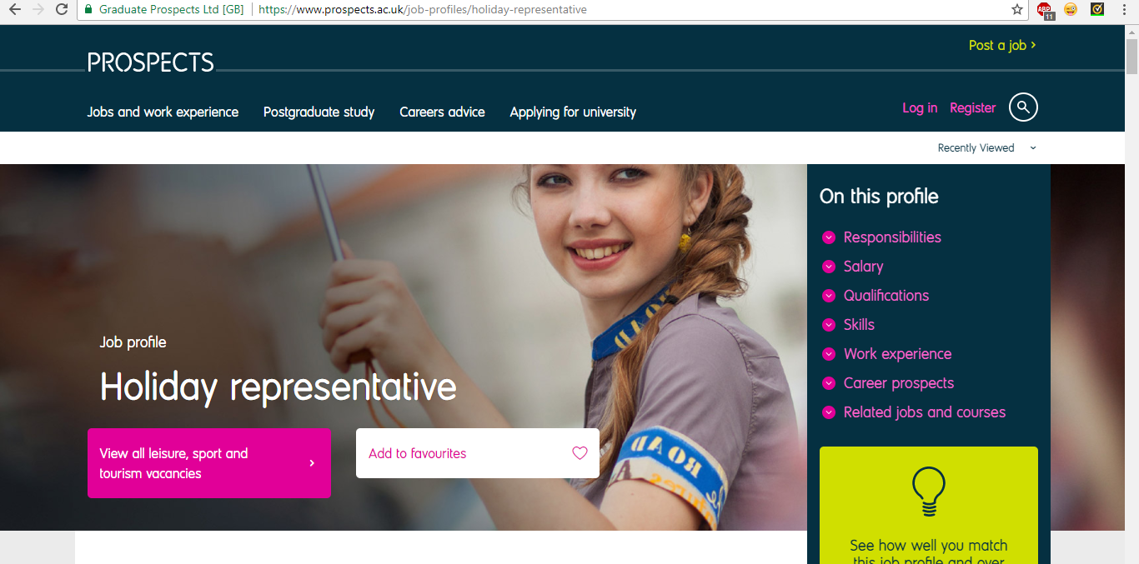
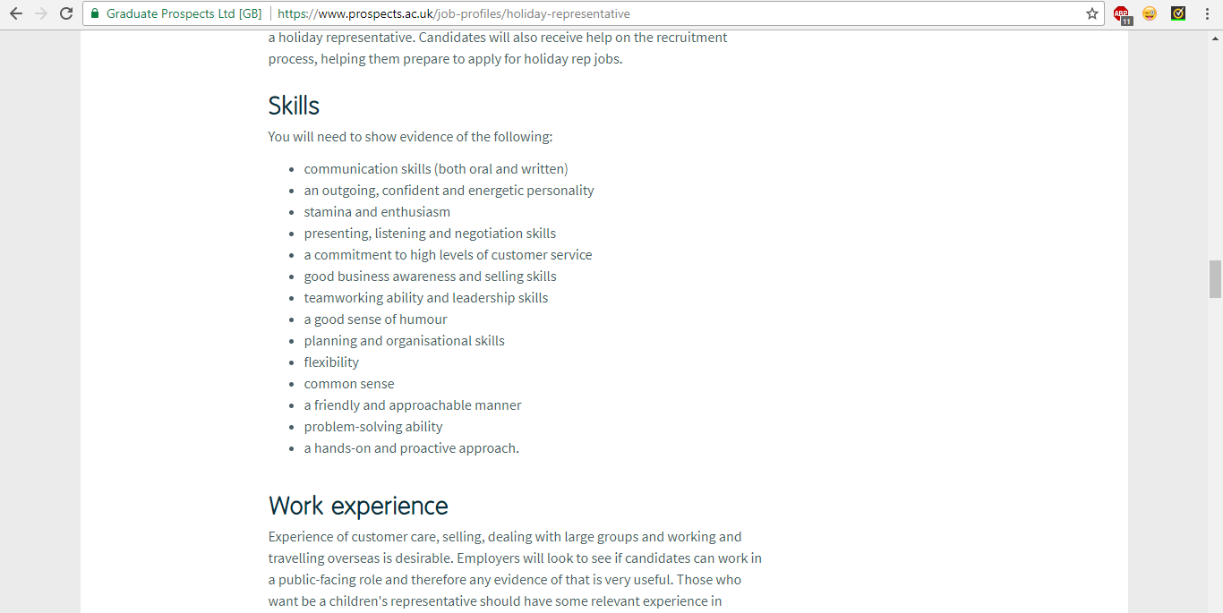

Appendix 2 – Travel agency manager job advertisement
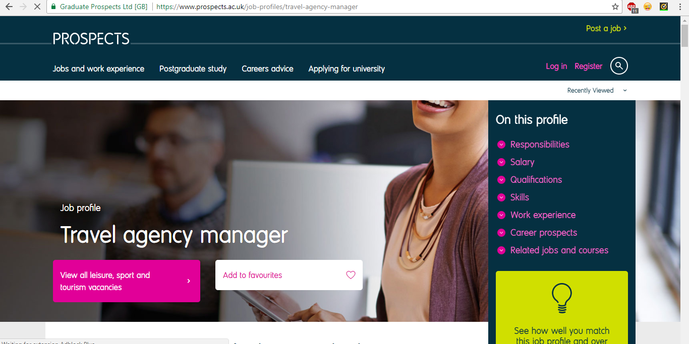
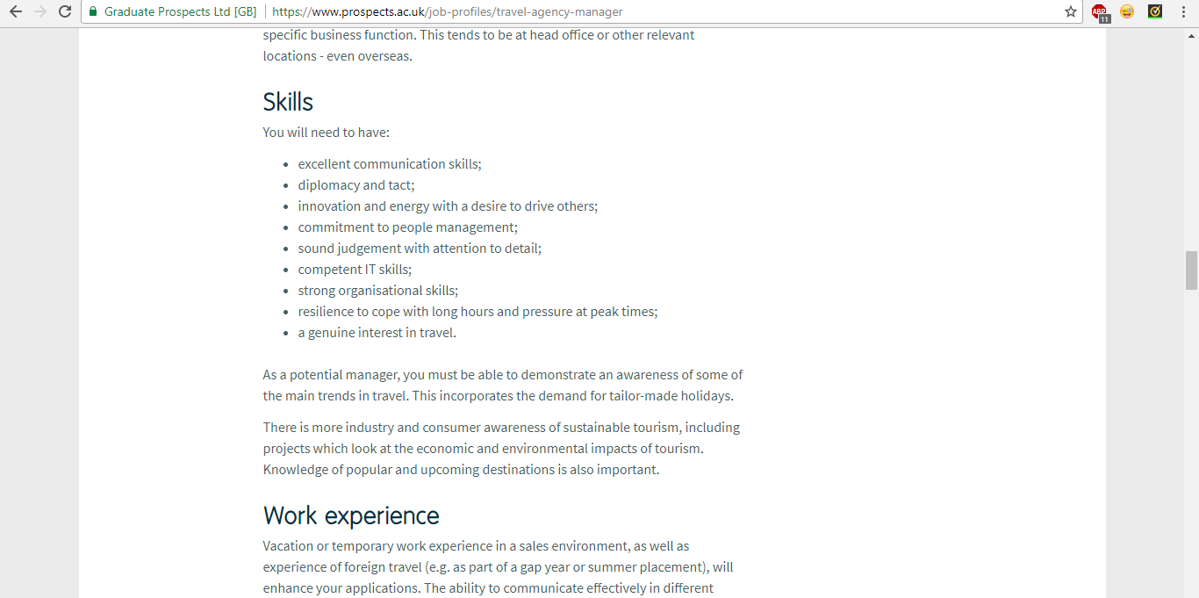

Appendix 3 – CV (Curriculum Vitae)
Nathan Price
16 Bryn Road, Neath
SA11 1UE
Telephone: 01639 689833 Mobile Number: 07391570813
E-Mail: rio-nathan@hotmail.co.uk
Personal Statement:
I am looking to gain employment in full time work. I am a fast learner and an excellent team player. I take a keen interest in technology, music, film and food. I am always polite and understanding. I'm always willing to help others and have a good sense of communication, being able to speak and work with a variety of people. I also have a strong desire to exceed customer expectations, being able to help willingly to any customer to achieve customer satisfaction. I take care of myself to ensure my appearance is up to standard, as I know how important it is for employees to look acceptable on the job.
Key Skills
- A team player
- Willingness to learn anything the job may throw at me
- A bubbly personality
- Punctual
- Excellent at time keeping
- Good IT skills and knowledge of technology
- Always positive and have a fast 'can do' attitude
Hobbies and Interests
I enjoy spending time with friends and family and take a keen interest in technology. My hobbies include going out to the cinema, bowling, shopping etc with friends and also exercising to keep fit and healthy.
Education and Qualifications
Cefn Saeson Comprehensive School
Start date: September 2009 End date: July 2014
English Language GCSE (Higher Tier): C ICT OCR: Distinction
English Literature GCSE (Higher Tier): C History GCSE: B
Mathematics (Higher Tier): C Business Studies BTEC: Merit
Science GCSE: C Welsh (Full Course) GCSE Higher Tier: E
Applied Science GCSE: D Intermediate Welsh Baccalaureate: Pass
Neath Port Talbot College
Start date: September 2015 End date: July 2017
BTEC Level 3 Extended Diploma in Travel and Tourism: Distinction* Distinction* Distinction*
Advanced Welsh Baccalaureate: A
Vocational Excellence Bursary
Work Experience
Gnoll Primary School
Start date: July 15th 2013 End date: July 19th 2013
During Year 10 at Cefn Saeson Comprehensive School, I was placed at Gnoll Primary School for a week on work experience. At the school, I learnt key skills in communication and teamwork especially. I also learnt how to work with a variety of different people and was always polite and a positive worker. The school held a fete halfway through the week and asked me to work on a stall, selling used items to parents and pupils. This helped me gain confidence and develop on my multitasking and communication skills.
McDonalds Glyn-Neath
Start date: March 2015 End date: April 2015
I worked for a short period of time in McDonalds, where I was a crew member. I worked at the drive-thru windows, serving customers their food and drinks and taking orders and handling money. My short time spent at McDonalds helped me to develop many key skills, such as communicating with new people, problem solving, teamwork, I.C.T and timekeeping.
Boots
Start date: December 2017 – Present
I currently work part time as a customer assistant in the Neath branch of Boots. My main duties include operating the tills, serving customers, restocking shelves, processing and distributing online orders, general store upkeep and day to day problem solving with customers. I was taken on by Boots for the festive period and have since had my contract extended due to hard work, enthusiasm and progression shown at work. During my time at Boots, I have also become a Dementia Friend, being able to help and work with customers whom have dementia and may need extra support and guidance. I have developed numerous skills thanks to this job including communication, problem solving, listening, numeracy, leadership and teamwork skills.
References:
Available upon request.

Appendix 4 – Cover letter
Mr David Williams,
TUI,
18 Travel Road, SA3 8UW.
31st March 2018
Dear Mr Williams,
I am writing to you today to express interest in the role of travel agency manager at TUI in Cardiff. The position was found upon a recruitment website and immediately stood out to myself when researching the role and TUI. I am interested in the role of travel agency manager as I have studied in the field of travel and tourism for many years, with links to management styles and how to successfully run an organisation in this industry. I am available to start with your company from 10th April 2018 and am looking for a long-term position within your business.
The role of travel agency manager appeals to myself as I take a keen interest in all aspects of the travel and tourism industry. I am highly interested in the business side of running an organisation; taking leadership and pushing a company to exceed its highest expectations. TUI is a global travel organisation with decades of experience in this sector, being one of the most highly regarded travel companies across the world. An opportunity to gain managerial skills and put them to the test within a successful and thriving organisation will help myself to learn how to become a more appropriate and confident manager.
As mentioned within my CV, I possess many skills that would help me in the role of a travel agency manager such as: communication, I.T., listening, problem solving, time keeping, numeracy, teamwork and ultimately, an overall interest in travel. I have previous experience managing team projects and taking a leadership role both within the workplace and in education. I believe I can bring positivity and a can-do attitude to the workplace, one of which I hope can reflect on other staff members within the organisation.
A face to face meeting would be great if possible, to discuss aspects I have highlighted within this letter and to display my interest in this role. I have enclosed my CV with this document for further details regarding my career and skills gained so far.
Thank you for your time, I look forward to hearing from you.
Kind regards,
Nathan Price.

