Lesson Plan Phase 1

Lesson Plan – Step 1 Cynllun Gwers – Cam 1

Student-teacher | Lauren Prynne | Class: | Year 1 Twmpa
AoLE or Subject | Y Siarter Iaith | Date: | 6/10/2019
Lesson Focus: | Weather/Tywydd
Meaningful links to Curriculum | Y Siarter Iaith (The Welsh Charter)  Increased opportunities for learners to speak Welsh in a variety of contexts and embed their use of Welsh language.  Language, Literature and Communication  What matter statement: Learning about identity and culture through languages prepares us to be citizens of Wales and the world.  Progression Step 1:  - I have developed an awareness of the different languages within my school and community including Welsh, English and, where applicable, home/community languages.  - I can see links between my languages, e.g. tri in Welsh, three in English  Progression Step 2:  - I can communicate in different languages including Welsh, English and, where applicable, home/community languages.  The Four Purposes  Develop ambitious, capable learners who can communicate effectively in different forms and settings, using both Welsh and English.
Meaningful links to:  Cross Curricular Responsibilities | Humanities  What matter statement: Our natural world is diverse and dynamic, influenced by physical processes and human actions.  Progression Step 1:  - opportunities to develop a curiosity about and an appreciation of the natural world  - recognise change within familiar places at different times of year  Expressive Arts  What matter statement: Exploration through and of the Expressive Arts deepens our artistic knowledge and contributes to our understanding of identities, cultures and societies.  Progression Step 1:  - I can explore a range of materials and resources, tools and technologies in art, dance, drama, film and digital media, and music for their sensory and productive qualities as a basis for my work.  AfL (Assessment for Learning)
Personal Targets (Linked to QTS and identifed in weekly review)

No personal targets have been set yet.

Learning Objectives (focus on Learning- use accessible vocabulary):
The pupils will learn to:

By the end of the lesson, the children will be able to communicate what the weather is in Welsh in a sentence and identify different weather types in Welsh.

Success Criteria (clearly linked to each Learning Objective and related to the process and/or product of learning) | Assessment of Pupils’ Learning  Evidence  (What have the learners to say/write/do/produce – to demonstrate learning)
- Children will be able to communicate weather phrases in Welsh  - Children will be able to distingish between different weather types in Welsh and apply this to sentence  - Children will be able to communicate today’s weather in Welsh | - Repeat weather phrases communicated by the teacher in Welsh  - Communicate the weather displayed in the symbol shown verbally in a sentence and splat the correct weather symbol coresponding to the teachers verbal Welsh weather phrase  - Communicate verbally today’s weather in a sentence

Time | Activities/Methodology/Key Concepts  (Teacher’s Role – including key teaching points, differentiation strategies and key questions) | Pupil Tasks  (Pupils’ role –including differentiation, engagement in formative assessment and homework) | Resources  (Including Health and Safety requirement)
Opening phase (with links to prior learning) | Teahcer to share sessions focus and success critera orally.  APK (activating prior knowledge): ask children if they remember from last year the weather in Welsh.  Teacher to ask children to listen to welsh song on the weather.  Teacher to show pictures of the weather whilst saying Welsh word (Haelog, Cymylog, Bwrw Glaw, Stromus, Bwrw Eira) | Children to engange in think, pair and share activity to active prior knowledge on the weather in welsh.  Children to engadge and listen to song whilst sitting on the carpet.  Children to engage and respond to welsh weather phrases by repeating. | YouTube Video  https://www.youtube.com/watch?v=WrjZzVQOEj4  Weather symbols
Teaching & Core Learning | Childern are split into four groups – Coch, Glas, Gwyrdd, Melyn  Teacher to adopt modeling teaching style in order to guide pupils through the welsh weather phrases (Haelog, Cymylog, Bwrw Glaw, Stormus, Bwrw Eira)  Teacher to assit children verbally to create sentences whilst using weather symbols for visual help ‘Mae hi’n ....’  MAT ‘Mae hi’n .... ac yn .... ‘  Teacher to lay out symbols on the floor and ask children to pick one symbol. | Children to engadge and repeat the welsh weather phrases corospodning to symbols and initated by teacher  Children to create sentence corresponding to teachers promt and visual picture of weather. E.g ‘Mae hi’n haelog’  One by one, children to take it in turns to choose one symbol from the floor and say “Mae hi’n .... “ | Weather Symbols  Weather symbols  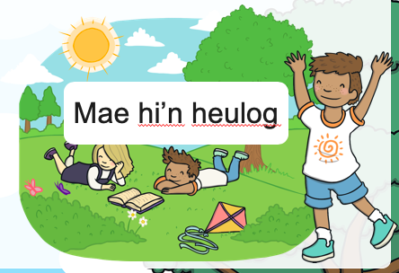
Plenary | Teacher to lay out weather symbols on the floor for splat game. Teacher to say ‘Mae hi’n ... ‘, Child to splat the symbol corosponding to the Welsh weather phrase  Discuss today’s weather  Sut mae’r tywydd heddi? (hows the weather today?) | Children to splat the weather symbol relating to the phrase  Children to respond with “Mae hi’n .... heddi” | Weather symbols and splatter  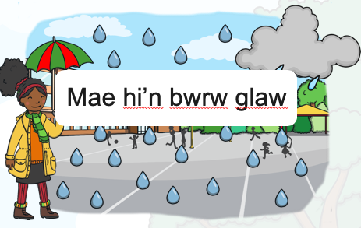

Lesson Plan – Phase 1
Evaluation of the Learning Experience
(include references to QTS)

Evaluation of Pupil Learning

Evidence of Learning (including attitude to learning over time)) | All children were able to join in with the “sut mae’r tywydd heddiw” song. All children were able to verbally respond to “sut mae”r tywydd heddiw?” with “mae hi’n...”. All children were able to either splat the correct weather phrase or correct their mistake after first time.
Next Steps for Progress | Teacher to introduce items of clothing to children in Welsh. Children to link clothing and weather phrases in Welsh. “Mae hi’n... Dwi’n gwisgo... “

Reflective Analysis of Teaching and Strategies For Development – including justification/rationale for pedagogical choices

Evidence of my Effective Practice | All children were involved in the song and engadged in welsh weather phrases.
Areas for my Development  Personal Targets for Progress | Talking partners to ask each other what the weather is like.

