Dynamic response characteristics of a seven-degree-of-freedom vehicle based on different excitations
Jian Song
Abstract: The study of vehicle dynamics has developed rapidly with the development of the automotive industry and vehicle dynamics models suitable for various operating conditions have been developed This paper describes the modelling and validation of a 7-degree-of-freedom (DOF) full vehicle model to study the driving performance of a Formula Ford race car. The software used for this simulation model is MATLAB Simulink.This paper proposes and describes the seven-degree-of-freedom (DOF) model and solves several real-world problems by simulating and analysing the model. It also compares the building process of the 1DOF model to the 7DOF model at each stage and presents the differences in the system response between each stage. Validation is carried out by comparing the simulation results. Smoothness tests were conducted at two different speeds, and the simulation results were analysed in terms of roll angle, pitch angle and body displacement.
Introduction: There are three types of models commonly used to represent vehicle suspension behaviors. These are quarter car model, half car model, and full car model. In this paper, a whole car model has been used to study a Formula Ford race car. The complete car model is a linear 7 degree of freedom consisting of an unsprung mass connected to an unsprang mass. The unsprung mass consists of four suspensions and four tyres located at each corner of the mechanism. The unsprung mass has 3 degrees of freedom representing body bouncing, rolling and pitching motions while the unsprung mass has 4 degrees of freedom in vertical motion. simulink as an important tool in MATLAB can be used for modelling and simulation analysis of various systems. In the process of modelling and simulation of the whole vehicle dynamics model, the use of simulink can effectively simplify the model calculation and analysis, and improve the visualisation and ease of use of the modelling process. This paper mainly introduces the modelling methods and application scenarios of the whole vehicle dynamics model_simulink (7 degrees of freedom), in order to help vehicle designers and developers better understand and apply the whole vehicle dynamics model technology.
Mathematical modelling of different degrees of freedom
The vertical dynamics model is mainly used to analyse the driving dynamics performance of the vehicle, i.e. the smoothness of the vehicle driving. In this section, a simple 1-degree-of-freedom model, a single-wheeled vehicle model, a half-vehicle model, and then a seven-degree-of-freedom whole-vehicle model are first introduced。
1. 1DOF model
As shown in Figure 1, the actual vehicle idealised description, that is, the mass of the entire vehicle is uniformly distributed in the body of each position, the role of the four wheels on the external road surface excitation are the same, then it can be found that, in a certain wheel at the vibration response results with the rest of the three are the same, and when the tyre deformation of the dynamic is very small, ignoring the elasticity of its wheels with the mass, so in order to avoid the repetition of the calculation of the vehicle is simplified into the following physical model.
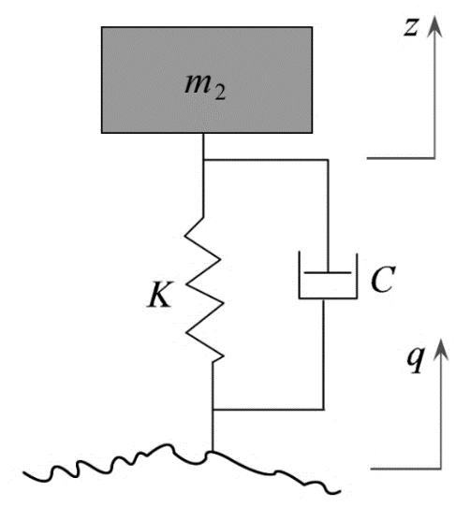
Figure 1
As in Fig. 3.3, z is the displacement of the body in the vertical direction ( m ), m_2 is the mass of the body ( kg ), k is the suspension stiffness coefficient (N/m), c is the suspension damping coefficient (N∙s/m), and q is the excitation input from the road surface (m). According to Newton's law, the mathematical model of the one-degree-of-freedom suspension model of the body can be obtained:
$-m_{2}\ddot{z}=k\left(z-q\right)+c(\dot{z}-\dot{q})$ (1)
2. Single-wheel vehicle model
When establishing the vehicle smoothness model, if the motion of the body's pitch and roll motion can be ignored, i.e., the relative motions of the vehicle's front and rear axles, and the left and right wheels are not taken into account, a simple single-wheel model can be used to study the vehicle's driving smoothness and the performance parameters of the suspension system, such as the body's vertical acceleration rms value, the dynamic perturbation of the suspension, and the tyre dynamic loads. Figure 1 shows a model with two degrees of freedom for the body and wheels, also known as a single-wheel vehicle model. The vertical displacement coordinates of the wheels and the body are z and y. The equilibrium position is chosen as the coordinate origin and can be obtained according to Newton's law:
$m\ddot{z}+C\left(\dot{z}-\dot{y} \right)+K_{s}\left(z-y\right)=0$ （2）
where m is the mass of the tyre and body, C is the suspension damping, K_s is the suspension stiffness and C is the tyre stiffness.
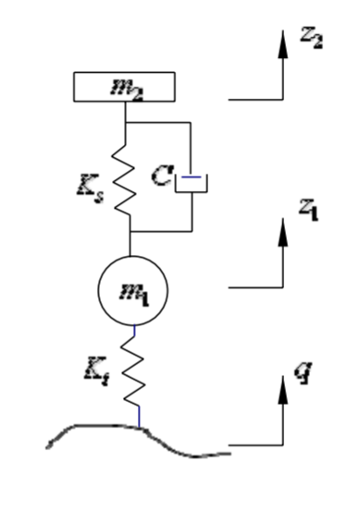
Figure 2 1DOF model
- 4DOF model
The single-wheel model ignores the pitch and sideways motion of the vehicle, and if the pitch motion of the vehicle is considered and only the sideways motion of the vehicle is ignored, the motion of the vehicle can be analysed by using the half-vehicle model. Figure 2 shows a schematic diagram of the half-vehicle model, which contains three mass blocks, respectively vehicle m, front wheel $m_{1}$ and rear wheel $m_{2}$, where the front and rear wheels each have a vertical displacement degree of freedom $z_{1}$ and $z_{2}$, and the body has two degrees of freedom, vertical displacement z and pitch θ. I is the pitch moment of inertia of half of the body, A is the centre of pitch, and $z_{3}$ and $z_{4}$ are the front and rear suspensions' upper end displacements respectively.
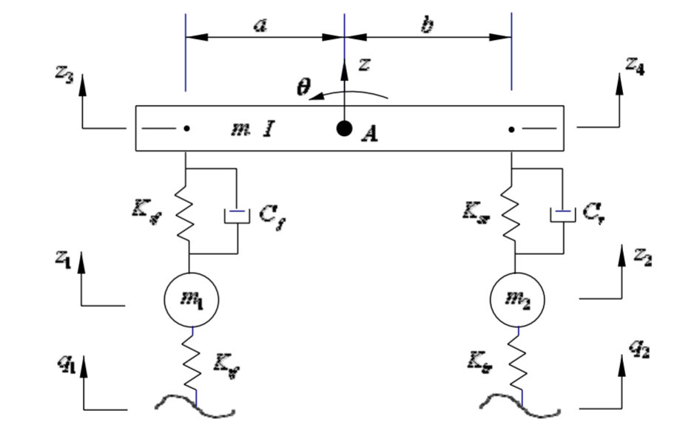
Fig. 3 Semi-vehicle model
Taking the front wheel vertical displacement$z_{1}$, rear wheel vertical displacement $z_{2}$, body vertical displacement z and body pitch angle θ as state variables, the following equations of motion can be listed:
$m_{1}{\ddot{z}}_{1}+K_{tf}(z_{1}-q_{1})+F_{f}=0$ （3）
$m_{2}{\ddot{z}}_{2}+K_{tr}(z_{2}-q_{2})+F_{r}=0$ （4）
$m\ddot{z}-F_{f}-F_{r}=0$ （5）
$I\ddot{θ}+aF_{f}-bF_{r}=0$ （6）
Where $F_{f}$ and$F_{r}$ are the front and rear suspension forces, expressed as
$F_{f}=K_{sf}(z_{1}-z_{3})+C_{f}({\dot{z}}_{1}-{\dot{z}}_{3})$ （7）
$F_{r}=K_{sr}(z_{2}-z_{4})+C_{r}({\dot{z}}_{2}-{\dot{z}}_{4})$ （8）
Considering that the quantities of interest in the analysis of suspension performance, such as suspension dynamic travel, are z_3 and z_4 more often than not, $z_{1}、z_{2}、z_{3}andz_{4}$ will be used as the state variables to list the system equations of motion, and when the pitch angle, θ, is small, we can obtain the body's vertical displacement and pitch angle as z=（b$z_{3}$+a$z_{4}$）/2, $θ$=$(z_{3}$-$z_{4}$)/(a+b), respectively. At the same time.
${\ddot{z}}_{3}=\ddot{z}-a\ddot{θ}$ （9）
${\ddot{z}}_{4}=\ddot{z}+b\ddot{θ}$ （10）
Replacing $z_{3}$、$z_{4}$ with z and θ in Eq. and (5) in (6) yields the equations of motion for the semi-cart model with state variables $z_{1}$、$z_{2}$、$z_{4}$and $z_{3}$.
$m_{1}{\ddot{z}}_{1}+K_{tf}(z_{1}-q_{1})+F_{f}=0$ （11）
$m_{2}{\ddot{z}}_{2}+K_{tr}(z_{2}-q_{2})+F_{r}=0$ （12）
$mI{\ddot{z}}_{3}-(I+ma^{2})F_{f}-(I-mab)F_{r}=0$ （13）
$ml{\ddot{z}}_{4}-(I-mab)F_{f}-(I+mb^{2})F_{r}=0$ （14）
3. Seven-degree-of-freedom vehicle model
Assuming that the vehicle body is a rigid body, when the vehicle u is moving in the horizontal plane with a uniform speed in a straight line, the body has three degrees of freedom for up and down jump z, pitch θ, and lateral inclination ϕ, and the four wheels also have four degrees of freedom for droop jump$z_{1}$, $z_{2}$, $z_{3}$, and $z_{4}$. For the study of the vehicle droop dynamics, these seven degrees of freedom describe the motion of the vehicle body and the four wheels in a complete way, and so it is also called the whole-vehicle model. The seven degree-of-freedom model of the whole vehicle is shown in Fig. 4:
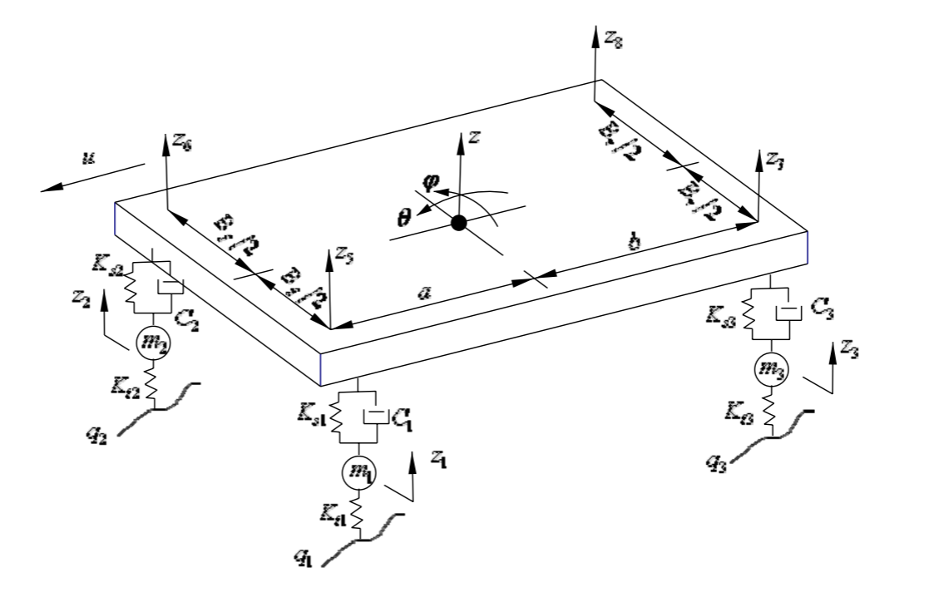
Fig. 4 Seven-degree-of-freedom vehicle model
At small body pitch angle θ and lateral inclination angle ϕ, the vertical displacements $z_{5}$ , $z_{6}$ , $z_{7}$and $z_{8}$ at the upper ends of the four suspensions can be expressed as:
$z_{5}=z-aθ+\frac{B_{f}}{2}φ$ （15）
$z_{6}=z-aθ+\frac{B_{f}}{2}φ$ （16）
$z_{7}=z-aθ+\frac{B_{f}}{2}φ$ （17）
$z_{8}=z-aθ+\frac{B_{f}}{2}φ$ （18）
If the forces on the four suspensions$F_{t1}$、$F_{t2}$、$F_{t3}$and$F_{t4}$：
$F_{t1}=K_{t1}(q_{1}-z_{1})$ （19）
$F_{t2}=K_{t2}(q_{2}-z_{2})$ （20）
$F_{t3}=K_{t3}(q_{3}-z_{3})$ （21）
$F_{t4}=K_{t4}(q_{4}-z_{4})$ （22）
The vertical equation of motion at the centre of mass of the body is thus：
$$-m\ddot{z}=k_{f1}\left(z-z_{f1}-aθ-β_{f}φ\right)+c_{f1}\left(\dot{z}-{\dot{z}}_{f1}-a\dot{θ}-β_{f}\dot{φ}\right)$$
$$+k_{f2}\left(z-z_{f2}-aθ+α_{f}φ\right)+c_{f2}\left(\dot{z}-{\dot{z}}_{f2}-a\dot{θ}+α_{f}\dot{φ}\right)$$
$$+k_{r1}\left(z-z_{r1}+bθ-β_{r}φ\right)+c_{r1}\left(\dot{z}-{\dot{z}}_{r1}+b\dot{θ}-β_{r}\dot{φ}\right)$$
$+k_{r2}\left(z-z_{r2}+bθ+α_{r}φ\right)+c_{r2}\left(\dot{z}-{\dot{z}}_{r2}+b\dot{θ}+α_{r}\dot{φ}\right)$ (23)

车身俯仰运动方程为
$$-I_{xx}\ddot{θ}=bk_{r1}\left(z-z_{r1}+bθ-β_{r}φ\right)+bc_{r1}\left(\dot{z}-{\dot{z}}_{r1}+b\dot{θ}-β_{r}\dot{φ}\right)$$
$$+bk_{r2}\left(z-z_{r2}+bθ+α_{r}φ\right)+bc_{r2}\left(\dot{z}-{\dot{z}}_{r2}+b\dot{θ}+α_{r}\dot{φ}\right)$$
$$-ak_{f1}\left(z-z_{f1}-aθ-β_{f}φ\right)-ac_{f1}\left(\dot{z}-{\dot{z}}_{f1}-a\dot{θ}-β_{f}\dot{φ}\right)$$
$-ak_{f2}\left(z-z_{f2}-aθ+α_{f}φ\right)-ac_{f2}\left(\dot{z}-{\dot{z}}_{f2}-a\dot{θ}+α_{f}\dot{φ}\right)$ (24)

车身侧倾运动方程为
$$-I_{yy}\ddot{φ}={α_{f}k}_{f2}\left(z-z_{f2}-aθ+α_{f}φ\right)+α_{f}c_{f2}\left(\dot{z}-{\dot{z}}_{f2}-a\dot{θ}+α_{f}\dot{φ}\right)$$
$$+α_{r}k_{r2}\left(z-z_{r2}+bθ+α_{r}φ\right)+α_{r}c_{r2}\left(\dot{z}-{\dot{z}}_{r2}+b\dot{θ}+α_{r}\dot{φ}\right)$$
$$-{β_{f}k}_{f1}\left(z-z_{f1}-aθ-β_{f}φ\right)-β_{f}c_{f1}\left(\dot{z}-{\dot{z}}_{f1}-a\dot{θ}-β_{f}\dot{φ}\right)$$
$-β_{r}k_{r1}\left(z-z_{r1}+bθ-β_{r}φ\right)-β_{r}c_{r1}\left(\dot{z}-{\dot{z}}_{r1}+b\dot{θ}-β_{r}\dot{φ}\right)$ (25)

四个车轮的垂向运动方程分别为
$-m_{f1}{\dot{z}}_{f1}=k_{tf1}\left(z_{f1}-y_{f1}\right)-k_{f1}\left(z-z_{f1}-aθ-β_{f}φ\right)-c_{f1}\left(\dot{z}-{\dot{z}}_{f1}-a\dot{θ}-β_{f}\dot{φ}\right)+c_{tf1}\left({\dot{z}}_{f1}-{\dot{y}}_{f1}\right)$ (26)
$-m_{f2}{\dot{z}}_{f2}=k_{tf2}\left(z_{f2}-y_{f2}\right)-k_{f2}\left(z-z_{f2}-aθ+α_{f}φ\right)-c_{f2}\left(\dot{z}-{\dot{z}}_{f2}-a\dot{θ}+α_{f}\dot{φ}\right)+c_{tf2}\left({\dot{z}}_{f2}-{\dot{y}}_{f2}\right)$ (27)
$-m_{r1}{\dot{z}}_{r1}=k_{tr1}\left(z_{r1}-y_{r1}\right)-k_{r1}\left(z-z_{r1}+bθ-β_{r}φ\right)-c_{r1}\left(\dot{z}-{\dot{z}}_{r1}+b\dot{θ}-β_{r}\dot{φ}\right)+c_{tr1}\left({\dot{z}}_{r1}-{\dot{y}}_{r1}\right)$ (28)
$-m_{r2}{\dot{z}}_{r2}=k_{tr2}\left(z_{r2}-y_{r2}\right)-k_{r2}\left(z-z_{r2}+bθ+α_{r}φ\right)-c_{r2}\left(\dot{z}-{\dot{z}}_{r2}+b\dot{θ}+α_{r}\dot{φ}\right)+c_{tr2}\left({\dot{z}}_{r2}-{\dot{y}}_{r2}\right)$ (29)
The above seven differential equations express the seven-degree-of-freedom whole vehicle dynamics model.
4.Correlation and variability between 1DOF and 7DOF of suspension
Different degrees of freedom vehicle model corresponds to increase the corresponding dynamic response characteristics, for example, 1DOF model for the analysis of the mass of the block, the vehicle will be theoretical study, when the four receive the same excitation, the elastic deformation of the wheels in the Hulun wheels as well as the quality of the wheels, so that the dynamic response of the wheels out of the results are the same. 2DOF model increases the overall unsprung mass of the analysis, i.e., a simple single-wheel to analyze the dynamic response characteristics of the vehicle's smoothness and suspension. The 2DOF model increases the overall unsprung mass, i.e. a simple single wheel, to analyse the smoothness and dynamic response of the suspension, and increases the damping characteristics, which also allows us to study the parameters of the active and semi-active suspensions, but it also prevents us from investigating the vehicle in the direction of pitch and roll. 4DOF model increases the dynamic response of the vehicle in the direction of pitch and at the same time, the front and rear wheels are no longer viewed as a single unit, which also increases the response of the front and rear wheels to a delayed response, which is not possible to analyse when we analyse the dynamic response of the vehicle in the road surface excitation. delayed response when receiving the road excitation, which should be noted when we analyse it. The 7DOF model adds the motion of the four wheels and the analysis of the body's overall vertical direction, the four wheels may be subject to different road excitation, in order to determine the vehicle's overall state and vibration trend of the body under different road excitation.

5、Modelling of SMD for 7DOF
The heavy vehicle model has been simulated using Simulink and Fig. 4 shows the Simulink block diagram of the ride model. Road profile perturbations acting on the unsprung mass system signals from the unsprung mass block diagram i.e. suspension tyre forces are transferred to the unsprung mass, pitch and roll block diagrams to calculate the output variables. The outputs from the unsprung mass, pitch and roll are then fed back to the unsprung system. The output variables i.e. pitch, side lean and unsprung mass displacement are recorded.

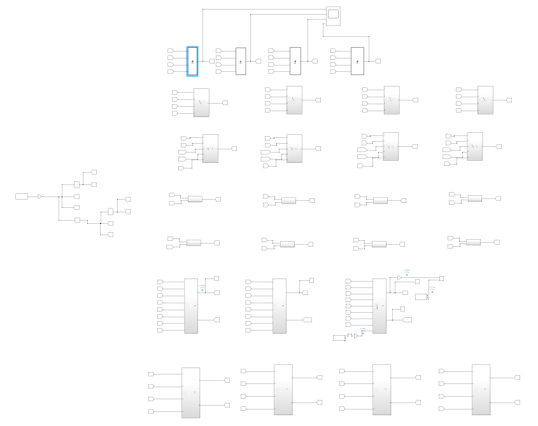 Fig 5 Simulink block diagram
The main parameters of the seven-degree-of-freedom vehicle model are shown in Table 1. Assuming that the vehicle is subjected to a vertical step displacement input of 0.1m from the ground and the simulation time is 20 seconds, the results of the simulation calculations are shown in Figures 5 to 7：

Vehicle Mass (kg) | M_{T} | 514
Front Corner Unsprung Mass (kg) | Musf | 22
Rear Corner Unsprung Mass (kg) | Musr | 22
Vehicle Sprung Mass (kg) | M_{s} | 426
Centre of Gravity Height (m) | CoG | 0.277
Weight Split F:R (%) | - | 45:55
Wheelbase (m) | W | 2.443
Front Track (m) | T_{f} | 1.62
Rear Track (m) | T_{r} | 1.57
Front Tyre Rolling Radius (m) | r_{f} | 0.2667
Rear Tyre Rolling Radius (m) | r_{r} | 0.2794
Front Motion Ratio | MR_{f} | 1
Rear Motion Ratio | MR_{r} | 1
Front Default Spring Rate (N/mm) | K_{sf} | 18
Rear Default Spring Rate (N/mm) | K_{sr} | 16
Front Roll Centre Height (mm) | h_{f} | 0.9
Rear Roll Centre Height (mm) | h_{r} | 59
Front Slow Bump | N/m/s | 1660
Front Fast Bump | N/m/s | 511
Front Slow Rebound | N/m/s | 1915
Front Fast Rebound | N/m/s | 511
Rear Slow Bump | N/m/s | 1477
Rear Fast Bump | N/m/s | 537
Rear Slow Rebound | N/m/s | 1612
Rear Fast Rebound | N/m/s | 537
Table 1 Reference parameter values of seven-degree-of-freedom vehicle model
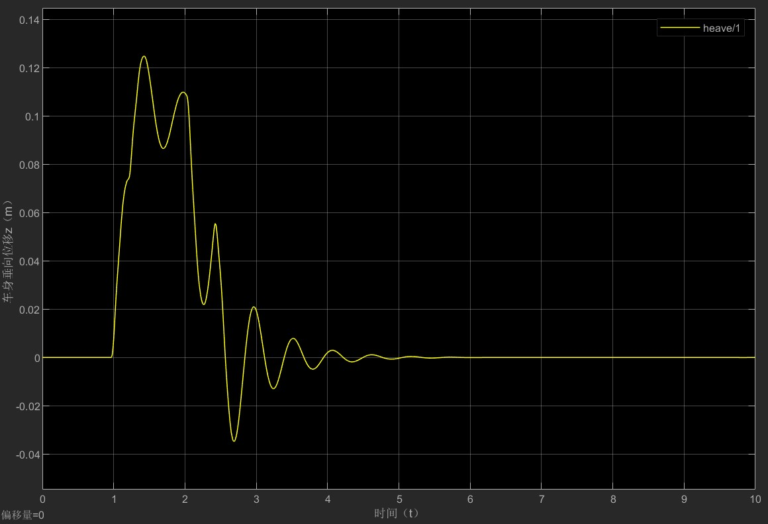
Fig 6 vertical displacement
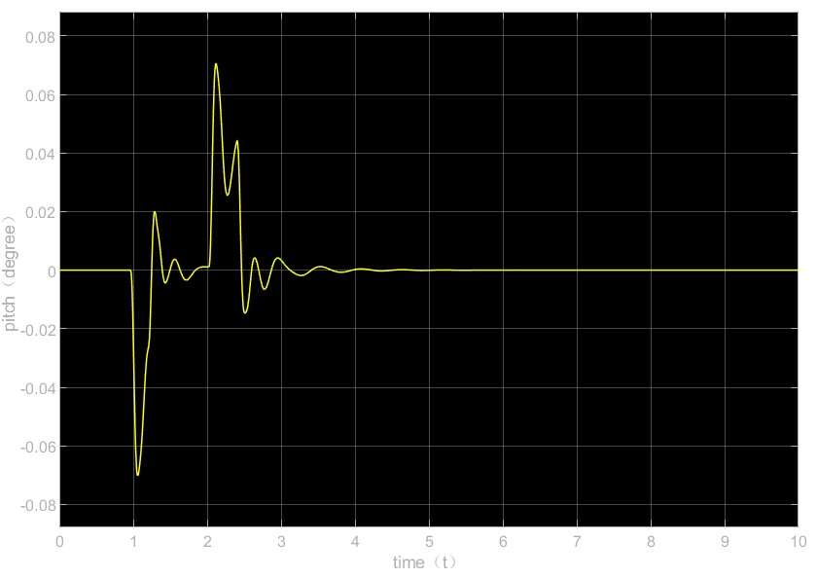
Fig 7 pitch（degress）
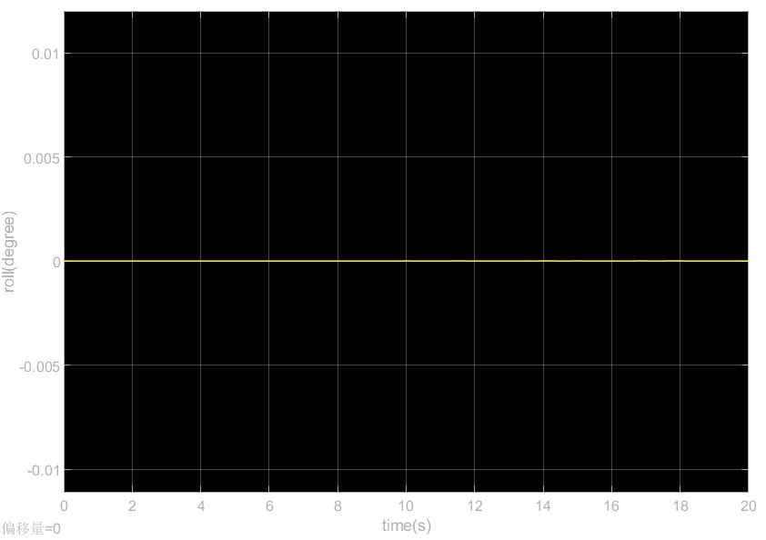
Fig 8 Roll（degree）
Table 1 Reference parameter values of seven-degree-of-freedom vehicle model
Fig. 6 shows that the vertical of the vehicle body jumps from 0 to 0.1m, and the maximum amplitude reaches 0.125m, and returns to the initial state after 5 seconds; Fig. 6 shows that the pitch angle of the vehicle body fluctuates above and below 0 degrees, and the maximum value is 0.07 degrees, and it tends to be stable after 3.5 seconds; Fig. 7 shows that the body's lateral inclination angle is 0, which is theoretically that the lateral inclination hardly occurs under the input of the vertical direction step displacement. In the example, the stiffness and damping coefficients of the left and right suspensions as well as the stiffness of the left and right tyres are equal, i.e., the vehicle is symmetrical between left and right, but in reality, the stiffness and damping coefficients of the left and right suspensions as well as the stiffness of the left and right tyres of the vehicle will be slightly different from each other, so the results of the sub-simulation are only used as a reference. Therefore, in the real driving process, the body parameters are changing every moment, so we need to consider more vehicle parameters to approach the real driving conditions and the real-time dynamic response of the body.
Give the body a lateral acceleration. To simulate the dynamic reference action of the test vehicle when performing a standard "lane change", we give a lateral acceleration to the frame and use it as input to the SMD model in Simulink, intercept the lateral acceleration profiles which are roughly the same for all three conditions, and import the signals from the motec, as well as the imported camber data, as shown below. are shown in the figure below:
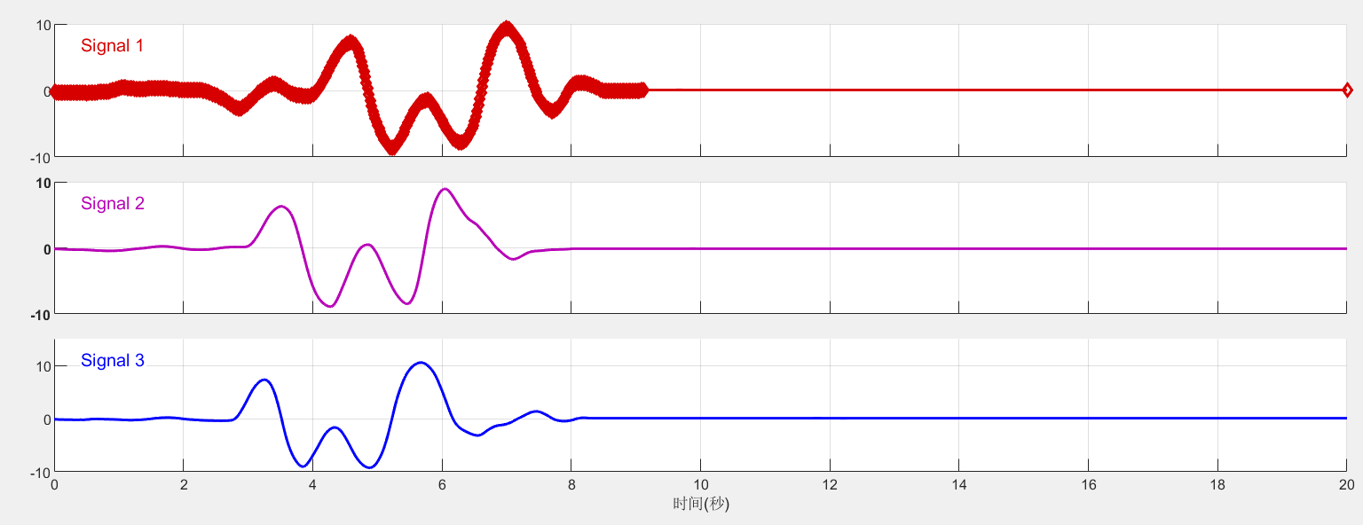
Fig 9 Lateral acceleration of Setup1, Setup2 and Setup3
Adjusting the simulation time to 20s, the solver type is selected as fixed-step with a step size of 0.0001s, and the superposition of the measured data with the simulator data is obtained by reproducing the test, as shown below:

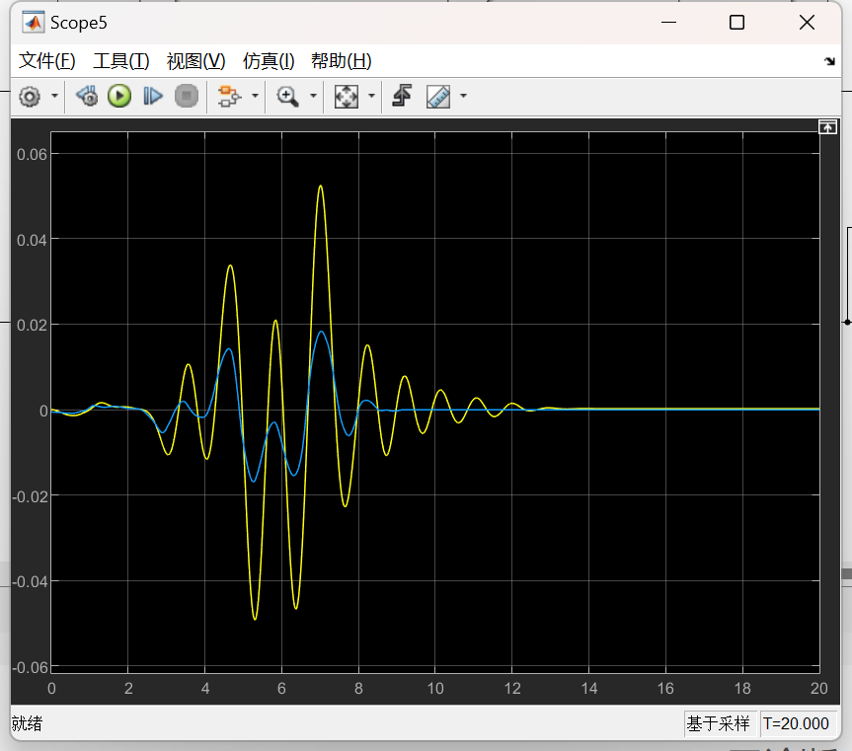
Fig 10
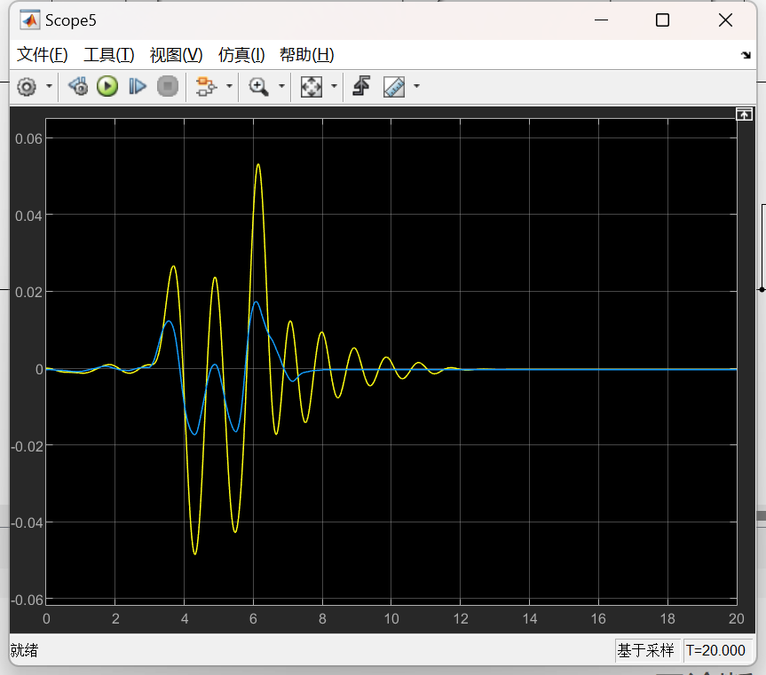
Fig 11
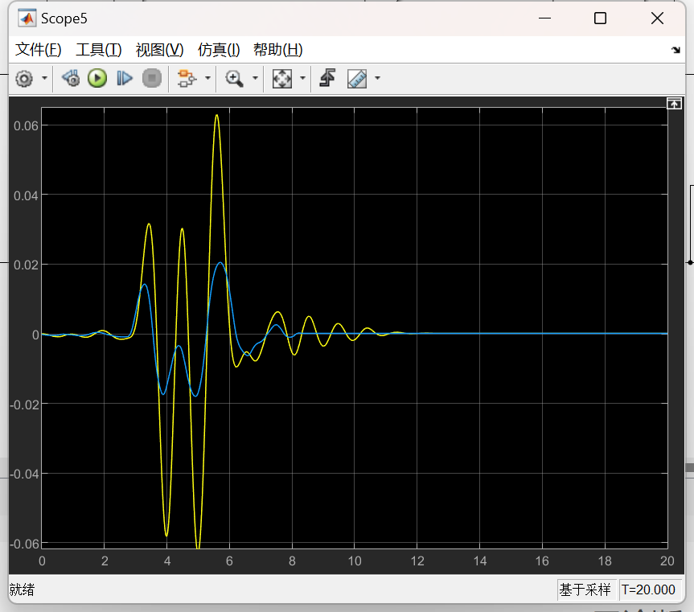
Fig 12
Based on the observation of Fig. 10, Fig. 11 and Fig. 12, we can analyse and conclude that the first group of data selected, the trend is basically similar before 8 seconds, which may be a deviation of the real vehicle parameters from the simulation parameters, resulting in a deviation of the lateral inclination angle after 8 seconds. The second group of data and the first group of data present basically the same trend, the difference in lateral inclination before 7 seconds is not much, and the angle is the same, and after 7 seconds there is a certain difference, and the third group of data and the results of the first two groups are also not much different. Combining the three sets of data, in general the simulator data and the model data show basically the same trend, but there is a difference in the angle of change. In the stage of importing data, all the conditions chosen are the return to the original lane after overtaking on a flat road, and since the conditions are the same, the trends of the three groups of data are not much different when compared.
The Front Spring Rate and Rear Spring Rate were also modified in the tests that were not tested, as shown in the table below:
Spring investigation |  | Setup1 | Setup2 | Setup3
Front Spring Rate (N/mm) | $$k_{sf}$$ | 14 | 18 | 23
Rear Spring Rate (N/mm) | $$k_{sr}$$ | 20 | 16 | 12
Table 2 Spring rate parameters
A comparison of the Vehicle body vertical displacement of Setup1, Setup2 and Setup3 is obtained by simulation as shown in Fig. 13, the trend of Setup1 and Setup2 is more similar in terms of vertical displacement, Setup1 is the first one to approach the peak value at 4 seconds, but the vertical displacement of Setup3 is the fastest one to converge to 0m, which indicates that the vibration time of Setup3 is less compared to the two groups mentioned.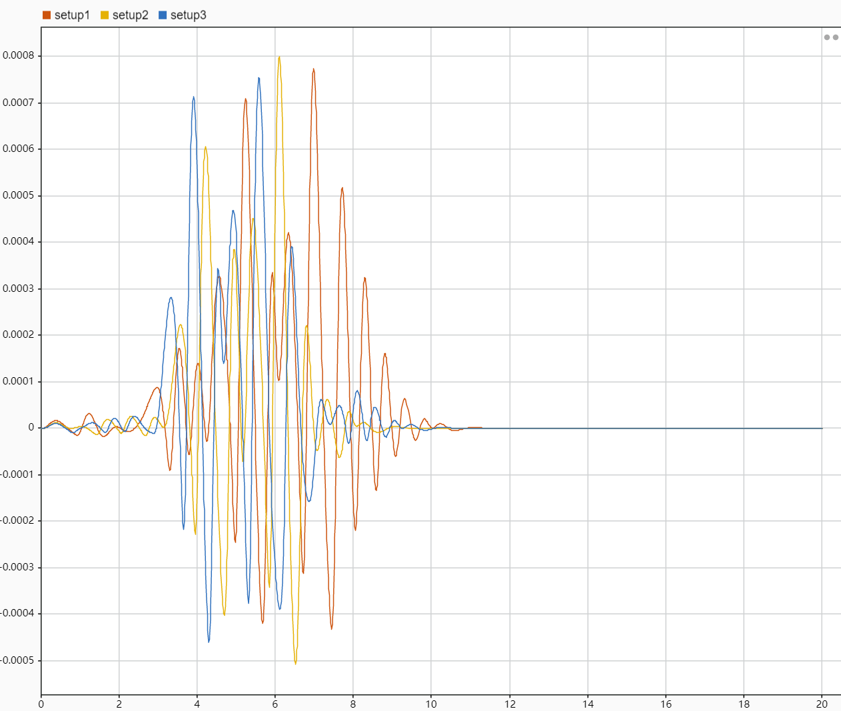
Fig 13 Vertical displacement
The Pitch angle comparison of Setup1, Setup2 and Setup3 is obtained through simulation as shown in Fig. 14, from which we can see that the Pitch angle is close to 0, and the maximum peak value of Setup1 is $1×{10}^{-4}$rad rad. Due to the test conditions, the amplitude of pitching motion is relatively small.
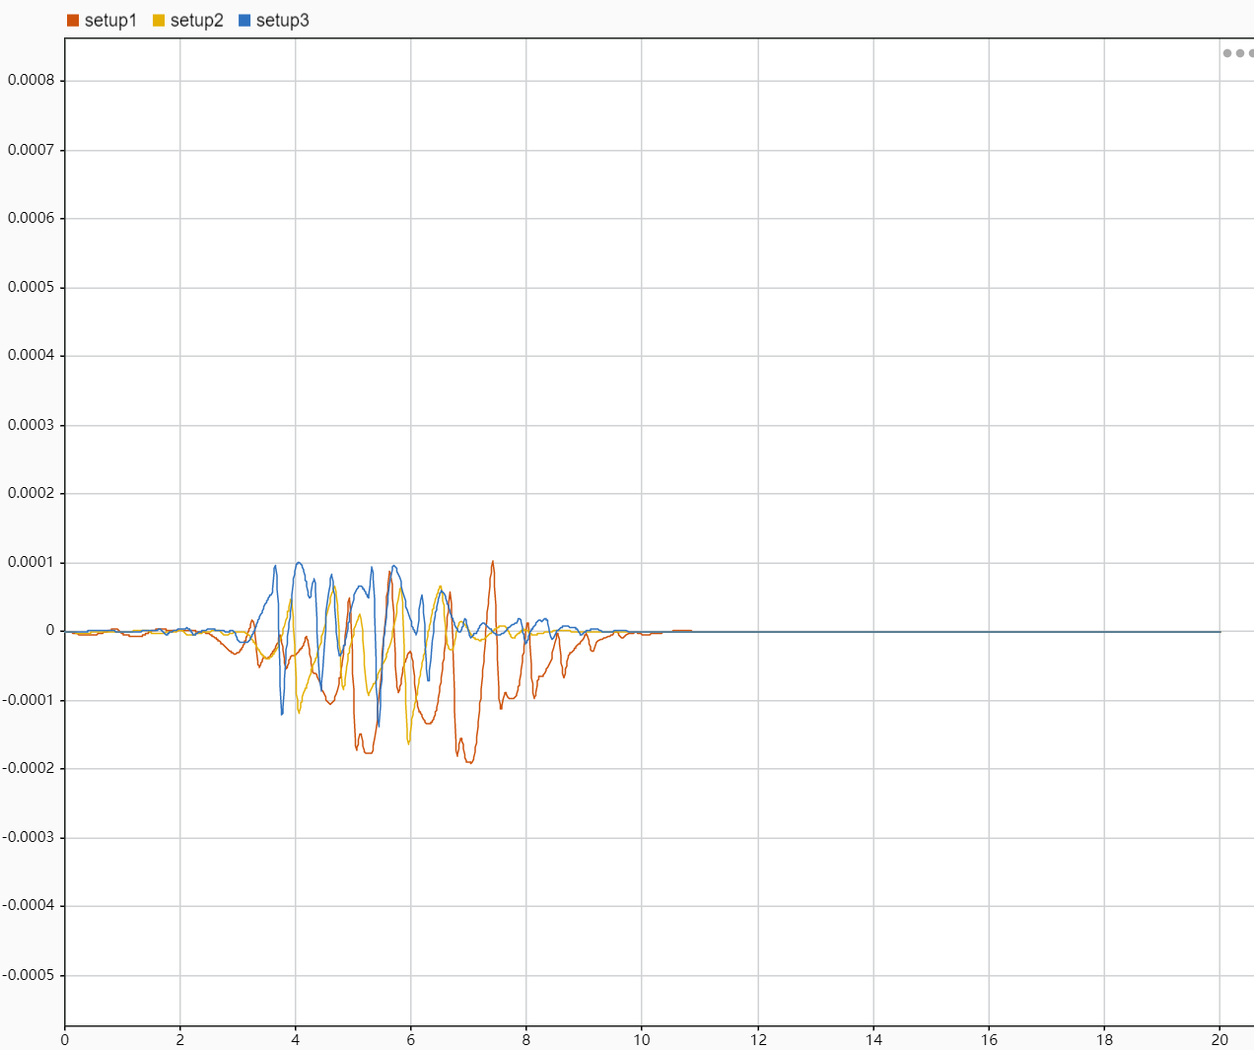
Fig 14 Pitch angle
The roll angle of Setup1, Setup2 and Setup3 is obtained through simulation as shown in Fig. 15, the roll angle of Setup3 is larger, but the roll angle of Setup3 is smaller, so the ride comfort of Setup3 is better.The roll angle of Setup3 is larger, but the roll angle of Setup3 is smaller, so the ride comfort of Setup3 is stronger.
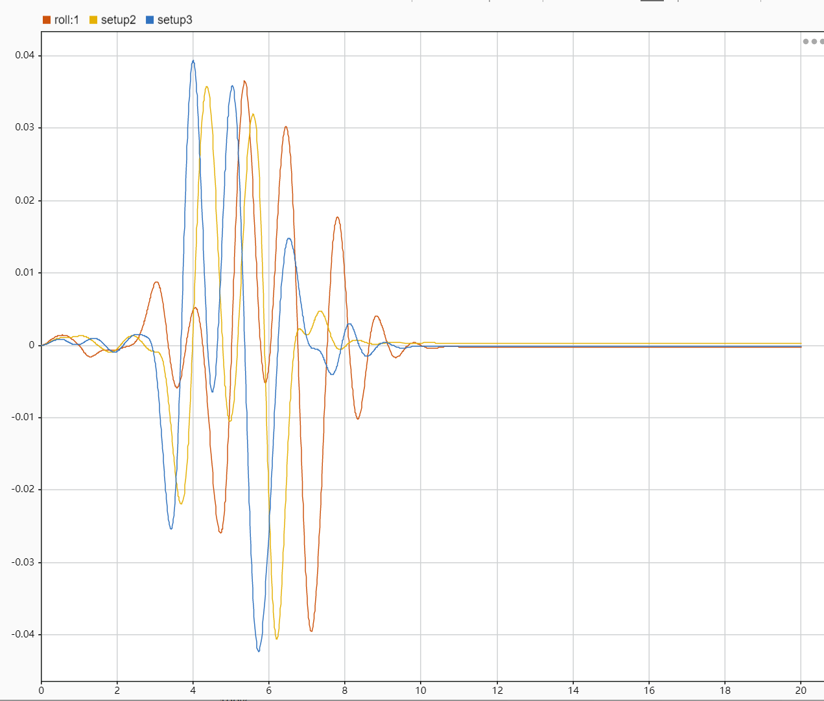
Fig 16 Roll angle
According to the above analysis, we can conclude that the front and rear spring rate for the vehicle driving stability has a huge impact on the front and rear spring stiffness balance, the dynamic response of the cabin parameters will not be too large changes in green, the stability is also better, too high spring stiffness for the vehicle there is also a certain degree of damage, which will lead to a reduction in the grip, and the occurrence of sideways sliding.

Limitations of the 7 DOF model
This model combines three degrees of freedom of linear motion(forward/backward, up/down, left/right) and four degrees of freedom of rotation (pitch, roll, yaw and wheel spin) for a car. The model provides a better understanding of the dynamics of the car. The seven-degree-of-freedom model alone can only discriminate the vertical displacement, lateral roll and longitudinal inclination of the car body, which also has its own defects.
1、Steering dynamics is the key to study the laws of motion when steering a car. If the seven-degree-of-freedom model does not involve the dynamics of the transverse swing, it cannot adequately predict and explain the performance of the car during steering.
2、Tyre is the only point of contact between the car and the road. The mechanical properties of the tyre and its interaction with the road surface are key factors in the handling performance of the car. If these factors are not properly incorporated into the model, the accuracy of the predictions is limited
3、Real vehicle suspension systems can be complex, including non-linear components, damping properties and different suspension structures. A simple seven-degree-of-freedom model cannot adequately reflect such complex dynamics.
4、Vehicle dynamics are affected by multiple interacting systems such as powertrain, suspension, and bodywork. a 7-degree-of-freedom model considers only the seven degrees of freedom of the suspension, which does not describe well the interactions between multiple systems.
5、The driver's manoeuvring inputs have an important influence on the real driving performance of the vehicle. If the driver's behavioural patterns are not considered, the seven-degree-of-freedom model will not be able to predict the car performance in real driving conditions well

Conclusion
Automotive suspension is a crucial part of the whole automotive system and plays an important role in smooth running and ride comfort in the vehicle. In this paper, the physical and mathematical models of automotive suspension are introduced, and a complex 7DOF (Degree of Freedom) model is built using MATLAB/Simulink software.
To verify the accuracy of the model, the researchers compared actual test data with simulated data. By comparing the data with published examples, they found that the built 7DOF model was able to accurately simulate the dynamic response of the vehicle.
In addition, the researchers imported lateral acceleration data from a Motec (a commonly used automotive test equipment) into the model and compared the lateral camber data from the actual data with the simulator data, which showed that the model's predictive ability was very accurate.
The simulation results of three different setups (setup1, 2 and 3) with different spring stiffnesses were further investigated. They found that setup1 and 3 have similar trends of vertical body displacement and lateral camber, which indicates that the spring stiffness has a significant effect on the dynamic response of the vehicle.
In summary, this paper explores the importance and influencing factors of vehicle suspension in vehicle dynamic response by developing and validating a complex 7DOF model. These findings provide a useful reference for improving the driving stability and ride comfort of vehicles.

