Impact of CSR Activities on Profitability: A John Lewis Case Study

Module: Dissertation

Lecturer Name: Anupam Mazumdar

Student Name: Georgiana Stan

Student number: 1915942

Abstract
The research paper aims to determine the importance of corporate social responsibility (CSR) and its impact on the growth and profitability on businesses. The research paper provide insights on what does it mean by CSR by incorporating different researchers’’ views and showing how CSR activities can increase the profitability. The research was conducted based on qualitative method conducting secondary research. By analysing the research papers, journals and other secondary sources a theme was derived, analysed and a conclusion was made. The research found that CSR activities include four responsibilities such as economical, ethical, legal and philanthropic responsibility. Besides, there is a positive correlation between the CSR activities and Profitability. It discussed the CSR activities on the light of John Lewis Partnership company and also shows specific ways organisations increase profitability doing CSR activities. Thus, it is different from existing research papers. It can be recommended that organisations should focus on performing CSR activities to increase trust and collaboration from consumers to increase profitability. Finally, it is recommended that researchers should understand the concept and the ways CSR impact profitability by taking information from this paper and conduct further researches more on this specific topic.

Acknowledgements
I would like to show gratitude to the parties involved who helped me to gather information. Besides, I would like to thank my course teacher for assisting me to conduct the research paper successfully.

Table of Content

Abstract 2
Acknowledgements 3
Table of Content 4
Chapter 1: Introduction 7
1.1: Introduction 7
1.2: Background of the Study 7
1.3: Problem Statement 7
1.4: Aims, Objectives, Research Questions, Hypothesis, Propositions 8
1.4.1: Aim 8
1.4.2: Objectives 8
1.4.3: Research Questions 8
1.4.4: Hypothesis 8
1.5: Rationale 8
1.6: Methodology 8
1.7: Scope of the Study 9
1.8: Structure of the Dissertation 9
1.9 Summary 9
Chapter 2: Literature Review 10
2.1: Introduction 10
2.2: Different Background Aspects of the Concept 10
2.3: Theoretical Perspective of CSR on Profitability 10
2.3.1 Stakeholders’ Theory 11
2.3.2 Carroll’s CSR Pyramid 11
2.4: Previous Studies and Lessons Learnt 12
2.5: Gaps in the current research 13
2.6 Summary 13
Chapter 3: Research Methods & Methodologies 14
3.1: Introduction 14
3.2: Research Philosophy 15
3.3: Research Approach 15
3.4: Research Methodology 15
3.5: Research Strategy 16
3.6: Data Collection 16
3.7: Data Analysis and Interpretation 16
3.8: Ethical Consideration 17
3.9: Summary 17
Chapter 4: Data Analysis and Interpretation 18
4.1: Introduction 18
4.2: Analysis and Discussion 18
4.2.1: The Concept of Corporate Social Responsibility in Businesses 18
4.2.2: Importance of CSR activities on Company’s Profitability 20
4.2.3: CSR activities that can increase the profitability of a company 21
4.3: Summary 23
Chapter 5: Conclusion, Limitations & Recommendation 24
5.1: Introduction 24
5:2: Conclusion on Research Objectives 24
5.2.1: Finding out the Concept of CSR in business 24
5.2.2: Importance of CSR activities on Company’s Profitability 24
5.2.3: CSR Activities that can increase Profitability 24
5.3: Conclusion of the Research Problem 24
5.4: Summary of Research Findings and Outcomes 25
5.5: Original Contribution to the Research 25
5.6: Limitations of the Research 25
5.7: Recommendation 26
5.8: Summary 26
Reference list 27

List of Figures

Figure 1: Carroll’s CSR Pyramid (Source: Carroll, 1991) 11
Figure 2: The Onion Research Model (Source: Brown, 2021) 14
Figure 3: Different CSR Frameworks based on Carroll’s Pyramid (Source: (Leclercq-Machado et al., 2022) 19
Figure 4: Impact of CSR activities on Customers’ Loyalty (Source: Statista, 2021) 20
Figure 5: Sustainable Shopping Behaviour of Consumers in the UK in 2022 (Source: Tighe, 2022) 23

Chapter 1: Introduction

1.1: Introduction
This section discusses the background of the study, the problem statement, and the rationale for choosing the topic. It also sets the aim, objectives, questions, hypothesis for the study, and scope of the study. Finally, it discusses the methodology for conducting the study.

1.2: Background of the Study
Presently, businesses around the globe are facing radical changes. Complying the with changes, stakeholders of businesses expect that businesses will engage in activities that will provide them benefits. Mayorova (2021) argued that currently, the concept of corporate social responsibility (CSR) is gaining more importance because of the expectation of society from businesses. CSR is a term that is referred to the social and environmental activities done by businesses for their betterment (Harjoto, 2018). According to the author, CSR is a commitment of businesses to constantly engage in such activities that will bring well-being to societies such as providing a good lifestyle to employees, taking care of their families, and doing good for the environment. Businesses have a responsibility to do such activities that bring a better life for their stakeholders and doing this also brings profitability for them. Due to the severe and complex impact of businesses on society, the issue of corporate responsibility has become more acute. Corporates exert a significant impact on societies and thus they should focus on the exertion of a positive impact on them. Therefore, the purpose of this research paper is to determine the impact of corporate social responsibility on the growth of the organisation and its profitability and its significance.

1.3: Problem Statement
The problem that the research will address is the importance of corporate social responsibility activities and their impact on the growth and profitability of the organisation. Corporate social responsibilities help to create a positive image among the stakeholders and also stakeholders expect organisations to invest in CSR activities. Thus, by not investing in CSR activities organisations will not be able to achieve their vision and mission. To solve this problem, this research paper will analyse the current research findings and will provide a thorough solution on how organisations can do CSR activities to improve their profitability and growth.

1.4: Aims, Objectives, Research Questions, Hypothesis, Propositions

1.4.1: Aim
The research papers aim to determine the importance of corporate social responsibility and its impact on the growth and profitability of businesses.

1.4.2: Objectives
- To find out the concept of corporate social responsibility in business.
- To find out the importance of CSR on a company’s profitability.
- To find out the CSR activities that can increase the profitability of the business.

1.4.3: Research Questions
- What is CSR in the context of business?
- What is the importance of CSR on business performance and profitability?
- What are the CSR activities that can increase profitability and business growth?

1.4.4: Hypothesis
Null Hypothesis: Corporate Social Responsibility activities have no impact on the growth and profitability of businesses.
Alternative Hypothesis: Corporate Social Responsibility has an impact on the growth and profitability of businesses.

1.5: Rationale
According to Weinger (2022), active participation in CSR activities can reduce employee turnover rate by 50% and 90% of customers will switch to the brands that engage in CSR activities from brands that do not. Hence, CSR activities have a profound impact on the overall operation of a business. However, the current research papers focused on the importance of CSR activities and their impact broadly but did not show exactly how an organisation can implement them properly. Besides, the current literature does not analyse the impact on John Lewis specifically. Thus, this research paper will address these gaps.

1.6: Methodology
Data will be collected from secondary sources to conduct this study, for example, online journals, news articles, websites, and other research papers. Thus, no primary data sources will not be collected. Hence, population or sample size does not apply to the conduct of this study. However, the data analysis will be qualitative because data collected from secondary sources are qualitative. Therefore, a thematic analysis approach will be used to analyse the data.

1.7: Scope of the Study
The study mainly focuses on the UK’s geographical area. However, the research paper can be used for understanding the importance and impact of CSR activities internationally and most people can use it.

1.8: Structure of the Dissertation
The dissertation will begin with a literature review to analyse the current research findings on the importance and impact of CSR activities on businesses. Secondly, it will discuss the methodology which has been used to conduct the research. Thirdly, it will analyse the collected data and will discuss them. Finally, it will bring the outcomes of the study; will conclude all the research findings, and will recommend how to incorporate CSR activities.

1.9 Summary
This section provides an overview of the history of the study, the justification for selecting the topic, as well as the aims, objectives, questions, and hypotheses for the research. The purpose of this research paper is to determine the significance of corporate social responsibility (CSR) activities and the effect that these efforts have on the expansion and profitability of organizations. In order to analyze the data, it will collect the data from secondary sources and then analyze the data using a qualitative data analysis approach. In conclusion, the study report will concentrate on the geographical region of the UK.

Chapter 2: Literature Review

2.1: Introduction
This part discusses the importance and impact of CSR activities reviewing current research papers and other sources. Firstly, it discusses different background aspects of the CSR concept. Secondly, it discusses theories related to CSR and critically evaluates them. Thirdly, it shows how organisations are implementing CSR activities and what results they are getting. Finally, it discusses the gaps in the current research findings.

2.2: Different Background Aspects of the Concept
At present, the demand for performing corporate social responsibilities (CSR) is all-time high because of globalisation, insecurity and poverty, and mistrust in the business areas. According to Harjoto (2018), the CSR activities demand has drastically increased when the European Commission announced 2005 as the Corporate Social Responsibility year for its European Union members. Thus, to comply with this, the UK has employed a CSR minister under the trade and industry department. Also, France has mandated CSR activities for businesses (Weinger, 2022).
According to Trong Tuan (2019), CSR is the process of maintaining a good relationship with organisations’ stakeholders and doing activities that will bring benefits to the society and environment. However, the author argued that CSR goes beyond the idea of only performing legal and environmental requirements that a government poses on business. Rather it is something that businesses will do beyond their legal requirements for the betterment of society and the environment.
However, Basuony and Elseidi (2014) stated that CSR activities are the activities that an organisation does for its society and environment which impact the operation of the businesses. It also indicates that organisations should be transparent about their activities which are done for the society and environment. Moreover, CSR activities should also consider the well-being of organisations’ stakeholders; should comply with regulations and comply with international standards.

2.3: Theoretical Perspective of CSR on Profitability
At present, a lot of information is available on this topic, the impact of CSR on profitability. As a result, numerous theories and models have been developed regarding this issue over time.

2.3.1 Stakeholders’ Theory
The theory centralises the attention on the relationship between the organisations and their stakeholders. Stakeholders are the groups upon which an organisation’s operation is dependent (Fletcher, 2019). It also means the groups who are impacted by the operation of an organisation. The theory stated that organisations' main focus should not be on making a profit continuously but rather focusing on providing benefits to their stakeholders. The theory also ramifies CSR activities into three categories which are normative, descriptive, and instrumental. According to (Fletcher, 2019), the normative category focuses on how organisations treat the stakeholders; the descriptive category focuses on the relationship with stakeholders and the instrumental category focuses on the alignment of organisational performance and stakeholder management.

2.3.2 Carroll’s CSR Pyramid
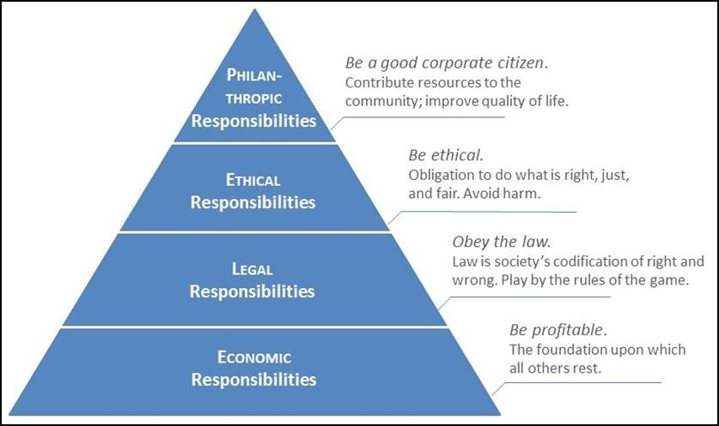
Figure 1: Carroll’s CSR Pyramid (Source: Carroll, 1991)
Carroll’s CSR pyramid classifies the CSR activities of an organisation into four classes. The four aspects are economic responsibilities, legal responsibilities, ethical responsibilities, and philanthropic responsibilities. The economic responsibilities require an organisation to be profitable which is a base upon which the other four categories are set in. Secondly, legal responsibilities require an organisation to obey the law (Carroll, 2016). Because the law states what is good and wrong for society and complying with it an organisation ensures betterment of the society. Thirdly, ethical responsibilities require organisation to be ethical by taking fair, right, and transparent actions. Finally, philanthropic responsibilities require organisations to be good corporate citizens. It means an organisation should contribute its resources for the betterment of society and will improve the lives of the people in society.

2.4: Previous Studies and Lessons Learnt
According to Basuony and Elseidi (2014), CSR activities increase the customers’ attraction to the business. Leclercq-Machado et al. (2022) agreed with it and stated that CSR activities ensure customer satisfaction and customer trust which brings customers loyalty. The author also found that CSR activities have a 0.636 correlation with customer loyalty. It means that the relationship between CSR activities and customers’ loyalty is positively correlated. Customer loyalty has a direct impact on the profitability of a business. Because Harjoto (2018) argued that customers’ loyalty ensures the repeating purchase of customers and businesses can charge premium prices to customers. Thus, it brings higher profit for customers. Moreover, the author stated that increasing customer retention just by 5% will increase profits by 25% to 95% of a business. Here, the increment of customer retention is impacted by the CSR activities which were found previously.
Moreover, Basuony and Elseidi (2014) found that CSR activities help organisations to have a strong public image. For example, the company ‘Lego’ has strong contributions towards sustainability, education, and social contributions. Also, they replaced their plastic materials with plant-based plastics that will be made from sugarcane. Such CSR activities have allowed ‘Lego’ to be in the top ten list of the most reputed companies in the world (Gonçalves, 2019). Similarly, Unilever has also been declared as the pioneer in corporate social responsibility because Unilever has incorporated a strategy that will ensure the reduction of greenhouse gases, for example, achieving a net zero carbon emission goal, reducing plastic waste by 50%, and so on (Amdur, 2021). These CSR activities have established a strong brand image for Unilever.
However, John Lewis company has also planned for CSR activities and already performed some activities. The company is largely focusing on sustainability by offering two features to customers. Firstly, customers can recycle their unused technologies via the company. Secondly, it is offering customers to recycle their old clothes by re-purchasing the old clothes of customers. Because, 30% of old clothes are dumped into landfills and thus by recycling old clothes, the company is reducing waste (John Lewis & Partners, 2022). According to John Lewis Partnership (2022), active participation in CSR activities has set John Lewis company as a role model in the UK. However, Ethical Consumer (2018) has marked John Lewis negatively considering ethical actions regarding climate change, animal rights, and human rights.

2.5: Gaps in the current research
It can be noticed that the current research paper mainly focuses on illustrating the concept of corporate social responsibility and its characteristics. For example, Carroll’s CSR pyramid discusses the four CSR activities which an organisation should do. But these research findings do not explicitly show how organisations are implementing them and what results they are getting. Besides, the current research papers also do not show how CSR activities are specifically influencing the performance of an organisation. Finally, they also lack in recommending specific solutions on how to implement CSR activities in an organisation. The findings are general guidelines that can vary based on organisational context.

2.6 Summary
Corporate Social Responsibility refers to the activities that an organisation engages in for the better of society, the environment, and its stakeholders. The stakeholders’ theory states an organisation should focus on building a strong relationship with the stakeholders. Whereas, Carroll’s CSR pyramid identifies four responsibilities for organisations that should be performed. Organisations such as Unilever, Lego, and John Lewis are performing CSR which is bringing them a strong social image and high profitability.

Chapter 3: Research Methods & Methodologies

3.1: Introduction
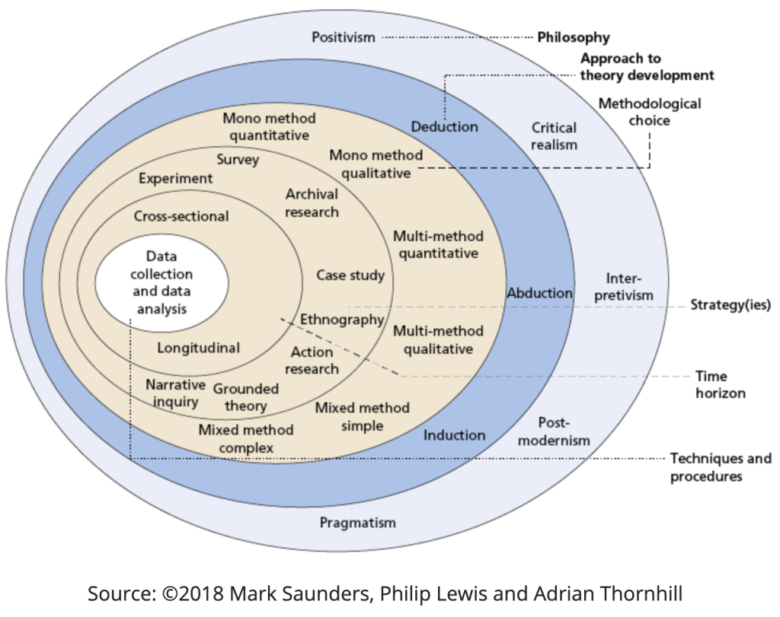
The research methodology shows how the research will be conducted. Thus, the methodology gives a step-by-step process based on which research is done. However, to conduct this research, the research onion is used. The research onion illustrates each step of research like the peels of an onion. Therefore, it makes the conduct of research effective and simple. The main advantage of following this methodology is that it provided flexibility throughout the conduct of the research.

Figure 2: The Onion Research Model (Source: Brown, 2021)

3.2: Research Philosophy
To conduct this research, the positivist research philosophy will be used. The positivism philosophy is objective and thus it will be used. Moreover, to conduct this research, primary data will not be collected. Besides, qualitative data will be collected and for analysing qualitative data, the Positivism research philosophy is suitable. Finally, this research paper has largely relied on factual knowledge. Hence, it supports the main theme of positivism philosophy.
Justification: According to Dudovskiy (2022), the positivist research philosophy is more reliable for qualitative data analysis. Besides, positivism follows a specific structure. As it follows specific rules and regulations, there is less chance of error, the author argued. However, the positivist philosophy brings inflexibility in the research process as it thinks everything can be measured and calculated.

3.3: Research Approach
There are two approaches Inductive and Deductive. Thus, a deductive approach will be used to conduct this research. According to Lefley (2016), the deductive approach is utilised to determine the relationship among different variables available in the research paper. This approach also helps to test the hypotheses in a research paper. It evaluates the pre-set propositions and conclusions and based on the evaluation, this approach brings a conclusion. However, this research will focus on determining the relationship between CSR activities and profitability in the light of stakeholders’ theory, Carroll’s CSR pyramid. Therefore, the deductive approach has been chosen.
Justification: Dudovskiy (2022) stated that the main advantage of the deductive approach is that it can help to determine the interrelationship among different variables when there is a large amount of information available. Besides, it takes short time to complete research whereas the inductive approach takes a long time. Thus, the deductive approach is chosen rather than selecting inductive approach.

3.4: Research Methodology
The research methodology that has been used here is qualitative research methods. This method is used when there have deep descriptive findings on a study topic (Dudovskiy, 2022). It is applicable in this research because this research considers only qualitative data from secondary sources rather than sampling data and collecting information and doing quantitative analysis. Moreover, this research paper focuses on sourcing information that is backed up by population experience and different views. Therefore, the qualitative research method has been used here. Furthermore, the qualitative research method assists to determine probable problems in a research paper and thus it makes it easier for the researcher to conduct the study. As the objectives of the qualitative research method comply with this research paper, the qualitative method has been used to conduct the study.
Justification: This research paper specifically has focused on identifying the importance and impact of CSR activities on businesses. There are a lot of data available out there which requires depth analysis. Therefore, conducting quantitative or numerical analysis on such a broad range of data is quite impossible (Gelsthorpe, 2016). Thus, the qualitative method has been chosen. Besides, it helps to understand topics more in-depth and recommends future studies.

3.5: Research Strategy
To conduct this research, the secondary research strategy has been followed. This research has collected qualitative data from secondary sources rather than sampling respondents from the population and asking respondents questions. Therefore, the secondary research strategy was appropriate to use for this study. Moreover, due to the time convenience of the secondary research strategy research has been conducted in a short time (Gelsthorpe, 2016).
Justification: To clearly understand the importance and impact of CSR activities, numerous types of businesses and their operation has to be evaluated which is not an easy task. Therefore, collecting primary data from vast information will be a costly and labourious process. Therefore, a secondary strategy has been chosen to collect data from secondary sources.

3.6: Data Collection
To conduct this research, data has been collected from secondary sources. Here the secondary sources are journals, online articles, online newspapers, books, and other websites. To use journals, and websites such as research gate, science direct, and Springer Link are used for gathering information to complete this research.

3.7: Data Analysis and Interpretation
To analyse the qualitative data, the research has followed thematic analysis. According to Dudovskiy (2022), the thematic analysis consists of six steps that have been applied in this research. At first, the collected data was matched with the analysis for getting a theme. Then, finding out the theme, the theme was given a name. The thematic analysis was suitable here because the research paper has shown the relationship between CSR activities and profitability among different businesses. Besides, it analysed the case studies and examples of several businesses that are impacted by CSR activities.

3.8: Ethical Consideration
Data that has been collected from newspapers, online articles, books, and journals are properly acknowledged by giving reference to their original authors. However, provided that data belonging to other sources or data was not available, the consent of the authors or publishers has been collected through written permission.

3.9: Summary
To conduct this research, the Onion research model has been used. Therefore, a positivist philosophy has been chosen. The positivism philosophy was chosen because the research is following qualitative analysis. Secondly, the deductive approach is chosen as it helps to determine the relationship among different variables. Then, the qualitative research method is selected as no primary data was collected. Therefore, the research relied on secondary research to collect data and for analyzing data thematic analysis has been followed.

Chapter 4: Data Analysis and Interpretation

4.1: Introduction
Here, the researcher has gathered information from a wide range of journals, news articles, books, and websites to analyse data that show the importance and impact of CSR activities. As the research is based on qualitative data collected from secondary sources, the interpretation of the collected data will be provided here.

4.2: Analysis and Discussion

4.2.1: The Concept of Corporate Social Responsibility in Businesses
According to (Mayorova, 2021), corporate social responsibility (CSR) refers to the operation of businesses that mainly targets exerting a positive impact on the society and environment. CSR does not mean that an organization will comply with all the laws and regulations of a country rather the concept goes beyond the idea of just complying with rules. Here, an organisation voluntarily engages in such activities that bring well-being to society and its stakeholders. For example, Unilever does its CSR activities by ensuring working flexibility for its employees, designing sustainable products, and ensuring a sustainable approach to serving the community (Sachs, Rühli, and Mittnacht, 2015).
However, Carroll’s CSR pyramid identifies four responsibilities for organisations that should be performed for being socially responsible organisation. The pyramid identifies ethical, legal, economic, and philanthropic responsibilities. Complying with Carroll’s CSR pyramid, Sachs, Rühli, and Mittnacht (2015) also discussed a similar framework for organisations. The authors discussed four responsibilities of an organisation which are Moral, Social, Economic, and Benevolence responsibility. It slightly differs in moral responsibility which was stated as ethical responsibilities in Carroll’s pyramid. Besides, the authors also changed the prioritization of each responsibility. But the concept remained the same. Similarly, Leclercq-Machado et al. (2022) developed a framework of CSR responsibility that has four dimensions that are people, environment, contribution to the development, and corporate governance and ethics. Here, the author’s main theme is that a corporation’s responsibility arises from these four areas where it should focus on. Although the framework seems to be different than Carroll’s pyramid, the main theme and responsibilities under each category are identical.
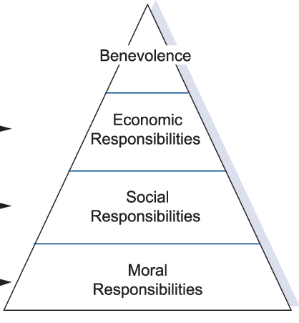
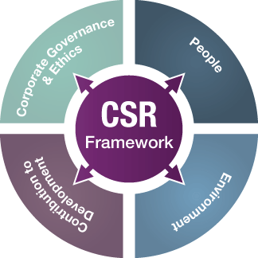
Figure 3: Different CSR Frameworks based on Carroll’s Pyramid (Source: (Leclercq-Machado et al., 2022)

Interpretation: Based on the analysis of multiple research papers and journals, it was found that most of the authors have followed Carroll’s CSR pyramid to present the CSR activities in structure. However, some authors changed the dimension or outlook of the framework but the main theme remained the same. Therefore, to understand the concept of CSR, Carroll’s pyramid is widely accepted. Hence, according to the authors, the CSR for an organisation should consist of four responsibilities will focus on the economic situation of the company, its impact on society, asking ethical questions about the company’s operation, and performing responsible acts for the betterment of the lives of the people. These four responsibilities require companies to serve people, society, and the environment so that the overall value creation eco-system of the companies is being served.

4.2.2: Importance of CSR activities on Company’s Profitability
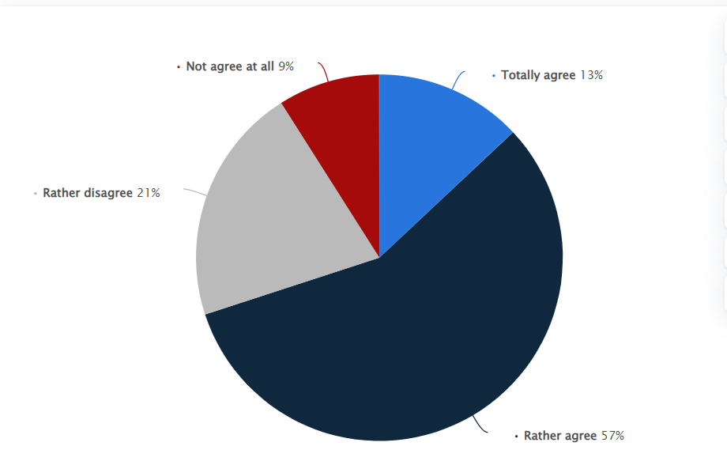
Basuony and Elseidi (2014) conducted research and studied multiple variables that indicate the financial performance of a company such as return on assets, return on equity, revenue growth, and competitive position. The authors found a positive correlation between CSR activities and the financial performance of a company and the company’s growth. However, the authors noticed that the CSR activities of a company work as a moderator for improving the financial performance but not as a direct factor that can enhance the overall financial performance. However, customer loyalty is the most important factor that impacts the profitability of a company. Thus, CSR activities help to attain loyal customers and thus help to increase profitability. For example, Statista (2021) surveyed customer loyalty. The authors asked respondents if they are loyal to the businesses that regularly engage in socially responsible activities. 57% of the respondents agreed that they are loyal to the businesses that engage in CSR activities and 13% strongly agreed with the statement. However, 21% disagreed with the statement.

Figure 4: Impact of CSR activities on Customers’ Loyalty (Source: Statista, 2021)
According to Mohyletska (2021), stated that customers become loyal and pay a premium price for CSR-engaged companies and thus it creates a strong public image for the companies. However, the author came to the conclusion that CSR efforts do not have an effect on the short-term profitability of organizations nor do they directly impact that profitability. Instead, CSR contributes to improvements in brand equity, customer loyalty, and public image, all of which can help businesses increase their profits.
John Lewis company is working based on CSR frameworks, for example, achieving net zero carbon emission, ensuring animal welfare, reduction of waste by 30%, and serving communities through financial support. These activities will surely enhance the business image of the company which will result in higher profit. For example, in the last four years, the company’s net profit has increased by £4.5 billion and the increasing CSR activities of the company have a significant contribution to it (Smith, 2022).
Interpretation: Based on the analysis of different authors’ perspectives, it can be said that CSR activities increase a company’s customer loyalty, brand image, and reputation in society. These factors contribute to the increment of profitability in a company. However, engaging in CSR activities does not directly enhance profitability in the short term. Besides, customer loyalty is the most important factor for the profitability of a company. But customers’ loyalty is largely dependent on the quality of service or product customers receive rather than engaging in CSR activities. Hence, to increase customers’ loyalty, CSR activities are not the best or only to achieve. Thus, profitability can be improved in better alternative ways than just engaging in CSR activities.

4.2.3: CSR activities that can increase the profitability of a company
According to Stobierski (2021), the major CSR activities belong to the areas such as environmental, philanthropic, ethical, and economic responsibility. These are the main activities that can ensure the growth of the business resulting in higher profitability. Firstly, the author recommends decreasing contagious activities such as air or water pollution, plastic pollution, and greenhouse gas emission. Besides, organisations should focus on controlling energy consumption such as using more renewable energy sources. Then, they should minimize the negative influence on the environment by planting more trees and donating to environment-related matters. Secondly, according to the author, organisations should take ethical actions towards their operation e.g. ensuring fair treatment to all of its stakeholders. Ensuring ethical responsibility in the organisation creates an environment of trust and transparency. Employees trust the leadership as fair treatment is provided. Thus, their job satisfaction increases. Increased job satisfaction leads to higher organizational performance and job satisfaction.
Thirdly, an organisation should be liable for its environment. It means not doing things that can harm the environment. For example, incorporating recycling concepts, reducing carbon footprints, and so on are some of the activities. Moreover, Butler (2018) found that 88% of consumers are loyal to the consumers that are environment friendly and thus it also increases the profitability of the business. Finally, organisations should also engage in philanthropic activities. It includes actively participating in activities that ensure the overall well-being of society. For example, Giving (2018) Kraft and Keinz donated money worth a meal to people who are hungry whenever someone liked their Facebook page. Also, Microsoft donates 3 million hours of volunteer work worth $25 per hour to charities.
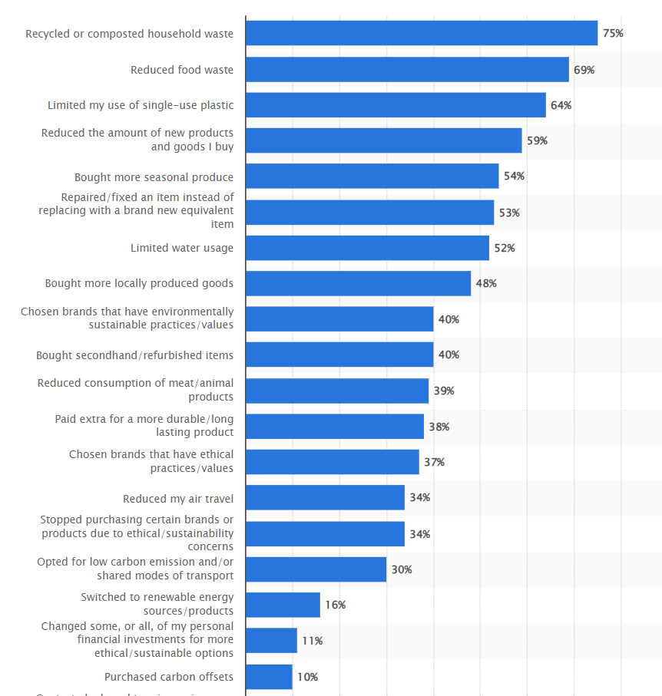
However, Tighe (2022) conducted a survey and found the sustainable shopping behavior of people in the UK. The behavior indicates the social responsibilities that businesses should do to retain customers and make them loyal. The following graph shows the result of the study.

Figure 5: Sustainable Shopping Behaviour of Consumers in the UK in 2022 (Source: Tighe, 2022)
Interpretation: The graph shows sustainable shopping behavior among UK consumers which means what factors consumers consider while purchasing a product. Ensuring these factors can certainly increase a business’s profitability. However, these factors broadly can be classified under four responsibilities such as economic, philanthropic, ethical, and environmental. Moreover, John Lewis Partnership also performed highly impactful CSR activities such as donating £6.5 million to society and reducing greenhouse gas emissions by 22.18% (John Lewis Partnership, 2021).

4.3: Summary
Corporate Social Responsibility refers to the activities which are done for the betterment of society, the environment, and stakeholders. However, Carroll’s CSR pyramid illustrates the concept showing four responsibilities under CSR and other authors also used this model to describe CSR slightly changing it. Moreover, CSR activities have an impact on profitability because it increases brand image, and trust among customers. Consequently, it increases profitability. However, CSR does not directly impact profitability. Finally, CSR activities that comply with the sustainable behavior or awareness of consumers are likely to bring the most growth and profit to the businesses such as philanthropic and environmentally friendly activities.

Chapter 5: Conclusion, Limitations & Recommendation

5.1: Introduction
This gives a conclusion on the research objectives that is how each objective has been achieved. Besides, it gives a brief overview of the research problem, original contribution to the sources, limitations of the research paper, and future recommendations.

5:2: Conclusion on Research Objectives

5.2.1: Finding out the Concept of CSR in business
Corporate Social Responsibility (CSR) refers to the activities that provide value to the society and stakeholders of a business. However, Carroll’s CSR pyramid identifies four responsibilities such as economic, philanthropic, legal, and ethical that manifest the roles that are expected from businesses. Thus, it clearly shows the concept. Although other authors defined the activities, their main concept matched Carroll’s model.

5.2.2: Importance of CSR activities on Company’s Profitability
It was found that 57% of consumers are loyal to the brand that engages in CSR activities. Thus, customers’ loyalty brings higher profit as they repeatedly purchase and can also pay a higher price. Moreover, in the long term, consistent CSR activities increase the company’s brand image and trust which increases the profit also. However, CSR does not directly impact profitability.

5.2.3: CSR Activities that can increase Profitability
It was found that four responsibilities such as economic, ethical, philanthropic, and environmental activities can bring higher profit for businesses. Besides, consumers are becoming more aware than ever regarding sustainability. Thus, businesses whose activities resemble the sustainability concept can increase their profitability by increasing consumers’ trust.

5.3: Conclusion of the Research Problem
The research problem was to identify the importance of CSR activities and their impact on the profitability of a company. Thus, it was found that CSR activities bring important value to the organisations such as an increment in the customer's trust, customer loyalty, and customers’ retention. Besides, it also attracts investors and provides a large investment opportunity. These all factors contribute to the growth of the businesses and increment in profitability. Besides, the research also identified the impact of CSR activities on John Lewis's partnership which was absent in the current research. Also, it discusses different CSR activities incorporated by John Lewis Partnership.

5.4: Summary of Research Findings and Outcomes
The research found that the concept of corporate social responsibility incorporates four aspects which are ethical, legal, economic, and philanthropic activities, according to Carroll. Besides, companies that engage in activities that fall under any aspects of CSR will be called they are performing CSR activities. Secondly, it was found that there is a positive correlation between profitability and the CSR activities undertaken by the companies. The profitability was measured by ratios such as ROA, ROE, and company revenue growth. Also, it was found that John Lewis was successful enough to bring positive results performing CSR activities which impacted their profitability and brand image.

5.5: Original Contribution to the Research
The existing research papers identified the concept of CSR and the impact of CSR on profitability. It was found that CSR activities had a positive correlation with profitability. However, this research paper showed the ways CSR activities increase profitability. Besides, incorporating different perspectives of authors regarding the CSR concept developed a common model of CSR that showed the CSR activities that can improve profitability. Finally, it also showed how John Lewis Partnership have done CSR activities and their impact on the company.

5.6: Limitations of the Research
The main limitation of the research was time and the extent to of the research was conducted. The time was limited for conducting the research. Thus, if the researcher got more time, he could do the research more perfectly. Besides, the time spent on conducting secondary research was also limited. Therefore, if more time was allocated for secondary research, more information could be collected. Secondly, there was a lot of information available regarding CSR activities. But the research used a sample of that information for conducting the research. Thus, if more information is incorporated into the secondary research, the research could be more perfect in giving recommendations and results.

5.7: Recommendation
The research paper has focused solely on the concept of CSR activities and the impact of CSR activities on the profitability of the organisation such as the John Lewis Partnership. This paper has set the base for further research on this topic. More research could be done that may focus on specific areas, for example, identifying the ways CSR improves profitability or how shareholders' value is maximized through CSR activities. In such future research, researchers can use this paper to gauge the idea of CSR activities; how they impact profitability and identify in which areas of profitability they should focus.

5.8: Summary
CSR is comprised of four duties, which are charitable, ethical, legal, and economic respectively. These efforts of corporate social responsibility serve to build the trust and loyalty of customers. Therefore, businesses who participate in CSR initiatives have a better chance of increasing their profits. In addition, the most growth will be achieved for a company through CSR efforts that are aligned with the sustainable behavior of customers. In addition, the most significant limits were the amount of time and scope that were allocated to the research. In conclusion, the research report has laid the groundwork for subsequent specific research on the subject matter.

Reference list
Amdur, E. (2021). Unilever: A Global Pioneer Again ... A Tradition Of Corporate Social Responsibility. [online] Forbes. Available at: https://www.forbes.com/sites/eliamdur/2021/01/15/unilever-a-global-pioneer--again-a-tradition-of-corporate-social-responsibility/?sh=36177faf7d18.
Basuony, M. and Elseidi, R. (2014). (PDF) The impact of corporate social responsibility on firm performance: Evidence form a MENA country. [online] ResearchGate. Available at: https://www.researchgate.net/publication/284332490_The_impact_of_corporate_social_responsibility_on_firm_performance_Evidence_form_a_MENA_country.
Brown, P.K. (2021). Can the ‘research onion’ help your thinking around the philosophical and methodological underpinnings of your SoTL project? [online] #UofGSoTL. Available at: https://uofgsotl.blog/2021/07/02/research-onion-sotl-project/.
Butler, A. (2018). Council Post: Do Customers Really Care About Your Environmental Impact? [online] Forbes. Available at: https://www.forbes.com/sites/forbesnycouncil/2018/11/21/do-customers-really-care-about-your-environmental-impact/?sh=52c1aac8240d.
Carroll (1991). Carroll’s pyramid model of corporate social responsibility. [online] ResearchGate. Available at: https://www.researchgate.net/figure/Carrolls-pyramid-model-of-corporate-social-responsibility-Carroll-1991_fig1_308937632.
Carroll, A.B. (2016). Carroll’s Pyramid of CSR: Taking Another Look. International Journal of Corporate Social Responsibility, 1(3), pp.1–8.
Dudovskiy, J. (2022). An Ultimate Guide to Writing a Dissertation in Business Studies.
Ethical Consumer (2018). John Lewis Plc | Ethical Consumer. [online] Ethical Consumer. Available at: https://www.ethicalconsumer.org/company-profile/john-lewis-plc.
Fletcher, R. (2019). Ecotourism discourse: challenging the stakeholders theory. Journal of Ecotourism, 8(3), pp.269–285. doi:10.1080/14724040902767245.
Gelsthorpe, L. (2016). Book Review: Criminological Research: Understanding Qualitative Research Methods. Qualitative Research, 6(2), pp.275–277. doi:10.1177/1468794106065247.
Givinga (2018). 5 Successful Corporate Philanthropy Examples | Givinga. [online] givinga. Available at: https://www.givinga.com/insights/blog/5-corporate-philanthropy-examples-inspire-csr-strategy/.
Gonçalves, A. (2019). What Are The 100 Companies With The Best Reputation On Corporate Responsibility? [online] Youmatter. Available at: https://youmatter.world/en/top-100-companies-best-csr-reputation2019-28108/.
Harjoto, M.A. (2018). Corporate social responsibility and corporate fraud. Social Responsibility Journal, 13(4), pp.762–779. doi:10.1108/srj-09-2016-0166.
John Lewis & Partners (2022). Sustainable Products & Initiatives. [online] John Lewis & Partners. Available at: https://www.johnlewis.com/content/sustainability.
John Lewis Partnership (2021). Ethics & Sustainability Report. [online] Available at: https://www.johnlewispartnership.co.uk/content/dam/cws/pdfs/Juniper/ethics-and-sustainability/Progress-Report-2022/Ethics-and-Sustainability-Report-2021_22.pdf.
John Lewis Partnership (2022). John Lewis Partnership - 2020/21 Ethics & Sustainability Progress Report. [online] www.johnlewispartnership.co.uk. Available at: https://www.johnlewispartnership.co.uk/csr/reporting/progress-report.html.
Leclercq-Machado, L., Alvarez-Risco, A., Esquerre-Botton, S., Almanza-Cruz, C., de las Mercedes Anderson-Seminario, M., Del-Aguila-Arcentales, S. and Yáñez, J.A. (2022). Effect of Corporate Social Responsibility on Consumer Satisfaction and Consumer Loyalty of Private Banking Companies in Peru. Sustainability, 14(15), p.9078. doi:10.3390/su14159078.
Lefley, F. (2016). A pragmatic approach to management accounting research: a research path. Management Research News, 29(6), pp.358–371. doi:10.1108/01409170610683879.
Mayorova, E.A. (2021). Corporate Social Responsibility of Retailers: A Review of the European Studies. Social Entrepreneurship and Corporate Social Responsibility, 2(2), pp.89–112. doi:10.18334/social.2.2.112341.
Mohyletska, U. (2021). How does CSR affect companies’ financial performance? [online] www.ecohz.com. Available at: https://www.ecohz.com/blog/how-does-csr-affect-companies-financial-performance#:~:text=The%20findings%20revealed%20that%20CSR.
Sachs, S., Rühli, E. and Mittnacht, V. (2015). A CSR framework due to multiculturalism: the Swiss Re case. Corporate Governance: The international journal of business in society, 5(3), pp.52–60. doi:10.1108/14720700510604698.
Smith, P. (2022). John Lewis Partnership revenue 2009-2022 | Statista. [online] Statista. Available at: https://www.statista.com/statistics/420173/john-lewis-partnership-revenue-united-kingdom-uk/.
Statista (2021). France: impact of the CSR approach on the customer loyalty 2019. [online] Statista. Available at: https://www.statista.com/statistics/1064093/impact-csr-policy-customer-loyalty/.
Stobierski, T. (2021). Types of Corporate Social Responsibility to Be Aware Of. [online] Business Insights - Blog. Available at: https://online.hbs.edu/blog/post/types-of-corporate-social-responsibility#:~:text=Corporate%20social%20responsibility%20is%20traditionally.
Tighe, D. (2022). UK shoppers: sustainable shopping behaviors 2019. [online] Statista. Available at: https://www.statista.com/statistics/1056522/sustainable-shopping-behavior-of-uk-shoppers/.
Trong Tuan, L. (2019). Corporate social responsibility, ethics, and corporate governance. Social Responsibility Journal, 8(4), pp.547–560. doi:10.1108/17471111211272110.
Weinger, A. (2022). How CSR Impacts Businesses: A Guide For Corporations. [online] Double the Donation. Available at: https://doublethedonation.com/how-csr-impacts-businesses/#:~:text=Nearly%202%2F3%20of%20young.

