University of Wales Trinity St. David
Electrical / Electronic Engineering

ACDA5012
The design and development of a Senior Smartwatch to monitor the vulnerable and elderly
Research Proposal

Matt Haycock
2012802
Date 5th May 2022

Contents
1. Introduction 4
2. Background to the Proposed Research 5
3. Aims & Objectives 6
4. Development methodology 6
4.1 Outline of developmental method 7
4.1.1 Requirements 7
4.1.2 Analysis 7
4.1.3 Design 8
4.1.4 Implementation 9
4.1.5 Testing 9
4.1.6 Deployment 9
4.1.7 Maintenance 9
4.2 Data Collection 9
4.3 Data Evaluation 13
4.4 Risks & Limitations 13
4.5 Ethical Issues 13
5. Resources and Planning 13
5.1 Resources Required 13
5.2 Physical Resources 14
5.3 Human Resources 14
5.4 Gantt Chart 15
6. Reference List 16
7. Appendix 18

Figures
Figure 1 - The Waterfall Mode 6
Figure 2 - Block diagram of the Senior Smartwatch 8
Figure 3 - The Research Onion 9
Figure 4 - Pie chart of Senior Smartwatch as a concept results 10
Figure 5 - Pie chart results for helpfulness of the Smartwatch 10
Figure 6 - Pie chart results for mood of the wearer 11
Figure 7 - Pie chart result of scope for Smartwatch 11
Figure 8 - Pie chart results of researcher’s benefit of the Smartwatch 12
Figure 9 - Pie chart to show if the Smartwatch would be beneficial to the NHS 12
Figure 10 - Gannt Chart for project proposal 15

Appendix
Appendix 1 - Senior Smartwatch Survey
Appendix 2 - Healthcare Questionnaire
Appendix 3 - UWTSD Ethics form

1. Introduction
Healthcare has been a contentious issue for many years. With many cutbacks implemented, this industry has suffered from staff shortages, long hours and underfunded departments. The people who then suffer the most from these issues are the clients who are serviced by these professionals to either sustain life or recover, they are the patients. [1]
The author’s partner’s grandparents has onset dementia and COPD respectively, so felt inspired to think of an aid that would help them in their everyday life. It would also provide a peace of mind for the family with daily monitoring of vitals and location. There could be a possible gap in the market for a standalone system that monitors health and vitals that send alerts exists at a more affordable price than what is currently on the market.
With the advancement in technology over the years, the option to use this has never been more apparent to monitor the people who are either vulnerable or elderly. Either private or NHS funded companies hire workers to attend numerous patients daily, sometimes more than once, to make sure they are well and healthy. They also help to dress, wash and feed the patients. [2]
All these duties have to be performed in person, but monitoring the patient’s vitals and location could be done with these advances in technology via an adaption of a smartphone.
Average annual salary for a district nurse in Wales is around £31k [3]. These nurses would perform routine health checks on people who are unable to travel to a local clinic for checkups.

2. Background to the Proposed Research
The project proposal was one of development as there is already many devices to deal with elderly and vulnerable monitoring on the market.
For a dementia patient, it would be impossible for the carer or family member to be present 24/7. Dementia patients also tend to wander from their property in confusion. This could lead to them being exposed to the elements, becoming lost or unaccounted for. By leaving, the property unlocked could also leave it susceptible to crime. GPS would detect if the wearer has left the property without notification. [4]
Elderly or vulnerable people with underlying health issue are susceptible to possible heart attacks or strokes. A heart monitor will detect any anomalies in the output.
If blood pressure is high or low, it could be a warning that a serious issue is eminent. Therefore, the monitoring will act as a pre-emptive approach to have a checkup before something serious and potentially life changing could happen. [5]
Increase in temperature could mean the wearer may have contracted Covid -19. This would alert the carer to ask the wearer to take a lateral flow test to confirm it the wearer is positive. Daily monitoring of the wearers temperature will show patterns if their temperature is higher than normal.
By the patient being monitored by the watch, it will restrict the possibility of contracting Covid by cutting the amount of visits from carers.
There could business opportunities for a company to manufacture the device in an off the shelf design. This in turn could lead to a contract with a private healthcare company or the NHS to purchase the monitors. This would help alleviate staff shortages in either care homes or mobile workers doing daily visits. [6]
Baby monitors have been use in the past with family members able to monitor via video link. The Life Alert system was created to be worn around the neck and contacts emergency services and carers if it detects the patient has fallen. Technology has since developed with Alexa’s Care Hub Skill, which monitors by giving the patient activities and if they ask for a song to be played, this will come up on the caregivers’ smartphone and know all is well. [7]
Even more advanced technology now exist such the Aeyesafe System, which monitors thermal and sound. It is voice activated and uses artificial intelligence. This gives the user independence. [8]
A plus side of having vitals monitored daily is that data gathering has become more prevalent over the last couple of years. Epidemiology is data driven. So the more data available for elderly or vulnerable people will aid in the possibility of prolonging their lives. It could help to detect telltale signs of underlying illnesses or patterns that help to form studies on people living in certain areas of the country. [9]

3. Aims & Objectives

The aim of this study was to design and develop a monitoring system for the wellbeing and vitals of the elderly and vulnerable person.
Objectives to aid in the aim included:
- Design a system to include pulse and temperature monitor. System must be able to detect wearer’s location.
- Gather data from individuals to ascertain the benefit of a Smartwatch.
- Understand if the Smartwatch would help people living on their own.
- Complete project proposal by 5th May 2022.

4. Development methodology
The Waterfall model, as shown in figure 1, was used for the development criteria. This model broke down the project into linear stages during the development. Where the next stage was dependent on the previous. This methodology is standard for typical engineering design. [10]
Research for this objective was performed with a development methodology, as the technology already exists through normal smartwatches and home monitoring systems. However, this watch could be expanded and be primarily a monitoring system. The data could also be extracted to see patterns in people’s health.

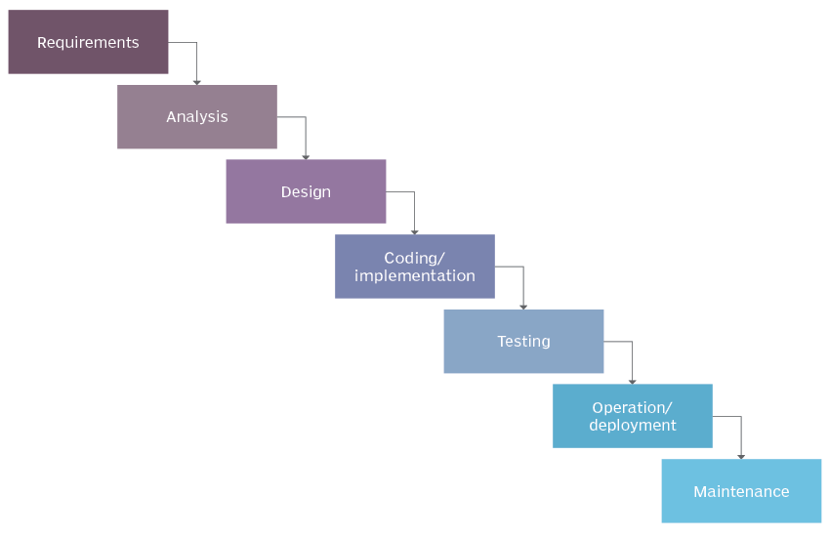
Figure 1 - The Waterfall Mode

4.1 Outline of developmental method

Requirements
Guidelines and a description of what was needed to fulfill the construction of the final product. It defines how the product will look and function.
The Smartwatch shall contain the follow functionality:
- The design will be able to detect heartrate and temperature of the wearer. This would send out readings per day to monitor vital signs.
- The design shall be able to detect location of the wearer via a GPS device. A boundary limited could be set to trigger an alert to acknowledge if the patient has wandered from the property.
- Alerts shall be communicated via an SMS that would be sent to either a nurse, family or carer.
- The watch shall have Bluetooth connect ability for wireless communication.
- Shall be connected to wearer 24/7 via a wrist strap.
- The time, date and actions will be displayed via an LCD screen
- Emergency alert button. This shall be a fail-safe panic button that the wearer could use if in difficulty.
- Chargeable battery connection
- 5V supply
- All sensors to be connected through a microcontroller

Analysis
From a business perspective, this shall determine production. The generation of models are done by analyzing specifications of the system as a whole.
Below is list of components required to make up the Senior Smartwatch:
- Microcontroller
- Rechargeable battery
- Pulse Sensor
- Temperature Sensor
- LCD Display
- GPS module

Microcontroller
The microcontroller shall be battery operated to make the design mobile and shall be low powered. 5V was required to power the unit. Minimum of 10 I/0 ports were required to connect all considered components. Shall require analogue to digital convertor to take analogue readings from the sensors and convert into digital signal for the microcontroller to read. A bus system was required to interconnect systems. Clock for timing purposes. ROM and RAM functions to store memory functions. It also required a level of sample to keep taking readings from the user.

Rechargeable battery
With the microcontroller requiring 5V for power, the battery would need to be higher than this. A lithium rechargeable battery was required. This would be backed up with another battery in series to give a longer charge. Connection between the battery and microcontroller required a step down component to avoid damaging the MCU.

Pulse Sensor
The sensor requires an analog signal conditioning and processing to determine the fluctuations in the pulse. Data acquisition to send the signal to the MCU to read and distribute. An internal system function to run the process of recording the data. Connection to the MCU shall be applied to one channel of the ADC of the MCU. The sensor requires 3V to power.

Temperature Sensor
The sensor requires an analog signal conditioning and processing to determine the fluctuations in temperature. Data acquisition to send the signal to the MCU to read and distribute. An internal system function to run the process of recording the data. Connection to the MCU is applied to one channel of the ADC of the MCU. The sensor requires 3V to power.

LCD Display
A display showing a minimum of 16 bits is required to show readings and commands sent to and from the sensors. A backlight is required to show the readings clearly. The LCD requires 5V to power.

GPS Module
Altitude, Latitude, Longitude and time are required to be read from a satellite for positioning. Requires USART connection to the microcontroller.

Design
The requirement of software, hardware and architecture is driven by a document of specification that would be created.
As shown in figure 3, a block diagram was created to show the layout of the Senior Smartwatch. Visio software was used to create the diagram. [11]
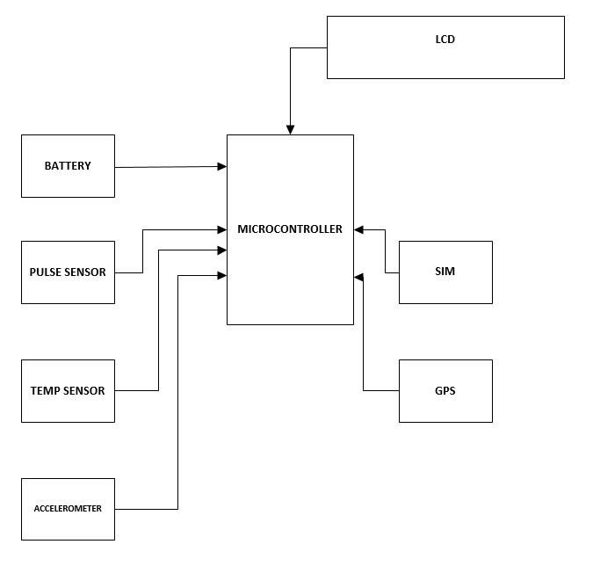
Figure 2 - Block diagram of the Senior Smartwatch

Implementation
This is the stage when all components are connected together.

Testing
Quality assurance and system tests will take place at this stage. It will see if the components assembled together can interact with one another. Any bugs in the system will also be ironed out before the next stage.

Deployment
The product has passed all tests and can be released for production.

Maintenance
Maintenance from a correctional or updated viewpoint will take place in order to either sustain the product or enhance with modification in the future.

4.2 Data Collection
The Research Onion, as shown in figure 3 [12], was used as a model for research methodology to collect data and conduct research for objectives criteria. The onion uses positivism and deduction, which translates as facts and figures. Crucial elements for developing a system as these are stimuli, which are measurable.
Methods from the onion are qualitative, which involved interviewing family members of people who need care and are living on their own, current care workers and nurses in their roles to support vulnerable people living on their own. Another method of research taken from the onion was quantative, which is a translation from numbers.
For the survey, 20 people were interviewed. Ten carers who worked for the Borough of Gwent Council, four Nurses who work in a Hospital in Newport, a General Practitioner based in Swansea and five members from different families whose relatives live on their own. Their ages ranged from 24 - 62 and all have different levels of exposure to the patients covered in this study.
As shown in appendix 1, the survey was to ascertain what they thought of the Smartwatch concept and if it would be worthwhile.
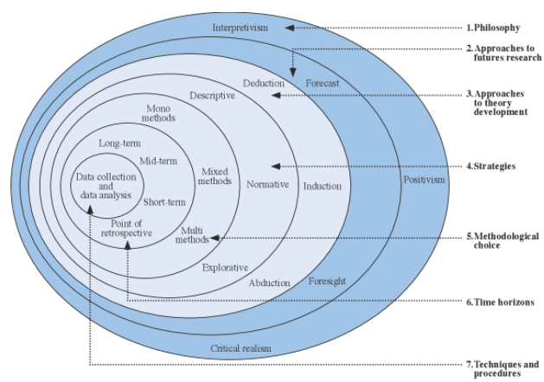
Figure 3 - The Research Onion
For the survey, the volunteers were asked a number of questions in relation to the watch being used on an elderly or vulnerable person under care. The results of the survey are shown in figures 4 - 9.

Figure 4 - Pie chart of Senior Smartwatch as a concept results
Results from the chart, shown in figure 4 showed that the Senior Smartwatch would generally be a very good idea.

Figure 5 - Pie chart results for helpfulness of the Smartwatch
Results as shown in figure 5 showed results to enhance this feeling that the watch would be helpful to the wearer.

Figure 6 - Pie chart results for mood of the wearer
Results from figure 6 shows the wearer would be very keen to wear the watch to monitor them when alone or isolated.

Figure 7 - Pie chart result of scope for Smartwatch
Results from figure 6 shows that the volunteers felt there would be plenty of scope to enhance the watch in future iterations. This aiding all concerned.

Figure 8 - Pie chart results of researcher’s benefit of the Smartwatch
Results shown in figure 8 showed that the monitoring system would help aid researchers in data gathering and precautions in future medicine studies.

Figure 9 - Pie chart to show if the Smartwatch would be beneficial to the NHS
Results in figure 9 shows the volunteer’s confidence in the Senior Smartwatch aiding the NHS or private medical companies with regards to relieving staff shortages and monitoring purposes.

4.3 Data Evaluation
For the questionnaire, as shown in appendix 2, the same group of people were involved as those who had taken part in the survey.
From the outset, the two studies of quantitate and qualitative were deemed to be connected, and showed that the two methods of data extraction link to one another.
The questionnaire, as shown in appendices 2, was using the qualitative method. So asked them the volunteers taking part in the study a set of questions how well their methods and tools for caring for vulnerable people who are distanced from society are working and is there any way in which they could be aided.
From the questionnaire, the overall feeling for the carers and nurses being overworked due to staff shortages. This in turn led to the nurses feeling that they could not take more time with the patients for monitoring. The carers also felt that they had little time to complete their chores. The GP felt that with the carers being rushed in their work they may not notice that the patient may be feeling unwell. This in turn would be escalated to the nurse to perform a check up on the patient, which in turn would be escalated to the doctor for diagnosis. The general concern from the families was that of little in the way of monitoring their family member as most had busy lives and could not be there for them constantly.

4.4 Risks & Limitations
By data being gathered from persons linked with healthcare, the risk of this data being made public could affect the person’s organization or family. The data gathered in the survey and questionnaire was stored on a personal pc, which required password access. The file containing the data was also password protected, so gave an additional security measure.

4.5 Ethical Issues
During the questionnaire and survey, no names were taken of the percipients. Therefore, data protection was not an issue. An ethics form, as shown in appendix 3, was filled out to accompany to survey as it was dealing with sensitive issues. In addition, professionals were involved in the survey and questionnaire.

5. Resources and Planning

5.1 Resources Required
With the Smartwatch being aimed at elderly or vulnerable people, access to people either working in healthcare or people being aided by healthcare was required. This was to gain knowledge and gather data to process into qualitive and quantitive measures.
For the Smartwatch, access to electrical components to create the system was required. The author owned a Microcontroller, but would have to purchase the remaining components to complete the system.
Coding software was already available on the author’s personnel pc in order to run the Microcontroller. This was Arduino IDE. [13]

5.2 Physical Resources
A personnel laptop was used to create the project proposal. Software used on the laptop included Microsoft application such as Word [14], to create the actual report and Excel [15], to produce the data gathered by way of pie charts. Visio was used to create the block diagram for the MCU. Literature review sources were compiled by reading journals and articles from UWTSD online library, notably the IEEE Xplore digital library, [16] and Science direct databases. [17]

5.3 Human Resources
Due to the author’s partner working with in the healthcare industry, there was a great deal of resource to hand. This would come from hands on experience in the field of healthcare. This also gave the exposure to co-workers in the field to help with the questionnaire and surveys.
By working in the healthcare industry, the author also had access to families whose loved ones are under healthcare, so they could also take part in the surveys.
Tutors from UWTSD were also used for resources for the project proposal.

5.4 Gantt Chart

Figure 10 - Gannt Chart for project proposal

6. Reference List

[1] |  | B. Rechel, ""Funding for public health in Europe in decline?" Health Policy," Jan 2019. [Online]. Available: https://www-sciencedirect-com.ezproxy.uwtsd.ac.uk/science/article/pii/S0168851018306596. [Accessed 4 April 2022].
[2] |  | Age UK. [Online]. Available: https://www.ageuk.org.uk/. [Accessed 6 April 2022].
[3] | "Indeed," [Online]. Available: https://uk.indeed.com/jobs?q=district%20nurse&l=Newport&from=searchOnHP&vjk=7371049767d2ab03. [Accessed April 2022].
[4] |  | C. A. S Paiva, "Low Cost GPS Tracking for the Elderly and Alzheimer Patients," Sep 2012. [Online]. Available: https://www-sciencedirect-com.ezproxy.uwtsd.ac.uk/science/article/pii/S2212017312005191. [Accessed 27 March 2022].
[5] |  | D. K. ZH Janjua, "Knowledge-driven feature engineering to detect multiple symptoms using ambulatory blood pressure monitoring data," 4 May 2021. [Online]. Available: https://pdf.sciencedirectassets.com/271322/1-s2.0-S0169260722X00035/1-s2.0-S0169260722000232/main.pdf?X-Amz-Security-Token=IQoJb3JpZ2luX2VjEBIaCXVzLWVhc3QtMSJGMEQCIByxgWasLwOZ8IGkcAZjSoekP6hy%2F48tTog9zALIMlnQAiAWXEn64lkVj7DWL2WGXh23%2FHHsLxCMFsUp158lJr9P. [Accessed 2 April 2022].
[6] |  | P Windle, "Addressing the Nurse Staffing Shortage," June 2008. [Online]. Available: https://pdf.sciencedirectassets.com/272463/1-s2.0-S1089947208X00036/1-s2.0-S1089947208000622/main.pdf?X-Amz-Security-Token=IQoJb3JpZ2luX2VjEBIaCXVzLWVhc3QtMSJIMEYCIQCmYKaAvaxEwBuEHi2etGcZyWrDSV5VpeA7YfrHlVvnnQIhAKerllDYmpd9NjeJgEIYWQ%2FRIytsNkUi3ELqLSRqkN. [Accessed 2 April 2022].
[7] |  | R. Schiltz, "How To Monitor Elderly Parents: Aging At Home Technology. Senior Safety Advice," [Online]. Available: https://seniorsafetyadvice.com/senior-safety-how-to-monitor-elderly-parents/. [Accessed 23 March 2022].
[8] |  | M. Whitley, "5 Helpful Elderly Monitoring Devices for Senior Safety," 10 May 2021. [Online]. Available: https://www.aplaceformom.com/caregiver-resources/articles/senior-monitoring-sensors. [Accessed 4 April 2022].
[9] |  | L. v. Amelsvoort, "Connecting patient care and clinical epidemiology: The anniversary of the key concepts in clinical epidemiology series," Jan 2022. [Online]. Available: https://pdf.sciencedirectassets.com/271297/1-s2.0-S0895435622X00024/1-s2.0-S0895435622000555/main.pdf?X-Amz-Security-Token=IQoJb3JpZ2luX2VjEBIaCXVzLWVhc3QtMSJGMEQCIByxgWasLwOZ8IGkcAZjSoekP6hy%2F48tTog9zALIMlnQAiAWXEn64lkVj7DWL2WGXh23%2FHHsLxCMFsUp158lJr9P. [Accessed 16 March 2022].
[10] |  | S. Lewis, "Waterfall Model," June 2006. [Online]. Available: https://www.techtarget.com/searchsoftwarequality/definition/waterfall-model. [Accessed 7 April 2022].
[11] |  | Visio, Microsoft, https://office.live.com/start/visio.aspx, 2002.
[12] |  | P. L. M Saunders, "Research Methods for Buisness Students," England, Prentice-Hall, 2009.
[13] |  | A. IDE, Arduino, https://www.arduino.cc/en/software, 2019.
[14] |  | Word, Microsoft, https://office.live.com/start/word.aspx, 2016.
[15] |  | Excel, Microsoft, https://office.live.com/start/excel.aspx, 2016.
[16] |  | I. X. d. library, "UWTSD," Accessed Mar 2022, https://ieeexplore-ieee-org.ezproxy.uwtsd.ac.uk/Xplore/home.jsp.
[17] |  | S. Direct, "UWTSD," Accessed Mar 2022, https://www-sciencedirect-com.ezproxy.uwtsd.ac.uk/.

7. Appendix

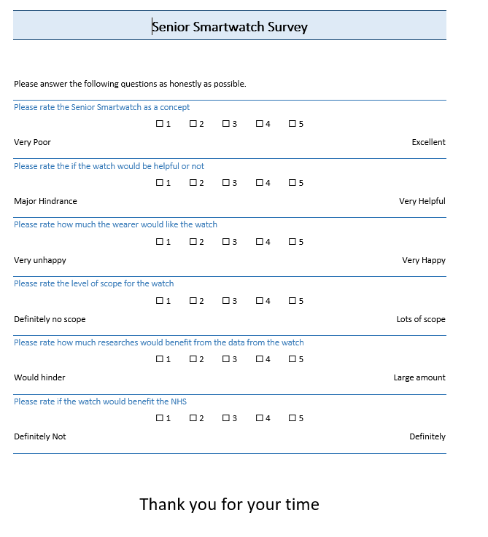
Appendix 1 - Senior Smartwatch Survey
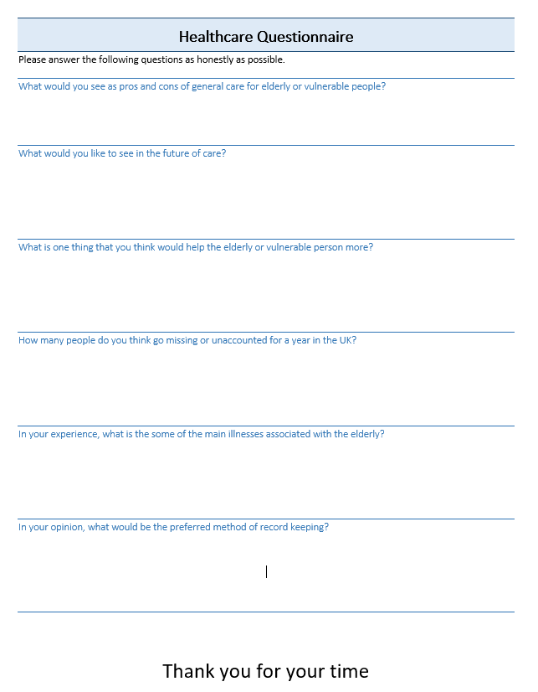
Appendix 2 - Healthcare Questionnaire

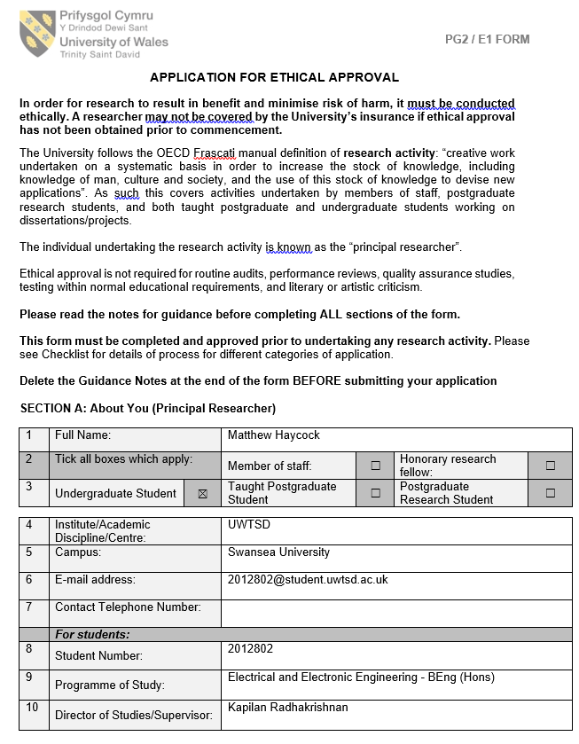

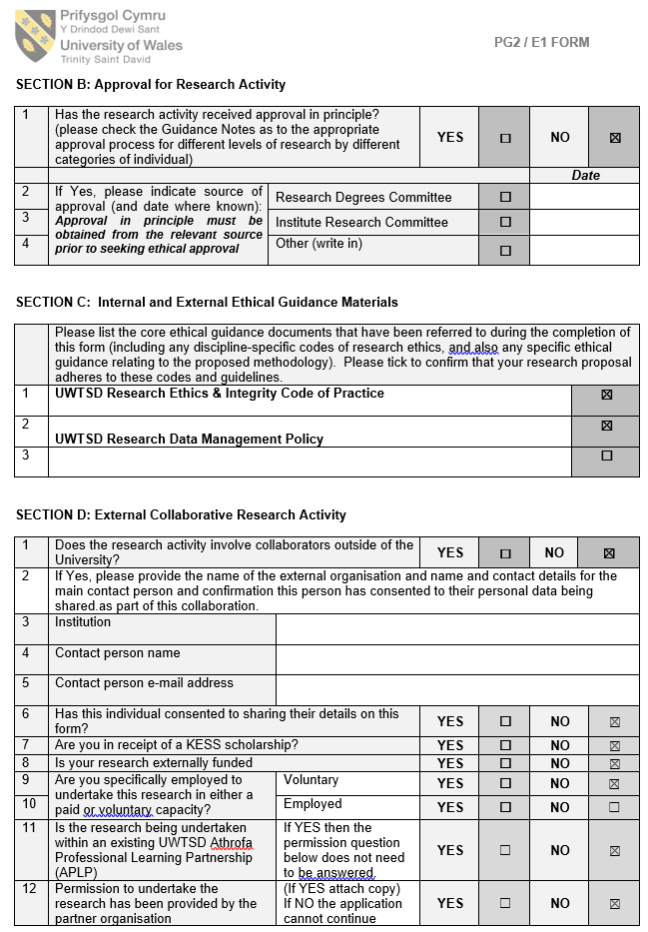

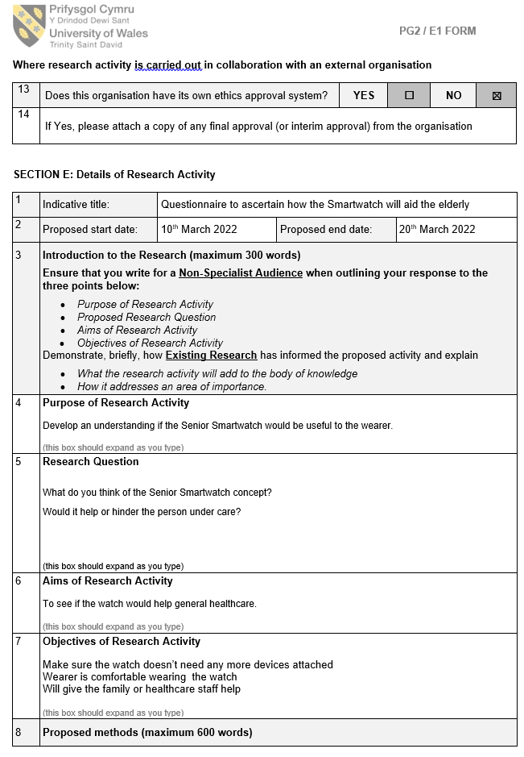

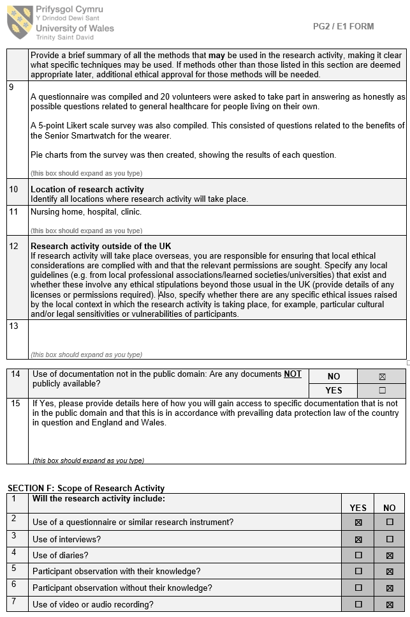
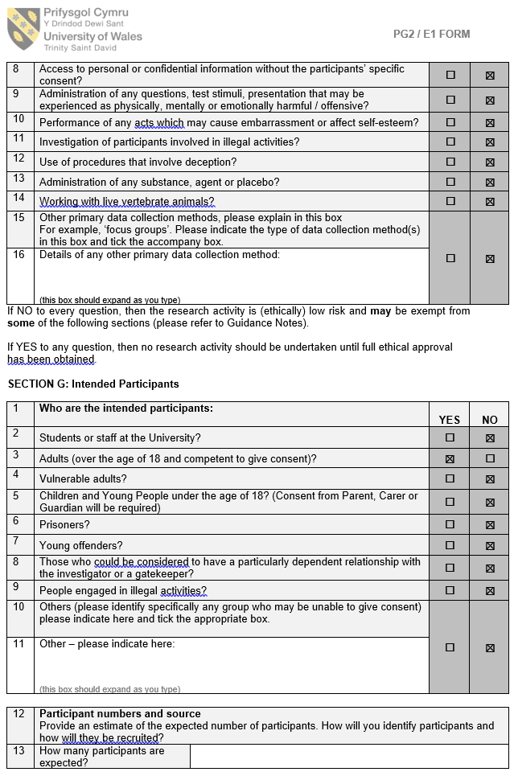
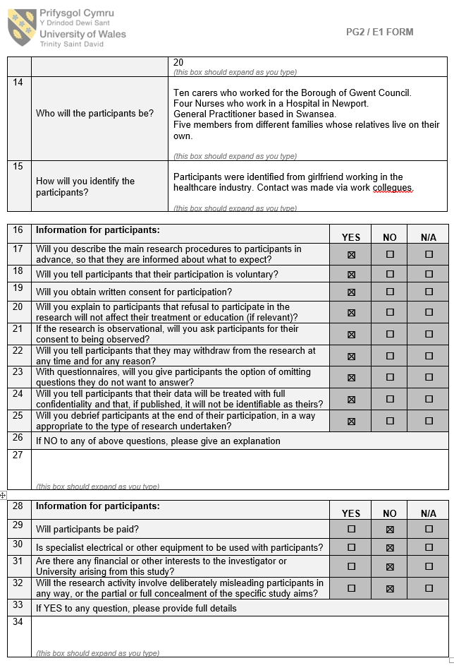

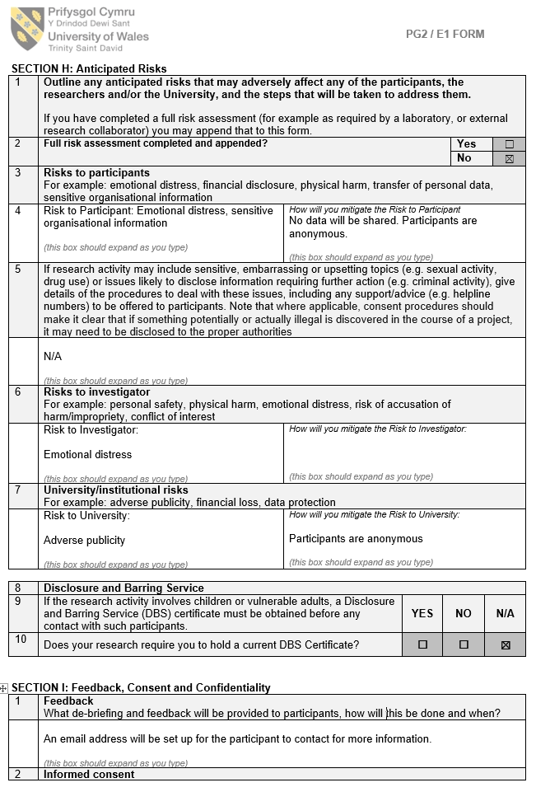

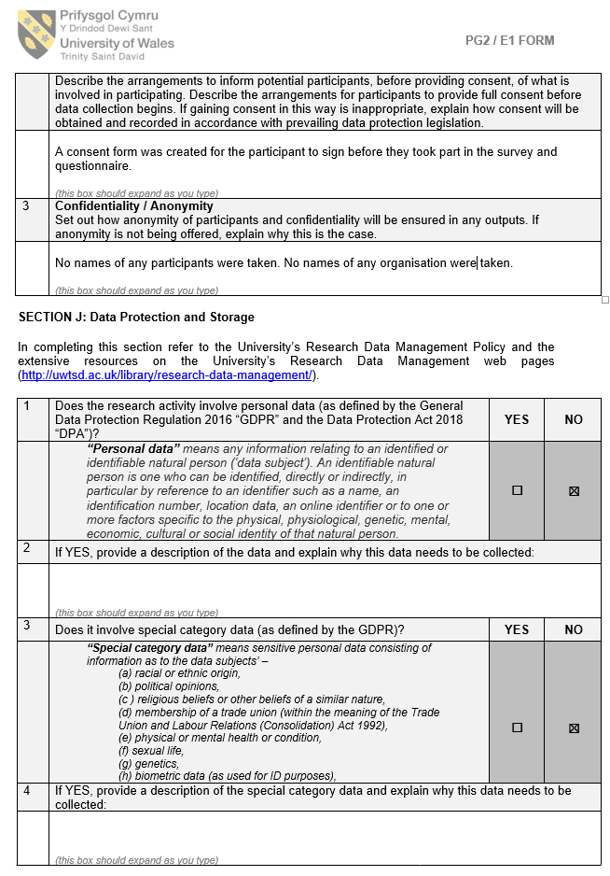

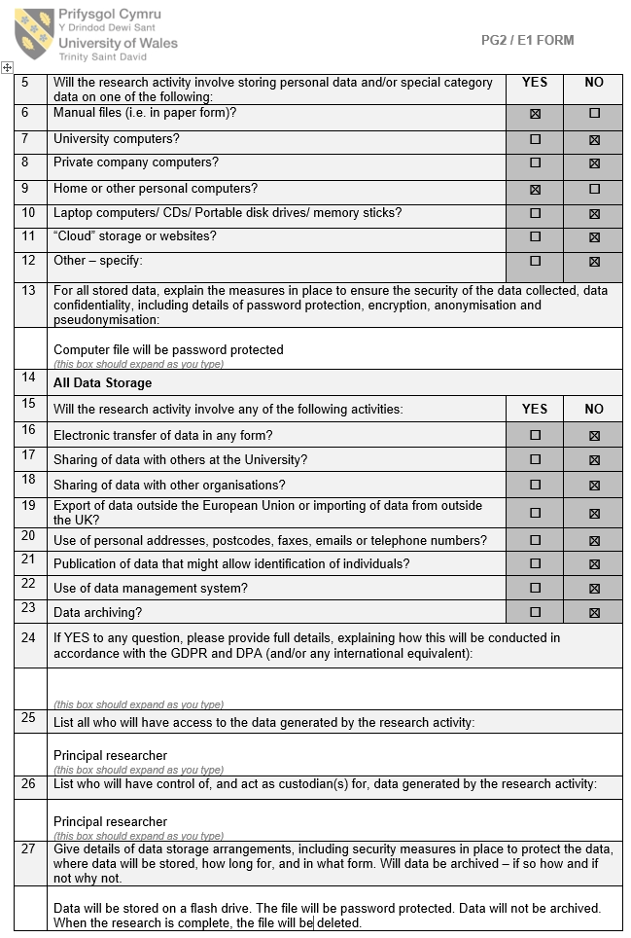

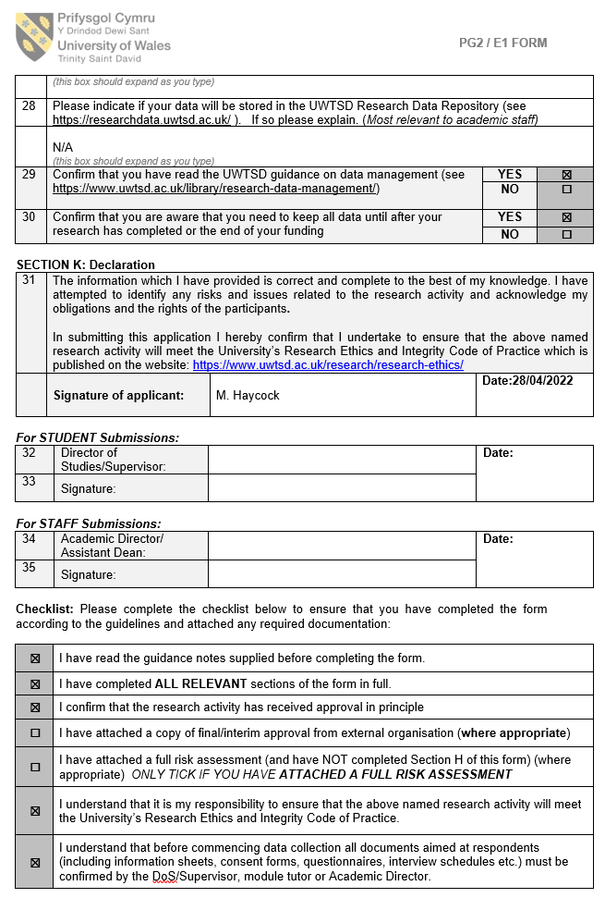
Appendix 3 - UWTSD Ethics form

