

Master of Business Administration

LCMB7003 - Strategic Management
Individual Report: Organisational Expansion Plan for Amazon in Indonesia
Student Name: Md Samiul Bashir
Student Id: 2422544
Lecturer Name: Andry Rakotovololona
Word Count: 4995
Table of Contents
1. Introduction 2
2. Company and Target Market 2
2.1. Amazon as the selected company and Justification 2
2.2. Indonesia as the Target Market for Expansion and Justification 2
3. Comprehensive Strategic Analysis 3
3.1 Macro-Environment Analysis of Indonesia 3
3.2 Analysis of Competitive Landscape in Indonesia 6
3.3 SWOT Analysis 8
3.4 Effectiveness and Limitations of the employed Analytical tools 9
4. Development of Market Expansion Strategy 10
4.1 VRIO Analysis for Competitive Advantages of Amazon in Indonesia 10
4.2 Uppsala Model for Internationalisation 11
4.3 Porter’s Generic Strategies for Strategy of Amazon in Indonesia 13
4.4 BCG Matrix for identifying the appropriate product in Indonesia for Amazon 14
4.5 Market Entry Strategies of Amazon 16
4.6 Summarised Market Expansion Strategy and Action Plan 17
5. TBL-based Performance Evaluation Framework for the Expansion Plan 19
6. Conclusion 21
7. References 22

1. Introduction
This Report aims to analyse the Indonesian Market as a potential target market for the internationalisation of Amazon, wherein a comprehensive strategic analysis will be conducted to understand the macro-environment and competitive landscape of Indonesia. Moreover, based on several key strategy development frameworks like Porter’s Generic Strategies, BCG Matrix, VRIO Framework, and Uppsala Model, the Market Entry Strategy for Amazon in Indonesia, as well as a relevant action plan, will be drawn in this report. Finally, a sustainability-based Performance Evaluation Framework will also be designed to gauge the progress of the internationalisation action plan.

2. Company and Target Market

2.1. Amazon as the selected company and Justification
Amazon is a global conglomerate with its operations across multiple industries, in many countries, globally, including 24 countries where the company has set up its official marketplace (Bits & Atoms, 2025). In this regard, the company has a global consolidated sales of US$637.9 billion earned through a global workforce of about 1,556,000 full-time and part-time employees (Amazon, 2025). Currently led by Jeffrey P. Bezos, Amazon is one of the most popular global business conglomerates with its operations in different fields, including but not limited to Entertainment, E-Commerce, Cloud Services and others (Amazon, 2025). This company is specifically selected as Amazon, with its main potential for global expansion mostly realised, and it lacks many opportunities for further internationalisation. However, it is also essential for the company to effectively penetrate the markets in which it is present. Thus, Amazon is selected for the development of the organisational expansion plan.

2.2. Indonesia as the Target Market for Expansion and Justification
For the international market expansion of Amazon, Indonesia is chosen as a target market. Harvey (2020) reports that Indonesia is one of the biggest countries globally, as the fourth-largest country with a population of 270 million, who have an average age of 30. Moreover, Harvey (2020) states that Indonesia is the largest economy in Southeast Asia, as the markets for Fintech and E-Commerce witness rapid growth in the market with the rapid digitalisation and internet penetration within the country. Harvey (2020) further added that in Indonesia, out of 175 million active Internet Subscribers, 171 million use online services for online streaming of videos and music (99%), online shopping (55%) or mobile banking (33%). Considering the ability of Amazon to compete in these market spaces within Indonesia, using its Amazon Prime Services, Amazon Pay services, as well as the most staple Amazon.com services, Indonesia is indeed an attractive market for Amazon to set up its official marketplace, providing it with the potential to be the 25th country across the globe to have an official Amazon marketplace. Moreover, as the largest economy in Southeast Asia, Indonesia also has economic access and cross-border supply chains into other ASEAN Markets. Therefore, strategically, Indonesia can also act as a launchpad for Amazon’s rapid penetration into the ASEAN Markets. Thus, Indonesia is an appropriate Target Market for the international expansion plans of Amazon.

3. Comprehensive Strategic Analysis

3.1 Macro-Environment Analysis of Indonesia
PESTLE Factors | Indonesian Market
Political | Political Stability in Indonesia increased in 2023 to -0.40 from -0.55 in 2022 (The Global Economy, 2024). This shows a slightly unstable political environment in Indonesia, which is noticeably improving and stabilising, providing opportunities for uninterrupted business activities. Opportunity
Economic | The change in Real GDP in Indonesia is at 5.03% in 2024, declining from 5.05% in 2023 (The Global Economy, 2025). However, the over 5% annual improvement in real GDP shows the growing economic strength of Indonesia, which improves affordability for services among the Indonesian population. Opportunity.
Social | It was previously found that the penetration of the Internet and Online Services is growing rapidly in Indonesia (Harvey, 2020). Moreover, the growing digital habits of the population are reflected in their consumption of streaming applications, fintech solutions and e-commerce (Harvey, 2020). Opportunity
Technological | While securing global tech investments, Indonesia is also improving its local innovation ecosystem, aiming to improve tech sector investments from 0.28% to 2.2% of the country’s GDP by 2045 (Liasko, 2025). Opportunity
Legal | A flat Corporate Income Tax of 22% is charged on business income annually in Indonesia (PwC, 2025). Moreover, Indonesian legislation curbs digital freedom of users, making the country’s legal framework harmful for the proliferation of digital systems (ICJ, 2023). Threat.
Environmental | Arifin et al. (2024) found that the governmental policies and initiatives are conducive towards the aggressive achievement of environmental sustainability within the country. Threat.
Table 1: Macroenvironment Analysis for Indonesia
(Source: Self-Developed)
In Table 1, the Macroenvironmental analysis was conducted for Indonesia. Herein, it was found that apart from the stringent environmental sustainability policies of Indonesia, and the harmful legislation of the country regarding digital services and their usage, which curtails the freedom of the users, while also taxing a sizeable portion of corporate income (22%), the rest of the PESTLE factors provides opportunity making Indonesia a lucrative market for the entry of Amazon. In this regard, it was found that the country’s political environment is consistently stabilising, making the market more capable of large-scale businesses like Amazon.
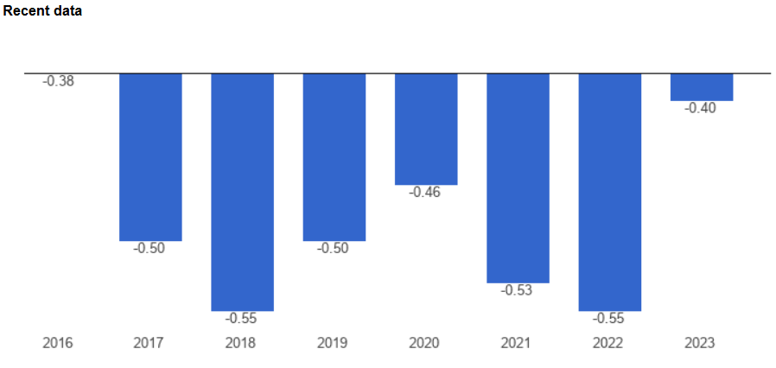
Figure 1: Political Stability in Indonesia
(Source: The Global Economy, 2024)
Moreover, it was also found that the real GDP of Indonesia is growing rapidly at over 5% annually. This, in turn, shows that the financial capability of the population and their ability to afford digital services are increasing rapidly. Herein, it was also found that the Indonesian Market is facing rapid digitalisation and internet penetration, which is increasing the percentage of the population engaging in the usage of online services, for shopping, streaming of videos and music, as well as mobile banking. This also provides Amazon with an excellent opportunity to enter the Indonesian Market with services like Amazon Pay and Amazon.com while also increasing its market penetration in the Amazon Prime Video segment. Moreover, the Indonesian IT sector is also poised to face rapid growth, providing excellent IT support for companies like Amazon, which require strong local IT support to manage their massive daily operations. This further proves Indonesia as an excellent market for the entry of Amazon.
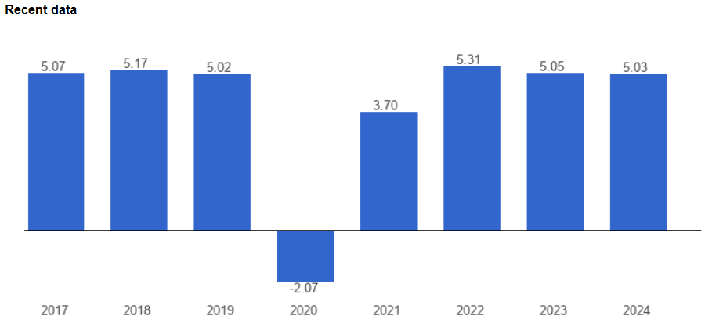
Figure 2: Consistent change of Real GDP in Indonesia above 5% annually
(Source: The Global Economy, 2025)

3.2 Analysis of Competitive Landscape in Indonesia
Porter’s 5 Forces | Indonesian Market | Threats
Competitive Rivalry | Rivalry from E-Commerce Platforms like Shopee, Zalora, Blibli, Bukalapak, and Tokopedia (DHL Discover, 2024). Major Digital Payment Platforms like Dana Wallet, Ovo, ShopeePay, LinkAja and GoPay are also major competitors (Fintech News, 2025). Vidio, Viu, Netflix, and Disney Hotstar+ are some of the major competitors in the streaming segment (KenResearch, 2025). | High
Threat of New Entrants | With the rapid growth of the economy and digitalisation in Indonesia, and increasing Internet Penetration, many new ventures can enter the market with ease. | High
Threat of Substitute Products | With the increasing competition with similar services, these services, as well as other forms of services like offline banking services, other forms of entertainment and offline shopping, act as substitutes in the market. | High
Bargaining Power of Buyers | With the increase in the number of competitors, buyers have a choice to choose the most favourable deal from these businesses. This increases the bargaining power of buyers. | High
Bargaining Power of Suppliers | With increasing global tech investment in Indonesia, there is an increasing number of suppliers for online service providers. This reduces the bargaining power of suppliers. | Low
Table 2: Competitive Landscape for Indonesia
(Source: Self-Developed)
Table 2, through the analysis of the competitive landscape in the Indonesian Market using Porter’s 5 Forces, identified that Amazon, after potentially entering the market, would face heavy competition from multiple companies. For instance, Amazon Pay as a mobile banking service would face competition from firms like Ova, GoPay, ShopeePay, LinkAja and others, while Amazon Prime Video faces competition from Netflix, Viu, and Vidio. Moreover, the main e-commerce business of Amazon would also face challenges from firms like Shopee, Zarola, Blibli, and others. In this regard, the multitude of competitors with similar services as well as alternatives like offline shopping, offline banking and other forms of entertainment, enhances the threat of substitute products which is faced by Amazon in the market. Moreover, this presence of many competitors provides the power to choose the best deals for the customers, giving them bargaining power. Moreover, with the increasing digitalisation and economic strength of Indonesia, it can be confirmed that the market encourages new entrants to enter the market, which is also a major threat to Amazon’s entry into Indonesia. While the bargaining power of suppliers does not pose a threat to Amazon, the high risks from other Industry forces make the Indonesian market complex and challenging for Amazon to navigate upon entry. Therefore, based on the PESTLE and Porter’s 5 Forces, it can be stated that Amazon can enter the market for internationalisation; however, it should do so only after making a proper internationalisation plan and considering the industry-based threats.

3.3 SWOT Analysis
Strengths | Weaknesses
- A Large Workforce of over 15,00,000 people working in Amazon’s global value chain.  - Global Brand Reputation of Amazon  - Strong Financial Resources of Amazon | - Ugochukwu (2025) reports thinning profitability resulting from aggressive pricing and free shipping policies.  - Over-dependence on AWS makes it difficult for Amazon to improve other segments of its business.
Opportunities | Threats
- Growing Digitalisation and Internet Penetration in Indonesia  - A growing economy provides affordability to consumers  - Improving the Tech sector and political stability support Online Services in Indonesia  - Lower bargaining power of Suppliers reduces procurement costs. | - Increasing Competition from existing and new firms.  - Unsupportive Legislation for Digitalisation and Stringent Environmental Policies  - The threat of Buyers is high, increasing the need for discounts and offers.  - Alternate options like services of other forms, as well as offline arrangements, can threaten market position.
Table 3: SWOT Analysis for Indonesia
(Source: Self-Developed)
Table 3 essentially summarises the previous research, identifying and categorising the internal strengths and weaknesses of Amazon as well as the external opportunities and threats to the firm in the Indonesian Market. Herein, it was identified that the large workforce of Amazon, its immense financial resources, as well as global brand reputation are strengths of the firm, while its over-dependence on AWS, as well as thinning profitability resulting from penetrative pricing as well as free shipping policies are the weaknesses. Moreover, in terms of opportunities, it was found that growing digitalisation as a social trend in Indonesia, as well as the growing economy, political stability and improving tech sectors in the country, provide growth opportunities for Amazon. Finally, in terms of Threats, it was identified that increasing competition from new and existing firms, as well as challenging legislation and environmental policies alongside the bargaining power of buyers, are major threats for Amazon upon its entry into Indonesia, alongside the threat of alternative options to the services offered by the firm.

3.4 Effectiveness and Limitations of the employed Analytical tools
PESTLE Framework: Rastogi and Trivedi (2016) explained in their study that PESTLE is a well-known strategic analysis and business planning tool used by many business firms for gauging the external environment in which they operate. Buye (2021) also added that the PESTLE Framework is useful among other tools in identifying the key drivers in the external environment which can influence the internal activities of the firm. PESTLE Framework in this regard covers the political, economic, technological, social, environmental and legal dimensions of the external environment. For the present analysis, the PESTLE analysis was also used to evaluate the Indonesian market across the above-mentioned dimensions. This provided valuable insights into Indonesia’s suitability as an appropriate market for the internationalisation of Amazon, thus demonstrating the effectiveness of the PESTLE Framework. Buye (2021) further added that the PESTLE Framework also has its limitations, including the fact that it is a static framework which cannot accommodate the rapidly changing external environment conditions requiring increasing costs, resources and effort to consistently conduct the analysis multiple times, to gain a better understanding of the changes in the external environment.
Porter’s 5 Forces Framework: Pangarkar and Prabhudesai (2024) explain in their study that the Five Forces Analysis Framework provided by Michael Porter is one of the finest and widely applied tools for strategic analysis due to its ability to provide insights into an integrated view of the external environment, well beyond the scope of existing competitors within an industry, grounded in industrial organisation economics. This framework was also used in this report for examining the competitive landscape in the Indonesian Markets where Amazon could potentially compete in, upon its market entry. Herein, insights far beyond the simple competitors were identified, especially related to the changing dynamics of the substitutes, new businesses, buyers and suppliers. This further shows the overall effectiveness of Porter’s 5 Forces framework. On the other hand, the challenges and limitations of Porter’s 5 Forces implementation are similar to those of PESTLE analysis in its static nature, which makes it obsolete in being able to gauge the rapid changes in the industry factors. This is, however, still one of the most widely applied and relevant frameworks for the purpose, making it appropriate for the report.
SWOT Framework: Benzaghta et al. (2021) explained in their study that the SWOT Analysis Framework, which gauges the strengths, weaknesses, opportunities and threats, has become a fundamental tool used by organisations in times of indecision, to evaluate their position in the market and also for gauging the dynamics between the internal and external environment of a firm. In relation to the present report, the SWOT Framework has presented its effectiveness by effectively summarising the previous macroenvironmental analysis while also extracting information from previous research to identify the strengths and weaknesses of Amazon relevant to its market entry in Indonesia. However, although SWOT Analysis is a very practical and simple tool, it simply categorises the positive and negative internal and external factors of a firm, rather than enabling further processing of these insights into tangible, actionable insights. This is a major limitation of SWOT Analysis. However, even with its limitations, SWOT is still a highly relevant and effective framework for strategic analysis as used by businesses, and its application in this report is appropriate.

4. Development of Market Expansion Strategy

4.1 VRIO Analysis for Competitive Advantages of Amazon in Indonesia
Resource | Value | Rarity | Imitability | Organisation | Advantage
Technological Advancements | Yes | Yes | No | Yes | Long-term Competitive
Brand Equity | Yes | Yes | No | Yes | Long-term Competitive
Product Variety | Yes | Yes | Yes | No | Short-term Competitive
Market Capitalisation | Yes | Yes | No | Yes | Long-term Competitive
Human Resources | Yes | Yes | No | Yes | Long-term Competitive
Table 4: VRIO Analysis of Amazon in Indonesia
(Source: Self-created)
Analysis: The VRIO analysis of Amazon primarily focuses on 4 resources or factors, which include Technological Advancements, Brand Equity, Product Variety, and Market Capitalisation. These resources identify that the company has a competitive overall advantage in the global market, with its technology, logistics, and brand reputation. Technological advancements in the company are known as valuable, rare, and organised; however, it is not imitable (Slidegeeks, 2025). Thus, it makes the company have a permanent competitive edge in the market. Other than this, the brand equity, the market capitalisation, and the human resources also have a permanent competitive advantage, even if the resources may not be imitable. The product variety on Amazon, however, is permanently competitive even though it is underutilised.
VRIO analysis is a strategic management tool that is used to recognise the internal resources and capabilities of a company. With its four components, it analyses the competitive or sustainable advantage of companies (VanZandt, 2021). In Indonesia, Amazon has shown its global strength by having a competitive advantage in all its resources. The company also has significant rivalries with local companies; however, it only resulted in the better positioning of the company in the Indonesian market. They have opted for strong local partnerships and an understanding of consumer preferences.

4.2 Uppsala Model for Internationalisation
The Uppsala model describes that the internationalisation of an organisation is based on market expansion and knowledge. Amazon can use this model and its four stages to outline the incremental growth of the company. Amazon's internet-based model allows for faster and more direct expansion than traditional companies. The first of the four stages is: No regular export activities. In the earliest days of Amazon’s operations, the company did not have the option for regular exports; thus, it only focused on the domestic market (Prezi, 2025). However, after becoming a top-selling company in the USA, the company started to expand into other regions. It primarily focuses on freedom of choice, motivation, competition among local companies, and a limited government.
In the second stage, Amazon begins to expand its reach in the international market by working with independent agents and distributors. This helped it to gain a significant following in the global market and allowing for more customers. Amazon's global expansion can be seen as moving beyond its initial US market. It uses third-party sellers on its platform to sell products in different countries, which is similar to using independent representatives (Igwe, Rugara, and Rahman, 2021). With Amazon Prime and Amazon Web Services, the company soon grew into a company with a competitive advantage in the industry.
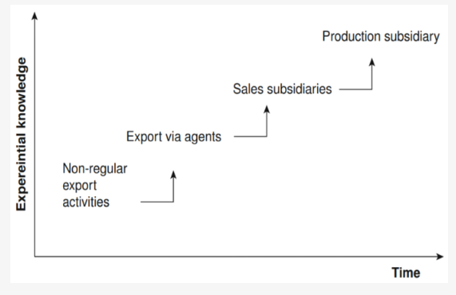
Figure: Uppsala Model for Internationalisation
(Source: Igwe, Rugara, and Rahman, 2021)
In the third stage, the company focused on foreign sales subsidiaries in various countries. For example, in India, the company is known for its great commitment and investment in the indian market. In the fourth stage, where the company currently stands, it has established several foreign productions. Its global network is centered around AWS, which is crucial for its operations in the retail sector.

4.3 Porter’s Generic Strategies for Strategy of Amazon in Indonesia
Porter’s generic strategy is a model that develops the competitive advantage for a company, while assessing the most influential factor out of cost leadership, differentiation, and focus. Amazon uses a combination of Differentiation and cost leadership strategy to differentiate through its vast selection of products and a customer-centric feature.
Factor | Description
Differentiation | It helps to create unique products with several benefits for customers, at a premium price.
Cost Leadership | It aims for competitive pricing and production in the Indonesian industry, and produces its products at a lower price than.
Focus | It targets a narrow market segment for its focus and achieves it through cost leadership or differentiation.
Table 5: Porter’s Generic Strategy for Amazon in Indonesia
(Source: Self-created)
Amazon primarily uses differentiation for its strategy to attain a broad selection of products with a diverse range on its platform. It uses various technologies for customer reviews and personalisation of services through its online app. With services such as Prime Membership, Free Shipping, and Personalised Search, the company easily differentiates its services from other brands, both international and local. The company uses the cost leadership strategy to gain a competitive advantage in the pricing of its products (Smithson, 2024). The massive global reach of this company helps it with logistics and purchasing at a low cost.
The company has a significant focus on its niche target market in Indonesia, and also tailors specialised services for the local market, with several payment options and delivery infrastructure. Salsabila et al. (2025) explain that Amazon can have a significant market share in Indonesia with its competitive advantage in the market.
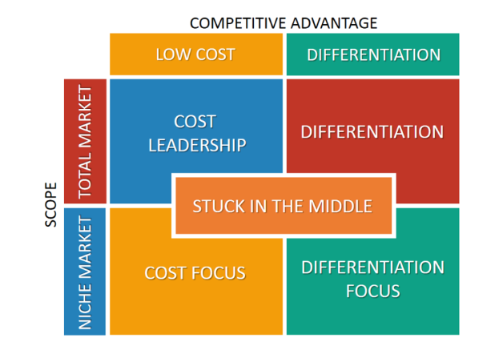
Figure 2: Porter’s Generic Strategy
(Source: de Bruin, 2021)

4.4 BCG Matrix for identifying the appropriate product in Indonesia for Amazon
The BCG Matrix is a strategic planning tool used for the assessment of their product based on market growth and market share. The four quadrants of the matrix, Star, Cash Cow, Question Mark, and Dog, describe the growth and sales of products. The figure below shows various products and services of Amazon and puts them in the grid of the matrix.
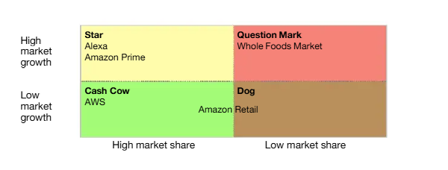
Figure: BCG Analysis of Amazon
(Source: Mahanani, 2025)
In Indonesia, Amazon Web Services is the most significant Star product of the company. The service garners a significantly high growth in the cloud computing market (LFB, 2025). In the future, the web service is likely to remain a star product. Other products and services of Amazon can also be recognised as star products in the Indonesian market, such as the retail and logistics industry. The Cash Cow product and the service of the organisation are, most importantly, Amazon Prime. The platform is a prime example of how companies can create services for a global Cash Cow while generating a larger profit from a loyal customer base. Its strong position in Indonesia suggests it is a Cash Cow there as well, benefiting from Amazon's vast user base in the country.
Jeff Bezos, the CEO of Amazon, describes the online store as an “Everything Store”, where anything can be bought. Therefore, the online retail store is the perfect example of a Cash Cow (Mahanani, 2025). The question marks of the company are the products from Amazon Fresh. Amazon Fresh, a derivative of the online platform, is still developing in various countries, including Indonesia. The country has a vast focus on fresh food from the local market; thus, it becomes a challenging requirement for investment in the market share for the platform to grow (Edraw Team, 2025). For the products on Amazon that can be considered as Dogs, it basically refers to a product or service that is underused or underutilised in the country.

4.5 Market Entry Strategies of Amazon
Amazon is known for its customer-based focus and market strategy for its market in Indonesia. The company primarily adapts a hybrid approach for its strategies, creating rivalries with local businesses. In Indonesia, the company has no dedicated e-commerce platform; however, it focuses on various strategies to gain a competitive advantage. Through strategic investments, it involves gaining insight into the market and challenging the local industries to gain an entry in the market. One of the most influential strategies of the company is its pricing strategy. The strategy focuses on various important aspects of retail, both offline and online (Hu, 2025). For Amazon, a wholly owned subsidiary is the most appropriate, as it can not only have complete control and integration, but also implement business models directly in its business. Exporting can help the company expand its global reach, increase product selection, and gain a diverse revenue.
Amazon uses data analytics and market research to understand its consumer behaviour for tailored customer segmentation and market trends. Their marketing strategy is a series of grand plans describing the operations of the company. Therefore, the marketing strategy is a logic where the company hopes to create a proper value and relationship for customers (Onggowidjojo and Ellitan, 2023). Amazon takes partnerships and acquisitions to collaborate with local companies and expand its market share and reach. With its customer-centric value proposition, Amazon can operate with platforms such as Amazon Prime and provide services such as fast shipping, exclusive deals, and customised products.
Amazon already dominates the global market, boosting its capitalisation to $1.7 trillion in 2024. Thus, in Indonesia, the company has several opportunities for its operations. The company successfully tailors to local tastes and needs to provide localised marketing campaigns. For example, in India, the company focuses on various payment options, including “Cash on Delivery” for its customers. Similarly, in Japan, the company focuses primarily on customer service to provide convenience, which is deeply rooted in the culture of the country (Guillén, 2024). If the company wants to expand its business in Indonesia, it needs to have a “multi-pronged expansion strategy.”

4.6 Summarised Market Expansion Strategy and Action Plan
The study focuses on establishing strategies for Amazon, using several models and frameworks. The VRIO analysis assesses the resources and determines if they are sustainable or competitive in the market. It also assesses the competitive advantage of the company in the Indonesian market. The company opts for strong local partnerships and an understanding of consumer preferences. The Uppsala model focuses on the market expansion and the knowledge of the company regarding the global market and its implementation of strategies in the Indonesian market. It uses the four stages of market expansion and assesses he operations of Amazon in the market.
Porter’s generic model focuses on three factors and establishes which is the most used factor for the company. It states that the differentiation strategy is the most effective strategy for Amazon and how it can help the company to create unique products with a premium price for the benefit of the customers. The BCG matrix is used for analysing the products of Amazon and where they fall in the BCG grid. Most of the products and services of Amazon in Indonesia fall under Cash Cow, and thus, benefit the customers in the country.
Action Plan
Goal | Specific | Measurable | Achievable | Relevant | Time-bound
Increase in Product Sales | Amazon can use various strategies to boost its product sales in Indonesia. | The company needs to reach a 20% increase in its revenue to track sales volume using Amazon Seller Central. | The company needs to implement advertisements targeted to campaigns and promotions for products. | This goal is relevant as it can directly support the goals of expanding the market share and revenue. | The company can achieve this goal by 2026.
Expansion of E-commerce | Amazon needs to expand its e-commerce through various strategies in Indonesia to have marketing campaigns and partnerships with local distributors. | It needs to achieve a 15% increase in the international market share to reach $2 billion in annual revenue by the end of the expansion period. | Amazon has a robust infrastructure and capital strength; therefore, for the company, it is achievable through AWS and data analytics. | The expansion is relevant as it aligns with the mission of the company to have a fast-growing e-commerce business in various regions. | The company can achieve this goal by 2028.
Improvement in Customer Review | The company can use strategies to increase the number of positive customer reviews in the company. | The company needs a 15% increase in its positive reviews to achieve proper improvement and gain a positive following. | Amazon needs to improve the quality of positive customer reviews to provide improved customer service and gain positive feedback from customers. | Implementing strategies for improving customer reviews can boost the trust of customers, conversion rates, and search rankings. | The company can achieve this goal by 2026.
Table: SMART Goals for Amazon
(Source: Self-created)

Goal | Key Actions | Responsible Team | KPIs | Timeline
Increase Product Sales by 20% | Launch targeted ads, offer discounts, and track sales via Seller Central. | Marketing & Sales | Sales growth 20%, Conversion rate | Within 6 months
Expand E-commerce in Indonesia | Form local partnerships, localise the platform, and run awareness campaigns. | Business Development | Market share, Revenue growth | Within a year
Improve Customer Reviews by 15% | Use follow-up reviews, improve service, and monitor feedback trends. | Customer Service | Positive review 15%, CSAT score | Within 6 months
Table 6: Action Plan for Amazon
(Source: Self-created)

5. TBL-based Performance Evaluation Framework for the Expansion Plan
Strategic Activity | People (Social) | Planet (Environmental) | Profit (Economic) | KPIs
Local Partnerships | Job creation and collaboration with local vendors. | Reduces import emissions via local sourcing. | Expands brand localisation and market access. | No. of partnerships; % local vendors.
E-commerce Expansion | Improves Rural Internet Connectivity and digital access. | Efficient fulfilment centres lower carbon output. | Boosts Online retail share and Sales Efficiency. | Market share; fulfilment efficiency.
Targeted Marketing | Enhances inclusive customer engagement. | Digital ads minimise paper waste. | Increases customer acquisition. | ROI; conversion rate growth.
Localised Payment & Delivery | Improves Payment Convenience Supports unbanked users. | Encourages online transactions. | Strengthens order frequency and loyalty. | Repeat purchases; transaction success rate.
AWS Integration | Builds tech skills among the locals and generates digital employment. | Promotes energy-efficient cloud solutions. | Expands high-margin digital services. | AWS clients onboarded; cloud adoption %.
Customer Review Systems | Improves trust and consumer protection. | Reduces physical service footprint. | Improves customer retention and satisfaction. | CSAT; % positive reviews.
Sustainable Logistics | Provides safe jobs in local delivery chains. | Uses optimised supply routes and recyclable packaging. | Cost-cutting enhances the sustainability image. | Carbon per delivery; % green packaging.
Table 7: TBL-based Performance Evaluation Framework
(Source: Self-Developed)
Shim et al. (2021) in their research identified that, according to the Triple Bottom Line Approach, companies need to demonstrate a responsible attitude towards the environment and society, while also focusing on economic profit, so that the firms achieve sustainable management effectively within the workplace. Considering the Triple bottom line approach, Table 7 here presents a performance evaluation framework for evaluating the detailed strategic actions to be implemented by Amazon for a successful market entry in Indonesia. In this regard, for each of the Strategic Areas, relevant activities in the economic, social and environmental spheres have been discussed alongside the corresponding KPIs necessary for measuring the progress and achievements in these activities. Herein, the main market entry strategy focused on a hybrid approach, which mixed exporting, alongside a wholly owned subsidiary, for achieving market entry for Amazon in Indonesia. The strategic activities and areas discussed here are tabulated under the implementation of the Exporting-wholly owned subsidiary as a market entry strategy.

6. Conclusion
Based on the above research, the report presents that in the external environment of Indonesia, the political, economic, social and technological aspects provide opportunities for effective growth of Amazon, while legal and environmental factors, as well as the industrial landscape, showcase the threats and challenges that Amazon might face in the process of entering the Indonesian market. Furthermore, based on the SWOT analysis as well as the VRIO analysis, the strengths and the competitive advantages of the firm are identified. Furthermore, through the application of the Uppsala Model for Internationalisation, as well as the supportive models like Porter’s Generic Strategies, which suggests diversification, and the BCG Matrix, the market entry strategy is justified, wherein a mix of Wholly-owned subsidiaries and the exporting method has been identified as the appropriate strategy for the market entry of Amazon in Indonesia has been explained. Furthermore, an action plan based on SMART Goals, as well as a TBL-based Performance Evaluation Framework for ensuring effective performance in the strategy implementation has also been developed.

7. References
Amazon, 2025. Annual Report 2024. Available at:https://s2.q4cdn.com/299287126/files/doc_financials/2025/ar/Amazon-2024-Annual-Report.pdf [Accessed 10 November 2025]
Arifin, R., Masyhar, A., Sumardiana, B., Ramada, D.P., Kamal, U. and Fikri, S., 2024, June. Indonesian sustainable development policy: How the government ensures the environment for future generations. In IOP Conference Series: Earth and Environmental Science (Vol. 1355, No. 1, p. 012005). IOP Publishing.https://iopscience.iop.org/article/10.1088/1755-1315/1355/1/012005
Benzaghta, M.A., Elwalda, A., Mousa, M.M., Erkan, I. and Rahman, M., 2021. SWOT analysis applications: An integrative literature review. Journal of Global Business Insights, 6(1), pp.54-72.https://pdfs.semanticscholar.org/1ce6/a88073a1fedd93547b395c7b1898970736ad.pdf
Bits & Atoms, 2025. Amazon Global Marketplaces Explained: Which Countries Have Amazon Marketplaces in 2025? Available at: https://bitsandatoms.eu/which-countries-have-amazon-marketplaces-2025 [Accessed 10 November 2025]
Buye, R., 2021. Critical examination of the PESTEL Analysis Model. Project: Action Research for Development, pp.1-12.https://www.researchgate.net/profile/Ronald-Buye/publication/349506325_Critical_examination_of_the_PESTEL_Analysis_Model/links/6093f3fd92851c490fbd6e7e/Critical-examination-of-the-PESTEL-Analysis-Model
de Bruin, L. (2021). Porter’s Generic Strategies: Differentiation, Cost Leadership and Focus. [online] B2U - Business-to-you.com. Available at: https://www.business-to-you.com/porter-generic-strategies-differentiation-cost-leadership-focus/ [Accessed 10 Nov. 2025].
DHL Discover, 2024. 5 top e-commerce platforms in Indonesia to build your brand store. Available at: https://www.dhl.com/discover/en-id/e-commerce-advice/e-commerce-best-practice/top-e-commerce-platform-indonesia [Accessed 10 November 2025]
Edraw Team (2025). Amazon BCG Matrix Analysis. [online] EdrawMax. Available at: https://edrawmax.wondershare.com/business-tips/amazon-bcg-matrix-analysis.html [Accessed 10 Nov. 2025].
Fintech News, 2025. 5 Top E-Wallets in Indonesia and What They’re Best For (2025). Available at:https://fintechnews.id/top-e-wallets-in-indonesia-best-for [Accessed 10 November 2025]
Guillén, S. (2024). Amazon’s International Expansion Strategy: What We Can Learn. [online] Accelingo. Available at: https://www.accelingo.com/amazons-international-expansion-strategy/ [Accessed 10 Nov. 2025].
Harvey, M., 2020. Challenges for growing Fintech & eCommerce markets in Indonesia. Available at: https://www.ipification.com/blog/challenges-for-growing-fintech-ecommerce-markets-in-indonesia/ [Accessed 10 November 2025]
Hu, J. (2025). An Analysis of Amazon’s Market Management Strategies in the Digital Age. Advances in Economics, Management and Political Sciences, 199(1), pp.222–228. doi:https://doi.org/10.54254/2754-1169/2025.bj25198.
ICJ, 2023. Indonesia: Regulation of digital platforms should comply with international human rights law and rule of law standards. Available at:https://www.icj.org/resource/indonesia-regulation-of-digital-platforms-should-comply-with-international-human-rights-law-and-rule-of-law-standards/ [Accessed 10 November 2025]
Igwe, P.A., Rugara, D.G. and Rahman, M. (2021). A Triad of Uppsala Internationalization of Emerging Markets Firms and Challenges: A Systematic Review. Administrative Sciences, 12(1), p.3. doi:https://doi.org/10.3390/admsci12010003.
KenResearch, 2025. Indonesia OTT Platform Market Outlook to 2030. Available at: https://www.kenresearch.com/industry-reports/indonesia-ott-platform-market [Accessed 10 November 2025]
LFB (2025). What is Amazon BCG Matrix (2025 Update). [online] Lfbbd.com. Available at: https://lfbbd.com/amazon-bcg-matrix/ [Accessed 10 Nov. 2025].
Liasko, E., 2025. Key Trends in Indonesia's IT Sector for 2025. Available at:https://globalcio.com/longread/Digital-Strategies-of-Indonesia/ [Accessed 10 November 2025]
Liesch, P.W. and Welch, C. (2024). Asynchronicities of growth: a process extension to the Uppsala model of internationalisation. Journal of international business studies, 55. doi:https://doi.org/10.1057/s41267-024-00702-w.
Mahanani, D.F. (2025). Analyzing_the_BCG_Matrix_of_Amazon.pdf. [online] Scribd. Available at: https://www.scribd.com/document/458933614/Analyzing-the-BCG-Matrix-of-Amazon-pdf [Accessed 10 Nov. 2025].
Onggowidjojo, V. and Ellitan, L. (2023). Strategies for Achieving Competitive Advantage: the Case of Amazon. Zenodo (CERN European Organization for Nuclear Research), [online] 10(9), pp.249–265. doi:https://doi.org/10.5281/zenodo.8373836.
Pangarkar, N. and Prabhudesai, R., 2024. Using Porter's Five Forces analysis to drive strategy. Global Business and Organisational Excellence, 43(5), pp.24-34. https://onlinelibrary.wiley.com/doi/pdf/10.1002/joe.22250
Prezi (2025). The internationalization of amazon. [online] prezi.com. Available at: https://prezi.com/sh4lsbdkflco/the-internationalization-of-amazon/ [Accessed 10 Nov. 2025].
PwC, 2025. Indonesia - Corporate Income Tax. Available at:https://taxsummaries.pwc.com/indonesia/corporate/taxes-on-corporate-income [Accessed 10 November 2025]
Rastogi, N. and Trivedi, M.K., 2016. PESTLE technique–a tool to identify external risks in construction projects. International Research Journal of Engineering and Technology (IRJET), 3(1), pp.384-388.https://www.researchgate.net/profile/Manoj-Trivedi-2/publication/363640549_PESTLE_TECHNIQUE_-A_TOOL_TO_IDENTIFY_EXTERNAL_RISKS_IN_CONSTRUCTION_PROJECTS/links/6326de560a70852150026dfc/PESTLE-TECHNIQUE-A-TOOL-TO-IDENTIFY-EXTERNAL-RISKS-IN-CONSTRUCTION-PROJECTS.pdf
Salsabila, H., Sari, P., Mardhiyah, W. and Dinita, R. (2025). Comparison of Porter’s Generic Strategies in Indonesia’s FMCG Companies: A Case Study. [online] IEOM Society. Available at: http://ieomsociety.org/proceedings/2021rome/422.pdf [Accessed 10 Nov. 2025].
Shim, J., Moon, J., Lee, W.S. and Chung, N., 2021. The impact of CSR on the corporate value of restaurant businesses using the triple bottom line theory. Sustainability, 13(4), p.2131.https://www.mdpi.com/2071-1050/13/4/2131
Slidegeeks (2025). Strategic VRIO Analysis Of Amazon Internal Scenario Ppt PowerPoint Presentation File Example File PDF. [online] Slidegeeks.com. Available at: https://www.slidegeeks.com/strategic-vrio-analysis-of-amazon-internal-scenario-ppt-powerpoint-presentation-file-example-file-pdf#images [Accessed 10 Nov. 2025].
Smithson, N. (2024). Amazon.com Inc.’s Generic Strategy, Intensive Growth Strategies. [online] Panmore Institute. Available at: https://panmore.com/amazon-com-inc-generic-strategy-intensive-growth-strategies [Accessed 10 Nov. 2025].
The Global Economy, 2024. Political Stability in Indonesia. Available at:https://www.theglobaleconomy.com/Indonesia/wb_political_stability/ [Accessed 10 November 2025]
The Global Economy, 2025. Economic Growth in Indonesia. Available at:https://www.theglobaleconomy.com/Indonesia/Economic_growth/ [Accessed 10 November 2025]
Ugochukwu, J., 2025. Amazon SWOT Analysis: Strengths, Weaknesses, Opportunities and Threats- 2025. Available at:https://entrepreneurs.ng/amazon-swot-analysis/ [Accessed 10 November 2025]
VanZandt, P. (2021). VRIO Framework: What it is, Tips & Advantages. [online] QuestionPro. Available at: https://www.questionpro.com/blog/vrio-framework/ [Accessed 10 Nov. 2025].

